

**GOVERNMENT COLLEGE OF TECHNOLOGY**

**COIMBATORE**

(An Autonomous Institution Affiliated to Anna University)

**COLLEGE CODE-7177**

**PROJECT TITLE: FAKE NEWS DETECTION USING NLP**

**TEAM MEMBERS:**

**SUBASH S -71772114146**

**ATCHAYA A -71772114104**

**ARUNTHATHI R -71772114103**

**RITHISHA P -71772114L01**

**PROBLEM STATEMENT:**

It involves developing algorithms and models to accurately identify and classify misinformation in news articles or social media posts. The goal is to create a system that can distinguish between reliable and fake news sources based on various factors such as credibility, source reputation, fact-checking, and content analysis. The challenge lies in designing effective algorithms that can analyse large amounts of data and detect patterns or indicators of fake news with high accuracy.

**PROBLEM SOLUTION :**

* To solve the problem of fake news detection, various approaches can be taken.
* One solution involves using natural language processing (NLP) techniques to analyse the content of news articles and identify patterns that indicate misinformation.
* This can include analysing the language used, fact-checking claims, and identifying biased or misleading information.
* Additionally, machine learning algorithms can be trained on labelled datasets to classify news articles as either reliable or fake based on features such as source credibility, writing style, and social media engagement.
* Regular updates and improvements to the algorithms are crucial to keep up with evolving techniques used by those spreading fake news.
* To tackle the problem of fake news detection is by leveraging the power of crowdsourcing.
* Platforms can engage users to report and flag suspicious or misleading content, which can then be reviewed by fact-checkers or community moderators.
* This collaborative approach helps in identifying and verifying the accuracy of news articles through collective efforts.
* Additionally, educating users about media literacy and critical thinking skills can empower them to identify and question sources of fake news, thereby reducing its impact.

**PROCESS:**

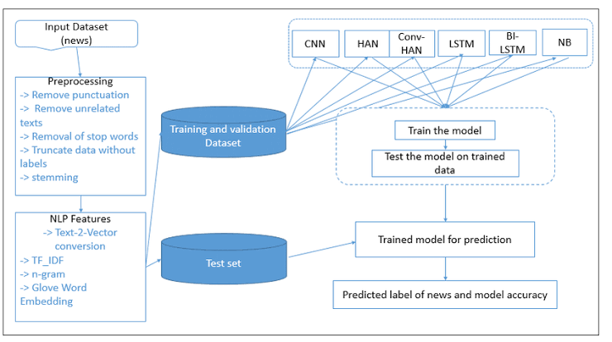

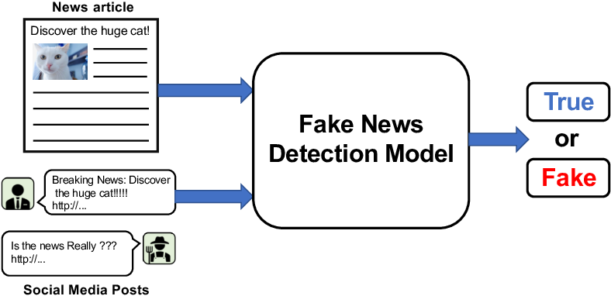

**DATASET:**

The dataset is taken from

<https://www.kaggle.com/c/fake-news/data>

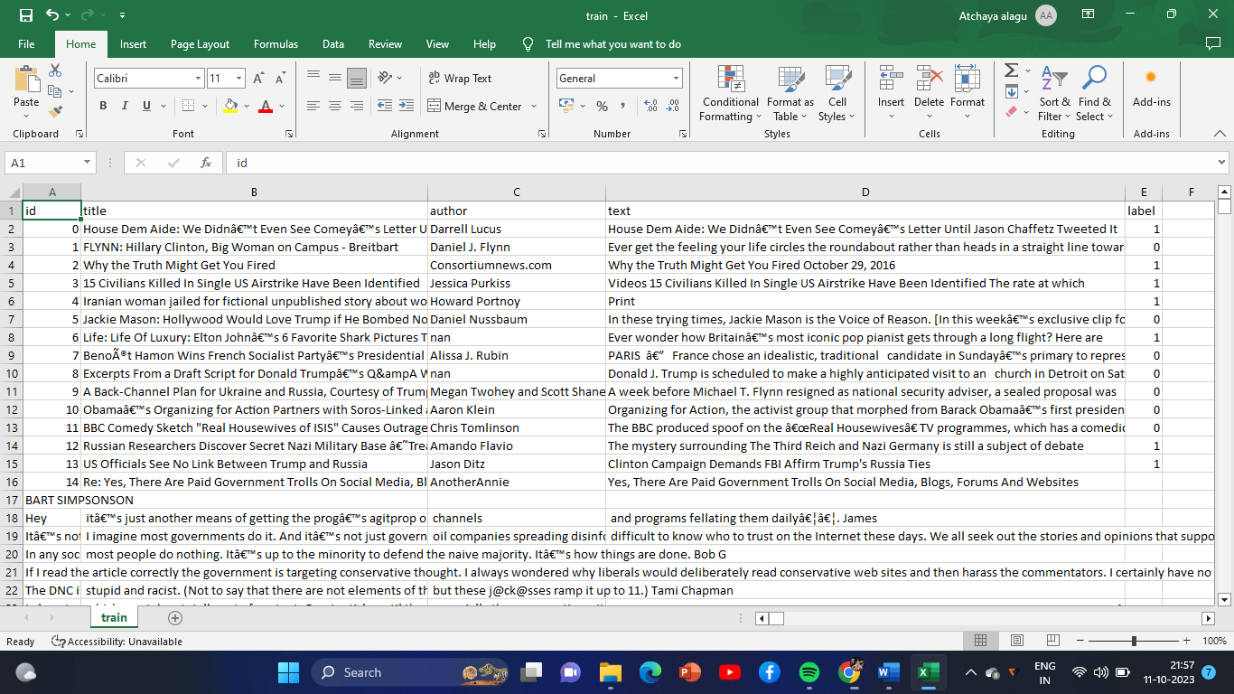

**SOFTWARE USED:**

Python – 3.X

**LIBRARIES USED:**

* + - Pandas
    - Scikit – learn
    - Nltk (Natural Language Toolkit)

**IMPORTING LIBRARIES:**

import pandas as pd

import numpy as np

import nltk

from nltk.corpus import stopwords

from nltk.stem import PorterStemmer

from sklearn.feature_extraction.text import TfidfVectorizer

from sklearn.model_selection import train_test_split

**JUPYTER NOTEBOOK:**

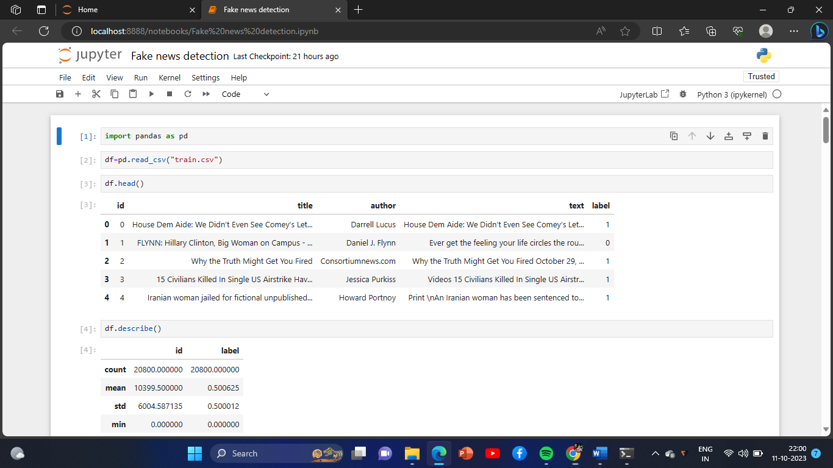

**PROGRAM:**

port_stem = PorterStemmer()

vectorization = TfidfVectorizer()

vector_form = pickle.load(open('vector.pkl', 'rb'))

load_model = pickle.load(open('model.pkl', 'rb'))

def stemming(content):

con=re.sub('[^a-zA-Z]', ' ', content)

con=con.lower()

con=con.split()

con=[port_stem.stem(word) for word in con if not word in stopwords.words('english')]

con=' '.join(con)

return con

def fake_news(news):

news=stemming(news)

input_data=[news]

vector_form1=vector_form.transform(input_data)

prediction = load_model.predict(vector_form1)

return prediction

if __name__ == '__main__':

st.title('Fake News Classification app ')

st.subheader("Input the News content below")

sentence = st.text_area("Enter your news content here", "",height=200)

predict_btt = st.button("predict")

if predict_btt:

prediction_class=fake_news(sentence)

print(prediction_class)

if prediction_class == [0]:

st.success('Reliable')

if prediction_class == [1]:

st.warning('Unreliable')

**UP-TO-DATE:**

* Get data from BuzzFeed news and politifact.
* Extend the dataset using data from social media.
* Detect communities around fake news posts and real news posts.
* Analyse our results to detect unusual user behaviour.

**CONCLUSION:**

After finishing all these process run this file and make api server with local host then paste the news . The compilation process will check whether the entered news is reliable or not.