2019115044
KABILAN HUSSAIN M K

1.Develop a JavaScript program that will determine whether a department-store customer has exceeded the credit limit on a charge account.
For each customer,
a) Account number
b) Balance at the beginning of the month
c) Total of all items charged by this customer this month
d) Total of all credits applied to this customer's account this month e) Allowed credit limit
The program should input each of these facts from a prompt dialog as an integer, calculate the new balance (= beginning balance + charges – credits), display the new balance and determine whether the new balance exceeds the customer's credit limit. For customers whose credit limit is exceeded, the program should output XHTML text that displays the message “Credit limit exceeded.”.
Code:
<?xml version="1.0" encoding="UTF-8"?>
<!DOCTYPE html
PUBLIC "-//W3C//DTD XHTML 1.0 Strict//EN"
"DTD/xhtml1-strict.dtd">
<html xmlns="http://www.w3.org/1999/xhtml" xml:lang="en" lang="en">
<head>
<title> First Question </title>
</head>
<body>
<script>
function myFunction()
{
let accno = parseInt(prompt("Enter account number "));
let bal = parseInt(prompt("Enter balance at the beginning of the month "));
let charge = parseInt(prompt("Enter total of all items charged this month"));
let credits = parseInt(prompt("Enter total of all credits applied this month"));
let limit = parseInt(prompt("Enter credit limit"));
let newbal= bal+charge-credits;
if (newbal != null)
{
document.getElementById("output").innerHTML = "New Balance is: "+newbal;
}
if (newbal>limit)
{
document.getElementById("status").innerHTML = "Credit limit exceeded";
}
else
- {
document.getElementById("status").innerHTML = "Credit limit was not exceeded";
}
}
</script>
<center><h2>Enter details to calculate new balance and credit limit status</h2></center>

<center><button onclick="myFunction()">Enter</button></center>
<center><h4 id="output"></h4></center>
<center><h4 id="status"></h4></center>
</body>
</html>
Output:
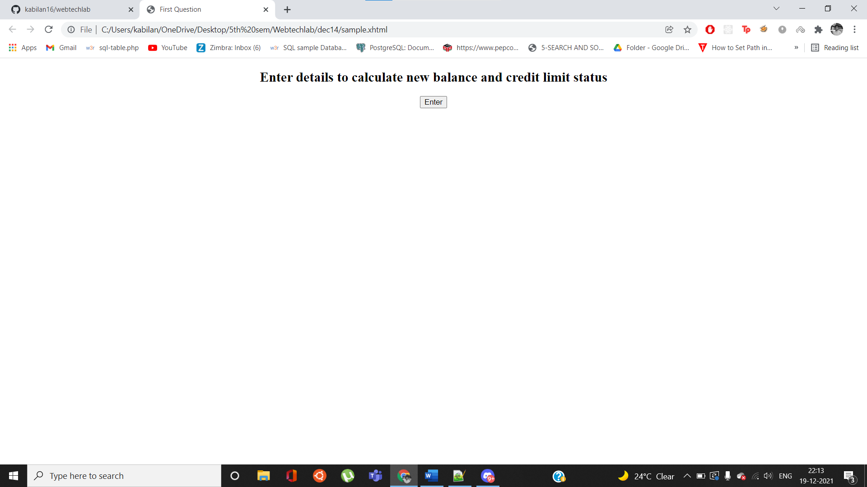
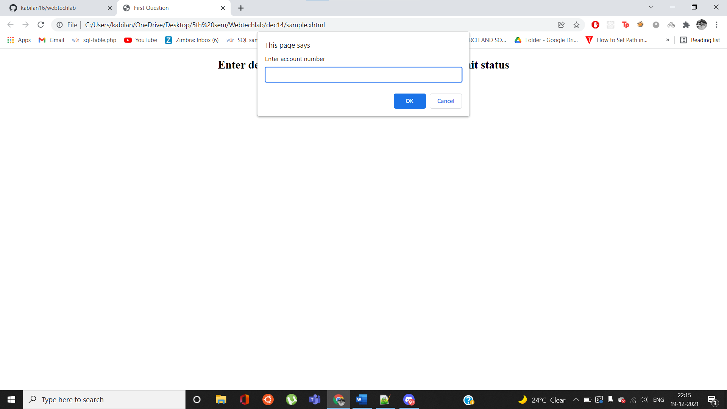
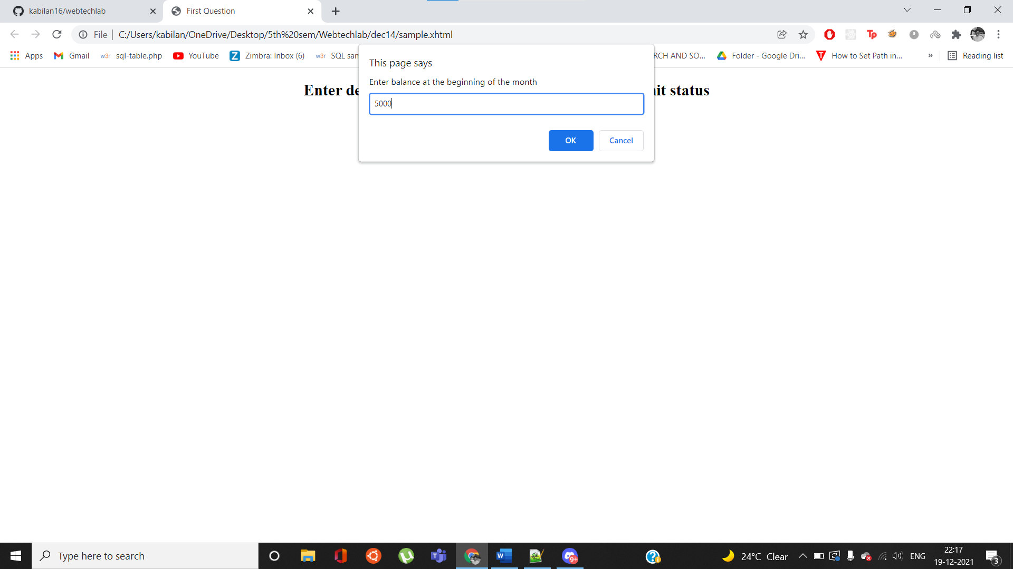
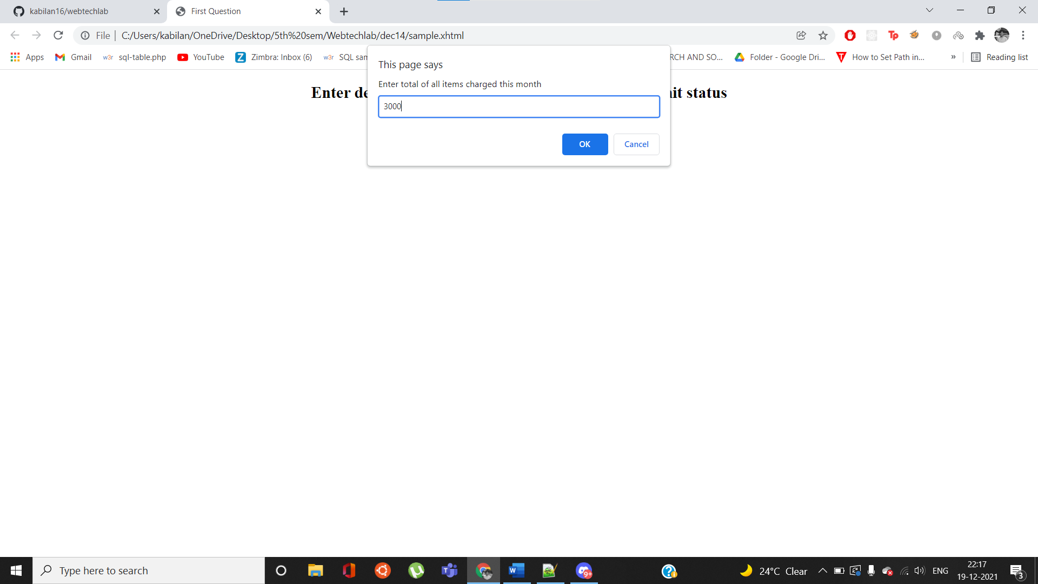

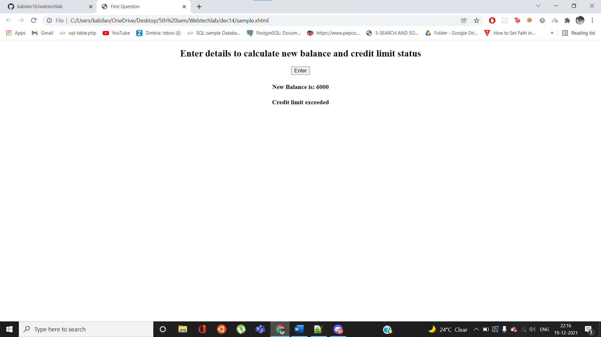

2. The process of finding the largest value (i.e., the maximum of a group of values) is used frequently in computer applications.
Forexample, a program that determines the winner of a sales contest would input the number of units sold by each salesperson. The salesperson who sells the most units wins the contest. Write a pseudocode program and then a JavaScript program that inputs a series of 10 single-digit numbers as characters, determines the largest of the numbers and outputs a message that displays the largest number. Your program should use three variables as follows:
a) counter: A counter to count to 10 (i.e., to keep track of how many numbers have been input and to determine when all 10 numbers have been processed);
b) number: The current digit input to the program;
c) largest: The largest number found so far.
Code:
Eval2nd.xhtml
<?xml version="1.0" encoding="UTF-8"?>
<!DOCTYPE html
PUBLIC "-//W3C//DTD XHTML 1.0 Strict//EN"
"DTD/xhtml1-strict.dtd">
<html xmlns="http://www.w3.org/1999/xhtml" xml:lang="en" lang="en">
<head>
<title> Second Question </title>
</head>
<body>
<script src="secondqs.js">

</script>
<center><button onclick="myFunction()">Start entering values</button></center>
<center><h4 id="output">The largest value is: </h4></center>
</body>
</html>
secondqs.js
function myFunction()
{
let counter=1;
let maxval=Number.NEGATIVE_INFINITY;
while(counter<=10)
{
let num=parseInt(prompt("Enter units sold by person "+counter));
counter+=1;
if(num>maxval)
{
maxval=num;
}
}
document.getElementById("output").innerHTML = "The largest value is: "+maxval;
}
Output:
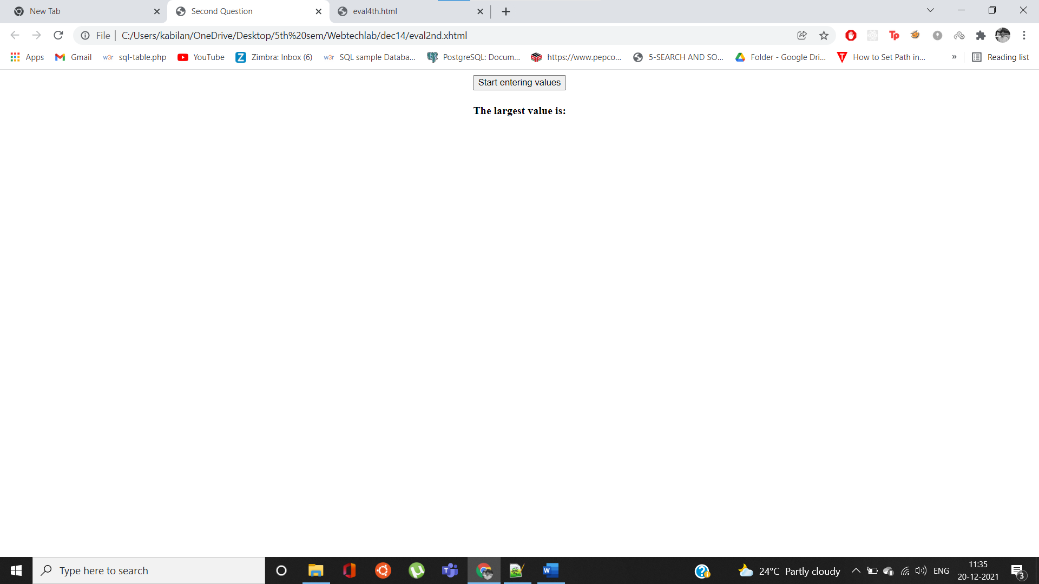
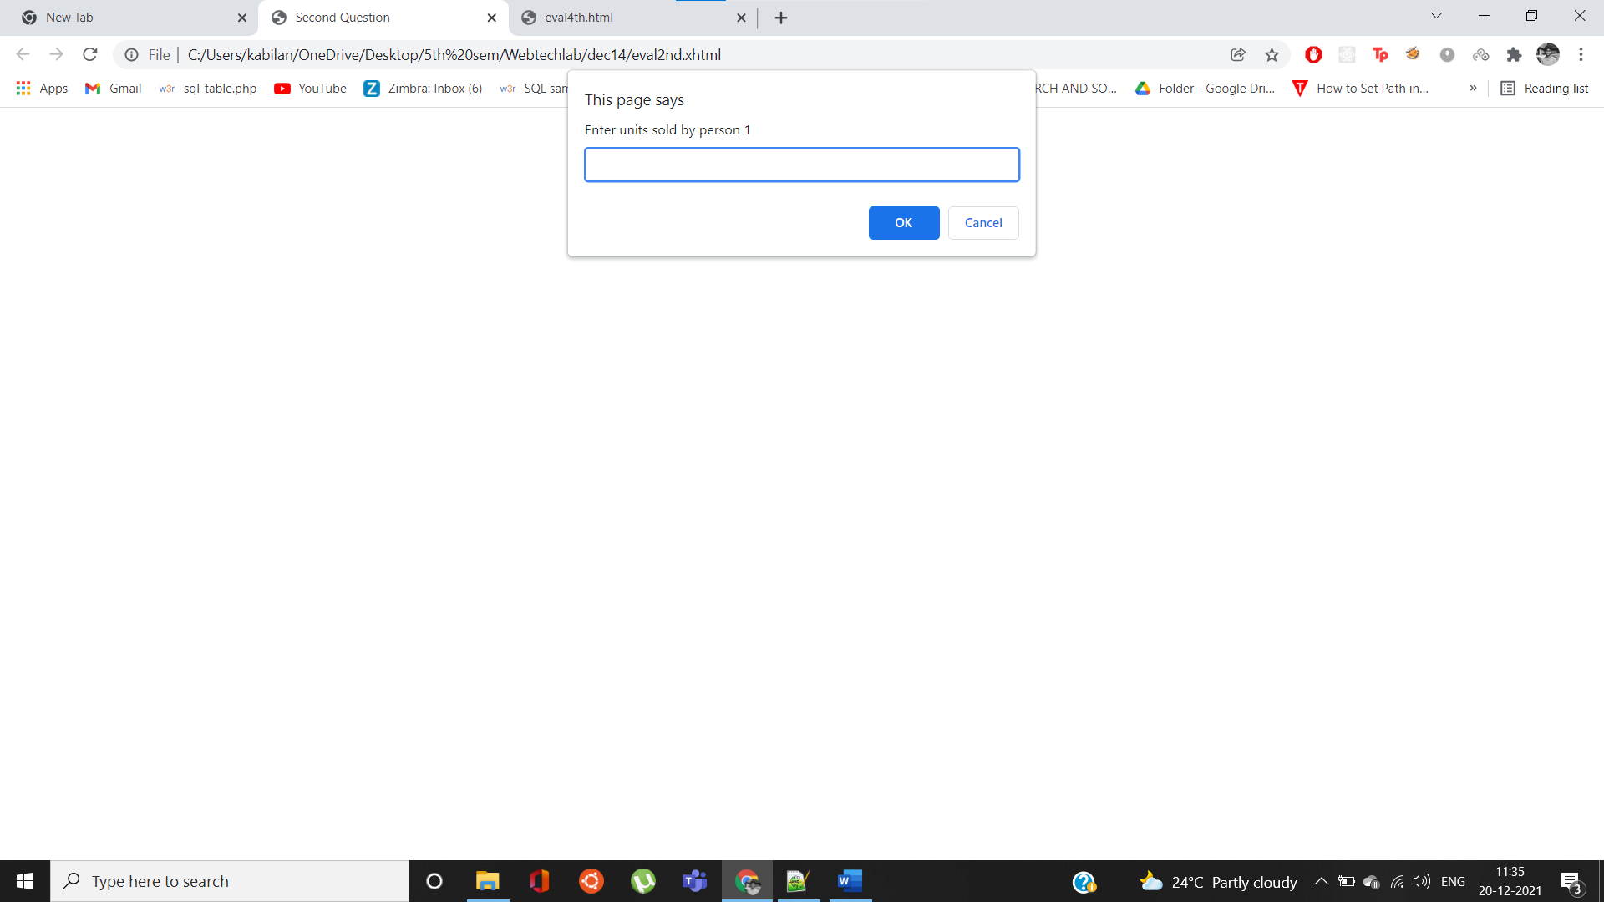
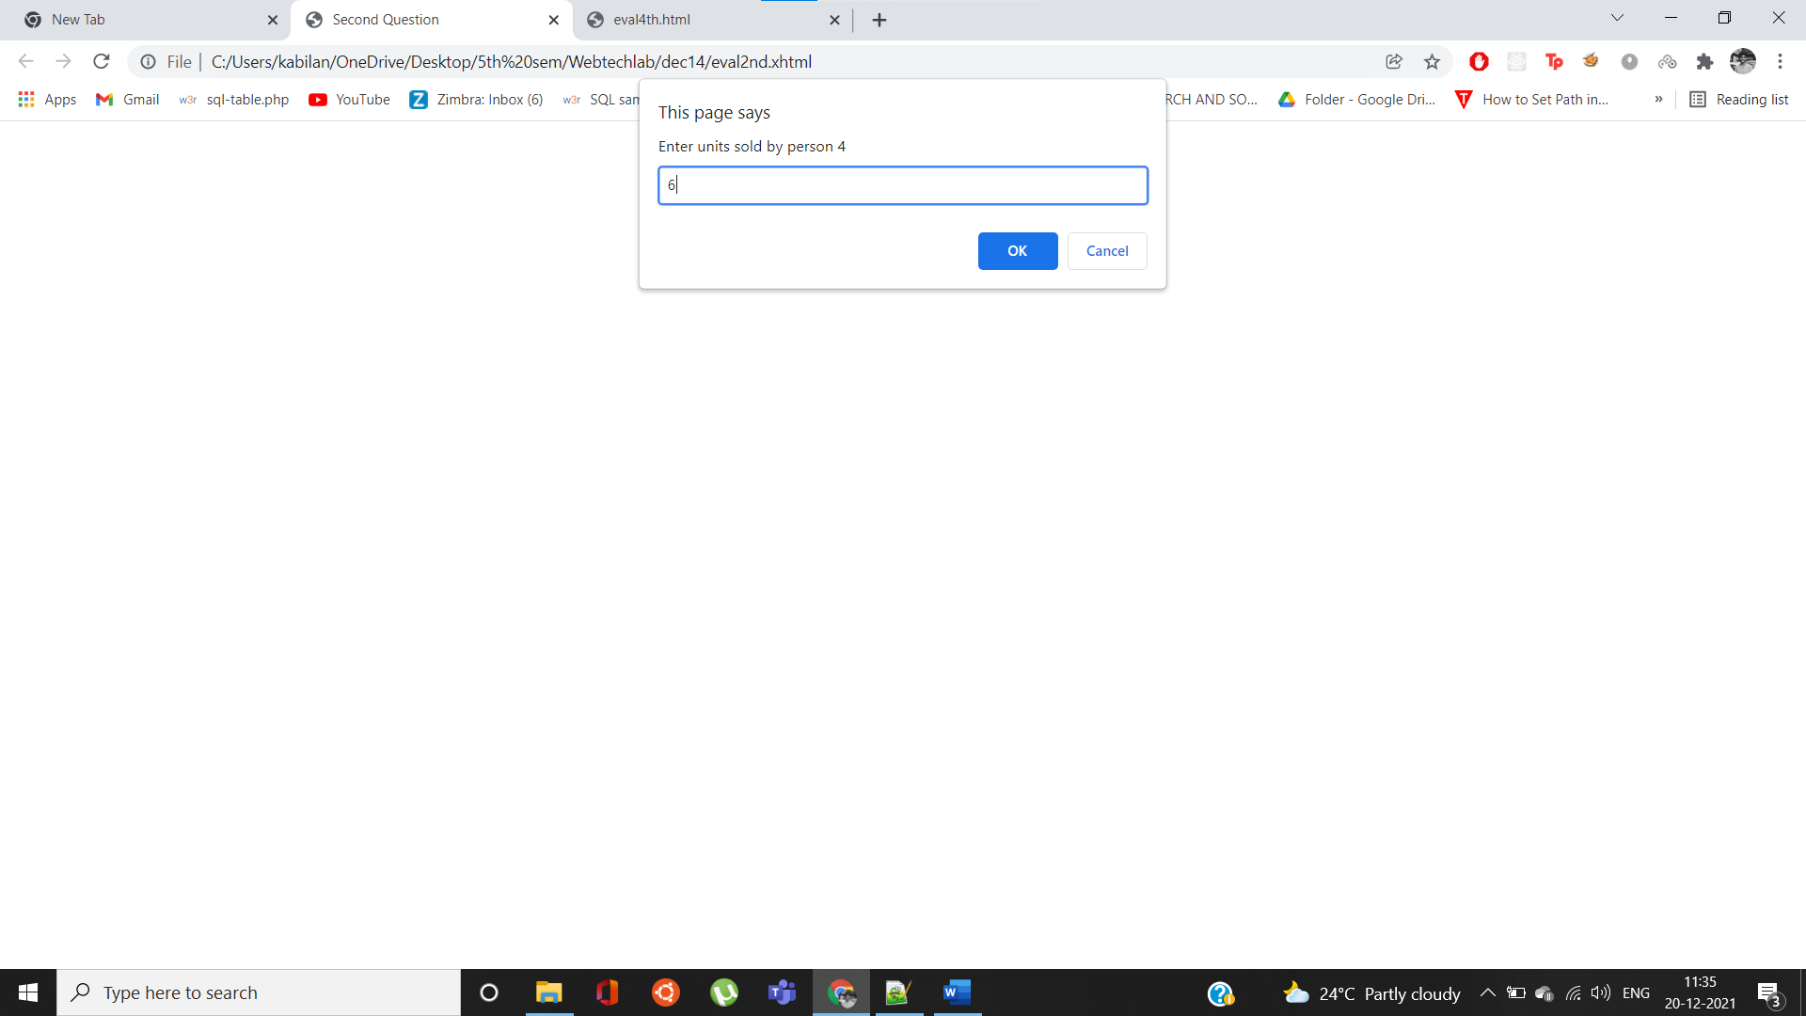
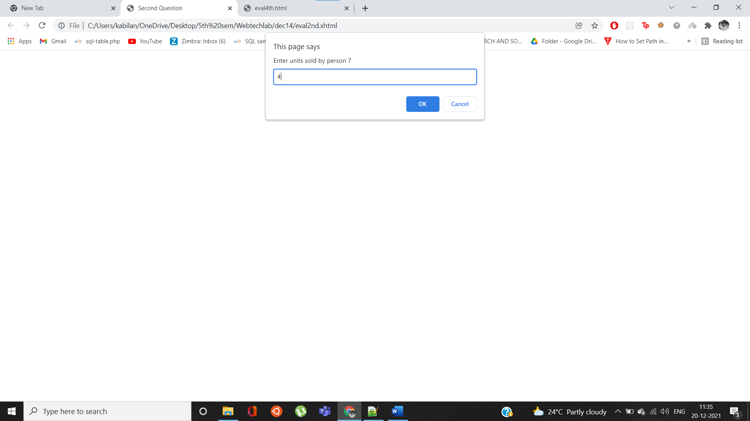
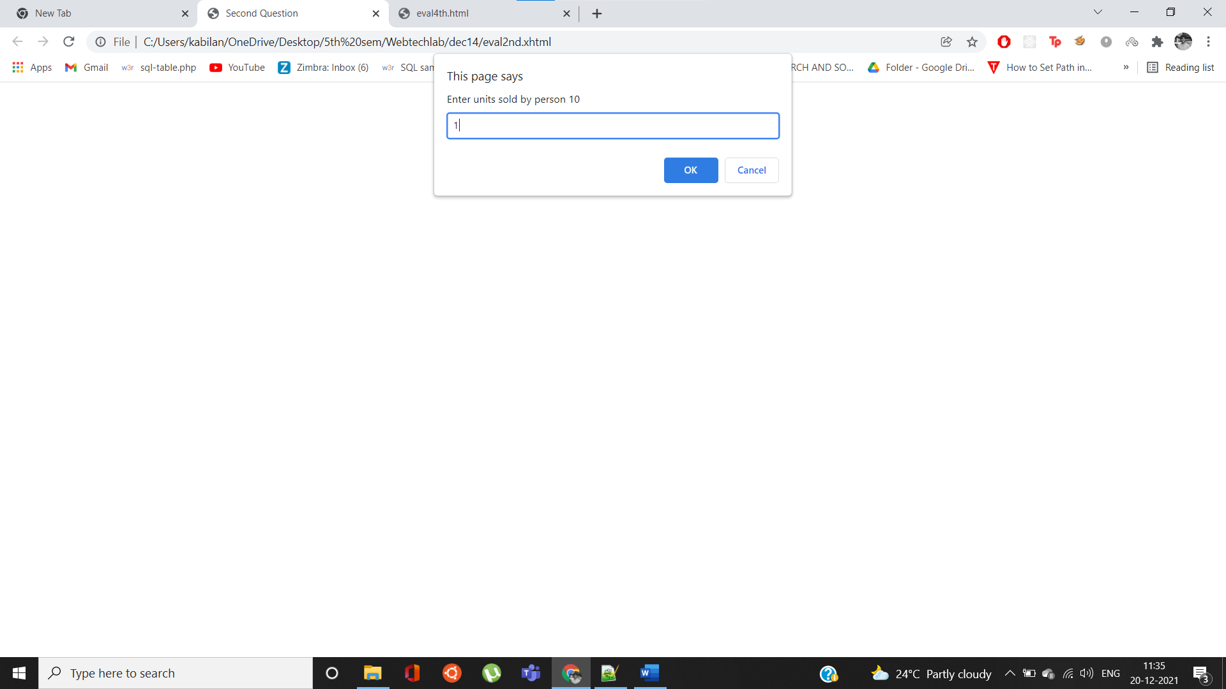
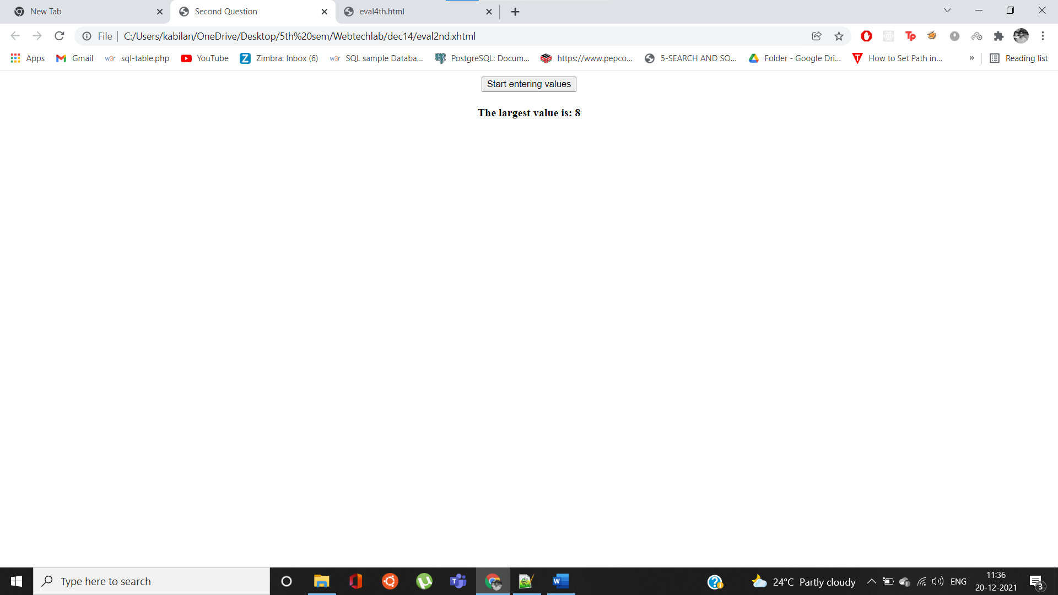
3. Write a script that outputs XHTML text that keeps displaying in the browser window the multiples of the integer 2, namely 2, 4, 8, 16, 32, 64, etc. Your loop should not terminate (i.e., you should create an infinite loop). What happens when you run this program?
Code:
<?xml version="1.0" encoding="UTF-8"?>
<!DOCTYPE html
PUBLIC "-//W3C//DTD XHTML 1.0 Strict//EN"
"DTD/xhtml1-strict.dtd">
<html xmlns="http://www.w3.org/1999/xhtml" xml:lang="en" lang="en">
<head>
<title>
Third Question
</title>
</head>
<body>
<script>
function MyFunction(){
let i=2;
while(true)
{
i*=2;
}
}
</script>
<body>
<button onclick="MyFunction()">Enter</button>
</body>
</html>
Output:
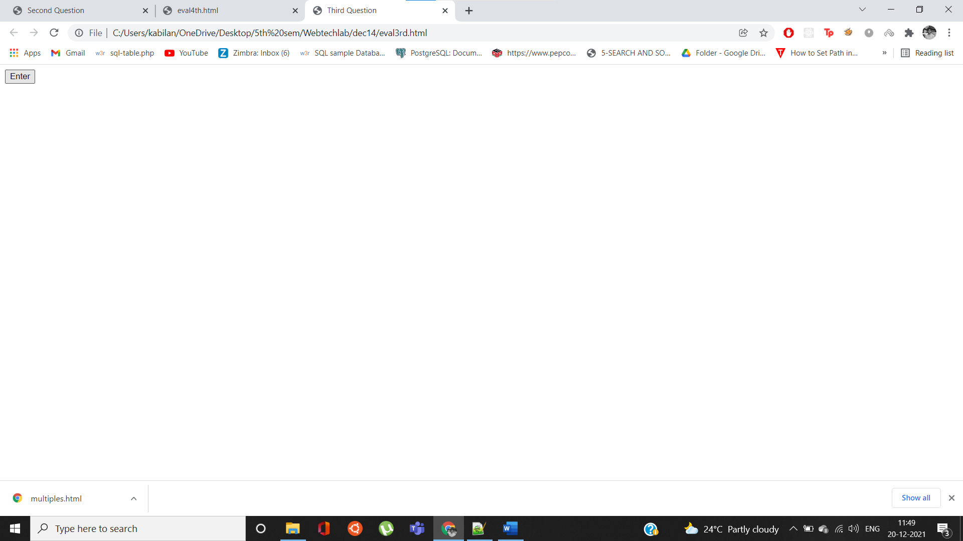
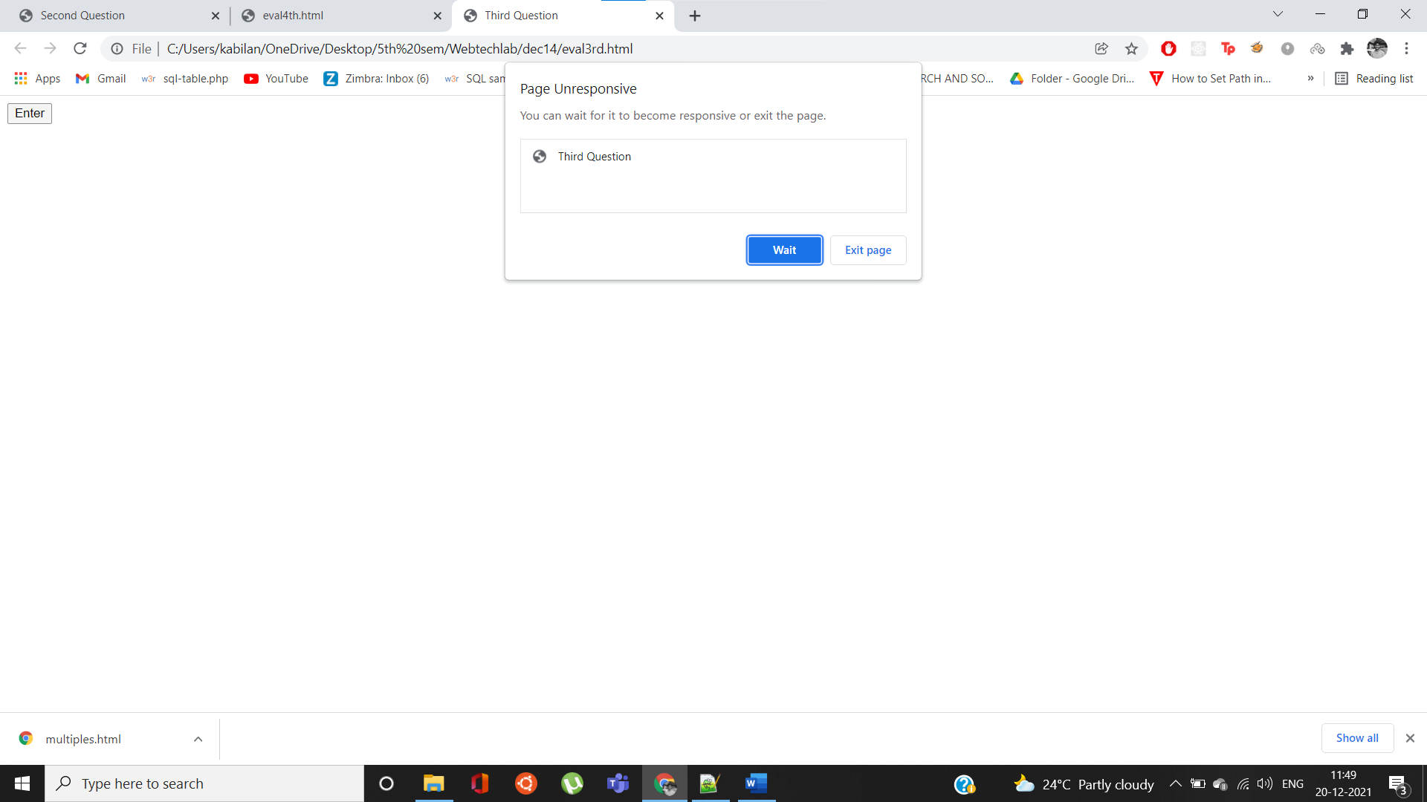

The page becomes unresponsive because the loop inside the function never terminates, hence the code keeps running and it makes the page to crash and it causes the warning sign.

4. Write function distance that calculates the distance between two points (x1, y1) and (x2, y2). All numbers and return values should be floating-point values. Incorporate this function into a script that enables the user to enter the coordinates of the points through an HTML form.
Code:
<!DOCTYPE html>
<html>
<body>
<h2>DISTANCE BETWEEN THE COORDINATES</h2>
<script>
function myFunction()
{
let x1 = document.getElementById("x1").value;
let y1 = document.getElementById("y1").value;
let x2 = document.getElementById("x2").value;
let y2 = document.getElementById("y2").value;
let res=Math.sqrt(Math.pow(x1-x2,2)+Math.pow(y1-y2,2));
document.getElementById("demo").innerHTML = "The distance between the coordinates is: " + res;
}
</script>
<form onSubmit="return false">
<label for="x1">x1 coordinate:</label><br>
<input type="number" step="0.1" id="x1" name="x1" value=""><br>
<label for="y1">y1 coordinate:</label><br>
<input type="number" step="0.1" id="y1" name="y1" value=""><br><br>
<label for="x2">x2 coordinate:</label><br>
<input type="number" step="0.1" id="x2" name="x2" value=""><br>
<label for="y2">y2 coordinate:</label><br>
<input type="number" step="0.1" id="y2" name="y2" value=""><br><br>
<input type="submit" value="Submit" onClick="myFunction()">
</form>
<br><br>
<h1 id="demo">The distance between the coordinates is: </h1>
</body>
</html>
Output:
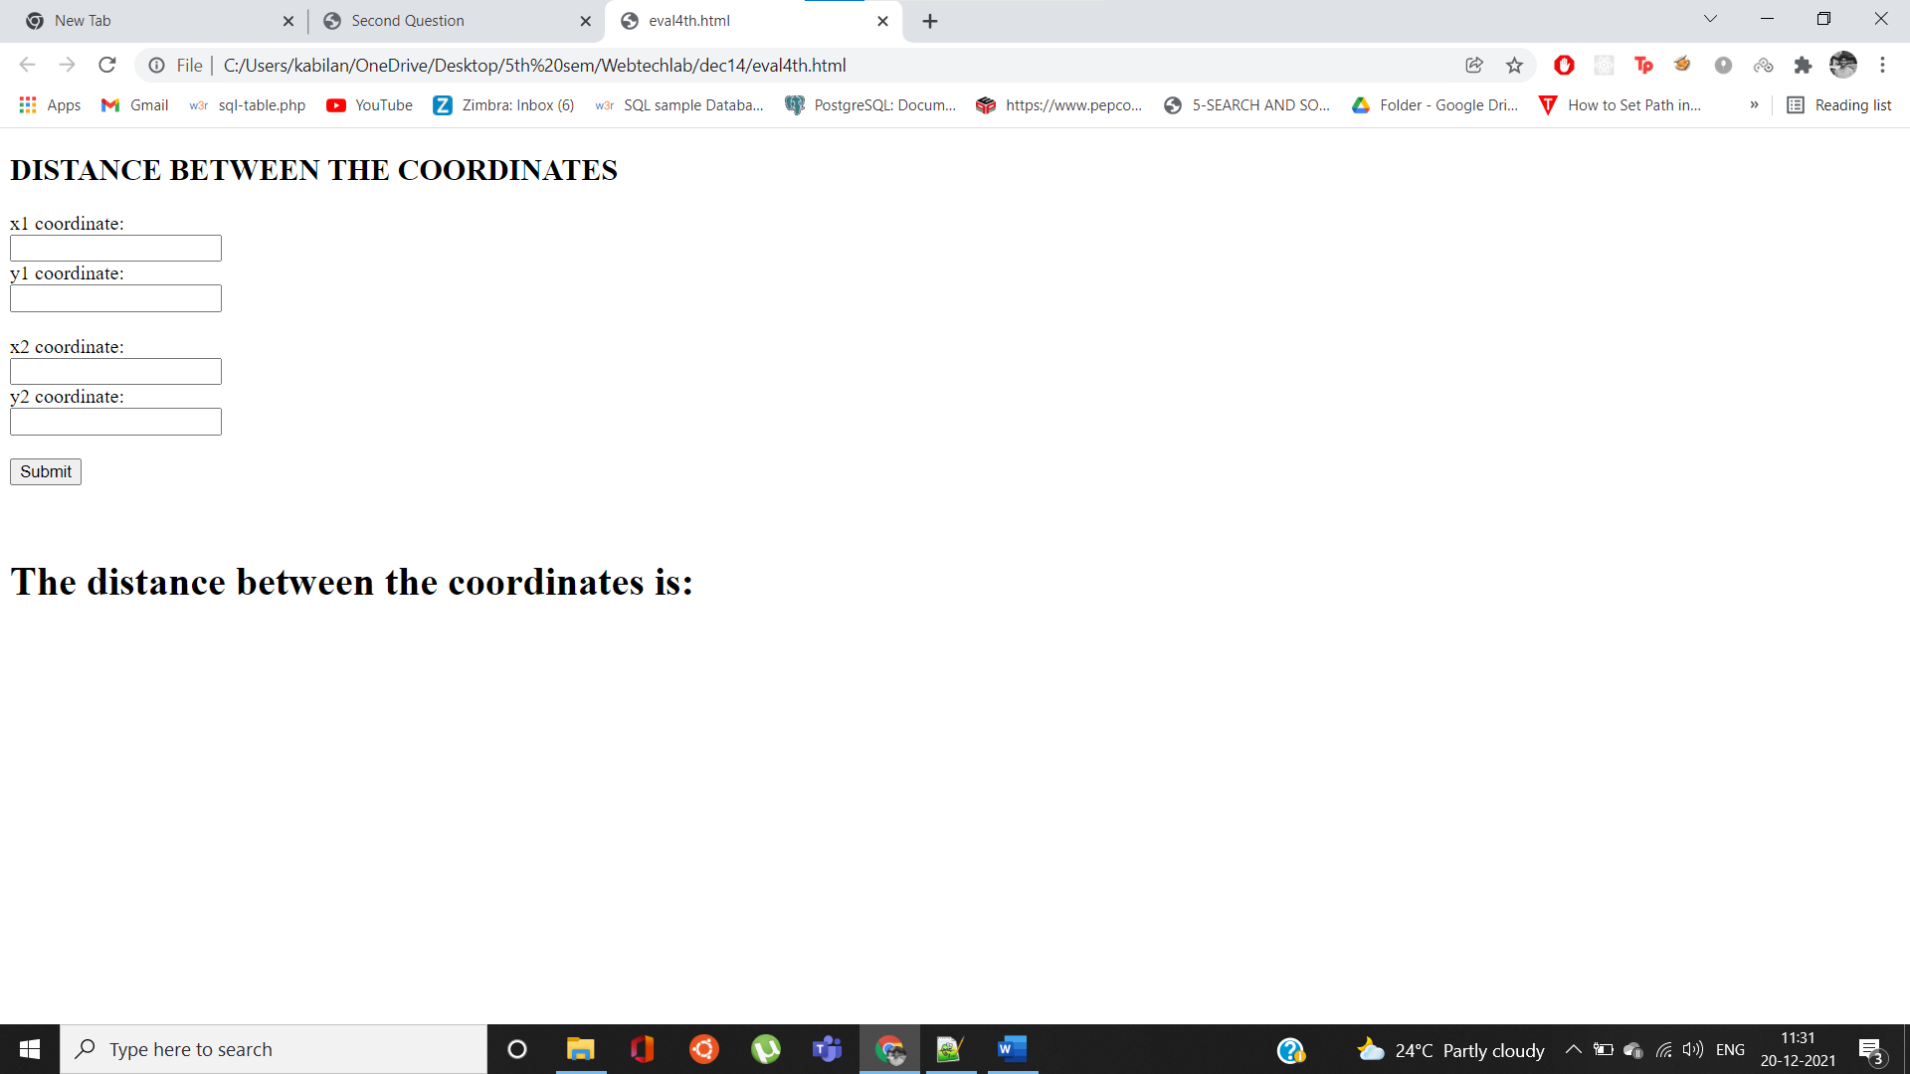
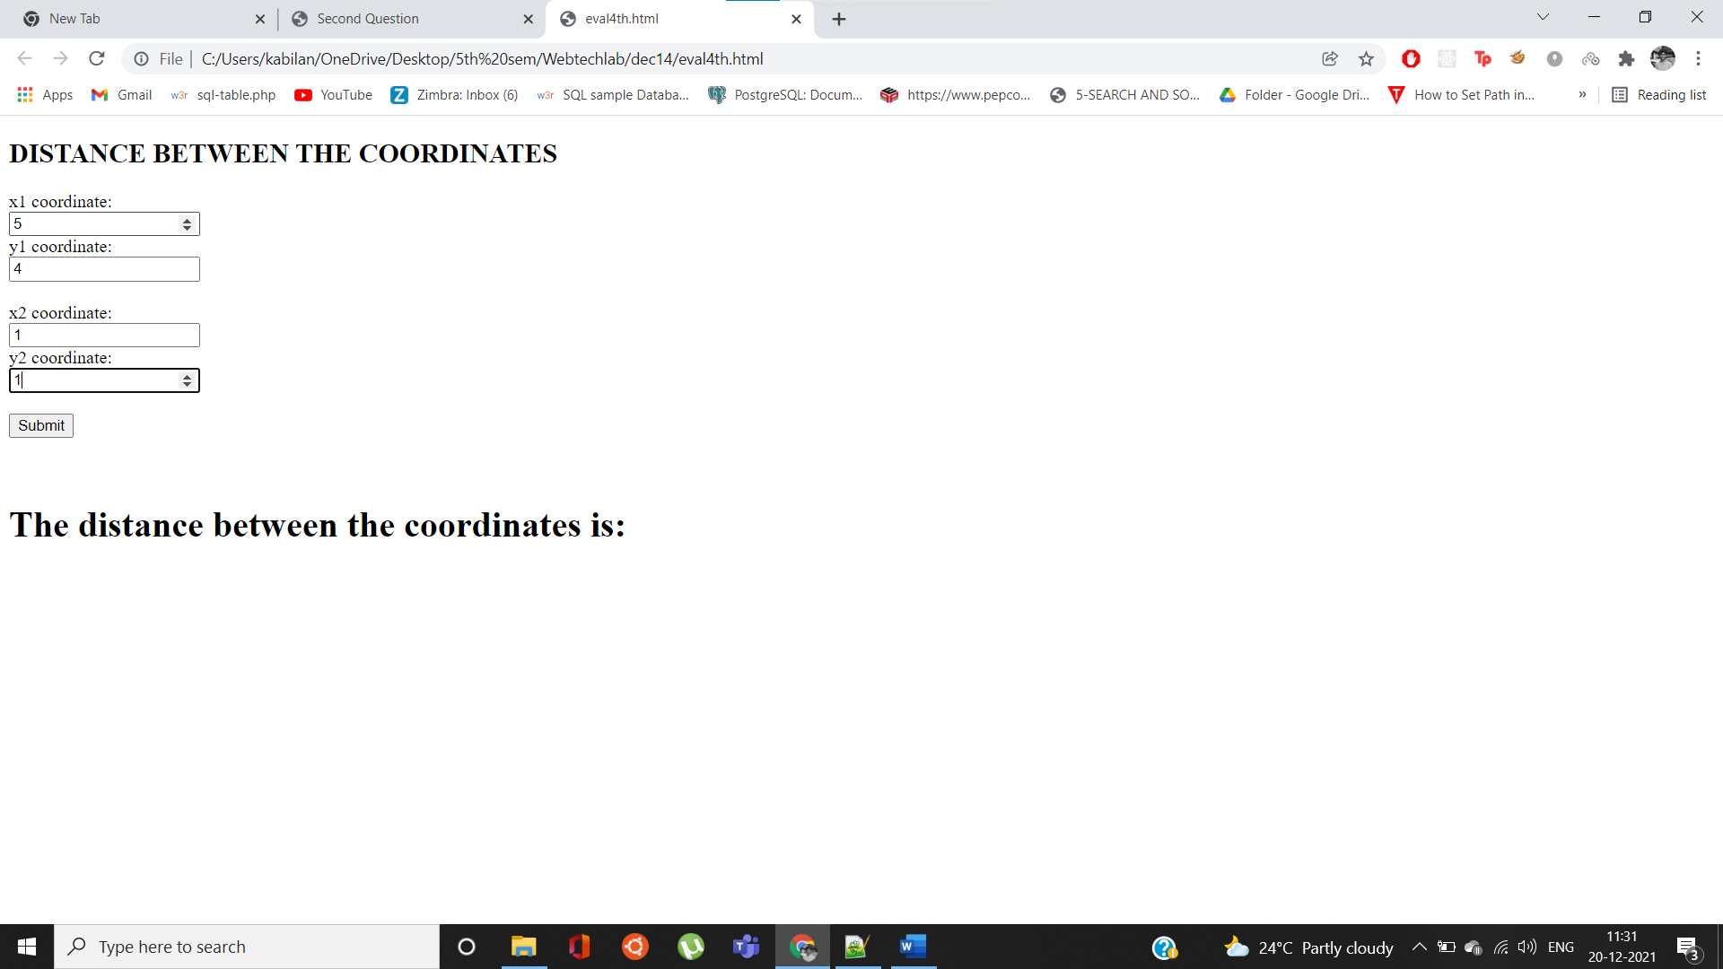
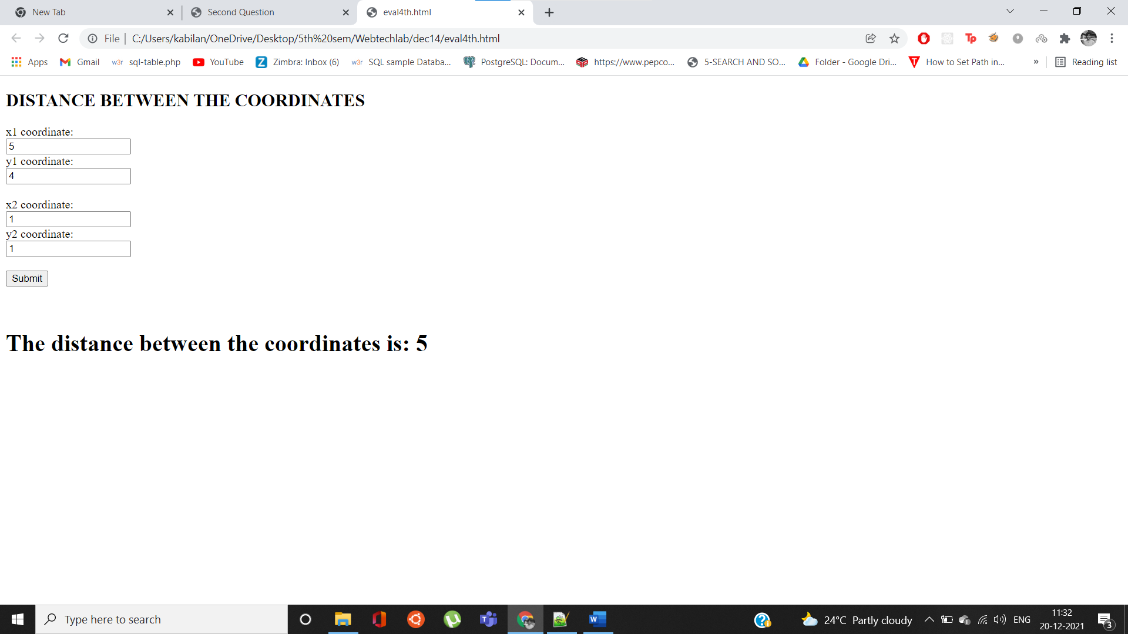
5. Write program segments that accomplish each of the following tasks:
a) Calculate the integer part of the quotient when integer a is divided by integer b.
b) Calculate the integer remainder when integer a is divided by integer b.
c) Use the program pieces developed in parts (a) and (b) to write a function displayDigits.
Code:
<!DOCTYPE html>
<html>
<head>
<title>
5th Question
</title>
</head>
<body>
<h2>Enter the Integer Values</h2>
<script>
function displayDigits()
{
let a = parseInt(document.getElementById("a").value);
let b = parseInt(document.getElementById("b").value);
let quo= Math.floor(a/b);
let rem= a%b;
document.querySelector("#quotient").innerHTML = "The Quotient is: " + quo;
document.querySelector("#reminder").innerHTML = "The Reminder is: " + rem;
}
</script>
<form onSubmit="return false">
<label for="a">Enter Integer A: </label><br>
<input type="number" id="a" name="a" value=""><br>
<label for="b">Enter Integer B: </label><br>
<input type="number" id="b" name="b" value=""><br>
<input type="submit" value="Submit" onClick="displayDigits()">
</form>
<br><br>
<h3 id="quotient">The Quotient is: </h3>
<h3 id="reminder">The Reminder is: </h3>
</body>
</html>

Output:
