**A CRM APPLICATION FOR WHOLESALE RICE MILL**

1) Introduction To Salesforce

**What Is Salesforce?**

Salesforce is your customer success platform, designed to help you sell, service, market, analyze, and connect with your customers.

**Creating Developer Account**

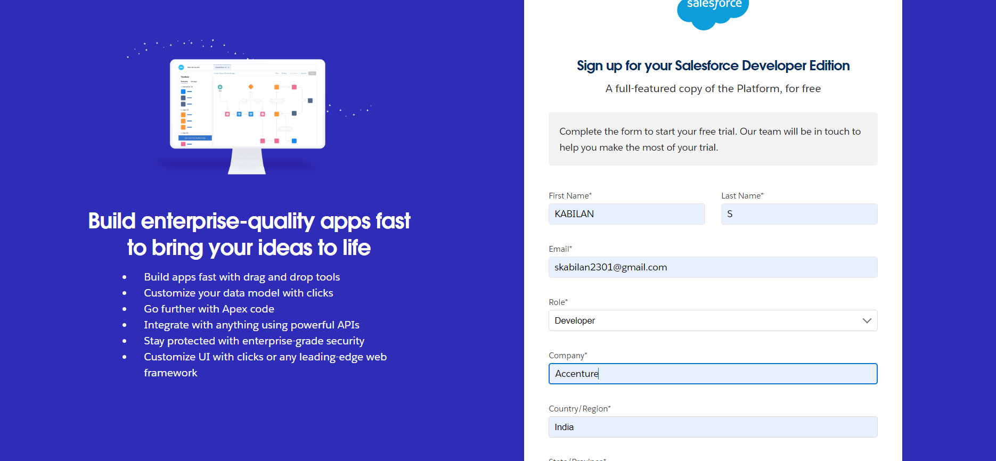

**Account Activation**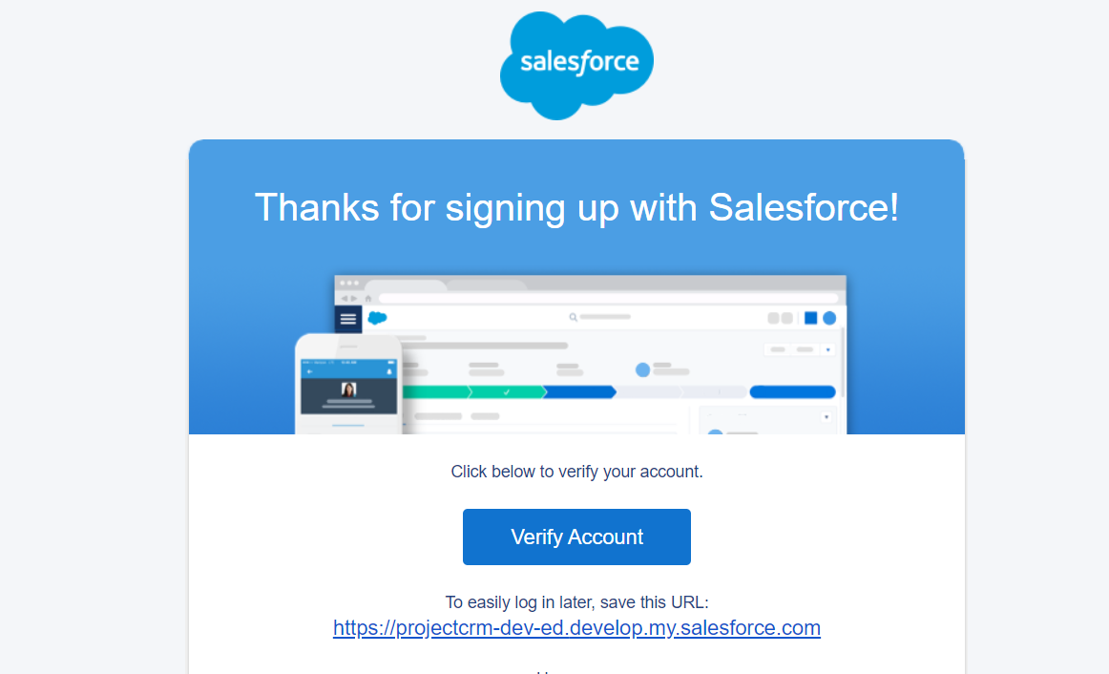

**2) Object**

**What Is an Object?**

Salesforce objects are database tables that permit you to store data that is specific to an organization

**Supplier Object**

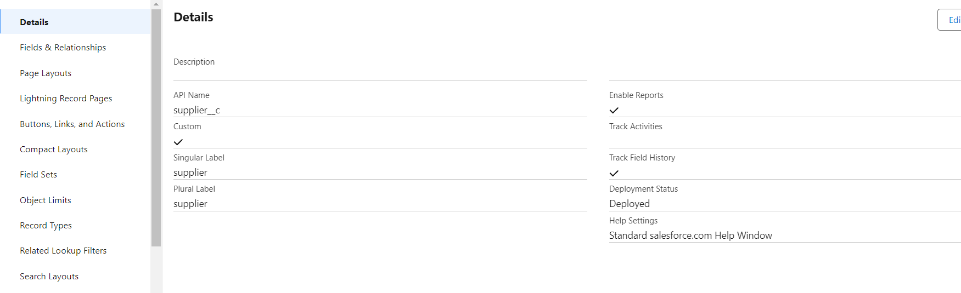

**Rice Mill Object**

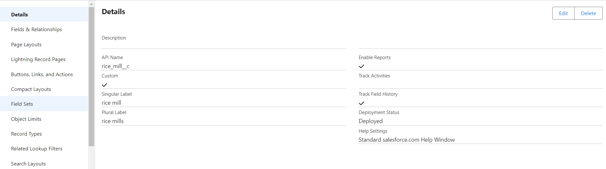

**Consumer Object**

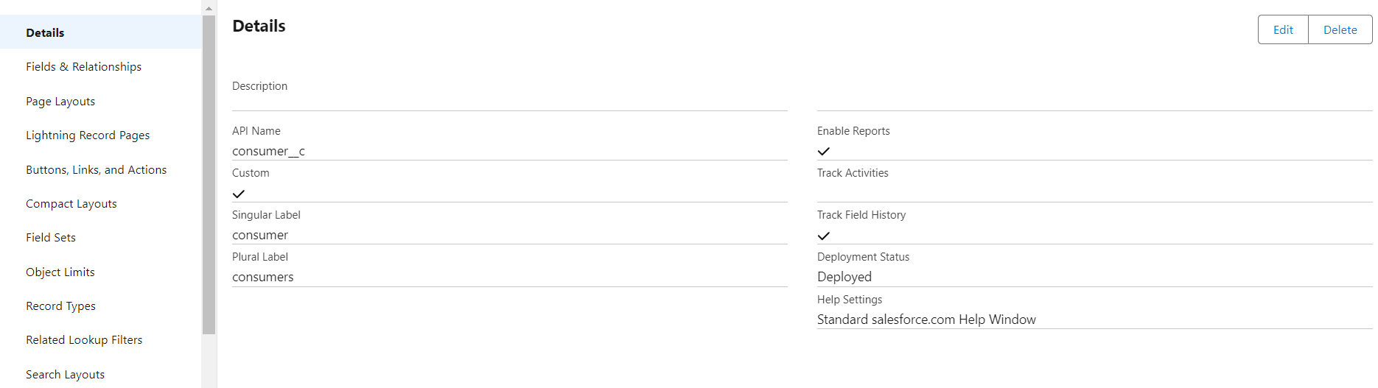

**Rice Details Object**

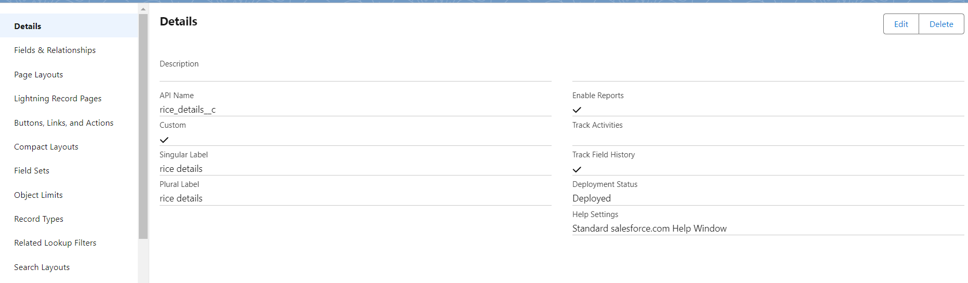

**3)Tabs**

**Custom Tabs Creation**

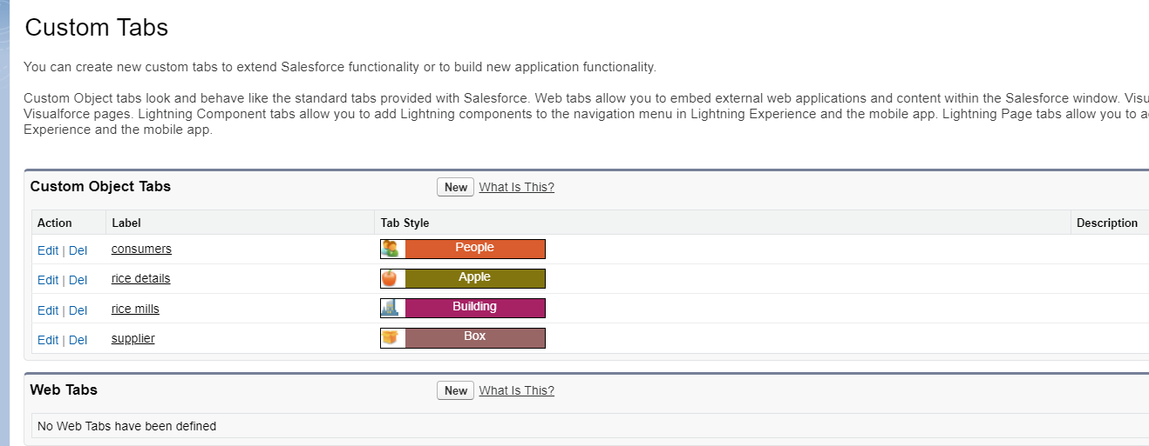

**4)The Lightening App**

**Creating Lightening App**

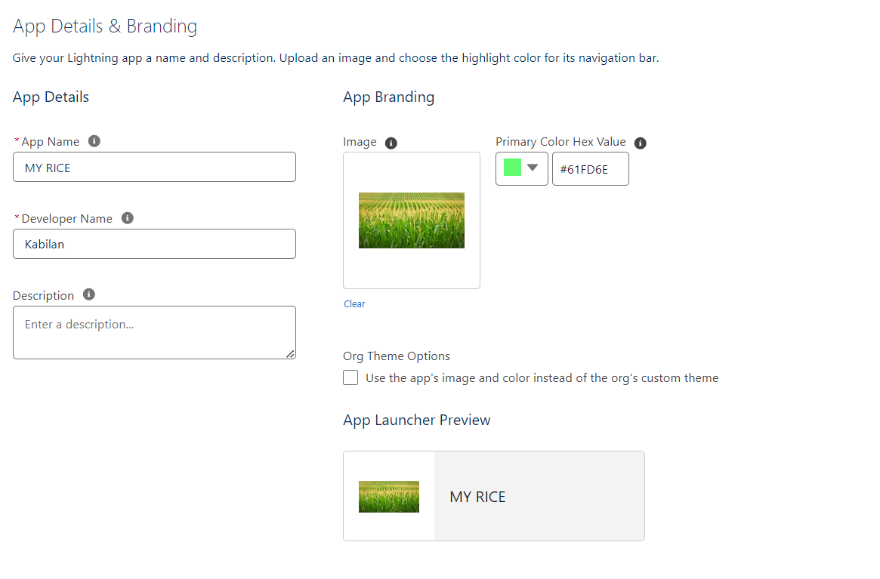

**5) Fields**

**Fields in Rice Detail object**

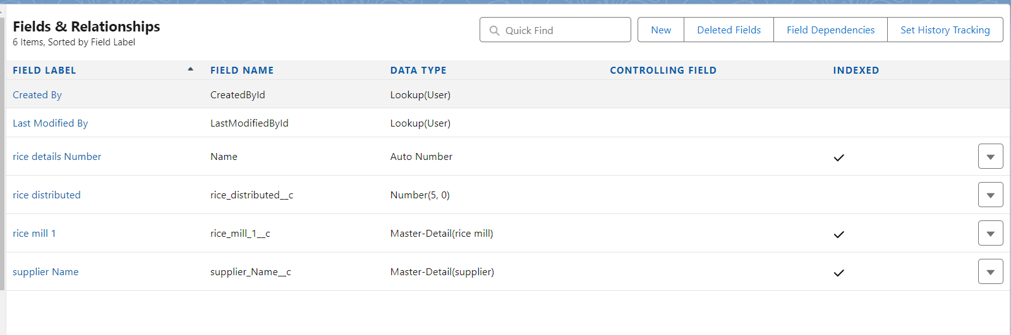

**Creating Junction Object**

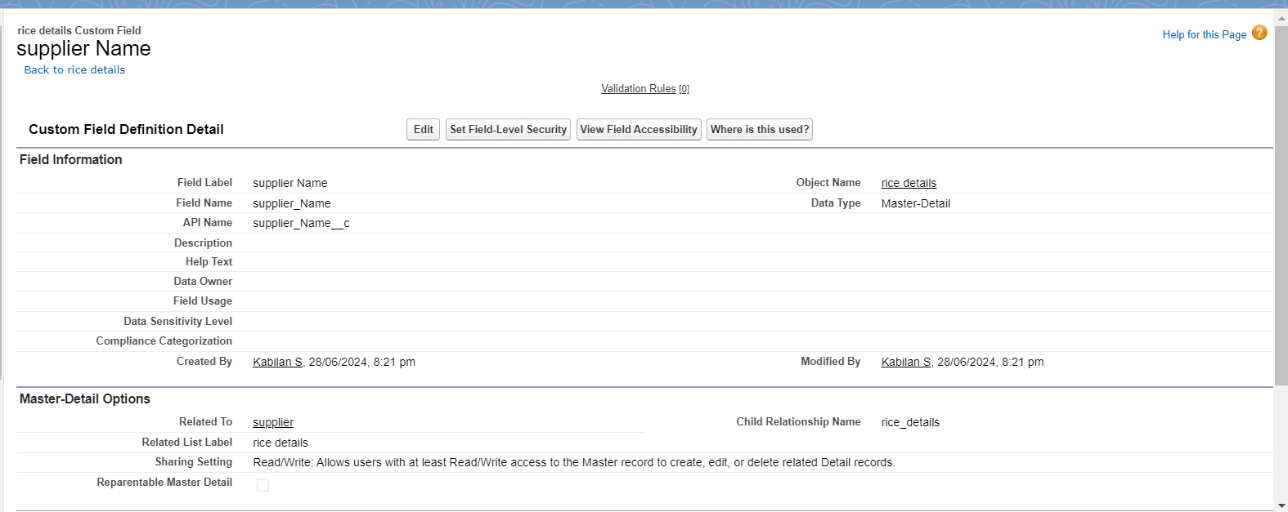

**Creating a Master Detail Relationship**

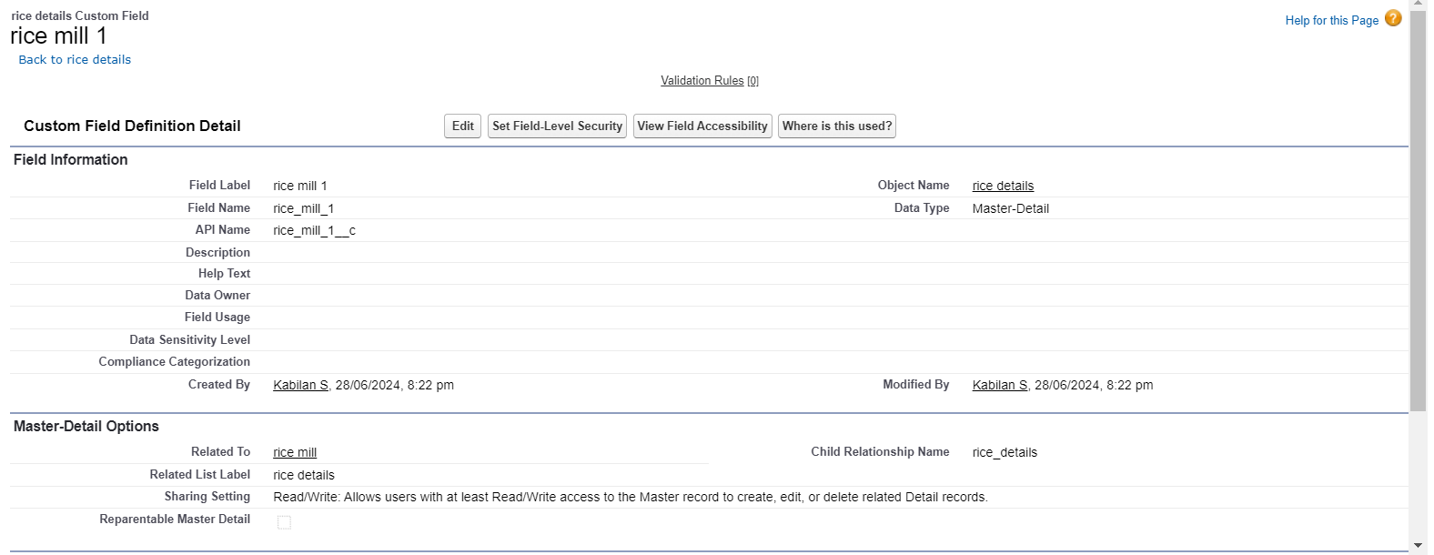

**Creating Roll-up Summary**

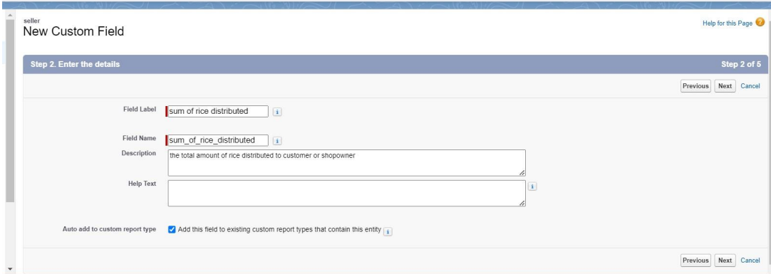

**Creating Fields in Objects**

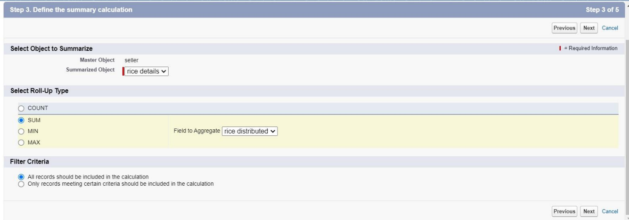

**Creating Fields in Supplier Object**

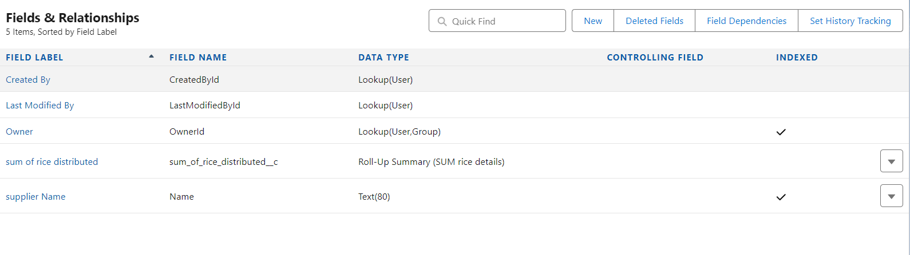

**Creating Fields in Rice Mill Object**

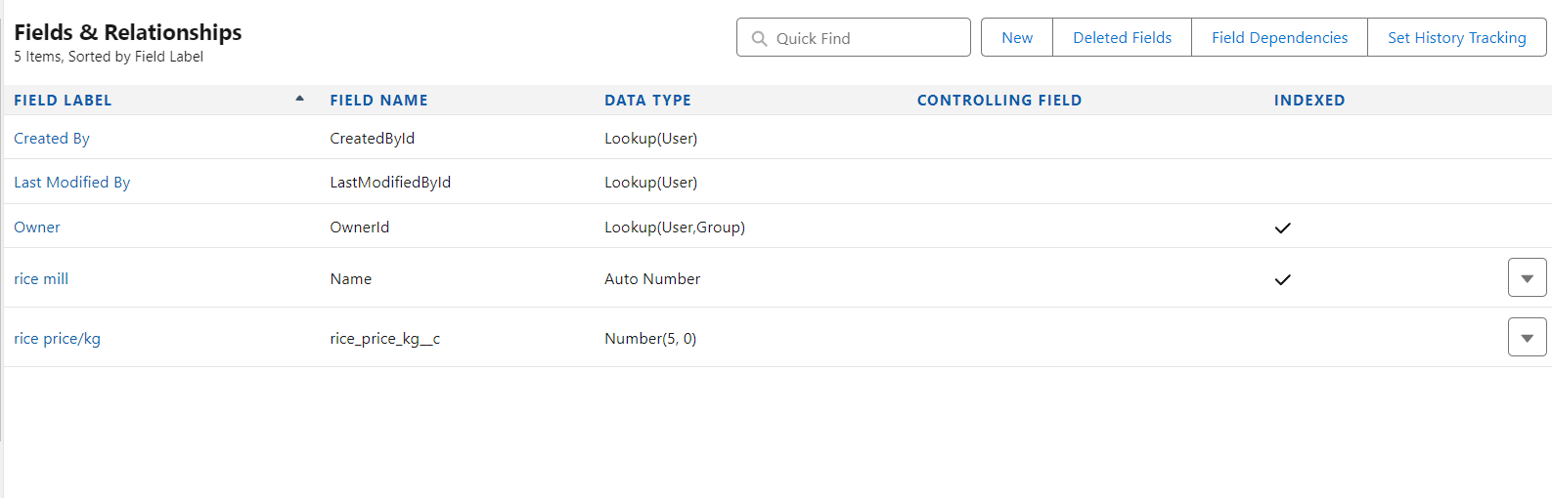

**Creating Fields in Rice Details Objects**



**Creating Fields in consumer Objects**

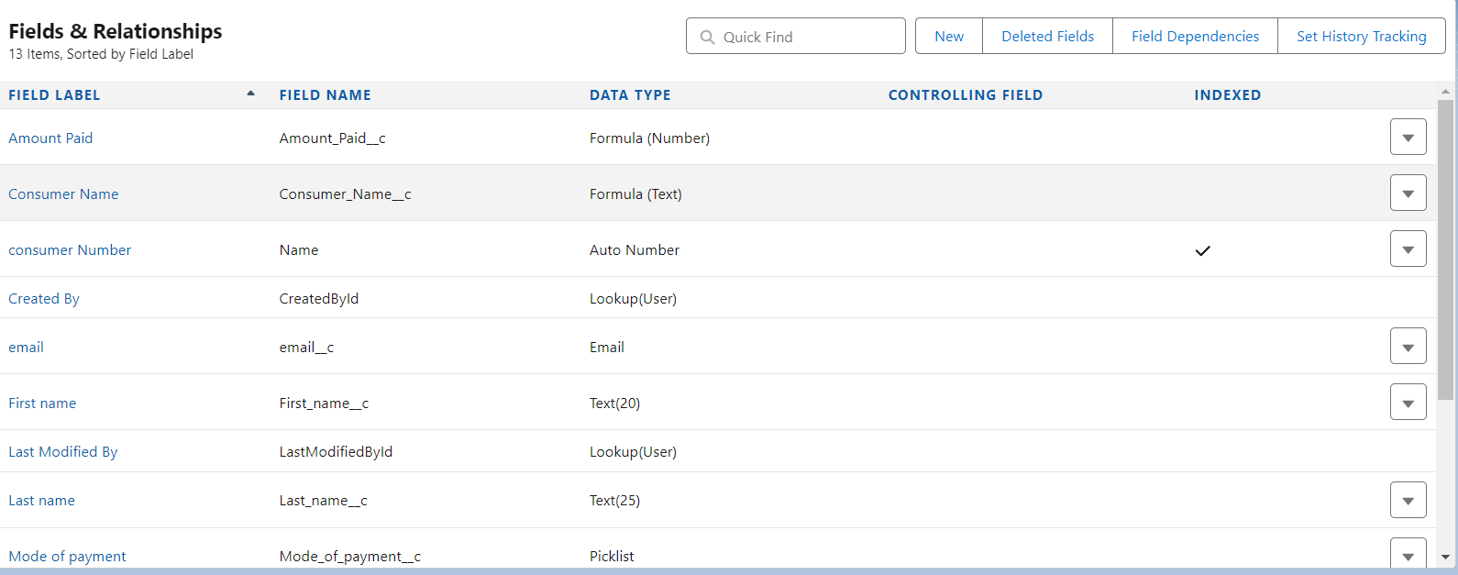

**Creating the Validation Rule**

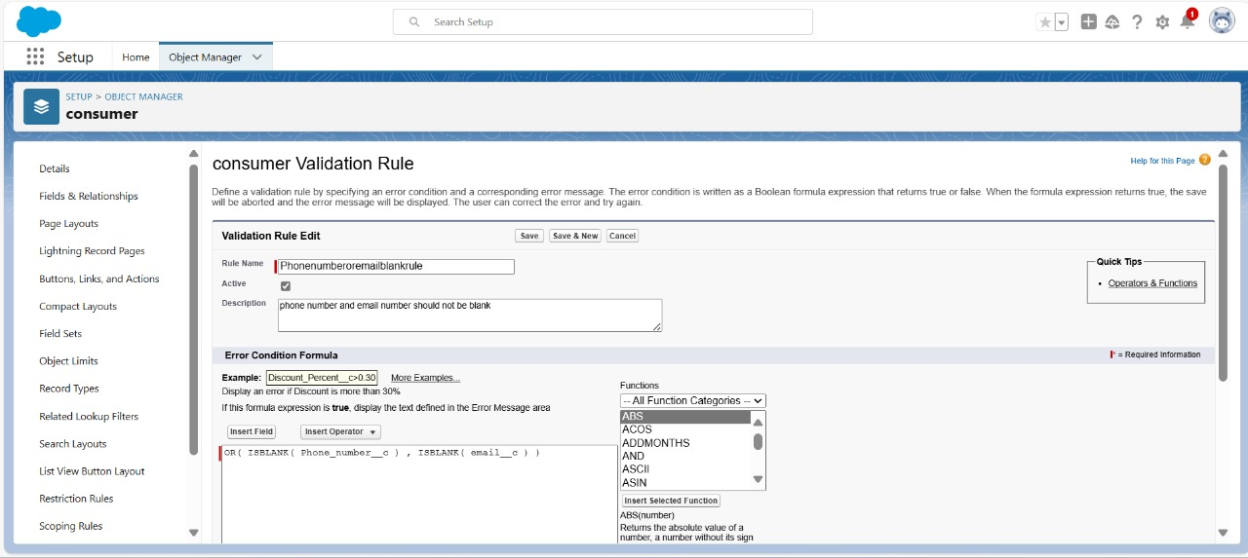

**6) Page Layouts**

**Creating the Page Layout**

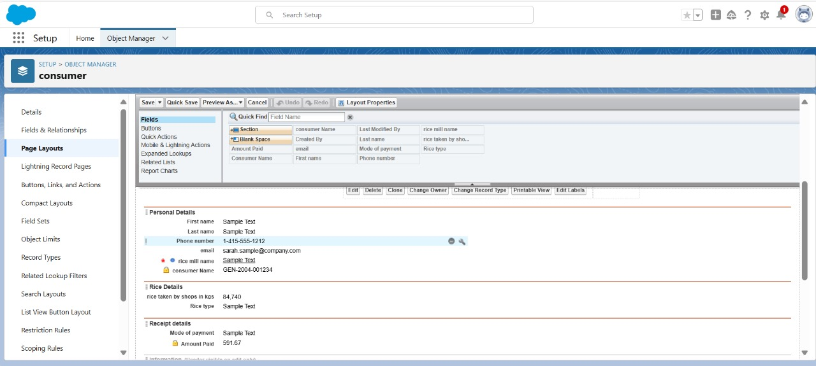

**7) Profiles**

**Creating Owner Profile**

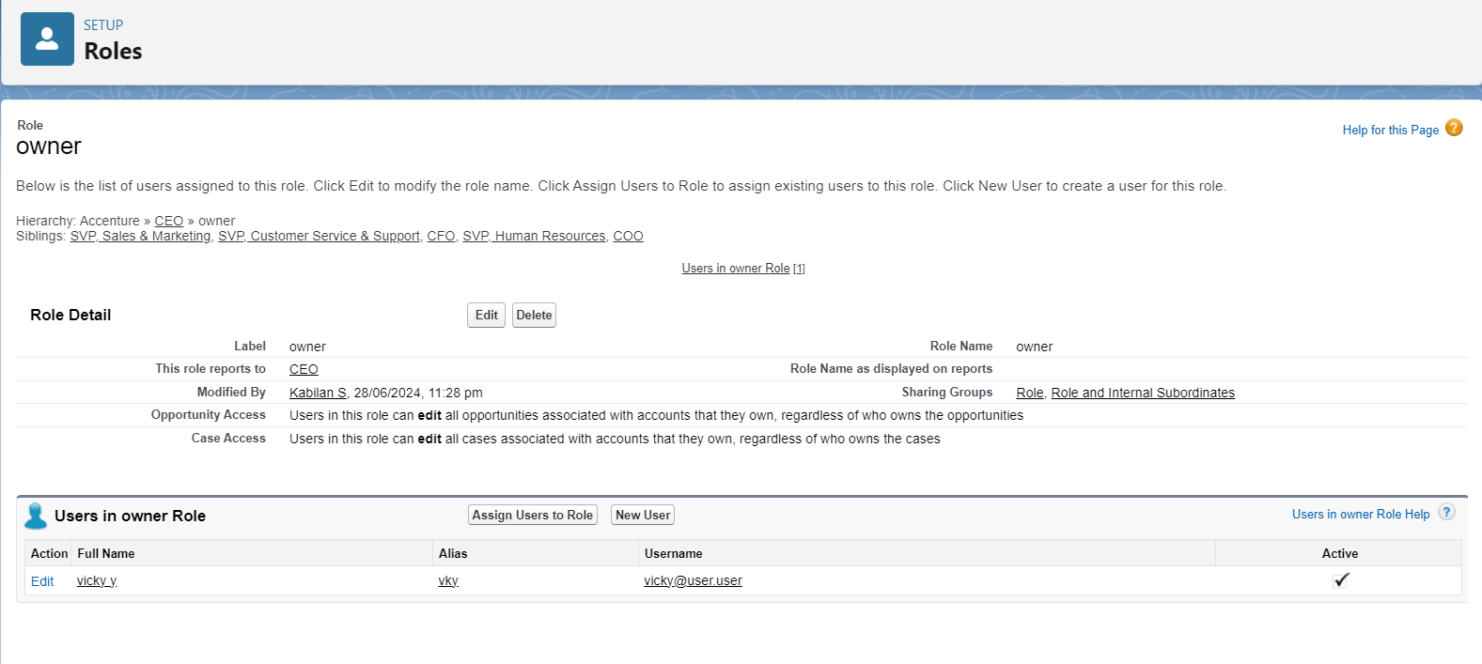

**Creating Employee Profile**

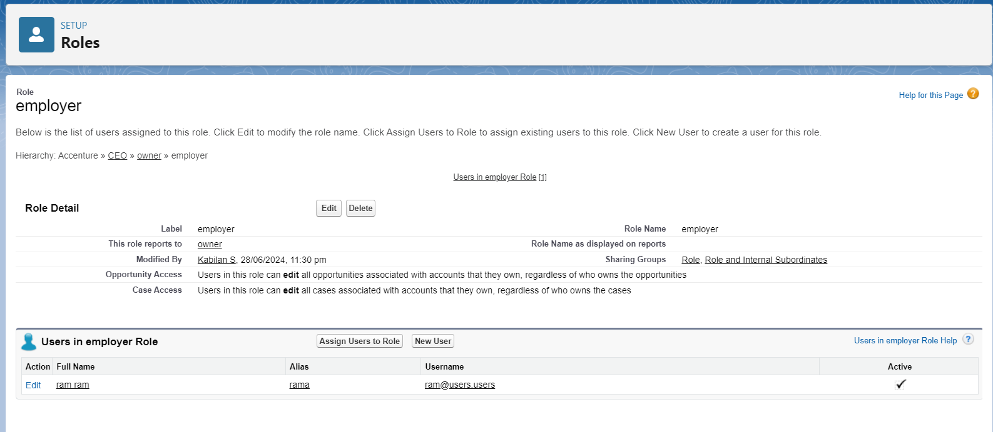

**Creating Worker Profile**

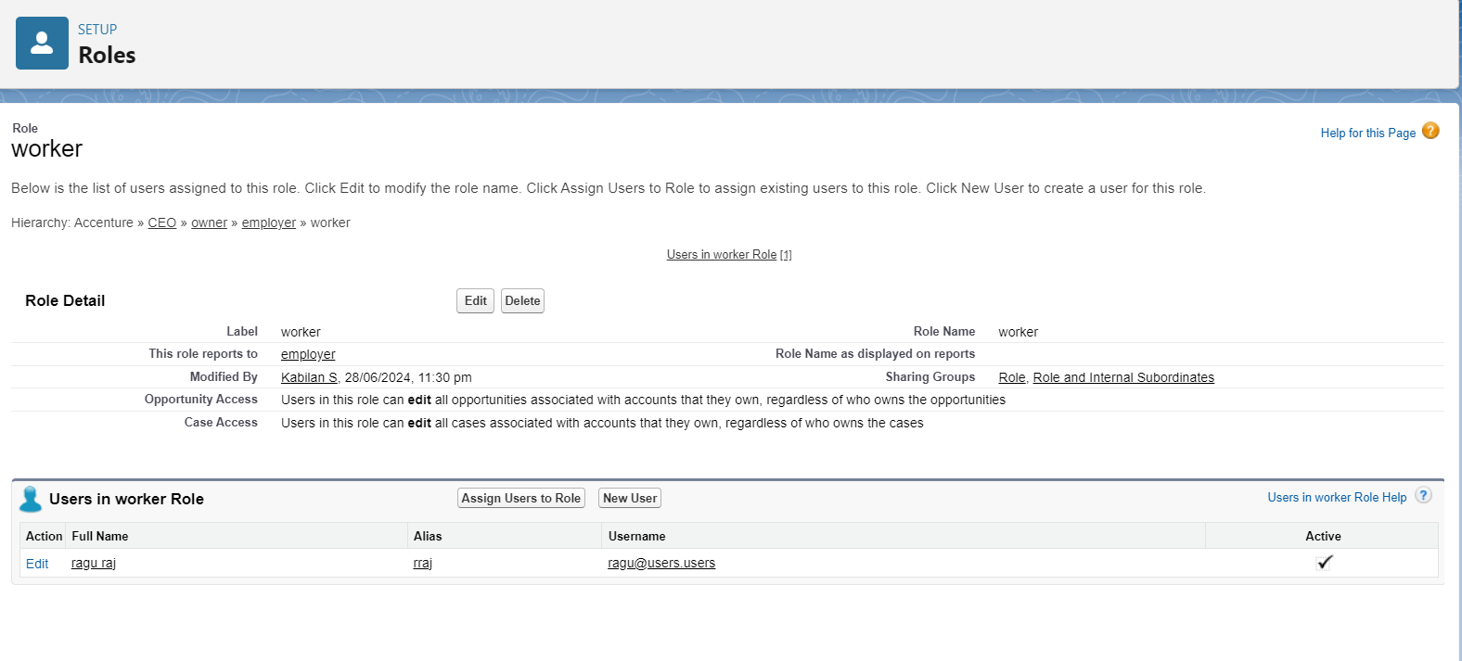

**8) Role and Hierarchy**

**Creating Role Hierarchy**

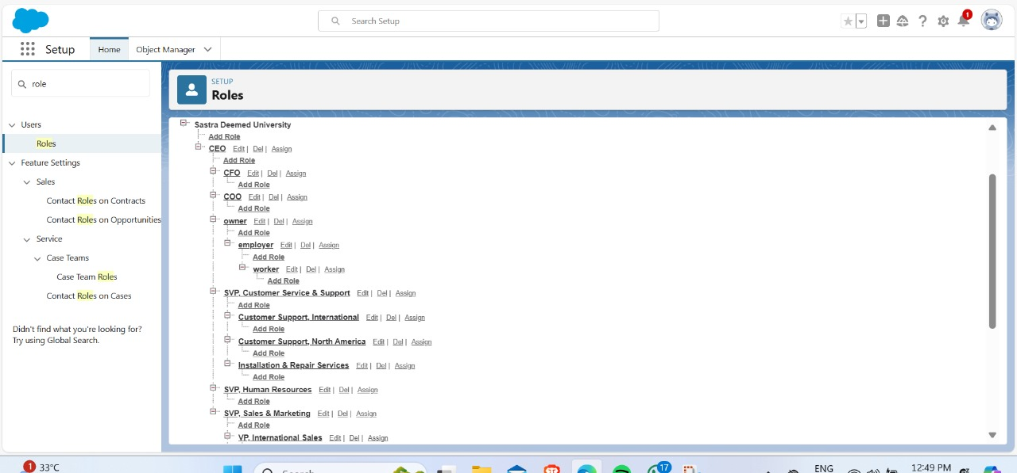

**9) Users**

**Creating Users**

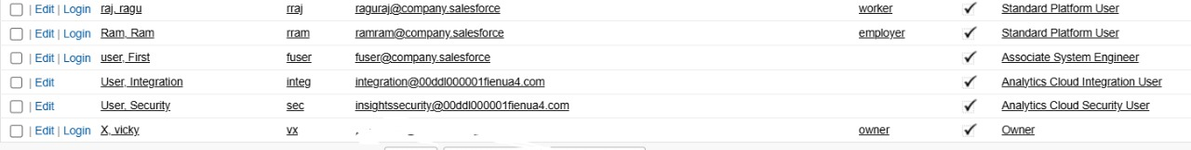

**10) Permission Sets**

**Creating OWD Settings**

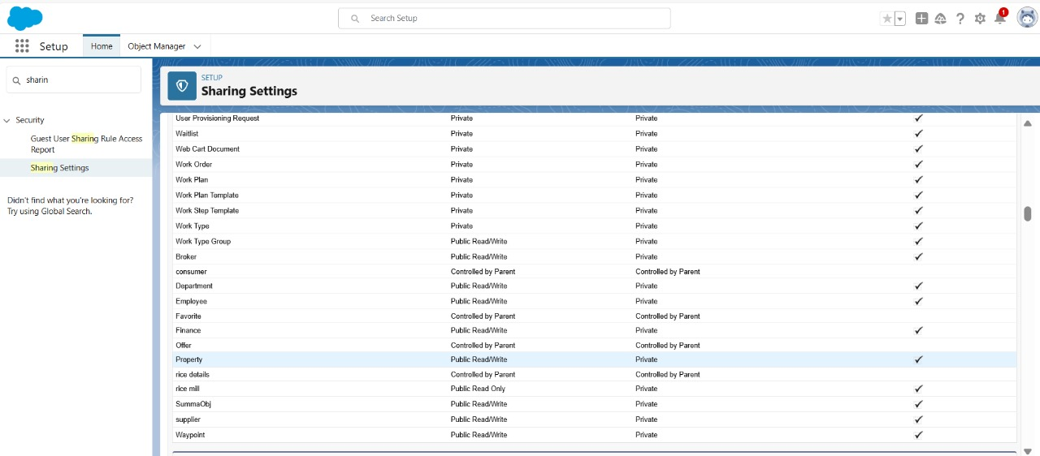

**11) Reports**

**Creating Report in Folder**

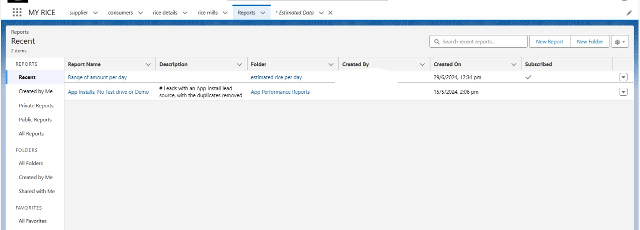

**Sharing Report to Owner**

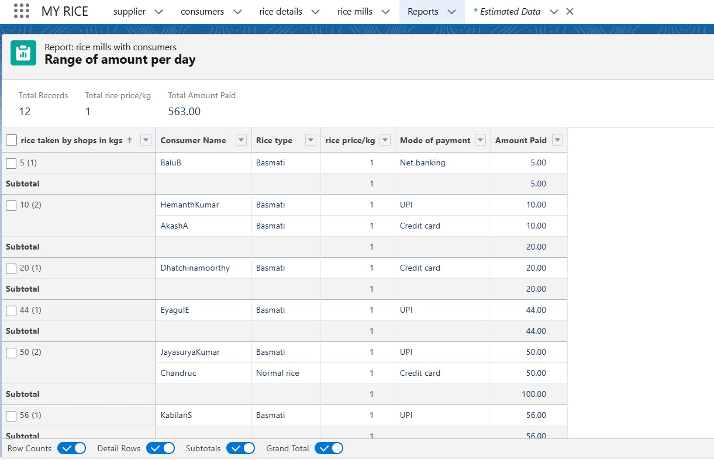

**12) Dashboard**

**Creating Dashboard**

