CIA 1

727721EUIT101

Kabilesh N

QUESTION 1:

CODE 1:

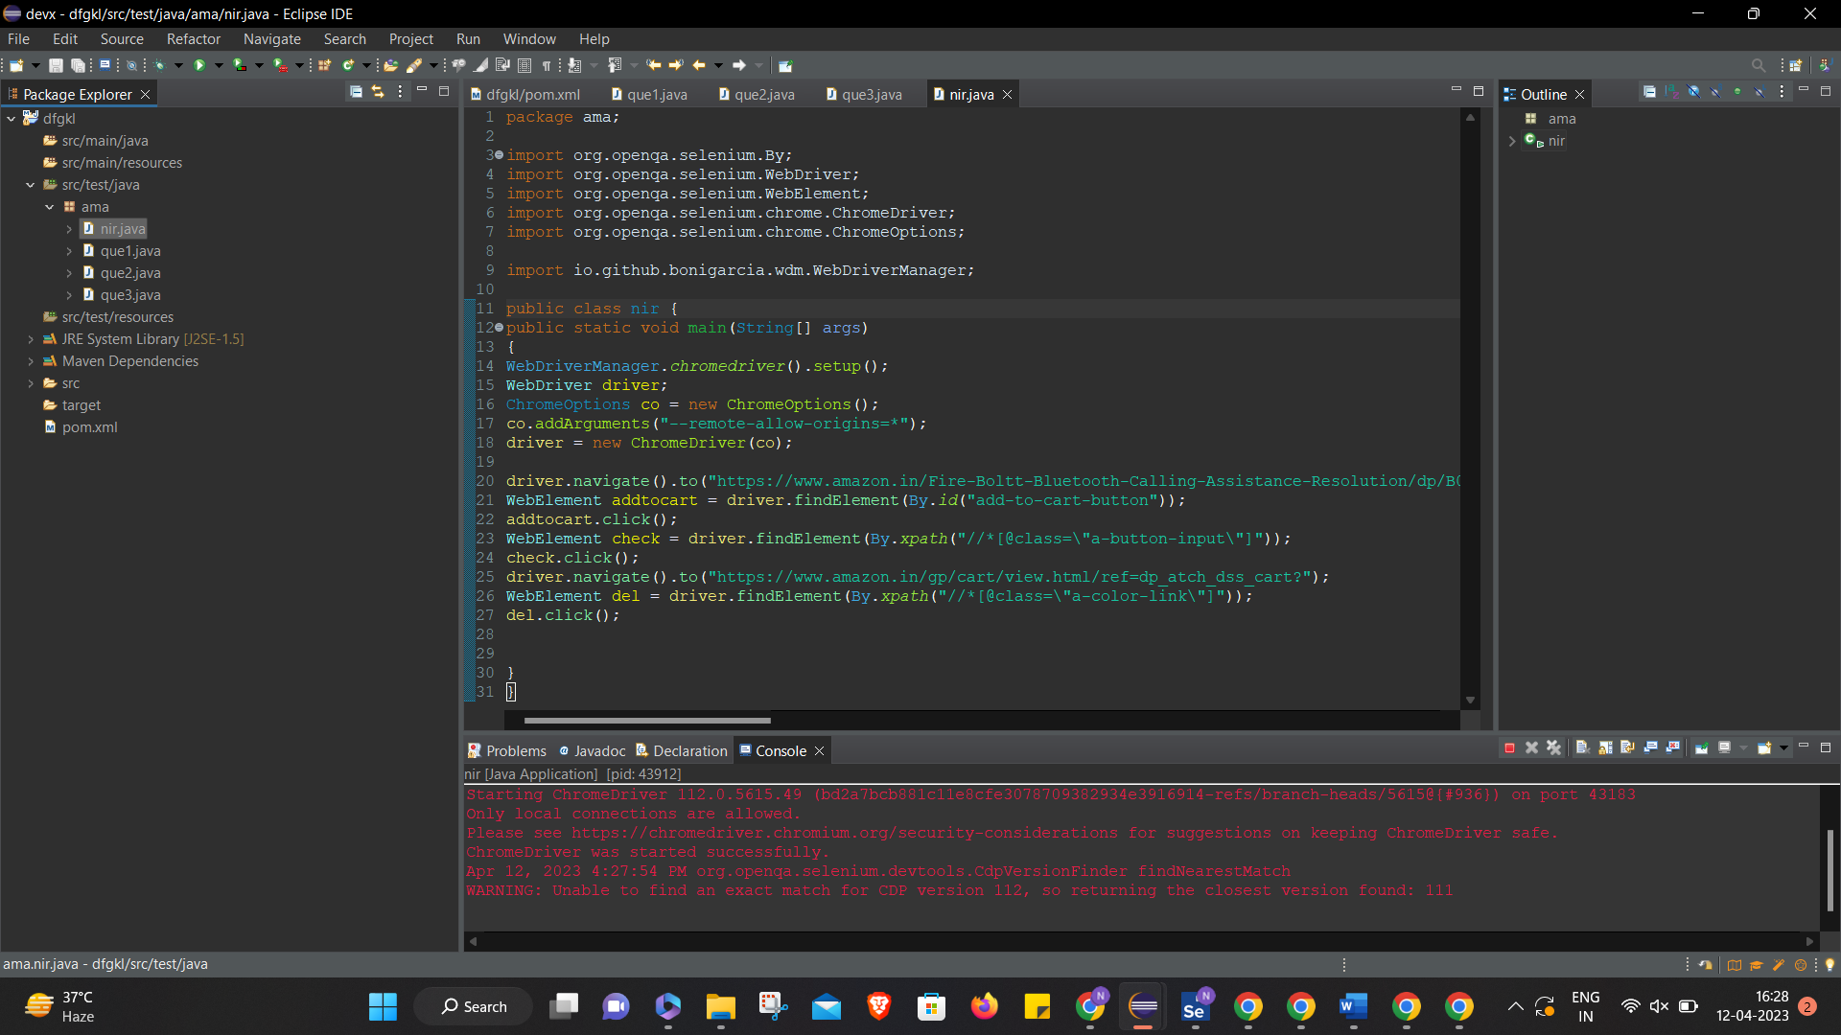

OUTPUT :

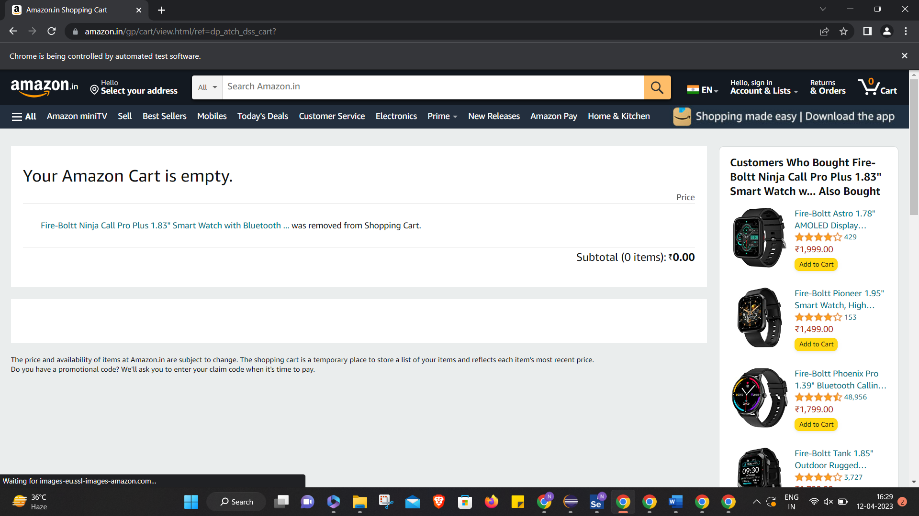

QUESTION 2:

CODE :

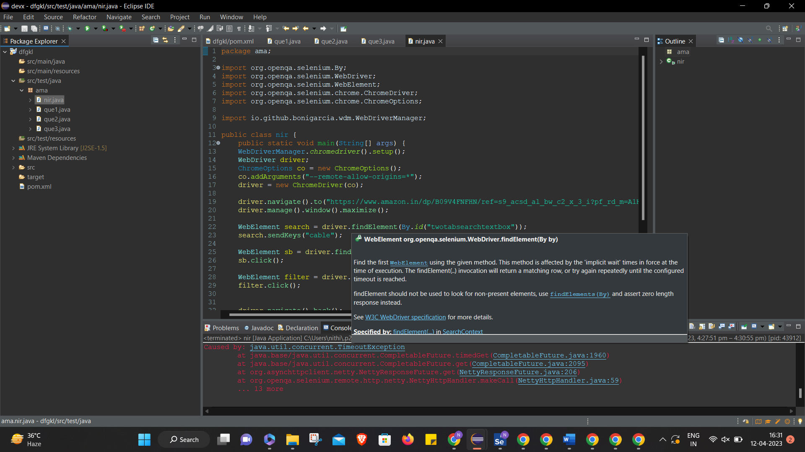

OUTPUT:

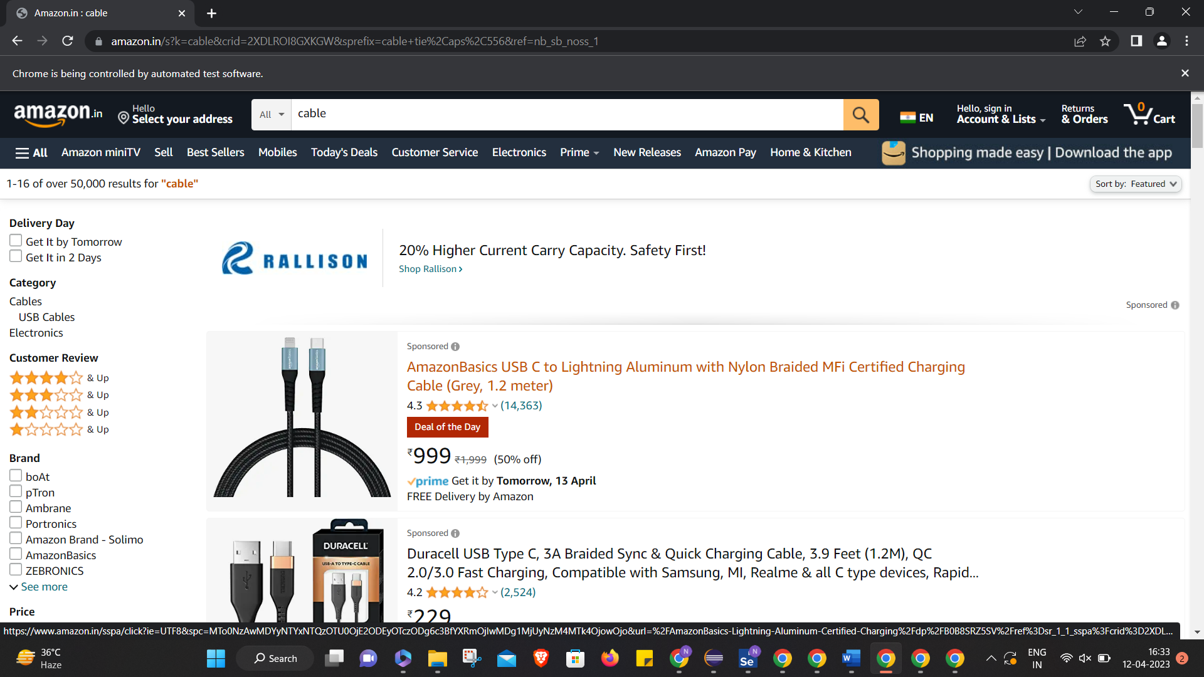

QUESTION 3: