**MCA302**

**IT PROJECT MANAGEMENT**

**Lab Evaluation – I**



Submitted to: Submitted by:

Dr. Harkiran Kaur Rahul Bajaj (202201029)

(Associate Professor) Rakshit (202201031)

Saksham (202201034)

Tanu (202201045)

Khuwaish (202201054)

Software Requirements Specification

for

<REAL ESTATE MANAGEMENT >

Version 1.0 approved

Prepared by <Tanu, Khuwaish, Saksham, Rakshit, Rahul>

<Team D>

# Introduction

## Purpose

Real Estate Management is a comprehensive online platform designed to revolutionize the way people buy, sell real estate properties. The platform aims to provide a seamless and user-friendly experience for buyers, sellers, and real estate agents by offering an extensive range of features and tools. Real Estate Management aims to be the go-to platform for all real estate needs, connecting buyers, sellers, and agents in a dynamic and user-centric online environment. By offering a wide array of features and exceptional user experiences, Real Estate Management aims to simplify and enhance the real estate journey for everyone involved.

## Intended Audience and Reading Suggestions

This document is intended to show the technical and functional requirements to the developers, testers and project managers. When reading the SRS document, it is recommended to start with the overview section to gain a high-level understanding of the project's objectives and context. Then, readers can proceed to the sections that are most pertinent to their role or interest. For example, developers may focus on the functional requirements, system architecture, and algorithms sections. Testers may prioritize the non-functional requirements and quality assurance sections. Project managers may read the entire document to understand the project's scope, constraints, and timeline.

## Project Scope

The purpose of Real Estate Management is to provide an effective and efficient way for individuals to acquire knowledge about the properties they want to buy and dealers who are aiming to get the best value and profit from each property. The benefits of such applications include flexibility, convenience, and personalized experiences tailored to individual needs styles.

From a corporate perspective, a real estate management can help organizations achieve their business strategies and goals by providing employees with the skills and knowledge needed to succeed in their roles. This can improve job performance, productivity, and ultimately contribute to the success of the organization. Additionally, providing learning opportunities to employees can increase job satisfaction and retention rates, which can be a competitive advantage for the organization.

## Overview

1. User Authentication and Authorization: Users should be able to register and create accounts. Users should be able to log in using secure authentication methods. Different user roles (buyers, sellers, agents) should have appropriate access and permissions.

2. Property Listings: Sellers should be able to create property listings with details such as location, price, features, and Images. Buyers should be able to search and filter properties based on criteria like location, price range, property type, etc. Property listings should include high-quality images and detailed descriptions.

3. Property Details: Users should be able to view comprehensive property details, including property size, layout, amenities, and contact information for the seller or agent.

4. Reviews and Ratings: Allow users to leave reviews and ratings for properties and agents.

5. Property Alerts: Users can set up alerts for specific property criteria and receive notifications when new listings match their preferences

# Overall Description

## Product Perspective

**Context and Origin:**

The real estate management development described in this SRS represents a new, self-contained product aimed at providing a comprehensive and interactive buying and selling experience. The platform is not a follow-on member of a product family or a replacement for any existing systems.

The real estate management is being developed to meet the increasing demand for effective and trustworthy tools in an era of globalization. With the need to acquire language skills for communication, business, and personal growth, there is a market opportunity for an innovative.

**Admin's interface:**

Admin is a person who will handle the entire website. For that person has to give the user name and password to enter the admin page. After entering right password admin person can enter the admin home area. Here user buy different property & sell them to the system. Buyer user property & builder verify each-other & make reliable communication to each other.

**User's interface:**

User can visit the home page of real estate in which first the introduction of our site mention first. The registered user can login from the login module. Here guest can register free account to sell and buy property &buyer verify each- other & make reliable communication to each other. User can search the property and it can select the type of property and its budget and also find the location of property.

## Product Functions

- we will create and design a login form for the admin and the other users to login, with username and password verification.

- we will create a class to connect our project with the MySQL database we will create.

- we will create a form to manage the property owner.

- we will create a form to manage the real estate property client.

- we will create a form to manage the property type:

1. Residential real estate.

2. Commercial real estate.

3. Industrial real estate.

4. Land.

- we will create a form to manage the property:

search, add, edit, delete the property,

- we will create a form to manage the property images:

in this form you can't edit the property image only add and delete you can also see the property images in a slideshow with a next and previous button to navigate the images.

- we will create a form to manage the sales.

## User Characteristics

-Real Estate Agent/Brokers

-Property owners

-Property Managers

-Buyers and Sellers

-Administrators

## General Constraints, Assumptions and Dependencies

- A general knowledge of basic computer skills and of basic working of smart card-based system is required to use the product.

**Assumptions:**

-The code should be free with compilation errors/syntax errors.

-The product must have an interface which is simple enough to understand

**Dependencies:**

-All necessary hardware and software are available for implementing and use of the tool.

-The proposed system would be designed, developed and implemented based on the software requirements specifications document.

-End users should have basic knowledge of computer and we also assure that the users will be given software training documentation and reference material.

-The system is not required to save generated reports.

# Specific Requirements:

## External User Interface:

External user interface is designed in such way that it is easy to understand by user and user can find properties according to his need and budget requirements, dealer can list the properties and images are not too big or too small. Design is responsive to any commands

## Detailed Description for Fundamental Requirements:

User Authentication and Authorization: Users should be able to register and create accounts. Users should be able to log in using secure authentication methods. Different user roles (buyers and agents) should have appropriate access and permissions. New user should have the option for registration and then further access the rest of features.

Property Listings: Sellers should be able to create property listings with details such as location, price, features, and Images. Buyers should be able to search and filter properties based on criteria like location, price range, property type, etc. Property listings should include high-quality images and detailed descriptions.

Property Details: Users should be able to view comprehensive property details, including property size, layout, amenities, and contact information for the seller or agent. Property must be free from any legal suites and proper paperwork

Reviews and Ratings: Allow users to leave reviews and ratings for properties and agents.

Property Alerts: Users can set up alerts for specific property criteria and receive notifications when new listings match their preferences.

## Performance Requirements:

1. Search response should load with in few seconds.
2. System should handle the increased load of concurrent users.
3. System should notify user in form of property alerts.
4. Horizontal scrolling should be less.
5. Font and image size neither too big nor too small.

## Logical Database Requirements:

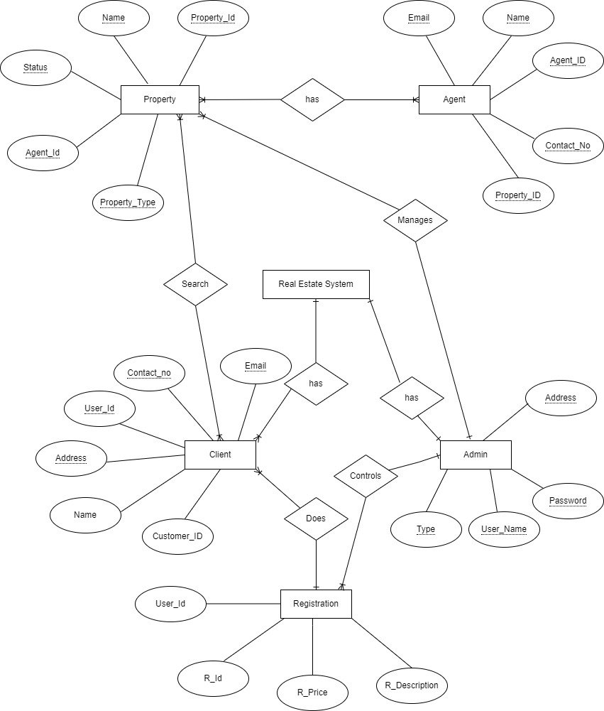

## Quality Attribute:

1. Performance: The system should provide fast response times for property searches, listings, and user interactions. The system should be able to handle a large number of concurrent users without significant performance degradation.
2. Security: User authentication and sensitive data should be encrypted and protected using industry standard security practices. The system should implement role-based access control to ensure that users can only access appropriate features and data.
3. Scalability: The system architecture should be designed to scale horizontally or vertically to accommodate growing user loads.
4. Usability and User Experience: The user interface should be intuitive, user-friendly, and accessible to users of varying technical abilities. The system should provide clear and informative error messages to guide users in case.

# Change History:

|  |  |
| --- | --- |
|  | Version1.0- Initial Release |
|  |  |
|  |  |

# Document Approvers

We hereby declare that the design principles and working prototype model of the project entitled Real Estate Management is an authentic record of our own work carried out in the Computer Science and Engineering Department, TIET, Patiala, under the guidance of

(Dr. Harkiran Kaur)

Professor, CSED

Date:12/10/2023

**DFD Level 0**

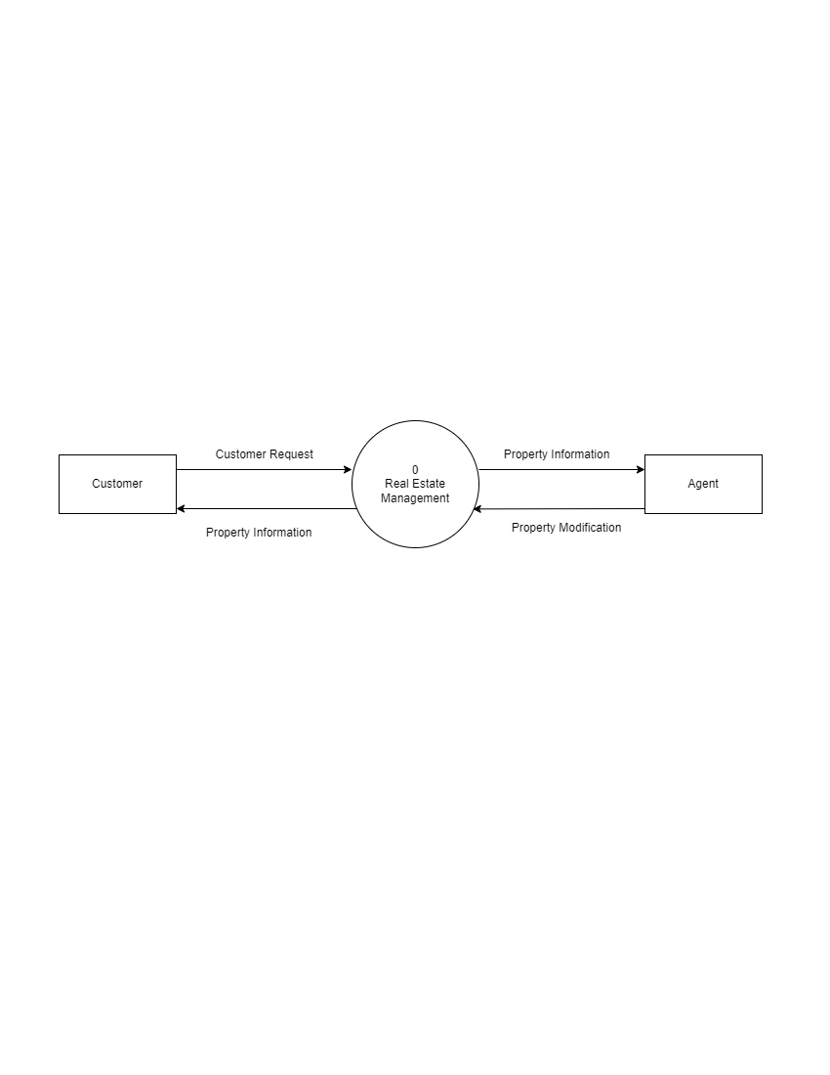

**DFD Level 1**

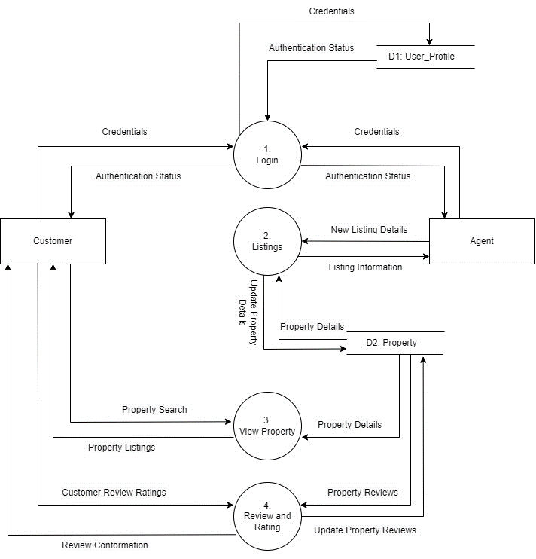

**WBS Dictionary Entry**

**Date: - 8/10/2023**

**Project Title:** Real Estate Management

**WBS Item Number:** 1

**WBS Item Name:** Planning

**Description:** This phase involves defining project goals, identifying stakeholders, and outlining the overall project strategy, including budgeting and resource allocation.

**WBS Dictionary Entry**

**Date: - 8/10/2023**

**Project Title:** Real Estate Management

**WBS Item Number:** 1.1

**WBS Item Name:** Estimate Time

**Description:** In this phase, the project team assesses the time required for various project activities, helping to create a realistic timeline and schedule for project execution. This involves considering tasks, dependencies, and resource availability.

**WBS Dictionary Entry**

**Date: - 8/14/2023**

**Project Title:** Real Estate Management

**WBS Item Number:** 1.2

**WBS Item Name:** Estimate Effort

**Description:** This involves determining the amount of work required for each task, helping allocate resources effectively.

**WBS Dictionary Entry**

**Date: - 8/18/2023**

**Project Title:** Real Estate Management

**WBS Item Number:** 1.3

**WBS Item Name:**  Estimate Cost

**Description:** In this phase, project costs are calculated, including materials, labor, and other expenses, ensuring accurate budgeting for the project.

**WBS Dictionary Entry**

**Date: - 8/23/2023**

**Project Title:** Real Estate Management

**WBS Item Number:** 1.4

**WBS Item Name:** Software Project Management

**Description:** This segment involves overseeing and coordinating all aspects of the software project, ensuring it stays on track, within scope, and on budget while meeting its objectives.

**WBS Dictionary Entry**

**Date: - 8/25/2023**

**Project Title:** Real Estate Management

**WBS Item Number:** 2

**WBS Item Name:** Requirements Gathering

**Description:** This phase involves gathering and documenting all necessary information and criteria for the software project, outlining what the system needs to achieve based on user and stakeholder input.

**WBS Dictionary Entry**

**Date: - 8/25/2023**

**Project Title:** Real Estate Management

**WBS Item Number:** 2.1

**WBS Item Name:**  Functional Requirements

**Description:** These are specific features and functionalities that the software must provide to meet the needs of users and stakeholders. They describe what the system should do, such as user actions, system responses, and data processing functions.

**WBS Dictionary Entry**

**Date: - 8/29/2023**

**Project Title:** Real Estate Management

**WBS Item Number:** 2.2

**WBS Item Name:** Interview

**Description:** This is a requirement-gathering technique where project stakeholders and users are directly engaged in discussions to collect valuable information, insights, and feedback about the project's needs and objectives.

**WBS Dictionary Entry**

**Date: - 8/31/2023**

**Project Title:** Real Estate Management

**WBS Item Number:** 2.3

**WBS Item Name:** Survey

**Description:** From survey, we can collect various kinds of data. We, will get to know if the project which we are going to develop already exists in the market or not. If exists, then what are the required functions which are not there in already existing system and what new functionality does customers want to add in the system.

**WBS Dictionary Entry**

**Date: - 9/6/2023**

**Project Title:** Real Estate Management

**WBS Item Number:** 2.4

**WBS Item Name:** Interface Analysis

**Description:** In Interface analysis we will identify the interfaces according to the requirements for ensuring that the components interact with one another effectively. How the interface should look like is determined at this stage.

**WBS Dictionary Entry**

**Date: - 9/8/2023**

**Project Title:** Real Estate Management

**WBS Item Number:** 3

**WBS Item Name:** Design

**Description:** Design involves the actual designing of the frontend of the project. Designing involves various tasks such as designing a SRS report, designing the interfaces. All the frontend development of the project will be done over here.

**WBS Dictionary Entry**

**Date: - 9/06/2023**

**Project Title:** Real Estate Management

**WBS Item Number:** 3.1

**WBS Item Name:** Document SRS

**Description:** Documenting the SRS involves listing down all the functional and non-functional requirements for the project. This will consist of all the needs and resources which are required throughout the project.

**WBS Dictionary Entry**

**Date: - 9/08/2023**

**Project Title:** Real Estate Management

**WBS Item Number:** 3.2

**WBS Item Name:** Interface Design

**Description:** Interface Design involves the designing of interfaces for the project. It mainly focuses on the design and style of the project. How the system will look like is all designed over here.

**WBS Dictionary Entry**

**Date: - 9/12/2023**

**Project Title:** Real Estate Management

**WBS Item Number:** 3.3

**WBS Item Name:** Managing Data

**Description:** Managing data include the management of storage, data access, organizing the data in such manner that it occupies less storage space. This stage will include what kind of data it needs, how the data will be handled, who will be responsible for it.

**WBS Dictionary Entry**

**Date: - 9/14/2023**

**Project Title:** Real Estate Management

**WBS Item Number:** 3.4

**WBS Item Name:** Identify Risk

**Description:** At this step we will identify all the risks if occurring in our project that can hamper quality of project, performance get’s degraded. We will take into account the possible risks that can occur to our project.

**WBS Dictionary Entry**

**Date: - 9/18/2023**

**Project Title:** Real Estate Management

**WBS Item Number:** 4

**WBS Item Name:** Coding

**Description:** This step involves actual implementation of project. Here Project Developer will provide actual implementation to the project. Analyzing of different programming language is done and begin the coding according to the specifications.

**WBS Dictionary Entry**

**Date: - 9/18/2023**

**Project Title:** Real Estate Management

**WBS Item Number:** 4.1

**WBS Item Name:** Dashboard

**Description:** This is the main page of the project. All the components are placed on this page. This will be the main menu of our project. It will include various functions.

**WBS Dictionary Entry**

**Date: - 9/26/2023**

**Project Title:** Real Estate Management

**WBS Item Number:** 4.2

**WBS Item Name:** Login/Register

**Description:** Implementation of secure user authentication and registration functionalities, ensuring that users can create accounts, log in securely, and access the system with appropriate permissions.

**WBS Dictionary Entry**

**Date: - 10/04/2023**

**Project Title:** Real Estate Management

**WBS Item Number:** 4.3

**WBS Item Name:** Listings

**Description:**  Creation of a database and user interface for managing real estate property listings, including details like property type, location, price, and other relevant information.

**WBS Dictionary Entry**

**Date: - 10/12/2023**

**Project Title:** Real Estate Management

**WBS Item Number:** 4.4

**WBS Item Name:** Home Search

**Description:** Development of the search functionality within the real estate management system, allowing users to search and filter property listings based on their preferences, such as location, price range, and property type.

**WBS Dictionary Entry**

**Date: - 10/20/2023**

**Project Title:** Real Estate Management

**WBS Item Number:** 4.5

**WBS Item Name:** About Us

**Description:** Creation of the "About Us" section, providing information about the real estate management company, its history, mission, and team members to build trust and transparency with users.

**WBS Dictionary Entry**

**Date: - 10/26/2023**

**Project Title:** Real Estate Management

**WBS Item Number:** 4.6

**WBS Item Name:** Alerts

**Description:** Development of an alert system to notify users about important updates, such as new property listings, price changes, or relevant news, enhancing user engagement and satisfaction.

**WBS Dictionary Entry**

**Date: - 11/1/2023**

**Project Title:** Real Estate Management

**WBS Item Number:** 5

**WBS Item Name:** Testing

**Description:** In this phase, the system is rigorously evaluated to ensure it meets the specified requirements and functions correctly. Various testing methods, such as unit testing, integration testing, and user acceptance testing, are performed to identify and rectify any defects or issues before deployment.

**WBS Dictionary Entry**

**Date: - 11/1/2023**

**Project Title:** Real Estate Management

**WBS Item Number:** 5.1

**WBS Item Name:** Dashboard

**Description:** Test the accuracy and responsiveness of user dashboards, including widgets, customisation, real-time updates, and error handling.

**WBS Dictionary Entry**

**Date: - 11/06/2023**

**Project Title:** Real Estate Management

**WBS Item Number:** 5.2

**WBS Item Name:** Login/Register

**Description:** Testing the user authentication and registration process, including login with existing credentials and creating a new account. Ensuring the security of user data during registration and login. Verifying that users receive confirmation emails and can reset their passwords if needed. Checking for any usability issues, such as password requirements and error handling.

**WBS Dictionary Entry**

**Date: - 11/09/2023**

**Project Title:** Real Estate Management

**WBS Item Number:** 5.3

**WBS Item Name:** Listings

**Description:** Testing the property listings section, validating that all property details, images, and descriptions are correctly displayed. Ensuring accurate pricing information and availability status. Verifying that users can view and interact with property listings, such as saving, sharing, and contacting the seller. Checking for any issues with loading times, image rendering, or broken links.

**WBS Dictionary Entry**

**Date: - 11/14/2023**

**Project Title:** Real Estate Management

**WBS Item Number:** 5.4

**WBS Item Name:** Home Search

**Description:** Testing the search functionality on the home page, including keyword search, filters, and sorting options. Ensuring that search results are relevant and accurate. Verifying that users can easily navigate through search results and access property details. Checking for any issues related to search speed and responsiveness.

**WBS Dictionary Entry**

**Date: - 11/17/2023**

**Project Title:** Real Estate Management

**WBS Item Number:** 5.5

**WBS Item Name:** About Us

**Description:** Verifying the "About Us" section's content, layout, and functionality, ensuring that it accurately represents the company, its mission, and its team. Testing links and contact information for accuracy and validating the overall user experience.

**WBS Dictionary Entry**

**Date: - 11/22/2023**

**Project Title:** Real Estate Management

**WBS Item Number:** 5.6

**WBS Item Name:** Alerts

**Description:** Testing the alert system to ensure that users receive timely notifications about important updates, validating the system's functionality, reliability, and responsiveness to deliver a seamless user experience.

**CPM Diagram:**

**PERT Diagram:**

