Department of Computer Science & Engineering
Assignment 01
Semester 3rd , Batch: E-96th (2nd Shift)

Course No: Math 102 Course Name: Differential and Integral Calculus
Total Marks: 10
Answer the following questions
1. | a) Find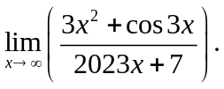
 | b) Examine the continuity of the following function at x=1: 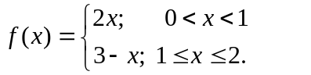
c) Test the differentiability of the following function at x = 0
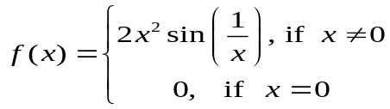
2. | 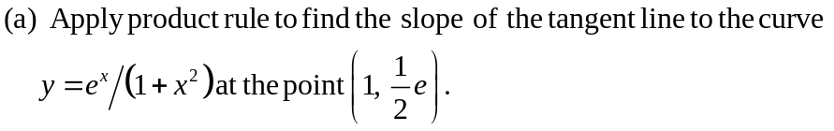
 | (b) Find 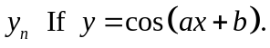
3. | (a) If 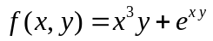then find 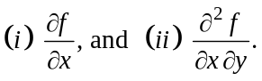
 | (b) Find the values of 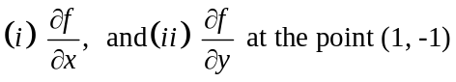, If 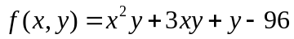
4. | Integrate the followings:  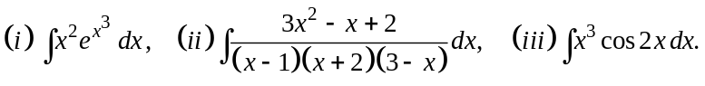
5, | Evaluate the integrals:  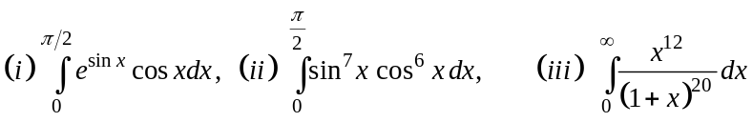

Dear Students,
You have to submit the assignment by 15th April.
Submit your assignment by using the URL: https://forms.gle/CxqUEou1bsiKDFE58

