WEEK 1 INTERNSHIP TASK
DATA SCIENCE PROJECT PLANNING AND STRATEGY DESIGN
Hypothetical Project:
Student Academic Performance Analysis and Prediction Using Python
Submitted as part of the Yuva Intern Data Science Internship
Name: Khadijah Kabirah
Course: BCA – 3rd Year
Week: 1
GitHub Repository: [Paste your GitHub repository URL here after uploading the project]

1. Introduction and Background
This project is planned around a common problem in education: understanding why some students perform better than others and identifying students who may need additional academic support. The proposed project will use Python and data science techniques to study student-related factors such as attendance, internal assessment marks, study time, previous marks, assignment performance and participation.
The main idea is not to label a student permanently. Instead, the analysis is intended to find useful patterns in the available data and estimate academic performance so that teachers or institutions can identify areas where support may be useful.

1.1 Problem Statement
Educational institutions usually have student records, but these records may not be analyzed beyond calculating marks and attendance. A data science approach can combine different factors, find relationships between them and build a simple prediction model for expected academic performance.

1.2 Motivation
I selected this problem because academic performance is influenced by more than one factor. Looking at only final marks does not explain the reasons behind the result. Python provides useful libraries for organizing data, visualizing patterns and building prediction models. The project is therefore a practical way to understand the complete data science workflow from problem definition to evaluation.

2. Project Objectives and Scope

2.1 Objectives
- Study the main factors that may be associated with student academic performance.
- Prepare a structured data pipeline for collecting and cleaning student records.
- Perform exploratory data analysis using tables, statistics and visualizations.
- Create useful features from the available student information where required.
- Build and compare suitable machine learning models for predicting academic performance.
- Evaluate the model using appropriate performance measures.
- Present the findings in a simple form that can be understood by non-technical users.

2.2 Project Scope – Included
- Student demographic and academic information that is legally and ethically appropriate to use.
- Attendance, previous academic performance, internal assessment, assignment and study-related variables.
- Data cleaning, missing-value handling, outlier checking and basic feature preparation.
- Exploratory analysis and visualization.
- Supervised machine learning for academic-score or performance-category prediction.
- Model comparison and interpretation of important factors.

2.3 Out of Scope
- Automatic decisions about scholarships, admission, promotion or disciplinary action.
- Using sensitive personal information that is not necessary for the analysis.
- Real-time monitoring of students.
- Deploying the model as a production application during Week 1.
- Guaranteeing a student's future result from the prediction.
- Replacing teachers' judgement with the machine learning model.

3. Methodology and Strategy
The project will follow a structured data science lifecycle. Each stage will produce an output that becomes the input for the next stage. Since this is a planning task, the actual dataset and model training are not required in Week 1; the plan explains how they will be handled in later stages.
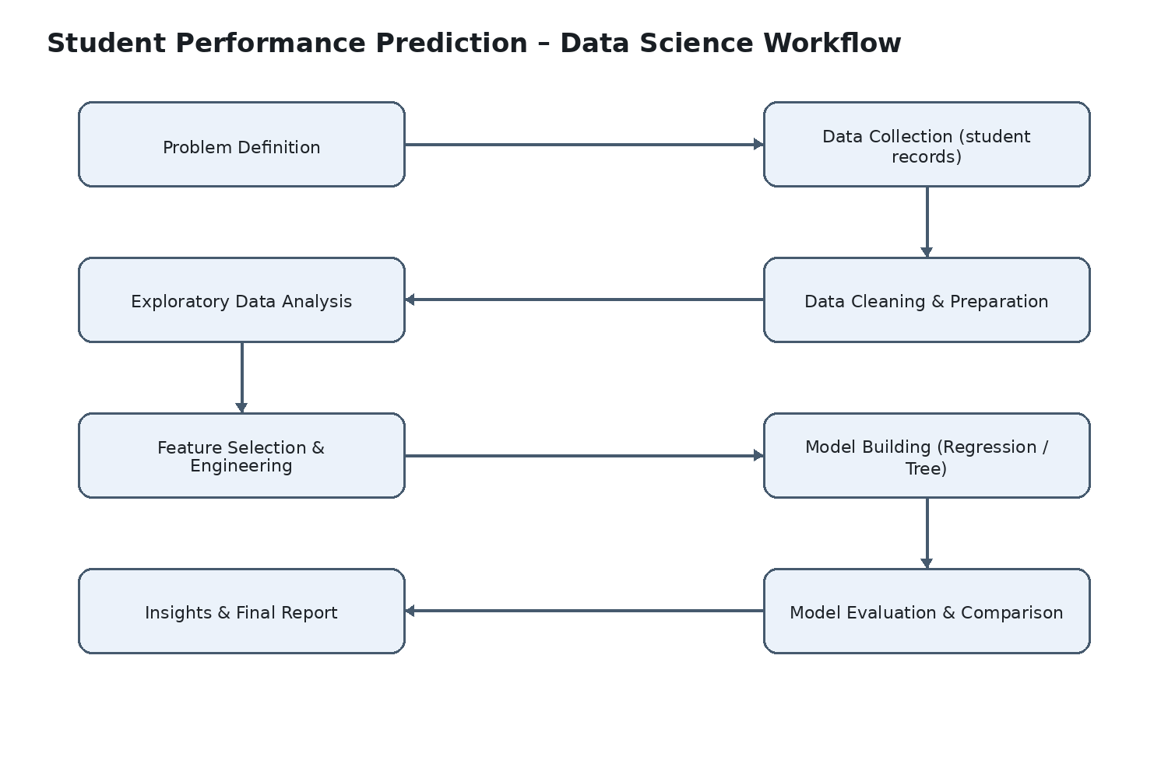
Figure 1: Planned end-to-end data science workflow

3.1 Problem Definition
Define the prediction target clearly. For example, the target can be the final academic score or a performance category such as Low, Average and Good. The target must be measurable and available in the historical data.

3.2 Data Collection
For the hypothetical project, data may come from anonymized college records, a suitable public educational dataset, or a simulated dataset created for learning. The expected columns may include attendance percentage, internal marks, assignment score, previous semester score, study hours and final score.

3.3 Data Cleaning
Check the dataset for missing values, duplicate rows, incorrect data types, impossible values and inconsistent entries. Missing numerical values may be handled using suitable statistical methods, while categorical values can be treated separately. Outliers will be reviewed before deciding whether they should be retained or removed.

3.4 Exploratory Data Analysis
Use descriptive statistics and visualizations to understand distributions and relationships. Examples include histograms for marks, box plots for outliers, scatter plots for relationships and correlation analysis for numerical variables.

3.5 Feature Engineering
Create or transform variables only when there is a clear reason. For example, attendance can be grouped into meaningful ranges, or several assessment components can be combined into an overall internal-performance measure.

3.6 Model Building
Depending on the target, regression models can be used for predicting a numerical score, while classification models can be used for performance categories. Possible models include Linear Regression, Decision Tree and Random Forest. A simple model will be kept as a baseline.

3.7 Evaluation
Split the data into training and testing sets. For regression, MAE, RMSE and R² can be used. For classification, accuracy, precision, recall, F1-score and a confusion matrix can be considered. Cross-validation may also be used when the dataset size permits.

3.8 Interpretation and Reporting
The final stage will explain the model results in simple language. Important factors, model performance and limitations will be reported instead of presenting only a prediction number.
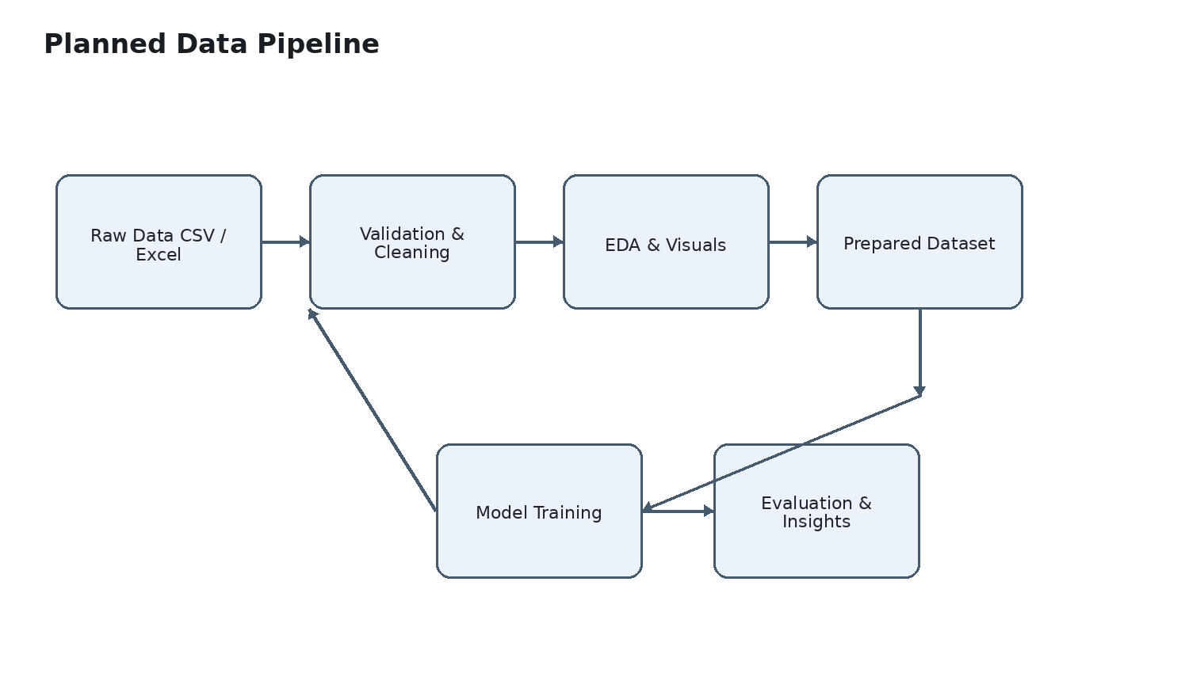
Figure 2: Planned data pipeline

4. Python Libraries and Tools
Tool / Library | Purpose | Expected Use
Python | Main programming language | Data preparation, analysis and modelling
Pandas | Data manipulation | Read, clean, filter and transform tabular data
NumPy | Numerical computing | Arrays and mathematical operations
Matplotlib | Visualization | Charts such as line, bar, histogram and scatter plots
Seaborn | Statistical visualization | Correlation plots and clearer statistical charts
Scikit-learn | Machine learning | Preprocessing, model training and evaluation
Jupyter Notebook | Interactive development | Documenting analysis step by step
VS Code | Code editor | Managing Python files and project structure
Git & GitHub | Version control | Store and submit the project work

5. Timeline and Work Allocation
The planned Week 1 workload is approximately 30 hours. The allocation below gives more time to planning the data and methodology because a clear strategy is important before coding begins.
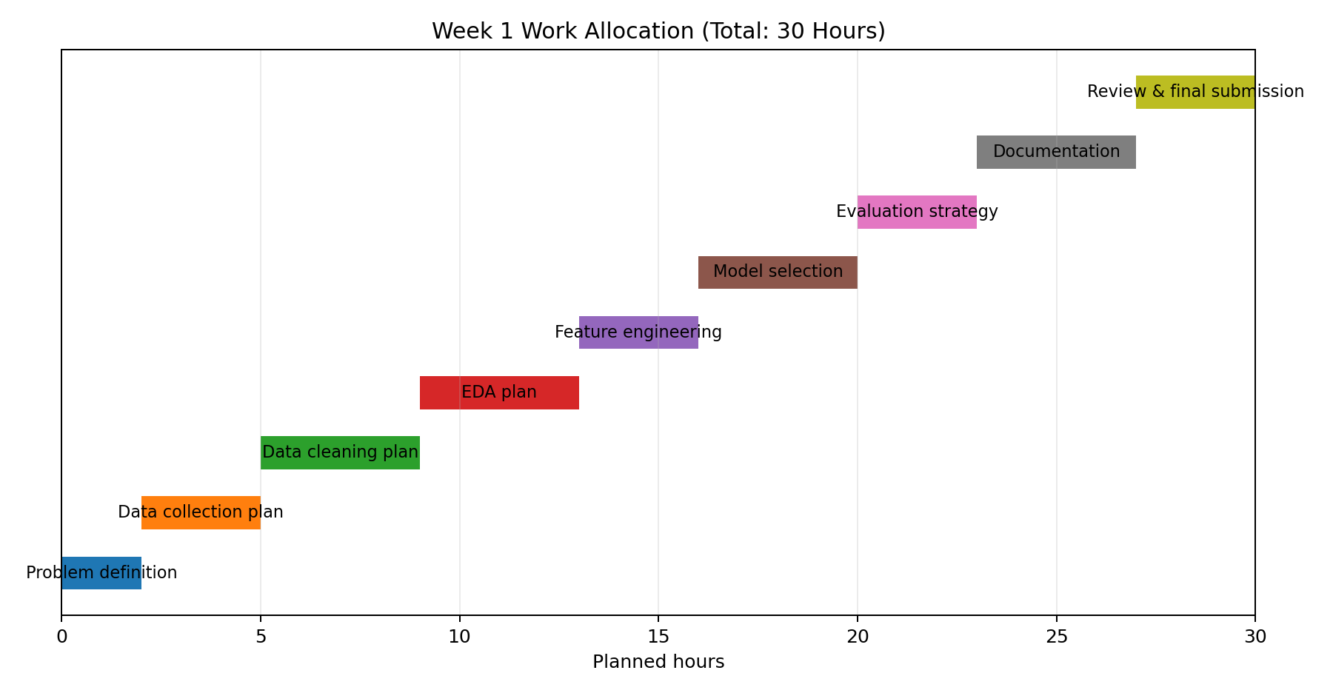
Figure 3: Planned 30-hour work allocation
Activity | Hours | Main Deliverable
Problem definition and project background | 2 | Problem statement and motivation
Data collection strategy | 3 | Source and variable plan
Data cleaning strategy | 4 | Cleaning rules and quality checks
Exploratory analysis plan | 4 | EDA questions and visualizations
Feature engineering plan | 3 | Candidate features
Model selection strategy | 4 | Baseline and candidate models
Evaluation strategy | 3 | Metrics and validation plan
Documentation and diagrams | 4 | Project plan document
Review and final submission | 3 | Final checking and submission

6. Expected Outcomes
- A clean and well-organized dataset prepared for analysis.
- A clear understanding of the variables related to academic performance.
- Visual summaries showing important patterns and relationships.
- At least one baseline machine learning model and one or more comparison models.
- An evaluation report showing how well the selected model performs.
- A simple explanation of the most useful factors identified by the analysis.
- A documented Python project that can be extended in later internship tasks.

6.1 Possible Benefits
The proposed approach can help an institution move from simply storing student records to learning from them. It may help identify broad academic patterns, support early academic intervention and provide a practical example of how Python can be used for data-driven decision making. The model should be treated as a support tool rather than a final decision-maker.

7. Anticipated Challenges and Mitigation
Challenge | Possible Effect | Mitigation
Missing or incomplete records | Can reduce model reliability | Check missingness, use suitable imputation and document assumptions.
Small dataset | Model may not generalize well | Use simple models, cross-validation and avoid unnecessary features.
Data imbalance | Some performance groups may be under-represented | Check class distribution and use suitable evaluation measures.
Outliers and incorrect entries | Can distort statistics and models | Validate ranges and investigate unusual values before removal.
Overfitting | High training performance but poor test performance | Use train/test separation, cross-validation and simpler models.
Privacy concerns | Student information may be exposed | Use anonymized data and collect only necessary variables.
Unclear target definition | Model may answer the wrong question | Define the target and success criteria before modelling.
Misinterpretation | Predictions may be treated as facts | Report limitations and use the model only as decision support.

8. Evaluation Criteria for the Project
The success of the project will be checked using the following points:
- Completeness: all planned stages from problem definition to reporting are addressed.
- Clarity: the project plan is understandable without needing advanced technical knowledge.
- Technical suitability: the selected Python libraries, models and evaluation measures match the problem.
- Logical strategy: each stage has a clear purpose and connects to the next stage.
- Visual presentation: diagrams and tables make the workflow easier to understand.
- Practical value: the proposed analysis should provide useful insights rather than only producing predictions.
- Ethical use: privacy, limitations and responsible interpretation are considered.

9. GitHub Submission Plan
Because this is a technical internship task, the final project should also be uploaded to GitHub. The repository can contain the Python notebooks/scripts, README file, sample or permitted dataset, and documentation. Only data that is legally shareable and free of personal information should be uploaded.
Recommended repository name: student-performance-data-science
GitHub URL: [PASTE YOUR ACTUAL GITHUB REPOSITORY URL HERE]
Before submitting the internship task, replace the placeholder above with the real public repository URL. Do not submit a made-up URL.

Suggested GitHub structure
student-performance-data-science/
├── README.md
├── notebooks/
│ └── week1_project_plan.ipynb
├── data/
│ └── README.md
├── src/
│ └── project_notes.py
└── docs/
└── Week1_Project_Plan.docx

10. Conclusion
This Week 1 plan provides a complete strategy for a hypothetical student performance data science project using Python. The focus is on understanding the problem first, preparing reliable data, exploring useful patterns, selecting suitable models and evaluating them carefully. The plan also considers practical issues such as privacy, missing data, overfitting and interpretation. Once a suitable dataset is available, the same plan can be followed step by step to complete the technical stages of the project.

11. Basic References and Learning Resources
- Python documentation – for the core Python language and standard tools.
- pandas documentation – for data manipulation and analysis.
- NumPy documentation – for numerical operations.
- Matplotlib and Seaborn documentation – for data visualization.
- scikit-learn documentation – for machine learning models and evaluation.
- Jupyter documentation – for notebook-based data science work.

