1. INTRODUCTION

Microblogging websites have evolved to become a source of varied kind of information. This is due to nature of micro blogs on which people post real time messages about their opinions on a variety of topics, discuss current issues, complain, and express positive sentiment for products they use in daily life. In fact, companies manufacturing such products have started to poll these micro blogs to get a sense of general sentiment for their product. Many times these companies study user reactions and reply to users on micro blogs. One challenge is to build technology to detect and summarize an overall sentiment.

The purpose of sentiment analysis is to determine the attitude or inclination of a communicator through the contextual polarity of their speaking or writing. Their attitude may be reflected in their own judgment, emotional state of the subject, or the state of any emotional communication they are using to affect a reader or listener. It is trying to determine a person’s state of mind on the subject they are communicating about. This information can be mined from various data sources like: texts, tweets, blogs, social media, news articles, product comments.

There are different classification levels in SA: document-level, sentence-level and aspect-level. Document-level SA aims to classify an opinion of the whole document as expressing a positive or negative sentiment. Sentence-level SA aims to classify sentiment expressed in each sentence which involves identifying whether sentence is subjective or objective. Aspect-level SA aims to classify the sentiment with respect to the specific aspects of entities which is done by identifying the entities and their aspects for instance researchers need a tool to generate summaries for deciding whether to read the entire document or not and for summarizing information searched by user on internet. News groups can use multi document summarization to cluster the information from different media.

This project of analyzing sentiments of tweets comes under the domain of “Pattern Classification” and “Data Mining”. Both of these terms are very closely related and intertwined, and they can be formally defined as the process of discovering “useful” patterns in large set of data, either automatically (unsupervised) or semi automatically (supervised). The project would heavily rely on techniques of “Natural Language Processing” in extracting significant patterns and features from the large data set of tweets and on “Machine Learning” techniques for accurately classifying individual unlabelled data samples (tweets) according to whichever pattern model best describes them.

Chapter-2

LITERATURE SURVEY

2. LITERATURE SURVEY

Aditya Joshi and Pushpak Bhattacharyya [1] proposed a fall back strategy for finding sentiment associated with Hindi language. Machine Translation, In-language and Resource Based SA where the three approach proposed for SA in Hindi. Alec, G.; Lei, H.; and Richa, B [2] presented that the results of machine learning algorithms for classifying the sentiment of Twitter messages using distant supervision. Our training data consists of Twitter messages with emoticons, which are used as noisy labels. S. Mukherjee and P. Bhattacharyya [3] told that the discourse relations like the connectives and conditionals can be used to incorporate discourse information in any bag-of-words model, to improve sentiment classification accuracy.

P. Nakov and S. Rosenthal. Some work has been done on unsupervised (e.g., [9] and [10]) and semi-supervised (e.g., [11] and [12]) approaches, and there is a lot of room of improvement. Various researchers testing new features and classification techniques often just compare their results to base-line performance. Authors have built a robust sense based classifier [14] which is a supervised document levels entiment classifier on basis of semantic space based on WordNet senses. Through the use of similarity metrics unknown synset in the training set was replace by similar synset in test set words in the corpus were annotated with their senses using combinations of manual senseannotation and automatic iterative WSD. In synset replacement algorithm a synset encountered in a test document is not found in the training corpus, it is replaced by one of the synsets present in the training corpus. The substitute synset is determined on the basis of its similarity with the synset in the test document. The synset that is replaced is referred to as an unseen synset as it is not known to the trained model.

Das and Bandopadhaya [13] used different strategies to predict the sentiment of a word in the given text. In one of the strategies they annotated the words with their associated polarity manually. In another strategy, to determine the polarity of the text, Bi-Lingual dictionary for English and Indian Languages was used. In next strategy synonym and antonym relations of words in WordNet are used, to determine the polarity.

Chapter-3
PROBLEM DEFINITION AND FUNCTIONALITY

3.1 PROBLEM DEFINITION

The problem in sentiment analysis is classifying the polarity of a given text at the document, sentence, or feature/aspect level. whether the expressed opinion in a document, a sentence or an entity feature/aspect is positive, negative, or neutral.

The research in the field started with sentiment and subjectivity classification, which treated the problem as a text classification problem. Sentiment classification classifies whether an opinionated document (e.g., product reviews) or sentence expresses a positive or negative opinion. Subjectivity classification determines whether a sentence is subjective or objective. Many real-life applications, however, require more detailed analysis because the user often wants to know what the opinions have been expressed. For example, from the review of a product, one wants to know what features of the product have been praised and criticized by consumers.
The question is: what we want to extract from this review? The first thing that we may notice is that there contains total seven sentences. Contains, both kind of sentiments; i.e. positive sentiment w.r.t. buyer and negative sentiment w.r.t. his mother. It contains two issues, i.e. quality of product (a positive sentiment is attached with it) and cost issues (negative sentiment is attached with this issue), so decision of more important sentiment is also a problem. With this example in mind, we can define sentiment analysis or opinion mining.

3.2 FEATURES AND FUNCTIONALITY

The process of computationally identifying and categorizing opinions expressed in a piece of text,

especially in order to determine whether the writer's attitude towards a particular topic, product, etc. is

positive, negative, or neutral. Sentiment analysis is computational study of emotions, opinions and

mainly the sentiment expressed in the text by user. Sentiment analysis is a challenging task due to

many challenges which are associated while processing natural language. Any sentiment analysis

system needs first to extract feature i.e. sentimental words or phrases from the given text and then
using suitable text classifier overall sentiment associated with the text is extracted.

3.2.1 Challenges for sentiment analysis

3.2.1.1 Contextual Information

To derive actionable insights, it is important to understand what kind of information is a user

discussing about. For example: Amazon would want to segregate messages that related to: late

deliveries, billing issues, promotion related queries, product reviews etc. On the other hand, Starbucks

would want to classify messages based on whether they relate to staff behaviour, new coffee flavours,

hygiene feedback, online orders, store name and location etc.

Identifying the context of the text becomes an important challenge to address in SA. Behaviour use of the word changes in a great aspect based on the context.

Ex-1 The journey was long.

Ex-2 Seminar was long.

Ex-3 Battery life of Nexus 5 is long.

In all the above 3 examples, meaning of long is same it indicates the duration or passage of time. In Ex-1 and Ex-2 “long” indicates bored hence a Negative expression whereas in Ex 3 “long” indicates efficiency hence a Positive expression. In Ex 3 “long” indicates efficiency hence a Positive expression.

3.2.1.2 Word Sense Disambiguation Word

The problem is that words often have more than one meaning, sometimes fairly similar and sometimes completely different. The meaning of a word in

a particular usage can only be determined by examining its context. Word Sense Disambiguation

(WSD) is the process of identifying the sense of a polysemic word.

For example, the word "cold" has several senses and may refer to a disease, a temperature sensation, or an environmental condition. The specific sense intended is determined by the textual context in which an instance of the ambiguous word appears. In "I am taking aspirin for my cold" the disease sense is intended, in "Let's go inside, I'm cold" the temperature sensation sense is meant, while "It's cold today, only 2 degrees", implies the environmental condition sense.

3.2.1.3 Word Order:

Word order plays a vital role in deciding the polarity of a text, in the text same set of words with slight variations and changes in the word order affect the polarity aspect. For example “X is efficient than Y” conveys the exact opposite sentiment from “Y is efficient than X”.
3.2.1.4 Entity Recognition

Same entity is not seen for all the texts in a document. When multiple entities are being mentioned about in a single document, the overall document polarity does not make much sense. We need to separate out the text about a particular entity and then analyse its sentiment.
Ex- I hate Heat, but I like ICE.

3.2.1.5 Emotion via Emoticons

This paper focuses on this problem by the analysis of symbols called emotion tokens,

including emotion symbols (e.g. emoticons and emoji ideograms). According to observation, these

emotion tokens are commonly used. They directly express one’s emotion regardless of his language;

hence become a useful signal for sentiment analysis on multilingual tweets

3.2.2 Features for sentiment analysis

3.2.2.1 Term Presence vs. Term Frequency

Term frequency is mostly used in different Information Retrieval (IR) and Text Classification tasks. But Pang-Lee [98 found that term presence is more important to Sentiment analysis than term frequency as for term presence binary-valued feature vectors are used, and those vectors the entries merely indicate whether a term occurs indicated as value 1 or do not occur indicated by value 0. Polarity based classification is very useful for SA ,as overall sentiment may not usually be highlighted through repeated use of the same term an also occurrences of rare word can have more sentimental value compared to frequently repeated word.
Term Position is more sentimental value is given to certain words based on their position in a sentence or a document. Generally words appearing in the 1st few sentences and last few sentences in a text are given more weightage than those appearing elsewhere in the document.

3.2.2.2 Emotion icons

In face-to-face communication, sentiment can often be deduced from visual cues like smiling. However, in plain-text computer-mediated communication, such visual cues are lost. Over the years, people have embraced the usage of so-called emoticons as an alternative to face-to-face visual cues in computer-mediated communication like virtual utterances of opinions. In this light, we define
emoticons as visual cues used in texts to replace normal visual cues like smiling to express, stress, or
disambiguate one’s sentiment. Emoticons are typically made up of typographical symbols such as “:”,
“=”, “-”, “)”, or“( ” and commonly represent facial expressions.

3.2.2.3 Negation Word

Negation is one of the most common linguistic means that can change text polarity. Therefore in sentiment analysis negation has to be taken into account. The scope size of a negation expression determines which sequence of words in the sentence is affected by negation words, such as, no, not, never.

We first have to tokenize the sentence which involves breaking a stream of text up into words, phrases, symbols, or other meaningful elements called tokens. It is done by segmenting text by splitting it by spaces and punctuation marks, and forms a bag of words. Care should be taken so that short forms such as “don’t”, “I’ll”, “she’d” will remain as one word.

Then important features are identified. Features such as Terms presence and frequency, Parts of speech (POS), Opinion words and phrases, Negations are identified. We need to take care of negations, since they will reverse polarities and decide whether we want to use only adjective, adjectives plus adverbs or simply all the words as features. Lexicon-based or statistical feature selection methods can be used to select features from documents which treat document as Bag of Words (BOW) or string. Stemming and removal of stop-words are mostly common feature selection step.
After we've tokenized and decided which features to use we need to classify the sentiment. Is it good or bad? Classification can be done with different algorithms. For example: Naïve Bayes, Support Vector Machines, or Max Entropy. Lexical resources like dictionary, WordNet, Senti WordNet are uses by these classifier algorithms. This technique attempts to determine whether a text is objective or subjective and whether a subjective text contains positive or negative sentiments. The system automatically collects, cluster, categorizes, and summarizes news from several sites on the web on a daily basis. A summarization machine can be viewed as a system which accepts either a single document or multiple documents or a query as an input and produces an abstract or extract summary.

Features | Accuracy | Subjective F. | Objective F.
Word tokens | 73.6 | 55.7 | 81.2
Words + prior polarity | 74.2 | 60.6 | 80.7
28 features | 75.9 | 63.6 | 82.1

Table 3.1: Step 1 sample results for Objective / Subjective Classification

Feature | Accuracy | Positive F. | Negative F. | Both F. | Objective F.
Word tokens | 61.7 | 61.2 | 73.1 | 14.6 | 37.7
Word + prior | 63.0 | 61.6 | 75.5 | 14.6 | 40.7
10 features | 65.7 | 65.1 | 77.2 | 16.1 | 46.2

Table 3.2: Step 2 sample results for Polarity Classification

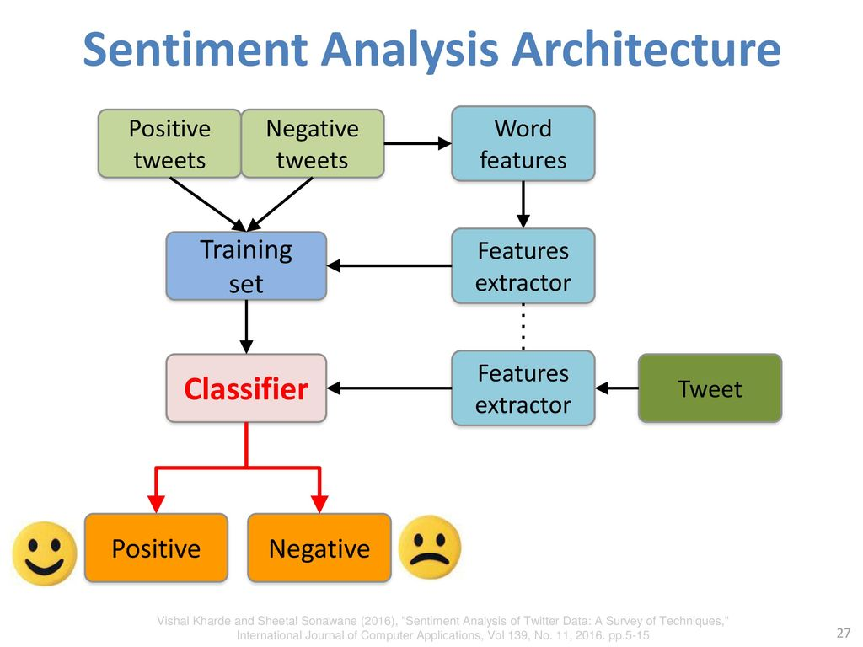

3.2.4 Sentiment Classification Techniques

3.2.4.1 Machine Learning Approach

The machine learning method uses several learning algorithms to determine the sentiment by training on a known dataset. Training and a test set are the two document sets which are mostly needed for machine learning based techniques. Training set is used by classifier to understand the different characteristics associated with documents, and to check the overall performance of the classifier test set are used.

3.2.4.1.1 Supervised learning

Supervised learning is the machine learning task of inferring a function from labelled training data. The training data consist of a set of training examples. In supervised learning, each example is a pair consisting of an input object (typically a vector) and a desired output value (also called the supervisory signal). A supervised learning algorithm analyses the training data and produces an inferred function, which can be used for mapping new examples. There are different types of supervised classifiers like: Rule-based Classifiers, Decision Tree Classifiers, Linear Classifiers and Probabilistic Classifiers.

A. Probabilistic Classifier

A probabilistic classifier is a classifier that is able to predict, given an observation of an input, a probability distribution over a set of classes, rather than only outputting the most likely class that the observation should belong to. Probabilistic classifiers provide classification that can be useful in its own right or when combining classifiers into ensembles.

1. Naive Bayes Classifier (NB)

Naive Bayes[appendix-1] classification model computes the posterior probability of a class is computed in Naive Bayes Classifier which is based on the way words are distributed in the particular document. The positions of the word in the document are not considered for classification in this model as it uses BOWs feature extraction technique. Bayes Theorem is used to predict the probability where given feature set belongs to a particular label of the content.
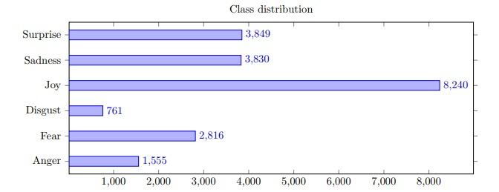
P(label_features) = (P(label)*P(features|label))/(P(features))

P (label) signifies the prior probability of a label. P (features | label) signifies the prior probability that a particular feature set is being classified as a label. P (features) specifies the prior probability that a

given feature set has occurred in the process. On basis of Naive assumption i.e. all features are independent; the equation can be rewritten as:

P(label_features) = (P(label)*P(f1_label)*….*P(fn_label))/(P(features))

2. Bayesian Network (BN)

A Bayesian network is is a probabilistic graphical model (a type of statistical model) that represents a

set of variables and their conditional dependencies via a directed acyclic graph (DAG). For example, a

Bayesian network could represent the probabilistic relationships between diseases and symptoms.

Given symptoms, the network can be used to compute the probabilities of the presence of various

diseases.

B. Linear classifiers

Probability of a particular classification is based on a linear combination of features and their weights. A linear classifier determines which class an object belongs by making a classification decision based on the value of a linear combination of the characteristics of the objects. Feature vector are used to represent object characteristics. Different linear classifiers are available.

1. Support Vector Machines Classifiers (SVM)

The main principle of SVM[appendix-2] is to determine linear separators in the search space which can best separate the different classes. Due to sparse nature of text the text data are well suited for SVM classification. In text data some of the features are irrelevant, but most of them seem to be correlated with one another and can be easily organized into linearly separable categories. The basic SVM has no dependency on probability as it predicts which two possible class forms an output for a given input.

2. Neural Network (NN)

Neural Network simply consists of neurons which are arranged in layers and convert a given input vector into meaningful output. Each neuron processes an input by applying nonlinear function to it and

the output is passed to the next layer for further process. Mostly neural networks are designed as feed-forward network .Signals passing from one neuron to another are assigned different weights and during the training phase these weights are adjusted so that neural network adapts to a particular problem to solve. Multi-layer neural networks are used for nonlinear boundaries. These multiple layers are used to create multiple piecewise linear boundaries, which are mainly used to approximate enclosed regions which belongs to a particular class of output. Here training process is more difficult as there is a need of back-propagation of errors over several layers.

C. Decision tree classifier

In decision tree classifier training data set ate hierarchical decomposed where to divide the data the condition on the attribute value is used. The condition or predicate of the attribute signifies the presence or absence of one or more words associated with it. Data space is divide recursively until certain minimum numbers of records which are used for the purpose of classification are available at leaf node.

3.2.4.1.2 Unsupervised learning

Unsupervised learning is where you only have input data (X) and no corresponding output variables. The goal for unsupervised learning is to model the underlying structure or distribution in the data in order to learn more about the data. These are called unsupervised learning because unlike supervised learning above there is no correct answers and there is no teacher. Algorithms are left to their own devises to discover and present the interesting structure in the data.

Unsupervised learning problems can be further grouped into clustering and association problems.

- Clustering: A clustering problem is where you want to discover the inherent groupings in the data, such as grouping customers by purchasing behaviour.

- Association: An association rule learning problem is where you want to discover rules that describe large portions of your data, such as people that buy X also tend to buy Y.

3.2.4.2 Lexicon-based approach

The lexicon-based approach involves calculating sentiment polarity for a review using the semantic orientation of words or sentences in the review. The semantic orientation is a measure of subjectivity and opinion in text. Sentiment lexicon contains lists of words and expressions used to express people’s subjective feelings and opinions. For example, start with positive and negative word lexicons, analyse the document for which sentiment need to find. Then if the document has more positive word lexicons, it is positive, otherwise it is negative. The lexicon based techniques to Sentiment analysis is unsupervised learning because it does not require prior training in order to classify the data.

Chapter-4

SOFTWARE DESIGN

4. SOFTWARE DESIGN

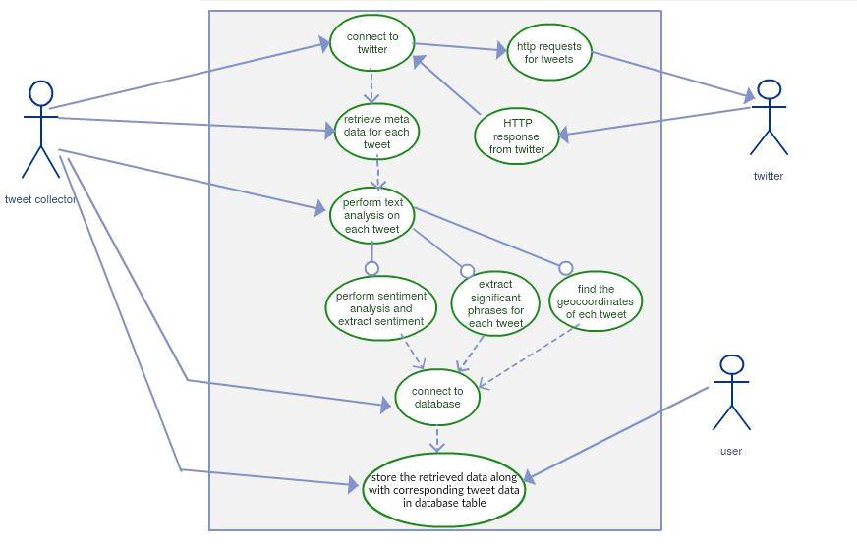

Figure 4.1: Use case diagram for Sentiment Analysis

Chapter-5

SOFTWARE AND HARDWARE REQUIREMENTS

HARDWARE/SYSTEM REQUIREMENT

Processor requirement - Minimum 1.5GHz, Memory requirement - Minimum 4 GB

SOFTWARE REQUIREMENT

- Python 3.0 or above,

- NLTK Package,

- WebPy Framework Package,

- Modern Web Browser,

- R Studio,

- HTML, CSS, JavaScript,

- Twitter API, Google API.

Chapter-6

CONCLUSION

6. CONCLUSION

The attitude or approach towards a subject can be determined by the writings of the communicator. If

this is done at mass level then the general opinion towards a particular topic or product can be deduced.

This is more reliable way to extract review rather than depending on word of mouth which could lead

in wrong directions sometimes. Understanding mass opinion can lead to building of better products,

and better business decisions.
Sentiment analysis is the process of computationally identifying and categorizing opinions expressed in

a piece of text, especially in order to determine whether the writer’s attitude towards a particular topic

is positive, negative or neutral. So basically it derives knowledge from the opinions of others about a

particular topic or problem. Sentiments can be mined from texts, tweets, bogs, social media, news

articles, comments or from any other source of text. The ability to leverage such voice of web to gain

consumer, brand reputation and market insights can be truly differentiating and valuable to an

organization. This work investigated whether sentiment analysis of public mood derived from larger

scale Twitter feeds can be used to identify important events and predict movements of stock prices.All

these aspects become important from the point of view that text categorization or polarity of the text is

an emerging and a very relevant field in Information Technology. Following are the overall findings of

this research work: Twitter APIs can be accessed only via authenticated requests. Twitter uses Open

Authentication and each request must be signed with valid Twitter user credentials. This Streaming API

is the best versatile tool to access data from twitter. Twitter API is a vital pre-processing step for the

Information. Retrieval. Only if a better API is adopted along with OAuth authentication it ispossible to

get a high quality data for classificationsentiment analysis enables enterprises to understand consumer

sentiments in relation to specific products/services. Moreover, these insights could be used to improve

their products and services by gauging consumers’ comments and feedback using sentiment analysis.

Chapter-7 FURTHER ENHANCEMENT

7. FURTHER ENHANCEMENT

At the end of the project we will be passing the data through the R studio and by using R programming we will be generating graph, polarity plot, customer sentiments score, comparison charts, pie chart and developing exploratory analysis & visualization skills. Researchers can identify new ways of classifying the textual data into various moods such as happiness, alertness, certainty, and calmness. Some use-cases of twitter sentiment analysis could review of products by business enterprises, public’s opinion on government policies by political parties, buzz around new tv shows, celebs, etc.

APPENDICES:

- Navie Bayes: Given a text d we want to calculate the probability for every class c (in our case: positive and negative) and choose the one that maximizes
argmaxcp(c|d) = argmaxc ^{( ) ( | )}

( )

Now, since p(d) is similar in all classes, we ignore it. d is represented here by a set of features, also known as, “bag of words”. The value of p(d|c) is then determined based on a multinomial distribution, so that we get:
p(d|c) = ^{(∑ )} ∏ ( , )^{Wi}

∏

where is the weight of feature (e.g. word, lemma) i, and ( , ) is the probability that feature i occurs in class c.

- Support Vector Machine: When experimenting with SVM we tried two different kernels. The first is a simple linear kernel, multiplying the two vectors directly. The second one is a degree 2 polynomial with additional coefficient 2,
i.e. (¹ × × + 2 )²

where N is the number of features and are two vectors. In general SVM with the linear kernel performs a little bit worst than Naïve Bayes on both datasets. On the other hand, when using polynomial kernel, we get the best results on both datasets.

REFERENCE

- Aditya Joshi, Balamurali A.R., Pushpak Bhattacharyya 2010, A Fall-Back Strategy for Sentiment Analysis in a New Language: A Case Study for Hindi, ICON 2010,Kharagpur,India.

- Alec G., Lei H., and Richa B. Twitter sentiment classification using distant supervision Technical report, Stanford University, 2009.

- S. Mukherjee and P. Bhattacharyya. Sentiment analysis in Twitter with light weight discourse analysis, Conference paper, December 2012,Mumbai,India.

- Hajibagheri, A., & Sukthankar, G. Political polarization over global warming: Analyzing twitter data on climate change. Academy of Science and Engineering (ASE), USA, 2014.

- Balahur, A., Steinberger, R., Kabadjov, M., Zavarella, V., van der Goot, E., Halkia, M., Pouliquen, B., and Belyaeva, J. (2010): Sentiment Analysis in the News. In: Proceedings of the 7th International Conference on Language Resources and Evaluation (LREC2010), pp. 2216-2220.

- Thelwall, M., Buckley, K., and Paltoglou, G. (2011): Sentiment in Twitter events. Journal of the American Society for Information Science and Technology, 62(2), pp. 406-418.

- Thelwall, M., Buckley, K., and Paltoglou, G. (2012): Sentiment strength detection for the social Web, Journal of the American Society for Information Science and Technology, 63(1), pp. 163-173.

- Pang, Bo, and Lillian Lee. "Opinion mining and sentiment analysis," Foundations and trends in information retrieval 2.1-2 (2008): 1-135.

- Peter D. Turney. Thumbs Up or Thumbs Down? Semantic Orientation Applied to Unsupervised Classification of Reviews. In Proceedings of the Annual Meeting of the Association of Computational Linguistics (ACL), 2002.

- Samuel Brody and Nicholas Diakopoulus. Cooooooooooooooollllllllllllll!!!!!!!!!!!!!! Using Word Lengthening to Detect Sentiment in Microblogs. In Proceedings of Empirical Methods on Natural Language Processing (EMNLP), 2011.

- Alexander Pak and Patrick Paroubek. Twitter as a Corpus for Sentiment Analysis and Opinion Mining. In Proceedings of international conference on Language Resources and Evaluation (LREC), 2010.

- Luciano Barbosa and Junlan Feng. Robust Sentiment Detection on Twitter from Biased and Noisy Data. In Proceedings of the international conference on Computational Linguistics (COLING), 2010.

- Das, Amitava, and Sivaji Bandyopadhyay, "SentiWordNet for Indian languages, " The 8th Workshop on Asian Language Resources. 2010.

- Balamurali, A. R., Aditya Joshi, and Pushpak Bhattacharyya, “Robust sense-based sentiment classification,"Proceedings of the 2nd Workshop on Computational Approaches to Subjectivity and Sentiment Analysis, Association for Computational Linguistics, 2011.

