Lab-01 Report: Bike Sharing Data Analysis
Course: CSE 4114 – Data Science Lab

1. Introduction
This project performs data cleaning and insight generation using authentic hourly bike-sharing data from the UCI Machine Learning Repository.

2. Dataset
The uploaded dataset contains 17,379 hourly observations. A reproducible sample of exactly 2,000 valid, unique observations was selected with random_state=42. No synthetic records were generated.

3. Selected Features
Eight columns were selected: season, mnth, holiday, workingday, temp, hum, windspeed, and cnt. The cnt column represents total bike rentals and is treated as the main outcome variable.

4. Data Cleaning
Duplicate rows, missing values, data types, and valid value ranges were checked. The final cleaned dataset contains exactly 2,000 records and 8 columns.

5. Insights
- Temperature-cnt correlation: 0.414.
- Humidity-cnt correlation: -0.321.
- Windspeed-cnt correlation: 0.114.
- Average rental counts vary across seasons and months.
- Working-day and non-working-day observations have different average rental counts.

6. Visualizations
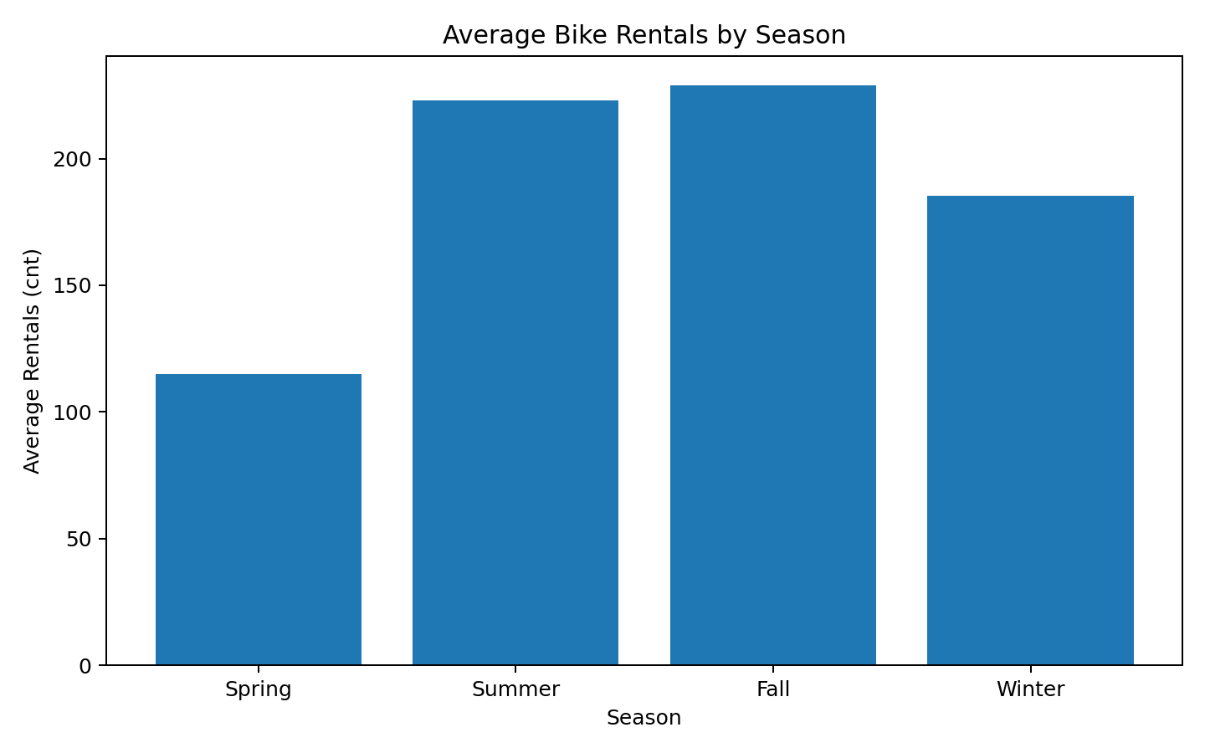
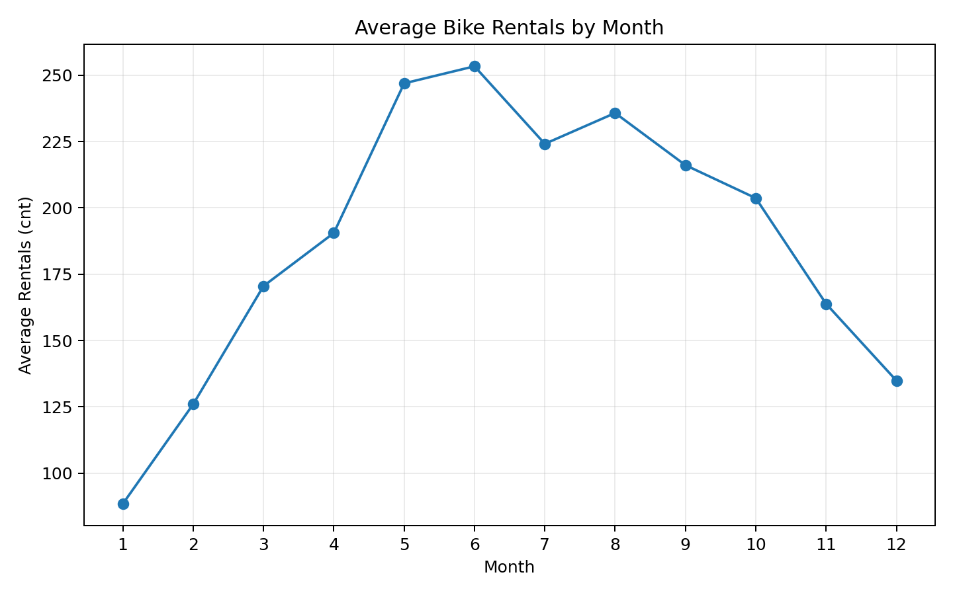
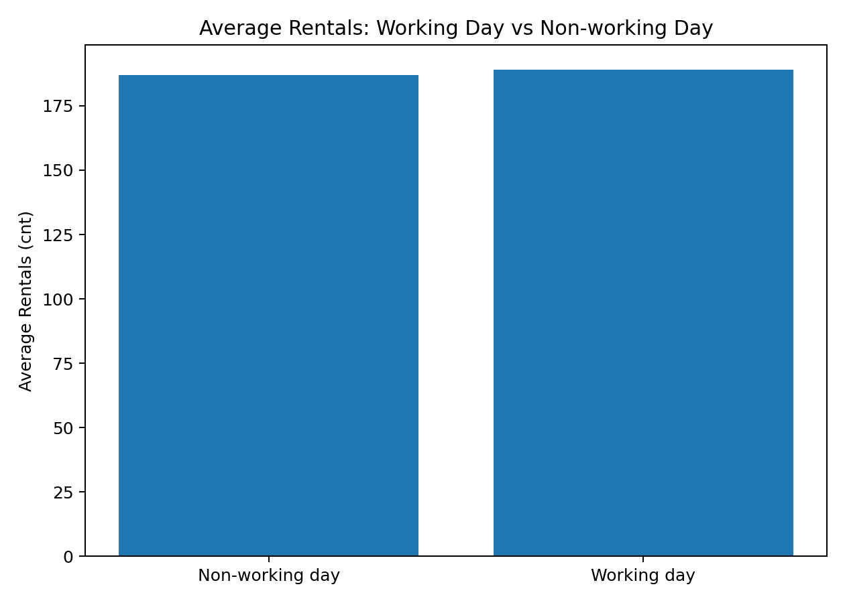

7. Conclusion
The project demonstrates a complete data-science workflow: authentic data selection, cleaning, descriptive analysis, visualization, and reporting. The observed correlations describe associations and do not establish causation.

Reference
Fanaee-T, Hadi and Gama, Joao. Bike Sharing Dataset. UCI Machine Learning Repository. DOI: 10.24432/C5W894.

