Influencer landing page to be set up as -

https://lifesmomentsapp/annualmembership

RED HAIRED GIRL PHOTO AND LOGO EXACTLY THE SAME AS THE MAIN PAGE

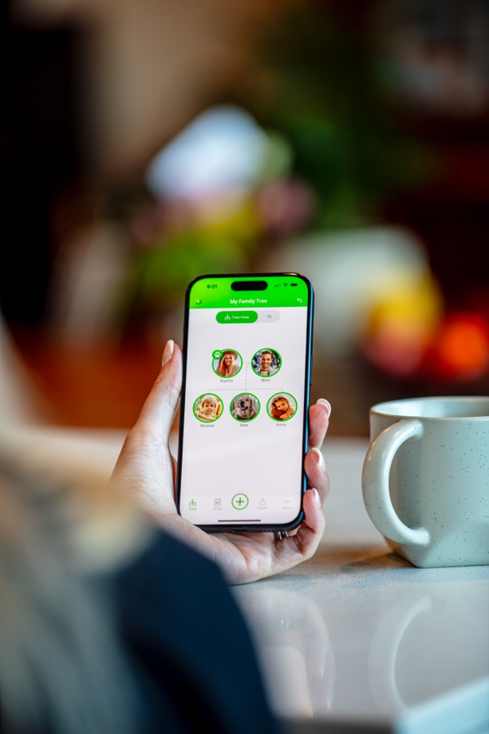
Life’s Moments Annual Membership
Gift or start your Modern Family Photo Album
to preserve your family’s memories.

- Buy for myself
- Gift to someone special

🔒 Secure online purchase
⚡ Instant delivery
📱 Available on iPhone & Android

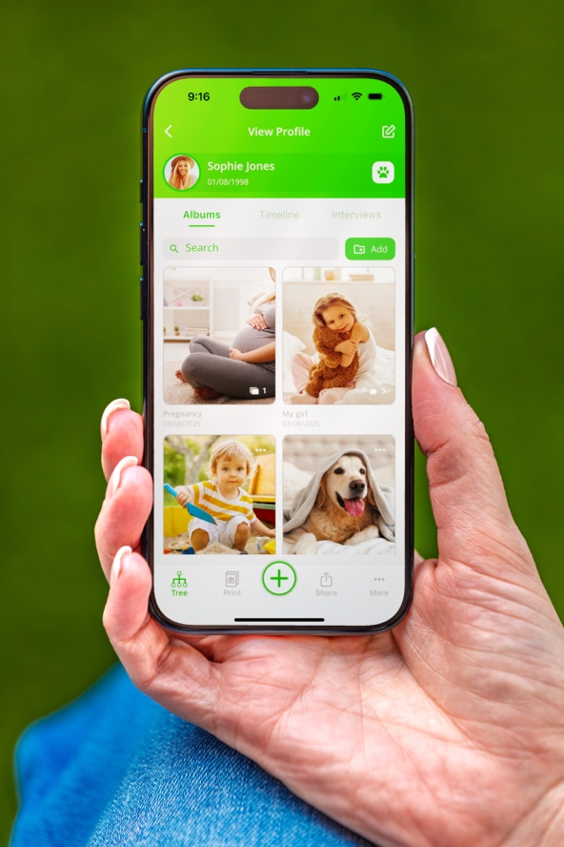

Most families take thousands of photos…
Most families take thousands of photos, yet very few of those memories survive long enough to be passed down.
Life’s Moments is a modern family photo album that helps you capture, organise and preserve your family’s photos, videos and stories in one place—ready to enjoy today and eventually pass on to the next generation.

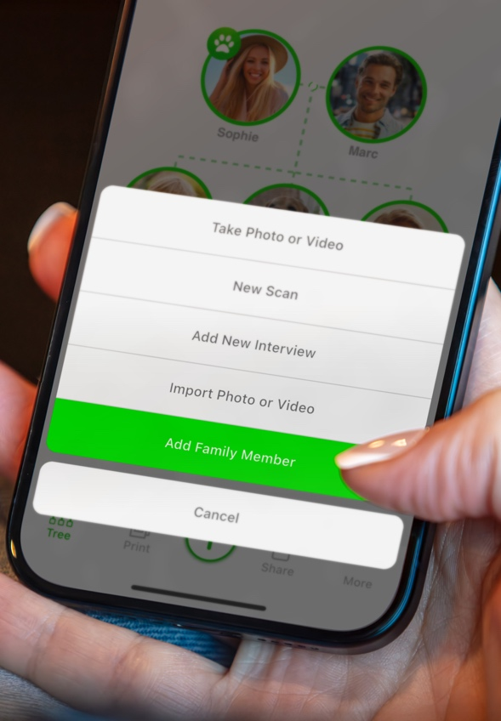

Your Membership includes

- Unlimited storage
- No ads
- Available in 12 languages
- Works on iPhone & Android
- Family Tree
- Dedicated albums for family members and pets
- Photos, videos, notes & scanned documents
- Free family sharing — Invitation only

“Our family’s memories “It’s exactly what I was looking for “Now I know our family’s
are finally in one place.” to organize a lifetime of photos.” memories won’t be lost.” ★★★★★ ★★★★★ ★★★★★

How it works
1️⃣ Purchase your Annual Membership
2️⃣ Receive your membership email instantly
3️⃣ Download Life’s Moments and sign in
4️⃣ Start preserving your family’s memories

THEN WE GO BACK TO THE SAME MAIN PAGE APP Screen Photos

Then same Video Player like we already have

Then same green boxes we already have etc

Ready to preserve your family’s memories?

Buy for myself Gift to someone special
*** The two call to action buttons should be green app style buttons with white writing like our deep link buttons in the email we do

THEN UNDERNEATH IS THE SAME SOCIALS AND FOOTER LINKS PLEASE

