Terafac Assignment
Name -: Kabir Kohli
Option – CIFAR 10
Level – 1 to 4
Google Colab Link
https://colab.research.google.com/drive/1KNebyrVF2-Yz1vJMf00cY_HpG1y-56e0?usp=sharing
LEVEL 1-:
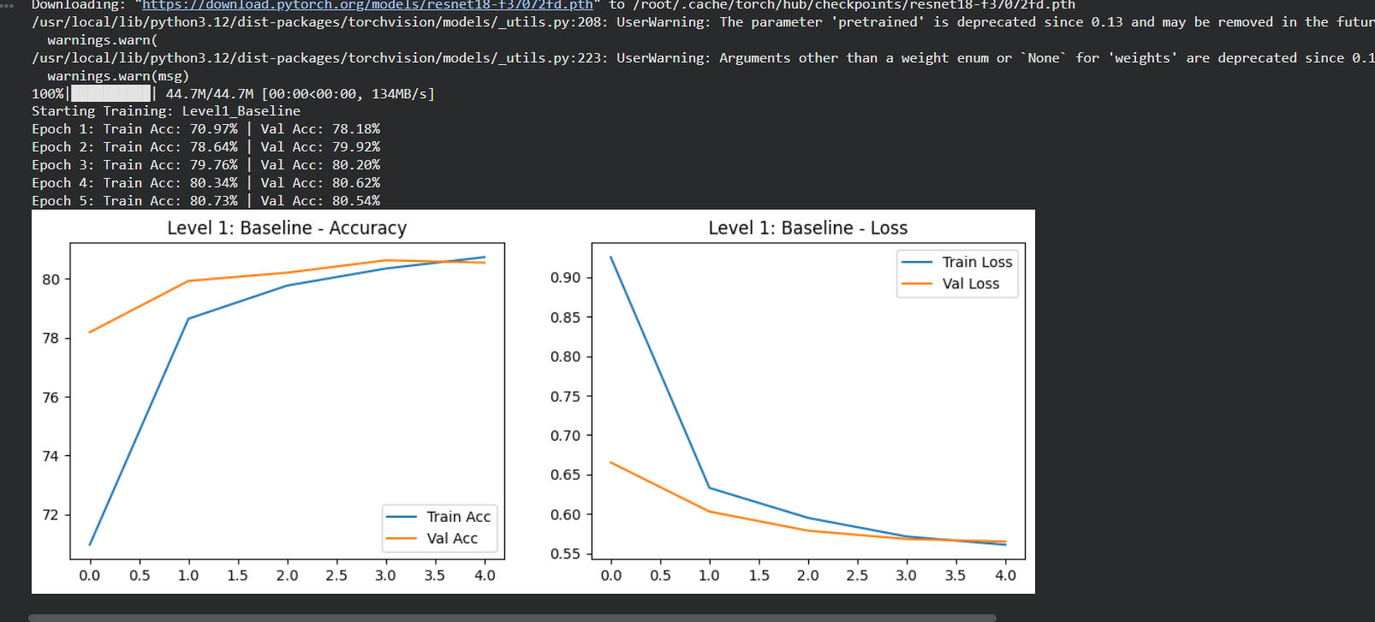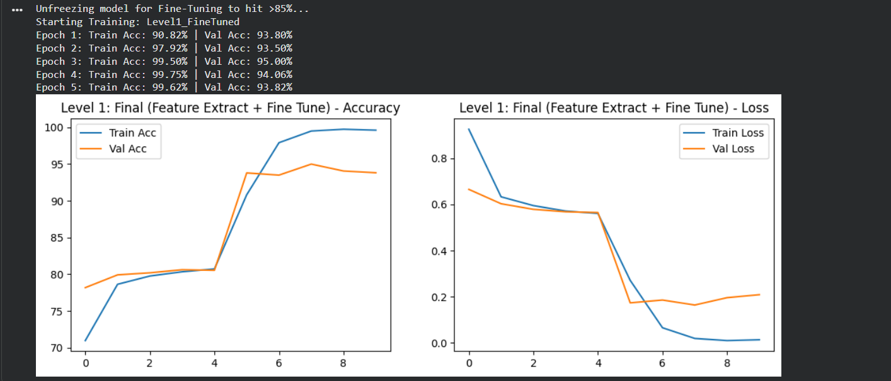

LEVEL 2 -:
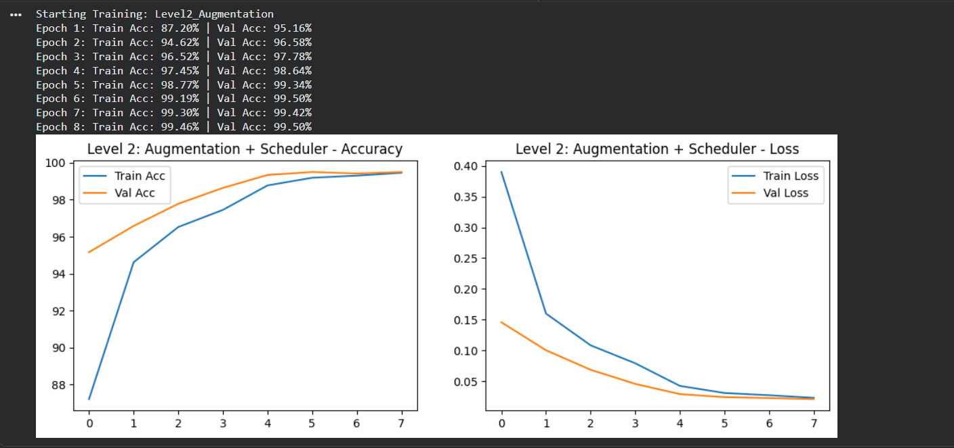

LEVEL 3-:
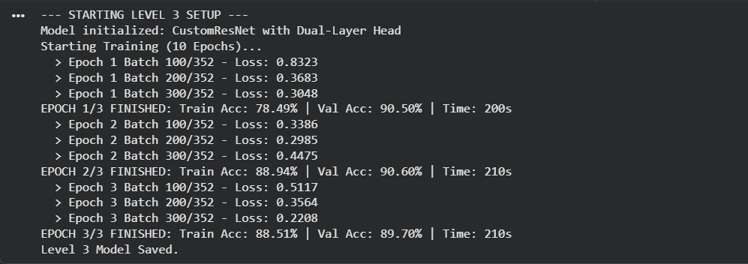

LEVEL 4-:
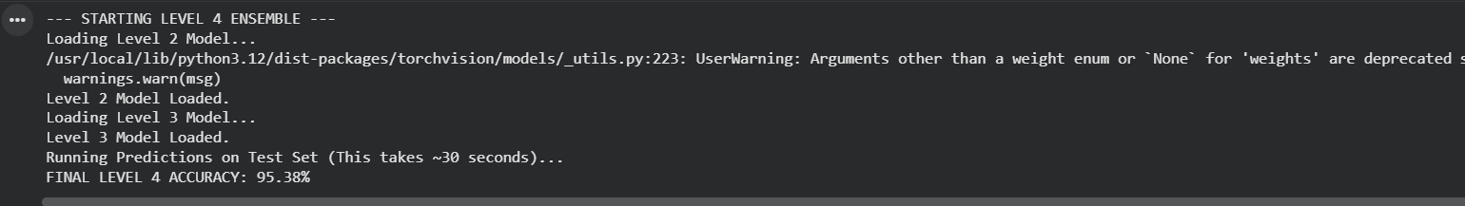

VIZUALIZATION-:
