Ceramsite Recovery from Dewatered Sludge
Techno-Economic Feasibility Study: Rotary Kiln Sintering of Municipal Sludge and MSWI Fly Ash for Ceramsite Production vs. Biogas Generation
Innovative Bioprocesses for Wastewater/Waste Valorization | ISAH, Leibniz Universität Hannover | July 2022
Course / Module | Innovative Bioprocesses for Wastewater/Waste Valorization
Institution | Institut für Siedlungswasserwirtschaft und Abfalltechnik (ISAH), Leibniz Universität Hannover
Submission Date | 21 July 2022
Supervisors | Prof. Dr.-Ing. Regina Nogueira; Varian Arif
Team Members | Kabir Kundapur Sheik (10050735)
Tools & Software | STAN (Substance Flow Analysis), Excel, Cost modelling (Hamid et al. 2021; Ruiz et al. 2018)
Focus Material | Municipal sludge (sewage sludge + MSWI fly ash) — sintered ceramsite production
Comparator Process | Conventional biogas (anaerobic digestion) plant — techno-economic benchmark

1. PROJECT OVERVIEW

This study investigates the technical feasibility and economic viability of producing ceramsite — a lightweight, porous, high-strength aggregate — from municipal sewage sludge combined with municipal solid waste incineration (MSWI) fly ash, using a rotary kiln sintering process. The work was conducted as part of the Innovative Bioprocesses for Wastewater/Waste Valorization module at Leibniz Universität Hannover's Institut für Siedlungswasserwirtschaft und Abfalltechnik (ISAH).

The core problem addressed is the growing volume of municipal sludge generated by wastewater treatment plants globally — and specifically in rapidly urbanising China, where 215.2 million tonnes of municipal solid waste were generated in 2017 alone, with 40% incinerated, producing approximately 300,000 tonnes of fly ash annually. Both sewage sludge and MSWI fly ash are problematic waste streams: the former contains heavy metals that limit conventional reuse pathways (anaerobic digestion, composting, land application), and the latter is classified as hazardous waste in China due to high heavy metal and dioxin content.

The study demonstrates that sintering a blended feedstock of sewage sludge and MSWI fly ash at 1,080°C for 8 minutes in a rotary kiln produces sludge ceramsite with comparable properties to conventional clay ceramsite — lightweight, waterproof, hard, and non-toxic — while simultaneously immobilising heavy metals within the ceramic matrix and rendering fly ash non-hazardous. A STAN mass flow model was developed to visualise the full process, and a detailed cost analysis was conducted to benchmark ceramsite production economics against a conventional biogas (anaerobic digestion) plant.

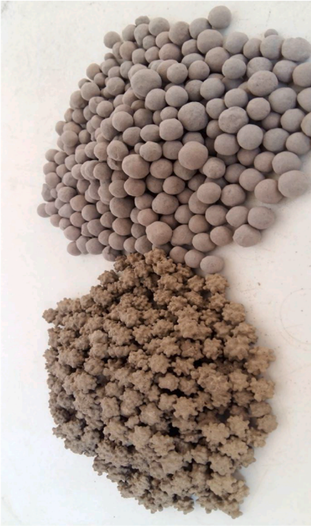
📷 Figure 1 — Ceramsite product comparison: sludge ceramsite (left, irregular granules) vs. clay ceramsite (right, smooth spheres)
Source: 3_SC_Presentation.pdf — Page 2 (Slide 2: content slide with ceramsite photo) / Report p. 2 (Figure 1, Wang et al. 2021)

2. OBJECTIVES

- Evaluate the chemical and physical suitability of municipal sewage sludge and MSWI fly ash as raw materials for ceramsite production, by comparing their elemental composition against Riley's (1950) criteria for lightweight aggregate formation.
- Develop a complete 5-stage production methodology (dewatering → drying → batching → sintering/curing → dust disposal) for sludge ceramsite and model the full mass flow using STAN substance flow analysis software.
- Conduct a techno-economic cost analysis of the ceramsite production unit, benchmarked against a conventional biogas (thermophilic anaerobic digestion) plant, covering capital investment, operating costs, revenue, and net profit per tonne.
- Assess environmental implications and identify key limitations — including bio-filter performance, heavy metal stabilisation completeness, and flue gas treatment requirements — and align the study with relevant UN Sustainable Development Goals (SDG 6, 8, 9, 11, 13, 14, 15, 17).

3. METHODOLOGY

3.1 Raw Material Characterisation
The chemical composition of dried sewage sludge, MSWI fly ash, and reference clay was determined by X-ray fluorescence spectrometry (Shimadzu Lab Center XRF-1700). Results were compared against Riley's (1950) criteria for lightweight aggregate production — the raw material must approximate clay chemistry to achieve the expansion and bloating needed for ceramsite formation. The optimal bulk ratio of sewage sludge to MSWI fly ash was determined to be 8:2, compensating for the lower SiO₂ and Al₂O₃ content of sludge relative to clay requirements.

Chemical composition of the three raw materials (% dry weight basis):

Material | SiO₂ (%) | Al₂O₃ (%) | Fe₂O₃ (%) | MgO (%) | CaO (%) | K₂O (%) | Na₂O (%)
Sewage Sludge | 15.6 | 4.5 | 5.3 | 1.2 | 19.8 | 0.8 | —
MSWI Fly Ash | 37.8 | 15.5 | 1.3 | 2.7 | 20.6 | 0.4 | —
Clay | 71.5 | 14.93 | 6.72 | 3.7 | 0.67 | 0.21 | 1.86
Riley (1950) range | 48–70 | 8–25 | 3–12 | 1–12 | — | 0.5–7 | 0.5–7

The table confirms that neither sewage sludge nor MSWI fly ash individually meets the Riley criteria — particularly for SiO₂ (48–70%) and Al₂O₃ (8–25%). Blending at an 8:2 sludge-to-fly-ash ratio brings the combined feedstock within acceptable range, providing the material basis for the production process.

3.2 Production Process — Five Stages
The ceramsite production process comprises five sequential stages, each modelled in the STAN mass flow framework:

- Stage 1 — Sludge Dewatering: Raw municipal sludge (93–99% water content) is dewatered using centrifugation, filter presses, or belt presses to achieve a manageable solid content. The STAN model shows 3,950 tonnes/year input of municipal sludge, with 3,239 tonnes of water removed as an output stream, leaving 711 tonnes of dewatered sludge (Flow 14).
- Stage 2 — Sludge Drying: The dewatered sludge undergoes thermal drying (paddle drying, solar drying, or natural air drying) to reduce moisture content to approximately 10–15% (total drying) or 40–50% (semi-drying). Natural air drying is the most economical method. The STAN model shows an additional 71 tonnes of water evaporated during drying, producing 640 tonnes of dried sludge (Flow 13).
- Stage 3 — Batching and Granulation: Dried sludge is blended with 160 tonnes of MSWI fly ash and 200 tonnes of sintering aids, along with a small release agent (4 tonnes) input, in granulation equipment to produce 1,000 tonnes of ceramsite blanks at the required particle size and composition for sintering.
- Stage 4 — Sintering and Curing: The ceramsite blanks enter a rotary kiln where pyrolysis and sintering occur at 1,080°C for 8 minutes, followed by steam curing to achieve optimal strength. This stage consumes 50 tonnes of coal powder and produces 839.84 tonnes of Flow 9 product, along with 138.16 tonnes of exhaust gas and 72 tonnes of dust. Heavy metals including Cd, Cr, Cu, and Pb are effectively immobilised in the ceramic matrix above 1,000°C.
- Stage 5 — Dust Disposal: The 72 tonnes of sintering dust are processed with 50.4 tonnes of fresh water and 72 tonnes of curing agent, with 0.04 tonnes of diesel input, to produce 194.4 tonnes of residual output. In Life Cycle Assessment terms, key emission contributors in the sintering scenario are transportation (34.2%), electricity (29.5%), and the curing agent in dust disposal (25.0%).

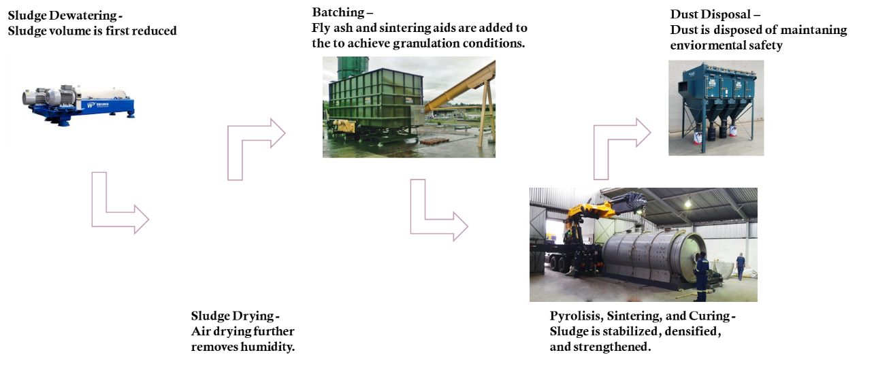

📷 Figure 2 — Methodology overview: Five-stage process flow (Dewatering → Drying → Batching → Sintering/Curing → Dust Disposal) with process equipment photographs
Source: 3_SC_Presentation.pdf — Page 6 (Slide 6: Methodology slide with equipment photos)

3.3 STAN Mass Flow Model
A complete substance flow analysis was developed in STAN software to quantify all input, output, and internal flow streams across the five process stages. The model captures the full mass balance from 3,950 tonnes/year of raw municipal sludge input through to 194.4 tonnes of residual output after dust disposal, providing a transparent and auditable process accounting framework.

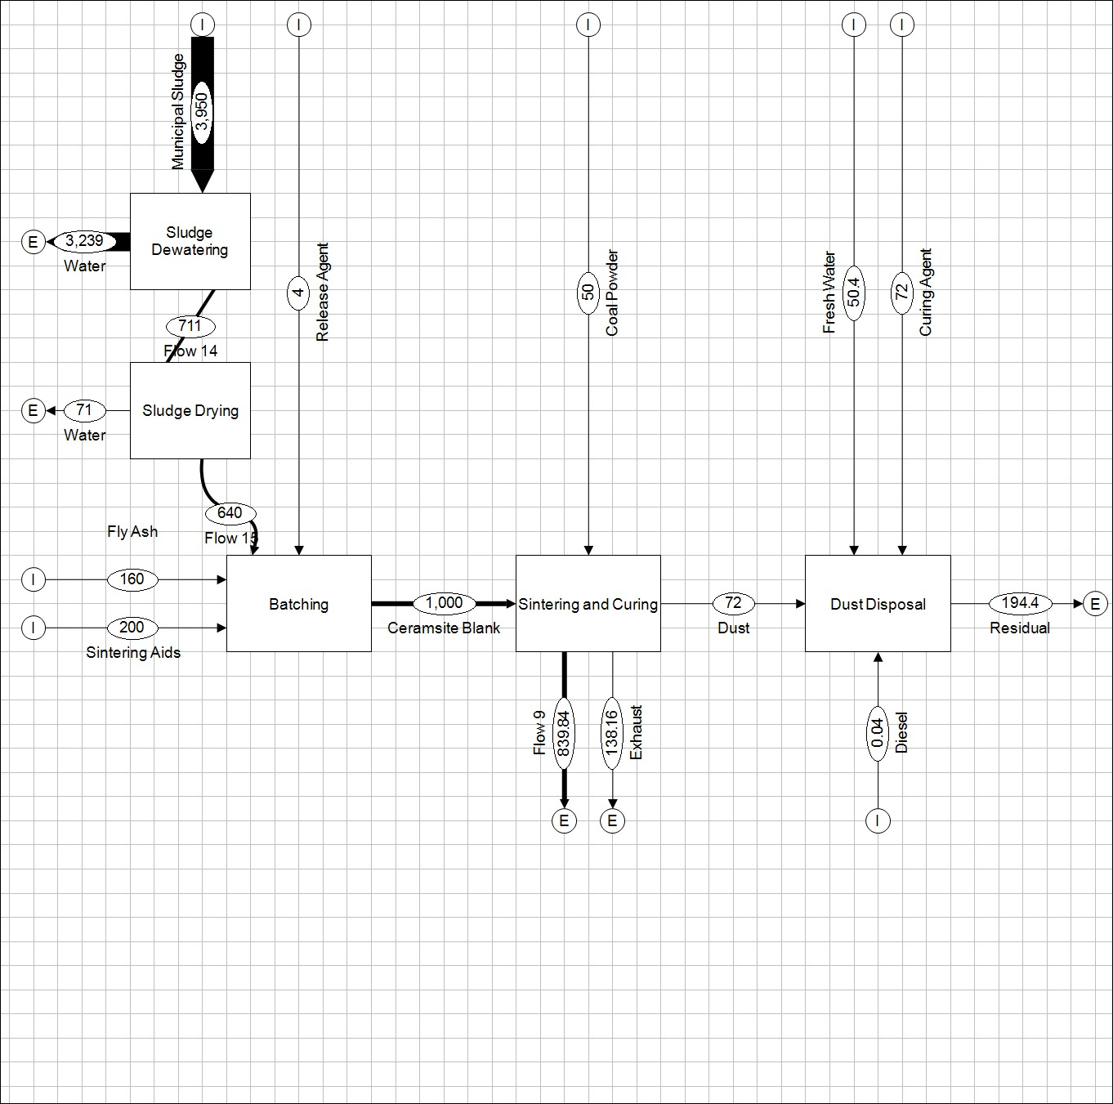
📷 Figure 3 — STAN mass flow model: Complete process diagram showing all material flows (tonnes/year) across all five stages — Sludge Dewatering, Sludge Drying, Batching, Sintering and Curing, and Dust Disposal
Source: 3_SC_Presentation.pdf — Page 7 (Slide 7: full STAN model diagram) / Report p. 7 (Figure 7)


📷 Figure 4 — STAN sub-process detail: Dewatering and Drying stages (municipal sludge 3,950 t → water out 3,239 t → Flow 14: 711 t → drying water out 71 t → Flow 13: 640 t)
Source: 3_SC_Presentation.pdf — Page 8 (Slide 8: dewatering and drying STAN detail)


📷 Figure 5 — STAN sub-process detail: Sintering/Curing and Dust Disposal stages (1,000 t ceramsite blank → sintering → 72 t dust → dust disposal → 194.4 t residual)
Source: 3_SC_Presentation.pdf — Pages 10–11 (Slides 10 and 11: sintering/curing and dust disposal STAN details)

4. KEY FINDINGS

4.1 Techno-Economic Cost Analysis
A comprehensive cost analysis was conducted for two sludge valorisation pathways: the ceramsite production unit (sintering) and a conventional biogas production unit (thermophilic anaerobic digestion). Cost structures were derived from Hamid et al. (2021) for ceramsite economics and Ruiz et al. (2018) for biogas economics. Key economic parameters are compared below:

Economic Parameter | Ceramsite Production Unit | Biogas Production Unit
Annual load capacity (tonnes/year) | 14,000 | 26,000
Total capital investment (€) | 482,928 | 2,904,140 (USD) ≈ 2.9M €
Investment cost per tonne (€/t) | 34.49 | 111.70
Annual O&M cost (€/year) | 540,880 | 239,960
Production / operation cost per tonne (€/t) | 93.63 (production + O&M) | —
Average selling price (€/t) | 96.00 | —
Annual revenue + waste income (€/year) | — | 617,852
Annual profit (€/year) | ~33,180 (net) | 377,892
Net profit per tonne (€/t) | 2.37 | 14.53
Capital investment comparison | ~4× cheaper than biogas | ~4× more expensive than ceramsite
Profitability comparison | 6× less profitable than biogas | 6× more profitable than ceramsite

The analysis reveals a clear trade-off: the ceramsite production unit requires approximately 4 times less capital investment per tonne than the biogas unit (€34.49 vs. €111.70 per tonne), making it highly accessible for lower-capital contexts. However, biogas production is approximately 6 times more profitable per tonne (€14.53 vs. €2.37 net profit per tonne), driven by the combination of electricity revenue, waste management income, and stronger market demand for renewable energy relative to ceramsite aggregate.

The ceramsite market price analysis, based on five major Chinese manufacturers, shows an average selling price of approximately €96/tonne, against a total production and operation cost of €93.63/tonne — a thin margin that is sensitive to energy costs, logistics, and market conditions. Biogas production benefits from government subsidies, feed-in tariffs for renewable electricity, and favourable policy environments in many countries, structural advantages not available to ceramsite producers.

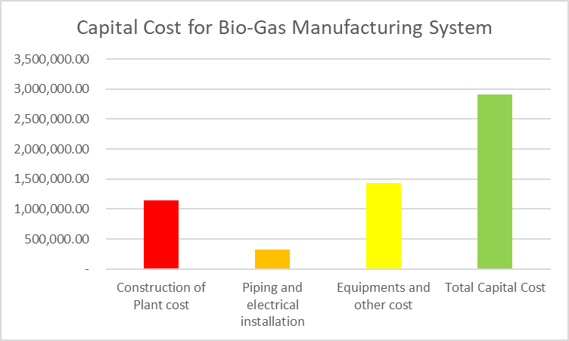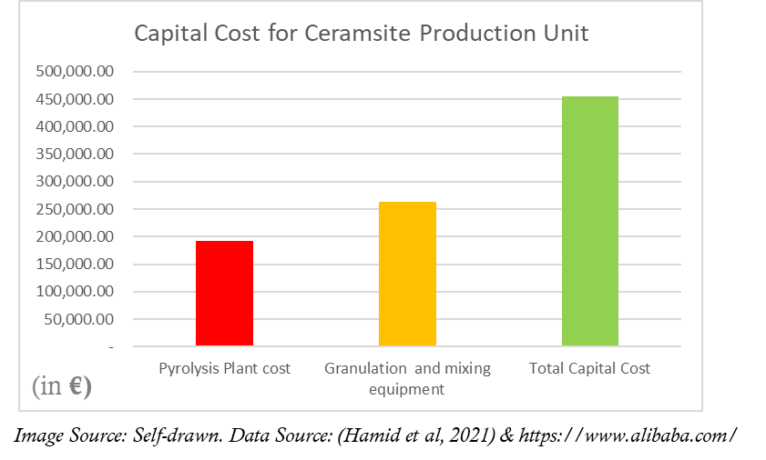
📷 Figure 6 — Capital cost breakdown charts: Ceramsite production unit (Pyrolysis plant + Granulation equipment) vs. Biogas manufacturing system (Construction + Piping + Equipment)
Source: 3_SC_Presentation.pdf — Pages 12–13 (Slides 12 and 13: capital cost bar charts for both systems)

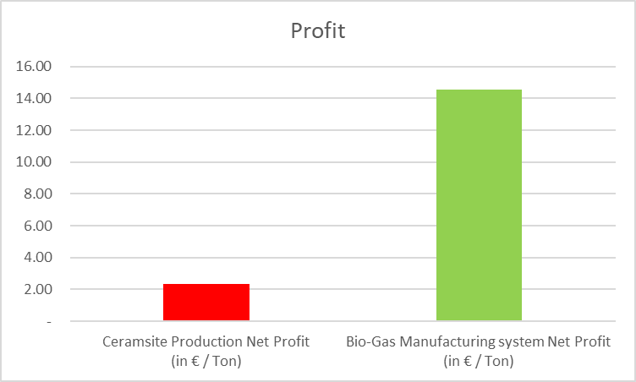
📷 Figure 7 — Profit comparison chart: Net profit per tonne (€/t) — Ceramsite (€2.37) vs. Biogas (€14.53) — showing 6× profitability gap
Source: 3_SC_Presentation.pdf — Page 14 (Slide 14: overall profit comparison bar chart)

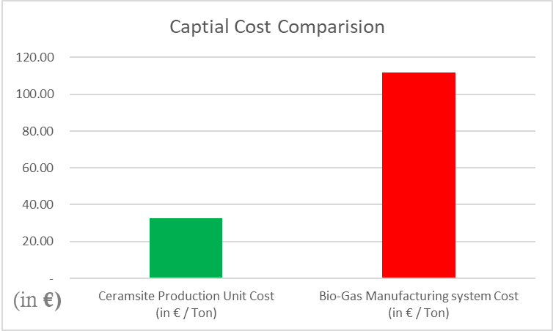
📷 Figure 8 — Capital cost comparison chart: Investment cost per tonne (€/t) — Ceramsite (~€34) vs. Biogas (~€112) — showing 4× capital cost advantage for ceramsite
Source: 3_SC_Presentation.pdf — Page 15 (Slide 15: capital cost comparison bar chart)

4.2 Applications of Sludge Ceramsite
Sludge ceramsite produced by the rotary kiln sintering process has been validated for multiple end-use applications, each leveraging its characteristic porous structure, high compressive strength, and chemical inertness:

- Bio-filter media in biological aerated filters (BAF): Ceramsite provides high specific surface area for biofilm attachment, enhancing microorganism activity and enabling continuous wastewater purification, particularly when integrated with aeration technology.
- Constructed wetland substrates: Wastewater treatment sludge ceramsite (WWTS ceramsite) demonstrates effective removal of COD, ammonia, total nitrogen, total phosphorus, and Cr(VI) in constructed wetland applications, outperforming conventional substrates in most pollutant categories.
- Construction insulation material: The lightweight, thermally stable nature of ceramsite makes it suitable as a structural insulating aggregate in construction applications.
- Soil conditioner: The porous structure enables water retention and aeration improvement in agricultural soils.

5. CONCLUSION

This study demonstrates that municipal sewage sludge combined with MSWI fly ash can be successfully converted into functional ceramsite through rotary kiln sintering, simultaneously addressing two hazardous waste streams while producing a commercially applicable material. Five conclusions emerge from the techno-economic and technical analysis.

- Material feasibility is confirmed: blending sewage sludge and MSWI fly ash at an 8:2 ratio compensates for the chemical shortfalls of each individual stream relative to Riley's lightweight aggregate criteria. The sintering at 1,080°C for 8 minutes produces ceramsite that is light, waterproof, hard, and non-toxic in property testing.
- Heavy metal immobilisation is effective: rotary kiln sintering stabilises Cd, Cr, Cu, and Pb within the ceramic matrix above 1,000°C, transforming a hazardous waste (MSWI fly ash) into a non-hazardous construction and filtration material — a genuinely circular outcome.
- The ceramsite production unit requires ~4× less capital investment per tonne than a biogas digester (€34.49 vs. €111.70/tonne), making it more accessible in lower-capital or space-constrained settings. However, its net profit of €2.37/tonne is ~6× lower than biogas (€14.53/tonne), reflecting weaker market pricing and absence of renewable energy policy support.
- Government policy and incentives are the decisive economic differentiator: biogas profitability is substantially driven by feed-in tariffs and renewable energy subsidies. Policy support specifically for ceramsite as a sustainable construction material or hazardous waste reuse technology could significantly improve its economic competitiveness.
- Key technical limitations requiring further research include: the synergistic effect of sludge ceramsite surface roughness on earthworm-based biofilters; the weaker Pb(II) adsorption performance of WWTS ceramsite compared to zeolite in constructed wetlands; and the need for robust flue gas purification systems to capture heavy metals and dioxins released during high-temperature pyrolysis.

IMAGE EXTRACTION GUIDE FOR PORTFOLIO PAGE

All recommended images with exact source locations for the Ceramsite Recovery portfolio HTML page:

# | Description | Source File | Page / Slide
1 | Sludge ceramsite vs clay ceramsite product photo | 3_SC_Presentation.pdf | p. 2 (Slide 2)
2 | Background: wastewater treatment plant aerial view | 3_SC_Presentation.pdf | p. 3 (Slide 3)
3 | Purpose diagram (5 objectives overlay on WWTP photo) | 3_SC_Presentation.pdf | p. 4 (Slide 4)
4 | Applicability of study diagram | 3_SC_Presentation.pdf | p. 5 (Slide 5)
5 | Methodology: 5-stage process with equipment photos | 3_SC_Presentation.pdf | p. 6 (Slide 6)
6 | Full STAN mass flow model diagram | 3_SC_Presentation.pdf | p. 7 (Slide 7) / Report p. 7
7 | STAN detail: Dewatering and Drying sub-process | 3_SC_Presentation.pdf | p. 8 (Slide 8)
8 | STAN detail: Batching sub-process | 3_SC_Presentation.pdf | p. 9 (Slide 9)
9 | STAN detail: Sintering/Curing + Dust Disposal | 3_SC_Presentation.pdf | pp. 10–11 (Slides 10–11)
10 | Capital cost chart — Biogas manufacturing system | 3_SC_Presentation.pdf | p. 12 (Slide 12)
11 | Capital cost chart — Ceramsite production unit | 3_SC_Presentation.pdf | p. 13 (Slide 13)
12 | Profit comparison bar chart (ceramsite vs biogas) | 3_SC_Presentation.pdf | p. 14 (Slide 14)
13 | Capital cost comparison bar chart | 3_SC_Presentation.pdf | p. 15 (Slide 15)
14 | SDG alignment slide (SDGs 6, 8, 9, 11, 13, 14, 15, 17) | 3_SC_Presentation.pdf | p. 17 (Slide 17)
15 | Sludge dewatering equipment photo | Report (text doc) | p. 4 (Figure 2)
16 | Sintering/rotary kiln equipment photo | Report (text doc) | p. 5 (Figure 5)

