DWD Seasonal Ensemble Forecast
Investigations into the DWD Seasonal Ensemble Forecast for the Weser River Basin — Flood 2023
M.Sc. Research Project | Hydrological Extremes Module | Institut für Hydrologie und Wasserwirtschaft
Institution | Institut für Hydrologie und Wasserwirtschaft, Leibniz Universität Hannover
Course / Module | Hydrological Extremes — Seminar Research Project
Submission Date | October 2024
Supervisor | Zoë Bovermann, M.Sc.
Tools & Software | Python (GeoPandas, Matplotlib, Shapely, Wetterdienst), ArcGIS Pro, Microsoft Excel
Data Sources | DWD Episodes (ICON-ALO, 50 EM), DWD Rain Gauge Network (Wetterdienst library)
Study Period | July 2023 – December 2023
Study Area | Weser River Basin, Northern Germany (47,394 km²)

1. PROJECT OVERVIEW

The winter of 2023/24 brought severe flooding to Northern Germany, with the Weser River Basin among the most heavily affected regions. This project investigates how well the Deutscher Wetterdienst (DWD) seasonal ensemble forecast system — specifically the ICON-ALO model generating 50 Ensemble Members (EM) — predicted the extreme precipitation that drove these floods.

The study spans the critical six-month window from July to December 2023, evaluating ensemble performance using four statistical skill metrics: Percentage Bias (PBias), Relative Standard Error (RSE), Mean Error (ME), and Correlation Coefficient (COR). A key research contribution is the evaluation of higher-percentile ensemble outputs (75th and 95th percentile) as early-warning tools for extreme rainfall events, demonstrating that the 95th percentile of the EM forecast was capable of signalling the December 2023 flood event up to 7 months in advance (Lead-6).

The Weser River Basin covers 47,394 km² and stretches from 50.35°N / 10.90°E in the south to 53.81°N / 8.62°E in the north, draining into the North Sea. Major cities including Hannover, Bremen, Kassel, and Bielefeld fall within the catchment. The basin's flat northern lowlands — where Hannover and Bremen are located — are particularly flood-prone.

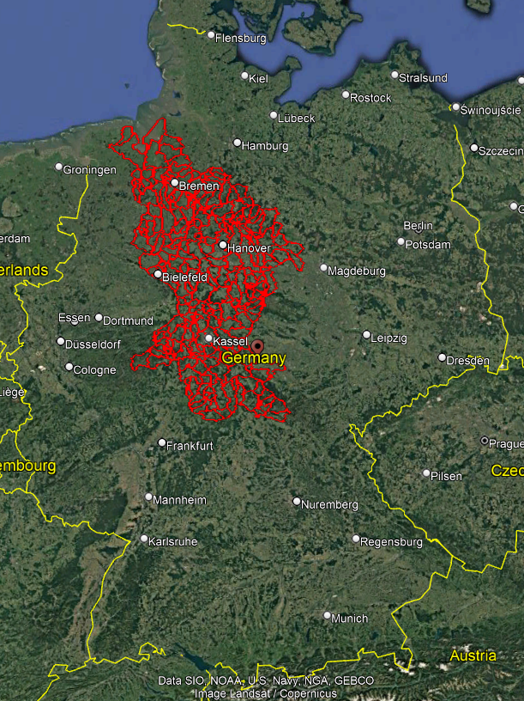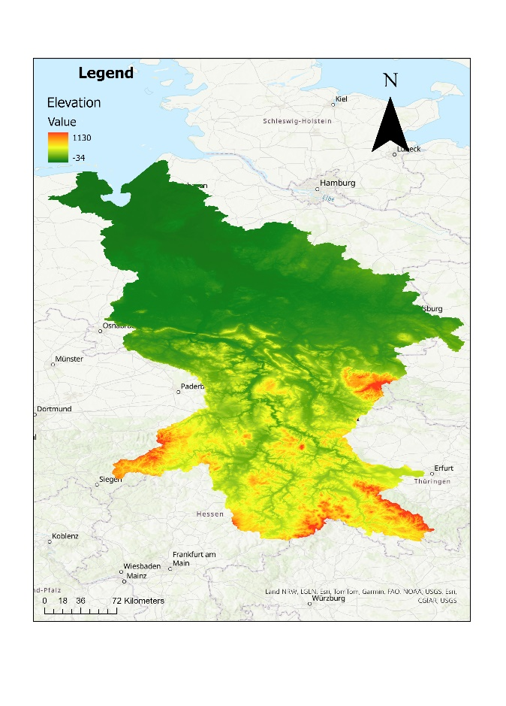
📷 Figure 1 — Study Area: Google Earth view and topographic map of the Weser River Basin
Source: 5_RP_Report.pdf — Page 9 (Figure 8: Google Map View + Topo Map side by side)

2. OBJECTIVES

The study was designed to answer four core research questions:

- When did the Weser Basin conditions become hydrologically critical during 2023?
- How accurately did the 50 DWD ensemble members predict the actual extreme rainfall event?
- Are there individual ensemble members that consistently outperform the ensemble median in forecasting extreme conditions?
- Is seasonal flood forecasting — specifically the DWD ICON-ALO system — a reliable and actionable tool for flood risk management and decision-making?

3. METHODOLOGY

3.1 Study Area and Data Collection
Ensemble forecast data was obtained from DWD Episodes via the ICON-ALO model. Each of the 50 ensemble members provides daily precipitation height for 184 days at a spatial resolution of 0.05° × 0.05° (approximately 5 km × 5 km grid cells). Ensemble members for each of the six forecast-start months (July through December 2023) were downloaded in Excel format.

Observed precipitation data was retrieved from 60 DWD rain gauge stations distributed across the Weser Basin using the Python Wetterdienst library, at daily resolution for the same six-month period.

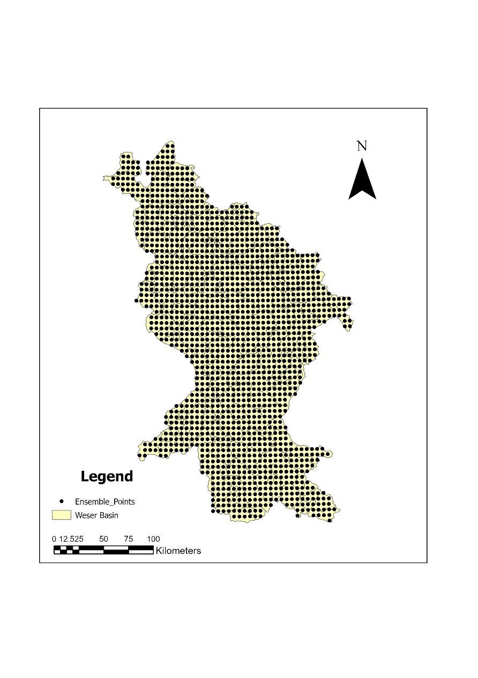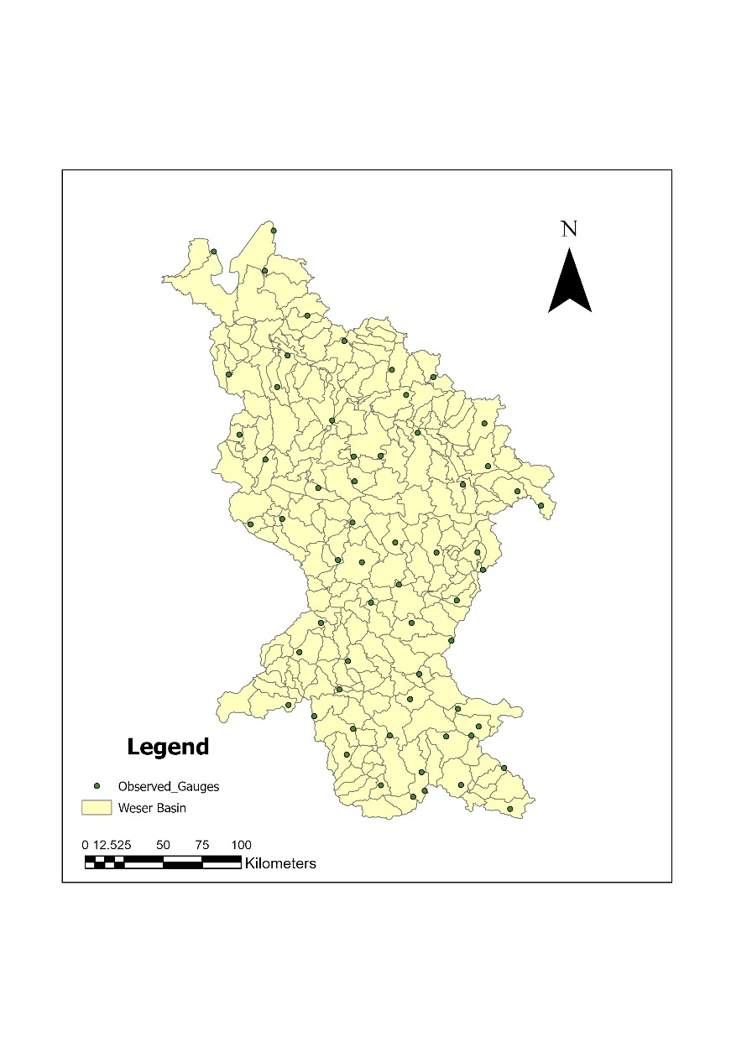
📷 Figure 2 — Data Collection: Ensemble Member grid points (5 km resolution) and observed rain gauge station locations across the Weser Basin
Source: 5_RP_Report.pdf — Page 10 (Figure 8a and 8b, side by side maps)

3.2 Spatial Interpolation of Observed Data
Because the 60 rain gauge stations are sparsely distributed relative to the ensemble grid, Voronoi polygon interpolation (conceptually equivalent to Thiessen polygons) was applied to assign observed precipitation values to each ensemble grid point. This enabled direct, spatially consistent comparison between observed and modelled precipitation across the entire basin. The workflow used GeoPandas for spatial operations, Matplotlib for visualisation, and Shapely for geometric calculations.

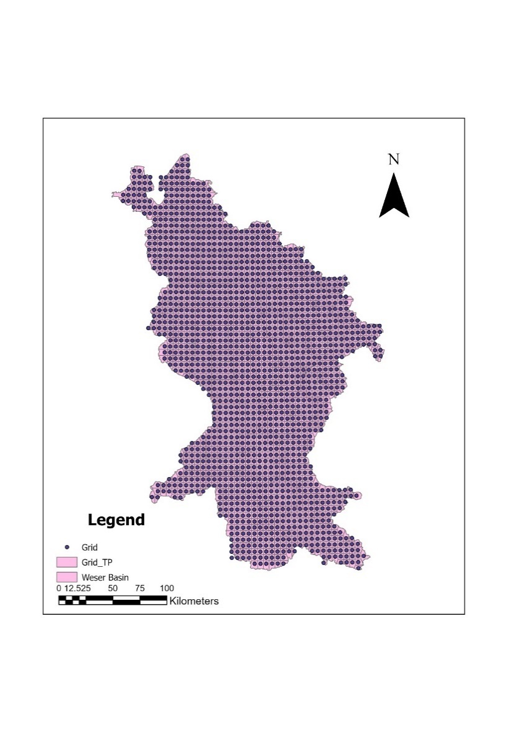
📷 Figure 3 — Spatial interpolation: Rain gauge data converted to EM grid coordinates using Voronoi polygons
Source: 5_RP_Report.pdf — Page 13 (Figure 9) and 5_RP_Presentation.pdf — Page 7 (Slide 7, Fig.6)

3.3 Observed Precipitation Patterns (July – December 2023)
Observed monthly precipitation data revealed a strongly non-uniform season. All months except September recorded well-above-average precipitation. December was the wettest month, with large parts of the catchment receiving 240–260 mm, compared to a long-term average of approximately 70 mm for Germany. September was anomalously dry, with Germany recording only 32 mm versus a long-term average of 61 mm, and the Weser Basin recording 40 mm.

This bimodal pattern — a dry September embedded within an otherwise extremely wet second half of 2023 — posed a significant challenge for ensemble forecast skill evaluation, as the models were assessed during both average-to-low and extreme precipitation conditions.

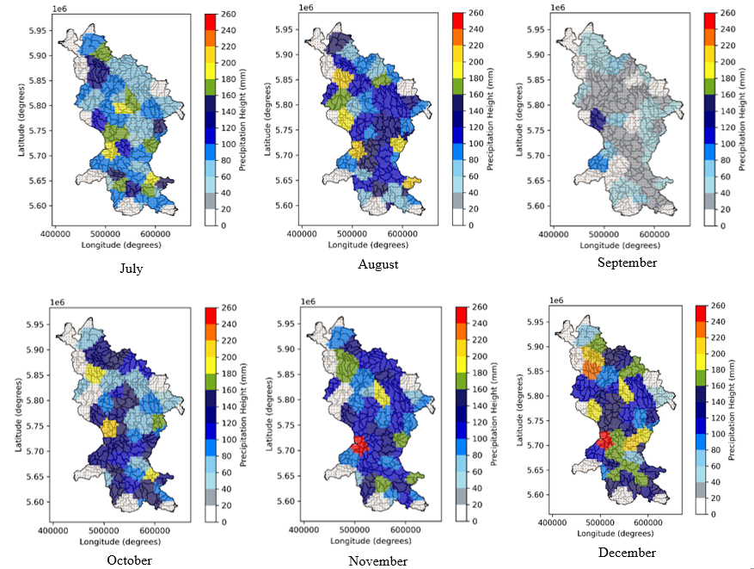
📷 Figure 4 — Observed precipitation: Spatial distribution of monthly precipitation (mm) across the Weser Basin, July–December 2023
Source: 5_RP_Report.pdf — Page 14 (Figure 11: six monthly maps, July through December)

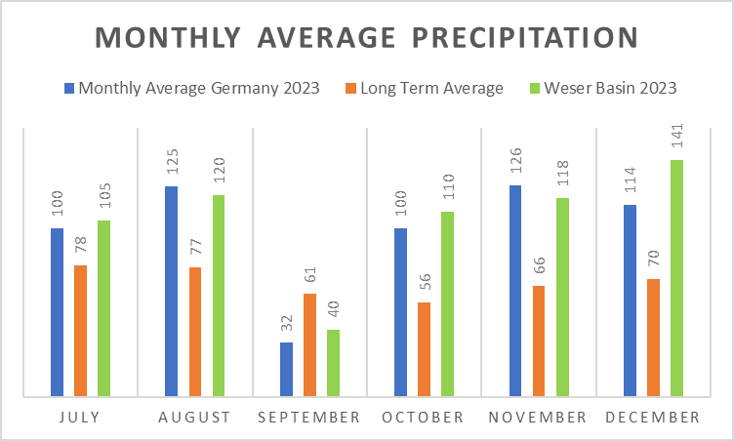
📷 Figure 5 — Monthly average precipitation comparison: Germany 2023 vs. long-term average vs. Weser Basin 2023 (bar chart)
Source: 5_RP_Report.pdf — Page 14 (Figure 12) / 5_RP_Presentation.pdf — Page 3 (Slide 3, right chart)

3.4 Skill Metrics
Four statistical metrics were selected based on prior literature (Golian et al., 2015; Dinku et al., 2007; Dollan et al., 2024) for their complementary ability to capture different aspects of forecast error:

Metric | Formula (abbreviated) | Range | Ideal Value
Percentage Bias (PBias) | Mean of (Z* − Z) / Z | −1 to +∞ | 0
Relative Standard Error (RSE) | √Σ(Z* − Z)² / Z̄ | 0 to +∞ | Near 0
Mean Error (ME) | Mean of (Z* − Z) | −∞ to +∞ | 0
Correlation Coefficient (COR) | Σ(Z*·Z) − nZ̄*Z̄ / … | −1 to +1 | +1

PBias and ME operate on monthly aggregated precipitation totals, providing a measure of overall forecast bias direction. COR was applied at daily timestep (31 daily values per month per lead), and RSE evaluated the precision of forecast spread relative to observed mean precipitation.

3.5 Ensemble Analysis Procedure
The analysis proceeded in three phases. In Phase 1, the mean of the 50 ensemble members was evaluated against observed precipitation for each month at Lead-1 using PBias, with spatial distributions plotted for each month. In Phase 2, the analysis was extended to include the 25th, 75th, and 95th percentile ensemble outputs for all months at Lead-1, to assess whether higher-percentile predictions captured the extreme events that the mean ensemble missed. In Phase 3, December was analysed in depth across all lead times (Lead-1 to Lead-6) using all four metrics for both the mean and the 95th percentile, and individual ensemble member performance (specifically EM-14, identified as the highest-frequency 95th-percentile exceedance member) was assessed against the ensemble mean and 95th percentile.

4. KEY FINDINGS

4.1 Performance of Mean Ensemble Members (Lead-1)
The mean ensemble performed adequately for months with moderate or near-average precipitation. For July (PBias = −0.32), August (−0.14), and October (+0.08), the mean ensemble members stayed within acceptable bias ranges, demonstrating reliable predictive capability for standard hydrological conditions.

September produced a severe outlier: with observed precipitation far below the long-term average, the ensemble dramatically overestimated rainfall (PBias = 1.70). This is a critical limitation for low-flow forecasting, which has direct consequences for agricultural planning and water resource management.

For the extreme-rainfall months of November (PBias = −0.40) and December (−0.51), the mean ensemble consistently underestimated actual precipitation. The mean ensemble was calibrated toward average conditions and was therefore structurally unable to capture tail-end extreme events.

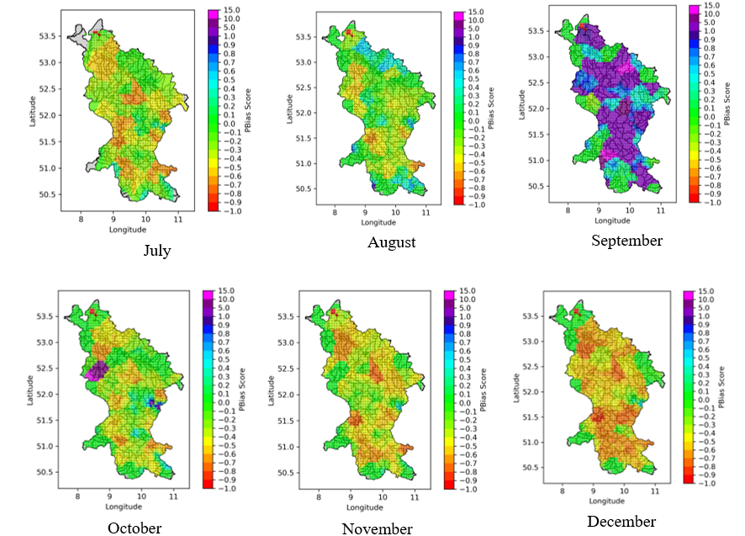
📷 Figure 6 — Mean PBias spatial maps (Lead-1): Monthly spatial distribution of PBias for the mean ensemble, July–December 2023
Source: 5_RP_Report.pdf — Page 18 (Figure 13: six spatial PBias maps) / 5_RP_Presentation.pdf — Page 10 (Slide 10)

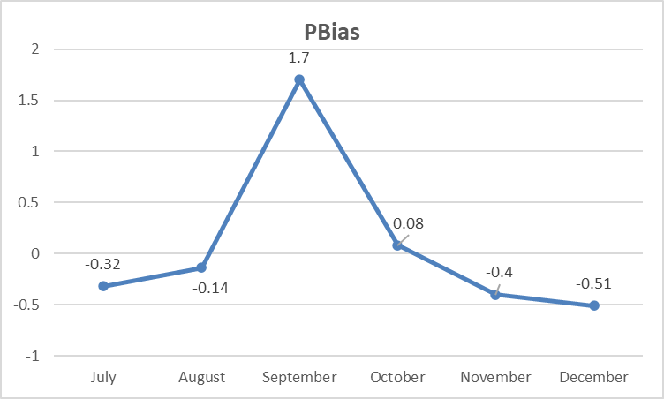
📷 Figure 7 — Mean PBias time series (Lead-1): Plot showing mean PBias values from July to December 2023
Source: 5_RP_Report.pdf — Page 19 (Figure 14: PBias line plot) / 5_RP_Presentation.pdf — Page 10 (Slide 10, right chart)

4.2 Interquartile and 95th Percentile Performance Summary
The full PBias results by percentile band across all months at Lead-1 are summarised in the table below:

Month (Lead-1) | Mean PBias | 25th Pctile | 75th Pctile | 95th Pctile
July | −0.32 | −0.55 | −0.12 | 0.20
August | −0.14 | −0.34 | 0.01 | 0.32
September | 1.70 | 0.80 | 2.51 | 3.89
October | 0.08 | −0.30 | 0.37 | 1.00
November | −0.40 | −0.62 | −0.25 | 0.03
December | −0.51 | −0.66 | −0.42 | −0.009

The 95th percentile consistently demonstrated the highest sensitivity to extreme precipitation conditions. For the critical flood months (November and December), the 95th percentile PBias values were near zero (0.03 and −0.009 respectively), indicating well-calibrated forecasts for extreme events. The 25th percentile persistently underestimated precipitation across all months, reflecting poor sensitivity to moderate-to-high rainfall conditions. The mean and 75th percentile performed best for average flow months.

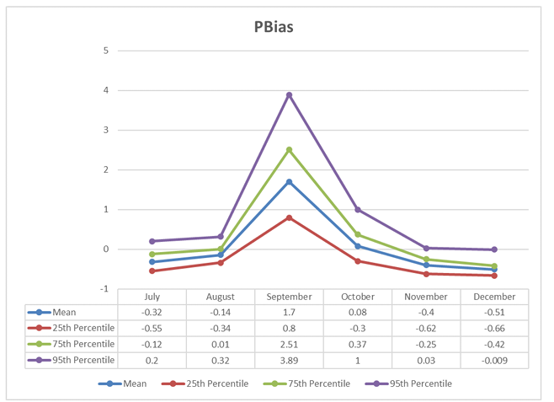
📷 Figure 8 — Interquartile PBias comparison (Lead-1): PBias for Mean, 25th, 75th, and 95th percentile across July–December 2023
Source: 5_RP_Report.pdf — Page 20 (Figure 15: multi-line PBias plot with data table) / 5_RP_Presentation.pdf — Page 11 (Slide 11)

4.3 December 2023 Flood Analysis — Lead-1 to Lead-6
December 2023 was the peak month of the flood event, with widespread precipitation of 240–260 mm across the basin. The 95th percentile analysis across Lead-1 to Lead-6 revealed a remarkable result: Lead-6 (forecast issued 7 months before December) achieved a near-zero PBias of −0.09, essentially an accurate prediction of the extreme rainfall magnitude. Lead-5 achieved a positive PBias of +0.16 (slight overestimate), while Leads 2–4 showed modest underestimation (around −0.08 to −0.20).

Correlation analysis at daily timestep showed uniformly low values (approaching zero) for both the mean and 95th percentile across all leads. This reflects the fundamental challenge of predicting exact day-by-day rainfall sequencing months in advance — seasonal forecasts capture magnitude and climatological tendency, not deterministic daily sequences.

The Mean Error analysis for December showed that the 95th percentile consistently outperformed the mean. For the mean ensemble, ME ranged from −79.8 mm (Lead-1) to −95.7 mm (Lead-2), indicating massive underestimation. The 95th percentile ME was substantially better, with Lead-3 achieving a positive ME of +3.5 mm and Lead-5 achieving −2.6 mm — errors close to zero relative to the observed ~141 mm basin-average precipitation.

RSE analysis confirmed these findings: the mean ensemble RSE ranged from 0.37 to 0.63 (high relative error), while the 95th percentile RSE was consistently lower at 0.20–0.34, indicating better precision relative to observed magnitude.

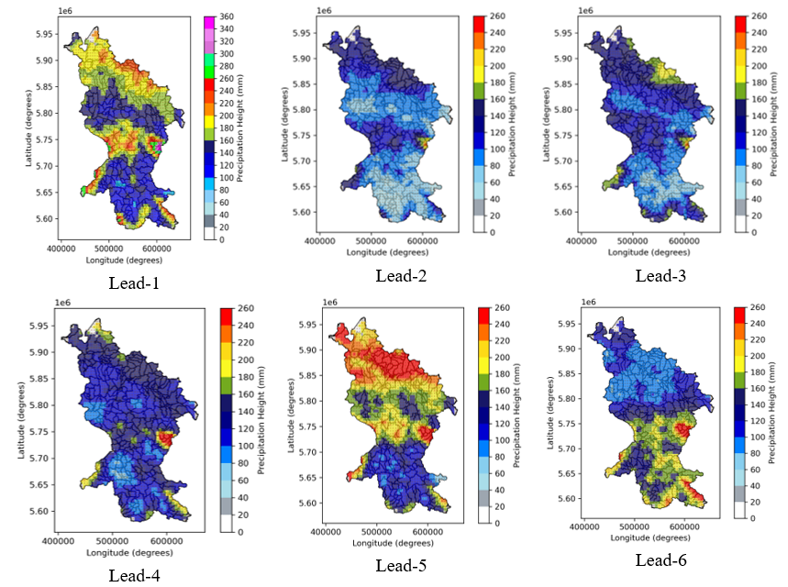
📷 Figure 9 — December 95th percentile spatial maps (Lead-1 to Lead-6): Spatial distribution of precipitation for the 95th percentile across all lead months
Source: 5_RP_Report.pdf — Page 22 (Figure 17: six lead-time spatial maps)

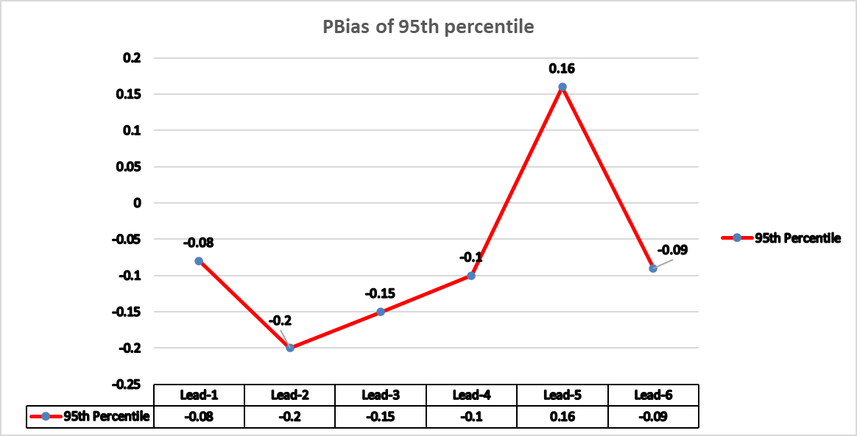
📷 Figure 10 — December PBias by lead time: Average PBias across the Weser catchment for the 95th percentile of EM for Lead-1 through Lead-6
Source: 5_RP_Report.pdf — Page 22 (Figure 17a: line chart with data table) / 5_RP_Presentation.pdf — Page 12 (Slide 12, right chart)

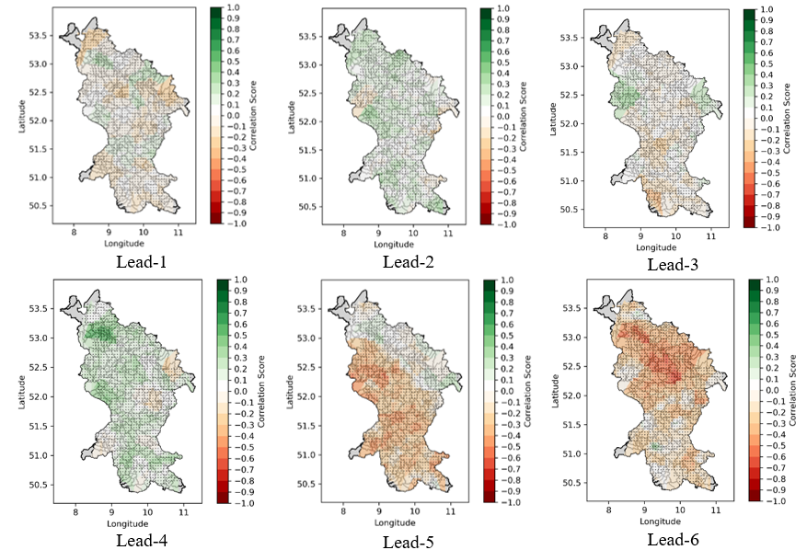
📷 Figure 11 — December Mean Error and RSE: Comparison of Mean Error (left) and Relative Standard Error (right) for Mean EM vs. 95th percentile across Lead-1 to Lead-6
Source: 5_RP_Report.pdf — Pages 25–26 (Figure 21 and Figure 22)

4.4 Individual Ensemble Member Analysis (EM-14)
EM-14 was identified as the individual member with the highest frequency of 95th-percentile exceedances. For December Lead-1, EM-14 achieved a PBias of +0.31, which while positive (slight overestimation), was significantly better than the mean ensemble PBias of −0.51. The 95th percentile achieved the best PBias at −0.009. In terms of ME, EM-14 recorded a positive mean error of +21.84 mm, contrasting with the mean ensemble's −79.75 mm and the 95th percentile's −26.19 mm. RSE for EM-14 was 0.31, intermediate between the mean (0.35) and 95th percentile (0.37). Correlation for all three was near zero, consistent with the daily-resolution findings.

These results demonstrate that select individual ensemble members can provide valuable early-warning signals for extreme events, complementing the statistical ensemble approaches. They highlight a potential operational strategy: monitoring the distribution of individual member predictions alongside the 95th percentile ensemble statistic.

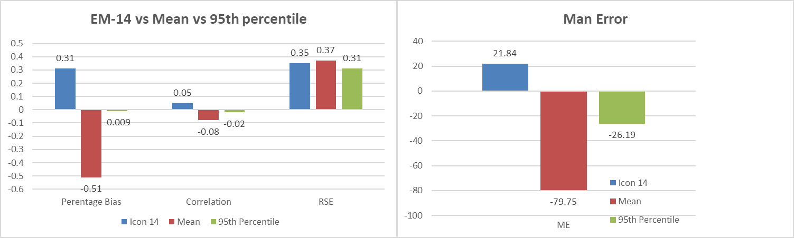
📷 Figure 12 — EM-14 performance comparison: Bar chart comparing EM-14 vs. Mean vs. 95th percentile for PBias, COR, RSE, and Mean Error for December Lead-1
Source: 5_RP_Report.pdf — Page 27 (Figure 23) / 5_RP_Presentation.pdf — Page 15 (Slide 15)
5. Implications for Flood Management Decision-Making
The ensemble skill results carry concrete operational implications across three planning horizons.
At Lead-1 to Lead-2, the 95th percentile provides reliable advance warning of above-normal precipitation. A practical decision rule: if the 95th percentile forecast for a given month exceeds 130% of the Weser Basin long-term monthly average, elevate flood preparedness to enhanced monitoring. Applied to November 2023, this would have triggered riverbank inspection, preliminary dyke reinforcement, equipment pre-positioning, and community alerts at least four weeks before the December flood peak. For average months, the mean ensemble remains a useful minimum-scenario baseline, while the 95th percentile should be treated as the high-impact scenario — the asymmetry of flood consequences strongly favours this conservative framing.
At Lead-3 to Lead-6, the persistence of 95th percentile skill is operationally transformative. A PBias of +0.16 at Lead-5 and −0.09 at Lead-6 means a forecaster examining the July 2023 ensemble run had a statistically valid basis for anticipating an extreme December — six to seven months ahead. This horizon is sufficient to commission emergency reservoir drawdown, accelerate dyke maintenance, pre-negotiate upstream water release agreements, and initiate community preparedness campaigns. The Weser Basin has significantly fewer large dams than other major German river basins, and this infrastructure deficit directly amplifies flood risk in the northern lowlands. Long-lead ensemble warnings provide precisely the planning horizon needed to activate emergency reservoir operations where capacity exists.
For the longer term, the 2023 event makes a compelling case for structural resilience investment: widening and deepening of the lower Weser channel, construction of polderised retention basins on the floodplain, earthen embankments at high-risk reaches, and expanded reservoir storage in the Hessian uplands and Thuringian Forest headwaters. Studies on analogous catchments have demonstrated flood risk reductions of 31–45% attributable to reservoir operations and river network connectivity improvements — comparable outcomes are achievable in the Weser catchment with sufficient advance planning enabled by ensemble early warning.
Three operational caveats apply: (1) the 95th percentile overestimates precipitation in anomalously dry months — triggers should be conditioned on antecedent catchment water balance; (2) seasonal ensembles are monthly-scale probability tools, not day-by-day forecasts — operational frameworks must hand off to short-range NWP models as lead time decreases to days; (3) monitoring individual ensemble member plumes (as shown by EM-14) provides supplementary information not captured by aggregate statistics alone.

6. CONCLUSION

- This study evaluated the predictive skill of the DWD ICON-ALO seasonal ensemble for the Weser River Basin, with particular focus on the extreme flooding of December 2023. Eight principal conclusions emerge.
- The ensemble mean adequately captures average precipitation months (July, August, October) but systematically underestimates extreme events, reaching PBias −0.51 for December at Lead-1 — it cannot serve as a standalone flood warning tool for upper-tail conditions. The 95th percentile substantially outperforms the mean for extreme months, achieving near-zero PBias for November and December, and represents the most operationally useful summary statistic for flood risk assessment.
- Most significantly, the 95th percentile maintains useful skill across all six lead times for December, including PBias −0.09 at Lead-6 — effectively a seven-month advance signal of the flood event. Daily COR values near zero across all leads are an inherent structural feature of seasonal forecasting, not a model deficiency, and should not be used as a primary verification metric. Individual member EM-14 outperformed the ensemble mean in PBias and ME for December, confirming the supplementary value of full-plume monitoring alongside aggregate statistics.
- Anomalously dry months such as September 2023 expose the 95th percentile's key structural vulnerability: extreme overestimation when antecedent conditions are below average. Operational application must therefore always be conditioned on the catchment water balance context.
- For decision-makers, a formalised monthly monitoring protocol based on the 95th percentile of the DWD seasonal ensemble — with defined action thresholds at each lead time linked to specific infrastructure responses — would substantially improve flood preparedness in the Weser catchment and analogous mid-latitude basins. Long-term structural investment in reservoir expansion and channel improvement, informed by ensemble early warning, remains the most durable path to flood resilience in the northern Weser lowlands.
- .

IMAGE EXTRACTION GUIDE FOR PORTFOLIO PAGE

The following table summarises all recommended images and their precise source locations for use when building the portfolio HTML page:

# | Description | Source File | Page / Slide
1 | Study area — Google Earth + Topo map | 5_RP_Report.pdf | p. 9
2 | EM grid + rain gauge locations | 5_RP_Report.pdf | p. 10
3 | Voronoi interpolation (gauges → EM grid) | 5_RP_Report.pdf / Presentation | p. 13 / Slide 7
4 | Monthly spatial precipitation maps (Jul–Dec) | 5_RP_Report.pdf | p. 14
5 | Monthly avg precipitation bar chart | 5_RP_Report.pdf / Presentation | p. 14 / Slide 3
6 | Mean PBias spatial maps (Lead-1, Jul–Dec) | 5_RP_Report.pdf / Presentation | p. 18 / Slide 10
7 | Mean PBias time series (Lead-1 chart) | 5_RP_Report.pdf / Presentation | p. 19 / Slide 10
8 | IQR PBias comparison plot (all months) | 5_RP_Report.pdf / Presentation | p. 20 / Slide 11
9 | Dec 95th pctile spatial maps (Lead 1–6) | 5_RP_Report.pdf | p. 22
10 | Dec PBias by lead time (95th pctile chart) | 5_RP_Report.pdf / Presentation | p. 22 / Slide 12
11 | Dec Mean Error + RSE comparison charts | 5_RP_Report.pdf | pp. 25–26
12 | EM-14 performance bar chart + spatial maps | 5_RP_Report.pdf / Presentation | p. 27 / Slide 15

