Guarani Aquifer System — Transboundary Management
The Guarani Aquifer System (GAS): Governance Architecture, Diplomatic History, and Water Resources Management of a Transboundary Freshwater System in South America
Water Resources Management Module | IWW, Leibniz Universität Hannover | Academic Poster Presentation
Course / Module | Water Resources Management — Transboundary Aquifer Systems
Institution | Institut für Hydrologie und Wasserwirtschaft (IWW), Leibniz Universität Hannover
Format | Academic Poster Presentation
Presenter | Kabir Kundapur Sheik (Matriculation No. 10050735)
Study Object | Guarani Aquifer System (GAS) — transboundary groundwater management across Argentina, Brazil, Paraguay, Uruguay
Aquifer Area | 1,000,000 km² | Users: ~15 million people
Governance Framework | PSAG — Proyecto del Sistema Acuífero Guaraní, funded by GEF/World Bank, coordinated by OAS
Key References | Hirata et al. (2020), Environmental Science and Policy; Sindico et al. (2018), Journal of Hydrology

1. PROJECT OVERVIEW

The Guarani Aquifer System (GAS) is one of the largest freshwater aquifer systems on Earth, covering approximately 1 million km² across four South American nations: Brazil (68%), Argentina (21%), Paraguay (8%), and Uruguay (3%). Estimated to hold between 37,000 and 40,000 km³ of water, the GAS supplies approximately 15 million people and represents a critical shared resource for agriculture, industry, and domestic water supply across the Southern Cone.

This academic poster investigates the transboundary governance framework developed to manage the GAS sustainably — focusing on the Guarani Aquifer System Project (PSAG, from its Portuguese acronym Projeto Sistema Aquífero Guarani), a landmark multi-country initiative funded by the Global Environment Facility (GEF) and the World Bank, coordinated through the Organisation of American States (OAS). The poster traces the full diplomatic and institutional history of PSAG from its 2000 inception through its 2003 operational launch, analyses its multi-layered governance architecture, and evaluates the key lessons it offers for international water law and transboundary groundwater management.

The GAS represents a particularly instructive case study in transboundary water management because it combines technical complexity (deep confined and unconfined aquifer zones, cross-border recharge and discharge areas), diplomatic sensitivity (four sovereign states with different legal frameworks and resource interests), and a genuine multilateral cooperation success story — making it directly relevant to sustainable development, international water law, and groundwater governance scholarship.

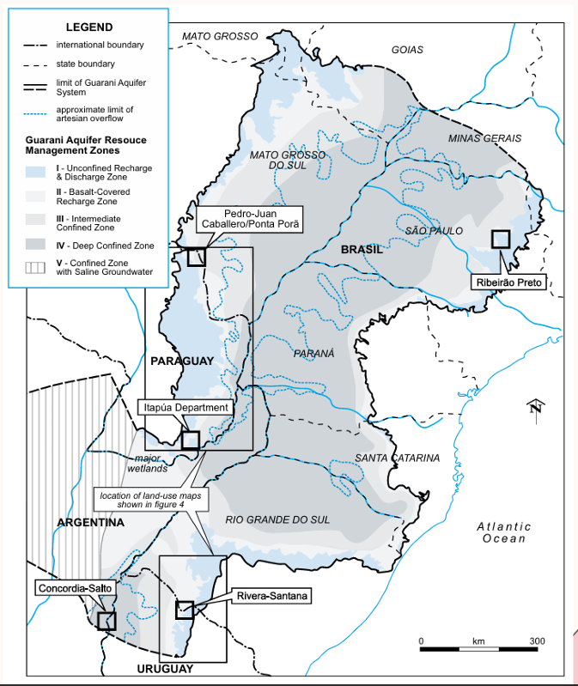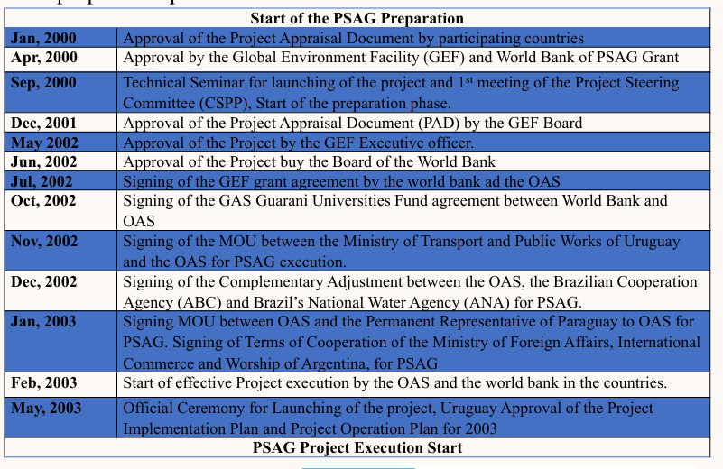
📷 Figure 1 — Full academic poster: Introduction section with GAS location map (showing Argentina, Brazil, Paraguay, Uruguay coverage) and Management section with PSAG preparation timeline table
Source: Image 1 (poster screenshot) — upper section showing Introduction + Management + beginning of Water Resources Management

2. OBJECTIVES

- Characterise the Guarani Aquifer System's physical extent, hydrogeological properties, and distribution across the four participating countries, establishing the scientific context for the governance analysis.
- Document the complete diplomatic and institutional history of the PSAG project from its preparation phase (January 2000) through formal execution launch (May 2003), identifying the key international agreements and signatories at each stage.
- Analyse the PSAG governance architecture — mapping the roles of the SPSC, OAS, GEF/World Bank, Coordination Council, Project Executive Unit, and the four National Project Executing Units — and assess how this multi-layered structure enabled cross-border coordination.
- Identify the key lessons learned from PSAG implementation, including the critical success factors and the challenges encountered in achieving technical and institutional cooperation across four sovereign states with different legal systems and water governance traditions.
- Assess PSAG's alignment with international water law principles, specifically the balance between state sovereignty over shared groundwater resources and the obligation to cooperate on sustainable management and conflict resolution.

3. CONTENT & ANALYSIS

3.1 Physical Characteristics of the Guarani Aquifer System
The GAS is a sedimentary aquifer of Triassic-Jurassic origin, formed in the Paraná and Chaco-Paraná basins. It exists as both confined (artesian, under pressure from overlying basalt formations) and unconfined zones, with recharge occurring primarily in outcrop areas in Brazil's highlands. Groundwater temperatures in artesian zones can reach 33–65°C due to geothermal gradient, making the GAS a potential geothermal energy resource in addition to a water supply. The aquifer crosses international boundaries without regard for political borders, making unilateral management both insufficient and potentially harmful — the hydrological reality that necessitates the PSAG framework.

Area coverage by country:

Country | GAS Area Share (%) | Key Role in PSAG Governance
Brazil | 68% | Largest territorial holder; host of key PSAG coordination activities; home of National Water Agency (ANA)
Argentina | 21% | Signed Terms of Cooperation through Ministry of Foreign Affairs; NPEU Argentina (AR)
Paraguay | 8% | Signed MOU via Permanent Representative to OAS; NPEU Paraguay (PY)
Uruguay | 3% | Host of official PSAG launch ceremony (May 2003); MOU via Ministry of Transport and Public Works; NPEU Uruguay (UY)

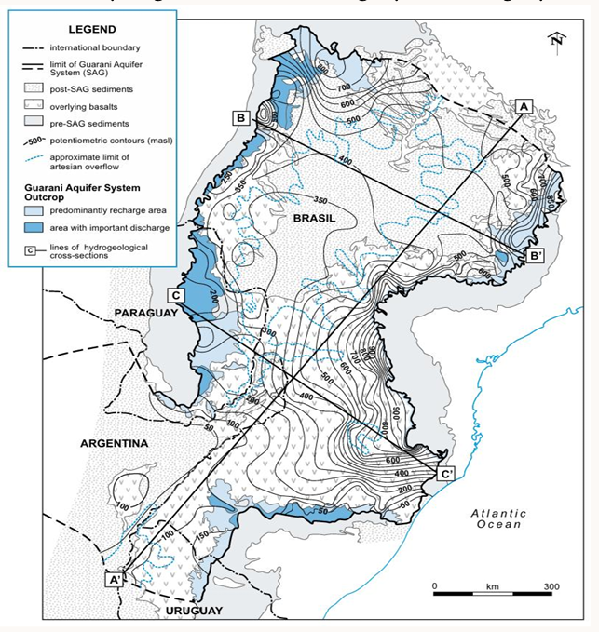
📷 Figure 2 — GAS maps: left panel showing location map with international boundaries and aquifer outcrop (pre-SAG sediments, SAG sediments, overlying basalts), and right panel showing groundwater management zones across the four-country basin
Source: Image 1 (poster screenshot) — left side: 'Guarani Aquifer System Outcrop' map with legend; right side: groundwater management zones map

3.2 PSAG Diplomatic Timeline — From Preparation to Execution
The PSAG preparation phase (2000–2003) required an extraordinary sequence of bilateral and multilateral agreements spanning international organisations, national governments, and their cooperation agencies. The timeline below documents all key milestones:

Date | Milestone
Jan 2000 | Approval of the Project Appraisal Document by the four participating countries
Apr 2000 | Approval of the PSAG Grant by the Global Environment Facility (GEF) and World Bank
Sep 2000 | Technical Seminar launching the project; 1st meeting of the Project Steering Committee (CSPP); start of preparation phase
Dec 2001 | Approval of the Project Appraisal Document (PAD) by the GEF Board
May 2002 | Approval of the Project by the GEF Executive Officer
Jun 2002 | Approval of the Project by the Board of the World Bank
Jul 2002 | Signing of the GEF Grant Agreement between the World Bank and the OAS
Oct 2002 | Signing of the GAS Guarani Universities Fund Agreement (World Bank and OAS)
Nov 2002 | Signing of MOU between the Ministry of Transport and Public Works of Uruguay and the OAS for PSAG execution
Dec 2002 | Signing of Complementary Adjustment between OAS, Brazilian Cooperation Agency (ABC), and Brazil's National Water Agency (ANA) for PSAG
Jan 2003 | Signing of MOU between OAS and the Permanent Representative of Paraguay to OAS for PSAG; Signing of Terms of Cooperation of the Ministry of Foreign Affairs, International Commerce and Worship of Argentina for PSAG
Feb 2003 | Start of effective Project execution by the OAS and the World Bank in all four countries
May 2003 | Official Ceremony for Launching of the Project, Uruguay; Approval of Project Implementation Plan and Project Operation Plan 2003 — PSAG Project Execution Start

3.3 Governance Architecture of PSAG
PSAG operates through a hierarchical but collaborative governance structure with six principal bodies, each with distinct roles and accountability relationships:

Governance Body | Role & Function | Significance
SPSC (Superior Steering Council) | Highest decision-making body; provides strategic direction and oversees major policy decisions for PSAG. | Involves ministerial-level representatives from all four countries; sets the overall governance framework
OAS (Organisation of American States) | Executing agency overseeing the project in collaboration with cooperation agencies; ensures alignment with geopolitical and environmental policies. | Provides the multilateral diplomatic umbrella enabling transboundary coordination
GEF / World Bank | Implementation Agency; manages funding and technical support; ensures project goals align with sustainable development objectives. | Provided the financial architecture (GEF grant + World Bank agreements) that made PSAG feasible
CC (Coordination Council) | Acts as coordination interface between the SPSC and the PEU, ensuring strategies are implemented effectively. | Critical 'translation layer' converting high-level policy decisions into operational guidance
PEU (Project Executive Unit) | Responsible for daily operational management of the project; implements activities as per strategic direction set by the SPSC. | Central operational hub — the report identifies PEU's critical role as a key lesson learned
NPEUs — Argentina, Brazil, Paraguay, Uruguay | National Project Executing Units in each country; implement project activities locally, adapting to national contexts and regulations; report back to PEU. | Country-level implementation ensuring national ownership and context-sensitive adaptation

This governance architecture reflects a carefully designed balance: the SPSC ensures national sovereignty is respected at the highest decision-making level, while the OAS provides the neutral multilateral platform that makes four-country coordination diplomatically feasible. The GEF/World Bank financial architecture was essential — without the grant mechanism and the credibility of international financial institutions, the project likely would not have secured the sustained political commitment required across four distinct national contexts.

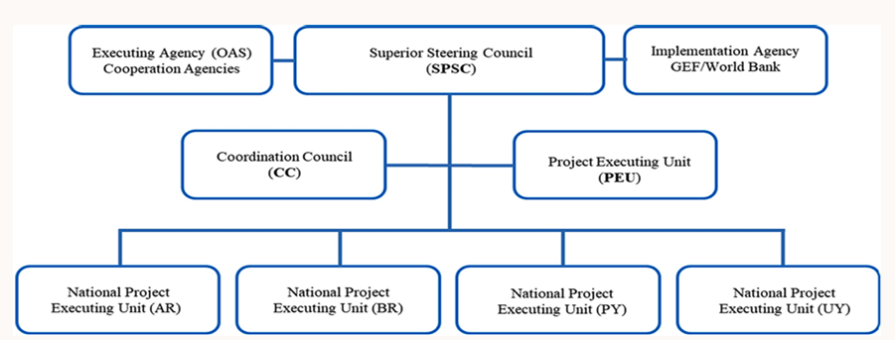
📷 Figure 3 — PSAG governance organisational chart: hierarchy diagram showing OAS (Executing Agency), SPSC, GEF/World Bank (Implementation Agency), Coordination Council (CC), Project Executive Unit (PEU), and the four National Project Executing Units (NPEUs: AR, BR, PY, UY)
Source: Image 2 (poster screenshot) — Water Resources Management section: 'Operating arrangement of the Guarani Aquifer System Project (PSAG)' organisational diagram

4. KEY FINDINGS

- Technical and institutional cooperation was achieved across four countries with significantly different legal, administrative, and political contexts. Despite diplomatic complexities and the absence of a pre-existing binding international legal instrument specific to the GAS, PSAG successfully produced joint technical assessments, shared groundwater monitoring networks, and common management domain definitions — representing a genuine multilateral achievement in transboundary water governance.
- Localized communication strategies were identified as critical: the communication and stakeholder engagement approaches that worked in Brazil's densely monitored states were often ineffective in Paraguay's or Uruguay's rural communities, requiring country-specific adaptation. This highlights the limits of purely top-down international governance frameworks when applied to geographically diverse, nationally distinct contexts.
- The Project Executive Unit (PEU) emerged as the institutional lynchpin of PSAG's success: its ability to translate strategic decisions from the SPSC into practical cross-border activities — while navigating the administrative realities of four different national bureaucracies — was identified as the single most operationally critical factor. Sustained and adequate financing of the PEU was correspondingly essential.
- Continuous financial support was identified as a structural vulnerability: the GEF/World Bank grant mechanism provided the initial foundation, but long-term sustainable management of the GAS requires embedding financial commitments into national water governance budgets and bilateral/multilateral agreements rather than relying on project-based international funding cycles.
- PSAG reflects and advances international water law principles, specifically the UN Watercourses Convention's framework of state sovereignty coupled with the duty to cooperate and avoid transboundary harm. The GAS case demonstrates that transboundary groundwater systems can be governed under a framework that respects national sovereignty while mandating operational cooperation — a model applicable to the estimated 600+ transboundary aquifers globally that currently lack any governance framework.

5. CONCLUSION

The Guarani Aquifer System Project represents one of the most comprehensive and diplomatically complex transboundary groundwater governance initiatives in history. Three conclusions stand out from the analysis.

- PSAG demonstrates that transboundary aquifer governance is feasible even across multiple sovereign states with different legal traditions, provided that: (a) a neutral multilateral coordinating body (OAS) provides the diplomatic platform; (b) international financial mechanisms (GEF/World Bank) provide the initial catalytic funding and credibility; and (c) a competent, adequately resourced Project Executive Unit handles day-to-day cross-border coordination.
- The GAS case highlights the academic community's underappreciated contribution to transboundary water management: scientific research on aquifer recharge zones, contamination risks, and groundwater flow patterns provided the shared technical knowledge base without which diplomatic cooperation would have been impossible. Sustained investment in hydrogeological science is therefore a prerequisite for effective governance of shared groundwater resources.
- International water law must evolve to explicitly address groundwater systems: PSAG operated primarily under principles designed for surface water (the UN Watercourses Convention), but transboundary aquifers have distinct characteristics — longer residence times, more diffuse recharge areas, and more complex contamination pathways — that require purpose-built legal frameworks. The 2008 ILC Draft Articles on the Law of Transboundary Aquifers, informed in part by the GAS experience, represent the first step toward such a framework, but binding implementation remains limited.

IMAGE EXTRACTION GUIDE FOR PORTFOLIO PAGE

All recommended images with exact source locations for the Guarani Aquifer portfolio HTML page:

# | Description | Source | Location
1 | Full poster overview (title + Introduction + Management) | Image 1 (screenshot) | Full poster — top half
2 | GAS location map (country boundaries + aquifer outcrop zones) | Image 1 (screenshot) | Introduction section — left side map
3 | PSAG preparation timeline table (Jan 2000 – May 2003) | Image 1 (screenshot) | Management section — right side timeline
4 | Groundwater management zones map (4-country basin detail) | Image 1 (screenshot) | Management section — lower right map
5 | Water Resources Management section + PSAG governance diagram | Image 2 (screenshot) | Upper half — governance org chart
6 | PSAG governance org chart (SPSC, OAS, GEF, CC, PEU, NPEUs) | Image 2 (screenshot) | Water Resources Management — centre diagram
7 | Conclusion section (3 bullets) | Image 2 (screenshot) | Lower half — Conclusion panel

