HDPE Recycling in the Circular Economy
Material Flows, Recycling Technologies, and Circular Economy Pathways for High-Density Polyethylene in the EU
Recycling and Circular Economy Module | ISAH, Leibniz Universität Hannover | 2022/2023
Course / Module | Recycling and Circular Economy
Institution | Institut für Siedlungswasserwirtschaft und Abfalltechnik (ISAH), Leibniz Universität Hannover
Academic Year | 2022/2023
Supervisor | PD Dr.-Ing. habil. Dirk Weichgrebe
Presenter | Kabir Kundapur Sheik (Matriculation No. 10050735)
Topic | Recycling of High-Density Polyethylene (HDPE) Material in the Circular Economy
Key Data Source | Eurostat PRODCOM (2019); PlasticsEurope; European Commission Circular Economy Report
EU HDPE production (2018) | Virgin: 9.8 Mt | Recyclate: 0.7 Mt | Net imports: 0.5 Mt | Total demand: 10.5 Mt

1. PROJECT OVERVIEW

This seminar presentation, delivered as part of the Recycling and Circular Economy module at ISAH (Leibniz Universität Hannover), provides a systematic review of the High-Density Polyethylene (HDPE) material cycle — from virgin production and product use through collection, sorting, and recycling back into secondary raw materials. The analysis is grounded in EU28 production and consumption data from Eurostat PRODCOM and the European Commission's circular economy research framework.

HDPE is the most widely used thermoplastic polymer globally, valued for its exceptional strength-to-density ratio (density > 0.941 g/cm³). Its primary applications span packaging (bottles, containers, films), pipelines and geomembranes, and industrial containers. In the EU28, total HDPE demand stands at approximately 10.5 Mt/year, with virgin production of 9.8 Mt and recyclate production of just 0.7 Mt — indicating that recycled HDPE (rHDPE) accounts for less than 7% of total supply, despite Europe producing 1.2 million tonnes of rHDPE from pre- and post-consumer sources in 2018.

The presentation covers three interconnected topics: (1) the HDPE supply chain in the circular economy context; (2) the full suite of mechanical and chemical recycling technologies applied to HDPE; and (3) emerging research on radiation crosslinking as a novel pathway to upgrade recycled HDPE into higher-value applications while preventing landfill disposal.

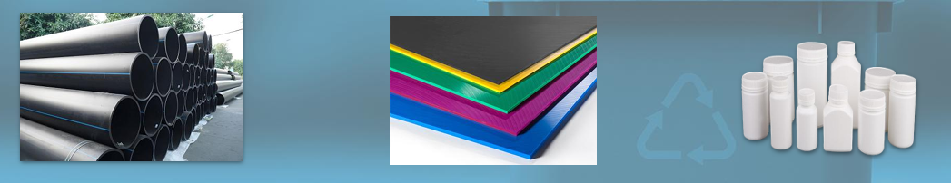
📷 Figure 1 — HDPE product applications: pipelines (black corrugated pipe), coloured sheets/geomembranes, and white HDPE containers
Source: Screenshot 1 (Image 1) — Slide 2 (Introduction): three HDPE product photographs

2. OBJECTIVES

- Map the HDPE supply chain within the EU28 circular economy framework, quantifying virgin production, recyclate production, net imports, and total demand flows using Eurostat data.
- Review and compare the key mechanical and chemical recycling technologies applied to HDPE — NIR sorting, hot washing, extrusion filtering, solvent purification, and pyrolysis — in terms of their process mechanisms, quality outcomes, and applicability.
- Evaluate radiation crosslinking (HDPEx) as an emerging research pathway for upgrading recycled HDPE, enabling its use as a filler material in virgin LDPE pipe manufacturing and thereby closing a previously unaddressed material loop.
- Identify actionable policy and market recommendations to increase HDPE collection rates, stimulate demand for rHDPE, and improve quality standards for circular economy compliance.

3. METHODOLOGY & CONTENT

3.1 HDPE Supply Chain in the EU Circular Economy
The HDPE circular economy material flow was analysed using Eurostat PRODCOM data (2019 release) covering EU28 production, exports, imports, and recyclate volumes. The supply chain encompasses six key nodes: virgin HDPE/PP production in Europe; converter demand (manufacturers using HDPE as feedstock); HDPE products in use; collection and sorting of HDPE waste arisings; rHDPE production from mechanical recycling; and reprocessing losses.

EU28 HDPE production and demand summary (Mt, primary forms):

Parameter | Virgin Production (Mt) | Recyclate Production (Mt) | Total Demand (Mt)
EU28 HDPE (2018, Mt) | 9.8 | 0.7 | 10.5
Net Imports (Mt) | 0.5 | — | —
rHDPE produced in Europe (2018) | 1.2 million tonnes | (pre + post-consumer) | —

Europe produces nearly enough virgin HDPE to meet internal demand (9.8 Mt production vs. 10.5 Mt total demand, with the 0.5 Mt gap covered by net imports). The recycled fraction remains small at 0.7 Mt recyclate production — though when including pre-consumer recyclate (0.4 Mt estimated), total rHDPE output reached 1.2 Mt in 2018. Eurostat reported net demand at 6.2 Mt, reflecting that a significant share of HDPE production is exported or goes into long-life product categories not fully captured in annual consumption figures.

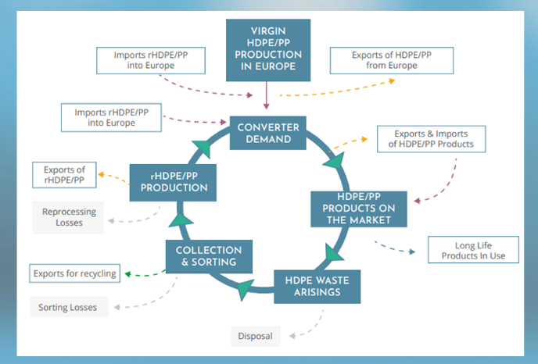
📷 Figure 2 — HDPE supply chain circular economy diagram: flow chart showing virgin production, converter demand, products in use, collection/sorting, rHDPE production, and reprocessing losses — with import/export flows
Source: Screenshot 2 (Image 2) — Slide 3 (HDPE Supply Chain): circular economy flow diagram

3.2 Recycling Technologies for HDPE
A comprehensive review of HDPE recycling technologies identifies six principal methods operating across the mechanical and chemical recycling spectrum:

Recycling Method | Process Description | Key Advantage / Outcome
NIR Sorting | Near Infrared spectroscopy used to identify and separate specific polymer types and remove contaminating materials from mixed plastic waste streams. | High throughput, polymer-specific; standard in industrial recycling lines
Hot Washing | Treatment with caustic soda or detergents to remove inks, adhesives, organic pollutants, odours, and microbial contamination from plastic flakes. | Significantly improves quality and adaptability of recycled flakes for high-value applications
Extrusion Filtering | Fine filtration during melt extrusion combined with vacuum degassing removes physical contaminants and volatile organic compounds. | Ensures physical purity; NIR aids simultaneous colour separation
Solvent Purification | Chemical recycling approach: solvent dissolves HDPE, contaminants are removed by filtration/precipitation, then polymer is recovered. | Removes contaminants effectively but may not restore molecular weight / polymer chain length
Pyrolysis | Thermal cracking of HDPE at elevated temperature in absence of oxygen, breaking polymer chains into a hydrocarbon mixture (oils, gases, waxes). | Output usable as fuel or feedstock for chemical synthesis; handles contaminated/mixed streams
Radiation Crosslinking (HDPEx) | Electron beam irradiation produces crosslinked HDPE (HDPEx) with enhanced chemical resistance, strength, stress-cracking resistance, and thermal resistance. | HDPEx can be used as filler in virgin LDPE pipe manufacture — prevents HDPE waste going to landfill (Navratil et al., 2015)

The mechanical recycling pathway (NIR sorting → hot washing → extrusion with filtration and degassing) is the dominant industrial approach, producing rHDPE suitable for packaging, pipes, and containers. The key quality challenge is residual contamination — particularly from inks, adhesives, and incompatible polymers — which reduces the mechanical properties of rHDPE relative to virgin material. Chemical recycling via pyrolysis offers a complementary pathway for contaminated or mixed-polymer HDPE streams that cannot be mechanically recycled cost-effectively.

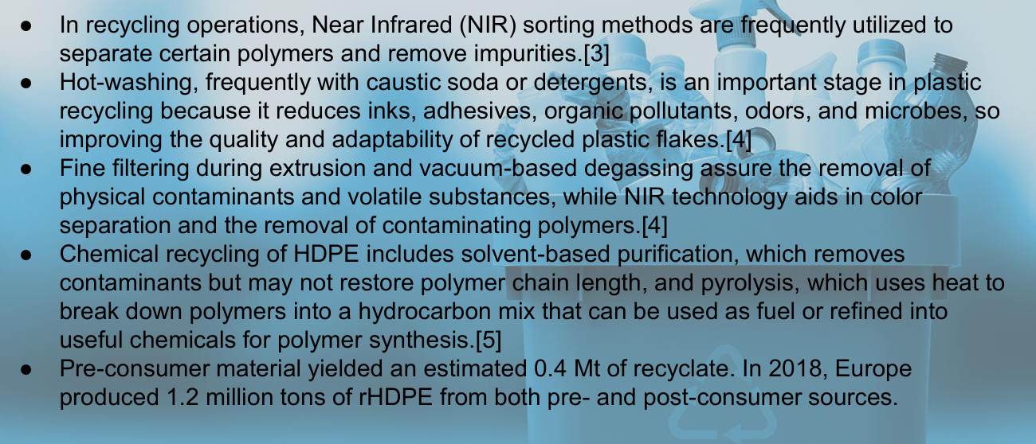
📷 Figure 3 — Recycling process slide: bullet points covering NIR sorting, hot washing, fine filtering/degassing, chemical recycling (solvent purification + pyrolysis), and EU rHDPE production statistics (1.2 Mt in 2018)
Source: Screenshot 2 (Image 2) — Slide 4 (Recycling): lower half of screenshot

3.3 Research Frontier: Radiation Crosslinking (HDPEx)
The presentation's research contribution focuses on radiation crosslinking as a novel end-of-life pathway for HDPE waste. In this process, HDPE is subjected to electron beam radiation, producing irradiated HDPE (HDPEx) — a crosslinked polymer network with significantly enhanced properties compared to standard recycled HDPE. Published research (Navratil et al., 2015, Radiation Physics and Chemistry) demonstrates that HDPEx achieves superior chemical resistance, tensile strength, stress cracking resistance, and thermal resistance.

The critical circular economy insight is that HDPEx can be used as a filler material in the manufacture of virgin LDPE pipes — incorporating recycled HDPE waste directly into new pipe products without requiring the rHDPE to match virgin HDPE quality in all respects. This creates a functional downcycling pathway that diverts HDPE from landfill while adding value, and supports blended virgin-recyclate pipe products that meet performance standards.

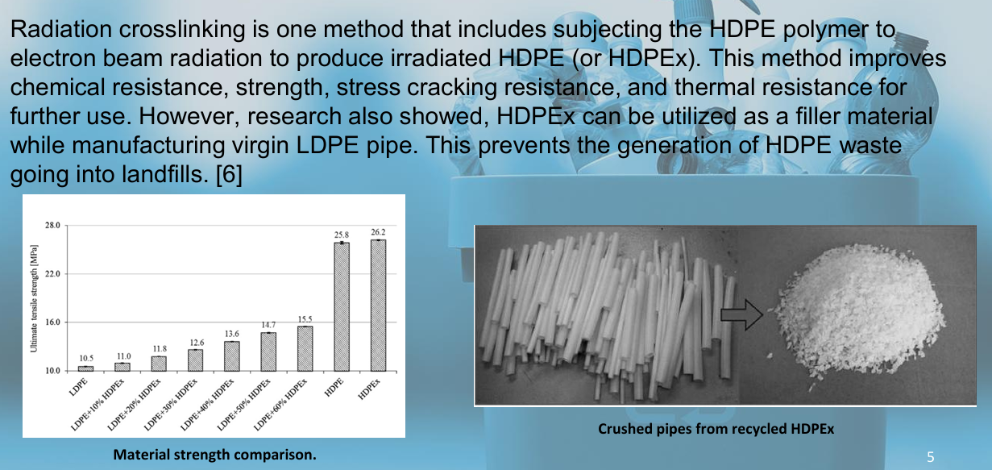
📷 Figure 4 — Research Ideas slide: material strength comparison bar chart (LDPE/HDPEx blends at various ratios vs. virgin HDPE) and photograph of crushed HDPEx pipes ready for use as filler material
Source: Screenshot 3 (Image 3) — Slide 5 (Research Ideas): upper half — material strength chart + HDPEx crushed pipe photograph

4. KEY FINDINGS

- The EU28 HDPE recycling rate remains structurally low: recycled production (0.7 Mt) represents only ~6.7% of total demand (10.5 Mt). Despite Europe producing 1.2 Mt of rHDPE in 2018, the recycled fraction is insufficient to meaningfully substitute virgin material at scale without significant collection and processing infrastructure investment.
- Mechanical recycling quality is the primary barrier to market uptake of rHDPE: the combination of NIR sorting, hot washing, and melt filtration produces material suitable for most packaging and pipe applications, but residual contamination limits rHDPE acceptance in food-contact, medical, and high-specification engineering applications where virgin material is still preferred.
- Chemical recycling (pyrolysis) provides a complementary route for HDPE streams that cannot be mechanically recycled, converting mixed or contaminated plastic waste into hydrocarbon products (fuel oil, chemical feedstocks). However, pyrolysis does not produce polymer-grade rHDPE — it downcycles the material to fuel or monomer level, suitable for chemical synthesis but not direct polymer replacement.
- Radiation crosslinking (HDPEx) represents a high-value research pathway: by upgrading HDPE waste properties through electron beam irradiation, HDPEx becomes a functional filler in LDPE pipe production, demonstrating that 'quality upgrading' of recycled plastics — rather than simple mechanical recycling — can unlock premium applications and prevent landfill disposal.
- Policy and market development are essential complements to technical recycling improvements: without government procurement mandates for rHDPE-containing products, without collection infrastructure investment, and without harmonised quality standards, the demand side of the rHDPE market cannot absorb the recycled material that improved technologies can produce.

5. CONCLUSION

HDPE is a technically recyclable polymer with well-established mechanical and chemical recycling pathways. However, the EU circular economy for HDPE remains far from closed: recycled content represents less than 7% of total supply, collection rates are insufficient, and quality barriers limit rHDPE market penetration. Three strategic priorities emerge from the analysis.

- Increase collection rates: HDPE packaging collection and sorting infrastructure must be expanded to capture a larger fraction of the 10.5 Mt consumed annually. This requires both regulatory mandates (Extended Producer Responsibility frameworks) and investment in separate collection systems for HDPE-dominated waste streams.
- Stimulate rHDPE demand through market development: higher demand from industries — supported by government procurement initiatives requiring minimum recycled content in pipes, containers, and packaging — is essential to create reliable offtake markets that justify investment in recycling capacity. Without demand certainty, recyclers cannot invest in quality-upgrading technologies.
- Improve rHDPE quality cost-effectively: bridging the quality gap between virgin and recycled HDPE requires investment in advanced sorting (NIR), hot-washing systems, and extrusion technologies, alongside emerging approaches like radiation crosslinking that can upgrade waste HDPE into higher-value applications. These improvements must be achieved at costs compatible with rHDPE market prices to be commercially viable.

IMAGE EXTRACTION GUIDE FOR PORTFOLIO PAGE

All recommended images with exact source locations for the HDPE Recycling portfolio HTML page:

# | Description | Source | Location
1 | Title slide (HDPE recycling + ISAH logo) | Screenshot 1 (Image 1) | Top half — Slide 1
2 | Introduction slide: HDPE product photos (pipes, sheets, containers) | Screenshot 1 (Image 1) | Bottom half — Slide 2
3 | HDPE circular economy supply chain flow diagram | Screenshot 2 (Image 2) | Top half — Slide 3
4 | EU28 HDPE production/demand table (virgin + recyclate + imports) | Screenshot 2 (Image 2) | Top half — Slide 3 (right side)
5 | Recycling technologies bullet list (NIR, hot-wash, chemical, pyrolysis) | Screenshot 2 (Image 2) | Bottom half — Slide 4
6 | Material strength comparison bar chart (LDPE/HDPEx blend ratios) | Screenshot 3 (Image 3) | Top half — Slide 5 (left chart)
7 | Crushed HDPEx pipes photograph (recycled pipe filler material) | Screenshot 3 (Image 3) | Top half — Slide 5 (right photo)
8 | Conclusion slide (3 bullet recommendations) | Screenshot 3 (Image 3) | Bottom half — Slide 6
9 | References and SDG alignment (if desired) | Presentation text | Slide 7

