Hydrological Modelling — Hahle Catchment
Semi-Distributed HBV-IWW Rainfall-Runoff Modelling, Flood Frequency Analysis & Sensitivity Calibration
Hydrological Extremes Module | Institut für Hydrologie und Wasserwirtschaft | Leibniz Universität Hannover | 2024
Institution | Institut für Hydrologie und Wasserwirtschaft, Leibniz Universität Hannover
Course / Module | Hydrological Extremes — Project Assignment
Academic Year | 2024
Supervisor | M.Sc. Adina Brandt
Team Members | Kabir Kundapur Sheik (10050735)
Study Area | Hahle Catchment, Lower Saxony / Thuringia border, Germany
Sub-catchments | Westerode (W01, 33.16 km²) — upstream; Rollshausen (W02, 153.16 km²) — downstream
Tools & Software | ArcGIS Pro, HBV-IWW Model, Python, Excel
Data Period | 1950–2013 (climate); 1961–2012 (discharge at Rollshausen)

1. PROJECT OVERVIEW

This project assignment models the rainfall-runoff process of the Hahle catchment, a small-to-medium river basin located on the border between Lower Saxony (south-east) and Thuringia (north-west) in central Germany. Using ArcGIS Pro for catchment delineation and the semi-distributed HBV-IWW conceptual model for hydrological simulation, the study covers the complete modelling workflow: from catchment characterisation and time series quality control through to flood frequency analysis, sensitivity analysis, and manual calibration/validation.

The Hahle catchment was divided into two sub-catchments corresponding to the two available gauging stations: Westerode (W01, upstream, 33.16 km²) and Rollshausen (W02, downstream, 153.16 km²). The catchment elevation ranges from 154.39 m to 526.21 m a.m.s.l., with a mean slope of approximately 5% across both sub-catchments. Land use is dominated by agriculture (60–83%), followed by forest (13–36%) and minor settlements (4%).

The project is structured around four interconnected tasks: (1) catchment characterisation and GIS-based mapping; (2) time series pre-processing, plausibility, consistency, and stationarity analysis; (3) flood statistics including GEV and Gumbel probability distribution fitting using L-moments and goodness-of-fit testing; and (4) HBV-IWW model setup, sensitivity analysis across 12 parameters, and manual calibration/validation against observed discharge at the Rollshausen station.

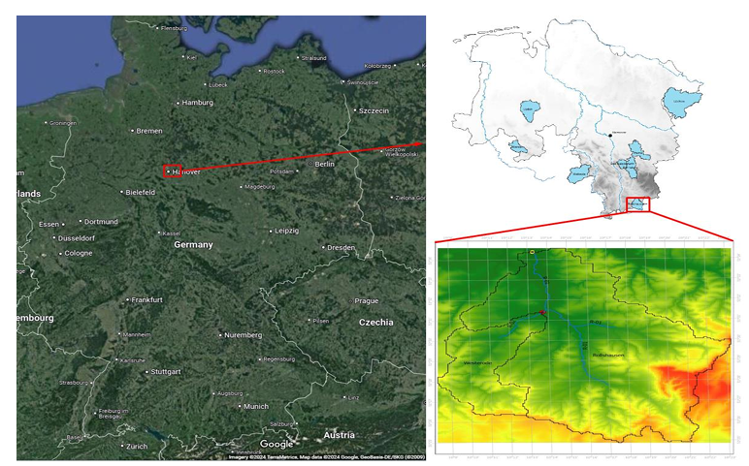
📷 Figure 1 — Study Area: Location map of the Hahle Catchment (Lower Saxony / Thuringia border)
Source: Hahle.pdf — Page 2 (Figure 2-1: Location of the Study Area)

2. OBJECTIVES

- Delineate the Hahle catchment and its two sub-catchments (Westerode and Rollshausen) using ArcGIS Pro hydrology tools applied to a DEM100 digital elevation model.
- Characterise the catchment's topography, river network, land use (CORINE CLC), and soil properties (HWSD) through GIS-based spatial analysis and tabulation.
- Pre-process available hydrological and climate time series (daily mean runoff DME, monthly peak flows MMA, precipitation PCP, temperature TAV, evapotranspiration ETP, crop coefficient CRO) for plausibility, consistency, and stationarity.
- Conduct flood frequency analysis by fitting GEV and Gumbel probability distributions using L-moments to both DME and MMA datasets, with goodness-of-fit testing and derivation of design floods for 10-year and 50-year return periods.
- Set up, run, and calibrate the semi-distributed HBV-IWW rainfall-runoff model for the Hahle catchment, with sensitivity analysis of all 12 model parameters and manual calibration optimised by Nash-Sutcliffe Efficiency (NSE).

3. METHODOLOGY

3.1 Catchment Delineation and Characterisation (ArcGIS Pro)
The watershed boundary was delineated using ArcGIS Pro hydrology tools applied to the DEM100 digital elevation model. The workflow involved filling sinks, computing flow direction and flow accumulation rasters, defining the stream network at a threshold drainage area of 25 km², and snapping pour points to the Westerode and Rollshausen gauging stations to extract sub-catchment boundaries.

Key topographical characteristics derived for each sub-catchment include: area, perimeter, areal centroid coordinates, elevation statistics (min, max, mean, standard deviation), and mean slope (classified). Both sub-catchments have a mean slope of approximately 5%, placing them in the moderate slope class — implying a mix of infiltration-dominated and moderate runoff-generating behaviour.

Characteristic | Westerode (W01) | Rollshausen (W02)
Area (km²) | 33.16 | 153.16
Perimeter (km) | 40.4 | 89.8
Elevation range (m a.m.s.l.) | 154–526 | 154–526
Mean slope (%) | ~5 | ~5
Primary land use | Agriculture (83.3%) | Agriculture (60.1%)
Forest cover (%) | 12.55 | 35.58
Settlement cover (%) | 4.16 | 4.33
Dominant soil type | Loam | Loam / Clay Loam

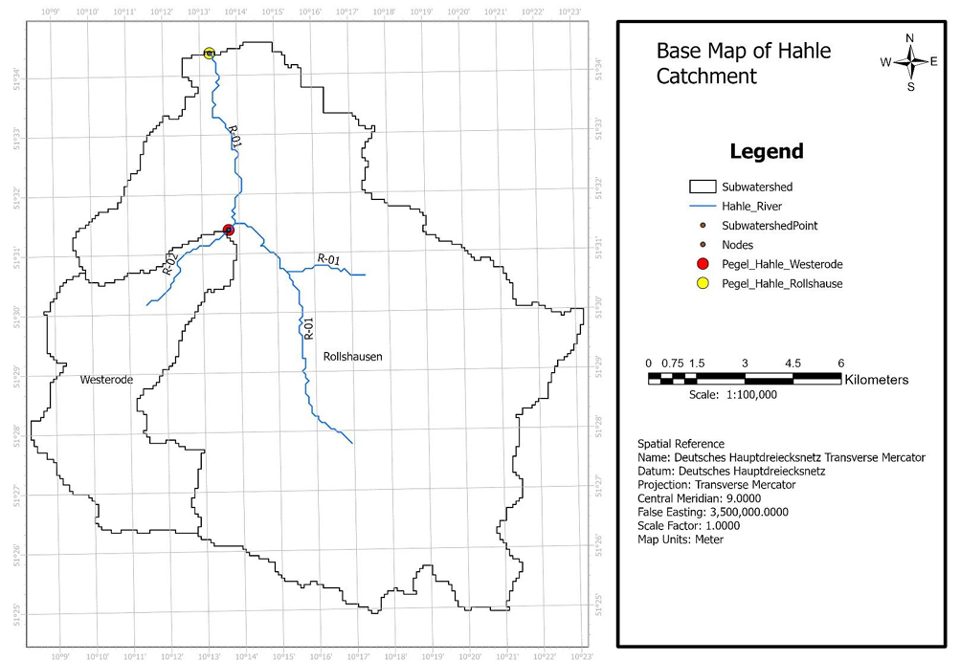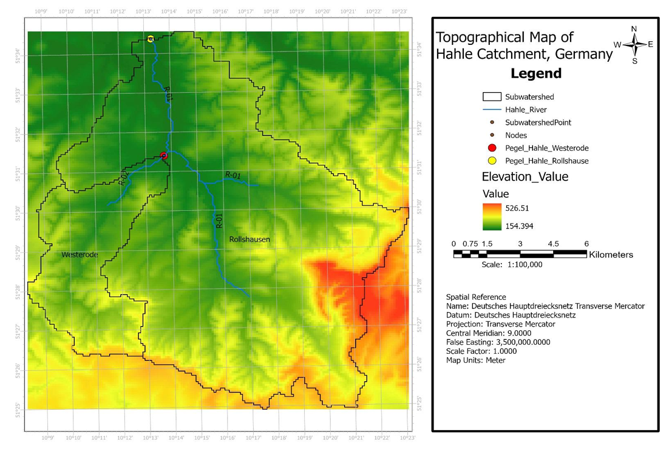

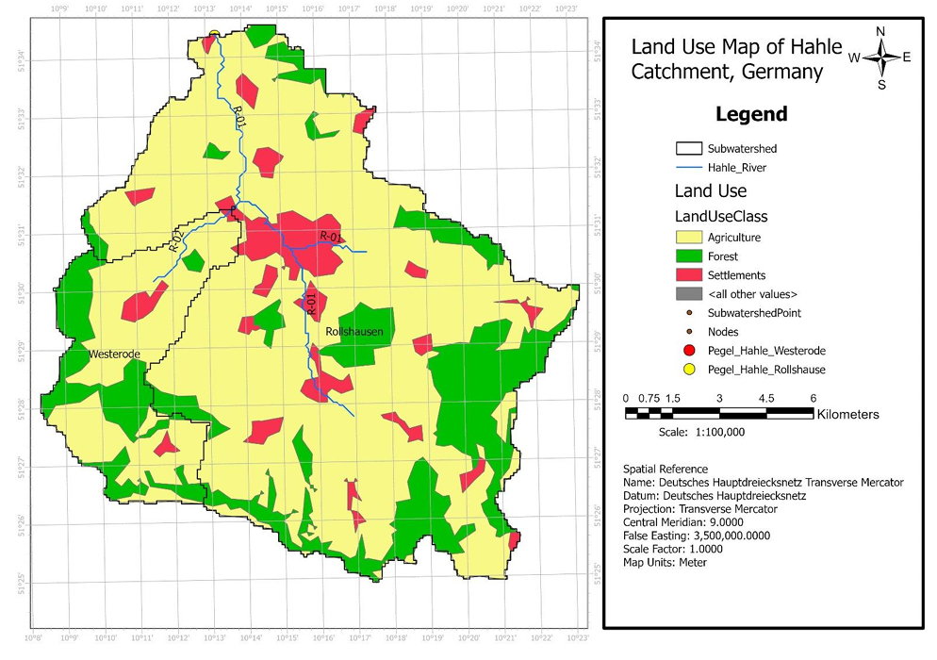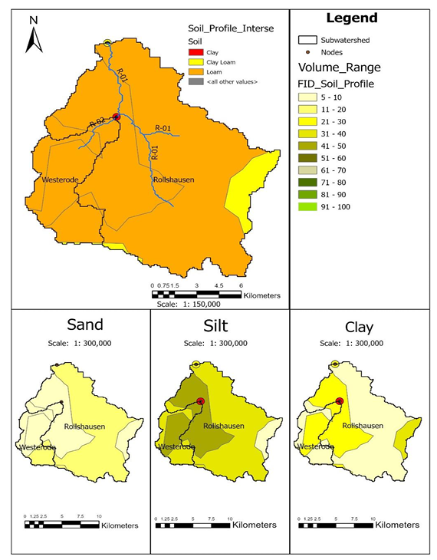
📷 Figure 2 — GIS maps (four panels): Base map with river network, topography (DGM), land use (CLC), and soil distribution (HWSD) of the Hahle Catchment
Source: Hahle.pdf — Pages 1–4 of Section 2.2 (Figures 2-5, 2-6, 2-7, 2-8)

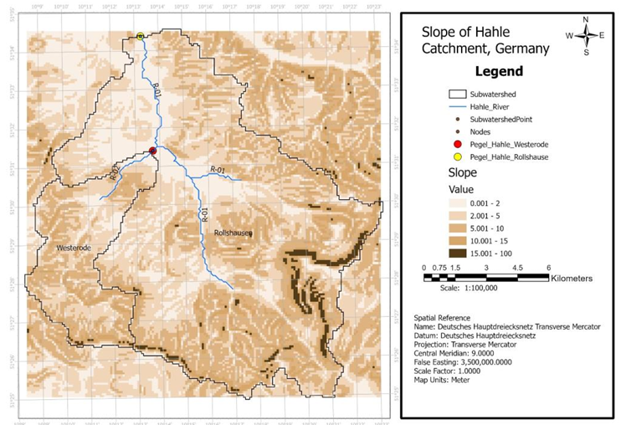
📷 Figure 3 — Slope classification map of the Hahle Catchment showing spatial distribution of slope classes across both sub-catchments
Source: Hahle.pdf — Page 5 (Figure 2-3: Slope Classification)

3.2 Time Series Pre-Processing
All input time series were subjected to three quality control steps before modelling. Plausibility checks confirmed that temperature (TAV), precipitation (PCP), evapotranspiration (ETP), and crop coefficient (CRO) values fell within physically realistic ranges verified against DWD Climate Data Center benchmarks. A small number of erroneous MMA values (coded as −999 at Rollshausen) were flagged and treated as missing data.

Consistency was verified by mapping the availability of each parameter over the full record period. The only significant gap was in the DME daily runoff at Rollshausen, where recording began in November 1961 rather than from 1950. All other parameters were continuous and complete. Stationarity was confirmed by linear regression trend analysis of the DME hydrograph (no significant drift detected) and by Double Sum Analysis (DSA) comparing cumulative DME and cumulative PCP — the linear, slope-consistent DSA curve confirmed a homogeneous and stable precipitation-runoff relationship throughout the record.

3.3 Flood Frequency Analysis
Annual peak flows were extracted from both the DME (daily mean values) and MMA (monthly instantaneous peaks) datasets on a hydrological year basis, yielding 52 years of record. An independence check confirmed all extracted annual peaks were temporally separated by more than 7 days, ensuring statistical independence.

GEV and Gumbel probability distributions were fitted using the method of L-moments. The L-moment parameters (b0, b1, b2) were computed from ranked data, from which location, scale, and shape parameters were derived for both distributions and both datasets. Goodness-of-fit was assessed using the nω² test at α = 0.05. All four fits passed: nω² = 1.36 (GEV/DME), 5.11 (Gumbel/DME), 1.30 (GEV/MMA), and 1.29 (Gumbel/MMA), against critical values of 7.81 and 5.99 respectively.

Return Period | HQ DME — GEV (m³/s) | HQ MMA — GEV (m³/s) | HQ DME — Gumbel (m³/s) | HQ MMA — Gumbel (m³/s)
10 years (P_ne = 0.90) | 18.3 | 32.5 | 18.6 | 32.5
50 years (P_ne = 0.98) | 31.6 | 47.7 | 27.4 | 46.8

The MMA dataset consistently produces higher design flood estimates than DME for both distributions, as expected — instantaneous monthly peaks capture higher short-duration flows than 24-hour averages. The GEV distribution yields higher estimates than Gumbel at longer return periods, making GEV more appropriate for risk-averse infrastructure design.

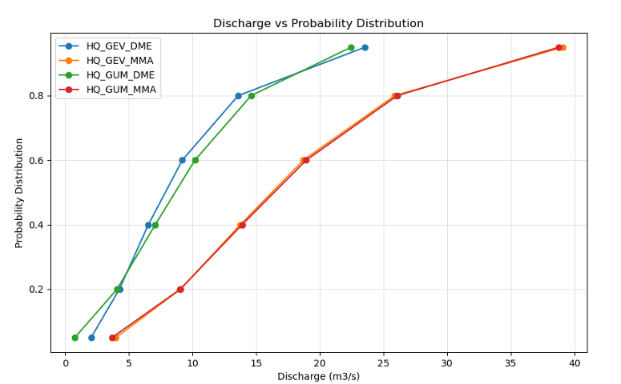
📷 Figure 4 — Flood frequency curves: Probability of non-exceedance vs. discharge (left) and return period vs. discharge (right) for GEV and Gumbel fitted to DME and MMA datasets
Source: Hahle.pdf — Pages 17–18 (Figures 3-6 and 3-7)

3.4 HBV-IWW Model Setup
The semi-distributed HBV-IWW model (a modified version of the SMHI HBV model) was configured for the Hahle catchment with two sub-catchments (W01: Westerode upstream; W02: Rollshausen downstream). The model operates at a daily time step with a sub-daily partitioning factor of 96 (effectively 15-minute internal steps). Input data comprised daily precipitation, temperature, potential evapotranspiration, and crop coefficient for the period 1950–2013.

The model structure comprises five routines: snow (degree-day snowmelt), soil moisture (field capacity FC, shape factor β, LP threshold), response (upper groundwater UZ producing direct runoff Q0, interflow Q1, and percolation to lower zone; lower groundwater LZ producing baseflow Q2), transformation (triangular unit hydrograph, parameter maxbas), and river routing (Muskingum method with weighting factor mx = 0.2 and lag time mk derived from Manning–Strickler hydraulics).

The Muskingum lag time mk was calculated using the Manning–Strickler equation with river dimensions measured from Google Earth (width = 11.95 m) and estimated water depth (1.1 m), yielding a mean flow velocity of 0.948 m/s and a lag time of 1.17 hours for the 4,007.71 m river reach at the Rollshausen outlet (reach slope 0.00352 from ArcGIS Pro).

4. KEY FINDINGS

4.1 Sensitivity Analysis Results
A one-dimensional sensitivity analysis was conducted for all 12 HBV-IWW parameters over the 1985 calendar year, with 1979 as warm-up, varying each parameter across its full range at 25% intervals. NSE values and seasonal hydrographs (winter and summer) were examined to identify the most influential parameters.

Parameter | Routine | Winter Peak Sensitivity | Summer Peak Sensitivity | Baseflow Effect
hl | Response | High decrease | High decrease | Increase
K0 | Response | High decrease | High decrease | Negligible
K1 | Response | Decrease + slight delay | Decrease + slight delay | Increase
K2 | Response | Very low decrease | Very low decrease | Increase
Kperc | Response | High increase | Increase | Low decrease
fc | Soil | Decrease | High decrease | Decrease
lp | Soil | Low increase | High increase | Increase
wsmf | Snow | Negligible | Negligible | Negligible
tt | Snow | Negligible | Negligible | Negligible
dd | Snow | Low decrease | Negligible | Negligible
maxbas | Transform | Negligible | Negligible | Negligible
β | Soil | Negligible | Negligible | Negligible

The response routine parameters (hl, K0, Kperc) were the most influential across both seasons — controlling the partitioning between fast direct runoff, interflow, and deeper percolation. Soil routine parameters (fc, lp) were most sensitive in summer, when evapotranspiration and soil moisture deficits directly control runoff generation. Snow routine parameters (wsmf, tt, dd) showed minimal influence, confirming that the Hahle catchment's hydrology is not dominated by snowmelt processes. The transformation parameter maxbas and shape factor β had negligible effect on NSE or hydrograph shape.

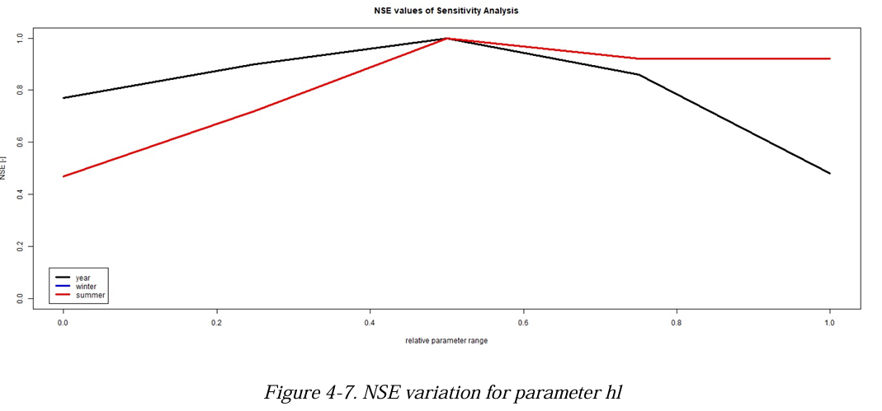

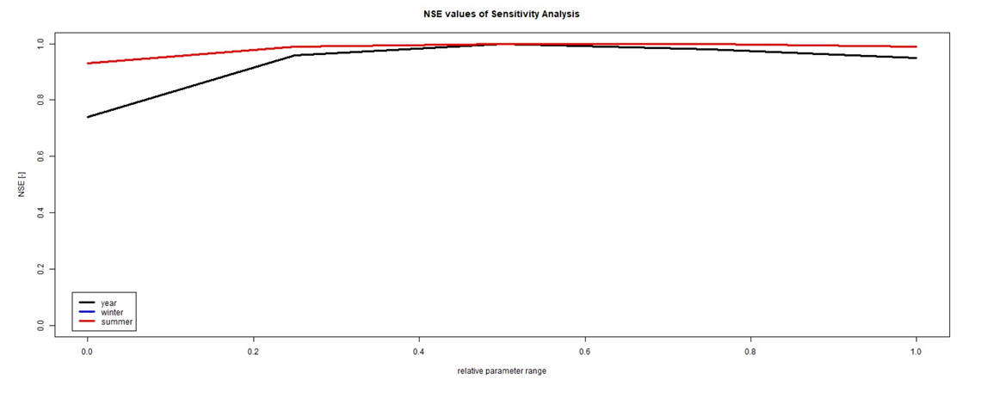

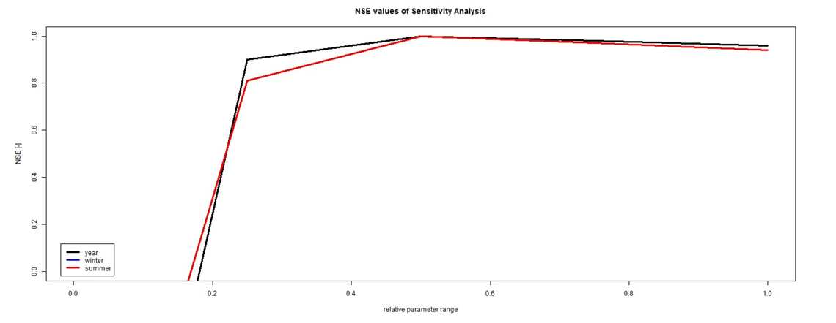
📷 Figure 5 — Sensitivity analysis: NSE variation plots for the three most sensitive parameters (hl, K0, Kperc) showing NSE vs. parameter value across the full parameter range
Source: Hahle.pdf — Pages 27–33 (Figures 4-7, 4-10, 4-19: NSE plots for hl, K0, and perc)

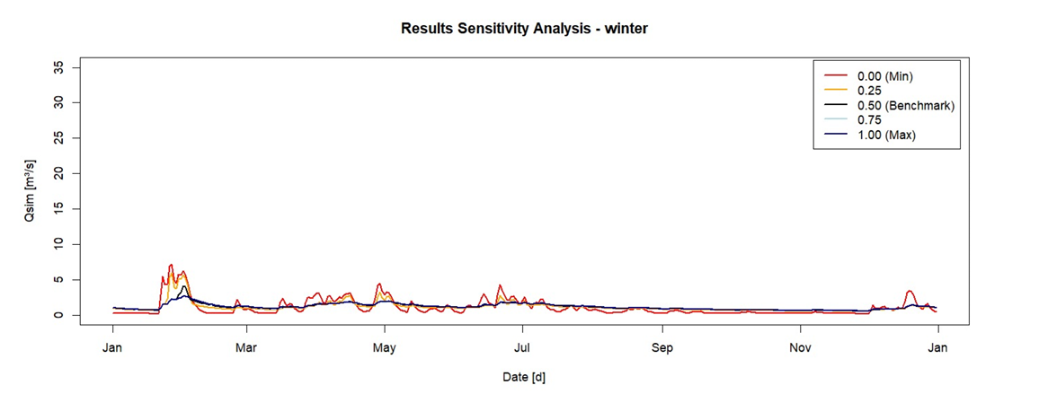

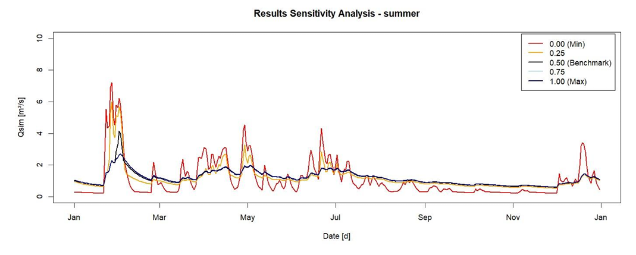

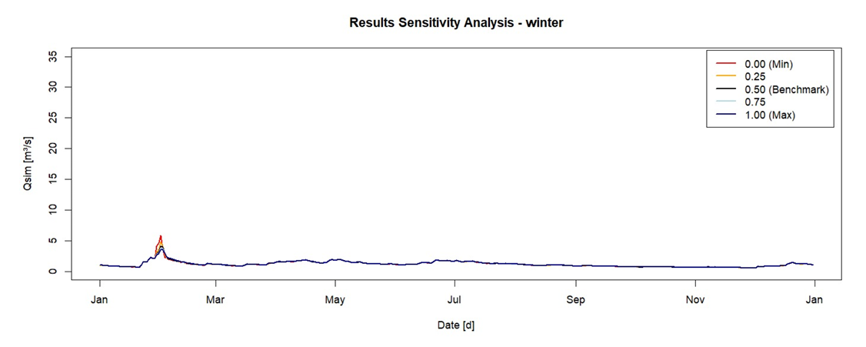

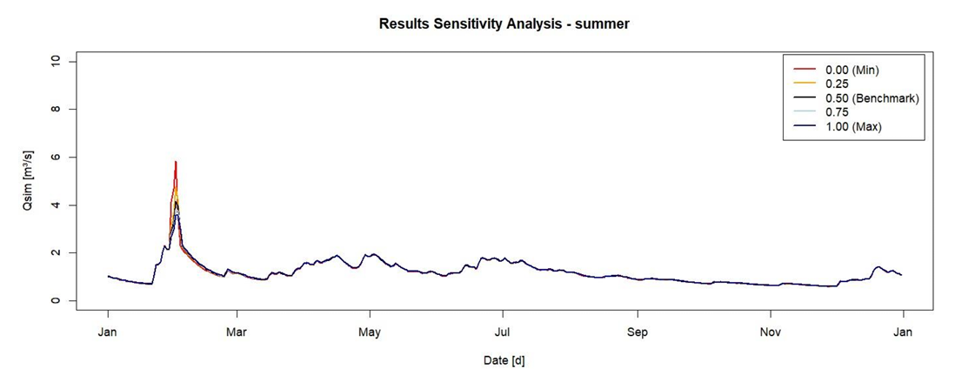
📷 Figure 6 — Seasonal hydrograph comparison for sensitivity analysis: Winter and summer hydrographs for parameter hl (left pair) and K0 (right pair) showing peak magnitude and timing changes
Source: Hahle.pdf — Pages 27–29 (Figures 4-8, 4-9, 4-11, 4-12: winter and summer hydrographs for hl and K0)

4.2 Calibration and Validation
Manual calibration was performed for the period January 1980 – December 1990, selected because it contains the highest observed runoff events in the record — making it the most demanding and informative calibration interval. A one-year warm-up period (1979) was applied before the calibration window. The initial default parameter set yielded NSE = 0.55. Seven manual iterations were performed, adjusting parameters guided by the sensitivity analysis results. The final optimal parameter set retained NSE = 0.55 — no improvement beyond the initial value was achieved through the manual iterations attempted.

The reference efficiency classification for the Rollshausen station (catchment area 153.16 km²) defines NSE Class 1 ≥ 0.80, Class 2 ≥ 0.70, Class 3 ≥ 0.60, and Class 4 ≥ 0.50. The achieved NSE of 0.55 places the model in Class 4 — marginally acceptable performance. The BIAS metric was used as a secondary validation indicator, with values near 0 indicating minimal volume error.

The validation phase revealed limitations in the model's ability to reproduce peak flows for periods outside the calibration window, particularly for very high runoff events. The assumption of identical parameter values across both sub-catchments may have constrained achievable performance; future work should explore spatially varying parameter sets. The NSE result also reflects the inherent difficulty of manually calibrating a 12-parameter model without automated optimisation.

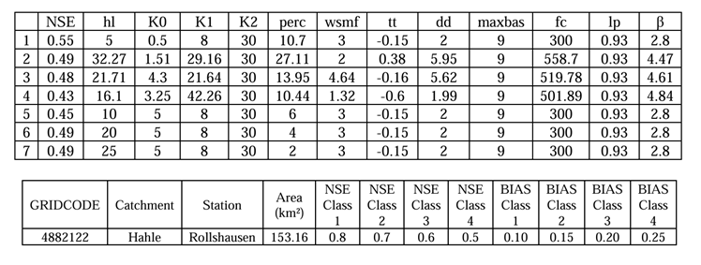

📷 Figure 7 — Calibration hydrograph: Observed vs. simulated daily discharge at Rollshausen (Node 2) for the calibration period 1980–1990, showing NSE = 0.55
Source: Hahle.pdf — Section 4.5 (Calibration and Validation figures — extract the calibration period hydrograph comparison)

5. CONCLUSION

This project successfully implemented the full hydrological modelling workflow for the Hahle catchment, from GIS-based delineation and characterisation through flood statistics to semi-distributed HBV-IWW model calibration. Five principal conclusions emerge.

- The Hahle catchment is predominantly agriculture-dominated (60–83%) with moderate slopes (~5%), resulting in a mixed runoff regime that is sensitive to soil moisture conditions and not significantly influenced by snowmelt.
- Both GEV and Gumbel distributions passed the nω² goodness-of-fit test for both DME and MMA datasets. The MMA instantaneous peak dataset consistently produces higher design flood estimates — for a 50-year return period, GEV/MMA gives 47.7 m³/s versus GEV/DME at 31.6 m³/s — underlining the critical importance of data type selection in flood frequency analysis.
- Sensitivity analysis confirmed that response routine parameters (hl, K0, Kperc) dominate model behaviour year-round, while soil parameters (fc, lp) are particularly influential in summer. Snow routine parameters have minimal effect, confirming the catchment's rain-dominated hydrology.
- Manual calibration achieved NSE = 0.55 (Class 4 — marginally acceptable), indicating that while the model captures the general runoff dynamics, further refinement through automated optimisation (e.g., MCMC or SCE-UA), spatially varying sub-catchment parameters, or a longer calibration period would be necessary to achieve Class 1–2 performance.
- The project demonstrated comprehensive applied competency in GIS-based catchment analysis (ArcGIS Pro), statistical flood frequency methods (L-moments, GEV, Gumbel), and conceptual hydrological modelling (HBV-IWW), providing a robust foundation for flood risk management applications in similar mid-sized German catchments.

IMAGE EXTRACTION GUIDE FOR PORTFOLIO PAGE

All recommended images with exact source locations for the Hahle Catchment portfolio HTML page:

# | Description | Source File | Page / Figure
1 | Location map of the Hahle Catchment | Hahle.pdf | p. 2 (Fig 2-1)
2 | Base map — river network and sub-basins | Hahle.pdf | Section 2.2.1 (Fig 2-5)
3 | Topography map (DGM) | Hahle.pdf | Section 2.2.2 (Fig 2-6)
4 | Land use map (CLC) | Hahle.pdf | Section 2.2.3 (Fig 2-7)
5 | Soil distribution — 4 sub-maps (HWSD) | Hahle.pdf | Section 2.2.4 (Fig 2-8)
6 | Slope classification map | Hahle.pdf | p. 5 (Fig 2-3)
7 | Data consistency review chart | Hahle.pdf | p. 4 (Fig 3-1)
8 | Double Sum Analysis (DSA) chart | Hahle.pdf | p. 6 (Fig 3-4)
9 | Annual peak flows bar chart (DME + MMA) | Hahle.pdf | p. 8 (Fig 3-5)
10 | Flood frequency curves (P_ne vs HQ) | Hahle.pdf | p. 17 (Fig 3-6)
11 | Return period vs HQ comparison chart | Hahle.pdf | p. 18 (Fig 3-7)
12 | HBV model schematic diagram | Hahle.pdf | p. 20 (Fig 4-1)
13 | HBV-IWW vertical structure + parameter list | Hahle.pdf | p. 21 (Figs 4-2 & 4-3)
14 | NSE sensitivity plots (hl, K0, perc) | Hahle.pdf | pp. 27, 28, 33 (Figs 4-7, 4-10, 4-19)
15 | Winter/summer hydrographs — key parameters | Hahle.pdf | pp. 27–39 (Figs 4-8, 4-9, 4-11, 4-12)
16 | Calibration hydrograph (observed vs simulated) | Hahle.pdf | Section 4.5 (calibration period plot)

