LCA & Sustainability
LCA Framework for Photovoltaic Systems
Developing a qualitative framework to facilitate the execution of Life Cycle Assessments for PV Systems
Institution | Leibniz Universität Hannover — Institute for Sanitary Engineering and Waste Management
Programme | M.Sc. Water Resources and Environmental Management (WATENV)
Submitted | 15th October 2024
Supervisor | Prof. Dr.-Ing. Habil. Dirk Weichgrebe | M.Sc. Sara Zahedi Nezhad
Tools Used | STAN2, Umberto, ISO 14040/14044, SimaPro, Literature Review
Collaborators | Kabir Kundapur Sheik

1. Project Overview
This research project was conducted at the Institute for Sanitary Engineering and Waste Management, Leibniz Universität Hannover. The core objective was to develop a qualitative framework that simplifies and structures the execution of Life Cycle Assessments (LCA) for Photovoltaic (PV) systems — addressing a critical gap in how environmental impacts of solar energy technologies are evaluated.
PV systems are growing rapidly worldwide as a substitute for fossil fuels. However, their full environmental impact across the entire lifecycle — from raw material extraction through manufacturing, installation, operation, and end-of-life disposal — remains incompletely understood. This project aimed to make LCA methodology more accessible, structured, and transparent for the renewable energy sector.
[ IMAGE PLACEHOLDER ]
Figure 1: Four Stages of Life Cycle Assessment (ISO 14044)
Source: 4_LCA_Reports.pdf — Page 10, Figure 2

2. Objectives
- Develop a qualitative LCA framework for PV systems following ISO 14040 and ISO 14044 standards
- Review and synthesise 10+ existing LCA studies on PV technologies
- Compare crystalline silicon (c-Si) and thin-film PV technologies across environmental impact categories
- Model material flows and energy consumption using STAN2 and Umberto
- Assess GWP, EPBT, material utilisation, and emission profiles across the full PV lifecycle
- Contribute to circular economy thinking by evaluating end-of-life strategies for PV modules

3. Methodology

3.1 LCA Framework — ISO 14040/14044
The study followed the four-phase LCA methodology prescribed by the International Organisation for Standardisation:
- Goal and Scope Definition: Defined the functional unit as 1 kWh of electricity generated by PV systems, enabling direct comparison across technologies and configurations.
- Life Cycle Inventory (LCI) Analysis: Collected and quantified material and energy inputs/outputs across all lifecycle stages — raw material extraction, manufacturing, assembly, installation, usage, and end-of-life.
- Life Cycle Impact Assessment (LCIA): Evaluated environmental impact categories including Global Warming Potential (GWP), Energy Payback Time (EPBT), human toxicity, resource depletion, freshwater ecotoxicity, and acidification potential.
- Life Cycle Interpretation: Synthesised findings, identified significant issues, and drew conclusions with recommendations for industry and policymakers.

3.2 Material Flow Modelling — STAN2 and Umberto
Two complementary software tools were used to model material and energy flows through the PV circular economy system:
- STAN2: Used to model the full material flow system for PV panels, tracking goods (panels), aluminium, and silicon through stages including raw material refining, manufacturing, assembly, installation, usage, end-of-life, collection, and recycling. Required separate layers for each material type.
- Umberto: Used for integrated LCA modelling, enabling carbon footprint estimation as part of the lifecycle assessment without the need to separate layers by material. Provided the complete Circular Model visualisation with quantified flows.
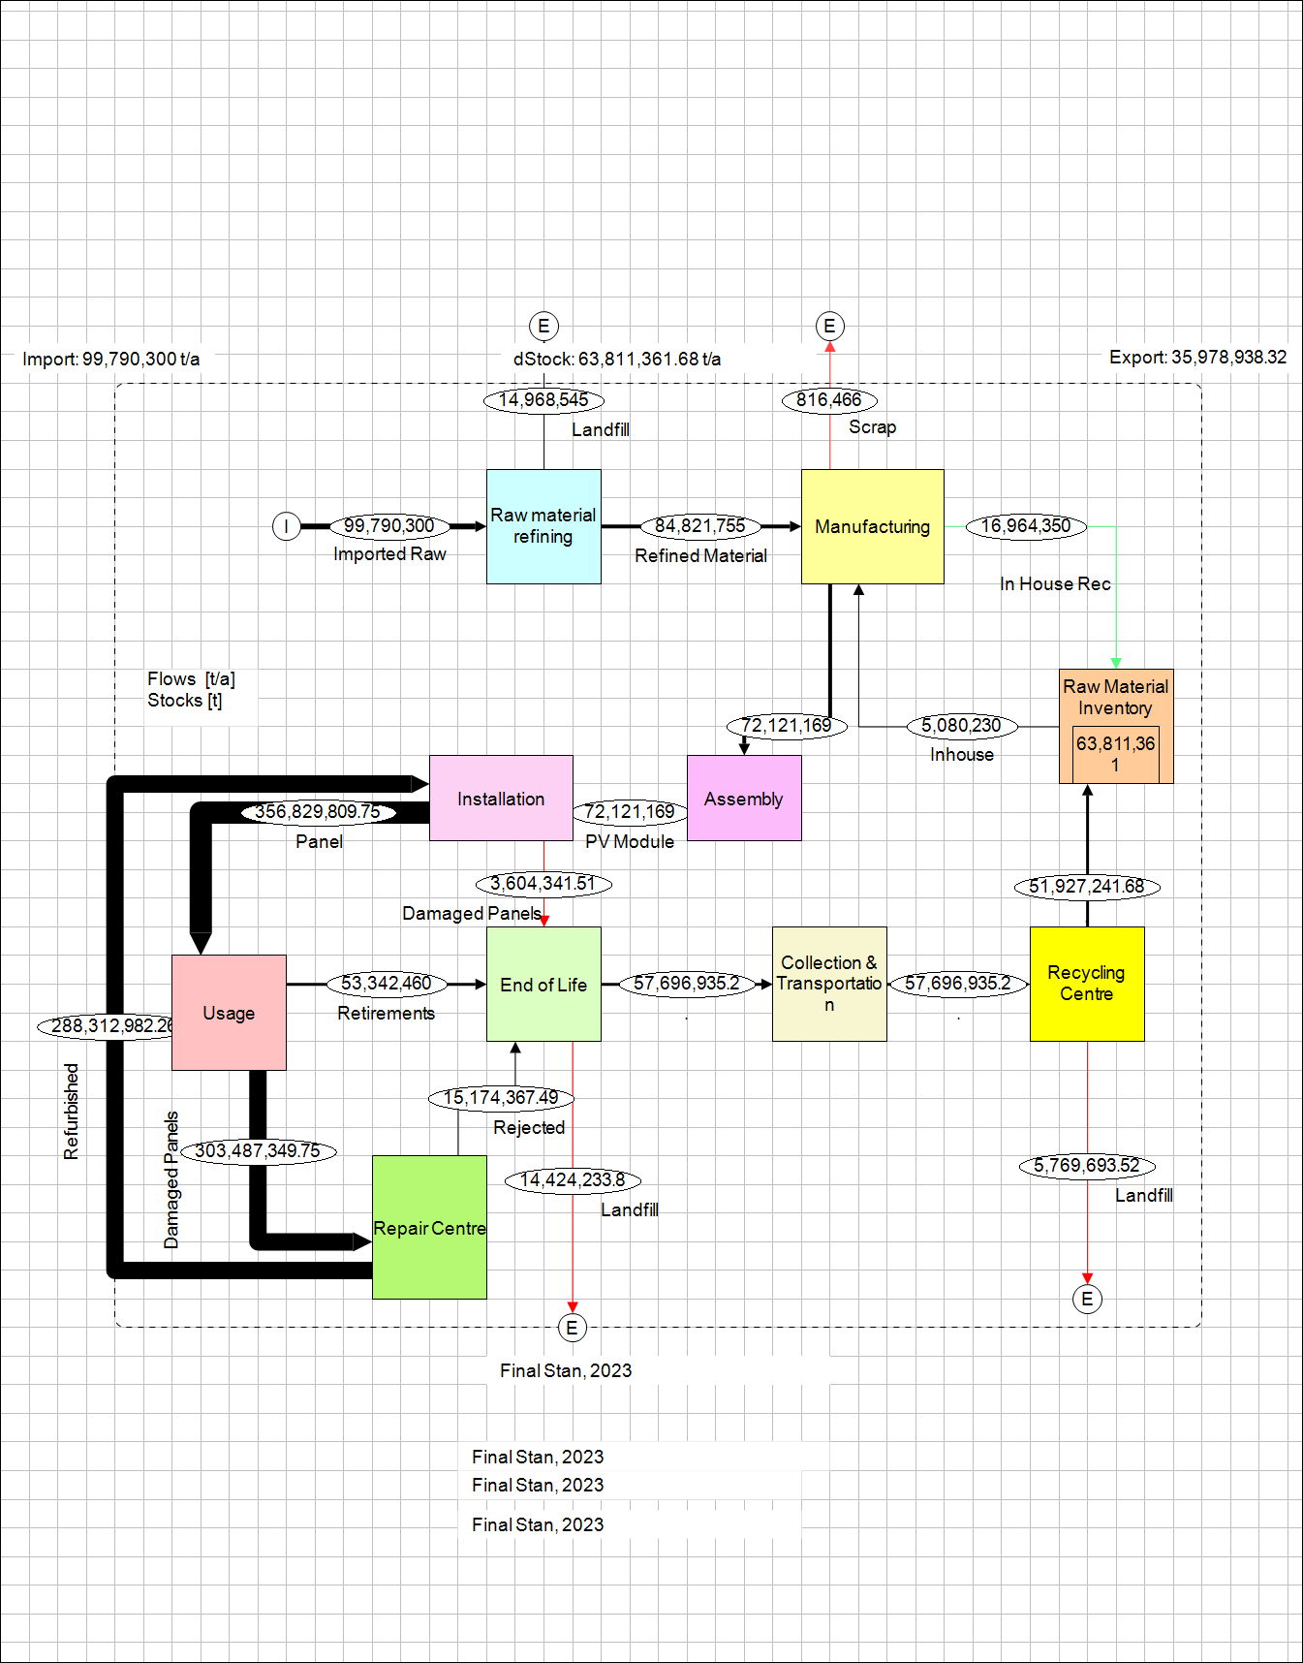
Figure 2: STAN2 Material Flow Model — Goods (PV Panels) through the circular economy system
Source: 4_PV_Presentation1.pdf — Page 5 (Goods slide, STAN model)

3.3 Data Collection
Data was gathered from multiple sources to ensure accuracy and reliability:
- Research papers: Weighted material quantities and energy consumption data
- Technical reports: Specifications of PV modules and system configurations
- IEA Technology Collaboration reports: Energy usage at different lifecycle stages
- Real-time data: Transport distances from Google Maps for logistics calculations
- Company profiles: Module dimensions, weight, and energy generation potential

3.4 Assumptions
Key assumptions applied to the model:
- Raw material import origin: China
- Energy consumption during all modelled processes: Renewable energy sources
- Type of wafer used: M2 (standard silicon wafer format)
- Type of PV module: Multi-Si (multicrystalline silicon)
- Transport distances modelled: Residential to industrial area, repair centre, and recycling centre

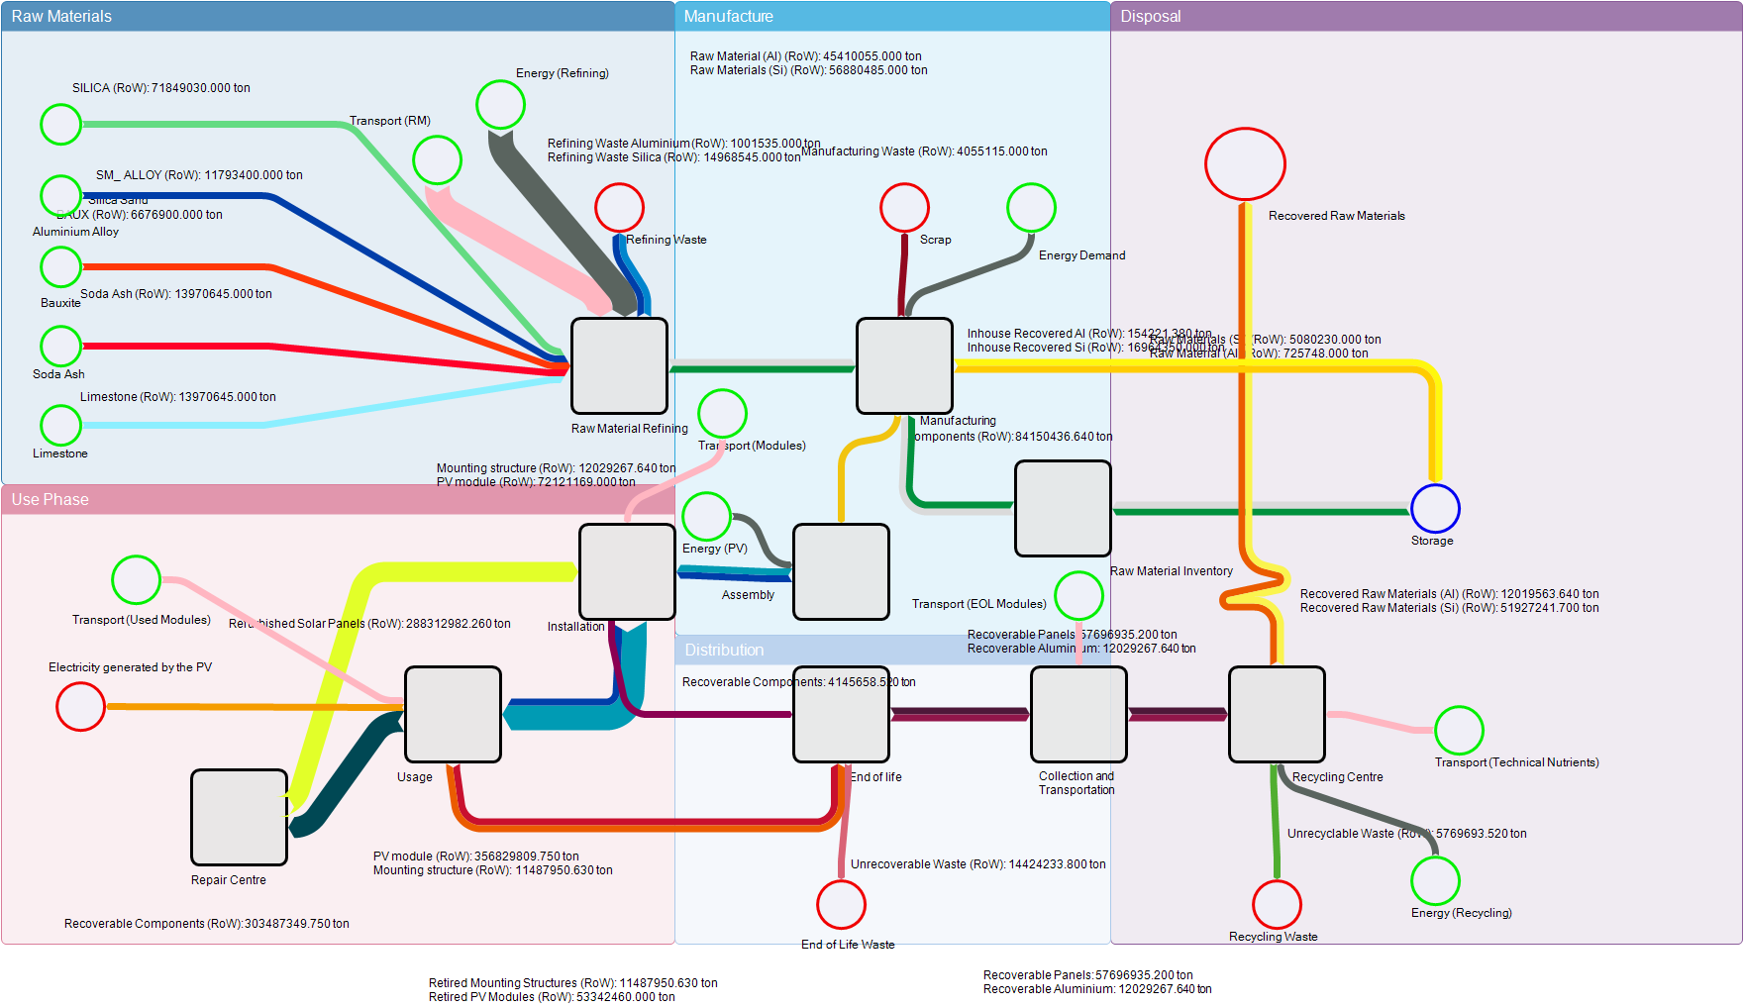Figure 3: Circular Model — Full material flow of PV system lifecycle (Umberto)
Assembly
Energy Demand
Scrap
Energy Demand
Transport
Source: 4_PV_Presentation1.pdf — Page 10 (Circular Model slide)

4. Key Findings

4.1 Material Utilisation
Silicon-based PV technologies (monocrystalline and polycrystalline) dominate the market due to reliable performance, but their production is energy-intensive and generates significant GHG emissions. Thin-film technologies (CdTe, CIGS) offer lower material requirements but raise concerns about rare material availability and recycling challenges.
Key finding: Only 25 out of 117 reviewed LCA studies covered the full lifecycle. 92 studies focused solely on the production stage — indicating a major gap in end-of-life and use-phase assessment that this framework aims to address.

4.2 Energy Consumption
Energy consumption is highest during raw material refining and module production. The model quantified the following energy demands:
Process | Energy Demand (kWh)
Raw Material Refining | 486,730,021,000
Assembly | 11,265,500,000
Recycling Centre | 6,034,889,872
Manufacturing | 2,075,574,189

Key finding: Raw material refining accounts for by far the largest share of energy demand — approximately 97% of total process energy — highlighting the critical importance of improving refining efficiency and material recovery.

4.3 Global Warming Potential (GWP)
GWP analysis showed that installation and usage phases are the dominant contributors, followed by repair centre operations and manufacturing. GHG emissions by technology ranged from:
- Polycrystalline silicon: 22–27 g CO₂-eq/kWh
- Amorphous silicon: ~34.3 g CO₂-eq/kWh
- CdTe thin-film (mono-Si): 0.0187–0.0673 kg CO₂-eq/kWh DC
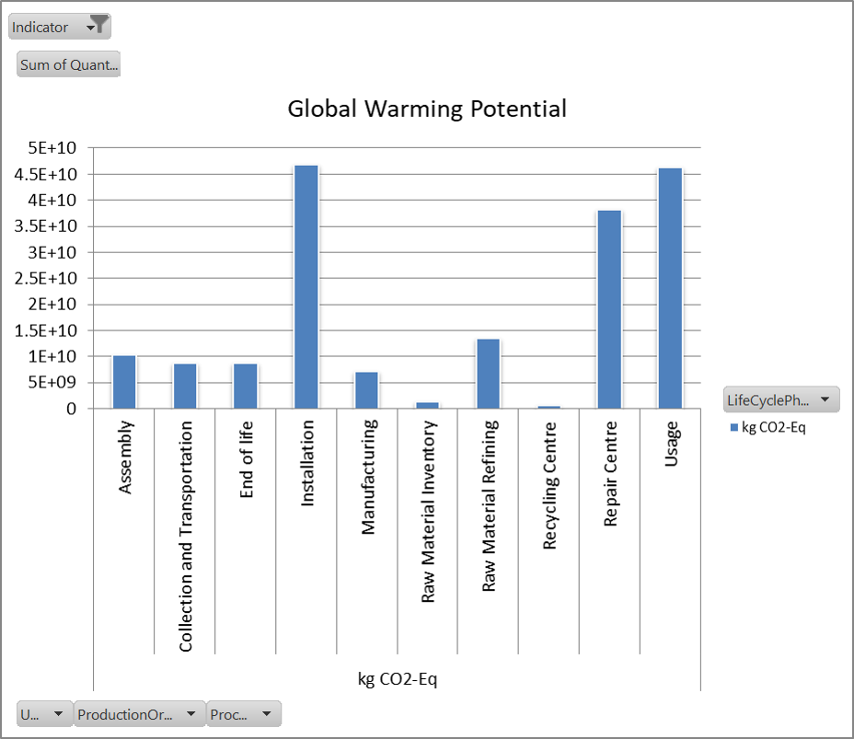
Figure 4: Global Warming Potential across lifecycle phases (GWP results chart)
Source: 4_PV_Presentation1.pdf — Page 13 (Results slide — GWP bar chart)

4.4 STAN2 vs Umberto — Tool Comparison
A key contribution of this project was the practical comparison of two LCA/material flow tools:
- STAN2 requires creating separate layers for each material (goods, aluminium, silicon) — more granular but time-consuming for complex multi-material systems.
- Umberto allows modelling of entire products as a whole, integrates carbon footprint estimation directly into the LCA workflow, and produces the full circular model in one environment.
Recommendation: Umberto is more suitable for integrated LCA work that includes carbon footprint estimation, while STAN2 is better for detailed material-specific flow analysis.
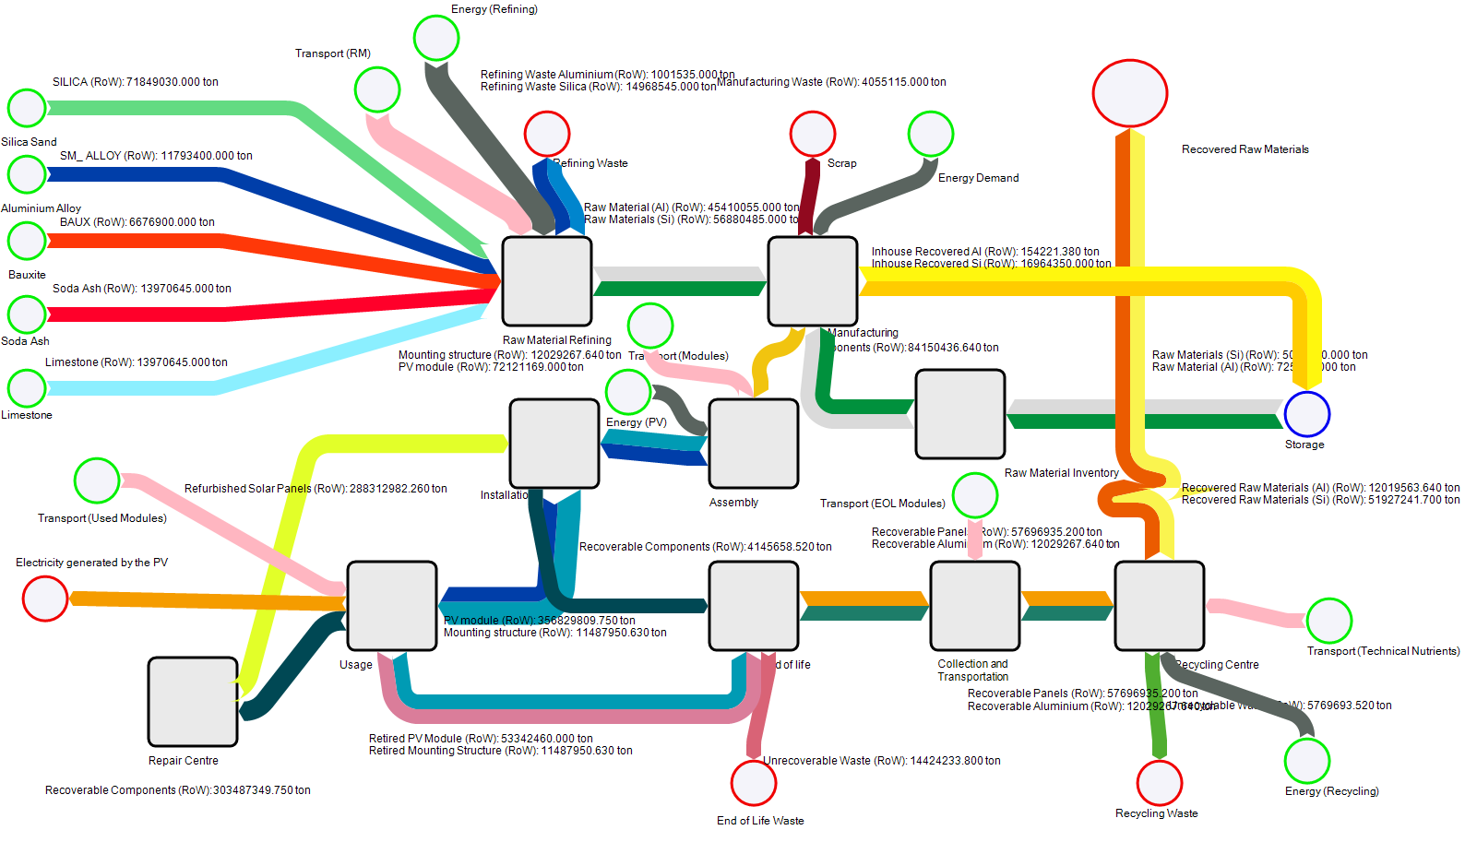

[ IMAGE PLACEHOLDER ]

Figure 5: STAN2 vs Umberto — Side-by-side circular model comparison
Source: 4_PV_Presentation1.pdf — Page 15 (STAN2 and Umberto comparison slide)

5. Conclusion
This project successfully developed a qualitative LCA framework that structures the assessment of environmental impacts for PV systems across all four ISO lifecycle phases. The framework addresses a documented gap in existing LCA studies — most of which focus only on the production stage and neglect end-of-life impacts.
Key conclusions:
- Raw material refining is the most energy-intensive process in the PV lifecycle and the primary target for efficiency improvements.
- Circular economy strategies — particularly repair, reuse, and recycling — have significant potential to reduce the overall environmental footprint of PV systems.
- Standardised LCA methodologies (ISO 14040/14044 and PEF Guide) are essential for consistent and comparable assessments across different PV technologies.
- Future LCA studies must include end-of-life phases, BOS components, and emerging technologies such as organic PVs for a complete environmental picture.
This framework is a practical tool for researchers, manufacturers, and policymakers seeking to make data-driven, sustainability-aligned decisions in the renewable energy sector — and directly supports the industry's transition to a circular economy model.

6. Relevance to Sustainable Development Goals
Ten of the seventeen UN SDGs are relevant to efficient PV recycling and lifecycle management. The most significant:
- SDG 7 — Affordable and Clean Energy: PV systems directly support the transition to renewable energy.
- SDG 12 — Responsible Consumption and Production: Circular economy strategies for PV modules reduce waste and resource consumption.
- SDG 13 — Climate Action: Reducing GWP across the PV lifecycle contributes directly to climate targets.
- SDG 9 — Industry, Innovation and Infrastructure: Standardised LCA frameworks drive innovation in sustainable manufacturing.
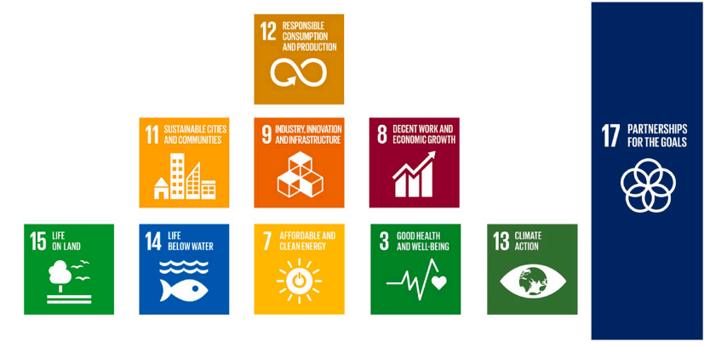Figure 6: SDGs applicable to the PV recycling industry
Source: 4_PV_Presentation1.pdf — Page 16 (SDGs in PV Recycling slide)

