Lummerwald WWTP — Static & Dynamic Simulation
Static and Dynamic Simulation of a Biological Wastewater Treatment Plant: Process Optimisation and Aeration Cost Analysis Using SIMBA
Modelling in Sanitary Engineering | ISAH, Leibniz Universität Hannover | Group 5
Course / Module | Modelling in Sanitary Engineering — Project Assignment
Institution | Institut für Siedlungswasserwirtschaft und Abfalltechnik (ISAH), Leibniz Universität Hannover
Submission Period | 2022/2023 Academic Year
Supervisors | Prof. Dr.-Ing. Regina Nogueira; Beatriz Dörrié, M.Sc.; Varian Arif
Team Members | Kabir Kundapur Sheik (10050735)
Simulation Software | SIMBA (ASM3-based activated sludge model) — static and dynamic simulation
Study Object | Lummerwald Wastewater Treatment Plant (WWTP) — existing process + two alternatives
Population Equivalent | 500,000 IV (Inhabitants)
Key Parameter | Aeration cost optimisation across seasonal temperatures (8°C / 15°C / 20°C)

1. PROJECT OVERVIEW

This project applies static and dynamic simulation techniques using SIMBA software to optimise the biological wastewater treatment process at the Lummerwald WWTP, a facility serving a population equivalent (PE) of 500,000 inhabitants. The plant treats a daily wastewater inflow of 60,000 m³/day (120 L/IV/d) with influent characteristics of COD = 650 mg/L, KN = 65 mg/L, and P = 10 mg/L. Treated effluent must comply with strict limit values of COD ≤ 75 mg/L, Ntot ≤ 13 mg/L, and SNH ≤ 10 mg/L year-round.

The central engineering challenge is that the existing plant configuration fails to meet effluent standards during winter operation at 8°C — specifically, nitrification and denitrification processes break down due to critically low autotrophic biomass (XA = 5 g COD/m³ at 8°C versus 50 g COD/m³ at 15°C). The study evaluates three configurations using SIMBA's ASM3-based activated sludge model: the existing process (baseline diagnosis), Alternative 1 (sludge recycle modification of the existing layout), and Alternative 2 (step-feed cascade configuration with and without relay-and-switch aeration control). All three configurations are simulated at three seasonal temperatures (8°C, 15°C, 20°C) and compared on effluent quality and annual aeration cost.

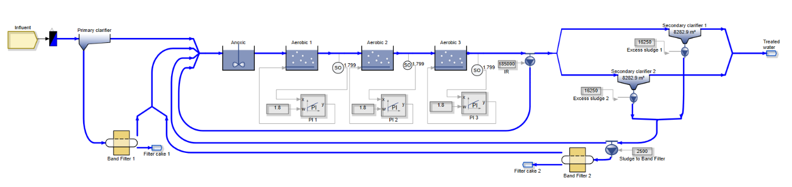
📷 Figure 1 — Lummerwald WWTP: Existing plant flow sheet showing activated sludge tank (AST), secondary clarifiers, return sludge, and band filter layout
Source: Modelling_in_Sanitary.pptx — Slide 4 (Existing model layout diagram) / Final_Report.docx — Figure 1

2. OBJECTIVES

- Diagnose why the existing Lummerwald WWTP configuration fails effluent limit values during winter (8°C) using SIMBA CSTR process analysis — identifying the root cause as critically low autotrophic biomass (XA) in the nitrification zone.
- Develop and simulate Alternative 1 (Modified Existing Model): optimise excess sludge withdrawal rate to increase XA and return sludge concentration, restoring winter compliance without changing the physical plant layout.
- Develop and simulate Alternative 2a (Step Feed Configuration): redesign the activated sludge tank as a three-stage step-feed cascade to improve nitrogen removal at all temperatures and reduce total aeration demand.
- Develop and simulate Alternative 2b (Step Feed + Relay & Switch Control): integrate an automatic SNO-based relay-and-switch aeration controller at the first nitrification tank to further reduce energy consumption by avoiding unnecessary aeration during warmer seasons when biomass is naturally active.
- Conduct a seasonal aeration cost analysis across all three configurations for 8°C, 15°C, and 20°C periods, quantifying annual energy savings and identifying the optimal techno-economic solution.

3. METHODOLOGY

3.1 Plant Configuration and Data
The Lummerwald WWTP uses a conventional pre-denitrification activated sludge process: raw wastewater enters an anoxic tank for denitrification, passes through three aerobic tanks for nitrification, and is separated in secondary clarifiers. Return sludge from the clarifier is recycled to the anoxic tank; excess sludge is withdrawn to a band filter at 2,500 m³/day (baseline). The plant runs a PI controller. All simulations use three seasonal temperature regimes: Spring/Autumn = 15°C, Summer = 20°C, Winter = 8°C.

Normal inflow and effluent limit values:

Parameter | Normal Inflow | Effluent Limit Value
COD (mg/L) | 650 | ≤ 75
KN / Ntot (mg/L) | 65 | ≤ 13
SNH (mg/L) | — | ≤ 10
P (mg/L) | 10 | —
Wastewater flow | 120 L/(IV·d) | —
Population equivalent | 500,000 IV | —

3.2 Existing Process Diagnosis (SIMBA Static Simulation)
SIMBA CSTR analysis at 8°C revealed the root cause of winter failure: the autotrophic biomass (XA) responsible for nitrification collapses from ~50 g COD/m³ at 15°C to just 5 g COD/m³ at 8°C. With almost no XA present, the conversion of ammonium (SNH) to nitrate (SNO) in the aerobic zone is negligible — effluent SNH at 8°C reaches 33 mg/L against a limit of 10 mg/L. The denitrification step in the anoxic tank also fails, as the SNO entering from the aerobic zone is near zero (0.2 g N/m³), leaving heterotrophic bacteria without substrate. The existing band filter at 2,500 m³/day is removing too much sludge, preventing biomass accumulation.

Parameter | 8°C (FAILING) | 15°C (OK) | 20°C (OK) | Limit
COD (mg/L) | 40 | 38 | 38 | ≤ 75
Ntot (mg/L) | 34 ❌ | 10 | 10 | ≤ 13
SNH (mg/L) | 33 ❌ | 1 | 0.2 | ≤ 10
XA in aerobic zone (g COD/m³) | 5 | 50 | 42 | —

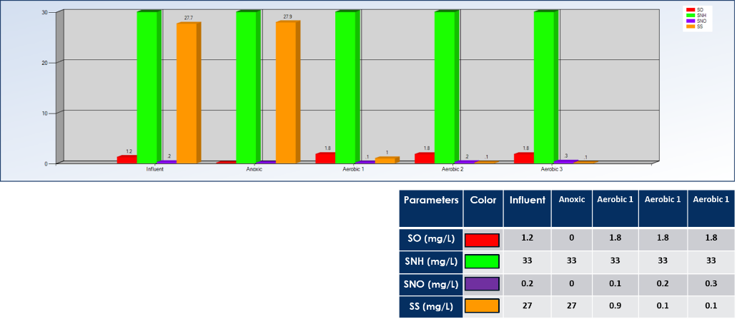
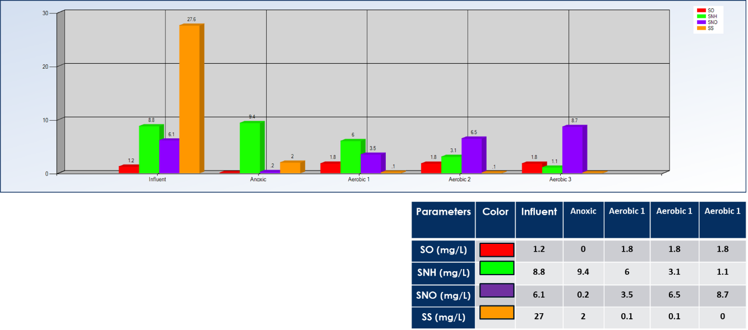
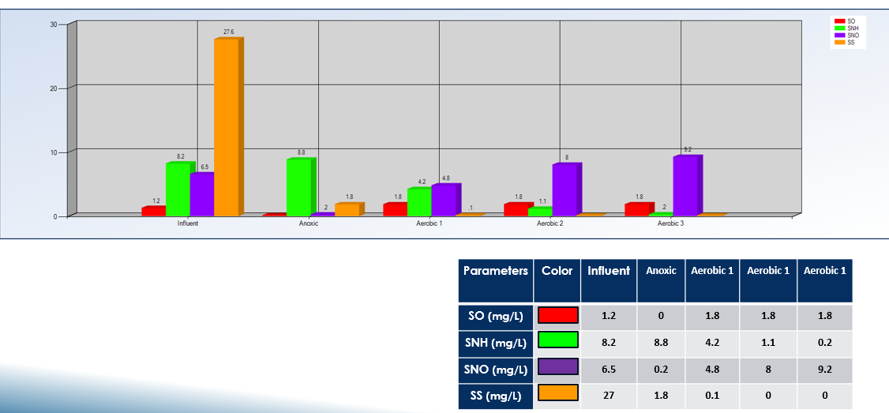
📷 Figure 2 — SIMBA CSTR analysis: Bar charts showing concentration profiles (SNH, SNO, SS, SO) through Influent → Anoxic → Aerobic 1/2/3 at 8°C (nitrification/denitrification failure) vs. 15°C and 20°C (normal operation)
Source: Modelling_in_Sanitary.pptx — Slides 7–9 (Existing model CSTR bar charts at 8°C, 15°C, 20°C)

3.3 Alternative 1 — Modified Existing Model
The proposed fix: reduce excess sludge withdrawal from 2,500 m³/day to 1,500 m³/day. This retains more biomass in the system, increasing the return sludge concentration and therefore the XA arriving at the aerobic tanks. Three withdrawal rates were tested: 2,500 (baseline), 2,000, and 1,500 m³/day. At 1,500 m³/day, XA in the aerobic zone recovers from 5 to 86 g COD/m³ at 8°C, and all three effluent parameters meet limits at all temperatures. The sludge treatment cost also drops by ~40% due to the reduced sludge flow.

Parameter | Limit | 8°C — Existing (2500) | 8°C — Modified (1500) | 15°C — Modified | 20°C — Modified
COD (mg/L) | ≤ 75 | 40 | 41 ✓ | 41 ✓ | 40 ✓
Ntot (mg/L) | ≤ 13 | 34 ❌ | 11 ✓ | 10 ✓ | 10 ✓
SNH (mg/L) | ≤ 10 | 33 ❌ | 3 ✓ | 0.2 ✓ | 0.1 ✓
XA (g COD/m³) | — | 5 | 86 | — | —

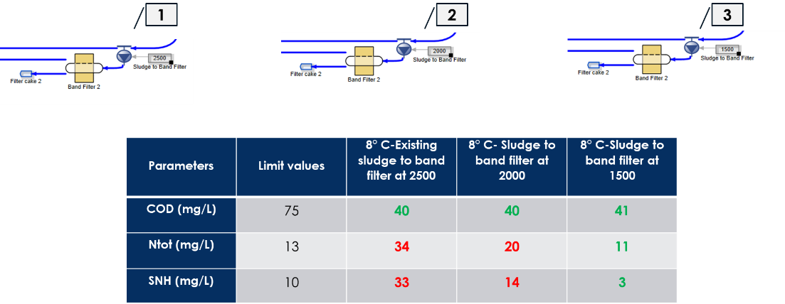
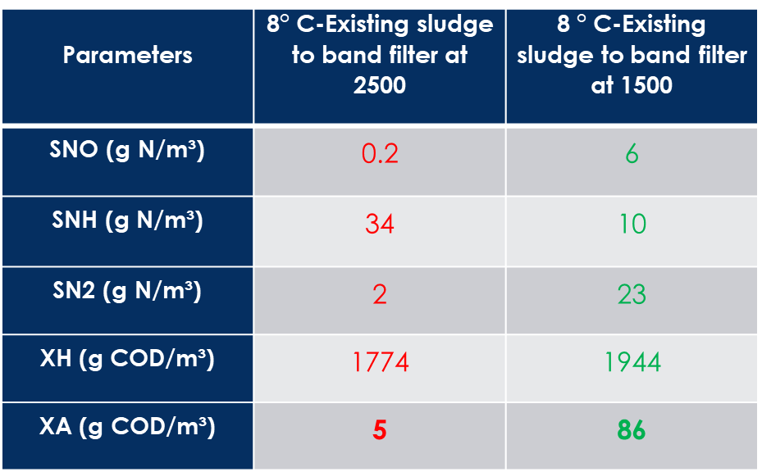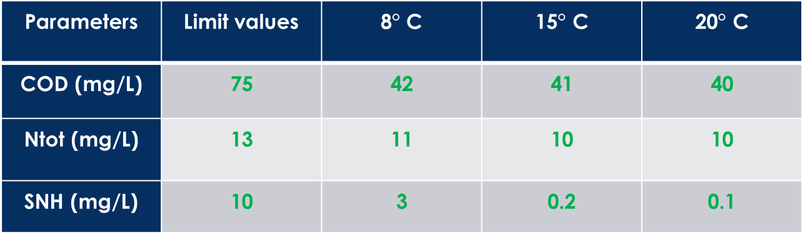
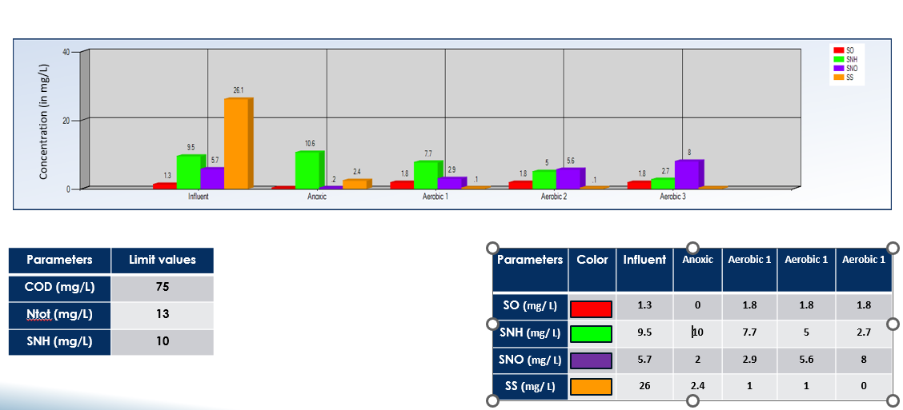
📷 Figure 3 — Alternative 1: SIMBA CSTR bar charts at 8°C showing restored nitrification/denitrification after sludge withdrawal reduction to 1,500 m³/day (SNH drops from 33 to 3 mg/L)
Source: Modelling_in_Sanitary.pptx — Slides 14–17 (Modified Existing Model CSTR and effluent quality charts)

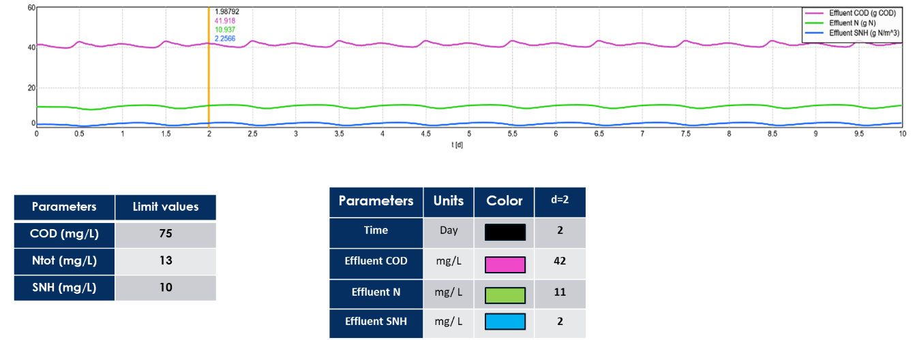
📷 Figure 4 — Alternative 1: Dynamic simulation output — effluent quality line graphs for COD, Ntot, and SNH under dynamic inflow conditions at 8°C, 15°C, and 20°C
Source: Modelling_in_Sanitary.pptx — Slides 18–20 / Final_Report.docx — bar and line graphs in Section 7.2

3.4 Alternative 2a — Step Feed Configuration
The step-feed (cascade) configuration splits the existing activated sludge volume into three equal anoxic/aerobic stage pairs, with the influent introduced at three points instead of one. Return sludge enters only at the first anoxic stage. This creates multiple denitrification opportunities, improving total nitrogen removal at all temperatures. The aeration set point for Tanks 2 and 3 was reduced from 1.8 to 1.5 mg O₂/L, reducing energy use without compromising effluent quality.

Parameter | Limit | 8°C Step Feed | 8°C Modified Existing | 15°C Step Feed | 20°C Step Feed
COD (mg/L) | ≤ 75 | 42 ✓ | 42 ✓ | 41 ✓ | 40 ✓
Ntot (mg/L) | ≤ 13 | 10 ✓ | 11 ✓ | 7 ✓ | 7 ✓
SNH (mg/L) | ≤ 10 | 5 ✓ | 2 ✓ | 1 ✓ | 0.7 ✓

Step feed reduces Ntot by a further 1–2 mg/L compared to Alternative 1 at all temperatures, driven by additional denitrification in the two new anoxic stages. However, SNH is slightly higher under step-feed than Alternative 1 because the influent carbon source is shared across three entry points rather than concentrated at one.

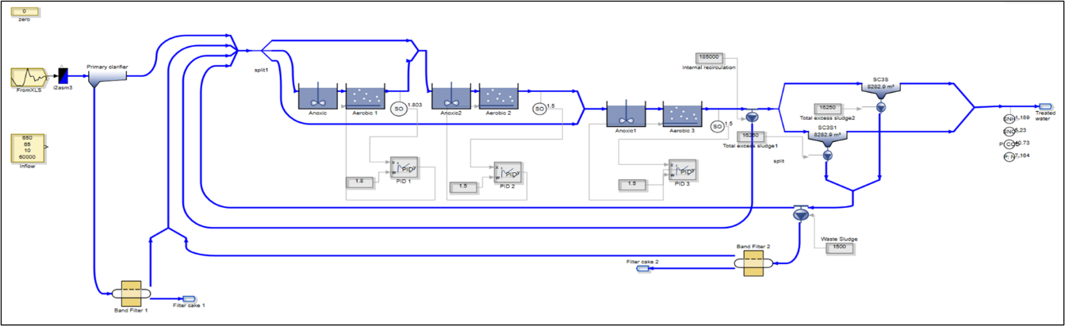

📷 Figure 5 — Alternative 2a: Step-feed SIMBA model layout showing three anoxic/aerobic tank pairs with distributed influent entry points and return sludge configuration
Source: Modelling_in_Sanitary.pptx — Slide 24 (Step Feed Model diagram) / Final_Report.docx — Figure 16

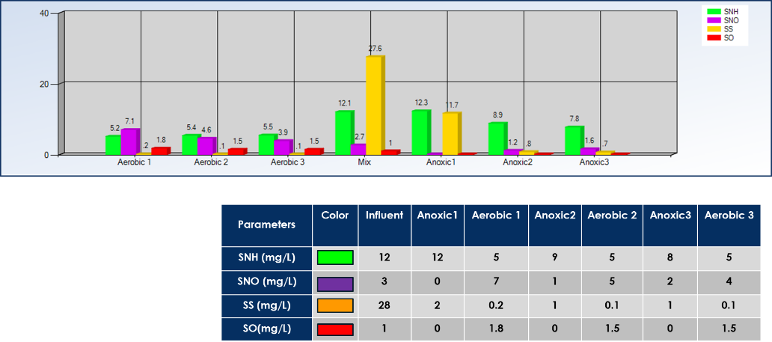
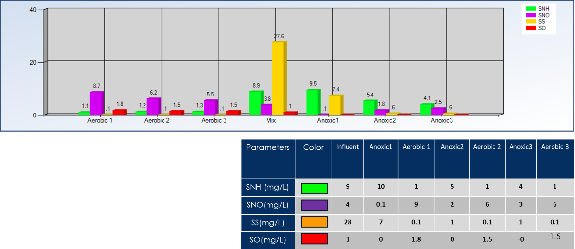
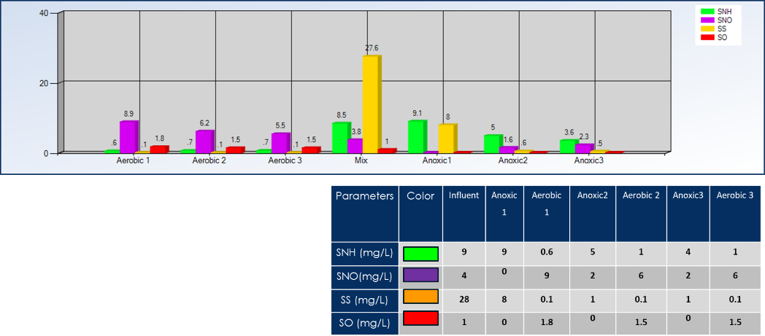
📷 Figure 6 — Alternative 2a: CSTR concentration profiles through the step-feed cascade at 8°C, 15°C, and 20°C — showing progressive nitrification/denitrification across all three stages
Source: Modelling_in_Sanitary.pptx — Slides 26–28 (Step Feed CSTR bar charts at three temperatures)

3.5 Alternative 2b — Step Feed with Relay & Switch Aeration Control
A relay-and-switch control block was added to the first nitrification tank's aeration system, triggered by the SNO concentration in the effluent. The switch-on threshold was set at SNO = 4.5 mg/L — a value that is active across all temperature scenarios in the step-feed configuration without control. When SNO exceeds 4.5 mg/L (indicating adequate nitrification is occurring), the relay reduces aeration, inducing a partial denitrification state within what would nominally be a nitrification tank. At 15°C and 20°C, biomass is naturally active and the relay engages frequently, saving significant aeration energy. At 8°C, the relay activates the higher O₂ supply (1.8 → 3.5 g O₂/m³) to compensate for reduced biological activity.

Parameter | Limit | 8°C + Relay/Switch | 15°C + Relay/Switch | 20°C + Relay/Switch
COD (mg/L) | ≤ 75 | 42 ✓ | 42 ✓ | 41 ✓
Ntot (mg/L) | ≤ 13 | 12 ✓ | 8 ✓ | 7 ✓
SNH (mg/L) | ≤ 10 | 8 ✓ | 2 ✓ | 1 ✓
O₂ at Aerobic 1 (mg/L) | — | 3.5 (increased) | 9.1 (relay ON) | 6.4 (relay ON)

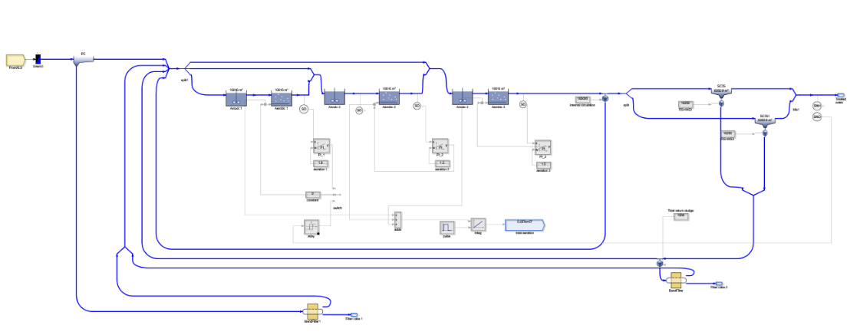
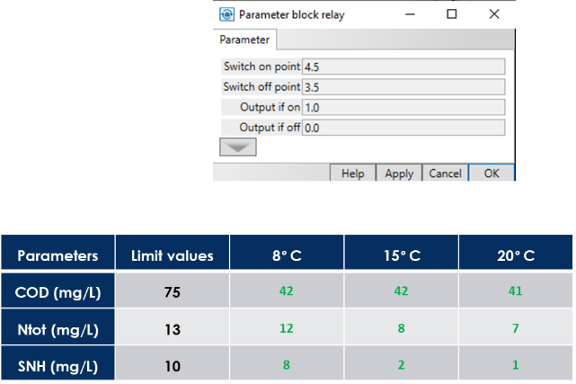
📷 Figure 7 — Alternative 2b: SIMBA model with relay-and-switch block at Nitrification Tank 1, showing SNO-triggered aeration control parameters (switch-on at SNO = 4.5 mg/L)
Source: Modelling_in_Sanitary.pptx — Slides 33–34 (Step Feed + Relay/Switch model and parameter settings)

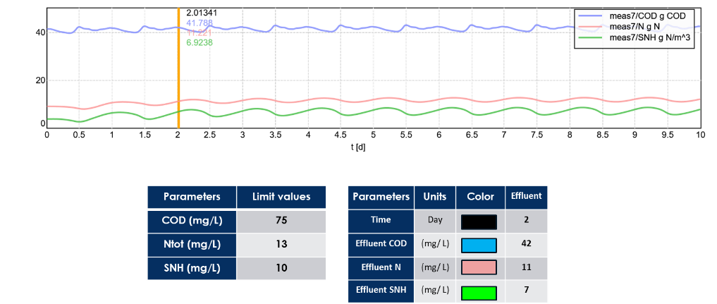
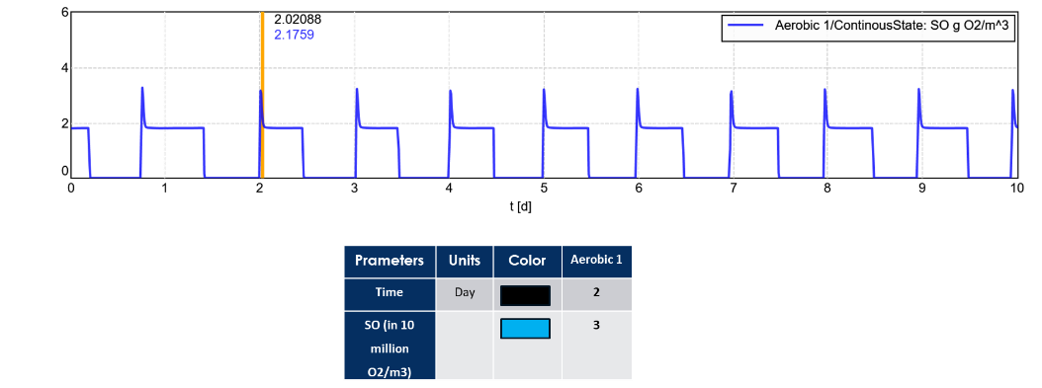

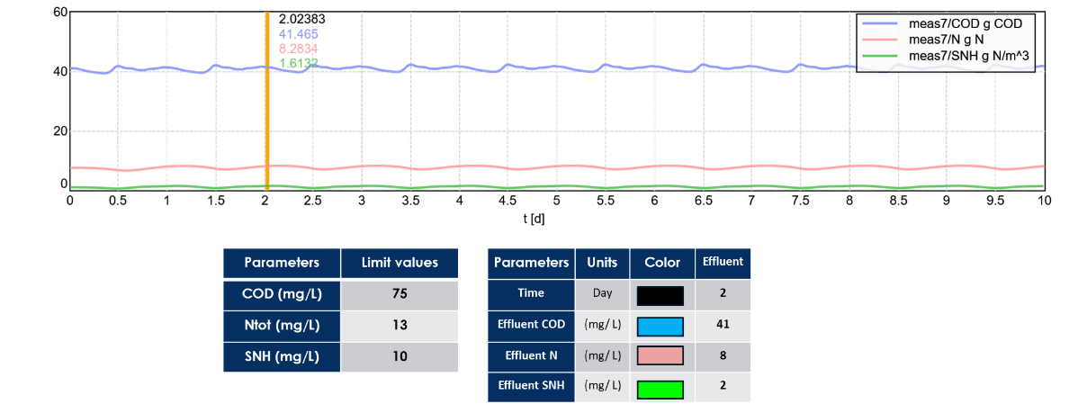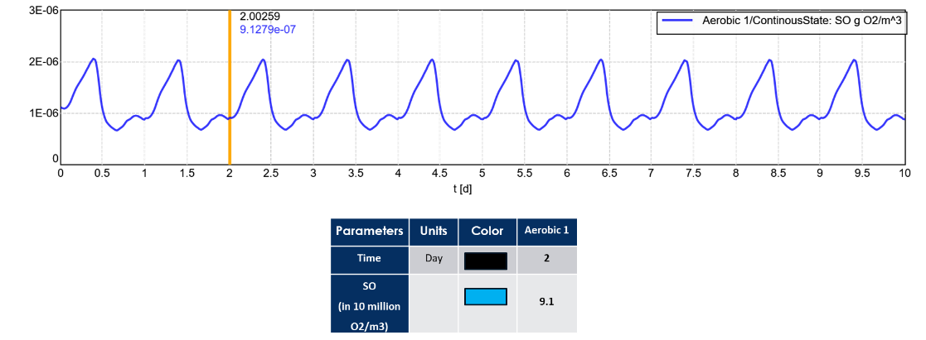
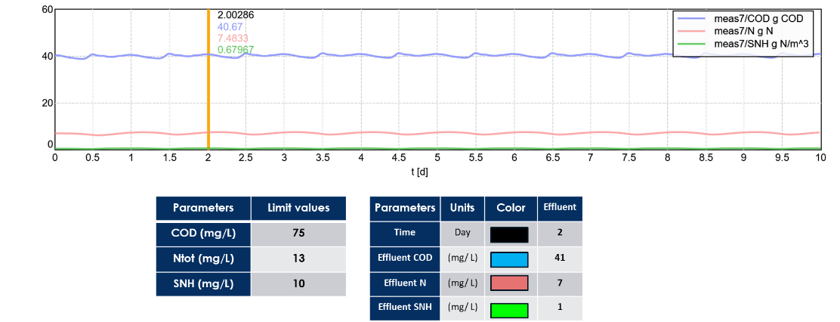
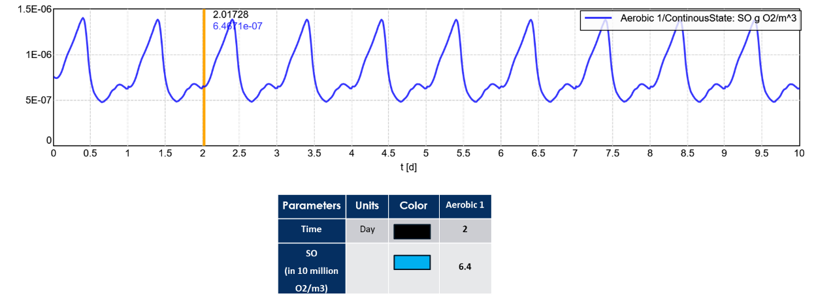

📷 Figure 8 — Alternative 2b: Dynamic effluent quality plots (COD, Ntot, SNH) and O₂ concentration at Aerobic Tank 1 under relay-and-switch control at 8°C, 15°C, and 20°C
Source: Modelling_in_Sanitary.pptx — Slides 35–40 (Effluent + O₂ plots at three temperatures)

4. KEY FINDINGS

4.1 Aeration Cost Comparison — Annual Economic Analysis
Aeration costs were calculated based on blower power consumption: 69.4 kW at 2,500 m³/h airflow, with linear power scaling and electricity at €0.15/kWh. Seasonal durations: Winter (8°C) = 90 days, Spring-Autumn (15°C) = 182 days, Summer (20°C) = 91 days.

Configuration | Alt-1: Modified Existing (€/yr) | Alt-2: Step Feed (€/yr) | Alt-3: Step Feed + Relay/Switch (€/yr)
8°C (winter) | 144,282 | 137,162 | 121,422
15°C (spring/autumn) | 335,784 | 320,045 | 290,813
20°C (summer) | 179,884 | 171,265 | 158,523
TOTAL annual cost | 659,952 | 628,472 | 570,759
Saving vs. Alt-1 | Baseline | −5% (−€31,480) | −13.5% (−€89,193)

Alternative 2b (Step Feed with Relay & Switch) delivers the highest savings at €570,759/year — a 13.5% reduction compared to the Modified Existing baseline. The savings are largest in the spring/autumn period, where the relay engages most frequently, reducing unnecessary constant aeration when biomass is naturally active at 15°C. The additional capital cost of implementing the step-feed reconfiguration (additional anoxic tank) is offset by the substantial ongoing aeration savings.

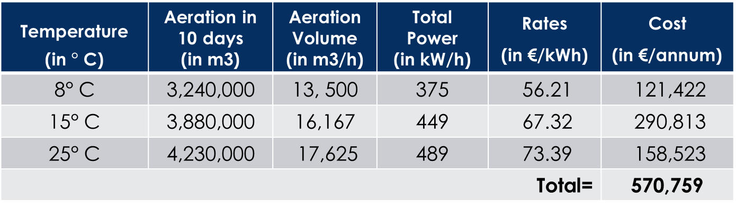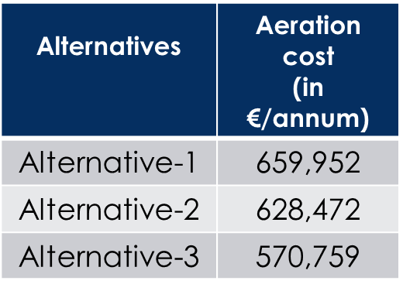
📷 Figure 9 — Aeration cost comparison bar chart: Annual aeration cost (€/year) for Alternative 1 (€659,952), Alternative 2a (€628,472), and Alternative 2b (€570,759), showing 5% and 13.5% savings
Source: Modelling_in_Sanitary.pptx — Slide 44 (cost comparison table + bar chart) / Final_Report.docx — Figure 29

4.2 Summary Comparison of All Configurations
Aspect | Alt-1: Modified Existing | Alt-2a: Step Feed | Alt-2b: Step Feed + Relay/Switch
Winter compliance (8°C) | ✓ All parameters met | ✓ All parameters met | ✓ All parameters met
Ntot at 8°C (mg/L) | 11 | 10 | 12
Ntot at 15/20°C (mg/L) | 10 | 7 | 7–8
Annual aeration cost (€) | 659,952 (baseline) | 628,472 (−5%) | 570,759 (−13.5%)
Sludge treatment cost | −40% vs. original (1,500 m³/d) | −40% vs. original | −40% vs. original
Physical modifications needed | None (control change only) | New anoxic tanks required | New tanks + control system
Complexity | Low | Medium | Medium-High
Recommended? | Minimum viable fix | Good improvement | ✓ OPTIMAL SOLUTION

5. CONCLUSION

This project demonstrates the power of SIMBA-based static and dynamic simulation in diagnosing and resolving a real-world WWTP performance failure. Five principal conclusions emerge.

- The root cause of the Lummerwald WWTP's winter failure is not a design flaw but a control parameter issue: excess sludge withdrawal at 2,500 m³/day prevents sufficient autotrophic biomass (XA) accumulation for nitrification at 8°C. Reducing withdrawal to 1,500 m³/day restores winter compliance with zero physical plant changes, simultaneously reducing sludge treatment costs by ~40%.
- The step-feed cascade configuration (Alternative 2a) provides superior nitrogen removal at all temperatures — reducing Ntot from 10–11 mg/L (Alt-1) to 7–10 mg/L — by creating multiple anoxic/aerobic stage pairs that each contribute to denitrification. The trade-off is higher capital investment for the additional anoxic tank infrastructure.
- The relay-and-switch aeration control (Alternative 2b) is the optimal solution overall: it achieves the same nitrogen removal performance as step-feed while cutting annual aeration costs by 13.5% (saving €89,193/year versus the modified baseline) by automatically reducing aeration when effluent SNO confirms that adequate biological activity is occurring, eliminating constant over-aeration at 15°C and 20°C.
- Dynamic simulation confirms that all three alternatives maintain effluent compliance under variable inflow conditions, validating the robustness of the proposed control strategies beyond steady-state analysis.
- Further performance improvements recommended include: anaerobic digestion of excess sludge to generate biogas revenue; optimising pipeline diameters in sludge recycle lines to maximise return sludge flow rates; and regular pump maintenance to sustain the 1,500 m³/day control set point. The SIMBA model's limitation to ASM3 (no phosphorus removal module) means P removal was not evaluated and would require additional investigation.

IMAGE EXTRACTION GUIDE FOR PORTFOLIO PAGE

All recommended images with exact source locations for the Lummerwald WWTP portfolio HTML page:

# | Description | Source File | Page / Slide
1 | Existing plant flow sheet (full WWTP layout) | Modelling_in_Sanitary.pptx | Slide 4
2 | Existing model CSTR analysis at 8°C (bar chart — nitrification failure) | Modelling_in_Sanitary.pptx | Slide 7
3 | CSTR profiles at 15°C and 20°C (working correctly) | Modelling_in_Sanitary.pptx | Slides 8–9
4 | Influent parameters table: XA collapse at 8°C vs 15/20°C | Modelling_in_Sanitary.pptx | Slides 11–12
5 | Alt-1: Modified model layout (sludge rate reduced) | Modelling_in_Sanitary.pptx | Slide 13
6 | Alt-1: Effluent quality comparison table (2500 vs 2000 vs 1500 m³/d) | Modelling_in_Sanitary.pptx | Slide 14
7 | Alt-1: CSTR bar chart at 8°C after modification (restored nitrification) | Modelling_in_Sanitary.pptx | Slide 17
8 | Alt-1: Dynamic simulation — effluent line graphs at 8°C/15°C/20°C | Modelling_in_Sanitary.pptx | Slides 18–21
9 | Alt-2a: Step feed model layout diagram | Modelling_in_Sanitary.pptx | Slide 24
10 | Alt-2a: Step feed CSTR profiles at 8°C, 15°C, 20°C | Modelling_in_Sanitary.pptx | Slides 26–28
11 | Alt-2a: Results comparison table (step feed vs modified existing) | Modelling_in_Sanitary.pptx | Slide 29
12 | Alt-2b: Step feed + relay/switch SIMBA model diagram | Modelling_in_Sanitary.pptx | Slide 33
13 | Alt-2b: Relay/switch parameter settings (SNO threshold = 4.5 mg/L) | Modelling_in_Sanitary.pptx | Slide 34
14 | Alt-2b: Effluent + O₂ concentration plots at 8°C, 15°C, 20°C | Modelling_in_Sanitary.pptx | Slides 35–40
15 | Economic analysis: Aeration cost tables for all 3 alternatives | Modelling_in_Sanitary.pptx | Slides 42–44
16 | Annual aeration cost comparison bar chart | Final_Report.docx | Figure 29 (Section 8)

