Re-Union — Circular Uniform Startup
A Circular Economy Startup: Uniform Rental, Repair & Recycling for Corporate India
IGCS–motan Workshop | Reduce | Re-Use | Recycle | Recover | 1st Place — University Competition
Event / Context | IGCS–motan Workshop: Reduce | Re-Use | Recycle | Recover
Organisation | Indo-German Centre for Sustainability (IGCS) in collaboration with motan GmbH
Date / Period | 2024 (Academic Year — Semester Project)
Role | Startup Founder & Presenter — Kabir Kundapur Sheik
Award / Recognition | 1st Place — University Startup Competition
Target Market | India — large corporates (5,000+ employees)
Business Model | Circular Economy — Uniform Rental, Repair, Recycle (B2B SaaS-style subscription)
Key Material | 100% Polyester (PET) uniforms — mono-material, mono-colour

1. PROJECT OVERVIEW

Re-Union is a circular economy startup concept developed by Kabir Kundapur Sheik as part of the IGCS–motan Workshop, a sustainability innovation competition jointly organised by the Indo-German Centre for Sustainability (IGCS) and motan GmbH. The startup won 1st place at the university-level competition.

The core idea is deceptively simple: instead of companies purchasing, owning, and eventually discarding work uniforms — which overwhelmingly end up in landfill — Re-Union offers a B2B subscription model where uniforms are rented, maintained (washed and repaired weekly), and at end-of-life, collected and sent to recycling facilities to be re-spun into new garments. The model closes the textile loop entirely.

The global fashion and textile industry generates approximately 92 million tonnes of waste annually, with about 87% ending up in landfill and only 1% recycled into new garments. The textile sector also produces around 42 million tonnes of plastic waste per year. Corporate uniforms are a concentrated, high-volume, mono-material subset of this problem — making them an ideal starting point for circular intervention.

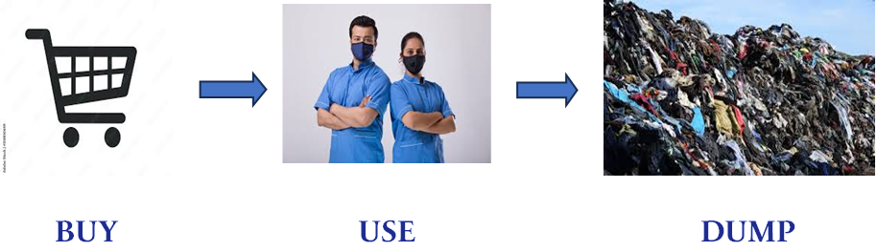

📷 Figure 1 — The Problem: Annual global textile waste statistics and the 'Buy–Use–Dump' linear model
Source: Uniforms_as_a_rental_.pdf — Pages 4–5 (Slides 4 and 5: global stats infographic + conventional model)

2. OBJECTIVES

Re-Union was designed to address four interlocking challenges:

- Divert corporate uniforms from landfill by creating a closed-loop rental and recycling system, eliminating the 'ownership and disposal' model.
- Exploit the material advantage of polyester (PET) uniforms — mono-material, mono-colour, and highly recyclable — to make post-consumer textile recycling economically viable at scale.
- Provide a cost-effective, hassle-free uniform management solution for large Indian corporations (5,000+ employees), converting a capital expenditure into a predictable operating expense.
- Strengthen corporate ESG profiles by embedding measurable circularity and reduced textile waste into clients' supply chains, enabling transparent sustainability reporting.

Why India? — Market Rationale
India generates approximately 9.4 million metric tonnes of plastic waste annually, with almost no post-consumer textile recycling infrastructure in place. With over 1.39 billion people and a rapidly growing corporate sector — including thousands of manufacturers employing 5,000+ workers who require uniforms — India represents an enormous untapped market for circular uniform services. The combination of scale, low recycling baseline, and growing ESG awareness among Indian corporates creates a compelling business case.

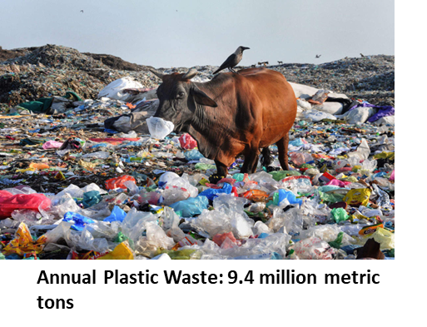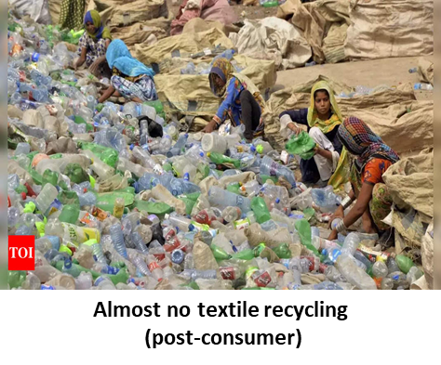
📷 Figure 2 — Why India? Plastic waste context and market opportunity
Source: Uniforms_as_a_rental_.pdf — Page 16 (last slide: India plastic waste statistics)

3. BUSINESS MODEL & METHODOLOGY

3.1 The Circular Model — Rent, Repair, Recycle
The Re-Union business model replaces the linear 'Buy–Use–Dump' chain with a six-step circular loop:

- Re-Union manufactures or procures 100% polyester (PET) uniforms and rents them to corporate clients under multi-year subscription contracts.
- Employees of the client company use the uniforms day-to-day.
- Re-Union collects the uniforms weekly for industrial laundering and any necessary repairs.
- Cleaned and repaired uniforms are returned to the client for continued use — extending garment life.
- At end of a garment's useful life, Re-Union collects and segregates the uniforms.
- The collected uniforms are sent to a recycling partner, where PET fibres are re-spun into new garments — closing the loop entirely.

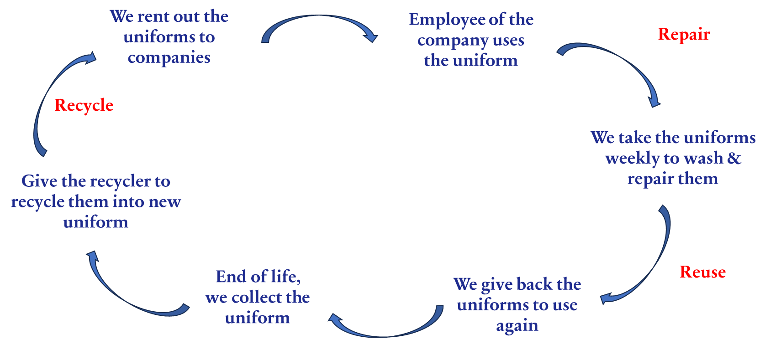

📷 Figure 3 — The Re-Union circular loop: Business execution diagram (Rent → Use → Repair → Reuse → Collect → Recycle → Rent)
Source: Uniforms_as_a_rental_.pdf — Page 8 (Slide 8: Business Execution circular flow diagram)

3.2 Why Polyester Uniforms? Material Selection Rationale
The choice of corporate uniforms as the product category was deliberate and grounded in material science logic. Three properties make polyester uniforms ideal for circular model implementation:

- Mono-material: Corporate uniforms are typically 100% polyester (PET), with no blended fibres — eliminating the sorting challenges that make most post-consumer textile recycling uneconomical.
- Mono-colour: Standard corporate uniforms are single-colour, simplifying the recycling process by removing the need for colour separation or bleaching steps.
- PET recyclability: Polyester (PET) is one of the most technically mature and economically viable materials to recycle. Crucially, recycling polyester from a homogeneous, readily available feedstock (used uniforms) is actually cheaper than producing virgin polyester — a fundamental economic driver for the model's viability.

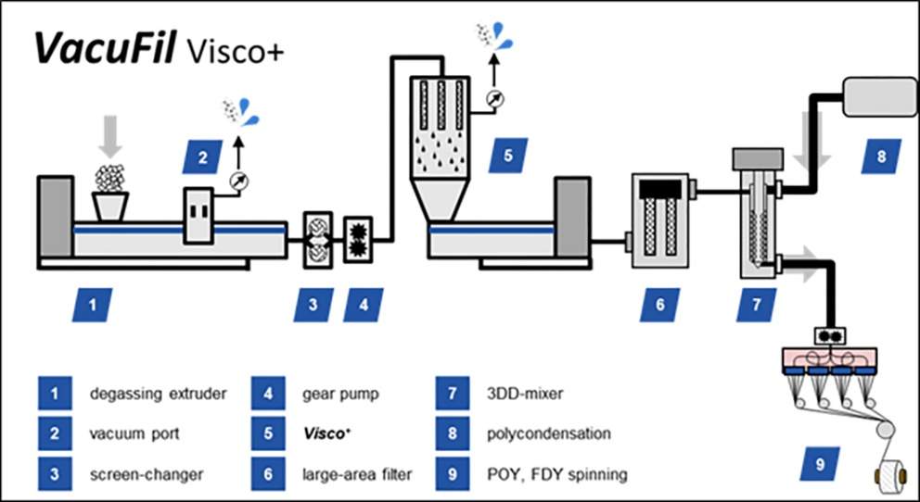
📷 Figure 4 — Recycling technology: PET mechanical recycling process diagram (degassing extruder through POY/FDY spinning)
Source: Uniforms_as_a_rental_.pdf — Page 9 (Slide 9: polyester recycling technology schematic)

3.3 Business Model Canvas
The full Business Model Canvas developed for Re-Union is summarised below:

Key Partners | Key Activities | Value Proposition | Customer Relationships | Customer Segments
Polyester garment suppliers Recycling facilities Industrial laundries Logistics providers | Manufacturing durable 100% recyclable uniforms Managing rental contracts & RFID inventory Weekly collection, washing & repair End-of-life recycling & re-spinning | Hassle-free all-inclusive uniform management Premium quality, consistently clean garments Fully circular model — old uniforms become new ones ESG reporting support for clients | Dedicated B2B account management Transparent sustainability reporting Direct sales to HR, Procurement & Sustainability teams | Large manufacturers (5,000+ employees) Companies with active ESG targets India-first, then global expansion
Cost Structure  Initial garment production (amortised over contract) Ongoing laundry, logistics & recycling expenses RFID/IT infrastructure and admin | Revenue Streams  Monthly subscription fee per employee (multi-year B2B contracts) Premium add-ons: specialised fabrics, faster turnaround, branded design Recycled fibre revenue at end-of-life

4. KEY FINDINGS

4.1 Unit Economics — Cost Per Employee Per Month
The financial model was built on a reference case of a company with 5,000 employees, each receiving 5 sets of uniforms with an assumed garment life of 2 years. The total subscription cost — covering garments, laundry, logistics, set replacement, admin, and a gross margin — was calculated as follows:

Cost Item | INR / month | EUR / month | % of Total
Garment cost | ₹ 104.17 | € 1.17 | 23%
Laundry cost | ₹ 160.00 | € 1.80 | 35%
Logistics cost | ₹ 20.00 | € 0.23 | 4%
Set cost | ₹ 10.42 | € 0.12 | 2%
Admin cost | ₹ 10.00 | € 0.11 | 2%
Gross margin | ₹ 152.29 | € 1.71 | 33%
TOTAL | ₹ 456.88 | € 5.14 | 100%

At ₹ 456.88 / € 5.14 per employee per month, the subscription model converts a large upfront capital expenditure (bulk uniform purchase) into a predictable, low monthly operating cost. The gross margin of 33% (₹ 152.29 / € 1.71 per employee per month) demonstrates a commercially viable business at this price point. Laundry cost represents the largest single cost component at 35%, followed by garment depreciation at 23%.

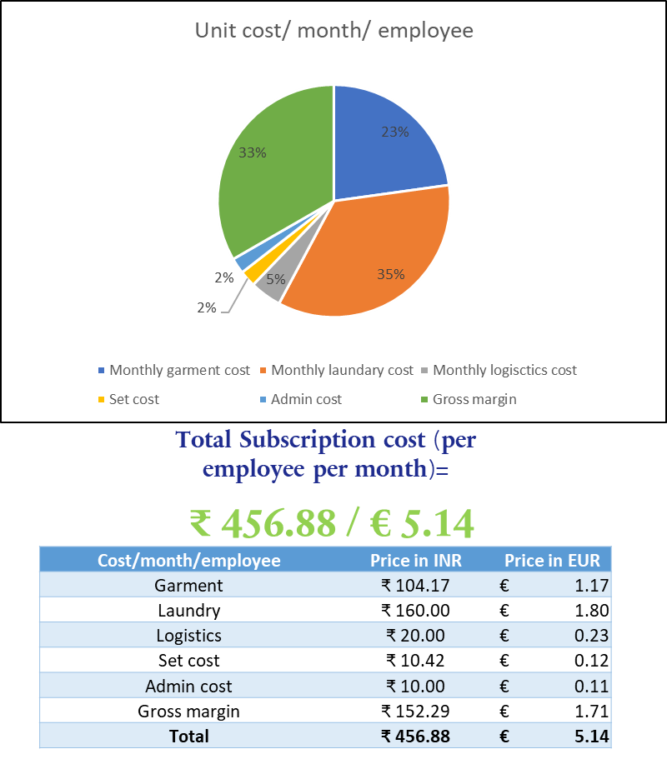

📷 Figure 5 — Unit economics: Cost breakdown pie chart and pricing table (cost per employee per month)
Source: Uniforms_as_a_rental_.pdf — Page 12 (Slide 12: unit economics pie chart + cost breakdown table)

4.2 Client Value Proposition — Advantages to Companies
Beyond the environmental benefits, Re-Union offers concrete operational and financial advantages to corporate clients:

- No upfront bulk purchase costs — the subscription model eliminates large one-time capital outlays and simplifies budgeting.
- Professional industrial laundering and maintenance — guaranteeing hygiene standards and uniform appearance consistency.
- Guaranteed fit and rapid replacements — reducing HR administrative burden around uniform management, especially for high-turnover workforces.
- Potentially branded, consistently high-quality uniforms — supporting corporate identity and employee confidence.
- Measurable sustainability and circularity — providing directly reportable ESG metrics, supporting clients' GRI, CSRD/ESRS, and UN SDG commitments without additional effort.

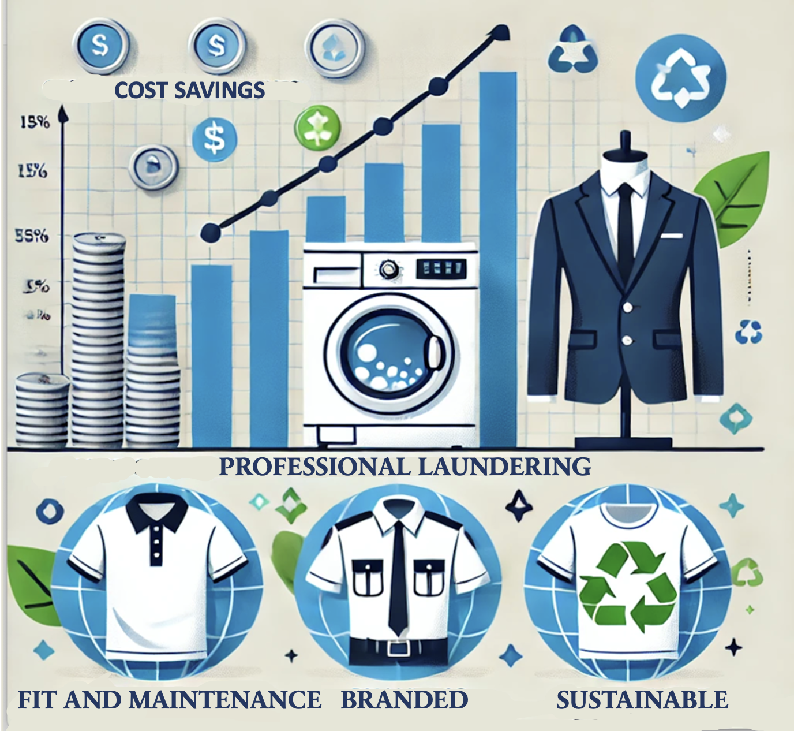
📷 Figure 6 — Advantages to companies: Cost savings, professional laundering, branded uniforms, sustainability benefits
Source: Uniforms_as_a_rental_.pdf — Page 13 (Slide 13: advantages infographic with cost savings / laundering / sustainable labels)

5. CONCLUSION

Re-Union demonstrates that a well-designed circular economy startup can simultaneously address a major environmental problem (textile waste), a commercial opportunity (corporate uniform management), and a material science advantage (PET recyclability) within a single, financially viable business model.

The key insight — that recycling polyester from a homogeneous, controlled feedstock is economically cheaper than virgin production — transforms the recycling step from a cost burden into a competitive advantage. This is a genuine circular economy case where the environmental and economic incentives are aligned, not in tension.

The project demonstrated proficiency in circular business model design, unit economics modelling, stakeholder value proposition development, and ESG-integrated strategic planning. The 1st place finish at the university competition validated both the commercial logic and the sustainability credentials of the concept.

Future development pathways identified include:

- Expansion of services to additional garment categories and geographies (Germany as a parallel market given its advanced recycling infrastructure).
- Technology integration — RFID tracking for real-time inventory and lifecycle monitoring of each garment.
- Strategic partnerships with recycling technology providers and industrial laundry networks.
- Advanced recycling innovation — exploring chemical (solvent-based) recycling alongside mechanical recycling to handle mixed-fibre contamination.
- Scaling logistics infrastructure to handle the collection and return cycles efficiently across multiple corporate campuses.

IMAGE EXTRACTION GUIDE FOR PORTFOLIO PAGE

All recommended images and their exact source locations for use when building the Re-Union portfolio HTML page:

# | Description | Source File | Page / Slide
1 | Global textile waste stats infographic | Uniforms_as_a_rental_.pdf | p. 4 (Slide 4)
2 | Conventional linear model: Buy–Use–Dump | Uniforms_as_a_rental_.pdf | p. 5 (Slide 5)
3 | Re-Union circular model diagram | Uniforms_as_a_rental_.pdf | p. 7 (Slide 7)
4 | Business execution circular flow (6-step loop) | Uniforms_as_a_rental_.pdf | p. 8 (Slide 8)
5 | PET recycling technology process diagram | Uniforms_as_a_rental_.pdf | p. 9 (Slide 9)
6 | Reasons for choosing uniforms (image + 3 points) | Uniforms_as_a_rental_.pdf | p. 10 (Slide 10)
7 | Unit economics pie chart + cost breakdown table | Uniforms_as_a_rental_.pdf | p. 12 (Slide 12)
8 | Advantages to companies infographic | Uniforms_as_a_rental_.pdf | p. 13 (Slide 13)
9 | Future plans image (recycling operations) | Uniforms_as_a_rental_.pdf | p. 14 (Slide 13/14)
10 | Why India? plastic waste context images | Uniforms_as_a_rental_.pdf | p. 16 (last slide)

