ELEVATE
Platform Design Reference
Supporting design material information architecture, feature scope,
user flows, and technical stack for the ELEVATE platform

Department of Information Technology
Walchand Institute of Technology, Solapur
Group No. B-07
Kabir Shitalkumar Patil (B-26)
Alok Shriniwas Perla (B-34)
Vidhi Jatinbhai Patel (B-23)
Rudraksh Rahul Vaidya (B-61)
Project Guide: Dr. Ms. D. D. Awasekar
Companion reference to the Project Synopsis — Academic Year 2026–2027

Contents

1. Page Inspirations 3
2. Information Architecture 4
3. Technology Stack & Feature Scope 6
4. Site Map 8
5. Student Journey Flow 9
6. Educator Course Builder Flow 10
7. Data & Storage Strategy 11
8. Domain Name Suggestions 12

Page Inspirations
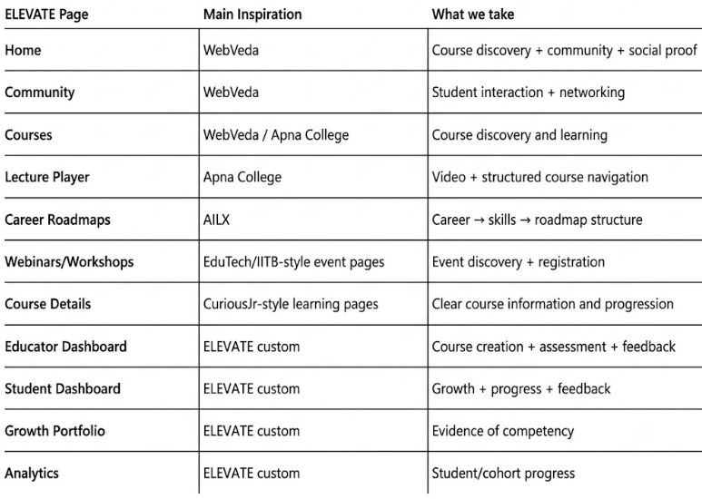

Pages

ELEVATE
│
├── PUBLIC
│ ├── Home
│ ├── Explore Courses / Growth Journeys
│ ├── Career Roadmaps
│ ├── Workshops & Webinars
│ ├── About ELEVATE
│ └── Login / Register
│
├── STUDENT — After Enrollment / Payment
│ ├── Dashboard
│ ├── My Learning / Growth Journeys
│ ├── Course / Lecture Player
│ ├── Activities & Assessments
│ ├── Feedback
│ ├── Growth Portfolio
│ ├── Community
│ ├── Workshops & Webinars
│ └── Profile
│
├── EDUCATOR
│ ├── Dashboard
│ ├── Journey / Course Builder
│ ├── Student & Submission Management
│ ├── Feedback & Analytics
│ └── Workshop Manager
│
└── ADMIN
├── Dashboard
├── User Management
├── Content & Journey Management
├── Events & Community Management
└── Platform Analytics

Proposed Stack
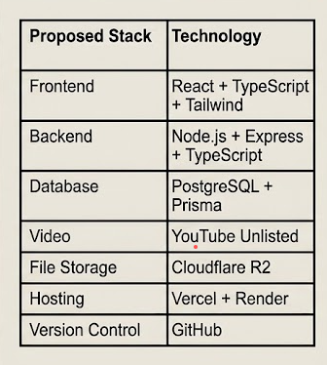

Actual Features
STUDENT
- Courses / Growth Journeys
- Lecture player
- Activities
- Assessments
- Feedback
- Career Roadmaps
- Community
- Workshops
- Growth Portfolio
- Progress Dashboard
EDUCATOR
- Create courses
- Create lessons
- Add YouTube lectures
- Create activities
- Create quizzes/tests
- Create rubrics
- Review submissions
- Give feedback
- Conduct workshops
- Student analytics
ADMIN
- User management
- Educator management
- Course management
- Event management
- Community moderation
- Platform analytics
COMMUNITY
- Posts
- Questions
- Comments
- Project showcase
- Collaboration
- Educator announcements

Page Map
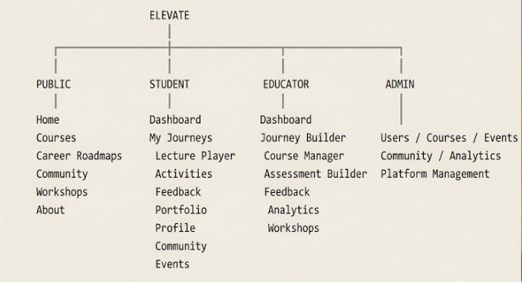

Student Journey
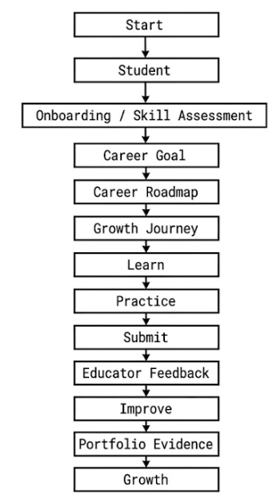

Educator Course Builder( Addition of new courses)
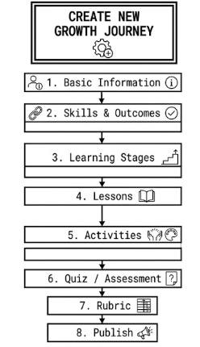

Storage Strategy
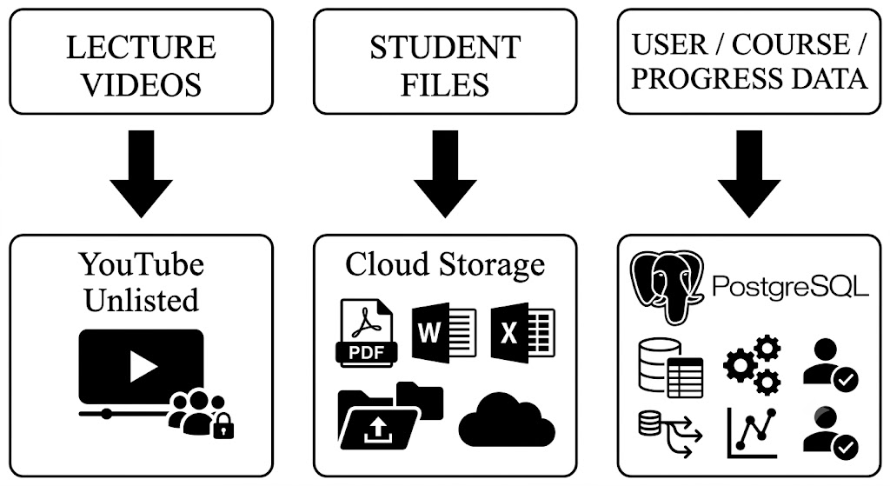

Domain Name Suggestions
Direct / Brand-first
Domain | Why it fits
elevateplatform.com | Clear, literal, safest pick for a formal submission or pitch.
getelevate.com | Common SaaS pattern (getslack.com-style); reads as an action to take.
joinelevate.com | Signals community + enrollment, fits the Growth Journey framing.
myelevate.app | .app TLD suits a product with a login-based dashboard experience.

Metaphor / positioning-led
Domain | Why it fits
elevategrowth.com | Foregrounds the 'Growth Journey' concept central to the pedagogy.
elevateyourjourney.com | Longer, but ties directly to the six-stage Growth Journey model.
elevatehub.io | Positions the platform as a central hub for learners, educators, and admins.
risewithelevate.com | Warmer, more human tone; works well for marketing/landing copy.

Short / modern TLDs
Domain | Why it fits
elevate.io | Short and tech-forward; common for product/dev-facing platforms.
elevate.co | Popular short alternative to .com when the .com is taken.
tryelevate.com | Low-commitment framing, good for a free-trial or beta landing page.

