DEPARTMENT OF INFORMATION TECHNOLOGY
WALCHAND INSTITUTE OF TECHNOLOGY, SOLAPUR
An Autonomous Institute | Affiliated to Solapur University

A PROJECT SYNOPSIS
Submitted in partial fulfillment of the requirements for the degree of
Bachelor of Technology in Information Technology
Design and Evaluation of an Educator-Led Experiential
Pedagogical Model and Personalized Digital Platform
for Holistic Student Growth

TEAM DETAILS — GROUP NO: B-07
Sr. | Name of Student | Roll No.
1. | Kabir Shitalkumar Patil | B-26
2. | Alok Shriniwas Perla | B-34
3. | Vidhi Jatinbhai Patel | B-23
4. | Rudraksh Rahul Vaidya | B-61

Project Guide: Dr. Ms. D. D. Awasekar | Academic Year: 2025–2026

1. Introduction & Background
The rapid expansion of digital infrastructure has fundamentally transformed the delivery of education and professional development. Modern learners expect flexible, personalized, and outcome-focused learning experiences that extend well beyond the passive consumption of recorded lectures. However, a persistent gap exists in the learning technology ecosystem: most platforms are either large-scale multi-vendor marketplaces optimized for content discovery, or heavyweight enterprise Learning Management Systems (LMS) that replicate the passive, content-centric model of traditional classrooms in digital form.
This project addresses that gap by proposing both a new pedagogical model and the digital platform that implements it. The pedagogical model — ELEVATE (Educator-Led Experiential Value and Life-skills Advancement Through Engagement) — is a six-stage structured learning framework grounded in experiential learning, mastery learning, and reflective practice. The platform serves as the implementation vehicle, enabling a single organizational content authority to design, deliver, and evaluate skill-development journeys for its learners.
The central departure from conventional LMS design is the unit of learning. Traditional platforms organize content into courses composed of video lessons and quizzes; the ELEVATE platform organizes content into Growth Journeys — structured sequences moving the learner from diagnostic self-assessment through educator-led instruction, experiential activity, multi-source feedback, authentic application, and reflective portfolio construction. The output is not a completion certificate but a documented, measurable evidence portfolio of skill development. The platform is domain-agnostic: the underlying data model supports academic instruction, professional certification, technical upskilling, and general life-skill development.
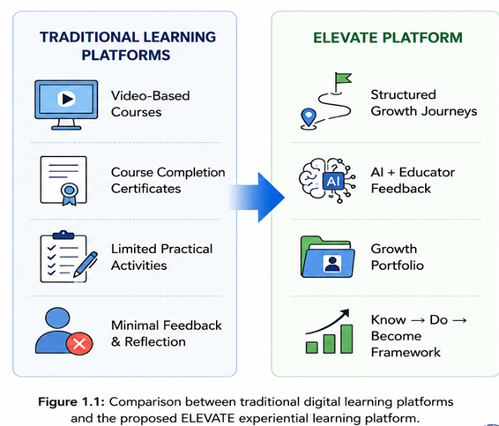
Figure 1.1: Comparison between traditional digital learning platforms and the proposed ELEVATE experiential learning platform.
2. Problem Statement
Engineering and professional education has long recognized a structural deficiency: the curriculum delivers technical knowledge but rarely develops the life skills, communication competencies, and professional capabilities that determine real-world success. Employer surveys consistently indicate that graduates are technically prepared but deficient in communication, leadership, critical thinking, and professional presence. Existing learning platforms fail to address this gap for the following reasons:
1. Passive Content-Centric Learning: Learning is limited to videos and quizzes with minimal practical application. There is no mechanism for learners to practise, receive structured feedback, or demonstrate applied competence.
2. Lack of Structured Experiential Learning: Students have limited opportunities to learn through guided activities, reflection, and hands-on experiences. No mainstream platform provides a structured activity-challenge-feedback cycle.
3. Limited Personalized Feedback: Most platforms provide generic assessments without continuous mentoring or individualized guidance. Educator insight is absent from the learning journey in most self-paced platforms.
4. Absence of Evidence-Based Skill Assessment: Course completion certificates do not demonstrate practical competencies. There is no platform-level mechanism to measure whether a learner has improved, and by how much, across a defined skill dimension.
5. Poor Support for Holistic Student Development: Technical knowledge is prioritized while communication, leadership, teamwork, and life skills receive limited attention. The prevalent model is binary — a learner has either completed a course or not — providing no information about the depth, quality, or trajectory of learning.
The problem is therefore not merely technological but pedagogical: there is a need for a platform built on an educationally principled model that moves beyond content delivery to structured, measurable, experiential growth.
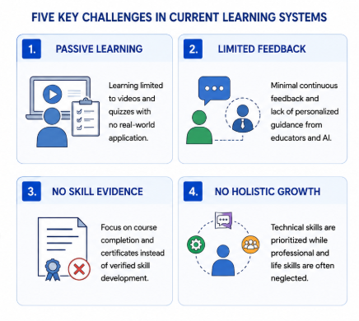
Figure 2.1: Five key challenges identified in current digital learning systems.
3. Objectives
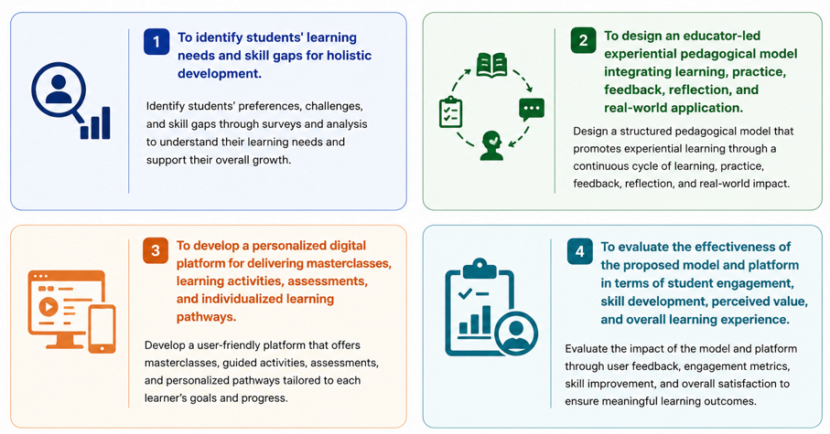
Figure 3.1: The four primary objectives of the ELEVATE project (as approved in the final synopsis presentation).
The objectives, formally stated, are as follows:
1. To identify students' learning needs and skill gaps for holistic development. Identify students' preferences, challenges, and skill gaps through surveys and analysis to understand their learning needs and support their overall growth.
2. To design an educator-led experiential pedagogical model integrating learning, practice, feedback, reflection, and real-world application. Design a structured pedagogical model promoting experiential learning through a continuous cycle — formalized as the six-stage ELEVATE Framework (Explore → Learn → Experience → Validate → Apply → Transform).
3. To develop a personalized digital platform for delivering masterclasses, learning activities, assessments, and individualized learning pathways. Develop a user-friendly platform offering masterclasses, guided activities, assessments, and personalized pathways, including a multi-source feedback pipeline (AI-assisted + educator rubric + peer review) and a Growth Portfolio subsystem.
4. To evaluate the effectiveness of the proposed model and platform in terms of student engagement, skill development, perceived value, and overall learning experience. Evaluate the impact through user feedback, engagement metrics, and skill improvement, applying the Know → Do → Become measurement framework for pre- and post-journey outcome assessment.
4. Student Learning Survey & Needs Analysis
A structured survey was conducted among 39 student respondents to identify learning preferences, skill gaps, and expectations from a personalized, educator-led learning platform. The findings directly informed the design of the ELEVATE model and platform features. Key findings are summarized below:
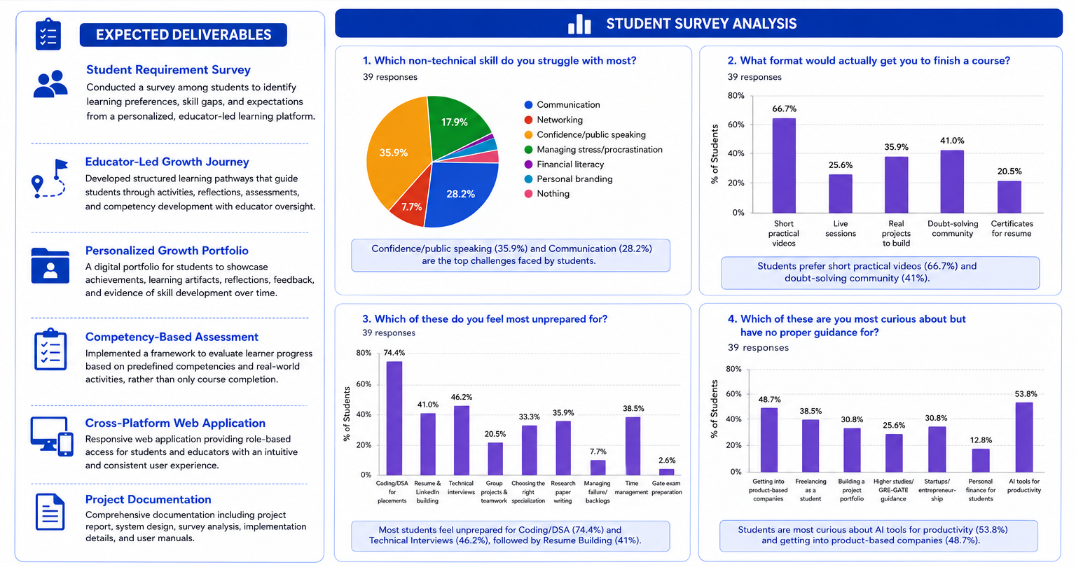
Figure 4.1: Student Survey Analysis — skill gaps, preferred learning formats, preparedness levels, and areas of curiosity (n = 39).
• Confidence/public speaking (35.9%) and Communication (28.2%) are the top non-technical skill challenges.
• Students prefer short practical videos (66.7%) and doubt-solving communities (41%) to complete courses.
• Most students feel unprepared for Coding/DSA (74.4%) and Technical Interviews (46.2%), followed by Resume Building (41%).
• Students are most curious about AI tools for productivity (53.8%) and getting into product-based companies (48.7%) but lack guidance.
These findings validate the need for a structured, educator-led experiential platform addressing life-skill development, technical preparedness, and personalized guidance — precisely the problem space ELEVATE is designed to solve.
5. Literature Survey
5.1 Existing Learning Platform Paradigms
Learning delivery systems in current use can be classified into two principal categories, neither of which satisfactorily addresses the pedagogical requirements of this project:
• Multi-Vendor Marketplaces (Udemy, Coursera, edX): These platforms aggregate content from many independent instructors, optimized for content discovery. They cannot support an educator-led, activity-centered, feedback-driven pedagogy; content is linear video sequences with optional quizzes. There is no mechanism for submission, rubric-based feedback, or Growth Portfolio construction [7][8].
• Single-Owner LMS Platforms (Moodle, TalentLMS, Docebo): These platforms support a single content authority managing its own learner population but replicate the passive content model. They do not implement a structured experiential pedagogy, do not provide a multi-source AI + educator feedback pipeline, and do not produce growth portfolios as learning outputs [4][5][6].
5.2 Structured Review of Related Literature
The following table presents a structured review of key foundational works, their strengths, limitations, identified research gaps, and how ELEVATE addresses each gap (IEEE format):
# | Research Paper / Author (Year) | Strength | Limitations | Research Gap | How ELEVATE Addresses the Gap
[1] | Kolb, D. A. (1984)  Experiential Learning: Experience as the Source of Learning and Development | Introduced the experiential learning cycle (Concrete Experience → Reflective Observation → Abstract Conceptualization → Active Experimentation). | No digital implementation. Does not address tools for tracking learner progress and competency development. | Need for a digital platform that operationalizes the experiential learning cycle with structured activities, reflection, and feedback. | ELEVATE implements Growth Journeys with experiential activities, reflection journals, educator feedback, and competency tracking.
[2] | Bloom, B. S. (1956)  Taxonomy of Educational Objectives: Handbook I – Cognitive Domain | Provides a hierarchical framework for classifying learning objectives in the cognitive domain. | Focuses mainly on the cognitive domain. Does not address affective, psychomotor, or holistic skill development. | Need for an approach that addresses holistic development across technical, professional, and life skills. | ELEVATE integrates technical, professional, and life skills in learning pathways targeting multiple skill domains.
[3] | Schön, D. A. (1983)  The Reflective Practitioner: How Professionals Think in Action | Highlights the importance of reflection-in-action and reflection-on-action for professional growth. | Does not provide digital tools or mechanisms to facilitate and monitor reflection systematically. | Need for digital support for guided reflection and feedback within learning platforms. | ELEVATE provides reflection journals, guided prompts, and educator feedback, making reflection a continuous and measurable part of learning (Transform stage).
[4] | Dabbagh & Kitsantas (2012)  Personal Learning Environments, Social Media, and Self-Regulated Learning. The Internet and Higher Education, vol. 15, no. 1, pp. 3–8 | Emphasizes self-regulated learning and the role of personal learning environments in fostering learner autonomy. | Limited focus on structured educator involvement. Lacks mechanisms for continuous feedback and personalized guidance. | Need for an educator-led approach combining self-regulation with personalized guidance and continuous feedback. | ELEVATE combines self-regulated learning with active educator mentorship, feedback, and personalized learning pathways.
[5] | Siemens, G. (2005)  Connectivism: A Learning Theory for the Digital Age. Int'l Journal of Instructional Technology & Distance Learning, vol. 2, no. 1 | Highlights the importance of networks, connections, and digital resources for learning in the digital age. | Limited emphasis on competency assessment and measurable learning outcomes. | Need for measurable skill development and evidence-based assessment in networked learning environments. | ELEVATE uses competency-based assessments, real-world activities, and growth portfolios to track measurable skill development.
[6] | Hattie & Timperley (2007)  The Power of Feedback. Review of Educational Research, vol. 77, no. 1, pp. 81–112 | Establishes that timely, specific feedback is among the most impactful teaching interventions. | Focuses on theoretical models; does not address automated or AI-assisted feedback mechanisms. | Need for scalable, real-time, structured feedback mechanisms that deliver educator-quality feedback at scale. | ELEVATE's multi-source feedback pipeline (AI + educator rubric + peer review) operationalizes the power of feedback at platform scale.
[7] | Ifenthaler & Yau (2020)  Utilizing Learning Analytics to Support Study Success in Higher Education. ETR&D, vol. 68, no. 4, pp. 1961–1973 | Demonstrates that learning analytics significantly improve student outcomes when used for personalized support and early intervention. | Focuses on institutional-level analytics; learner-facing dashboards and individual growth tracking remain underexplored. | Need for learner-facing growth analytics dashboards embedded within the learning journey itself. | ELEVATE's Progress Dashboard and Growth Portfolio give learners real-time visibility into their learning trajectory and skill development evidence.
Table 5.1: Structured Literature Review — Research Gap Analysis and ELEVATE's Proposed Contributions (IEEE Format).
5.3 Identified Research Gap
The academic literature and commercial product landscape together reveal a consistent gap: no existing platform combines (a) an educator-led, six-stage experiential pedagogical model, (b) AI-assisted multi-source feedback on practice submissions, and (c) a Growth Portfolio as the primary learning artifact, within a single organizational platform designed for life-skill and professional development. This project directly addresses that gap.
6. Proposed Architecture & Methodology
6.1 The ELEVATE Pedagogical Model — Six-Stage Framework
ELEVATE structures every Growth Journey into six sequential pedagogical stages. Unlike a course-and-lesson hierarchy, a Growth Journey is a unit of measurable skill development with a defined entry state (Learner Growth Profile from the diagnostic), a structured progression through six stages, and a defined exit artifact (the Growth Portfolio). The six stages are:
Stage 1 — EXPLORE — Diagnostic Assessment: Before beginning a Growth Journey, the learner completes a structured diagnostic assessment that establishes the Learner Growth Profile — capturing current competency level, prior experience, hesitation areas, and personal goals — providing a measurable baseline for pre/post comparison.
Stage 2 — LEARN — Educator-Led Learning Capsules: Rather than passive hour-long video lectures, the Learn stage delivers focused 8–15 minute educator-led learning capsules: concept demonstrations, experience-based stories, practical frameworks, and case situations, authored and curated by the organizational educator.
Stage 3 — EXPERIENCE — Activity Challenge: Every learning capsule is followed by an activity challenge requiring the learner to perform the skill, not merely understand it. Submissions may be video recordings, written documents, or structured responses depending on the skill domain.
Stage 4 — VALIDATE — Multi-Source Feedback: Submitted activities are assessed through a multi-source feedback pipeline: AI-assisted analysis (structure, clarity, pacing, language quality), educator rubric scoring, and optional peer feedback. Learners may iterate on their submission before advancing, consistent with the mastery learning principle.
Stage 5 — APPLY — Authentic Task: The learner transitions from practice activity to an authentic, real-world application. This stage closes the gap between classroom practice and real-world demonstration (e.g., updating a professional profile after a personal branding learning capsule).
Stage 6 — TRANSFORM — Growth Portfolio: The learner reflects on their journey and curates a Growth Portfolio: before-state diagnostic results, activity submissions, feedback received, revisions made, final artifact, and self-reflection. The portfolio becomes the primary credential artifact, demonstrably stronger than a completion certificate.
6.2 Know → Do → Become Measurement Framework
Every Growth Journey measures learner progress across three dimensions through pre- and post-journey assessments:
• KNOW — Conceptual Understanding: Measured through pre- and post-diagnostic assessments, quiz scores, and concept checks.
• DO — Demonstrated Performance: Measured through activity challenge submissions evaluated against the educator rubric.
• BECOME — Measurable Behavioral Growth: Measured through before/after portfolio comparison, final artifact quality, and rubric improvement scores across iterations.
6.3 System Architecture
The platform follows a client-server architecture with clear separation between the Learner Module and the Administrative Module, communicating through a RESTful API layer. The system is designed as a modular monolith with a componentized React.js SPA frontend, Node.js + Express.js backend, a core services layer (Authentication, Growth Journey, Assessment, AI Feedback, Portfolio, Analytics), and a persistent data layer (PostgreSQL + Cloud Storage). Figure 6.1 below presents the approved system architecture.
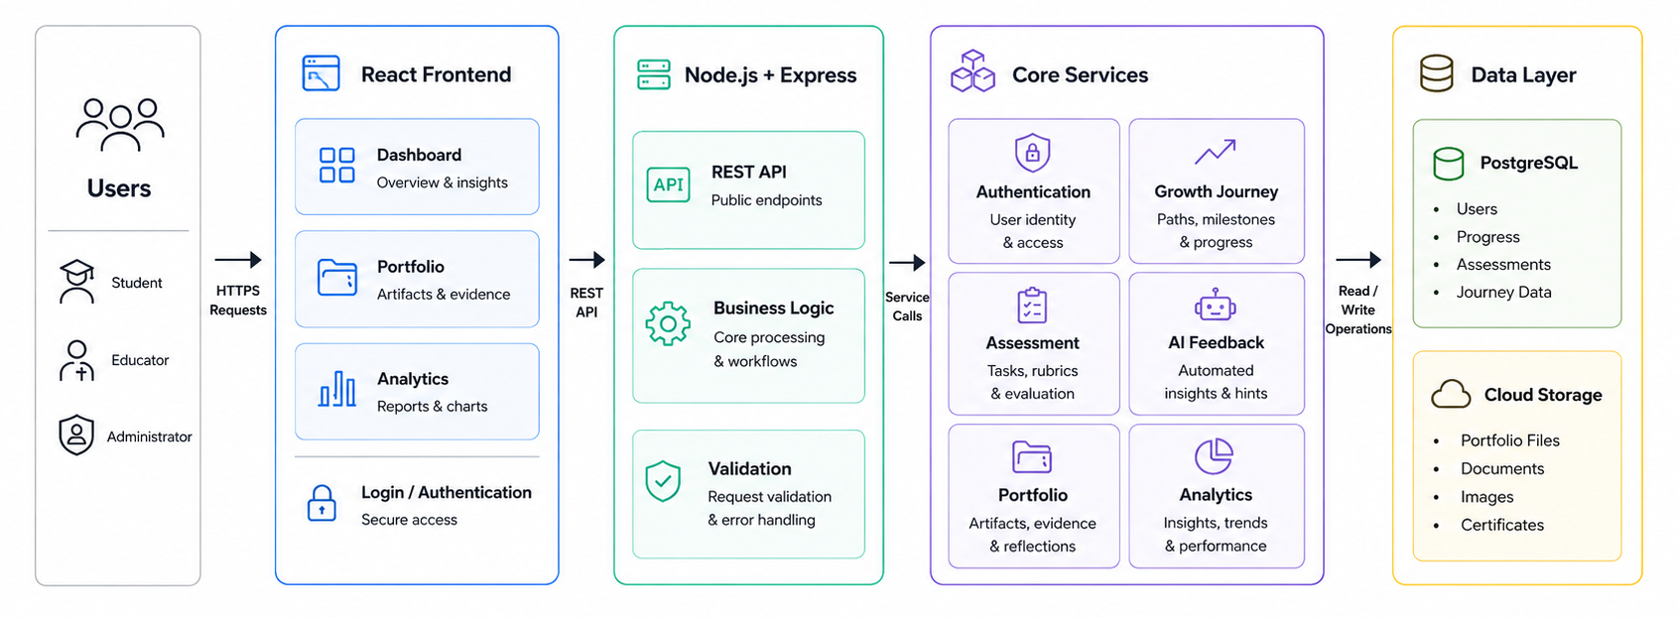
Figure 6.1: ELEVATE System Architecture — React Frontend, Node.js + Express API, Core Services, and Data Layer.
6.4 Core System Modules
• User Authentication and Role Management: Learner / Admin / Educator roles with JWT-based stateless authentication and Role-Based Access Control (RBAC).
• Learner Growth Profile: Diagnostic engine and personalization logic based on the learner's initial competency state.
• Journey and Stage Management (Admin): Authoring Growth Journeys with per-stage configuration, content, and rubric setup.
• Learning Capsule Delivery: Educator-led content playback in 8–15 minute focused capsules.
• Activity Submission System: File/video/text submission with status tracking and revision support.
• ELEVATE Feedback Pipeline: AI analysis, rubric scoring, and peer review orchestration.
• Growth Portfolio Builder: Evidence aggregation, before/after comparison, and skill badge issuance.
• Progress Dashboard (Learner): Journey stage status, feedback summary, and portfolio view.
• Administrative Dashboard: Journey analytics, submission queues, and learner cohort monitoring.
6.5 Development Methodology
Development will proceed under an iterative, phase-wise methodology aligned to the ELEVATE model's architectural layers:
• Phase 1 — Requirement Analysis: Formalizing functional and non-functional requirements from the ELEVATE pedagogical specification and representative organizational use cases.
• Phase 2 — System Design: Designing the database schema, API contracts, ELEVATE Engine logic, and UI component architecture for both the learner and administrative interfaces.
• Phase 3 — Implementation: Developing in incremental modules: Authentication & Roles → Diagnostic & Profile → Journey & Stage Management → Capsule Delivery → Activity Submission → Feedback Pipeline → Portfolio Builder → Dashboards.
• Phase 4 — Testing: Functional, integration, and usability testing of each module, followed by end-to-end growth journey simulation testing.
• Phase 5 — Pedagogical Evaluation: Pre/post assessment comparison with a learner cohort to evaluate whether ELEVATE produces measurably better skill-development outcomes than conventional content-centric learning, providing the empirical validation component of the project.
7. Hardware & Software Requirements
The table below specifies the hardware and software requirements for the ELEVATE platform. Technology stack selections (marked as candidate) will be finalized during detailed design.
COMPONENT | TECHNOLOGY / REQUIREMENT
Operating System | Windows 10/11, macOS, or Linux (development); Linux-based container image (deployment)
Programming Architecture | Client-server; RESTful API-based modular monolith; componentized frontend (SPA)
Frontend Framework | React.js; component-based SPA with role-based routing
Backend Framework | Node.js with Express.js; alternative: Django REST Framework (Python)
AI Feedback Component | NLP/ML pipeline for submission analysis (OpenAI API or custom model)
Database Management | PostgreSQL (relational) or MongoDB (document-oriented), selected in detailed design
Auth & Authorization | JWT-based stateless authentication; Role-Based Access Control (RBAC) — Learner / Educator / Admin
File/Media Storage | Cloud object storage for activity submissions (AWS S3 / Firebase Storage)
Version Control & CI/CD | Git / GitHub; automated build/test pipeline (GitHub Actions)
Hosting / Deployment | Containerized deployment (Docker) on cloud IaaS/PaaS (AWS / Azure / Render)
Development Hardware | Intel i5-class or higher; 8 GB RAM minimum (16 GB recommended); 256 GB SSD
Table 7.1: Hardware & Software Requirements for the ELEVATE Platform.
8. Expected Deliverables
01. ELEVATE Pedagogical Model Specification: A formal description of the six-stage framework (Explore → Learn → Experience → Validate → Apply → Transform), its theoretical foundations, and its operationalization within the digital platform.
02. Student Requirement Survey Report: A documented analysis of learning preferences, skill gaps, and expectations gathered from student respondents, validating the platform design decisions.
03. Cross-Platform Web-Based ELEVATE Platform Prototype: A fully functional prototype implementing all six pedagogical stages across at least two Growth Journeys, with role-based access for Student, Educator, and Administrator.
04. Learner Growth Profile Subsystem: Diagnostic engine, personalization logic, and profile dashboard capturing the learner's initial competency state.
05. Educator-Led Growth Journey Feature: Structured learning pathways guiding students through activities, reflections, assessments, and competency development with educator oversight.
06. Activity Submission and Multi-Source Feedback Pipeline: AI analysis, educator rubric scoring, and peer feedback components for structured, actionable feedback on learner submissions.
07. Personalized Growth Portfolio Builder: Evidence aggregation, before/after comparison, and skill badge issuance; a digital portfolio for students to showcase achievements, learning artifacts, reflections, and evidence of skill development over time.
08. Competency-Based Assessment Framework: A framework evaluating learner progress based on predefined competencies and real-world activities, rather than only course completion.
09. Administrative Interface: Journey authoring, stage configuration, learner management, submission queues, and analytics dashboard.
10. Pedagogical Evaluation Report: Pre/post assessment results from a learner cohort comparing ELEVATE-based outcomes against a baseline, providing empirical validation of the pedagogical model.
11. Complete Project Documentation: Architecture diagrams, database schema, API specification, test cases, system design documents, survey analysis, implementation details, and user manuals.
9. References
References are formatted in accordance with the IEEE Citation Style.
[1] D. A. Kolb, Experiential Learning: Experience as the Source of Learning and Development. Englewood Cliffs, NJ, USA: Prentice Hall, 1984. [Online]. Available: https://www.pearson.com/en-us/subject-catalog/p/Kolb-Experiential-Learning/P200000000384
[2] B. S. Bloom, Taxonomy of Educational Objectives: Handbook I — Cognitive Domain. New York, NY, USA: David McKay, 1956. [Online]. Available: https://archive.org/details/taxonomyofeducat00bloo
[3] D. A. Schön, The Reflective Practitioner: How Professionals Think in Action. New York, NY, USA: Basic Books, 1983. [Online]. Available: https://books.google.com/books/about/The_Reflective_Practitioner.html
[4] N. Dabbagh and A. Kitsantas, "Personal Learning Environments, Social Media, and Self-Regulated Learning: A Natural Formula for Connecting Formal and Informal Learning," The Internet and Higher Education, vol. 15, no. 1, pp. 3–8, 2012. doi: 10.1016/j.iheduc.2011.06.002
[5] G. Siemens, "Connectivism: A Learning Theory for the Digital Age," International Journal of Instructional Technology and Distance Learning, vol. 2, no. 1, 2005. [Online]. Available: http://www.itdl.org/Journal/Jan_05/article01.htm
[6] J. Hattie and H. Timperley, "The Power of Feedback," Review of Educational Research, vol. 77, no. 1, pp. 81–112, 2007. doi: 10.3102/003465430298487
[7] D. Ifenthaler and J. Y.-K. Yau, "Utilizing Learning Analytics to Support Study Success in Higher Education," Educational Technology Research and Development, vol. 68, no. 4, pp. 1961–1973, 2020. doi: 10.1007/s11423-020-09788-z
[8] UNESCO, Reimagining Our Futures Together: A New Social Contract for Education. Paris, France: UNESCO Publishing, 2021. [Online]. Available: https://unesdoc.unesco.org/ark:/48223/pf0000379707
[9] A. Warikoo, WebVeda Learning Platform. [Online]. Available: https://webveda.com
[10] React Documentation. [Online]. Available: https://react.dev
[11] Moodle Learning Management System Documentation. [Online]. Available: https://docs.moodle.org
[12] TalentLMS Platform Overview. [Online]. Available: https://www.talentlms.com

________________________________________  Signatures of Students  Kabir Patil (B-26) · Alok Perla (B-34)  Vidhi Patel (B-23) · Rudraksh Vaidya (B-61) | ________________________________________  Signature of Guide  Dr. Ms. D. D. Awasekar  Dept. of Information Technology, WIT Solapur

