**Ques 1:**



**Observation:** Initially as both x0 and b are zero so we only get one number that is 0, but as

We increase x0 we start to get 10 numbers for every value of x0 till 10 when (a, b, m) = (6, 0, 11).

Same is the case for (a, b, m) = (3, 0, 11) but as x0 go beyond 0 we start to get 5 distinct values

before repetition starts.

**Ques 2:**

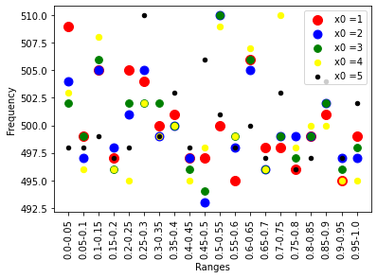

Observation: (I found that scatter plots give better intuition of what is happening for different values of x0, so I chose this) All of the values lie in a very close range that is (493, 510), there is max error of 6-7 in same ranges for different x0 and in different ranges for same x0.

**Ques 3:**

