- Overall Crime Statistics Dashboard:
    - For personnel and resource management, the department needs to understand the count and types of crimes reported across the city. Mark the locations on a geo-map highlighting the locations with recent criminal history.
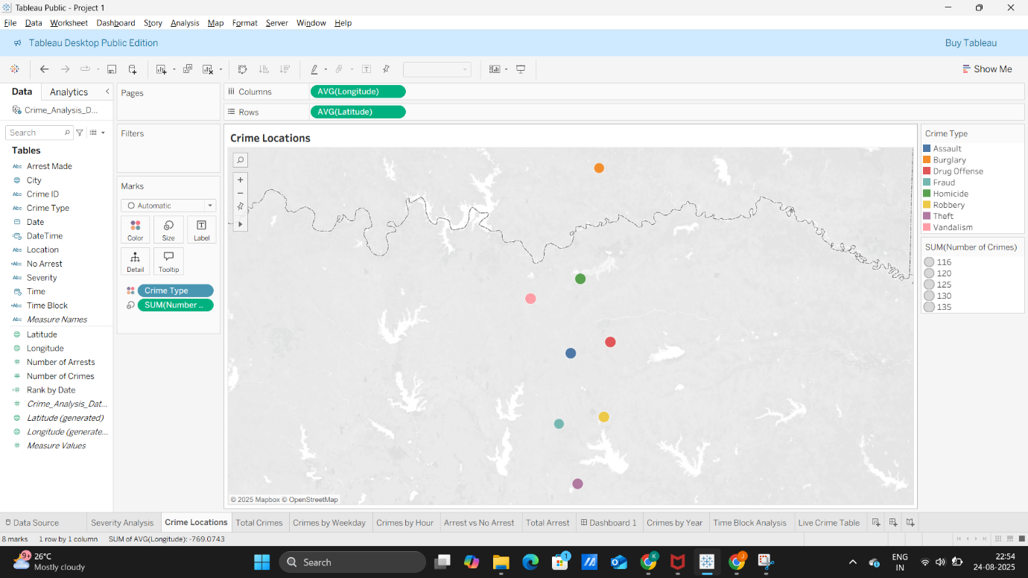
    - Identify the most common criminal incidents reported
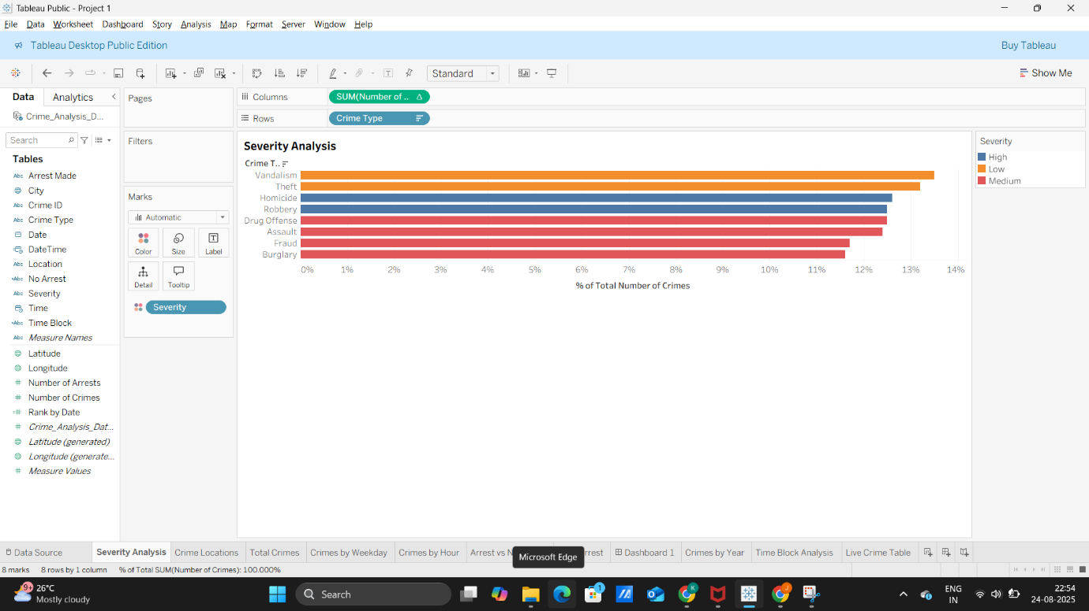
    - In this introductory dashboard, include a live crime feed to exhibit the total number of crimes reported to date for the current year and the most recently reported crimes with their time and locations
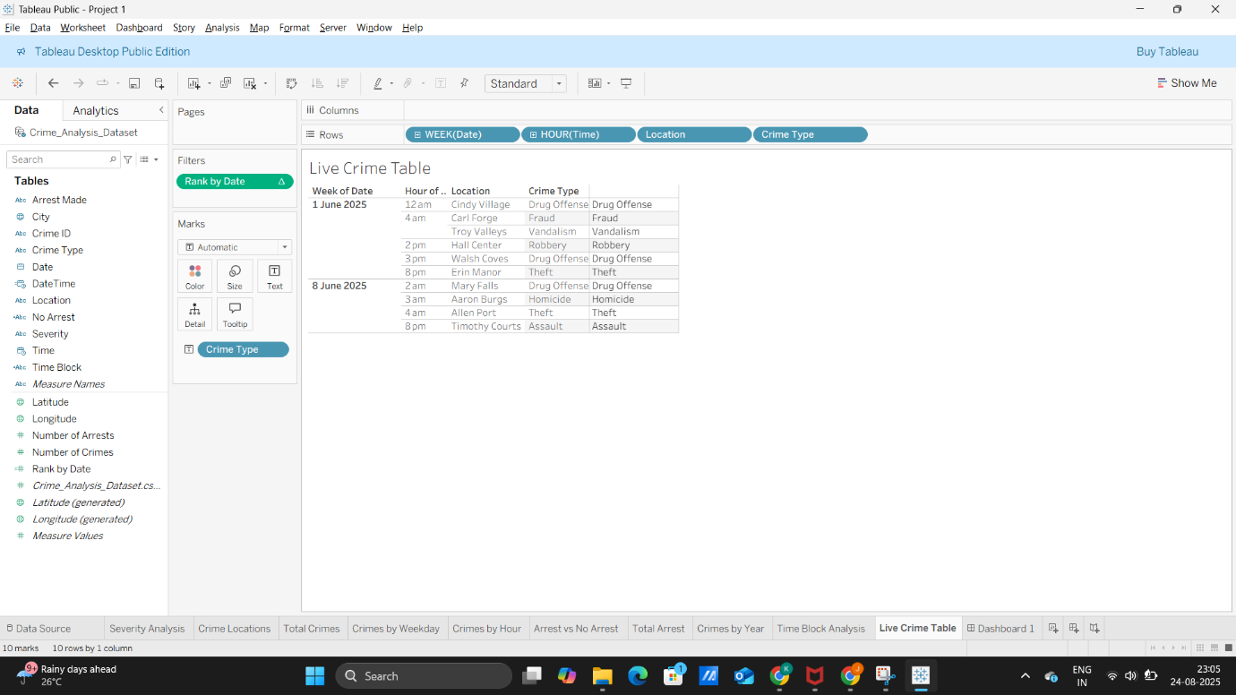
- Time Period Analysis Dashboard:
Along with locations, the study of crime statistics across time statistics is also crucial for understanding the patterns and planning those preventive strategies.
  - Study distribution count of crime incidents across different time periods, such as day of the week or hour
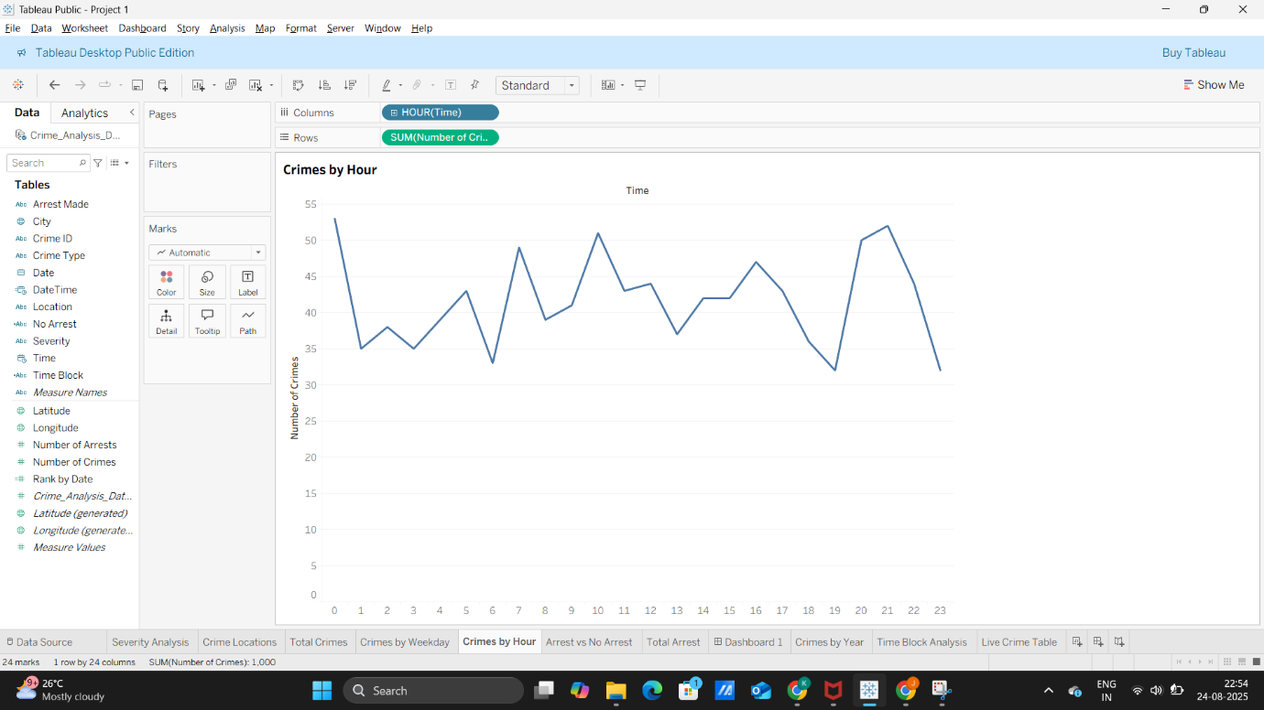
  - Further, explore the percentage of incident reporting for several time blocks (morning, afternoon, evening, and night)
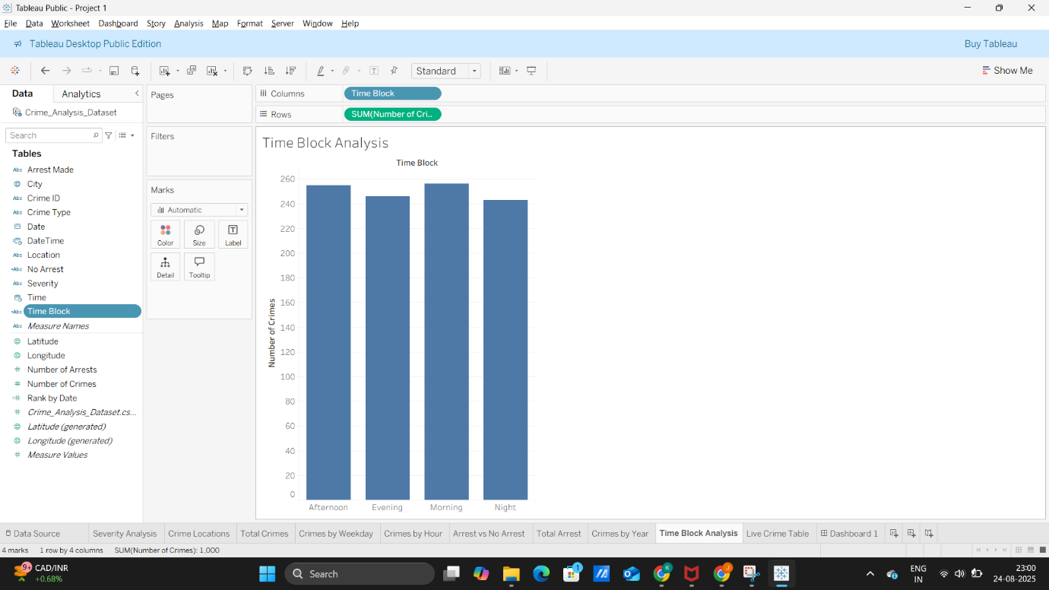
- Trend Analysis Dashboard:
  - Create a dashboard to study the change in crime rate over different years
  - Compare the change in the incident reporting over the years for the same date and time
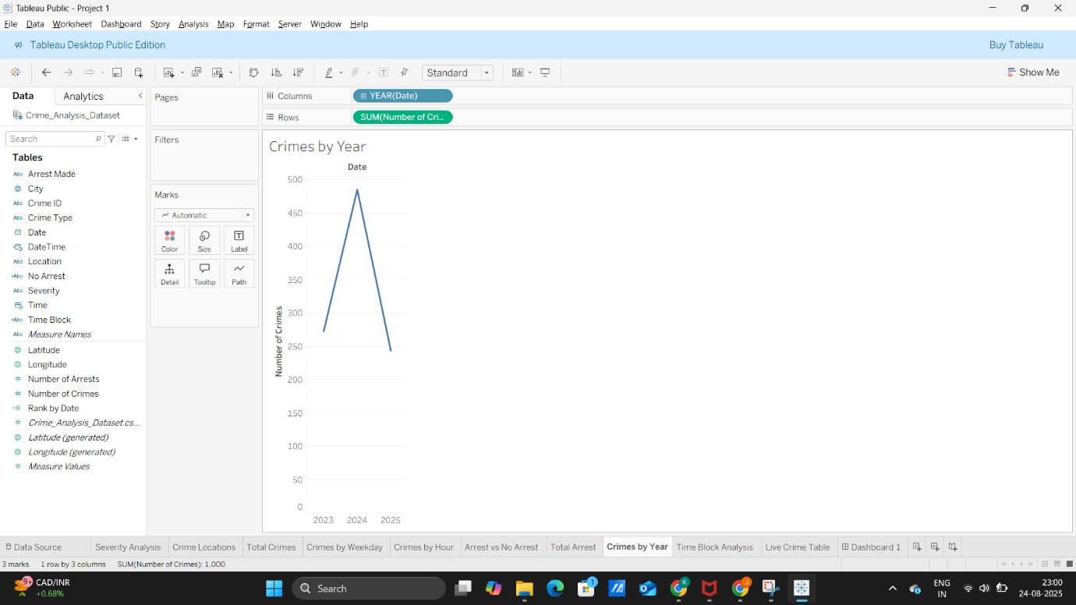
- Comparative Analysis:
    - Study the distribution of incidents reported where an arrest was made vs. not
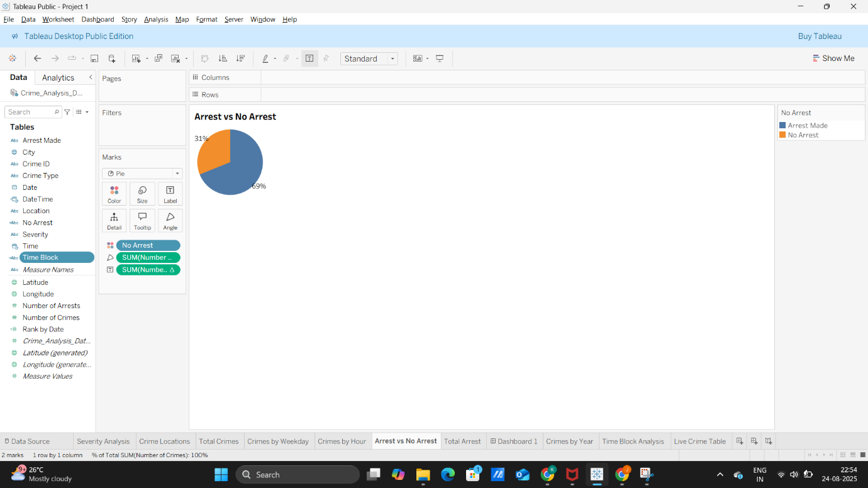
    - Identify what percentage of the reported incidents under each incident category are severe
    - To make the dashboard interactive, provide filters for incident type and location in these dashboards for a granular study
