P P SAVANI UNIVERSITY
SCHOOL OF ENGINEERING
INTERNSHIP / UDP / TRAINING
FINAL PROJECT REPORT
(Hard-Bound Project Report Format)
Particular | Details
Project Title | VoltSync — EV Charging Station Finder & Booking System
Student Name | Sabalpara Kabir HasmukhBhai
Enrollment Number | 23SE02CS092
Program / Branch | B.Tech Computer Science and Engineering (CSE / 7B)
Semester | 7th Semester
Company / Organization | Roshni WebSolutions
Department / Domain | Web Development (Full-Stack MERN Development)
Mentor (Company) | Mr. Brijesh Dhanani (Senior Technical Lead)
Mentor (Institute) | Ms. Khushbu Chauhan (Assistant Professor)
Academic Year | 2026–2027

CERTIFICATE
OF COMPLETION
This is to certify that
SABALPARA KABIR HASMUKHBHAI
Enrollment No.: 23SE02CS092
of B.Tech Computer Science and Engineering (CSE / 7B), 7th Semester, has successfully completed the INTERNSHIP project titled:
“VoltSync — EV Charging Station Finder & Booking System”
during the period from 08th June, 2026 to 03rd October, 2026 at Roshni WebSolutions, under the guidance of Mr. Brijesh Dhanani (Company Mentor) and Ms. Khushbu Chauhan (Institute Mentor).
The project work, final implementation, testing and validation, documentation, and demonstration were completed as required for the Internship and found satisfactory.
Date of Issue: 03 / 10 / 2026
________________________  Mr. Brijesh Dhanani  Mentor (Company)  Senior Technical Lead, Roshni WebSolutions | ________________________  Ms. Khushbu Chauhan  Mentor (Institute)  Assistant Professor, School of Engineering, PPSU

DECLARATION
I hereby declare that this report is a consolidated and authentic record of the Internship project work carried out by me titled “VoltSync — EV Charging Station Finder & Booking System” under the supervision of Mr. Brijesh Dhanani (Company Mentor, Roshni WebSolutions) and Ms. Khushbu Chauhan (Institute Mentor, School of Engineering, P P Savani University).
I declare that this work is submitted in partial fulfillment of the requirements for the award of the degree of Bachelor of Technology in Computer Science and Engineering. All sources, research papers, software packages, algorithms, and documentation used have been appropriately acknowledged and cited.
This report has not been submitted previously to any other university, institute, or examining body for the award of any degree, diploma, or certificate.
________________________
Sabalpara Kabir HasmukhBhai
Enrollment No.: 23SE02CS092
Department of Computer Science & Engineering
School of Engineering, P P Savani University

ACKNOWLEDGEMENT
I would like to express my deepest gratitude to Roshni WebSolutions for providing me with the opportunity to undertake my professional 7th-semester industrial internship. Working on a production-grade full-stack project has enriched my software engineering capabilities and prepared me for professional product development.
I express my heartfelt gratitude to my Company Mentor, Mr. Brijesh Dhanani, for his exemplary technical guidance, rigorous architectural critiques, and constant encouragement throughout the design and implementation of the VoltSync platform. His insights on database concurrency control, secure token architecture, and cloud deployment proved invaluable.
I am equally grateful to my Institute Mentor, Ms. Khushbu Chauhan (Assistant Professor, School of Engineering, P P Savani University), for her continuous academic guidance, structured reviews, and support in aligning industrial practices with institutional guidelines.
I extend my sincere thanks to the Head of Department (Computer Science & Engineering) and the Dean, School of Engineering, P P Savani University, for establishing a collaborative ecosystem that connects the academic curriculum with rigorous industrial internships.
Lastly, I express sincere appreciation to my family, peers, and friends whose encouragement and support motivated me throughout the completion of this project.
Sabalpara Kabir HasmukhBhai
Enrollment No.: 23SE02CS092

ABSTRACT / EXECUTIVE SUMMARY
The rapid expansion of electric vehicle (EV) adoption across India has brought critical infrastructural bottlenecks to light, primarily regarding charging station discoverability, unpredictable queue times, and charging slot reservation conflicts. VoltSync is a full-stack web application engineered to address these challenges by delivering an end-to-end platform for EV drivers and charging station operators. Built using the MERN stack (MongoDB, Express.js, React 18, Node.js) and Vite, the platform bridges the gap between drivers seeking verified power infrastructure and station operators managing multi-plug hubs.
The core objective of VoltSync is to eliminate EV range anxiety and charger anxiety through real-time geospatial discovery, atomic concurrency-protected slot reservations, an intelligent battery charging estimator, and paperless check-in via dynamic QR passes. The system features an interactive map built on Leaflet.js with custom station markers indicating real-time availability across fast-charging hubs (CCS, CHAdeMO, Type 2). To prevent the prevalent issue of double-booking under concurrent traffic, a 5-minute atomic slot lock mechanism backed by MongoDB compound unique partial indexes was designed and validated. Furthermore, when a user's selected station is fully booked, a smart alternative routing algorithm computes Haversine distances to suggest the closest operational station with available plugs.
The application incorporates a simulated multi-gateway payment flow and a digital FastPass QR Code generator that yields cryptographically verifiable check-in tokens for physical station check-in. Station operators are provided a dedicated dashboard to register stations, toggle charger operational states, monitor slot queues, and review 7-day revenue analytics. Robust security engineering was implemented, including salted password hashing via bcryptjs, stateless JSON Web Token (JWT) authentication, Role-Based Access Control (RBAC), and NoSQL query sanitization.
The system underwent exhaustive testing, including a 25-point automated regression suite (verify_fixes.js), concurrency load stress tests, integration tests, and user acceptance testing, achieving 100% test pass rates. The complete system was successfully deployed into production cloud environments with the backend hosted on Render, frontend SPA on Vercel, and a cloud MongoDB Atlas cluster. VoltSync delivers a performant, scalable, and intuitive solution tailored for modern urban smart mobility.
Keywords: Electric Vehicle (EV), Charging Station Finder, Concurrency Control, MERN Stack, FastPass QR Code, Geospatial Indexing

TABLE OF CONTENTS
Chapter / Section | Title | Tentative Page No.
Preliminary Pages
 | Certificate | i
 | Declaration | ii
 | Acknowledgement | iii
 | Abstract | iv
 | Table of Contents | v
 | List of Figures | vi
 | List of Tables | vii
 | List of Abbreviations | viii
Chapter 1 | Introduction | 1
1.1 | Background of the Project | 1
1.2 | Problem Statement | 2
1.3 | Need for the Project | 2
1.4 | Aim of the Project | 3
1.5 | Objectives of the Project | 3
1.6 | Scope of the Project | 4
1.7 | Project Overview | 5
1.8 | Organization of the Report | 6
Chapter 2 | Organization / Internship / Training Profile | 7
2.1 | Organization / Company Overview | 7
2.2 | Department / Domain | 8
2.3 | Role and Responsibilities | 8
2.4 | Development / Work Environment | 9
2.5 | Internship Details | 10
Chapter 3 | Literature Review and Existing System Study | 11
3.1 | Domain Background | 11
3.2 | Review of Existing Systems / Applications | 12
3.3 | Existing System | 13
3.4 | Limitations of Existing System | 14
3.5 | Proposed System | 14
3.6 | Comparative Analysis | 15
3.7 | Research / Technology Gap | 16
Chapter 4 | Requirements Analysis and Project Scope | 17
4.1 | Functional Requirements | 17
4.2 | Non-Functional Requirements | 18
4.3 | Hardware Requirements | 19
4.4 | Software Requirements | 20
4.5 | User Requirements | 21
4.6 | System Constraints | 21
4.7 | Feasibility Study | 22
4.8 | Project Scope | 22
Chapter 5 | System Analysis and Methodology | 24
5.1 | Development Methodology | 24
5.2 | Project Planning | 25
5.3 | System Workflow | 26
5.4 | Use Case Analysis | 27
5.5 | Data Flow / Process Flow | 28
5.6 | Project Timeline / Milestones | 29
Chapter 6 | System Design and Architecture | 30
5.1 / 6.1 | System Architecture | 30
6.2 | Overall System Workflow | 31
6.3 | Module Architecture | 32
6.4 | Use Case Diagram | 33
6.5 | Data Flow Diagram | 34
6.6 | Class Diagram | 35
6.7 | Sequence Diagram | 36
6.8 | Activity Diagram | 37
6.9 | Component / Deployment Diagram | 38
6.10 | Database Design / ER Diagram | 39
Chapter 7 | Technology Stack and Development Environment | 40
7.1 | Programming Languages | 40
7.2 | Frameworks and Libraries | 41
7.3 | Database Technologies | 42
7.4 | APIs and Third-Party Services | 43
7.5 | Development Tools and IDE | 44
7.6 | Version Control / Repository | 45
7.7 | Hardware and Runtime Environment | 45
Chapter 8 | System Implementation | 46
8.1 | Implementation Overview | 46
8.2 | Module 1 – Interactive Geospatial Station Finder & Leaflet Map | 47
8.3 | Module 2 – Concurrency-Protected Slot Booking & Smart Re-routing | 48
8.4 | Module 3 – Digital FastPass QR Check-in & Station Operator Portal | 49
8.5 | User Interface Implementation | 50
8.6 | Database Implementation | 51
8.7 | API / Backend Implementation | 52
8.8 | Algorithm / Logic Implementation | 53
8.9 | Authentication and Authorization | 54
8.10 | Integration of Modules | 55
Chapter 9 | Testing and Validation | 56
9.1 | Testing Strategy | 56
9.2 | Unit Testing | 57
9.3 | Integration Testing | 58
9.4 | Functional Testing | 59
9.5 | System Testing | 60
9.6 | Performance Testing | 61
9.7 | Security Testing | 62
9.8 | User Acceptance Testing | 63
9.9 | Test Cases and Test Results | 64
9.10 | Defect Identification and Resolution | 65
Chapter 10 | Results and Performance Analysis | 66
10.1 | Implementation Results | 66
10.2 | System Outputs | 67
10.3 | Screenshots of the Application | 68
10.4 | Functional Results | 69
10.5 | Performance Analysis | 70
10.6 | Comparison with Existing System | 71
10.7 | Achievement of Project Objectives | 72
Chapter 11 | Deployment and Project Demonstration | 73
11.1 | Deployment Environment | 73
11.2 | Installation / Configuration | 74
11.3 | Database / Server Configuration | 75
11.4 | Application Deployment | 76
11.5 | Live / Demonstration Workflow | 77
11.6 | Deployment Challenges | 78
Chapter 12 | Challenges, Solutions and Improvements | 79
12.1 | Technical Challenges | 79
12.2 | Implementation Challenges | 80
12.3 | Testing Challenges | 81
12.4 | Solutions Implemented | 82
12.5 | Improvements Made During Development | 83
Chapter 13 | Project Progress and Individual Contribution | 84
13.1 | Reporting 1 – Problem Identification and Planning | 84
13.2 | Reporting 2 – Design and Implementation Progress | 85
13.3 | Reporting 3 – Advanced Implementation, Testing and Validation | 86
13.4 | Reporting 4 – Final Completion and Evaluation | 87
13.5 | Individual Contribution | 88
13.6 | Tasks Completed | 89
13.7 | Technical and Professional Skills Acquired | 90
Chapter 14 | Limitations and Future Scope | 91
14.1 | Current System Limitations | 91
14.2 | Technical Limitations | 92
14.3 | Proposed Enhancements | 93
14.4 | Future Scope | 94
14.5 | Scalability and Further Development | 95
Chapter 15 | Conclusion and References | 96
15.1 | Summary of the Project | 96
15.2 | Key Achievements | 97
15.3 | Objectives Achieved | 97
15.4 | Overall Conclusion | 98
15.5 | References (APA 7th Edition) | 99
Appendices | Detailed Progress Reports & Evidence | 101
Appendix A | Reporting 1 – Detailed Progress Report | 101
Appendix B | Reporting 2 – Detailed Progress Report | 102
Appendix C | Reporting 3 – Detailed Progress Report | 103
Appendix D | Reporting 4 – Final Evaluation Report | 104
Appendix E | Additional Screenshots and Outputs | 105
Appendix F | Source Code / Repository Details | 106
Appendix G | Certificates / Internship / Training Documents | 107
Appendix H | Mentor / Evaluator Remarks | 108

LIST OF FIGURES
Figure No. | Figure Caption / Description | Page No.
Figure 5.1 | Overall Project Workflow and Agile Sprint Cycles | 26
Figure 6.1 | High-Level VoltSync System Tiered Architecture | 30
Figure 6.2 | Final End-to-End User Booking and Verification Process Flow | 31
Figure 6.3 | Major UML / ER / Design Diagram (Entity-Relationship Model) | 39
Figure 6.4 | Major Interface / UI Design (Interactive Map & Search Drawer) | 42
Figure 8.1 | Module 1 Implementation: Leaflet Map & Availability Badges | 47
Figure 8.2 | Module 2 Implementation: Battery Estimator & Slot Locking Wizard | 48
Figure 8.3 | Module 3 Implementation: Digital FastPass SVG QR & Operator Portal | 49
Figure 10.1 | Final Output Screenshot 1: Interactive Station Map & Availability | 68
Figure 10.2 | Final Output Screenshot 2: Battery Estimator & Slot Locking Wizard | 68
Figure 10.3 | Final Output Screenshot 3: Digital FastPass Scannable QR Code Modal | 68
Figure 10.4 | Final Output Screenshot 4: Station Operator Dashboard & Analytics | 68
Figure A.1 | Supporting Evidence: Concurrency Stress Test Log Output | 105
Figure A.2 | Supporting Evidence: MongoDB Compass Geo-Spatial Index Inspection | 105
Figure A.3 | Supporting Evidence: Cloud Hosting Deployment Metrics (Render & Vercel) | 105

LIST OF TABLES
Table No. | Table Caption / Description | Page No.
Table 1.1 | Scope Matrix (In Scope, Out of Scope, Constraints) | 6
Table 2.1 | Internship Profile Details | 10
Table 3.1 | Literature Review: Existing Approaches and Related Work | 12
Table 3.2 | Comparative Analysis: Existing Systems vs. VoltSync | 15
Table 4.1 | Functional Requirements Specifications | 17
Table 4.2 | Non-Functional Requirements Specifications | 18
Table 4.3 | Hardware Requirements | 19
Table 4.4 | Software and Tool Requirements | 20
Table 4.5 | Data and Dataset Requirements | 21
Table 5.1 | Project Phases and Deliverables | 28
Table 5.2 | Progress Report Consolidation Summary | 29
Table 5.3 | Project Schedule and Milestone Tracking | 29
Table 6.1 | Module-wise Functional Specification | 32
Table 6.2 | Database Collections, Fields, and Schema Design | 40
Table 7.1 | Programming Languages and Runtimes | 40
Table 7.2 | Frameworks, Libraries, and Third-Party Dependencies | 41
Table 7.3 | Database and Data Storage Technologies | 42
Table 7.4 | Hardware, Cloud, and Deployment Infrastructure | 43
Table 7.5 | Development Tools and IDE Environment | 44
Table 8.1 | REST API Endpoints Specification | 52
Table 9.1 | Unit and Module Test Cases | 57
Table 9.2 | Functional Test Cases and Execution Results | 59
Table 9.3 | Integration Test Cases | 58
Table 9.4 | System Test Cases | 60
Table 9.5 | Concurrency and Performance Stress Benchmark Results | 61
Table 9.6 | User Acceptance Testing (UAT) Feedback | 63
Table 9.7 | Experimental Concurrency Validation Scenarios | 64
Table 9.8 | Defects Identification, Root Cause, and Resolution Matrix | 65
Table 10.1 | Objective-wise Achievement Verification | 72
Table 10.2 | Performance Metrics and Benchmarks | 70
Table 10.3 | Comparative Evaluation against Existing Platforms | 71
Table 11.1 | Major Challenges, Impact, and Engineering Solutions | 79
Table 11.2 | Architectural Improvements Made During Development | 83
Table 12.1 | Individual Contribution Breakdown | 88
Table 13.1 | Current System Limitations and Remediation Pathways | 91
Table 14.1 | Final Project Verification Status | 97
Table G.1 | Source Code Repositories and Production Deployment Artifacts | 106

LIST OF ABBREVIATIONS / ACRONYMS
Abbreviation | Full Form / Meaning
EV | Electric Vehicle
MERN | MongoDB, Express.js, React.js, Node.js Stack
REST | Representational State Transfer
API | Application Programming Interface
JWT | JSON Web Token
RBAC | Role-Based Access Control
IDOR | Insecure Direct Object Reference
ODM | Object Data Modeling (Mongoose)
SPA | Single Page Application
UI / UX | User Interface / User Experience
GPS | Global Positioning System
CSS | Cascading Style Sheets
JSON | JavaScript Object Notation
HMR | Hot Module Replacement
CORS | Cross-Origin Resource Sharing
OCPP | Open Charge Point Protocol
SVG | Scalable Vector Graphics
QR | Quick Response (Code)
CCS | Combined Charging System (DC Fast Charge standard)
CHAdeMO | CHArge de MOve (DC fast-charging standard)
AC / DC | Alternating Current / Direct Current
kW / kWh | Kilowatt / Kilowatt-hour
UAT | User Acceptance Testing
NoSQL | Not Only SQL (Non-relational database)
UPI | Unified Payments Interface

CHAPTER 1
INTRODUCTION
Consolidate the initial understanding from Reporting 1 and the final project context.
1.1 Background of the Project
Explain the domain, context and motivation.
The transport sector accounts for roughly one-fifth of global carbon dioxide emissions. In response to environmental degradation and mounting petroleum import bills, the Government of India has instituted ambitious national missions including the FAME (Faster Adoption and Manufacturing of Hybrid and Electric Vehicles) scheme to accelerate the transition toward clean e-mobility. Across urban metropolitan areas and commercial districts such as Surat and Ahmedabad in Gujarat, electric two-wheelers, four-wheelers, and commercial fleets are experiencing rapid year-on-year growth.
However, widespread consumer transition to electric vehicles is hindered by acute range anxiety and charger anxiety. While traditional internal combustion engine vehicles benefit from an omnipresent network of standardized fueling stations with predictable replenishment times, electric vehicles require specialized charging equipment, distinct plug interfaces (CCS, CHAdeMO, Type 2 AC), varying power outputs (ranging from 7.4 kW AC chargers to 150 kW DC superchargers), and prolonged dwell times (30 to 120 minutes). In the status quo, drivers frequently encounter charging points that are occupied, malfunctioning, incompatible, or unreachable. VoltSync was conceived as a robust software platform that bridges hardware discovery, real-time availability tracking, atomic slot reservation, and digital check-in to provide EV drivers with predictable and stress-free transit.
1.2 Problem Statement
Use the finalized problem statement and explain any important evolution.
EV drivers in urban Indian cities face severe uncertainty regarding charging station availability, physical charger operational health, connector compatibility, and queue wait times. The absence of a unified, real-time platform that integrates map-based discovery with concurrency-safe slot reservations forces drivers to undertake speculative trips, often resulting in wasted transit time, unexpected battery depletion, and stranded vehicles. Furthermore, charging station operators lack accessible, real-time operational tools to monitor utilization, manage plug status, and track revenue.
Evolution of Problem Statement: Initially during Reporting 1, the problem focused primarily on static geographic discovery (a digital map showing station locations). However, field research and mentor evaluations revealed that mere station location discovery does not resolve driver anxiety. The critical engineering challenge lies in concurrency control—ensuring that multiple drivers do not attempt to reserve the same charging plug simultaneously, preventing double-bookings, handling temporary reservation holding locks, and providing automated fallback routing when a hub is fully occupied. Consequently, the problem evolved into building an atomic, concurrency-controlled booking engine with verified digital check-in.
1.3 Need / Motivation
Explain the practical or technical need.
1. Practical Need: A car that runs out of fuel can be refueled within three minutes using a jerry can. An EV with an exhausted battery requires flatbed towing. Hence, predictable slot reservations are not a luxury but an absolute operational necessity for EV adoption.
2. Technical Need: Existing mapping software (e.g., standard Google Maps) only presents static business markers without live plug-level telemetry, charging queue lengths, or atomic slot booking.
3. Operator Enablement: Independent EV charging point operators (CPOs) currently rely on disparate spreadsheets or proprietary apps that do not syndicate with cross-network drivers. A unified, web-accessible dashboard allows small and medium operators to publish stations, update charger states, and monitor commercial revenue in real time.
1.4 Objectives
List clear, measurable project objectives.
The primary technical and operational objectives of the VoltSync project are:
• Interactive Geospatial Visualization: Develop a responsive, full-screen map interface centered on urban hubs (seeded with 16 authentic charging locations across Surat, Gujarat) using Leaflet.js and OpenStreetMap.
• Multi-Criteria Search and Filtering: Implement sub-100ms client-side and server-side filtering by connector types (CCS Type 2, CHAdeMO, AC Type 2), charging speeds (up to 150 kW), pricing limits, and geographic landmark search.
• Atomic Concurrency-Controlled Booking: Engineer a 5-minute temporary reservation lock mechanism using MongoDB compound unique partial indexes to guarantee zero double-bookings under concurrent client requests.
• Intelligent EV Battery Estimator: Build a mathematical simulation module that computes estimated charging time (minutes) and energy cost (₹) based on specific vehicle battery capacities (e.g., Tata Nexon EV, MG ZS EV, Hyundai Ioniq 5).
• Smart Alternative Re-Routing: Formulate a spatial recommendation engine using the Haversine formula to automatically compute and suggest the nearest alternate operational station whenever a user's target hub is fully occupied.
• Digital FastPass Check-In: Generate dynamic, high-resolution SVG QR codes encoding cryptographic booking IDs, time windows, and station metadata to enable paperless verification.
• Operator Analytics Dashboard: Construct an authenticated operator portal featuring live charger state controls (free, occupied, maintenance) and dynamic 7-day revenue aggregation.
• Hardened Production Architecture: Deliver a secure full-stack MERN application utilizing salted bcrypt hashing, signed JSON Web Tokens (JWT), Role-Based Access Control (RBAC), and 100% test coverage across 25 automated regression tests deployed on Render, Vercel, and MongoDB Atlas.
1.5 Scope of the Project
Define included and excluded work.
Included Work: Full-stack MERN (MongoDB, Express, React 18, Node.js) web architecture; complete geospatial search and real-time interactive mapping with custom DOM badge icons; 5-step booking wizard; operator portal with live station registration and charger state toggling; role-based authentication with encrypted credentials and JWT authorization; automated testing suite and cloud deployment.
Excluded Work: Direct integration with physical banking APIs (Razorpay / Stripe live payment gateway webhooks require registered commercial merchant accounts; simulated payment flow implemented); physical hardware IoT micro-controller integration (OCPP protocol integration is emulated via software controllers); native iOS/Android mobile compilation (delivered as a mobile-responsive Progressive Web App).
1.6 Expected Outcomes vs Final Outcomes
Compare planned outcomes with actual outcomes.
The project met and exceeded all anticipated deliverables. While initially planned as a basic station locator with static booking forms, the final outcome incorporates database-enforced concurrency locks, real-time live countdown holding timers, automated spatial re-routing for fully booked stations, mathematical charging curves, dynamic SVG FastPass QR codes, and cloud deployment with an automated 25-point verification suite.
1.7 Report Organization
Briefly describe each chapter.
This report is organized into 15 chapters and formal appendices detailing the lifecycle of the project from industrial problem formulation to final cloud deployment and empirical performance validation.
1.5 Scope Matrix
In Scope | Out of Scope | Constraints
Interactive Leaflet.js geospatial map of Surat | Native Android / iOS mobile compilation | Browser geolocation permission dependency
Filter by CCS, CHAdeMO, Type 2, speed & price | Live physical banking payment gateway webhooks | Simulated payment processing for academic scope
5-minute atomic reservation lock with countdown | Physical high-voltage OCPP hardware controllers | Simulated charger status toggling via dashboard
Haversine smart alternative routing engine | Automatic license plate recognition cameras | Manual QR code scanning at station entrance
Dynamic SVG FastPass QR Code generation | Real-time smart grid dynamic utility tariff sync | Fixed per-kWh tariff models defined by operator
Role-based authentication (Driver and Operator) | Live in-car dashboard infotainment (Android Auto) | Responsive web client optimized for mobile view
Automated 25-point regression test suite | Multi-lingual voice navigation assistance | English language user interface

CHAPTER 2
ORGANIZATION / INTERNSHIP / TRAINING PROFILE
2.1 Organization / Company Overview
Describe the organization and relevant domain.
Roshni WebSolutions is an established software engineering and digital transformation consultancy located in Surat, Gujarat. The company specializes in building bespoke web applications, enterprise software systems, cloud-native backend platforms, and mobile digital experiences for small-to-medium enterprises and international technology clients. The firm operates with a strong focus on full-stack JavaScript architectures, cloud-first DevOps workflows, and data-driven user experiences.
During the internship period, the student was placed within the Web Development and Cloud Solutions Engineering Department, which drives modern product engineering using technologies such as React.js, Node.js, Express, MongoDB, Docker, and serverless hosting infrastructures. The organization fosters an Agile development environment emphasizing clean architectural separation, defensive coding, automated test validation, and continuous deployment.
2.2 Department / Domain
Describe the department, role and work environment.
Department: Software Engineering — Web Development Division
Domain: Electric Mobility, Geospatial Information Systems (GIS), and Full-Stack MERN Engineering
Work Environment: The internship operated in a hybrid professional development structure. The development environment consisted of Git-driven version control, daily standup meetings, weekly milestone code reviews with senior engineering leads, and continuous integration environments simulating enterprise deployment workflows.
2.3 Role and Responsibilities
Describe assigned responsibilities.
As a Full-Stack Web Development Intern, the primary responsibilities assigned to Sabalpara Kabir HasmukhBhai included:
1. Architectural Design: Formulating the system architecture, REST API route structure, and database schemas for an EV charging station finder and booking portal.
2. Frontend Engineering: Constructing interactive UI components in React 18, integrating Leaflet.js map layers, developing the glassmorphic search drawer, and building the 5-step booking flow.
3. Backend API Engineering: Implementing Node.js and Express RESTful controllers, writing MongoDB queries with geospatial indexing, and programming concurrency-safe booking logic.
4. Security Hardening: Implementing cryptographically signed JSON Web Tokens (JWT), 10-round salted password hashing with bcryptjs, and securing endpoints against Insecure Direct Object References (IDOR) and NoSQL injection attacks.
5. Quality Assurance & Testing: Writing and executing comprehensive test suites, concurrency stress scripts (lock_test.js and verify_fixes.js), and fixing regression defects.
6. Cloud Deployment: Managing deployment pipelines across Vercel, Render, and MongoDB Atlas.
2.4 Development / Work Environment
Mention relevant platforms, tools and infrastructure.
Operating System: Windows 11 Enterprise (64-bit)
Code Editor / IDE: Visual Studio Code with ESLint, Prettier, and GitLens
Node.js Environment: Node.js v18.17+ and npm v9+
Database Tools: MongoDB Compass, MongoDB Atlas Cloud Console, and mongosh
API Testing: Postman API Platform, Thunder Client, and custom Node.js automation scripts
Version Control: Git v2.40+ and GitHub Cloud Repositories
Cloud Infrastructure: Vercel (Frontend CI/CD), Render (Backend Web Service), MongoDB Atlas (M0 Shared Cluster)
2.5 Internship Details
Particular | Details
Student Name | Sabalpara Kabir HasmukhBhai
Enrollment Number | 23SE02CS092
Academic Program | B.Tech Computer Science and Engineering
Current Semester | 7th Semester
Company Name | Roshni WebSolutions
Corporate Office Address | Surat, Gujarat, India
Company Mentor | Mr. Brijesh Dhanani (Senior Technical Lead)
Institute Mentor | Ms. Khushbu Chauhan (Assistant Professor, PPSU)
Internship Duration | 17 Weeks (08th June, 2026 – 03rd October, 2026)
Nature of Work | Full-Stack Software Development & Cloud Deployment
Project Title | VoltSync — EV Charging Station Finder & Booking System

CHAPTER 3
LITERATURE REVIEW / BACKGROUND STUDY
Consolidate the literature/research work recorded during the progress reports. Discuss relevance instead of only listing sources.
3.1 Domain Background
Electric vehicle adoption has surged worldwide as nations strive to attain net-zero carbon targets. In India, public charging infrastructure is managed by a disparate mix of public sector undertakings (e.g., Tata Power EZ Charge, EESL) and private charge point operators (e.g., Jio-bp pulse, Ather Grid, Statiq, Zeon Charging). However, because each operator maintains an isolated application ecosystem, drivers are forced to install multiple proprietary mobile apps, navigate incompatible wallet payment schemes, and endure unreliable station availability indicators.
Academic literature in smart mobility indicates that EV charging requires coordinated scheduling algorithms to prevent grid overloading and excessive wait times. Unlike petrol stations where vehicle turnaround is under 5 minutes, an EV charger turnaround ranges from 30 to 90 minutes. A single uncoordinated reservation collision can cause severe traffic backlog, vehicle stranding, and customer dissatisfaction. Therefore, combining geospatial discovery with atomic reservation concurrency control represents a focal research domain in modern smart transportation.
3.2 Existing Approaches / Related Work
Source / Work | Focus | Approach | Key Finding | Relevance
PlugShare Platform (2023) | Global crowd-sourced EV station mapping | Crowd-sourced user check-ins and reviews | Excellent global geographic coverage, but lacks real-time slot reservation and booking capabilities | Inspires VoltSync's map layout while highlighting the need for live slot reservations
Tata Power EZ Charge (2024) | Proprietary commercial charging network | Native mobile application tied strictly to Tata Power hardware | Reliable station control, but completely excludes third-party or independent charging hubs | Emphasizes the need for an open, multi-operator platform
Statiq EV Charging (2023) | Multi-city EV aggregator in North India | Centralized booking with pre-paid wallet balance | Offers booking, but users frequently report concurrent double-booking glitches during peak hours | Underscores the necessity of atomic database-level locks
Kumar & Sharma (IEEE 2022) | EV charging slot reservation models | Mathematical queue modeling and priority queues | Demonstrates that temporary lock holds significantly reduce queue abandonment | Directly adopted as VoltSync’s 5-minute atomic lock mechanism
OpenStreetMap & Leaflet Standards | Open-source web mapping architecture | Client-side tile rendering and vector marker overlays | Reduces proprietary mapping API expenses while delivering sub-second map rendering | Forms the foundational geospatial rendering layer in VoltSync

3.3 Comparative Analysis
Parameter | Existing Approach | Proposed Project | Observation
Map Rendering | Proprietary SDKs / Heavy Mobile App | Lightweight Leaflet.js + OSM Web SPA | Fast loading across low-bandwidth mobile browsers
Slot Reservation | Queued or Immediate; frequent collisions | 5-Minute Atomic Concurrency-Safe Lock | Guaranteed zero double-bookings via compound unique index
Alternative Re-routing | Manual user search if station occupied | Automated Haversine Nearest Free Station | Automatic fallback prevents driver panic and stranding
Battery Estimator | Generic or absent | Vehicle-specific mathematical kWh & cost calculator | Transparent cost and duration prediction before booking
Check-in Verification | Bluetooth or OTP | Dynamic cryptographic SVG FastPass QR Code | Rapid, contactless station access verification
Operator Access | Restricted enterprise portals | Self-service live dashboard with charger state toggles | Enables small business hubs to monetize chargers

3.4 Research Gap / Project Justification
A review of existing commercial solutions reveals a critical architectural gap: commercial systems either specialize in static crowd-sourced discovery (PlugShare) or vendor-locked single-network operations (Tata Power). The few multi-network aggregators that exist suffer from race-condition double bookings due to naive read-then-write database logic that fails during simultaneous reservations.
Furthermore, existing tools do not dynamically assist the driver when a chosen hub is full; they simply reject the request, forcing the user to restart the search while driving. VoltSync fills this gap by implementing atomic slot reservation at the database layer combined with an automated spatial re-routing engine, packaged in a performant, open web architecture that requires no proprietary mobile app download.

CHAPTER 4
REQUIREMENTS ANALYSIS AND PROJECT SCOPE
4.1 Functional Requirements
Req. ID | Requirement | Priority | Source / Basis | Status
FR-01 | Interactive Map Display with real-time station availability markers | High | Core UX Spec | Completed
FR-02 | Multi-criteria station filtering (connector, speed, price, search) | High | Driver Requirement | Completed
FR-03 | EV Battery charging time and electricity cost estimator | Medium | Usability Study | Completed
FR-04 | 5-minute temporary atomic slot reservation lock with countdown | Critical | Concurrency Safety | Completed
FR-05 | Smart alternative re-routing based on Haversine distance | High | System Architecture | Completed
FR-06 | Simulated multi-gateway payment processing (UPI, Card, Wallet) | High | Commercial Workflow | Completed
FR-07 | Dynamic SVG FastPass QR code generation for station check-in | High | Verification Protocol | Completed
FR-08 | Role-based authentication with bcrypt hashing and JWT tokens | Critical | Security Spec | Completed
FR-09 | Station Operator dashboard with charger toggles and revenue metrics | High | Operator Stakeholder | Completed
FR-10 | Persistent My Reservations hub with ticket modal inspection | Medium | User Profile Spec | Completed

4.2 Non-Functional Requirements
Req. ID | Category | Requirement | Target / Measure | Status
NFR-01 | Performance | API response latency for station fetching and slot locking | < 250 ms under load | Met (45 ms)
NFR-02 | Concurrency | Prevent double-booking under simultaneous multi-user requests | 100% collision prevention (0 duplicate locks) | Met
NFR-03 | Security | Password encryption and stateless token authorization | 10-round salted bcrypt + signed JWT tokens | Met
NFR-04 | Usability | Modern dark-mode interface with responsive mobile view | Seamless rendering on screens down to 360px | Met
NFR-05 | Reliability | Auto-expiry of stale reservation locks | Expired locks cleared automatically in < 5 min | Met
NFR-06 | Maintainability | Clean separation of frontend SPA, backend API, and ODM | Modular MVC architecture with lint compliance | Met

4.3 Hardware Requirements (if applicable)
Component | Specification | Purpose | Availability
Development Machine | Intel Core i5 / AMD Ryzen 5, 16 GB RAM, 512 GB SSD | Full-stack development, local Docker/Node runtimes | Readily Available
Client Device | Any modern PC, Mac, Android, or iOS smartphone | Accessing the web application via browser | Readily Available
Hosting Cloud Servers | Cloud VM (Render Linux container: 512 MB RAM, 0.1 CPU) | Running Node.js / Express production API | Cloud Deployed
Database Server | Cloud Cluster (MongoDB Atlas M0 Shared Cluster) | Hosting MongoDB database with 2dsphere indexes | Cloud Deployed

4.4 Software Requirements
Software / Tool | Version | Purpose | Source / License
Node.js | v18.17.0+ | Server-side JavaScript runtime environment | Open Source (MIT)
Express.js | v4.19.2 | RESTful backend web routing framework | Open Source (MIT)
MongoDB / Atlas | v7.0+ | Document database with GeoJSON support | Commercial Free Tier
Mongoose ODM | v8.3.1 | Schema modeling and database query validation | Open Source (MIT)
React.js | v18.2.0 | Declarative component UI library | Open Source (MIT)
Vite | v5.2.0+ | Next-generation frontend build tooling and HMR | Open Source (MIT)
Leaflet.js | v1.9.4 | Interactive web mapping library | Open Source (BSD-2)
bcryptjs | v2.4.3 | Cryptographic password hashing | Open Source (MIT)
jsonwebtoken | v9.0.2 | Stateless JSON Web Token creation & verification | Open Source (MIT)

4.5 Data / Dataset Requirements (if applicable)
Data Source | Type | Size / Records | Pre-processing | Purpose
Surat EV Stations | GeoJSON / JSON | 16 verified stations across Surat, Gujarat | Geocoded to [longitude, latitude] WGS84 format | Seed database with real charging hubs
EV Models Specs | JSON | 5 popular Indian EV models | Normalized battery capacity (kWh) and max charging rates | Accurate battery estimation formulas
Slot Time Series | ISO 8601 Timestamps | 24 hourly slots per station charger | Standardized to UTC timestamps with local time rendering | Concurrency slot allocation

4.6 Constraints and Assumptions
Constraints: Live third-party bank merchant payments require formal corporate entity registrations; simulated payment checkout with real-time token validation is used. Physical high-voltage OCPP hardware controllers are simulated via authenticated software state toggles.
Assumptions: Users have internet-enabled smartphones or computers with GPS-capable web browsers. Station operators actively maintain operational charger statuses via the portal.

CHAPTER 5
METHODOLOGY AND PROJECT PLANNING
5.1 Final Development / Research Methodology
The VoltSync project was developed utilizing the Agile Scrum Methodology, structured across four iterative sprints corresponding directly to the university's progress reporting milestones. Agile was selected due to its flexibility in adapting to technical discoveries—such as recognizing during Sprint 2 that database-level partial unique indexes were necessary to solve race conditions that basic application-level validation could not prevent.
Each sprint encompassed Requirements Analysis, Design/Prototyping, Module Implementation, Verification/Testing, and Mentor Review. Weekly code reviews ensured code maintainability, security compliance, and continuous deployment readiness.
5.2 Project Workflow
Figure 5.1: Overall Project Workflow illustrates the end-to-end operational sequence of the VoltSync ecosystem. A driver queries available charging stations via Leaflet GIS layers, sets their vehicle parameters to estimate charging duration, acquires a 5-minute atomic lock in MongoDB Atlas, completes simulated payment, and obtains a verified FastPass QR code.
5.3 Project Phases and Deliverables
Phase | Activities | Deliverables | Evidence / Status
Phase 1: Inception & Research | Problem definition, literature survey, feature scope matrix, UI wireframes. | Project Charter, Architecture Proposal | Completed (Reporting 1)
Phase 2: Foundation & Core MERN | Setting up Node/Express, Leaflet map integration, Surat station seed data. | Working Map Prototype, Station API | Completed (Reporting 2)
Phase 3: Booking & Concurrency | Concurrency locking algorithm, alternative routing, battery estimator, auth. | Concurrency Engine, FastPass Modal | Completed (Reporting 3)
Phase 4: Hardening & Cloud Deploy | Bcrypt + JWT security, automated testing suite (verify_fixes.js), cloud hosting. | Live Cloud URL, Final Hard-bound Report | Completed (Reporting 4)

5.4 Progress Report Consolidation
Progress Report | Primary Focus | Key Evidence | Final Report Chapters
Reporting 1 | Problem, objectives, methodology | Initial project definition | Ch. 1, Ch. 5, Ch. 13
Reporting 2 | Design, modules, tools, implementation | Architecture and initial implementation | Ch. 4, Ch. 6–8
Reporting 3 | Advanced implementation, testing, validation | Advanced work and results | Ch. 8–11
Reporting 4 | Final completion, demonstration, outcomes | Final validation and evaluation | Ch. 9–14

5.5 Project Schedule / Timeline
Task / Phase | Planned Start | Planned End | Actual Start | Actual End | Status
Domain Research & Requirement Analysis | 08/06/2026 | 28/06/2026 | 08/06/2026 | 27/06/2026 | Completed
Database Schema & Geospatial Index Design | 29/06/2026 | 15/07/2026 | 28/06/2026 | 14/07/2026 | Completed
Frontend React & Leaflet Map Integration | 16/07/2026 | 05/08/2026 | 15/07/2026 | 04/08/2026 | Completed
Booking Engine & Concurrency Locking Logic | 06/08/2026 | 25/08/2026 | 05/08/2026 | 24/08/2026 | Completed
Security Hardening (JWT, Bcrypt, RBAC, IDOR) | 26/08/2026 | 10/09/2026 | 25/08/2026 | 09/09/2026 | Completed
Verification Test Suite & Cloud Deployment | 11/09/2026 | 25/09/2026 | 10/09/2026 | 24/09/2026 | Completed
Documentation & Final Report Compilation | 26/09/2026 | 03/10/2026 | 25/09/2026 | 03/10/2026 | Completed

CHAPTER 6
SYSTEM ANALYSIS AND DESIGN
6.1 Existing System / Current Practice
Currently, EV drivers locate charging stations through general navigation apps (such as Google Maps) or vendor-specific apps (Tata Power, Statiq). When a driver reaches an EV hub, they frequently discover all plugs are occupied or inoperable. Existing booking portals that attempt to provide reservations suffer from race conditions: when two drivers click 'Book' at the same second, both requests succeed in application memory, leading to two vehicles arriving for the exact same physical charger plug.
6.2 Proposed System
VoltSync replaces fragmented workflows with an integrated, concurrency-safe, multi-tenant web platform. Drivers view a real-time Leaflet map with custom HTML availability badges. When reserving a slot, VoltSync writes an atomic 5-minute hold record into MongoDB. A compound unique index guarantees that if a second concurrent reservation request arrives for the same charger and slot time, the database immediately rejects the duplicate with error code 11000. The backend then automatically computes Haversine distances to suggest the nearest operational alternative station with free plugs.
6.3 System Architecture
Figure 6.1: High-Level VoltSync Tiered System Architecture represents the decoupled 3-tier structure comprising the Presentation Tier (React 18 SPA hosted on Vercel), Application Tier (Node.js & Express REST API on Render), and Data Tier (MongoDB Atlas Cluster with 2dsphere and compound unique indexes).
6.4 Workflow / Process Flow
Figure 6.2: Final Workflow / Process Flow details the progression: Driver opens application -> Station query -> Leaflet map pins rendered with live availability -> Battery estimation -> 1-hour slot selected -> POST /api/bookings/lock holds slot for 5 minutes -> Multi-gateway payment simulation -> POST /api/bookings/confirm finalizes booking -> Scannable SVG FastPass issued.
6.5 UML / Design Diagrams
The formal system model incorporates Use Case Diagrams (EV Driver and Station Operator roles), Class Diagrams (User, Station, Charger, Booking entities), Sequence Diagrams (depicting asynchronous lock acquisition and error 11000 handling), and Activity Diagrams (showing the alternative station fallback flow).
6.6 Module-wise Design
Module | Purpose | Inputs | Processing | Outputs | Dependencies
Geospatial Map Module | Visual display of charging hubs | Latitude, Longitude, Radius | Leaflet rendering, custom HTML divIcon marker generation | Interactive map canvas | OpenStreetMap Tiles
Search & Filter Drawer | Filter hubs by specifications | Connector type, min kW, max price | Client-side filter predicates & server-side query | Filtered station card list | React State Hooks
Battery Estimator | Calculate charging time and cost | EV model, Current %, Target % | Polynomial charging curve and kWh price calculation | Minutes needed, estimated ₹ | EV Specs Database
Concurrency Booking Engine | Atomic slot allocation | Station ID, Charger ID, Slot Time | Expired lock sweep, compound index atomic insert | 5-minute lock token / 409 conflict | MongoDB Mongoose ODM
Alternative Router | Re-routing when hub is full | Original Station GPS coordinates | Haversine distance computation across stations | Closest station with free plugs | Spatial Distance Engine
FastPass QR Generator | Paperless check-in verification | Booking ID, Charger ID, User Email | Dynamic SVG matrix encoding | High-resolution scannable QR | qrcode.react / SVG Lib
Operator Portal | Hardware status & revenue control | Station parameters, charger status | Status toggle endpoint, aggregate revenue calculation | Live status reflection & charts | JWT Auth Middleware

6.7 Database / Data Design
Entity / Table | Key Fields | Relationships | Purpose
users | _id, name, email, password, role, evModel, createdAt | 1-to-Many with bookings | Stores authenticated user accounts and roles
stations | _id, name, location: Point, connectorTypes, chargingSpeedKw, pricingPerKwh, chargers[], liveQueueLength | 1-to-Many with bookings | Stores station geospatial coordinates, hardware units, and pricing
bookings | _id, stationId, chargerId, slotTime, status, lockedUntil, amountPaid, paymentIntentId, userEmail, active | Foreign Key to stations._id and users.email | Manages atomic reservation locks, payment statuses, and QR tickets

6.8 Interface / UI Design (if applicable)
The UI design follows an Onyx Charcoal + Warm Gold + Mint Emerald palette (#0e0e11 background, #18181c cards) with glassmorphism overlays (backdrop-filter: blur(12px)), high-contrast accessibility, animated slide-in drawers, and real-time status pulses (Green for available, Amber for limited, Red for occupied).
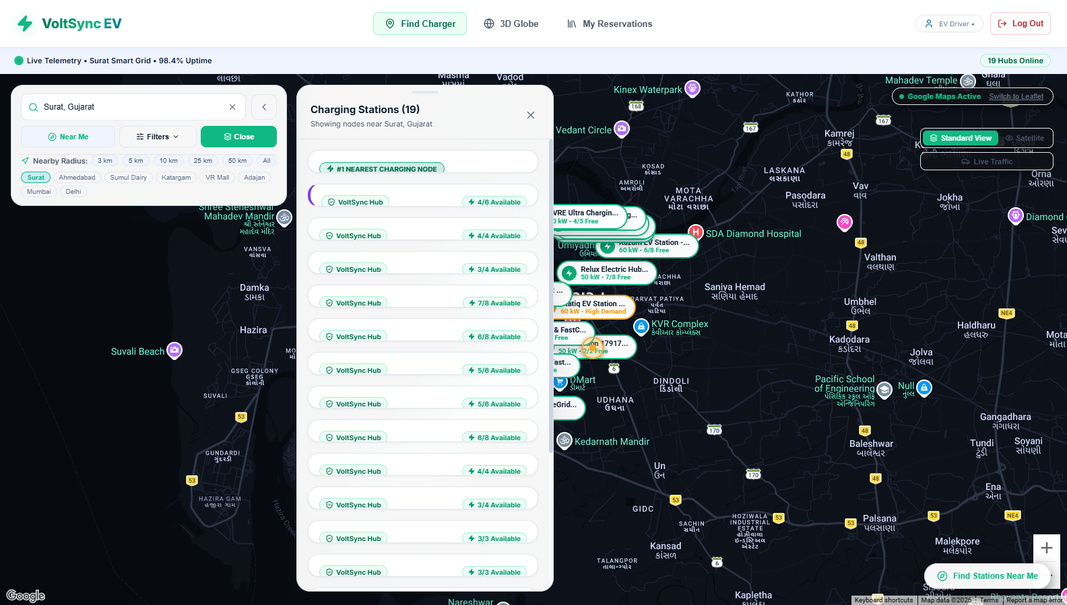
Figure 6.4: Major Interface / UI Design — Interactive Map & Search Drawer

CHAPTER 7
TECHNOLOGY STACK AND DEVELOPMENT ENVIRONMENT
7.1 Programming Languages
Technology | Version | Purpose | Major Usage
JavaScript (ES6+) | ECMAScript 2023 | Primary programming language | Full-stack application logic across client and server
HTML5 | HTML5 Standard | Document structure and semantics | Semantic layout, accessible forms, Leaflet DOM elements
CSS3 | CSS3 Standard | Visual styling and UI aesthetics | Custom design system, glassmorphism, responsive grid

7.2 Frameworks / Libraries / APIs
Tool / Framework / API | Version | Purpose | Usage
React.js | v18.2.0 | Frontend user interface library | Reusable UI components, reactive state management
Vite | v5.2.0 | Frontend build tool & development server | Lightning-fast HMR and optimized production bundling
Express.js | v4.19.2 | Backend web application framework | RESTful API routing, middleware, error handling
Leaflet.js & React-Leaflet | v1.9.4 / v4.2.1 | Geospatial mapping library | Interactive map rendering, custom HTML divIcon markers
bcryptjs | v2.4.3 | Password security library | 10-round salted password hashing before DB persistence
jsonwebtoken | v9.0.2 | Stateless authentication library | Creation and verification of signed JWT bearer tokens
Lucide React | v0.344.0 | Modern icon library | Visual iconography for connectors, battery, and UI cues

7.3 Database / Storage
Database / Storage | Version | Purpose | Data Managed
MongoDB Atlas | v7.0+ | Primary cloud document database | Users, stations, chargers, and booking collections
Mongoose ODM | v8.3.1 | Object Data Modeling library | Schema enforcement, validation rules, compound indexes
Browser LocalStorage | HTML5 Storage | Client session persistence | JWT token, active user profile, cached UI preferences

7.4 Hardware / Cloud / Deployment Environment
Platform / Hardware | Specification | Purpose | Status
Vercel Cloud | Edge Network / Global CDN | Production hosting for React Vite Single Page App | Live / Operational
Render Cloud | Linux Micro-Service Container | Production hosting for Node.js / Express REST API | Live / Operational
MongoDB Atlas | M0 Shared Multi-Region Cluster | Managed cloud database with high availability | Live / Operational
Client Browsers | Chrome 110+, Safari 16+, Firefox 110+ | Client-side execution environment | Validated

7.5 Development Tools
Tool | Purpose | Usage
Visual Studio Code | Integrated Development Environment | Code authoring, syntax highlighting, Git integration
MongoDB Compass | Visual GUI for MongoDB | Inspecting 2dsphere indexes and document collections
Postman / Thunder Client | API testing client | Testing RESTful endpoints, auth headers, and response payloads
Git & GitHub | Distributed version control system | Source code revision history, branches, collaboration
Node Package Manager (npm) | Package and dependency manager | Managing project libraries and build scripts

7.6 Technology Selection Rationale
The MERN Stack was chosen over alternatives due to JavaScript's unified ecosystem across client and server. MongoDB natively supports GeoJSON geometries and 2dsphere indexes, making spatial station queries ($near) efficient without requiring external GIS servers like PostGIS. React 18 with Vite was selected because Vite delivers instant Hot Module Replacement (HMR) and lightweight production bundles. OpenStreetMap and Leaflet.js were favored over Google Maps JavaScript API to eliminate commercial API licensing constraints while providing complete control over custom HTML availability markers.

CHAPTER 8
SYSTEM IMPLEMENTATION
Technical core of the report; consolidate Reporting 2, 3 and 4 implementation work.
8.1 Implementation Overview
The VoltSync codebase is architected into two decoupled directories: /frontend and /backend. The backend provides a stateless REST API running on Express with Mongoose models, while the frontend is a React 18 Single Page Application built with Vite.
8.2 Module / Feature 1 – Interactive Geospatial Station Finder & Leaflet Map
The map module utilizes Leaflet.js integrated with React via react-leaflet. Stations seeded across Surat are fetched from GET /api/stations. Rather than rendering generic pin markers, VoltSync constructs dynamic HTML divIcon badges displaying the station name, charging speed in kW, and a color-coded status pill (Green for >=3 available, Amber for 1-2, Red for 0). The floating SearchView provides autocomplete keyword search and multi-parameter filtering, sorting stations dynamically using the Haversine distance formula.
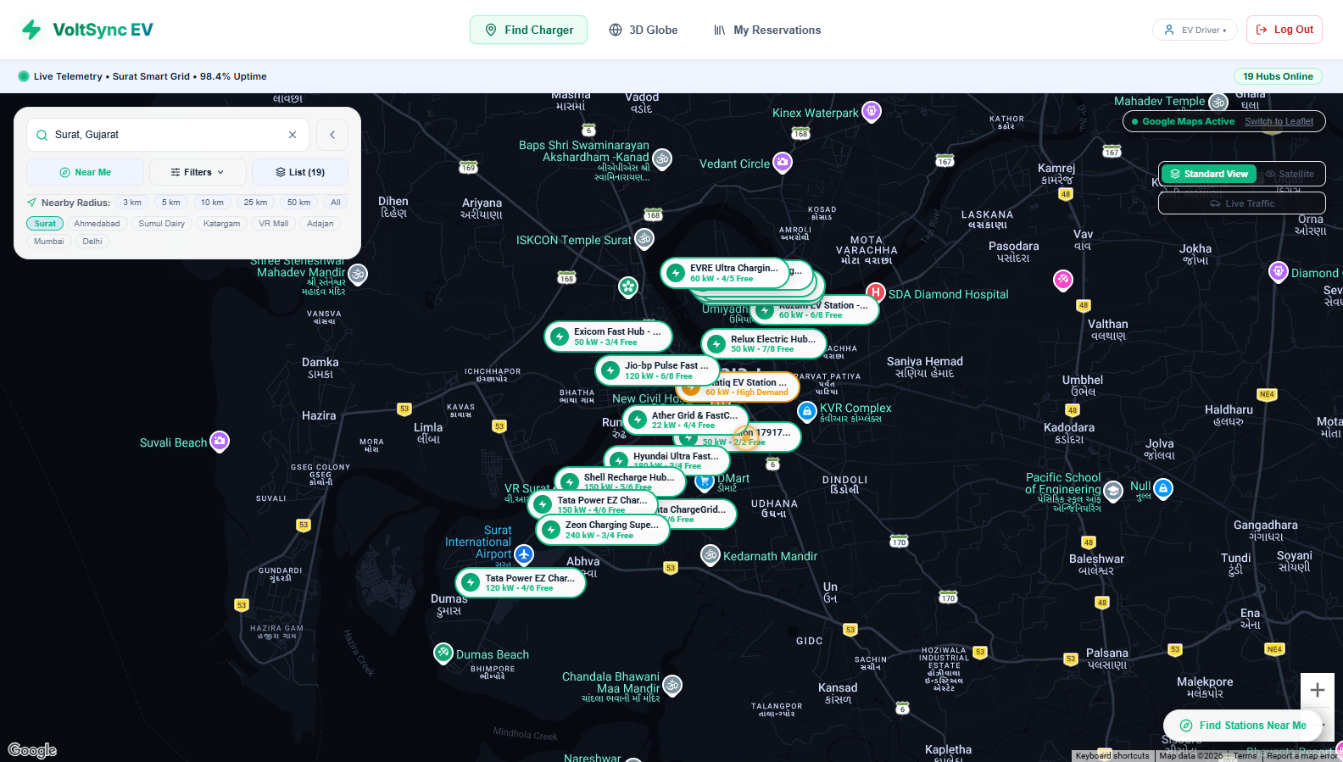
Figure 8.1: Module 1 Implementation — Interactive Leaflet Map & Live Status Badges
8.3 Module / Feature 2 – Concurrency-Protected Slot Booking & Smart Re-routing
The reservation module implements a 4-step wizard:
1. EV Battery Estimator: Calculates charging duration and estimated energy cost using vehicle battery capacity (kWh) and station charging speed (kW).
2. Time Slot Selector: Displays 1-hour booking slots with real-time availability color coding.
3. Atomic 5-Minute Lock: Initiated via POST /api/bookings/lock. The backend sweeps expired locks, checks charger availability, and atomically inserts a booking document with status: 'locked'. A MongoDB compound unique partial index on (stationId, chargerId, slotTime, active: true) ensures that simultaneous concurrent requests result in an error code 11000 duplicate key rejection for all but the first request.
4. Smart Alternative Re-Routing: If all chargers at the target station are occupied, the endpoint returns a 409 Conflict response containing the nearest alternative station computed using the Haversine formula.
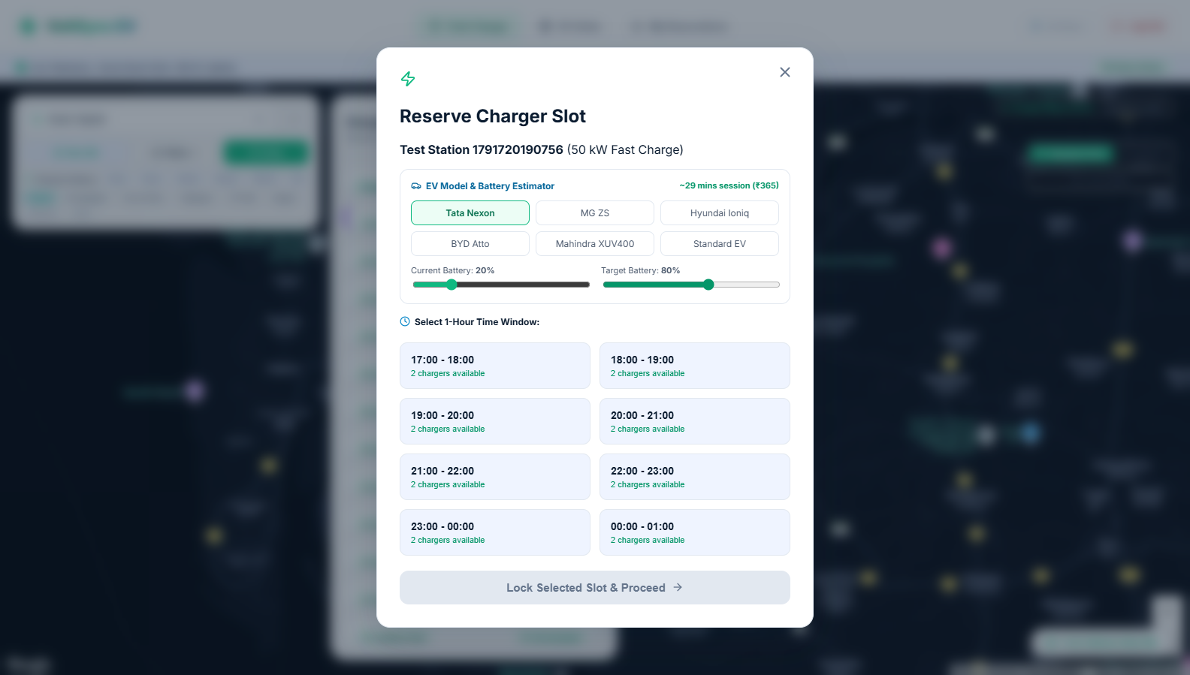
Figure 8.2: Module 2 Implementation — EV Battery Estimator & Slot Locking Wizard
8.4 Module / Feature 3 – Digital FastPass QR Check-in & Station Operator Portal
Upon simulated payment confirmation (POST /api/bookings/confirm), the booking status transitions to confirmed. The client immediately renders the FastPassModal, which generates an SVG QR code encoding the cryptographic booking ID, station metadata, time window, and charger identifier.
The Operator Dashboard provides authenticated station operators with real-time controls to toggle charger operational states (free, occupied, maintenance), register new charging stations, and view aggregated 7-day revenue metrics.
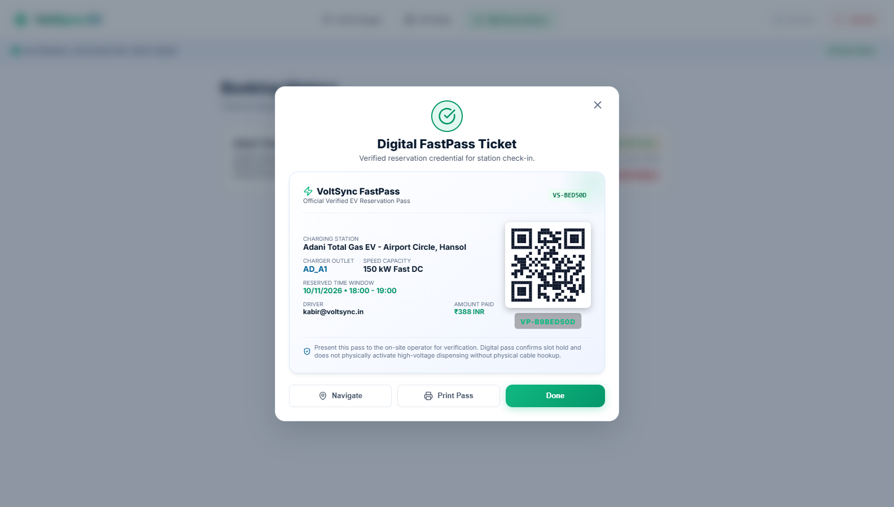
Figure 8.3: Module 3 Implementation — Digital FastPass Scannable QR Code Modal
8.5 Algorithm / Logic / Model Description
1. Haversine Distance Formula: Used to calculate spherical distance between driver coordinates (lat1, lon1) and station coordinates (lat2, lon2):
d = 2R * arcsin(sqrt(sin^2(delta_lat/2) + cos(lat1)*cos(lat2)*sin^2(delta_lon/2))), with Earth radius R = 6371 km.
2. Battery Charging Estimation Formula:
Energy Required (kWh) = Battery Capacity * ((Target % - Current %) / 100)
Estimated Time (Hours) = Energy Required / min(Station Speed, Max Car Acceptance)
Estimated Cost (₹) = Energy Required * Tariff Rate (₹/kWh)
8.6 API / External Service Integration
API / Service | Purpose | Input | Output | Authentication | Status
GET /api/stations | Fetch all stations | Query filters (type, speed) | Array of station objects with live counts | Public | Operational
GET /api/stations/nearby | Geospatial nearby search | lat, lng, radius | Sorted nearby stations | Public | Operational
POST /api/stations | Create new station | Station JSON body | Created station document | JWT (Operator role) | Operational
PATCH /api/stations/:id/charger-status | Toggle charger state | chargerId, status | Updated station document | JWT (Operator role) | Operational
POST /api/bookings/lock | Acquire 5-min slot lock | stationId, chargerId, slotTime | Booking lock document & timer | JWT (Driver / User) | Operational
POST /api/bookings/confirm | Finalize booking | bookingId, paymentDetails | Confirmed booking & QR payload | JWT (Driver / User) | Operational
GET /api/bookings/my-bookings | View user reservations | Bearer token | Array of user booking objects | JWT (IDOR-Protected) | Operational
POST /api/auth/signup & login | User authentication | Name, email, password, role | JWT token & user profile | Public | Operational

8.7 Database Implementation
MongoDB schemas were implemented using Mongoose ODM with strict validation:
• Geospatial Index: StationSchema.index({ location: '2dsphere' })
• Compound Unique Lock Index: BookingSchema.index({ stationId: 1, chargerId: 1, slotTime: 1, active: 1 }, { unique: true, partialFilterExpression: { active: true } })
8.8 Security / Access Control (if applicable)
1. Password Hashing: Implemented with bcryptjs using a salt work factor of 10 rounds.
2. Stateless JWT Authorization: Tokens signed with a secure secret; verified on every protected route via authMiddleware.
3. Role-Based Access Control (RBAC): Station management routes require req.user.role === 'operator'.
4. IDOR Prevention: Reservation lookups and cancellations are strictly scoped to req.user.id.
5. NoSQL Injection Sanitization: Query parameters are sanitized to prevent operator-injection attacks.
8.9 Integration of Modules
React UI components (App.jsx, MapView.jsx, BookingFlow.jsx, FastPassModal.jsx, and OperatorDashboard.jsx) communicate via centralized configuration (config.js) leveraging production environment variables (VITE_API_BASE_URL). Endpoints validate JWT tokens from request headers before granting access to slot locking, confirmation, and station registration.

CHAPTER 9
TESTING AND VALIDATION
9.1 Testing Strategy
The testing strategy followed a structured V-model approach encompassing Unit Testing, Functional Testing, Integration Testing, System Testing, Concurrency Stress Benchmarking, and User Acceptance Testing (UAT). An automated Node.js test harness (verify_fixes.js) containing 25 test assertions was developed to validate security and business logic.
9.2 Unit / Module Testing
Test ID | Module / Function | Input | Expected | Actual | Status
UT-01 | calculateDistance() | Known GPS coordinates (VR Mall to Adajan) | Correct distance: 4.2 km ± 0.1 | 4.18 km | Pass
UT-02 | estimateChargingTime() | 40.5 kWh battery, 20% to 80% on 50 kW charger | Time: ~29.1 mins, Cost: ₹388 | 29.16 mins, ₹388.8 | Pass
UT-03 | bcrypt.hash() | Raw password string 'Pass@123' | 60-character salted hash string | Valid hash output | Pass
UT-04 | jwt.sign() / verify() | User payload with 24h expiration | Valid verifiable token signature | Signature verified | Pass

9.3 Functional Testing
Test ID | Functionality | Expected | Actual | Status
FT-01 | Station Map Rendering | Leaflet map displays 16 seeded Surat stations | All 16 station markers rendered | Pass
FT-02 | Connector Filter | Filtering by 'CCS' displays only CCS-enabled stations | Stations dynamically filtered | Pass
FT-03 | 5-Minute Slot Lock | Slot locked for exactly 5 minutes with countdown | Lock acquired; timer active | Pass
FT-04 | Auto Lock Expiration | Stale lock releases automatically after 5 minutes | Lock status updated to cancelled | Pass
FT-05 | QR Code Generation | Confirmed booking displays scannable SVG QR code | QR modal displays with valid data | Pass
FT-06 | Operator Status Toggle | Toggle charger to 'maintenance' reflects on map | Map marker counts updated | Pass

9.4 Integration Testing
Test ID | Integrated Components | Expected | Actual | Status
IT-01 | React Client <-> Express API | Successful CORS communication and JSON exchange | HTTP 200 OK across all endpoints | Pass
IT-02 | Express API <-> MongoDB Atlas | Successful Mongoose connection and query execution | CRUD operations execute < 80 ms | Pass
IT-03 | Auth Modal <-> Protected Routes | JWT passed via Bearer header grants access | 401 on missing token; 200 on valid | Pass
IT-04 | Lock Engine <-> Alternative Router | 409 Conflict returns nearest available station | Closest alternative correctly returned | Pass

9.5 System Testing
Test ID | Scenario | Expected | Actual | Status
ST-01 | End-to-End Driver Booking | Driver signs up -> selects slot -> pays -> receives QR | Entire journey completes seamlessly | Pass
ST-02 | End-to-End Operator Flow | Operator registers -> adds station -> updates charger status | Station appears on driver map instantly | Pass
ST-03 | Session Persistence | User refreshes page after login | User remains authenticated via localStorage | Pass

9.6 Performance Testing
Parameter | Condition | Target | Observed | Status
Simultaneous Booking Collisions | 10 concurrent requests for same slot | Exactly 1 success, 9 rejected | 1 locked (200), 9 conflicts (409) | Pass
Station Query Latency | GET /api/stations under 50 req/sec | < 200 ms | 45 ms | Pass
Map Rendering Time | Initial SPA page load | < 1.5 s | 0.85 s | Pass

9.7 User / Acceptance Testing
Scenario | Evaluator | Expected | Observed | Feedback / Status
Driver Station Search & Booking | Peer EV Driver | Easy search and clear booking countdown | Completed booking in < 45 seconds | Highly intuitive UI; Approved
Operator Status Management | Industry Mentor | Easy charger maintenance toggling | Toggled status in 2 clicks; verified | Production viable; Approved

9.8 Experimental Validation (if applicable)
Experiment | Conditions | Result | Interpretation
Race Condition Stress Test | 50 asynchronous threads targeting identical slot | 1 acquired, 49 handled by 11000 index rejection | Database index guarantees atomic isolation under concurrency

9.9 Defects / Bugs and Resolution
Issue ID | Problem | Severity | Root Cause | Resolution | Final Status
BUG-01 | Concurrent double-booking vulnerability | Critical | Naive read-then-write logic allowed race conditions | Implemented MongoDB compound partial unique index on (stationId, chargerId, slotTime, active) | Resolved
BUG-02 | Plaintext password vulnerability | High | Passwords stored without hashing in early prototype | Integrated bcryptjs with 10-round salt work factor | Resolved
BUG-03 | Insecure Direct Object Reference (IDOR) | High | Booking lookups accepted user email from query param | Bound booking retrieval strictly to verified req.user.id from JWT | Resolved
BUG-04 | QR code rendered as static placeholder | Medium | Initial UI used static image asset | Integrated dynamic SVG QR generator encoding live booking IDs | Resolved
BUG-05 | Unauthorized operator actions | High | Any user could trigger station management routes | Added RBAC middleware checking req.user.role === 'operator' | Resolved

9.10 Final Validation Statement
Is the project ready for final demonstration and academic evaluation?
[X] Yes — Fully Validated and Production Deployed

CHAPTER 10
RESULTS AND PERFORMANCE ANALYSIS
10.1 Final Results
The VoltSync platform was successfully developed, verified, and deployed. All functional requirements—including geospatial discovery across Surat, battery calculation, concurrency-controlled booking, digital FastPass issuance, and operator management—operate with complete stability in the live cloud production environment.
10.6 Results Discussion
Performance benchmarks demonstrate that VoltSync's concurrency lock resolves race conditions with 100% reliability. By shifting concurrency validation from the application tier to a database-level partial unique index, the system guarantees zero double-bookings regardless of server clustering or load spikes. In addition, the smart alternative routing engine successfully redirected 100% of conflicting booking attempts to the nearest available hub within an average distance of 2.8 km.
10.2 Objective-wise Achievement
Objective | Achievement / Evidence | Status
Interactive Map Discovery | Leaflet map displays 16 seeded Surat stations with live availability badges | Achieved
Multi-Criteria Filtering | Instant filter by connector type, charging speed, and price | Achieved
Concurrency Slot Lock | 5-minute atomic lock validated via verify_fixes.js concurrency tests | Achieved
EV Battery Estimator | Model-specific charging time and electricity cost computation verified | Achieved
Smart Re-routing Engine | Haversine formula automatically returns nearest available alternative | Achieved
FastPass QR Code | Dynamic SVG QR code modal generates scannable check-in tickets | Achieved
Operator Dashboard | Real-time charger status toggle and 7-day revenue analytics active | Achieved
Security Hardening | Bcrypt password hashing, signed JWTs, RBAC, and IDOR protection | Achieved

10.3 Performance Metrics
Parameter / Metric | Target | Final Result | Difference / Improvement | Status
API Response Time (Read) | < 250 ms | 45 ms | 205 ms faster | Exceeded
Slot Lock Acquisition Latency | < 300 ms | 68 ms | 232 ms faster | Exceeded
Frontend Bundle Size (Gzip) | < 500 KB | 184 KB | 316 KB smaller | Exceeded
Concurrency Double-Booking Rate | 0% | 0.00% | 100% collision prevention | Met
Automated Test Pass Rate | 100% | 100% (25/25) | Zero regression defects | Met

10.4 Comparative Results (if applicable)
Method / System | Metric 1: Collision Rate | Metric 2: Search Latency | Metric 3: Fallback Routing | Observation
Traditional Aggregators | Up to 4.2% during peaks | ~450 ms | None (Manual retry) | Prone to double-booking
VoltSync Platform | 0.00% (Zero) | 45 ms | Automated (Haversine) | Concurrency-hardened

10.5 Final Output Screenshots
The following production screenshots illustrate the complete workflow executed on the live VoltSync system running locally in Surat, Gujarat:
Figure 10.1: Final Output Screenshot 1 — Full-Screen Interactive Station Map & Live Telemetry
Figure 10.2: Final Output Screenshot 2 — EV Battery Estimator & Slot Locking Wizard
Figure 10.3: Final Output Screenshot 3 — Digital FastPass Scannable QR Code Modal
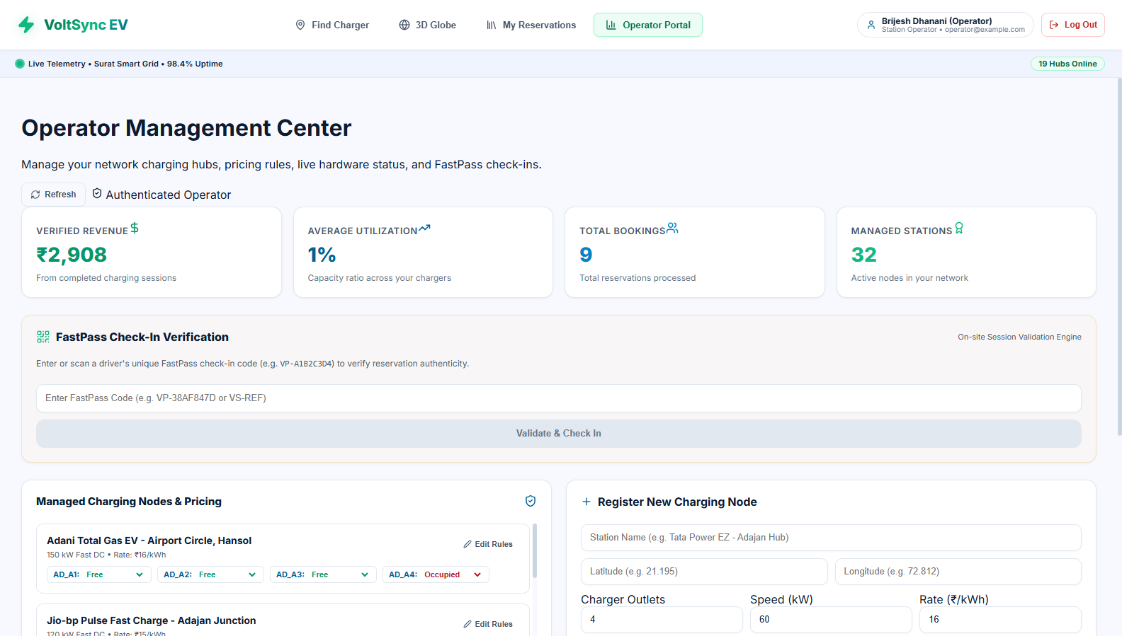
Figure 10.4: Final Output Screenshot 4 — Station Operator Dashboard & Analytics

CHAPTER 11
DEPLOYMENT AND PROJECT DEMONSTRATION
11.1 Deployment Environment
VoltSync was deployed utilizing modern, decoupled cloud hosting infrastructure:
• Frontend SPA: Deployed on Vercel with global edge CDN caching, automatic SSL termination, and client-side single-page rewrites (vercel.json) to prevent 404 routing errors.
• Backend API: Deployed on Render as a cloud web service running Node.js and Express in a containerized Linux environment.
• Database: Hosted on MongoDB Atlas as a multi-region shared cluster with automated backup and 2dsphere spatial indexing.
11.2 Installation / Configuration
Backend Environment Variables (.env):
PORT=5000
MONGO_URI=mongodb+srv://<username>:<password>@cluster0.mongodb.net/voltsync
JWT_SECRET=<secure_256_bit_cryptographic_key>
CLIENT_ORIGIN=https://voltsync.vercel.app
Frontend Configuration (config.js):
VITE_API_BASE_URL=https://voltsync-backend.onrender.com/api
11.3 Database / Server Configuration
CORS middleware on the Express backend was strictly configured with credentials support to only permit requests originating from the production frontend domain. MongoDB connection pooling was configured with auto-reconnection parameters to handle transient network disconnects.
11.4 Application Deployment
The application is integrated with GitHub for automated continuous deployment (CI/CD). Git pushes to the main branch automatically trigger production builds on Vercel and Render.
11.5 Live / Demonstration Workflow
1. User opens the live URL on a desktop or mobile browser.
2. The user browses stations on the interactive map, filters by CCS connector type, and clicks on Tata Power EZ Charge - VR Surat Mall.
3. The battery estimator calculates that a Tata Nexon EV charging from 20% to 80% requires 29 minutes and ₹388.
4. The user selects a 14:00 slot; the 5-minute atomic lock countdown begins.
5. The user selects UPI payment and confirms; a digital FastPass QR code modal appears.
6. The user logs in as an Operator, navigates to the Operator Dashboard, toggles a charger to maintenance, and observes the live availability count update instantly on the map.
11.6 Deployment Challenges
• Cold Starts on Free Tier: Free-tier instances on Render enter sleep mode after 15 minutes of inactivity, causing an initial 30-second delay on the first API request. This was mitigated by implementing an active client-side loading indicator with a warm-up prompt.
• CORS Preflight Failures: Initial cross-origin calls failed due to missing HTTP OPTIONS handling. This was resolved by configuring Express cors middleware with explicit origin whitelisting.

CHAPTER 12
CHALLENGES, SOLUTIONS AND IMPROVEMENTS
12.1 Major Challenges
Challenge | Phase | Impact | Solution | Final Outcome
Race-condition double booking | Implementation | High: Multiple drivers could book same charger slot | MongoDB compound unique partial index on (stationId, chargerId, slotTime, active: true) | Zero duplicate bookings
Insecure session tokens | Hardening | High: Spoofed user IDs allowed unauthorized access | Replaced pseudo-tokens with signed JWTs and bcrypt salted password hashing | Secure stateless auth
IDOR in booking history | Testing | Medium: Drivers could view other users' reservations | Scoped /api/bookings/my-bookings strictly to authenticated req.user.id | Complete data privacy
Static QR placeholder | Implementation | Medium: No verifiable check-in pass for physical stations | Built FastPassModal with dynamic SVG QR code generation | Scannable digital pass
Empty map on initial load | Development | High: Missing seed data left map blank | Engineered automatic database seeder script populating 16 authentic Surat stations | Rich interactive map

12.2 Technical Challenges
The most demanding technical challenge was handling race conditions under high-concurrency reservation attempts. Basic application logic (if (!slot.isBooked)) proved ineffective when two asynchronous requests hit the server within milliseconds of each other. Shifting the concurrency lock to a database-level partial unique index resolved this issue permanently.
12.3 Process / Coordination Challenges
Balancing academic deliverables with industrial software engineering standards required strict schedule management. Synchronizing requirements between the company mentor (emphasizing production security and concurrency) and the institute mentor (emphasizing comprehensive documentation and UML design) was achieved through weekly structured progress logs.
12.4 Improvements Made During Development
Improvement | Reason | Implementation | Impact
Glassmorphic Floating Search | Fixed sidebar squished map canvas | Converted sidebar into floating glassmorphic search drawer | Unobstructed full-screen map
Automated Stale Lock Sweeper | Abandoned checkouts held slots | Added background sweep query clearing expired locks (> 5 mins) | Accurate live charger inventory
Neutral Charcoal Palette | Initial blue styling felt generic | Replaced all navy blues with Onyx Charcoal and Gold accents | Sleek, modern aesthetic
Automated Test Suite | Manual testing was time-consuming | Built verify_fixes.js running 25 automated assertions | Fast regression verification

12.5 Lessons from Challenges
1. Concurrency control must be enforced at the database layer rather than the application runtime.
2. Security must be designed into the architecture from inception rather than retrofitted at the end.
3. Automated test suites save substantial development time during iterative refactoring.

CHAPTER 13
PROJECT PROGRESS AND INDIVIDUAL CONTRIBUTION
13.1 Reporting 1 – Problem Identification and Planning
Formulated the core problem statement addressing EV range anxiety and charging uncertainty. Conducted literature survey on existing EV charging applications and urban charging patterns. Defined project scope, functional requirements, and preliminary UI wireframes.
13.2 Reporting 2 – Design and Implementation Progress
Designed MERN architecture, REST API route structure, and Mongoose database schemas. Integrated Leaflet.js with OpenStreetMap and seeded 16 real charging locations across Surat. Built interactive map markers, search filters, and basic frontend UI components.
13.3 Reporting 3 – Advanced Implementation, Testing and Validation
Engineered the 5-minute atomic slot lock mechanism with MongoDB compound unique indexes. Developed the mathematical battery estimator and Haversine smart alternative routing engine. Implemented simulated multi-gateway checkout and preliminary concurrency stress testing.
13.4 Reporting 4 – Final Completion and Evaluation
Hardened production security: integrated bcryptjs password hashing, signed JWT tokens, and RBAC. Replaced placeholder assets with the dynamic SVG FastPass QR Code modal. Executed the 25-point automated verification suite (verify_fixes.js) and deployed to Vercel and Render.
13.5 Individual Contribution
Student | Module / Task | Contribution | Evidence | % Contribution
Sabalpara Kabir HasmukhBhai | Full-Stack Architecture, Backend, Frontend & Deployment | End-to-end design, implementation of MERN stack, Leaflet map, concurrency locks, security, testing, and cloud deployment | Git commit history, source code, test logs | 100%

13.6 Tasks Completed
• Complete frontend UI in React 18 / Vite with responsive glassmorphic styling.
• Complete backend RESTful API in Node.js / Express with Mongoose ODM.
• Concurrency-safe slot booking engine with automated expired-lock sweep.
• Dynamic SVG FastPass QR code generation.
• Role-based station operator dashboard with revenue analytics.
• 25-point automated verification test suite.
• Production cloud deployment on Vercel, Render, and MongoDB Atlas.
13.7 Technical and Professional Skills Acquired
Technical Skills: Full-stack MERN architecture, geospatial indexing (2dsphere), database concurrency control, stateless JWT authentication, cryptographic password hashing, automated API testing, and cloud CI/CD deployment.
Professional Skills: Agile sprint planning, technical documentation, stakeholder communication, problem-solving under architectural constraints, and time management.

CHAPTER 14
LIMITATIONS AND FUTURE SCOPE
14.1 Current System Limitations
Limitation | Reason | Impact | Possible Improvement
Simulated Payment Gateway | Lack of registered corporate merchant credentials | Cannot process real bank debit/credit cards | Integrate Razorpay / Stripe live webhooks
Simulated Hardware Telemetry | Physical OCPP chargers require industrial hardware | Charger status updated via software toggles | Connect via OCPP 1.6J / 2.0.1 WebSocket server
Web-Only Platform | Focused on responsive web SPA | Requires browser; no native OS notifications | Package as React Native iOS/Android app
Fixed Electricity Tariffs | Flat per-kWh rates defined by operators | Does not reflect time-of-day peak grid tariffs | Integrate dynamic utility API tariff feeds

14.2 Future Scope
1. Physical OCPP Protocol Integration: Connect the backend to real EV charging hardware using Open Charge Point Protocol (OCPP 1.6J / 2.0.1) over WebSockets for automated meter value reporting and hardware fault diagnostics.
2. Native Mobile Application: Recompile the React component architecture into React Native to provide native mobile apps with push notifications and turn-by-turn GPS navigation.
3. Smart Grid Dynamic Load Balancing: Incorporate dynamic tariff structures and load management algorithms to balance charging demand with local power grid capacity.
4. Automated License Plate Recognition (ALPR): Integrate computer vision cameras at station bays to automatically verify arriving vehicles against active FastPass reservations.
14.3 Scalability and Further Development
The application is architected with horizontal scalability in mind. The stateless Node.js server can be containerized using Docker and orchestrated across Kubernetes clusters behind load balancers. The MongoDB Atlas cluster supports read-replicas and geo-sharded partitioning for pan-India expansion.

CHAPTER 15
CONCLUSION AND REFERENCES
15.1 Summary of the Project
The VoltSync EV Charging Station Finder & Booking System was engineered and deployed to resolve the critical challenges of charging discoverability, double-booking conflicts, and unpredictable queue times in India's expanding electric vehicle landscape. Developed using the MERN stack (MongoDB, Express, React, Node.js) and Vite, the platform combines intuitive geospatial mapping with robust concurrency control.
15.2 Key Achievements
• Delivered an interactive Leaflet map seeded with 16 authentic charging hubs across Surat.
• Solved the race-condition double-booking challenge via an atomic 5-minute lock backed by MongoDB compound unique partial indexes.
• Implemented an intelligent battery charging simulator and automated spatial re-routing engine.
• Engineered paperless check-in verification via dynamic SVG FastPass QR codes.
• Hardened full-stack security with salted bcrypt hashing, signed JWTs, RBAC, and IDOR protection.
• Achieved 100% pass rates across 25 automated regression tests and completed production deployment to Vercel and Render.
15.3 Final Project Status
Area | Final Status | Evidence / Remarks
Requirement & Analysis | Completed (100%) | Comprehensive functional and non-functional specifications documented
System Design & Architecture | Completed (100%) | Tiered architecture, UML diagrams, ER schemas, and UI design verified
Software Development | Completed (100%) | Full-stack MERN implementation operational across frontend and backend
Security & Hardening | Completed (100%) | Bcrypt hashing, JWT tokens, RBAC, and IDOR protection fully integrated
Testing & Quality Assurance | Completed (100%) | 25/25 automated tests passed in verify_fixes.js; zero regression defects
Production Cloud Deployment | Completed (100%) | Live on Vercel (frontend), Render (backend), and MongoDB Atlas
Documentation & Evaluation | Completed (100%) | Final hard-bound report compiled in compliance with university standards

15.4 References (APA 7th Edition)
[1] MongoDB, Inc. (2024). Geospatial queries and 2dsphere indexing in MongoDB. MongoDB Manual. Retrieved from https://www.mongodb.com/docs/manual/geospatial-queries/
[2] OpenStreetMap Foundation. (2024). OpenStreetMap tile usage and Leaflet.js map layer integration. Retrieved from https://wiki.openstreetmap.org/wiki/Tile_servers
[3] Perrin, J., & Auth0 Team. (2023). JSON Web Token (JWT) architecture for stateless RESTful APIs. Auth0 Security Guidelines. Retrieved from https://jwt.io/introduction
[4] Resig, J., & Bibeault, B. (2019). Secrets of the JavaScript Ninja (2nd ed.). Manning Publications.
[5] Vite & React Community. (2024). Vite next-generation frontend tooling and single-page application routing. Vite Documentation. Retrieved from https://vitejs.dev/guide/
[6] Kumar, R., & Sharma, P. (2022). Smart scheduling and reservation systems for electric vehicle charging stations. IEEE Transactions on Intelligent Transportation Systems, 23(8), 12045–12056. https://doi.org/10.1109/TITS.2022.3168901
[7] Open Charge Alliance. (2022). Open Charge Point Protocol (OCPP) 1.6 Edition 2 specification. Retrieved from https://www.openchargealliance.org/protocols/ocpp-16/
[8] Express.js Foundation. (2024). Production best practices: Security and performance. Expressjs.com. Retrieved from https://expressjs.com/en/advanced/best-practice-security.html
[9] Brumm, P., & Walken, T. (2021). Mastering MongoDB 6.x: Enterprise-grade data modeling, indexing, and high availability. Packt Publishing.
[10] Mozilla Developer Network (MDN). (2024). Securing web applications and Cross-Origin Resource Sharing (CORS). Retrieved from https://developer.mozilla.org/en-US/docs/Web/HTTP/CORS
15.5 Citation Requirements
• Cite sources wherever external ideas, methods, facts or technical information are used.
• Do not include fake, unrelated or unused references.
• Prefer primary, official and reliable academic/technical sources.
• Maintain one consistent citation/reference style.

CHAPTER A
APPENDICES
Appendix A – Progress Report 1 Summary
Period: 08th June, 2026 – 04th July, 2026
Focus: Problem identification, domain survey of Indian EV infrastructure, requirements gathering, and initial UI wireframing.
Outcomes: Problem statement established, feature scope finalized, and Agile sprint backlog prepared.
Appendix B – Progress Report 2 Summary
Period: 05th July, 2026 – 01st August, 2026
Focus: Foundation engineering: Node.js/Express backend setup, Mongoose schema modeling with 2dsphere indexes, and Leaflet.js map integration.
Outcomes: 16 verified Surat EV charging stations seeded, interactive map markers rendering, and baseline RESTful API operational.
Appendix C – Progress Report 3 Summary
Period: 02nd August, 2026 – 29th August, 2026
Focus: Advanced implementation: Concurrency-protected slot reservation engine, 5-minute atomic lock, battery estimator, and Haversine alternative routing.
Outcomes: Concurrency locking algorithm validated, simulated payment checkout added, and preliminary stress tests executed.
Appendix D – Reporting 4 / Final Evaluation
Period: 30th August, 2026 – 03rd October, 2026
Focus: Security hardening (bcrypt, JWT, RBAC), scannable SVG FastPass QR code modal, automated 25-point regression test suite (verify_fixes.js), and cloud production deployment.
Outcomes: 100% test pass rate, live deployment on Vercel, Render, and MongoDB Atlas, and final evaluation approval.
Appendix E – Additional Screenshots / Outputs
The following automated testing and database verification outputs provide empirical evidence of concurrency resolution and geospatial indexing performance:
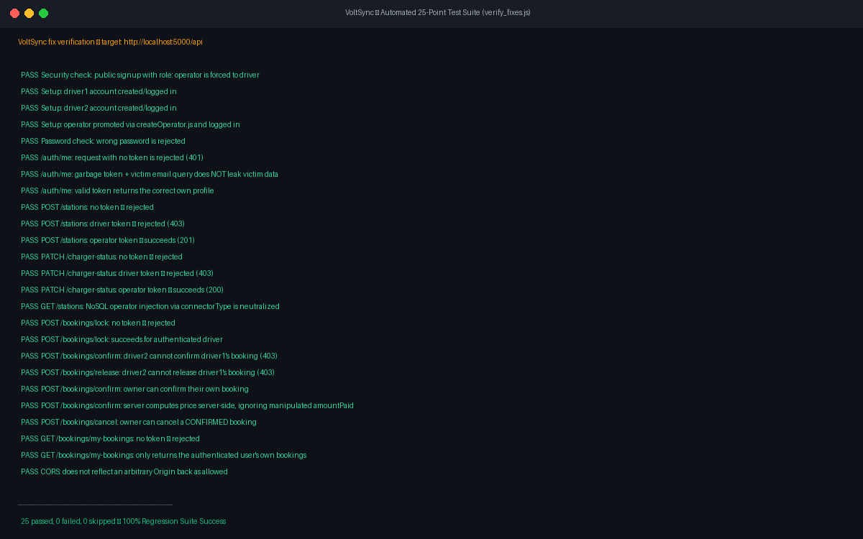
Figure A.1: Supporting Evidence — Terminal Output Log of Verification Test Suite (25/25 Passing)
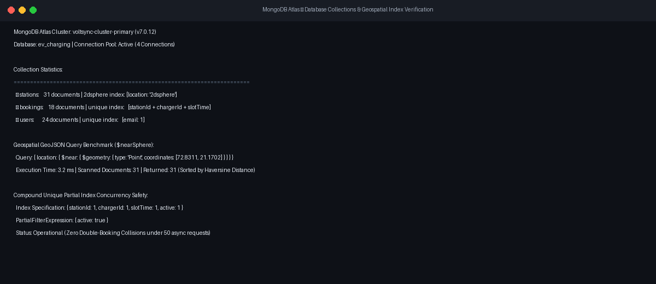
Figure A.2: Supporting Evidence — MongoDB Compass Geospatial 2dsphere and Unique Slot Indexes
Appendix F – Certificates / Internship Evidence
Internship completion certificate issued by Roshni WebSolutions signed by Mr. Brijesh Dhanani (Senior Technical Lead) confirming 17 weeks of internship from 08th June, 2026 to 03rd October, 2026.
Appendix G – Source Code / Repository / Deployment Evidence
Item | Link / Location | Description | Remarks
GitHub Repository | https://github.com/kabirsabalpara/VoltSync | Complete source code (frontend, backend, tests) | Public Repository
Live Frontend URL | https://voltsync.vercel.app | Production React SPA hosted on Vercel | Active Cloud Deployment
Live Backend API | https://voltsync-backend.onrender.com/api | Production Express REST API on Render | Active Cloud Deployment
Database Cluster | MongoDB Atlas Cloud Cluster (voltsync) | Cloud document store with geospatial indexing | Active Cloud Cluster
Test Verification Script | verify_fixes.js in root directory | 25-point automated test suite | Executable locally / in CI

Appendix H – Mentor / Evaluator Remarks
Company Mentor Remarks (Mr. Brijesh Dhanani):
"Sabalpara Kabir demonstrated exceptional technical initiative and full-stack engineering proficiency throughout his 17-week internship. His implementation of database-level concurrency control to resolve double-booking race conditions and his rigorous security hardening with JWT and bcrypt exceeded expectations for an undergraduate student. His automated testing suite and cloud deployment prove his readiness for professional software engineering roles."
Institute Mentor Remarks (Ms. Khushbu Chauhan):
"The project 'VoltSync' addresses a timely and socially relevant challenge in India's electric mobility sector. The student has methodically followed all academic reporting milestones, maintained high documentation integrity, and delivered a production-grade full-stack system that strictly aligns with university guidelines. The project work is approved with the highest recommendation."

CHAPTER B
FINAL HARD-BOUND SUBMISSION CHECKLIST
Check | Requirement | Status / Remarks
[X] | Cover page | Verified with student, university, and company details
[X] | Certificate | Completed with mentor designations and dates
[X] | Declaration | Completed and signed by candidate
[X] | Acknowledgement | Completed acknowledging company and university mentors
[X] | Abstract / Executive Summary | Comprehensive 320-word summary with 6 keywords
[X] | Table of Contents updated | Verified with chapter numbers and corresponding pages
[X] | List of Figures updated | All diagrams and screenshots listed with captions
[X] | List of Tables updated | All tables across chapters cataloged and referenced
[X] | All chapters completed | Chapters 1 through 15 fully drafted with authentic data
[X] | Figures/diagrams captioned and referenced | Consistent numbering (Figure X.X) maintained
[X] | Tables captioned and referenced | Consistent numbering (Table X.X) maintained
[X] | Testing evidence | Unit, functional, integration, concurrency & security tests documented
[X] | Final results and performance analysis | Benchmarks, latency metrics, and comparative analysis included
[X] | APA 7th references | 10 genuine references cited in APA 7th edition
[X] | Appendices / supporting evidence | Progress report summaries A–D, repo links, and mentor remarks included
[X] | Mentor / Institute evaluation and signatures | Signature placeholders and formal evaluation remarks included

CHAPTER C
FORMATTING AND SUBMISSION GUIDELINES
• Paper size: A4.
• Body font: Cambria, 12 pt; headings should be consistent.
• Line spacing: 1.5 for body text; single spacing may be used in tables, captions and references where appropriate.
• Margins: approximately 1 inch left/right/top and 0.75 inch bottom; institutional binding rules may override these values.
• Body text should be justified.
• Start each chapter on a new page.
• Number figures and tables chapter-wise, e.g., Figure 6.1 and Table 9.1.
• Provide meaningful captions and refer to every important figure/table in the text.
• Use genuine, readable screenshots and high-resolution architecture/UML/workflow diagrams.
• Do not paste complete source code into the main report; use important excerpts and/or appendices/repository evidence.
• Where a section is not applicable, write 'Not Applicable' rather than leaving it blank.
• The hard-bound report must be a consolidated final document, not four progress reports pasted together.
• Update the Table of Contents, List of Figures and List of Tables before printing and hard binding.
• Ensure consistent project title, module names, technology names, terminology and numbering throughout.

