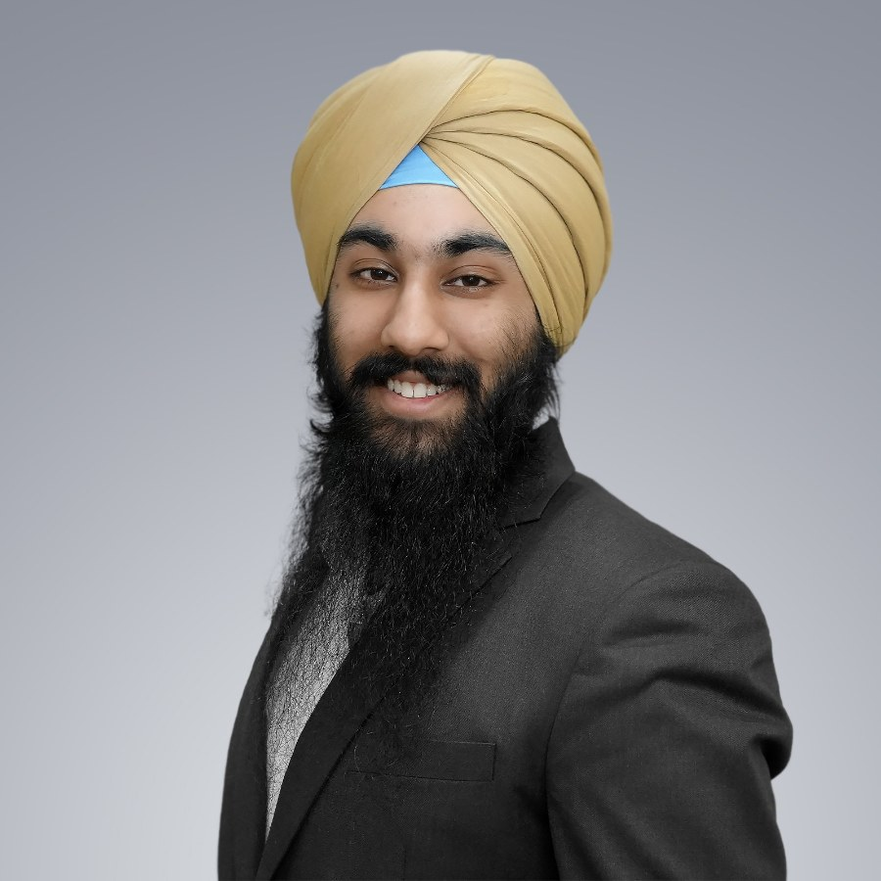 | Kabir Singh  kabirsinghji@gmail.com · +1 917 636 8664 · kabirsinghji.github.io · ORCID 0009-0002-5159-5879

Education
B.S. Mathematical Sciences (Mathematical Biology) Sep 2023 – May 2027
Albert Dorman Honors College & Jordan Hu College of Sciences & Liberal Arts, NJIT (Expected)
Newark, NJ, USA
- Dean’s List all semesters.
- Minors: Biomedical Engineering Technology, History, Philosophy & Applied Ethics; Honors tracks: Medical Humanities & Global Studies (first Honors College student to pursue two).
- Academic scholarships exceeding $100,000, including Academic Excellence, Honors Merit, Honors Residential, & Highlander Achievement scholarships; tuition & board scholarship support.
Biomedical Applications in Healthcare; Biochemistry; Biomedical Mechatronics; Cell & Molecular Biology
Medicine & society Biomedical Ethics; Health, Justice, & Capitalism; Medical Sociology; Medicine & Law in Modern History
Quantitative Applied Numerical Methods; Differential Equations (ordinary & partial); Linear Algebra; Mathematical Modeling; Stochastic & Discrete Models in Biology
Independent study Bioengineering (Dr Vivek Kumar); Maths (Dr James Maclaurin, Dr Horacio Rotstein); History (Dr Stephen Pemberton, Satnam Singh)
Exchange semester (Global E3), Lund University, Sweden Jan 2025 – Jun 2025
Faculty of Engineering (LTH); 44 ECTS Lund, Sweden
- Fellow, Institute of International Education’s Global Engineering Education Exchange (Global E3).
Master’s level Biomathematics; Immunotechnology; Microscopy, Bio-Imaging; Ultrasound Physics & Technology
Undergraduate Patent & Intellectual Property Rights

Research Experience

Computational & Mathematical Biology
Undergraduate Researcher & Computational Biology Team Lead Oct 2023 – Present
KumarLab; PI: Dr Vivek Kumar, University of Houston (previously NJIT) Houston, TX / Newark, NJ, USA
- Lead undergraduates & graduates in computational development of peptide therapeutics; trained 15+ lab associates & secured over $15,000 in direct project funding.
- Conducted dissections & assisted animal work on angiogenic hydrogels subsequently published; maintained computational research after the lab relocated to Houston.
A novel cyclic peptide that blocks human autoimmune antibodies for the treatment of multiple sclerosis.
- Designed cyclic peptides against multiple sclerosis autoantibodies with eight-residue design scaffold & Rosetta/FlexPepDock workflow; ran molecular-dynamics simulations for my top-ranked peptide CAP8, with GROMACS simulations & alanine scanning; in the published study, CAP8 bound anti-GlialCAM autoantibody with K_{d} = 0.294 mM, versus 4.82 mM linear & 2.61 mM unrelated cyclic controls & cut epitope detection on Western blot by 69% versus 27% & 5% for controls.
- Partial work through ‘independent study’ module, published in the European Journal of Medicinal Chemistry [1].
A novel cyclic peptide that blocks fertilization protein for a male contraceptive.
- Secured & led a funded non-hormonal male-contraception project: machine-learning-guided cyclic peptide design against redacted target, docking & refinement.
- 8 poster presentations, scientific manuscript & patent application in preparation [2].
Lipidated self-assembled peptides that modulate GPCR signaling of CB1 receptor.
- Helped run in-silico validation using NAMD, GROMACS for membrane simulations, aggregation propensity, docking, & persistence studies of peptide.
- Project still underway, simulations in progress, 1 poster presentation.
Undergraduate Researcher, Computational Bionanotechnology Jun 2026 – Present
SoftNanoLab; PI: Prof Stefano Angioletti-Uberti, Imperial College London London, UK
Binder squeeze: mimicking natural binders.
- Apply statistical mechanics, molecular dynamics, protein language models & machine-learning methods to enzyme & binder design & soft-matter/biomaterial systems; specifically developing methodology from previous papers “Mind the Gap” & “Squeezing Enzymes” (preprint) to develop more efficient miniproteins derived from natural binders.
- Project still underway, contributed code to BAGEL (Biomolecular Algorithm for Guidance in Energy Landscape); investigate peptide designs that mimic natural ligands; develop mathematical theory & equations from ‘squeeze’ & its complement ‘grow’.
Undergraduate Researcher, Mathematical Oncology Sep 2026 – Present
PI: Dr Horacio Rotstein, NJIT Newark, NJ, USA
A simplified model of the MAPK/ERK pathway for therapeutic modeling.
- Derive reduced mathematical descriptions & characterize retained dynamical properties for practical implementation.
- ‘Independent study’ module, project still underway, poster in preparation.
Undergraduate Researcher, Mathematical Modeling Oct 2025 – May 2026
PI: Dr James Maclaurin, NJIT Newark, NJ, USA
Modeling amyloid as an epidemic.
- Applied Hawkes self-exciting point processes in reframing Aβ42 secondary nucleation dynamics & feedback in amyloid formation.
- ‘Independent study’ module, project complete, internal paper for course written.

Intellectual & Cultural History
Emerging Scholars Research Fellow, Early Modern Sikh History Sep 2026 – Dec 2026
Harvard Sikh Center; mentor: Satnam Singh Remote
Dissemination and the making of Khalsa authority in a contested panth.
- How the early Khalsa came to dominate the wider Sikh world against rival claimants, including the Bandai Khalsa, Minas, Ram Raiyas & Hindaliyas.
- Argue that the answer lies less in politics than in transmission: the Khalsa’s consolidation of ‘authentic Sikh teachings’ through katha preceded & enabled its control of the panth.
- Sources: Gurmukhi & Persian primary materials, including works attributed to Bhai Mani Singh, hukamname, rahit-nama & sampardaic literature, alongside Persian & European accounts of the period.
- Twelve-week fellowship term producing a paper & a presentation: first, a characterization of the intellectual landscape & its conflicts; second, a prosopography linking intellectual influences to the period’s political figures.
Undergraduate Researcher, History of Medicine & Bioethics Sep 2026 – Present
PI: Dr Stephen Pemberton, NJIT Newark, NJ, USA
Physician, heal thyself: hidden death in American medicine.
- Trace the legal history of end-of-life decision-making from In re Quinlan (1976) to Cruzan v. Director, Missouri Department of Health (1990).
- Compare how three physician-authors, Sherwin Nuland, Atul Gawande & Haider Warraich, account for dying in modern American medicine.
- ‘Independent study’ module, project complete, academic manuscript in preparation.
Undergraduate Researcher, Digital History & Urban Studies Jan 2024 – May 2024,
PI: Dr Louis Hamilton, NJIT; field research in Rome & Florence Jan 2026 – May 2026
Newark, NJ, USA / Italy
- Two solo-authored geospatial narratives (StoryMapJS) mapping sites visited on foot against historical & archival sources.
Power vs. the People: the Via Giulia, Rome.
- Mapped 18 sites, layering Counter-Reformation Marian shrines against Julius II’s 1508 papal axis along the Via Giulia, Rome, drawing on the Early Modern Rome Reconstructed database & Rufini’s 1853 shrine census; argued the street shows superimposition & negotiation rather than a papal-versus-popular divide.
- Course project (HIST 328), complete; published online as a StoryMap.
Processions and Power: Florence.
- Mapped 22 Florentine sites to examine how urban expansion transformed liturgical processions into contests of ecclesiastical & household prestige, read against Dante’s critique of the gente nuova.
- Course project (HIST 329), complete; published online as a StoryMap.

Emergency Care & Health Services
Undergraduate Researcher, Collegiate Emergency Medical Services Sep 2025 – Present
PI: Dr Chang Yaramothu, NJIT Newark, NJ, USA
A comprehensive study of operational models in university based EMS organisations.
- Co-developed IRB protocol, questionnaire & recruitment materials for a national study of collegiate EMS organizations; examined resources, organizational structures, operating models & capabilities across US collegiate EMS squads.
- Data collection & analysis underway.

Publications & Manuscripts
[1] C. Heffernan, O. West, K. Singh, J. Dodd-o, M. James, A. Baradi, K. Rybak, A. Lateef, S. Elkabes, V. Kumar. “A novel cyclic peptide that blocks human autoimmune antibodies for the treatment of multiple sclerosis.” Eur. J. Med. Chem. (2026). doi:10.1016/j.ejmech.2026.119173
Contribution: ran the molecular dynamics simulations; designed the published peptide
[2] K. Singh, C. Heffernan, O. West, J. Dodd-o, V. Kumar. “Machine learning for rational design of a cyclic peptide-based male contraceptive.” In preparation; patent application in preparation
[3] J. Lau, D. Yun, K. Singh, A. Patananan, N. Jadavji. “Academic publishing as a launchpad: how publishing research in an undergraduate journal shapes future careers.” In preparation

Presentations
M. Kotta, G. Victorio, G. Karmacharya, K. Singh, N. Giovannetti, B. Shadpoor, J. Dodd-O, V. Kumar. “Putative computational design of novel inhibitors to modulate de-novo targets for CB1 receptor.”
University of Houston, Undergraduate Research Day (Poster & podium) 2026
K. Singh, C. Heffernan, J. Dodd-O, V. Kumar. “Development of a novel male contraceptive using cyclic peptides to inhibit fertilization.”
AAP/ASCI/APSA Joint Meeting (Poster) 2026
NJIT AI Exploration Day (Poster) 2026
NJIT Honors Interdisciplinary Research Forum, first place (Poster) Fall 2025
National Contraception Meeting (Poster) 2025
NJIT Honors Interdisciplinary Research Forum (Poster) Spring 2025
NJIT Dana Knox Research Showcase (Poster) 2025
NJIT Undergraduate Research & Innovation (Abstract & podium) 2025
Biomedical Engineering Society (BMES), co-presenter (Abstract & poster) 2024
NJIT Undergraduate Research & Innovation (Abstract & podium) 2024
K. Singh, J. Lau, H. Gerber, A. Alibilli, L. Goralsky. “Mitigating knowledge drain: a case study in optimizing workflow and training in a high-turnover, international peer-reviewed undergraduate science academic journal.”
National Conference on Undergraduate Research (NCUR) (Poster) 2026

Lectures & Features
Invited speaker (forthcoming), Science National Honor Society – Piscataway High School 2026
Invited student roundtable speaker 2026
- Margo Chaly, New Jersey Secretary of Education; NJIT
Invited speaker, NJIT University Advancement Dinner 2026
- Interdisciplinary medicine & healthcare research for NJIT leadership, including interim president & interim provost
Speaker, ‘Shaping the Future of Healthcare & Innovation’ dinner Oct 2026
- Peptide therapeutics, published multiple sclerosis research, & emergency care; alongside Dr Genoa R. Warner & Dr Bryan Pfister, NJIT
Lecture series, Ethics in Science and Research – Science Mentorship Institute 2026
Session moderator, Student Oral Presentations (Communications) – NCUR 2026
Featured presenter, ‘Navigating peer review and the student journal landscape’ 2026
- ‘Shaping Asia’s Future: Development, Innovation, and Society in Transition’, Nazarbayev University / Asian Universities Alliance
Featured panelist, ‘It’s Different for Girls’ 2026
- Documentary screening & panel; NJIT ADHC & CSLA co-sponsored colloquium
NJIT Makes: Undergraduate Research and Innovation – NJIT promotional material 2026
Invited speaker, NJIT Board of Trustees and President’s Town Hall 2025
- Presented with NJIT First Aid Squad leadership at the request of President Teik Lim
Honors in Action 2025 2025
- Albert Dorman Honors College publication: research, awards & study abroad
Article feature: ‘150+ Honors Scholars Showcase Findings at Interdisciplinary Research Forum’ – Nayib Morán, NJIT News 2025
Featured speaker, ADHC Advising Day – NJIT; appearances in both 2024 & 2025 2024, 2025
Honors in Action 2024 2024
- Albert Dorman Honors College publication: research & study abroad
Article feature: ‘Undergraduate Student Researchers on Campus’ 2024
- Gurnoor Kaur, The Vector, NJIT student newspaper
Lecture, ‘Introduction to PyMOL and Linear Peptide Design’ – NJIT, Genetically Engineered Machines 2024

Research Funding & Honours

Grants & awards
Undergraduate Research Opportunities Programme (UROP) bursary; ~£100 Jun – Jul 2026
- Imperial College London, Department of Materials; project: using protein language models to mimic natural ligands
- Personal compensation included
NSF I-Corps Regional Program, Northeast Hub; $750 May – Jun 2026
- Competitive cohort & customer-discovery project funding for Axioma Therapeutics
Grace Hopper AI Research Institute grant; $3,330 May – Aug 2025
- NJIT, computational protein design course development
Honors College Moonshot Grant for Engaged Scholarship; $6,500; 1 recipient per annum Jun – Jul 2025
- Male-contraceptive project
- Personal compensation included
Male Contraceptive Initiative Youth Advisory Board project grant; $1,000; 1 recipient in 2025 Jan – Jun 2025
- Grantee-led male-contraceptive project
- Personal compensation included
Male Contraceptive Initiative travel award; $500; only trainee selected May 2025
- National Contraception Meeting, Durham, North Carolina
NJIT Undergraduate Research & Innovation Student Seed Grant; $3,000 Oct 2024 – May 2025
- Phase-2 longitudinal research project, cyclic peptide therapeutic for multiple sclerosis
Honors Summer Research Institute (HSRI) grant; $3,000 Jun – Jul 2024
- ADHC & NJIT URI; multiple sclerosis & male-contraceptive projects
- Personal compensation included
First place, Honors Interdisciplinary Research Forum Fall 2025
- Male-contraceptive poster, NJIT Albert Dorman Honors College
Academic Excellence, Honors Merit, Honors Residential scholarships 2023 – 2027
- NJIT merit scholarships, part of award package exceeding $100,000
Highlander Achievement Scholarship – NJIT 2023 – 2027

Fellowships & selective programmes
Emerging Scholars Research Fellowship 2026
- Harvard Sikh Center; early modern Sikh history
Honors Summer Research Institute Fellowship – Fellow Jun 2024 – Jul 2024,
Jun 2025 – Jul 2025
Goldwater Ambassadors Program Aug 2025 – Present
- Selected mentee, mentored by Goldwater Scholars; programme for underserved or underrepresented students
National Science Foundation Accelerating Research Translation Integrated Student Ambassador Network (ARTISAN); 1 of 15 fellows Apr 2025 – Present
- Selected/inducted on the basis of translational-research engagement
No Patient Left Behind Fellowship – Fellow Jun – Aug 2024
American College of Cardiology – Young Scholar May 2023 – Apr 2024

Skills & Languages
Computational biology Rosetta; RosettaScripts; PyMOL; GROMACS & GROMACS scripting; NAMD; VMD; OpenMM; CHARMM; AlphaFold; Boltz; ESMFold; protein language models
Methods Computational peptide design; docking; molecular dynamics; statistical mechanics; RMSD analysis; mathematical & stochastic modeling
Laboratory Surface plasmon resonance (SPR); general dissection
Data & tools Python; LaTeX; molecular dynamics trajectory analysis
Languages English (C2); Punjabi (C1); Swedish (B2); Spanish (B1); Russian (B1)

Clinical & Translational

Emergency medical services
Emergency Medical Technician
Public Relations Chair, NJIT First Aid Squad Jan 2024 – Present
Senior Squad Member; former Cadet Crew Chief, Marlboro First Aid Squad Apr 2022 – Jan 2025
- Licensed New Jersey EMT; over 2,000 hours handling emergency medical situations across EMS roles.
- Represented the squad in presentations to NJIT senior leadership & Board of Trustees.

Public health education
Stop the Bleed Instructor
NJIT; ACS-certified instruction Oct 2025 – Present
New Jersey gurdwaras (hybrid English–Punjabi); NJ Office of Homeland Security & Preparedness; Sikh Youth Alliance Jan – May 2026
- Taught hemorrhage-control skills to 100+ people across NJIT & gurdwara outreach.
- Bilingual delivery because those most likely to be first on scene in a gurdwara are not always the most comfortable in English.

Commercialisation
Co-founder & Technical Lead May 2026 – Present
Axioma Therapeutics; funded through NSF I-Corps Northeast Hub
- Led customer discovery & lean-startup validation for peptide & mini-protein therapeutics targeting degenerative eye diseases.

Academic Service

Editorial & peer review
22nd Editor-in-Chief; former Associate Editor Dec 2024 – Present
Journal of Young Investigators (JYI)
- Led oldest international undergraduate research journal, funded & featured by Nature, Science, NSF & the Burroughs Wellcome Fund; earlier associate-editor work spanned biology, physical sciences & social sciences.
- Developed structured, multi-stage hiring, asynchronous onboarding, tiered training, & a shared manuscript workflow board to reduce institutional knowledge loss; re-established translations, bolstered peer review, restored perspective articles, & developed partnerships for undergraduate research events.
- 2025–26: 27 new staff from 96 applications; two associate editors & a research editor assigned to each manuscript, with a two-week review window; author/reviewer AI policy published.

Teaching & mentorship
Research Lead Sep 2026 – May 2027
Governor’s STEM Scholars; Research & Development Council of New Jersey (Expected)
- Mentor high-school team on a year-long engineering & research project aligned to a UN Sustainable Development Goal & a New Jersey community need; oversee meetings, budget, milestones & deliverables, with final presentation planned across four statewide conferences; $1,000 stipend.
Ethics Coordinator, Mentor (Neuroscience & Biology), Admissions Officer, Symposium Organizer & Grant Writer; former Ethics Curriculum Developer May 2024 – Present
Science Mentorship Institute (Sci-Mi)
- Contributed to ethics instruction & research mentoring; delivered 2026 lecture series on ethics in science & research.
Teaching Assistant, Honors First Year Seminar, Albert Dorman Honors College, NJIT Sep 2024 – Dec 2024,
Sep 2025 – Dec 2025
Teaching Assistant, Computational Protein Design, Grace Hopper AI Research Institute, NJIT May – Aug 2025
Sikh History (Virsa) Teacher, Khalsa School, Sikh Sabha of New Jersey Sep 2020 – Present
Research-team mentor & computational instructor, KumarLab; 15+ trainees Oct 2023 – Present

National & professional
Research Chair Jun 2025 – Present
American Association of Physicians of Indian Origin (AAPI) PreMed Board
- Lead research-focused committee & programming to support students, researchers & physicians.
- Helped organize & host 2025 & 2026 Fall Virtual Research Symposia; sole MC in 2025 & co-MC in 2026, with 11 US & international presentations & seven physician judges recruited.
Board Member & Grant Reviewer, Male Contraceptive Initiative (MCI) Youth Advisory Board Aug 2025 – Present
Member, Pre-Medical Committee, American Physician Scientists Association (APSA) Mar 2026 – Present

University
Member, Student Conduct Board Dec 2024 – Present
NJIT
- Adjudicate academic & behavioral conduct cases alongside faculty, staff & university administrators.
Chair; former Chair-in-Training, Highlander Integrity Council, NJIT Sep 2024 – Present
Member, Inclusive Excellence Student Advisory Board, NJIT Feb 2025 – Present
Member, Multifaith Council, NJIT Jan 2025 – Present
Organizer, ‘It’s Different for Girls’ screening & panel, NJIT ADHC & CSLA co-sponsored colloquium Mar 2026
University Representative, BioNJ 33rd Annual Dinner Meeting & Innovation Celebration Feb 2026
Steering Committee Lead, Albert Dorman Honors College First Year Retreat Mar – Aug 2025
Advisor; former President & Secretary, Honors Hall Council, NJIT Feb 2024 – May 2025
Honors College Representative, National Collegiate Honors Council Annual Conference Nov 2024

Leadership & Community
Vice President; former President & Events Coordinator Dec 2023 – Present
Sikh Association of NJIT (SANJIT)
- Vice President, 2026 – present; President, 2023 – 2026; earlier Events Coordinator.
Co-founder; former President & Treasurer, NJIT MedicZero Nov 2023 – May 2026
Co-founder, Delta Epsilon Mu, pre-medical professional fraternity Feb 2024 – May 2025
Youth Camp Organizer & Coordinator, Sikh Sabha of New Jersey Aug 2021 – Present
Youth Camp Counselor, Guru Nanak Sikh Heritage Aug 2021 – Aug 2025
Content Manager, The Mardana Project May 2026 – Present

Certifications
- New Jersey Emergency Medical Technician licence  - American College of Surgeons Stop the Bleed certification & instructor licence  - NIH, Introduction to the Principles & Practice of Clinical Research (IPPCR), certificate of completion  - OSHA General Industry Safety & Health certification | - CITI Biomedical Research certification  - CITI Responsible Conduct of Research (RCR) Basic certification  - American Heart Association BLS & CPR, Adult/Child/Infant

Supplemental Interests
Gurmat Sangeet (classical Indian music in the Sikh devotional tradition); wrestling & martial arts; ping-pong; travel; reading history, epistemology & comparative theology.
References available upon request

