RETAIL STORE
SALES ANALYSIS REPORT
- Project Overview
In this task, I worked on a complete retail store sales analysis project. The main purpose of this project was to create a sales dataset, clean the data, analyze customer behavior, and find useful business insights through data analysis and visualization.
This task helped me understand how real businesses use data to improve decision-making and increase sales.

- Dataset Description
I created a retail store sales dataset with 1000 records.
The dataset contains the following columns:
- Transaction ID
- Customer ID
- Product Category
- Product Name
- Quantity
- Unit Price
- Total Amount
- Purchase Date
- Customer City
- Payment Method
The dataset includes sales transactions from different cities and product categories.

- Data Cleaning Process
Before analysis, the dataset was cleaned properly.
The following cleaning steps were performed:
- Checked missing values
- Checked duplicate records
- Verified data consistency
- Standardized data formats
- Saved cleaned dataset separately
This ensured the dataset was ready for analysis.

- Analysis Methodology
I used Google Colab (Python) and Excel Dashboard for analysis.
The following analyses were performed:
- Monthly Sales Trend
- Top Selling Products
- Revenue by Category
- Revenue by City
- Payment Method Distribution
- Average Order Value
- Peak Sales Period
- Customer Purchasing Patterns
Charts and graphs were used to understand the data visually.

- Dashboard Overview
A dashboard was created in Excel to display important business metrics.
The dashboard includes:
- Total Revenue
- Total Orders
- Average Order Value
- Category Performance
- Revenue by City
- Payment Method Distribution
- Top Selling Products
This dashboard helps in understanding business performance quickly.
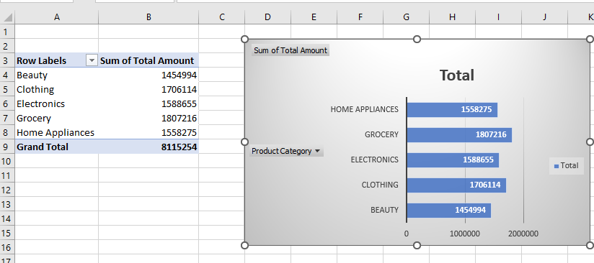

- Key Results :
- Total Revenue :
8,115,254
This represents total sales revenue generated by the retail store.
- Total Orders :
1000
A total of 1000 sales transactions were recorded.
- Average Order Value :
8115.25
On average, customers spent around 8115 per order.
- Customer Behavior Analysis
Purchasing by City
- Faisalabad → 630
- Karachi → 603
- Multan → 588
- Lahore → 587
- Islamabad → 576
This shows that Faisalabad customers purchased the highest quantity of products.
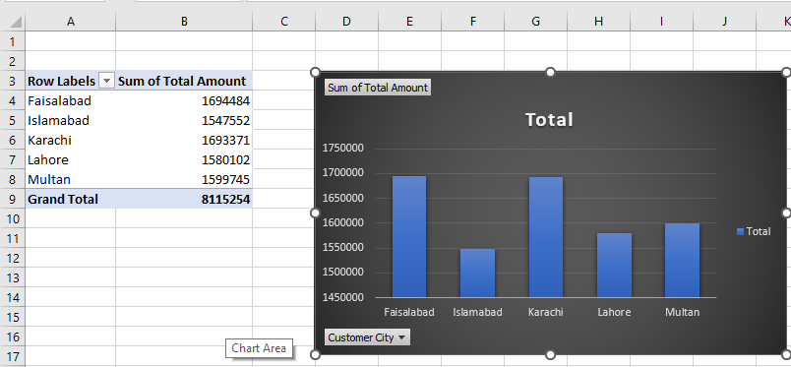
Payment Method Usage
- EasyPaisa → 277
- JazzCash → 248
- Cash → 246
- Card → 229
This shows that EasyPaisa is the most preferred payment method.
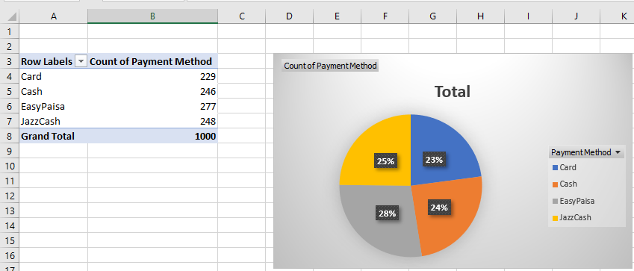

Product Category Purchase Pattern
- Beauty → 3.00
- Clothing → 3.03
- Electronics → 2.95
- Grocery → 3.00
- Home Appliances → 2.92
This shows that customer purchasing quantity is almost similar across categories.

Key Insights
- Grocery category generated the highest revenue.
- Beauty category generated the lowest revenue.
- Faisalabad contributed the highest product sales.
- EasyPaisa is the most preferred payment method.
- Customer purchasing behavior is almost balanced across product categories.
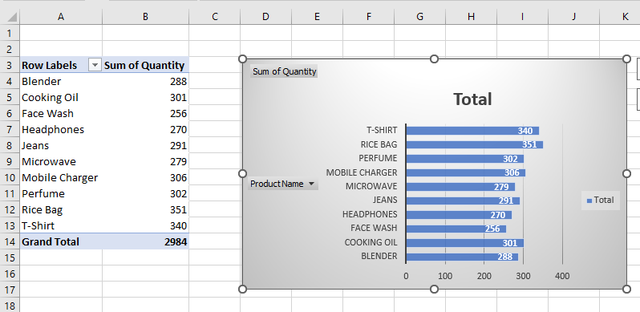
- Some product categories perform better than others in generating revenue.

- Recommendations
- Focus more on high-performing categories like Grocery.
- Improve sales strategies for low-performing categories like Beauty.
- Increase promotions in cities with lower sales.
- Offer more digital payment options since customers prefer them.
- Use customer behavior insights to improve business planning.

- Conclusion
This project helped me understand the complete data analytics workflow, including dataset creation, data cleaning, analysis, visualization, and dashboard development.
It improved my practical knowledge of data analytics and showed how businesses can use data to make better decisions and improve performance.

