**CIS 285: Software Engineering Tools**

**University of Michigan – Dearborn**

**Lab 4**

**Github, Jenkins**

Due Date: Thursday 10/2– Submission is due by 11:59 pm on Canvas

Laboratory tasks:

**GitHub Task (steps using web browser is highlighted)**

1. Create a Github account if you don’t have one then login to your github account
2. Create a Lab4 folder and open VS Code over this folder

**You can use either git command line or VS code Source Control for the following steps**

1. Create a new repository
2. Create Hello.java and commit (See appendix 2 for the Hello.java)
3. Make whatever change in Hello.java and commit and push to github (You will follow screen instruction to login to github for the first time pushing, make sure the github repository is a public one)
4. Create a new branch and switch to it
5. Use VS Code to make whatever change to the Hello.java
6. Commit it with a message
7. Publish the branch to the github
8. Create a pull request for merging the branch to the main in github
9. Approve the merge pull request and provide a screenshot of pull request process Appendix 1 is an example screenshot
10. Now master branch on github has the latest Hello.java but your local master still not update. Switch to master branch and then synchronize local master from github

**Jenkins**

1. Login

http://141.215.80.219:8080

user name: cis285

password: cis285

You will need campus VPN when accessing the site from off campus. Below is the VPN instructions.

<https://umdearborn.teamdynamix.com/TDClient/2019/Portal/KB/?CategoryID=8824>

1. Click on ‘New Item’ to create a freestyle project. The project Name must be **HelloWorld_YOUR_Name**. Please **DO NOT touch** other student’s project.
2. Config your project, the followings are example, you must connect to your own github

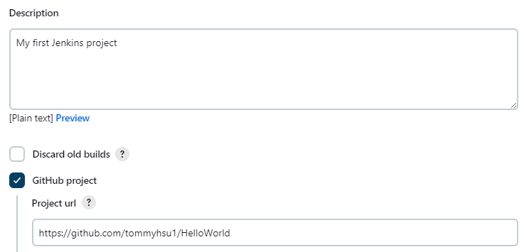

* + 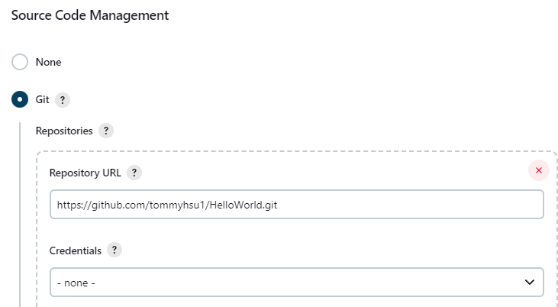

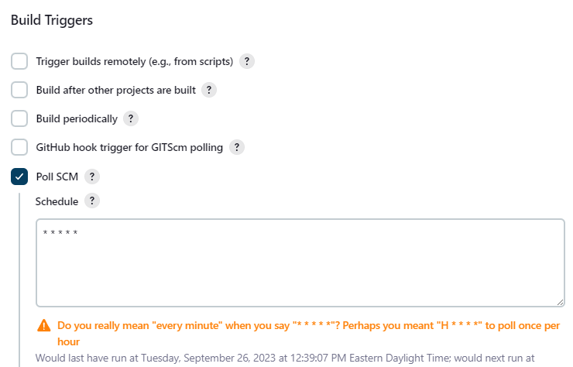

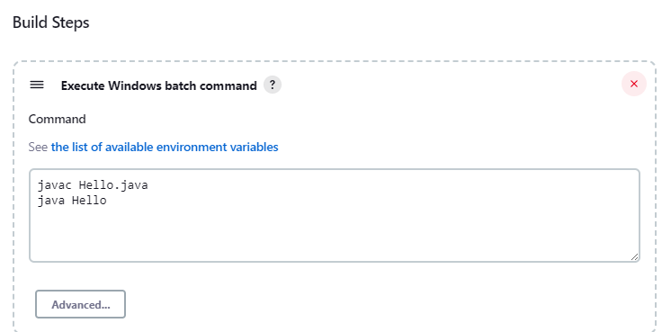

1. Update Hello.java (make sure you are on master branch).
2. Commit to master branch and then push to GitHub
3. After pushing, wait up to 1 min, Jenkins should build your project automatically. You may fail a few builds to adjust the project config, but the latest build must be successful.

**Submission items:**

**Github**

Screenshots in step 11 in task 1 and github project url

**Jenkins,** nothing to submit, I will check your work on Jenkins site, please keep in mind that you should not make any change in Jenkins after deadline. Late policy applies if you do

You are to submit ONE Word or pdf

**Appendix 1 screenshot of the pull request process**

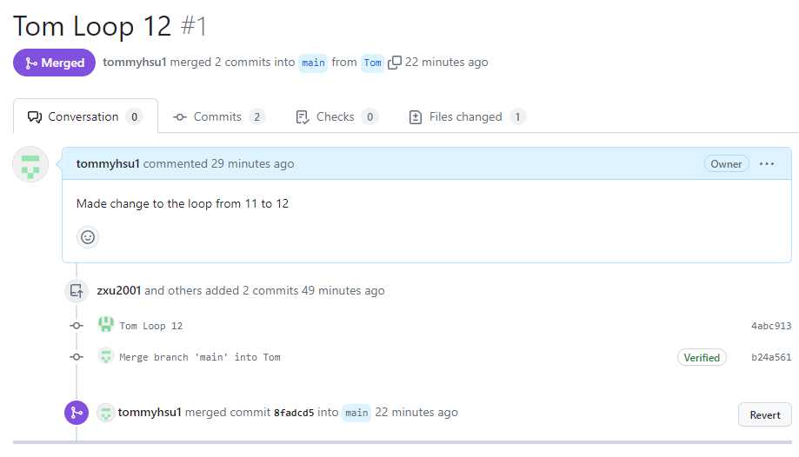

**Appendix 2: Sample Hello.java**

public class Hello {

public static void main(String[] args) {

for(int i=1;i<=10;i++) {

System.out.println("Hello World..."+i);

}

}

}