In the name of Allah how is Rahman and Rahim.

**What is multi client chat server?**

In multi client chat server, Most clients are connected to a server and send messages.

When a client want to communication, one of the clients send messages to the server

Server send back the messages to all other clients.

When client send message all other client see it message.

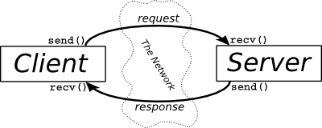

**Sockets**

In the previous lessons we know more about socket . Socket helps us to communicate

with the different hosts in a network

a multi users chat application runs a socket programming.

Chat applications like medical interface.

In the **client-Server modal**  every server has unique IP Address and port number.

Client make connection with server by this port number and IP Address .

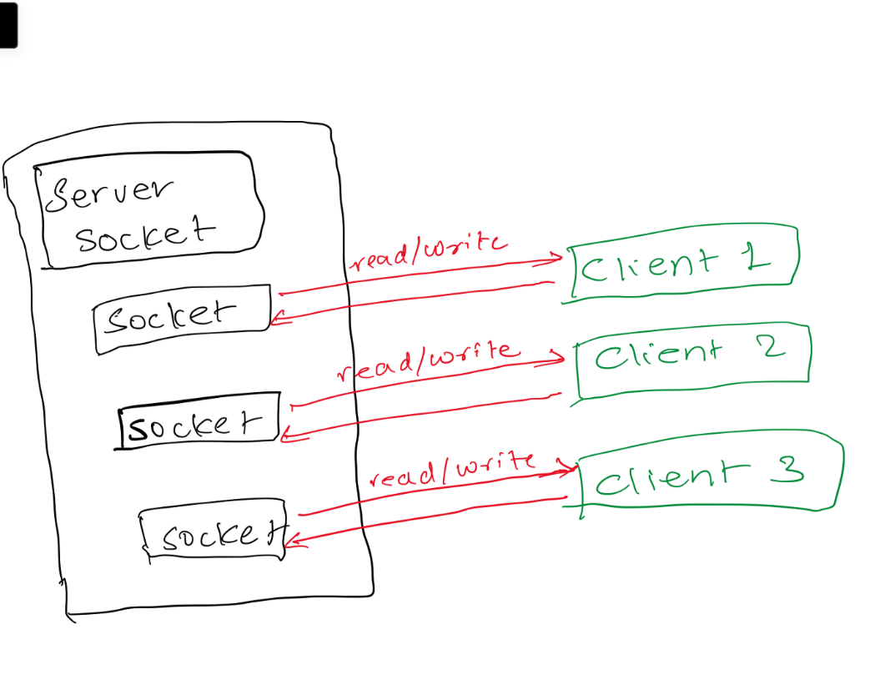

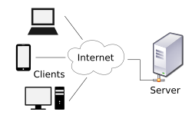

**Sereve ;**  is a process which waits for clients requests when client send request to server so server returns the result of it request.

**Client :** is a process that initiate a service request.

**TCP Protocol**

It is ( Transmission control protocol) and TCP is reliable control protocol before sending data between client and server TCP make connection. TCP is responsible bit

Data sending when did not send TCP send it again.

It is use **FTP , SMP** protocols

**UDP Protocol**

**(** Use Datagram protocol) it is communication protocol send data to to sever it does not know by sending more when data damage in way or not send UDP is irresponsible a bout that.