Simonida Savić  
3222055  
Royal Academy of Art, The Hague  
Graphic Design, Graduation Thesis 2023  
Supervisor: Fusun Turetken

***A VERTICAL GEOGRAPHY OF MUSHROOMS***

**TABLE OF CONTENT**

*abstract*  
Are you high yet?   
  
introduction  
***We see you, do you see us?***  
**_________________________________________________________________**    
   
*+-36.000km (GEO) Geostationary Orbit*  
**High in outer space: lonely astronauts**  
  
*(MEO) Medium Earth Orbit*  
  
*100-30km Kármán line*  
*30-15km Ozone Layer*  
_________________________________________________________________   
  
*15-0km Earth*   
Ingesting mushrooms

**The first humans meeting magic mushrooms**

**Psilocybin: the chemical compound in psychedelic mushrooms**  
  
**The cauldron of storytelling: witches brew and mushroom mysticism**  
   
**How did mushrooms influence human culture?**  
  
**Poisoning and weaponization of psychoactive drugs**  
  
**_________________________________________________________________**

*30–1 \mu m (micro meters)*  
**Our *unexpected* close relatives**  
  
**Eukaryotic body, multispecies and symbiotic relations**  
  
**The soils’ multi-universe: mother of ecosystems**  
  
**_________________________________________________________________**   
  
**conclusion**

*introduction*  
  
In this thesis I'd like to use the mushroom as a research method, finding small connections   
in topics that are very different, but also not that distant from each other. By making small connections through jumping from these various topics, I hope to find and understand my personal fascination of mushrooms. Using my thesis as a way to collect research material,   
I would like to be able to navigate within this overwhelming network of thoughts: by literally dissecting the space vertically, I'm trying to reconnect all layers that are related to “the mushroom.” An attempt to create a digestible system, where you could map out and transport in between these micro-theses, a non-linear approach of reconnecting, where getting lost is part of this exact same process.   
  
To create a scope or frame around my research, you'll start in outer space. Gradually we'll enter the Medium Earth Orbit, the Karman Line and earths’ Ozone Layer. Around 15-0 km above ground we find stories of the first potential encounters of the mushroom and human: where Indigenous practices and ancient histories meet. As you'd go further down, you'll slightly touch upon various aspects of the trails that the mushroom has left behind, such as the connection to psychoactive medical studies in between the 30's and 50's, that were quite important for the development and understanding of the chemical compound that somehow works inside the human brain. Zooming in the human cultural relations there are to mushrooms and what we associate with them; how psilocybin can offer us new perspectives and crack open our biggest fears, though still offering us enlightenment and a greater sense of consciousness. New doors open for the development of treating mental health problems, and this even stretches as far as being high in outer space.   
Nowadays’ western capitalized society seem to be more exhausted, stressed and detached from their well-being and nurtured minds. As we've been zooming in with arriving at each stage or layer of the mushroom, the last part of the thesis will magnify further than what we can see with our bare eyes to a microscopic scale.

**we see *you!* do you see us?**

*Connected through microscopic electrodes, patterns between time and space are being created. Following and directing a rhythmic pulsation - like a heartbeat, our fluids are trespassed through intrinsic small and absurd enormous places. We can see everything that can be mapped out; underneath the soil, through the roots of each plant,*   
*in any tree you can find in the forest. We are here, we are making noise - even though you might not be able to hear us. We are present in almost every living organism, extending far from our own species.*   
*And being one of the first organisms that have roamed and inhabited the earth for over billions of years.*   
  
*As you take more steps, more breaths will follow. Going inside your nostrils, into your lungs. We know you are with many, but whilst you can’t see us - that doesn’t mean we’re not present here, close at your side. We watch you as you move from place to place, trying to make things even more “convenient” than they already are. Losing your connections that go beyond the physical, you become strangers of your own kind. We see you struggle, trying to find this convenience while at the same time losing the feeling of connectivity.*   
  
*You’re most present in the light,*   
*at the same time, we roam in the dark.*  
  
*Even when you’d place your hand on the earths’ crust, you’d still have a hard time understanding our expressions. Your sciences are trying to document and scale up our hidden behaviours, but is there more than meets the eye - for both of us…? We could work together and learn from each other. Why do all things that have been told, all things you know - why do all things need to determine one specific outcome, only one great answer or possibility?*  
*You stack and build on top of each other, we grow and thrive through all gravitating boundaries. We map out every inch we can find, not just for ourselves but for all species among us. We lend out our “fluid filled veins”*   
*to secure a fruitful soil that is healthy and has completed countless essential life cycles. You can find us at the beginning of life, where whole ecosystems are blossoming and show extraordinary phenomena of biodiversity.*

*+/- 36.000km (GEO) Geostationary Orbit*  
**High in outer space**

Imagine the following: that mushrooms are not only relevant on earth but that psilocybin mushrooms could also play a greater role in outer space. How could we visualize this?  
  
Before astronauts are sent into space they must fulfil long periods of heavy studies, these include mental and physical tests, specified training and overall being prepared for their first time temporarily leaving the earth's surface.[1] They are then sent up with a top crew selected for their mission, each with their own skill set and specialty within the astronomic field.   
But astronauts are human, most of them will have a family to say goodbye for a long period. While having much to do for their mission, feelings do still get involved when being shot with a rocket into outer space and while having arrived at the assigned destination or space station, thoughts could still wonder off to life on earth.   
  
 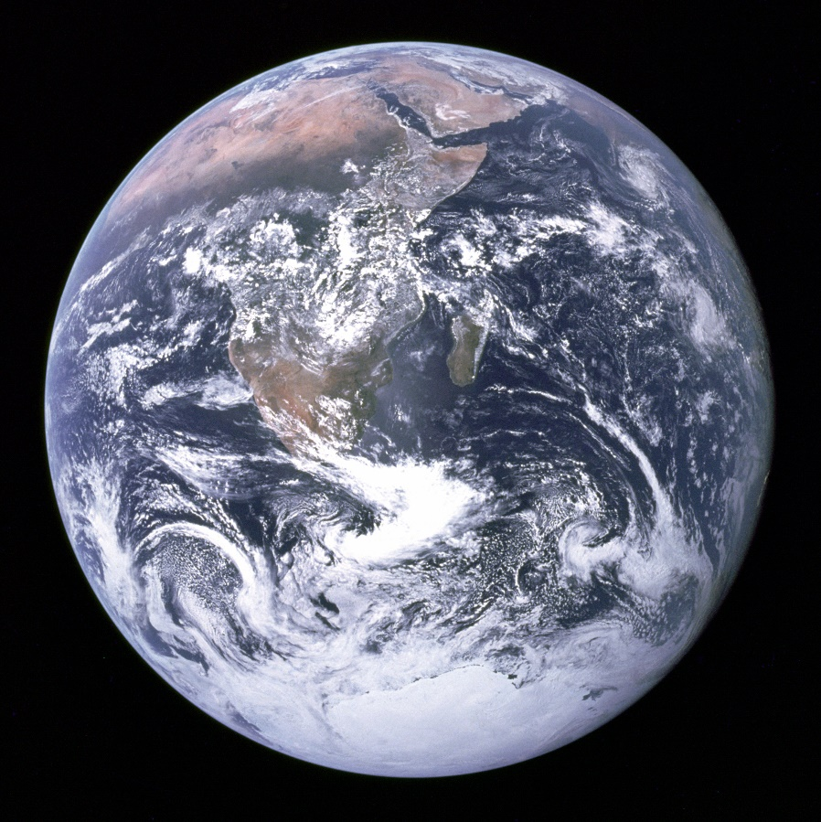[2]  
  
The research studies of Stamets[3] show there is benefit of psilocybin mushrooms for human mental health; a new gateway or passage could be opened for the astronauts in space. As Paul Stamets told Scientific American[4] magazine:   
  
...“Under carefully controlled conditions, our astronauts [being] able to take psilocybin in space and look at the universe and not feel distant and alone but feel like they're part of this giant consciousness will give them a better frame of mind — psychologically, emotionally — to work with other astronauts and stay on mission," Stamets told the magazine. "I feel that isolation, loneliness, and depression are going to be major issues that astronauts face”...

So how can astronauts continue their mission and stay on that mission, while having feelings of loneliness, developed trauma or sometimes fear and homesickness? As the extra value comes upon astronauts while looking at the blue marble[5], from a great distance the mental well-being of these brave space agents is certainly at a risk.   
  
Stamets will receive a funding to invest in his ideas on global mental health.[6] But how would this be managed? Are we ready for making psilocybin into a pharmaceutical drug?[7] If this will be a pharmaceutical for health benefits: In what kind of proposal are we supposed to imagine this? Will it be micro dosed alike pharmaceuticals that you can buy legally online for recreational use?

**On eco-anxiety**  
  
Instead of trying to eradicate mental health problems, could psilocybin offer us new altitudes besides the medicinal realm? Next to existing jobs, studies, and occasional social activities, also eco-anxiety[8] seems to be a connecting factor of fear when we're trying to shape and imagine the human future.  
As mental health issues are becoming more frequent in capitalist western society under people my age and younger generations; because of working on high demand always being on –and online available through social media, the internet and the pressure of "succeeding” and not being a failure, has opened a new development for suppressed anxiety and stress, just waiting around the corner. I hear more and more young people dealing with burnouts and the overall exhaustion that has made them look for coping mechanisms to often escape reality.[9] The term eco-anxiety was used and described as   
“a chronic fear of environmental doom.” by the APA[10] in 2017.   
 But climate anxiety has close roots and strong ties with the global history of racism and capitalist colonialism[11]. Tori Tsui, is a climate justice activist who advocates for fair climate policy by making an intersectional environment where climate action is organised “transformative and inclusive”. In an interview with Daphne Chouliaraki Milner, Tsui explores and opens up about the misconceptions there are about eco-anxiety and that mental health is a “planetary health”, as people that are most affected by the climate crisis are not included in the discussion of mental health and eco-anxiety. Tsui: “I don’t dream of labor. Capitalism is a huge aspect of my poor mental health and the climate crisis is a product of that. Our overuse of commodified care and our distance from community care is intentional and   
it is making us sick.”[12]

As heatwaves and natural disasters peaked in 2019[13], the rise   
of climate protest and the reoccurring theme within news items in Western media were filled around the worries of climate change. Eco-anxiety has a great impact on the mental well-being of people around the world, but this is also experienced differently for each person, depending on where each person lives[14].  
  
As daily news items still show: people that are suffering the most are the people that are in close relation to nature and their environment – the people that are economically drained and come from extracted countries are battling severe droughts, floodings (most recent Pakistan, 14 June to October 2022)[15], water and soil pollution in the Brazilian Amazon and Congolese[16] rainforests, and the suffering doesn't stop at people alone: Australian wildfires burn mammals alive and catches everything in these natural environments,   
also houses are being devoured by sinkholes[17] which are spread over the US; food supply shortages are rising due to dried out land and harvest failure; and so on. APA: “Changes in climate effect agriculture, infrastructure and liveability, which in turn affect occupations and quality of life and can force people to migrate.”  
  
So, what could psilocybin mushrooms offer us in this current situation?  
How could we use these earthly medicines[18], not for an escape, a quick fix and safe it from the commercialisation of capitalist indulgence?

*+/- 15-0 km*

**Humans encountering magic:**  
Our ancestors, indigenous knowledge and shamanism

When did we start ingesting magic mushrooms? Scientists and researchers   
are still not quite clear on the answer of the first human ancestors in the evolutionary spectrum,[19] where and when mind-altering psychedelic  
mushrooms were ingested. Did psilocybin mushrooms play a role in the cognitive development of the human brain?A study of McKenna presents a collected theory on the influence of psilocybin mushrooms on the social behaviour of early human evolution, originating from our ancient ancestors *Homonin*, in the Pliocene epoch.

“McKenna (1992) proposed that psilocybin’s effects stimulating visual acuity, sexual activity, and ecstatic/visionary experiences influenced hominins’ foraging, sensitivity to community, as well as religious and spiritual concerns. He also argued the presence of psychedelics in the early human diet drove the rapid reorganization of the brain’s information-processing capacities by catalyzing the emergence of self-reflective consciousness and language.”   
(Arce, Rodríguez, M. José and Winkelman, J. Michael)[20]

But how did this small substance influence our evolution, also, how is this still now being able to let the human brain react on this psychoactive drug?   
  
Mushroom hunting, foraging and collecting mushrooms have become a very popular activity for non-experts like you and me.[21] We must consider that the cultivation and ingestion of mushrooms hasn't suddenly re-emerged in the West, as its origins lay outside of the European border. When we dive into one of these ancient histories[22], there is an example of an early indigenous community: The Chimú culture in Peru. This specific culture shows mushroom representation and "mushroom knowledges by translating this into artworks that were of bronze, gold, ceramic, textile and stone.   
The Chimú culture dates back to early 900-1470 CE.

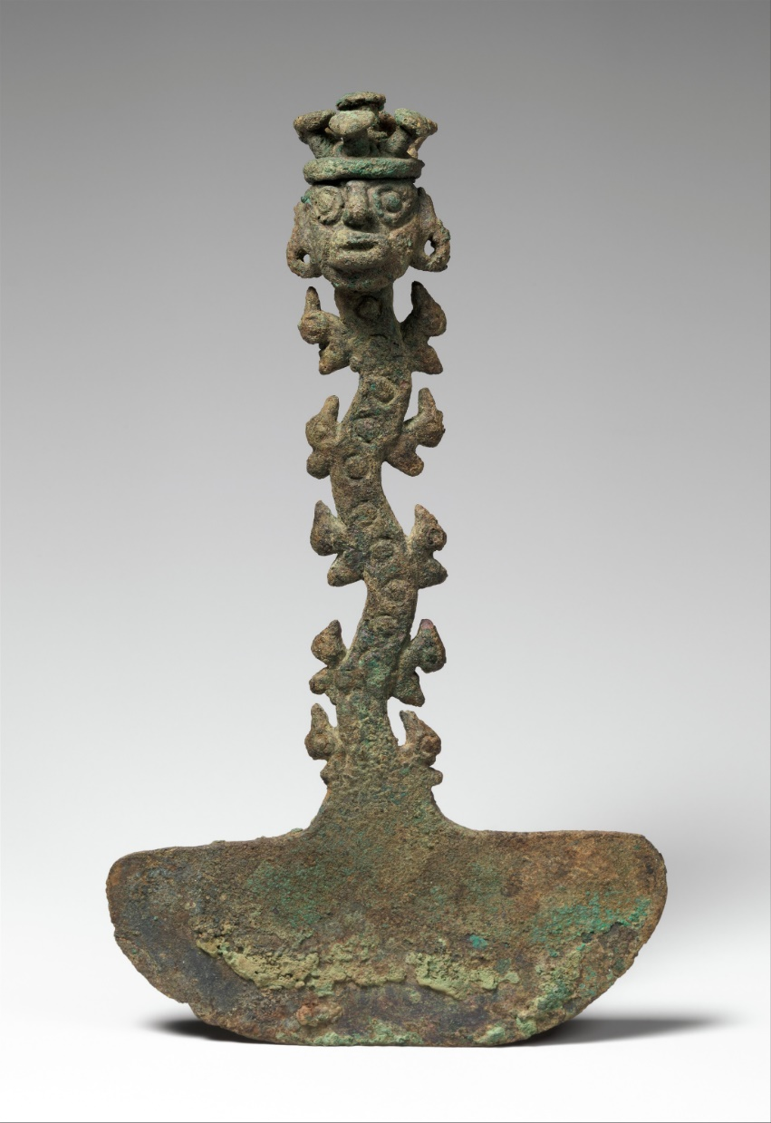

“Ceremonial Knife (Tumi)” *The MET*, [www.metmuseum.org](https://www.metmuseum.org/art/collection/search/315276)Accessed 5 Dec. 2022  
  
In the figure above you see a ceremonial knife, also known as a Tumi, that contains characteristics of mushrooms relating to the Chimú society in Peru.   
To their religious aspects and beliefs[23], this artifact is an example of many other objects that could have been used for ancient rituals, rites and ceremonies. This could be connected to the beliefs that embody, respect and honour nature's presence. The Chimú people would adapt their way of living to nature and to their natural living environments, whereas the epistemology of a capitalised western society would either destroy, outsource and separate the nature out of the human body[24].

In the findings of Trutmann, there is no specification of the Chimú people and their relation to psilocybin mushrooms. But there are findings that indicate that the Moche people or other indigenous societies such as the Paracas,[25] used the psilocybe species in their lives and practices. As psilocybin mushrooms were used for spiritual development and used in a sacred context, rituals and ceremonies were built around the psychedelic experiences. These findings have been documented in Mayan and the surviving language of Popul Vuh[26].

*What are psychoactive drugs?*   
**Psilocybin: the chemical compound in psychedelic mushrooms**

Would you believe me if I said that the chemical compound, psilocybin[27]   
in these mushrooms, is far from damaging the mind and that they aren't related to any addictive drugs we already know? While having the knowledge that XTC, alcohol, nicotine, marijuana (weed), benzoyl-methyl-ecgonine (coke), heroin, opioids (pain killers), amphetamine (speed) is more likely to be addictive? Other psychoactive substances, such as LSD, have also been re-invented in Western modern medicine by Albert Hoffman[28]; starting from the synthesizing process of “lysergic acid diethylamide” in 1938[29].  
As the stigma around psychedelics have been slowly dissolving, fears and taboos have been broken and there is a positive outlook on the future of psychedelics being accepted by more people in Western society.[30]   
  
*Psilocin* is the most active substance that is produced by the metabolic process of psilocybin.[31] There are approximately 116 species known and registered psilocybin species, growing at any place in the world. This potentially could be around the edges and trails of tropical forests or even across your local police station[32]. What exactly happens in our brain when we ingest psilocybin? How does the human brain change the space between neurones while being high on this psychedelic drug?   
In 1958 at the Sandoz[33] laboratories, the study on the metabolic process of psilocybin and psychoactive compounds in psilocybe species have been confirmed by Albert Hofmann. (p2438, Geiger, A. Haden, et al.).  
Later in 1959, Hofmann produced the first synthesized batch of psilocybin, and it was marketed and ready for its first pharmaceutical. The pharmaceutical drug was presented as *Indocybin (*Sandoz).  
  
  
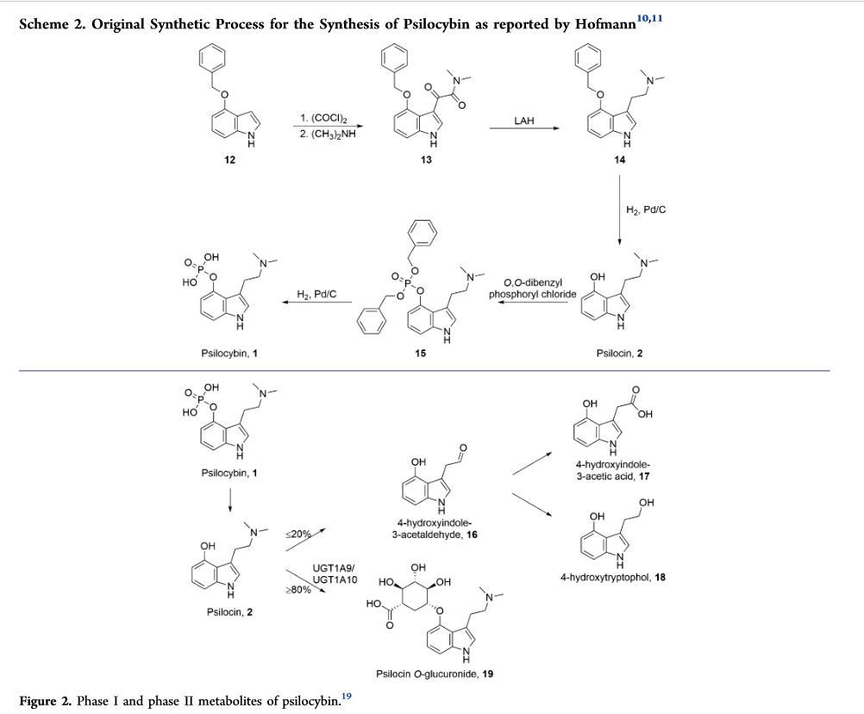  
(Geiger, et al. p2440, scheme 2: Synthesizing process of Psilocybin, documented and reported by Albert Hofmann, 1959)  
  
Once the drug is ingested, it will be absorbed and will start the metabolic process which is turned into psychoactive psilocin. Psilocin enters the bloodstream without any struggles, it travels and enters the systemic circulation[34] in the brain. Neurons within our *connectome* will connect to each other on multiple places, and as the drug psilocybin promises, we reach a 4th stage of consciousness as the drug becomes psychoactive and hallucinations start to form. The 4th stage of consciousness can be understood as the state where you're “separating yourself from your individual thoughts.” Moving away from emotions and the body, the 4th stage is seen as something “mystical, state of interbeing, everything becomes a single fabric.”[35]  
  
If we would jump back to the list addictive drugs, psilocybin just doesn't make the cut.[36]As psilocybin uses up a lot of the existing proteins, it occupies the space for new proteins to pop up. This is also the reason for dosing patients within medical studies; therapy sessions or recreational use; preferably with a high dose of psilocybin, in order to make this drug work   
in a more beneficial way for the therapy session.[37]

**The cauldron of storytelling: witches brew and psychedelic representations**

We cannot go around it: the mushroom is everywhere - even in the imaginary worlds. Fiction is intertwined with the connections and representation of mushrooms with fantasy figures and fictional characters[38]. Although these visual representations of the mushroom can not only be found in Western Europe, but there are also parts in Siberia and Scandinavia (Dugan, p29 & p38)[39] that show similarities and traces of the dominance of the fly agaric,   
in these regions.[40]   
  
Unfortunately, as we get older, we come to understand that these “original” fairy tales relate to horrifying folktales[41] that scare and warn people with a deeper and inner rooted metaphor. Where strangers and outsiders, people with disabilities and women have been demonized and were often portrayed as utterly evil.[42]

As the representation of mushrooms have also been widely connected to witches, either as part of their potion brews or “particular” species they maintain in their mystical garden, the image of the witch goes beyond the Western European fairy tale. Art and illustrations of the fantasy figure riding on brooms, the making of mysterious potions, they are either presented as an old and scary hag or a young and seductive woman.   
According to Federici's[43] work on *Witches, Witch-hunting and Women*, *Caliban and the Witch: Women the Body and Primitive Accumulation*, et al., the accusing and the forming of the term ‘*witch*’derives from the extensive torturing and killing of innocent people, predominantly women, but also queer and gay people, all come from the witch-hunt that already dates back around 3 centuries[44]. One of the biggest misconceptions on the figure of the witch, that originates from Western Europe, is that there were not any major witch-hunts in the start of the Middle Ages. This was something that developed later, near the end of the 15th century.

**Federici: “**The scandal of the witch,   
the portraying, the witch hunt has been thrown in the dustbin of history. The witch has been transformed into a legendary figure, a figure   
of fantasy, **…“**the history of these persecutions is being erased”… And has been transformed into a capitalist use of the figure of the witch**.”**

But “who were those so-called witches?”, Federici argued that there is a clear connection between the witch-hunting and the political and social transformations that were taking place in Western Europe. This also went hand in hand with the development of the capitalist economy. This was also the beginning of the slave trade and colonization in the 16th C. — the “conquest of American territories” and the “beginning of the capitalist world.”[45] The forming of this poisonous ideology has been one of the indicators for the development of fear and paranoia that have been surrounding psychoactive substances in human history.[46] We could say that this could have been one of the causes of the negative biases that were rooting on the medicinal use of psychoactive substances including psilocybin mushrooms in traditional healing rituals.[47]

The female body was seen as “a working machine” that would only benefit society in the form of sexual reproduction and labour. Next to labelling and accusing women who for instance weren’t married and/or had children;   
also, queer and gay people; folk healers and Indigenous people and their communities, became part of the new target the patriarchy had set their eyes on. Women were not allowed to express their sexual power, their desires; so far that not even just their love and “collective spirit” of female friendship, where the sharing of thoughts, ideas and feelings was seen as a threat and danger and were seen as untrustworthy, suspicious, and wrong.[48]  
  
**Alina Cohen**: “This vision of the witch, and its subsequent demonization of female sexuality, persisted for centuries.”[49]

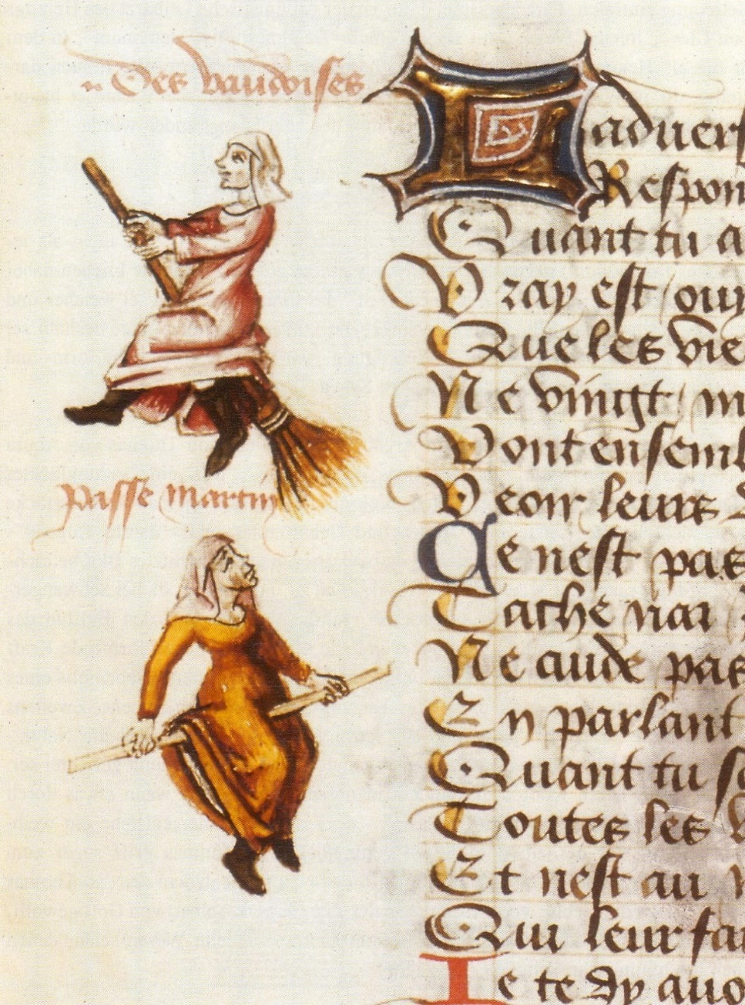  
Hexenflug der "Vaudoises" (hier Hexen, ursprünglich Waldenser) auf dem Besen, Miniatur in einer Handschrift von Martin Le France, Le champion des dames, 1451 Source: W. Schild. Die Maleficia   
der Hexenleut', 1997, p. 97 {{PD-art}}   
[50]

**Poisoning and weaponization of psychoactive drugs**  
  
As we already know by now that psychedelic plants and fungi have been   
used by Indigenous communities for medical practices and healing rituals   
for centuries, these substances used for medical studies and therapies didn't   
enter Western modern medicine until Hofmann's study in 1938,   
see *Ingesting Mushrooms: Our ancestors, indigenous knowledge and shamanism*, (note 26 & 27)

After his first accidental testing of LSD in 1938, there were in between 1940 and 1970[51] experiments and research studies have tested psychedelics for offering new medical approaches to mental disorders, depression, PTSD, alcoholism, anxiety disorders, etc. But Hofmann wasn't the first to introduce psychedelic medicine to modern Western pharmacy. Already in 1895 Prentiss and Morgan (US) documented the healing practices and ceremonial rites in “Central America” on the psychedelic effects of Mescaline[52].   
In 1958 Hofmann synthesized ‘psilocybe’, a deriving alkaloid of magic mushrooms (see note 35, *Sandoz*). Before the escape of psychoactive substances from laboratories entering non-scientific settings in the 60's   
and 70's, other drugs and psychoactive substances have been widely used during war times[53], such as the Vietnam war in 1955, also known as the “pharmacological war” - lasting for at least 20 years[54].

**Lukasz Kamienski:** ..."by the end of the 1960s...   
“The dark side of psychedelics began to receive tremendous amounts of publicity— bad trips, psychotic breaks, flashbacks, suicides—and beginning in 1965 the exuberance surrounding these new drugs gave way to moral panic. As quickly as the culture and the scientific establishment had embraced psychedelics, they now turned sharply against them.”

There were no policies from pharmaceutical companies who were “offering synthesized psychoactives”[55], researchers could participate on the condition of sharing the results of these studies. As psychedelics were not accompanied with an instruction manual, people were using them recklessly and basically anyone could get their hands on these drugs; using them without prescription in non-safe environments[56]. While the civil rights movement, war protests, African American civil rights movements and the second feminism wave were developing from the 1960's, in 1971 Nixon[57] declared a national “war on drugs” and signed the drug law enforcement on 28 Jan. 1972. Even though the war on drugs was there to solve a “national emergency”, there was a “full scale moral panic” (Pollan 24:50-24:56)[58] of the adult generation on the youth of America; the Vietnam war was also a factor to move the drug law enforcement of 72’ forward, mainly because of the drug addicted soldiers it had created.   
  
But the war on drugs was also designed to discriminate and set as a political strategy to demonize and criminalize people from different races and ethnicities, and mostly just from being black. By criminalizing a specific group in society, it shows the fear and overall malice of the politicians, who used the war on drugs to mark American politics with the criminalization of black people. As the war on drugs was generally failing, the US government was looking for a scapegoat in society, but more importantly, Nixon tried to cover his scandals[59] and mistakes of his time in the office. “A report by Dan Baum for Harper's Magazine, **John Ehrlichman (1994):**  
  
"*The Nixon campaign in 1968, and the Nixon White House*   
*after that, had two enemies: the anti-war left and black people. You understand what I'm saying? We knew we couldn't make it illegal to be either against the war or black, but by getting the public to associate the hippies with marijuana and blacks with heroin, and then criminalizing both heavily, we could disrupt those communities.*   
*We could arrest their leaders, raid their homes, break up their meetings, and vilify them night after night on the evening news. Did we know we were lying about the drugs? Of course we did.*"

While those communities of black people (and Hispanics)[60] were targeted   
in the 1980's, Hollywood[61] was being praised for the use of crack cocaine   
Barack Obama (8:46): “It's not normal for black and Latino youth   
to go through the system in this way.” ... “This is not normal.”   
There is a huge link to the “violent” arrestment’s we see in the news and media almost every day, where innocent black people are being targeted   
and where the police are always looking for a “drug involvement”[62] — so that those police officers, who are guilty of violent arrests and the killing of black people, can find a way and an excuse to justify their actions while being   
in service and duty of the American Law Enforcement[63].   
  
Slowly from the 90's, small groups[64] of scientists and psychotherapists still believed in the potential benefits of studying and testing psychoactives for mental health therapies and this slowly developed into the rebirth of psychedelics we know today, “The Psychedelic Renaissance”.[65]

*30–1 \mu m (micro meters)*  
**Our *unexpected* close relatives**

What are mushrooms – and how does humankind relate to them?   
Somewhat mysterious, envied and still misunderstood, these amazing, intelligent and extraordinary organisms are often connected to negative stereotypes of being dirty or in general not important.

Consisting of a cap with gills, filled with spores that release and travel   
by wind for expanding their kinon big geographical distances. What are mushrooms? Basically, a fungus itself, a mushroom is considered the fruit of the fungal body, whereas the roots are growing underneath the soil: *mycelium.* When we look closer to the microscopic thin threads, they consist of rooted structures, the *hyphae*. Mushrooms are made of these hyphae and are the reproductive organ of the fungal body. From spore germination, the way how fungi with mushrooms reproduce, hyphae starts to form.[66]  
Not all fungi produce mushrooms, and they can also be classified into   
sub-species: poisonous, medicinal, invading or even symbiotic species.   
When we look at the cell structure of mushrooms, we see that these eukaryotic organisms are very different from the cell structure of plants.   
As fungi have a special and very own regna[67] of species, and they don't belong to the plant or mammal regna; we humans, share the same evolutionary cell characters as fungi. Also, fungal behaviours are very   
similar to our human-social-interactions.

**Eukaryotic body, multispecies and symbiotic relations**  
  
Fungi share similarities with us in social behaviour, survival instincts and collaboration. But these similarities are even literally on a cellular level.[68]   
Did you know that fungi and mushrooms are closer to humans than you might think? In the *biological field*, regna and their species can be divided   
in 3 domains: *Bacteria*[69], *Archaea* and *Eukaryotic*, (Sheldrake, p86-87)[70].   
When we enlarge on of these domains, the Eukaryotic, the microscopic features reveal these elements of similarity between human and mushroom very well.

Animals, plants, algae or fungi are eukaryotic organisms and share therefore also the story of “the long-lasting intimacy of strangers”[71]. This evolutionary theory is based on the symbiosis of organisms and not on the interpretation we also know as Darwin’s [72] evolution theory, where the survival of the fittest reflects similarly on the competitive nature of the capitalised western society. What makes this story so interesting and relevant to us, is that it is based on most of the significant moments in the evolution. It shows the convergence, the collaboration, the coming together and staying together of different organisms. (1967, *Lynn Margulis,* US biologist)   
We could call this coming together and sticking together of species   
a symbiosis. As mammals and fungi are both Eukaryotic organisms,   
ourcell structure is even almost alike*.* Could mushrooms help us find the answers we’re looking for? And could fungi actually be the most dominating species on earth?

The term originates from the former Botanist Anton DeBary in 1873, and the idea of symbiogenisis has been invented by Konstantin Berezovsky (1855-1921), which can be understood as "the living together of very different kinds of organisms.” Margulis: “*In some situation (I think over the course of evolution) this shared living and collaboration came from sharing the habitats, leading to living and sticking together. This process can be understood as symbiogenisis.*” Lynn is aware of her different approach and belief on evolution. Even when she had to stand her ground to other leading figures   
that weren't taking her alternative studies on the evolution theory seriously, she wouldn't give up on trying to publish them under a pseudonym.   
**Margulis:** “Appearance of new bodies, new organs, new species.” (p43, ch3)[73]  
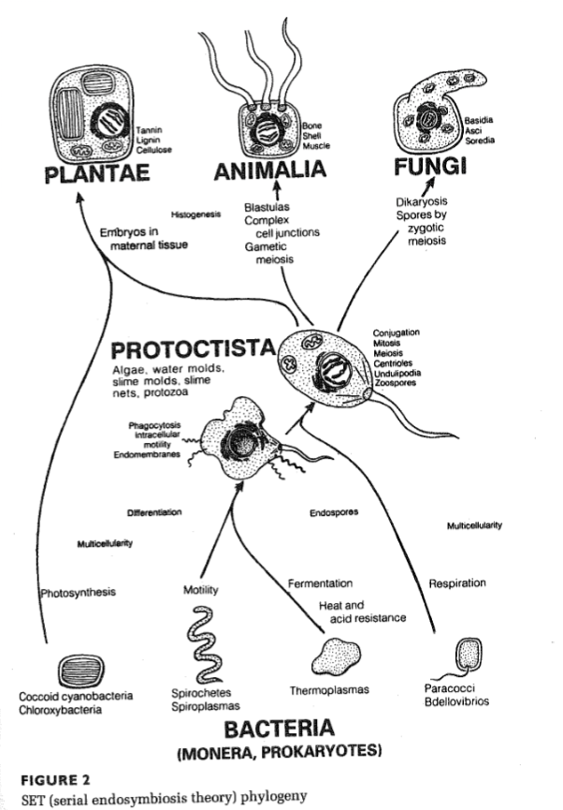  
Figure and example of Lynn's symbiogenisis evolution theory  
(p41 figure 2, SET *Serial Endosymbiosis Theory*) phylogeny  
  
  
  
Another scholar who supports this theory is Donna Haraway[74]: her   
Camille stories[75] speculate on a different future for our earthly survival, a way to break down the barrier that has been put by the western capitalist driven minds between people and nature. The Camille Stories were a way for Haraway to explain her theory on making kin and not babies.[76] She is breaking the previous and current paths we take as human individuals while allowing us to reimagine future aspects of our earthly world, by looking for solutions beyond the human centred world. Haraway sees multispecies as the intersection of symbionts[77] not only working and cooperating together,   
but also, by love and care, trying to preserve multispecies habitat and sustain balance by speculating on symbiogenisis of human and animals. Haraway (21:05–22:05):[78]

“*Camille is a symbiont put together by the biological operations of sym (yoking) bio (living) genesis (beginnings). Symbiogenisis, bio from linking. Only humans can take on the flesh of their symbionts to be able to do their job better, see better, able to taste the air better. To see things differently*.”

**The soils’ multi-universe: mother of ecosystems**  
  
Next to human relations with fungi, plants too share a profound symbiosis,   
in order to survive, thrive and “involve” with one another (Meyers and Hustak)[79]. This relation and long-lasting intimacy of strangers even made it possible for “ancestor plants” to transfer from the ocean and grow on land[80].

**(Sheldrake, p137):** Mycorrhizal fungi can provide up to **80%** of a plant’s nitrogen and as much as a hundred percent of its phosphorus.

These relations between plant and fungi can be understood as quite a fluid process and an open exchange, depending on where plants grow and what type of species are able to interact with existing types of fungi. This type of relationship between plants and fungi is also known as a "mycorrhizal relationship.” Fungi make sure the soil is fertile: holding and spreading water they give to plants; but they also give and exchange nutrients like "zinc” and “copper.” Within this exchange, fungi take up 30% of the carbon that's being submerged by plants and get sugars in return by the process of the photosynthesis of plants. Without the involvement of fungi in the soil,  
landscapes would face severe droughts and wouldn't be able to hold and absorb any water: they are vital for maintaining healthy and longevity for earthly soils. The relation of exchange doesn't really have a power play; between both plants and fungi as neither of them are in control within this relationship. They negotiate the possibilities of this exchange depending on what they could offer one another.[81]   
  
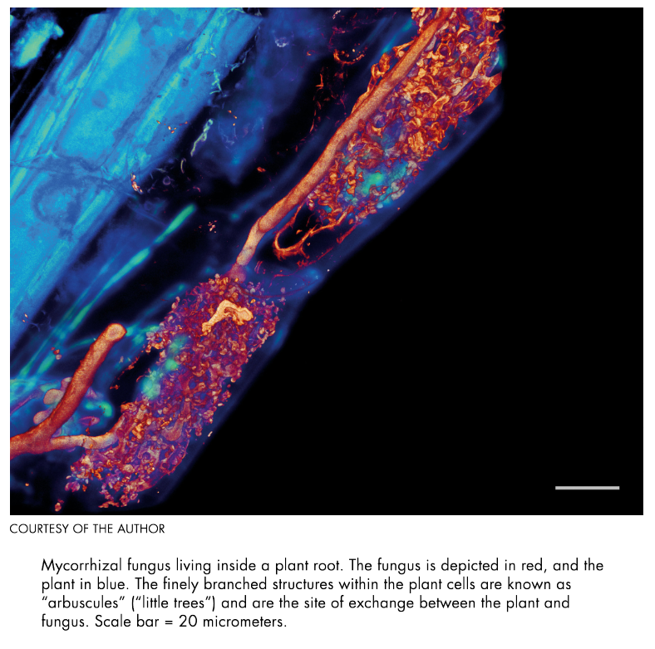  
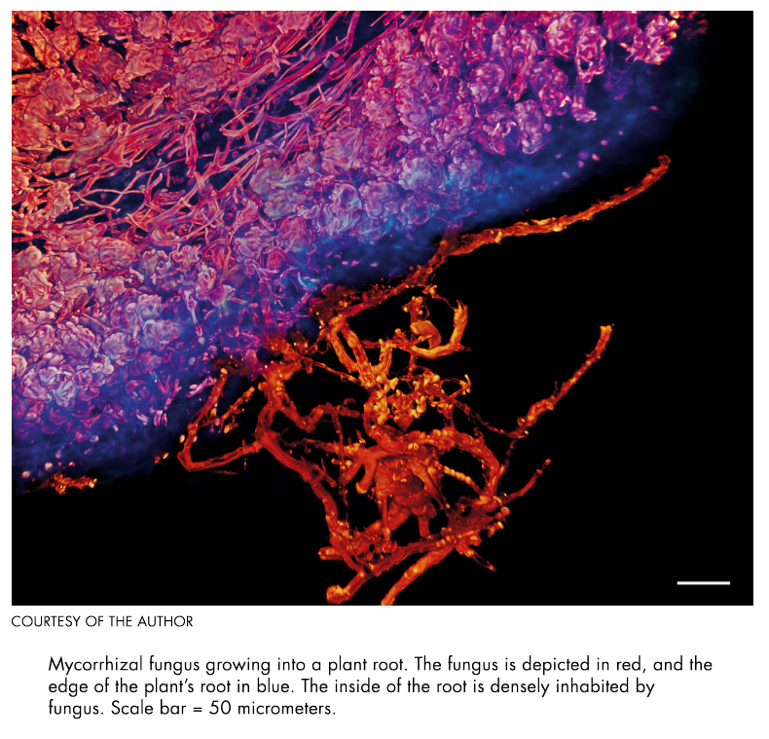  
[82] Sheldrake, p246 & p247

*Conclusion*

As new questions are popping up due the rise of interest in the development of psychoactive pharmaceuticals, soon this could potentially become part of a new generation of space agents during their preparation courses, trials, special trainings and missions in outer space. When we arrive on the earth, the mushroom has a long and ancient history, that has caught the eye of many white male scholars, to investigate and explore for greater purposes,   
but also for extracting and benefiting a specific group in western society.

Eco-anxiety is not a white privileged phenomenon: this anxiety and fear is rooted and connected to the idea of “climate doomism”, which is a driving force of the westernized capitalist society. Eco-anxiety cannot be separated from the mental health crisis and should be advocating for all environmental injustice. The re-invention of psilocybin mushrooms in western modern medicine have proven to be a significant game changer for both political involvements ultimately leading to the drug law enforcements where new spaces that have been created as a cultural phenomenon of the mushroom that is either praised by groupies or criminalized by governments and prejudices, by putting their targets on black and Hispanic and Indigenous communities. What has been practiced and used as a means of bringing people closer to oneself, closer to the community and closer to *nature*, the drug law enforcement has separated people and polarized the understanding of psychedelics for potential mental health benefits from 1970. The mushroom, integrated in the human mind and the human body, is everywhere – no division has ever taken place, for as long as humans have habituated the earth. The wonders of the fungal world should compel to re-learn, to re-adjust and re-connect new and old spaces for us to speculate in. The fungal intersections that are present in earthly soils are vital for the balance of eco-systems of which human culture cannot sustain itself without this unity.

**Bibliography**

A. Cernan, Eugene, et al. (The Apollo 17 crew)  
“Blue Marble - Image of the Earth from Apollo 17.” *Nasa*, 30 Nov. 2007,  
[*www.nasa.gov/content/blue-marble-image-of-the-earth-from-apollo-17*](https://www.nasa.gov/content/blue-marble-image-of-the-earth-from-apollo-17)   
*Accessed 24 Jan. 2023*  
  
*“Afdeling Psychiatrie”, LUMC,* [www.lumc.nl/over-het-lumc/afdelingen/psychiatrie](http://www.lumc.nl/over-het-lumc/afdelingen/psychiatrie).  
*Accessed 10 Jan. 2023*  
  
*Anonymous, Submitted. “Lynn Margulis (1938-2011).” Nasa*, 1 June 2022,  
[science.nasa.gov/lynn-margulis-1938-2011](https://science.nasa.gov/lynn-margulis-1938-2011).   
  
Arce, Rodríguez, M. José and Winkelman, J. Michael. “Psychedelics, Sociality, and Human Evolution.”   
Frontiers, 29 September 2021, <https://doi.org/10.3389/fpsyg.2021.729425>“Bacteria: They Are Everywhere.” *Micropia*, www.micropia.nl/en/discover/microbiology/bacteria.   
Accessed 8 Jan. 2023.  
  
Basciano, Oliver. “‘When We Grew up, Luis Buñuel Was on Channel 4’: The Proudly Highbrow Otolith Group.” The Guardian, 14 July 2022, [www.theguardian.com/artanddesign/2022/jul/06/luis-bunuel-channel-4-proudly-highbrow-otolith-group-apocalypse](http://www.theguardian.com/artanddesign/2022/jul/06/luis-bunuel-channel-4-proudly-highbrow-otolith-group-apocalypse). Accessed 9 Feb. 2023  
  
Beaumont, Susanna. “Questions and Answers / Cooking Sections.” Interview by Susanna Beaumont. *Design Exhibition Scotland*, 14 Oct. 2021, [www.designexhibitionscotland.co.uk/questions-answers-cooking-sections](http://www.designexhibitionscotland.co.uk/questions-answers-cooking-sections). Accessed 27 Jan. 2023  
  
Bogdanovic, Zoran. “De psychedelische hype in de ggz is niet zonder gevaar.”   
VICE, 11 Oct. 2022, [www.vice.com/nl/article/4ax74m/psychedelische-hype-ggz](http://www.vice.com/nl/article/4ax74m/psychedelische-hype-ggz).  
  
Brand, Steward. *Whole Earth Catalogue*, Spring of 1969, [doorofperception.com/wp-content/uploads/whole_earth_catalog-spring-1969.pdf](https://doorofperception.com/wp-content/uploads/whole_earth_catalog-spring-1969.pdf).

Brand, Steward. *Whole Earth Catalogue*, Fall 1968, [monoskop.org/images/0/09/Brand_Stewart_Whole_Earth_Catalog_Fall_1968.pdf](https://monoskop.org/images/0/09/Brand_Stewart_Whole_Earth_Catalog_Fall_1968.pdf).

Burgemeister, Bella. “‘I Want My Childhood Back’: Young Climate Activist’s Letter to Australia.” *The Sydney Morning Herald*, 4 May 2019, [www.smh.com.au/national/i-want-my-childhood-back-young-climate-activist-s-letter-to-australia-20190504-p51k2i.html](http://www.smh.com.au/national/i-want-my-childhood-back-young-climate-activist-s-letter-to-australia-20190504-p51k2i.html).  
  
Burns, Ken and Novick, Lynn. “The Vietnam War Explained in 25 Minutes | Vietnam War Documentary.” YouTube, uploaded by The Life Guide. 1 Nov. 2019, [www.youtube.com/watch?v=7tNTh6KlXXU](http://www.youtube.com/watch?v=7tNTh6KlXXU).   
  
Cohen, Alina. “A Brief History of Witchcraft in Art.” *Artsy*, 26 Oct. 2019, [www.artsy.net/article/alina-cohen-artists-enchanted-witchcraft-centuries](http://www.artsy.net/article/alina-cohen-artists-enchanted-witchcraft-centuries).  
Accessed 27 Jan. 2023

Cohen, Alina. “Frances F. Denny’s Portraits of Modern-Day Witches.” *Artsy*, 5 Sept. 2018, [www.artsy.net/article/artsy-editorial-challenging-stereotypes-frances-denny-captures-modern-day-american-witches](http://www.artsy.net/article/artsy-editorial-challenging-stereotypes-frances-denny-captures-modern-day-american-witches).   
Accessed 27 Jan. 2023  
  
Cooke, Rachel. “High Hitler: How Nazi Drug Abuse Steered the Course of History.” The Guardian, 22 Mar. 2018, [www.theguardian.com/books/2016/sep/25/blitzed-norman-ohler-adolf-hitler-nazi-drug-abuse-interview](http://www.theguardian.com/books/2016/sep/25/blitzed-norman-ohler-adolf-hitler-nazi-drug-abuse-interview).   
Accessed 9 Feb. 2023  
  
Corpuscoli, Maurizio. “Work.” *Officina Corpuscoli*, [www.corpuscoli.com/](http://www.corpuscoli.com/).  
  
“Descending The Mountain.” De Boeddistische Blik, season 18, episode 10, directed by Maartje Nevejan, production by Global Inside, 2021, NPO start, [www.npostart.nl/de-boeddhistische-blik/29-06-2022/VPWON_1340806](http://www.npostart.nl/de-boeddhistische-blik/29-06-2022/VPWON_1340806).   
  
Doblin RE, Christiansen M, Jerome L, Burge B. “The Past and Future of Psychedelic Science: An Introduction to This Issue. J Psychoactive Drugs.” *National Library of Medicine,* 27 May 2019, pp.93-97, <https://doi.org/10.1080/02791072.2019.1606472>.  
  
Drake, Nadia. “Where, Exactly, Is the Edge of Space? It Depends on Who You Ask.”   
National Geographic Science, 3 May 2021, [www.nationalgeographic.com/science/article/where-is-the-edge-of-space-and-what-is-the-karman-line](https://www.nationalgeographic.com/science/article/where-is-the-edge-of-space-and-what-is-the-karman-line). Accessed 23 Jan. 2023  
  
Dugan, M. Frank. “Fungi, Folkways and Fairy Tales: Mushrooms & Mildews in Stories,   
Remedies & Rituals, from Oberon to the Internet.” *North American Fungi*, vol. 3, 2008.   
<http://dx.doi.org/10.2509/naf2008.003.0074>.  
  
Edwards, Phil, and Estelle Caswell. “The Hallucinogens That Might Have Sparked the Salem Witch Trials.”   
*Vox*, 29 Oct. 2015, [www.vox.com/2015/10/29/9620542/salem-witch-trials-ergotism](http://www.vox.com/2015/10/29/9620542/salem-witch-trials-ergotism).   
  
ESA. “Apply now to become an ESA astronaut.” *ESA (European Space Agency)*,   
31 March 2021, [www.esa.int/About_Us/Careers_at_ES/Apply_now_to_become_an_ESA_astronaut](http://www.esa.int/About_Us/Careers_at_ES/Apply_now_to_become_an_ESA_astronaut).   
Accessed 24 Jan. 2023  
  
ESA. “Astronaut selection 2021-22 FAQs.” *ESA (European Space Agency)*, [www.esa.int/About_Us/Careers_at_ESA/ESA_Astronaut_Selection/Astronaut_selection_2021-22_FAQs](http://www.esa.int/About_Us/Careers_at_ESA/ESA_Astronaut_Selection/Astronaut_selection_2021-22_FAQs).   
Accessed 24 Jan. 2023  
  
ESA. “Explore career opportunities.” *Jobs / ESA (European Space Agency)*,   
[jobs.esa.int](https://jobs.esa.int/), Accessed 23 Jan. 2023  
  
ESA. “The Kessler Effect and how to stop it.” *Enabling & Support /* *ESA (European Space Agency)*, [www.esa.int/Enabling_Support/Space_Engineering_Technology/The_Kessler_Effect_and_how_to_stop_it.](http://www.esa.int/Enabling_Support/Space_Engineering_Technology/The_Kessler_Effect_and_how_to_stop_it.)Accessed 30 Jan. 2023  
  
ESA. “Types of Orbits.” *Enabling & Support / Space Transportation / ESA (European Space Agency),*  
[*www.esa.int/Enabling_Support/Space_Transportation/Types_of_orbits#GEO*](https://www.esa.int/Enabling_Support/Space_Transportation/Types_of_orbits#GEO). Accessed 30 Jan. 2023  
  
*Fantastic Fungi.* Directed by Louis Schwartzberg, Stephen Apkon, Geralyn Dreyfous, et al.,   
written by Mark Monroe, production by Louis Schwartzberg, Lyn Lear, Elease Lui,   
Moving Art Studio and Reconsider, 11 Oct. 2019, *Netflix*, [www.netflix.com/nl/title/81183477.](http://www.netflix.com/nl/title/81183477.)Federici, Silvia. Caliban and the Witch Publisher: Autonomedia. Autonomedia, 2023.  
  
Fernández, Daniel and Schwabe Alon, Pascual. “Cooking Sections.”  
Tropical Papers, [tropicalpapers.org/cooking-sections/](https://tropicalpapers.org/cooking-sections/). Accessed 26 Jan. 2023  
  
Fawbert, Dave. “Eco-anxiety: How to Spot It and What to Do About It.”   
BBC Three, 27 Mar. 2019, [www.bbc.co.uk/bbcthree/article/b2e7ee32-ad28-4ec4-89aa-a8b8c98f95a5](http://www.bbc.co.uk/bbcthree/article/b2e7ee32-ad28-4ec4-89aa-a8b8c98f95a5).  
  
Gago, Verónica. “Witchtales: An Interview with Silvia Federici.” Interview by Verónica Gago. *Viewpoint Magazine*, 15 April 2015, [viewpointmag.com/2015/04/15/witchtales-an-interview-with-silvia-federici/](https://viewpointmag.com/2015/04/15/witchtales-an-interview-with-silvia-federici/).   
Accessed 25 Jan. 2023  
  
Geiger, A. Haden, et al., “DARK Classics in Chemical Neuroscience: Psilocybin.”  
ACS Publications, 29 June 2018, pp. 2438-2447, <https://doi.org/10.1021/acschemneuro.8b00186>Gordon, Arielle Eden. "Chernobyl’s Strange Black Fungi Have a Superpower." *Atlas Obscura*, 1 April 2022, <https://www.atlasobscura.com/articles/chernobyl-black-fungi-space.>Haraway, Donna. *Staying With the Trouble: Making Kin in the Chthulucene*. Duke UP, 2016.  
  
Harkup, Kathryn. “We Need to Talk About Rudolph: Sex, Drugs and Aerodynamic Reindeer.” The Guardian, 21 Dec. 2017, [www.theguardian.com/science/blog/2017/dec/21/we-need-to-talk-about-rudolph-sex-drugs-and-aerodynamic-reindeer](http://www.theguardian.com/science/blog/2017/dec/21/we-need-to-talk-about-rudolph-sex-drugs-and-aerodynamic-reindeer). Accessed 9 Feb. 2023

Hart, Liam, host. Billings, Robin, guest. “Clinical Psychologist: Dr. Robin Billings.” *Perspectives*   
*on Psilocybin: The Science and Mysticism of Magic Mushrooms*, *Spotify*, 11 Jan. 2022  
  
Hendelman, Ariel Dominique. “The Peyote Plot: The Indigenous Fight to Conserve the Sacred Plant and the Spiritual Medicine It Contains.” *DoubleBlind Mag*, 3 Aug. 2022, doubleblindmag.com/the-peyote-plot.   
Accessed 9 Feb. 2023

Hilden, Nick. “Future Space Travel Might Require Mushrooms.” *Scientific American*, 3 Aug. 2021, [www.scientificamerican.com/article/space-travels-most-surprising-future-ingredient-mushrooms](http://www.scientificamerican.com/article/space-travels-most-surprising-future-ingredient-mushrooms).  
  
Islam, M. “Morphology and Mechanics of Fungal Mycelium.” s*cientific reports*, 6 Mar. 2018, [www.nature.com/articles/s41598-017-13295-2?error=cookies_not_supported&code=be83095e-aa67-4640-a5eb-7b3ab450f9b2](http://www.nature.com/articles/s41598-017-13295-2?error=cookies_not_supported&code=be83095e-aa67-4640-a5eb-7b3ab450f9b2). Accessed 23 Jan. 2023  
  
Kamienski, Lukasz. “During the Vietnam War, the U.S. Army Used Drugs to Build Super Soldiers.” *The Atlantic*,   
3 May 2016, [www.theatlantic.com/health/archive/2016/04/the-drugs-that-built-a-super-soldier/477183](http://www.theatlantic.com/health/archive/2016/04/the-drugs-that-built-a-super-soldier/477183).  
  
Kennedy, D. O. (2014). *Plants and the Human Brain.* New York NY: Oxford University Press.  
  
Klein, Jesse. “The Rise of Shroom Slang and the New Language of Tripping.”   
DoubleBlind Mag, 24 Aug. 2021, [doubleblindmag.com/shroom-slang](https://doubleblindmag.com/shroom-slang).

Klein, Joanna. “A Mushroom Out of a Fairy Tale That You Might Find in the Forest.” The New York Times,   
17 Oct. 2017, [www.nytimes.com/2017/10/17/science/mushrooms-fly-agaric.html](http://www.nytimes.com/2017/10/17/science/mushrooms-fly-agaric.html). Accessed 9 Feb. 2023  
  
Lopez, German. “Nixon official: real reason for the drug war was to criminalize black people and hippies.”  
Vox, 23 March 2016, [www.vox.com/2016/3/22/11278760/war-on-drugs-racism-nixon](http://www.vox.com/2016/3/22/11278760/war-on-drugs-racism-nixon).  
Accessed 20 Jan. 2023  
  
LSD - Alcohol and Drug Foundation. [adf.org.au/drug-facts/lsd/](https://adf.org.au/drug-facts/lsd/).   
Accessed 29 Jan. 2023  
  
Margulis, Lynn. *The Symbiotic Planet, A new look at evolution*.   
First publish 1998, Great Britain by Weidenfeld & Nicolson, 2001.  
  
Mayer, Johanna. “Michael Pollan on the ‘Psychedelic Renaissance.’” Science Friday, 9 June 2020, [www.sciencefriday.com/articles/michael-pollan-on-the-psychedelic-renaissance](http://www.sciencefriday.com/articles/michael-pollan-on-the-psychedelic-renaissance).  
  
Mazur, Suzan. “Lynn Margulis: Intimacy Of Strangers & Natural Selection.” *Scoop News*, 16 March 2009, [www.scoop.co.nz/stories/HL0903/S00194/lynn-margulis-intimacy-of-strangers-natural-selection.htm](http://www.scoop.co.nz/stories/HL0903/S00194/lynn-margulis-intimacy-of-strangers-natural-selection.htm).   
Accessed 24 Jan. 2023  
  
Mohns, Lovina. “Making Kin, staying with the trouble Donna Haraway.” *Beyond Social*,   
17 Nov. 2020 <https://beyond-social.org/wiki/index.php/Making_Kin> Accessed 27 Jan. 2023  
  
“Mushrooms 101.” *Youtube*, uploaded by Mycological Association of Washington DC,   
YouTube, 9 Dec. 2020, [www.youtube.com/watch?v=oDyvDwRjdoU](http://www.youtube.com/watch?v=oDyvDwRjdoU).

Myers, Natasha. “From the Anthropocene to the Planthroposcene: Designing Gardens for Plant/People Involution.” *History and Anthropology*, vol. 28, no. 3, Informa UK Limited, Mar. 2017, pp. 297–301. <https://doi.org/10.1080/02757206.2017.1289934.> Accessed 14 Feb. 2023  
  
Nowell, Charles E. , Webster, Richard A. and Magdoff, Harry. "Western colonialism". *Encyclopedia Britannica*, Invalid Date, [www.britannica.com/topic/Western-colonialism](https://www.britannica.com/topic/Western-colonialism). Accessed 30 January 2023.  
  
Nugent, Ciara. “Terrified of Climate Change? You Might Have Eco-Anxiety.”   
TIME, 21 Nov. 2019, [time.com/5735388/climate-change-eco-anxiety/](https://time.com/5735388/climate-change-eco-anxiety/).   
Accessed 24 Jan. 2023  
  
Office, Eames. “Powers of TenTM (1977).” *YouTube*, 26 Aug. 2010,   
[www.youtube.com/watch?v=0fKBhvDjuy0&feature=youtu.be](http://www.youtube.com/watch?v=0fKBhvDjuy0&feature=youtu.be).   
  
Orita, M., Nakashima, K., Taira, Y. *et al.* “Radiocerium concentrations in wild mushrooms after the accident at the Fukushima Daiichi Nuclear Power Station: Follow-up study in Kawauchi village.” *scientific reports* **7**, 6744 (2017). <https://doi.org/10.1038/s41598-017-05963-0>.  
  
Paglen, Trevor. “Some Sketches on Vertical Geographies.” *e-flux Architecture*,   
Oct. 2016, [www.e-flux.com/architecture/superhumanity/68726/some-sketches-on-vertical-geographies](http://www.e-flux.com/architecture/superhumanity/68726/some-sketches-on-vertical-geographies).  
  
PaulStamets. [paulstamets.com](https://paulstamets.com/resume)   
Accessed 15 Nov. 2022  
  
Paulstamets. “Astromycology funded by NASA, Science Fiction becomes Science Fact.”   
28 February, 2021, [paulstamets.com/news/astromycology-funded-by-nasa](https://paulstamets.com/news/astromycology-funded-by-nasa).  
Accessed 24 Jan. 2023  
  
“Psilocybin.” *How to Change Your Mind,* created by Alex Gibney and Michael Pollan, season 1,  
 episode 2, Jigsaw Productions, Tree Tree Tree, 2022. *Netflix,* [www.netflix.com/nl/title/80229847](https://www.netflix.com/nl/title/80229847).   
  
Robitzski, Dan. “Scientist Says Astronauts Should Take Psychedelic Mushrooms in Space.”   
*Neoscope*, 3 Aug. 2021, [futurism.com/neoscope/astronauts-psychedelic-mushrooms-space](https://futurism.com/neoscope/astronauts-psychedelic-mushrooms-space).  
  
Rucker, James J. H., et al. “Psychiatry and the Psychedelic Drugs. Past, Present &Amp; Future.” Neuropharmacology, vol. 142, Elsevier BV, Nov. 2018, pp. 200–18. <https://doi.org/10.1016/j.neuropharm.2017.12.040>. Accessed 9 Feb. 2023  
  
Rutledge, Kim. McDaniel, Melissa. et al. “Sinkhole: A sinkhole is a hole in the ground   
that forms when water dissolves surface rock.” *National Geographic Society*, 15 July 2022, [education.nationalgeographic.org/resource/sinkhole](https://education.nationalgeographic.org/resource/sinkhole).  
  
Schons, Mary. "Witch Trials in the 21st Century." *National Geographic*, 15 Sep. 2022, [education.nationalgeographic.org/resource/witch-trials-21st-century/](https://education.nationalgeographic.org/resource/witch-trials-21st-century/)Schrader, Niels. “Acid Clouds: Mapping Data Centre Topologies.” *Acid Clouds*, [acidclouds.org/](https://acidclouds.org/).  
Accessed 30 Jan. 2023  
  
“SG Online: Wxtch Craft with Silvia Federici, Reclaiming magic as subversive practice.”   
KABK Studium Generale 2020-2021, 12 November 2020 lecture created by Erika Sprey,   
hosted by Melanie Bonajo, published by Janne van Gilst, 16 Nov. 2020,   
[web.microsoftstream.com/video/e5847ed0-9041-451c-ad1a-3ae90803e8d4](https://web.microsoftstream.com/video/e5847ed0-9041-451c-ad1a-3ae90803e8d4).   
  
Sheldrake, Merlin. *Entangled Life: How Fungi Make Our Worlds,*   
*Change Our Minds and Shape Our Futures*. Reprint, Random House Trade Paperbacks, 2021.  
  
Silverman, Leah. "The History Of Witches: How Christianity And Misogyny Turned Revered Healers Into Wicked Pariahs." *All Thats Interesting*, 31 Oct. 2015, [allthatsinteresting.com/history-of-witches](https://allthatsinteresting.com/history-of-witches).  
  
Sliwa, Jim. " Climate Change's Toll On Mental Health." American Psychological Association,   
29 March 2017, [www.apa.org/news/press/releases/2017/03/climate-mental-health](https://www.apa.org/news/press/releases/2017/03/climate-mental-health).   
Accessed 26 Jan. 2023  
  
Stadlen, Matthew, host. “Michael Pollan - How to Change Your Mind.”   
How To Academy Podcast, *Spotify*, 28 Aug. 2019  
  
Stone, Maddie. " The Plan to Mop Up the World's Largest Oil Spill With Fungus." *VICE*, 5 March, 2015, [www.vice.com/en/article/jp5k9x/the-plan-to-mop-up-the-worlds-largest-oil-spill-with-fungus.](http://www.vice.com/en/article/jp5k9x/the-plan-to-mop-up-the-worlds-largest-oil-spill-with-fungus.)“Storytelling for Multispecies Justice and Care | Donna J. Haraway.” *YouTube*, uploaded by Techno,   
 24 Mar. 2021, [www.youtube.com/watch?list=PLP42VXgsNEi-aZxvDUDqdYTjvHnPBPaGu&v=OSZw-AMsYeI&feature=youtu.be](http://www.youtube.com/watch?list=PLP42VXgsNEi-aZxvDUDqdYTjvHnPBPaGu&v=OSZw-AMsYeI&feature=youtu.be).  
  
“The War on Drugs Is Designed to Discriminate | the War on Drugs.” *YouTube*,   
uploaded by VICE, 4 Nov. 2020, [www.youtube.com/watch?v=Xf5qFIpJ2sk](http://www.youtube.com/watch?v=Xf5qFIpJ2sk).  
  
Tsui, Tori. “Conserving Biodiversity, Preserving Mental Health.” told by Daphne Chouliaraki Milner.   
*Atmos*, 17 May 2022, [atmos.earth/tori-tsui-climate-justice-conserving-biodiversity-preserving-mental-health/](https://atmos.earth/tori-tsui-climate-justice-conserving-biodiversity-preserving-mental-health/)

Tsui, Tori, [www.toritsui.com](http://www.toritsui.com).   
  
Tran, Lina. “The Private Companies Pioneering the (New) Space Race.” *AFAR*,11 Oct. 2022, [www.afar.com/magazine/these-companies-are-the-future-of-space-tourism.](http://www.afar.com/magazine/these-companies-are-the-future-of-space-tourism.)   
  
Trutmann, Peter. *The Forgotten Mushrooms of Peru*, *Ph.D.*, Global Mountain Action, 2012.  
Accessed Jan. 8, 2023  
  
Tsing, Anna Lowenhaupt. *The Mushroom at the End of the World: On the Possibility of Life in Capitalist Ruins*. Amsterdam, Netherlands, Amsterdam UP, 2021.  
  
“Types of Orbits.” ESA, 30 Mar. 2020,   
[www.esa.int/Enabling_Support/Space_Transportation/Types_of_orbits](http://www.esa.int/Enabling_Support/Space_Transportation/Types_of_orbits).   
Accessed 24 Jan. 2023.  
  
Ward, Mary. “Climate anxiety is real, and young people are feeling it.” *The Sydney Morning Herald*,  
20 Sept. 2019, [www.smh.com.au/lifestyle/health-and-wellness/climate-anxiety-is-real-and-young-people-are-feeling-it-20190918-p52soj.html](http://www.smh.com.au/lifestyle/health-and-wellness/climate-anxiety-is-real-and-young-people-are-feeling-it-20190918-p52soj.html).

Warmerdam, et al. “Antwoorden op Kamervragen over therapeutisch gebruik van psychedelica   
zoals psilocybine, mdma en ketamine.” *Ministerie van Volksgezondheid, Welzijn en Sport*, 15 March 2022.  
[open.overheid.nl/repository/ronl-85eb1e2fa66550f5821ac79a115ca20d29370df2/1/pdf/antwoorden-op-kamervragen-over-therapeutisch-gebruik-van-psychedelica-zoals-psilocybine-mdma-en-ketamine.pdf](https://open.overheid.nl/repository/ronl-85eb1e2fa66550f5821ac79a115ca20d29370df2/1/pdf/antwoorden-op-kamervragen-over-therapeutisch-gebruik-van-psychedelica-zoals-psilocybine-mdma-en-ketamine.pdf)Whalebone. “Psilocybin on the Psyche” *The Hippie Issue*, 28 Oct. 2021,   
[whalebonemag.com/psilocybin-on-the-psyche/](https://whalebonemag.com/psilocybin-on-the-psyche/)Williams, Matt. “Mushrooms Could Solve a Huge Problem in Outer Space.”   
Inverse, 24 May 2021, [www.inverse.com/innovation/mushroom-satellites](http://www.inverse.com/innovation/mushroom-satellites).  
  
Zukerman, Wendy, host. “Magic Mushrooms: Trip Through the Science.” *Science Vs, Spotify,* 11 Dec. 2020

1. ESA. “Apply now to become an ESA astronaut.” *ESA (European Space Agency)*, 31 March 2021, [www.esa.int/About_Us/Careers_at_ES/Apply_now_to_become_an_ESA_astronaut](http://www.esa.int/About_Us/Careers_at_ES/Apply_now_to_become_an_ESA_astronaut).   
   Accessed 24 Jan. 2023  
     
   ESA. “Astronaut selection 2021-22 FAQs.” *ESA (European Space Agency)*, [www.esa.int/About_Us/Careers_at_ESA/ESA_Astronaut_Selection/Astronaut_selection_2021-22_FAQs](http://www.esa.int/About_Us/Careers_at_ESA/ESA_Astronaut_Selection/Astronaut_selection_2021-22_FAQs).   
   Accessed 24 Jan. 2023  
     
   ESA. “Explore career opportunities.” *Jobs / ESA (European Space Agency)*,   
   [jobs.esa.int](https://jobs.esa.int/), Accessed 23 Jan. 2023
2. Brand, Steward. *Whole Earth Catalogue*, Spring of 1969, [doorofperception.com/wp-content/uploads/whole_earth_catalog-spring-1969.pdf](https://doorofperception.com/wp-content/uploads/whole_earth_catalog-spring-1969.pdf).

   Brand, Steward. *Whole Earth Catalogue*, Fall 1968, [monoskop.org/images/0/09/Brand_Stewart_Whole_Earth_Catalog_Fall_1968.pdf](https://monoskop.org/images/0/09/Brand_Stewart_Whole_Earth_Catalog_Fall_1968.pdf).
3. Paul Stamets (1955, Salem, Ohio) is a self thought mycologist from the US, whom also has a PhD from NUMN, National University of Natural Medicine, as Doctor of Science (HON.). He's also known for his great discoveries on new psilocybin species and genomic preservations, but next to this, he's very populair in the field of mycology under experts and amateur mycologists.

   *PaulStamets.* [paulstamets.com](https://paulstamets.com/resume)   
   accessed 15 Nov. 2022

   As Stamets has been a (self-thought) expert in the field already for decades, he's an innovative mycologist, medical researcher and author of *The Mushroom Cultivator* (1983), *Psilocybin mushrooms of the world* (1996), *Mycelium Running* (2005), and so forth. Stamets has discovered four new psilocybe species in his career of mycology.

   Whalebone. “Psilocybin on the Psyche” *The Hippie Issue*, 28 Oct. 2021,   
   [whalebonemag.com/psilocybin-on-the-psyche/](https://whalebonemag.com/psilocybin-on-the-psyche/)Accessed Nov. 27 2022
4. Robitzski, Dan. “Scientist Says Astronauts Should Take Psychedelic Mushrooms in Space.”   
   *Futurism*, 3 Aug. 2021, futurism.com/neoscope/astronauts-psychedelic-mushrooms-space.   
     
   From this small but very informative article, that also talks about astronauts literally being high in space, it also touches upon the use and waste of current building materials and potential new investments being made for ‘space’ constructions, either build for space stations or on planets, made up out of mushrooms or other parts of fungal bodies. I'm happy to see new interventions being made and the deepening of our minds and mental well-being, besides from our western jobs that overtime make us feel exhausted, sad and sometimes quite terrible physically and eventually mentally as well.   
   As psilocybin and other psychedelic drugs are not legal without the framing of medical research, the species have been outlawed and are considered to be an illegal species. On the positive note: there might be a possibility that the Dutch government will invest more in psychedelic studies in the near future!

   Hilden, Nick. “Future Space Travel Might Require Mushrooms.” *Scientific American*, 3 Aug. 2021, [www.scientificamerican.com/article/space-travels-most-surprising-future-ingredient-mushrooms](http://www.scientificamerican.com/article/space-travels-most-surprising-future-ingredient-mushrooms).
5. A. Cernan, Eugene. et al, (The Apollo 17 crew).   
   “Blue Marble - Image of the Earth from Apollo 17.” *Nasa*, 30 Nov. 2007,  
   [*www.*nasa.gov/content/blue-marble-image-of-the-earth-from-apollo-17](https://www.nasa.gov/content/blue-marble-image-of-the-earth-from-apollo-17)   
   *Accessed 24 Jan. 2023*
6. Robitzski, Dan. “Scientist Says Astronauts Should Take Psychedelic Mushrooms in Space.”   
   *Neoscope*, 3 Aug. 2021, [futurism.com/neoscope/astronauts-psychedelic-mushrooms-space](https://futurism.com/neoscope/astronauts-psychedelic-mushrooms-space).
7. Stadlen, Matthew, host. “Michael Pollan - How to Change Your Mind.”   
   *How To Academy Podcast*, *Spotify*, 28 Aug. 2019
8. Fawbert, Dave. “Eco-anxiety: How to Spot It and What to Do About It.”   
   BBC Three, 27 Mar. 2019, [www.bbc.co.uk/bbcthree/article/b2e7ee32-ad28-4ec4-89aa-a8b8c98f95a5](http://www.bbc.co.uk/bbcthree/article/b2e7ee32-ad28-4ec4-89aa-a8b8c98f95a5).
9. Young people, like me, who have the privilege in Western European society to study, to have a job and that can pay for extra social activities. Even though I'm aware that climate anxiety has no age limitations, and I would like to make a disclaimer that I don't want to exclude the adults and elderly people in society. *On Eco-anxiety* is an opportunity to address this rising issue connecting to our mental well-being and how interconnected these very different topics (chapters being presented) are. It's important to think in long-term possibilities, but there are countless cases where we're running behind the facts. Mental health problems should be at every following step at the planetary agenda of the European Parliament. We see that the importance of mental health problems arose during and slightly after the covid-pandemic, but the last time this was on the European Parliament Agenda was 5 July 2022.

   “Agenda - Dinsdag 5 Juli 2022.” *© Europese Unie, 2022 - Bron: Europees Parlement*, 5 July 2022, [www.europarl.europa.eu/doceo/document/OJQ-9-2022-07-05_NL.html](http://www.europarl.europa.eu/doceo/document/OJQ-9-2022-07-05_NL.html), [www.europarl.europa.eu/doceo/document/OJQ-9-2022-07-05_NL.pdf](http://www.europarl.europa.eu/doceo/document/OJQ-9-2022-07-05_NL.pdf), Accessed 10 Feb. 2023
10. Sliwa, Jim. " Climate Change's Toll On Mental Health." *American Psychological Association*,   
    29 March 2017, [www.apa.org/news/press/releases/2017/03/climate-mental-health](https://www.apa.org/news/press/releases/2017/03/climate-mental-health).   
    Accessed 26 Jan. 2023
11. Nowell, Charles E. , Webster, Richard A. and Magdoff, Harry. "Western colonialism". *Encyclopedia Britannica*, Invalid Date, [www.britannica.com/topic/Western-colonialism](https://www.britannica.com/topic/Western-colonialism). Accessed 30 January 2023.
12. Tori Tsui, born in Hong Kong, is a climate justice activist, consultant, organiser, writer and speaker. Currently located in Bristol (UK) for her work. She has been collaborating with: Sail for Climate Action/Unite for Climate Action, co-founder of the Bad Activist Collective, Pass the Mie and many other climate justice organisations, such as Greenpeace and #STOPCAMBO. She is an advisory board member of the Earth Percent group, Climate Resilience Project and a strategist with Hero Circle.   
    “Collaborations.” *Tori Tsui*, [www.toritsui.com/collaborations](http://www.toritsui.com/collaborations).   
      
    She's currently working on *It's Not Just You: How to Navigate Eco-Anxiety and the Climate Crisis*, a book where she uses 4 pillars to guide us through climate justice and our mental health within western capitalized societ:  
    “1: There is commonality in solidarity, 2: Appreciate other perspectives, 3: Systems are also responsible for suffering, 4: Employ collectivism, dismantle individualism.”   
    Tsui, Tori. *It’s Not Just You*. Simon Schuster Audio UK, July 6, 2023  
      
    Tsui, Tori. “Conserving Biodiversity, Preserving Mental Health.” told by Daphne Chouliaraki Milner.   
    *Atmos*, 17 May 2022, [atmos.earth/tori-tsui-climate-justice-conserving-biodiversity-preserving-mental-health/](https://atmos.earth/tori-tsui-climate-justice-conserving-biodiversity-preserving-mental-health/)
13. Nugent, Ciara. “Terrified of Climate Change? You Might Have Eco-Anxiety.”   
    *TIME*, 21 Nov. 2019, [time.com/5735388/climate-change-eco-anxiety/](https://time.com/5735388/climate-change-eco-anxiety/).   
    Accessed 24 Jan. 2023
14. Aimee Lewis-Reau and Laura Schmidt: The range and "spectrum” of climate anxiety hits very different places on that scale: nothing much going on, to denial and to destruction of humankind in the coming decade. People living in wealthy countries or countries that haven't dealt with disasters of climate damage have more a response of uncertainty than that of those living close to the actual impact of the climate crisis.  
    
15. “Devastating Floods in Pakistan.” *UNICEF*, [www.unicef.org/emergencies/devastating-floods-pakistan-2022](http://www.unicef.org/emergencies/devastating-floods-pakistan-2022).
16. Where Indigenous communities must fight for their lands as mass companies from the west not only push these communities away, criminalize, use physical abuse and intimidation, sometimes leading to unnecessary killings of innocent people.  
    <https://www.oneworld.nl/lezen/essay/onze-energietransitie-is-koloniaal/>
17. Rutledge, Kim. McDaniel, Melissa. et al. “Sinkhole: A sinkhole is a hole in the ground that forms when water dissolves surface rock.” *National Geographic Society*, 15 July 2022, [education.nationalgeographic.org/resource/sinkhole](https://education.nationalgeographic.org/resource/sinkhole).
18. Described by Camille Barton in the Ancestor Project.  
    “Studium Generale - Ancestor Project With Camille Barton.” *KABK*, March 10 2022,   
    [www.kabk.nl/agenda/studium-generale-ancestor-project-with-camille-barton](http://www.kabk.nl/agenda/studium-generale-ancestor-project-with-camille-barton).
19. Kennedy, D. O. (2014). *Plants and the Human Brain.* New York NY: Oxford University Press.
20. Arce, Rodríguez, M. José and Winkelman, J. Michael. “Psychedelics, Sociality, and Human Evolution.”   
    *Frontiers*, 29 September 2021, <https://doi.org/10.3389/fpsyg.2021.729425>
21. People that are infatuated with mushroom, newbies to the topic, mushroom enthusiasts, foragers and researchers, mycologists, people that like to go for walks in the forest and that stumble upon something quite odd and interesting such as mushrooms. But maybe also people who are just curious to see what they can find out and learn during the process of a new developing hobby.

    Foraging mushrooms are always advised to do either under guidance of mushroom experts, mycologists, scientists or locals that know the area and know the different characteristics between a safe and poisonous mushroom.  
      
    *Nederlandse Mycologische Vereniging*. [www.mycologen.nl](http://www.mycologen.nl).   
    *De Interactieve Paddenstoelengids.* [paddenstoelen.linnaeus.naturalis.nl/linnaeus_ng/app/views/species/nsr_taxon.php?id=3605&epi=2](https://paddenstoelen.linnaeus.naturalis.nl/linnaeus_ng/app/views/species/nsr_taxon.php?id=3605&epi=2).
22. In the *Forgotten Mushrooms of Peru*, Trutmann documented and studied not only findings of the Chimú culture, also “coastal cultures” such as the Cupisnique Culture (1200-200 BC), the Paracas Culture (800 –100 BC), The Moche Culture (100 BC-800 AD) and The Chimú Culture (900-1470 AD). Also, “highland cultures” including the Pukará Culture (1200 BC – 400 AD), The Wari Culture (500-1000 CE), Mushrooms and the Incas (1200 –1532 AD) and the cultures of the Selva and Amazon Basin. In anthropological terms, *coastal* and *highland* cultures are a medium to divide Andean civilizations and human culture, to categorize, but also to understand harmonies and alterations within Andean ancient cultures.  
      
    Trutmann, Peter. *The Forgotten Mushrooms of Peru,* Ph.D,Global Mountain Action, 2012.
23. As we might not know for sure what the function of the human transfiguration with the mushrooms means, it does show a deep awareness and consciousness about the idea of human and nature not being identified as separate entities. What I'm looking at is not the object itself, it is a representation of the artifact, placed out of context, within an archive of a Western institute and presented through a digital medium as an image/photograph that has probably been taken in a studio setting, far away from its original roots.
24. I must be very cautious writing this, while knowing I'm writing from the perspective of a white person,   
    growing up in a dominant white western society, that has roots in colonialisation and exploitation (still to this day) of the indigenous people to the lands. Including Africa, Tasmania, India, parts of Asia including Java and Jakarta, but also, South America, Mesoamerica and the Amazonian regions, and so on.  
      
    What I find so fascinating, again beautiful about this piece, is that there is no separation from the natural environment whatsoever. Even the end of the knife reminds me of the soil, the earths’ edge, where all living organisms come from – a place where these organisms use minerals and nutrients to survive. I see this reoccurring life cycle, where the soil and the fungi are both at the beginning and the end.  
      
    Nowell, Charles E. , Webster, Richard A. and Magdoff, Harry. "Western colonialism". *Encyclopedia Britannica*, Invalid Date, [www.britannica.com/topic/Western-colonialism](https://www.britannica.com/topic/Western-colonialism). Accessed 30 January 2023.
25. (Trutmann p9)  
    The Paracas culture shows a prominent representation of mushrooms embedded on ceramics and textiles.   
    In these findings of these beautiful objects and artifacts, symbolism of the shaman and mushroom could be seen, especially flying shamans with holding mushrooms in their hands. Trutmann: "The representation of mushrooms in the Paracas culture may indicate their role in the transformation, since through transformations it is believed shamans were able to communicate and even battle with spirits and thus heal illness or become clairvoyant.”
26. Libraries were burned to the ground by Spanish colonizers, destroying almost all documented ritual traditions within these cultures.

    (Trutmann, p27): *“We now know Peruvian ancestors were highly expressive in representing mushrooms in ceramics, textiles and sculpture representing them either realistically, or stylistically or symbolically.*”
27. Psilocybin is the alkaloid found within magic mushrooms. This chemical enhances –and functions as an amplifier for hallucinative experiences. Psilocybin is an alkaloid or chemical compound found in the *psilocybe* species.
28. Doblin RE, Christiansen M, Jerome L, Burge B. “The Past and Future of Psychedelic Science: An Introduction to This Issue. J Psychoactive Drugs.” *National Library of Medicine,* 27 May 2019, pp.93-97, <https://doi.org/10.1080/02791072.2019.1606472>.  
      
    Smith, Craig. “Albert Hofmann, Swiss Chemist Who First Made LSD, Dead at 102.” *The New York Times*, 1 May 2008, [www.nytimes.com/2008/05/01/world/europe/01iht-obits.1.12479501.html](http://www.nytimes.com/2008/05/01/world/europe/01iht-obits.1.12479501.html).
29. This is a "synthetic chemical” that is made from the infection of rye grain that the fungi *Ergot* causes in this process. Hoffman didn't know of the psychoactive properties until 5 years after his lab experiment in 1938.  
      
    Up until the 50s and 60s, medical experiments with psychoactive substances like LSD were able to be explored. By studying and documenting indigenous communities, we have again been exploiting and misunderstanding the meaning of spirituality, practices and rituals that abide to psychedelic mushrooms.
30. There are still countries where these substances are restricted and stigmatised as harmful, making it hard for medicinal possibilities to test and develop research and studies for people suffering mental health issues, mental disorders, as they're still marked as an *illegal* species in most countries internationally.   
      
    The Netherlands has its own drug law enforcement of which truffles and micro dosing of psilocybin have found a loophole in the system. Hallucinogenic mushrooms, or also known in the Netherlands as Paddo's or on the drug Opium Law, which places these mushrooms on list 2 of Softdrugs. Paddo's or Hallucinogenic mushrooms, have been made illegal since 2008 on the Opium Law in the Netherlands.   
      
    *“Opiumwet - BWBR0001941*.“ 28 Oct. 2021, wetten.overheid.nl/BWBR0001941/2021-10-28.   
    Michalik, Jan. “Paddo’s: De Wet.” *DRUGSinfo.nl*, 1 Dec. 2020, [www.drugsinfo.nl/paddos/wet-en-paddos](http://www.drugsinfo.nl/paddos/wet-en-paddos).   
    
31. ACS Neuroscience Chemical, *Dark classics in Chemical Neuroscience*, sep. 2018  
    
32. *How to Change Your Mind*. Directed by Lucy Walker and Alison Ellwood , written by Alex Gibney and [Michael Pollan](https://www.imdb.com/name/nm2293679/?ref_=ttfc_fc_wr2), 2022. *Netflix*. (*How to Change Your Mind,* S1:E2Psilocybin 0:21:43-00:23:33)
33. Geiger, A. Haden, et al., “DARK Classics in Chemical Neuroscience: Psilocybin.”  
    ACS Publications, 29 June 2018, pp. 2438-2447, https://doi.org/10.1021/acschemneuro.8b00186

    The metabolic process of ingesting the substance is the transformation of psilocybin to psilocin in the absorption of the drug in the bloodstream.   
    
34. 18 The connectome is the mapping of neural pathways that are present in the brain.   
    For more interesting information on the invention of high-definition MRI scanning of human brain activity,   
    see the Human Connectome Project, led by USC-Harvard Consortium. HCP was a five-year project which got its fundings from The National Institutes of Health (US). This research project was set to be able and figure out a way where the entire ”human neural wiring system” would be mapped and scanned.   
      
    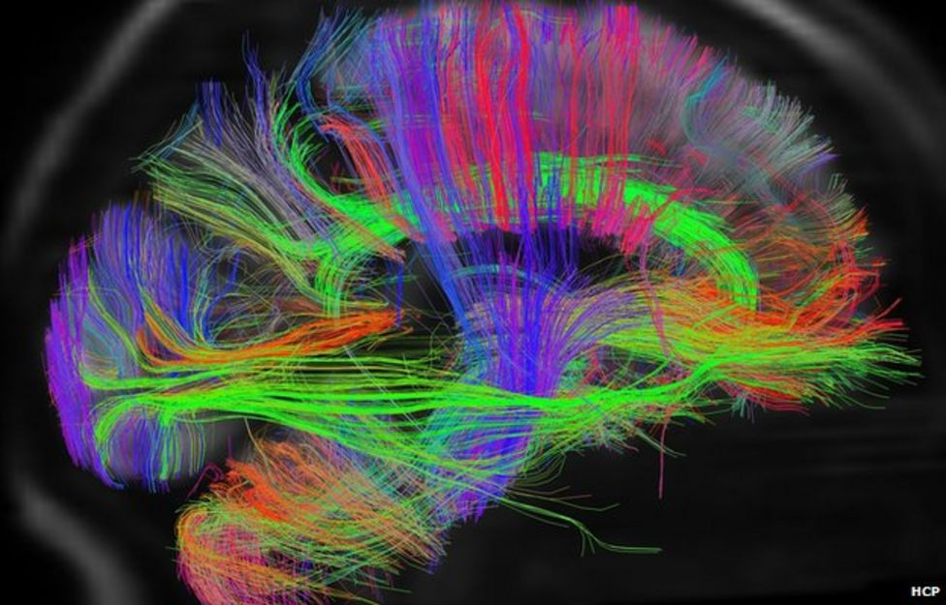  
    Pallab Ghosh: “*A side view of brain pathways, from the right. At far left is the visual cortex, connected by a large bundle, green, which connects to the frontal lobes. At center, the vertical pathways in blue serve voluntary movement, connecting the motor areas of the brain with the spinal cord and muscles. The green path at center is the right cingulum bundle, here seen from the side. The cerebellum, which controls coordinated movement, can be seen at bottom left.*”   
      
    Ghosh, By Pallab. “Scans Reveal Intricate Brain Wiring.” *BBC News*, 17 Feb. 2013, [www.bbc.com/news/science-environment-21487016](http://www.bbc.com/news/science-environment-21487016). Accessed 15 Feb. 2023  
      
    Olson, Sarah. “Mapping the Brain With Data Science.” *Purdue University News*, [www.purdue.edu/newsroom/releases/2018/Q2/mapping-the-brain-with-data-science.html](http://www.purdue.edu/newsroom/releases/2018/Q2/mapping-the-brain-with-data-science.html). Accessed 15 Feb. 2023  
      
    Glasser, M., Smith, S., Marcus, D. *et al.* The Human Connectome Project's neuroimaging approach.   
    Nat *Neurosci* **19**, 1175–1187 (2016). <https://doi.org/10.1038/nn.4361> Accessed 15 Feb. 2023
35. Hart, Liam, host. Billings, Robin, guest. “Clinical Psychologist: Dr. Robin Billings.” *Perspectives*   
    *on Psilocybin: The Science and Mysticism of Magic Mushrooms*, *Spotify*, 11 Jan. 2022 (31:40-34:10)  
      
    Timothy Leary (1920-1996), known as a psychoactive enthusiast, was a clinical psychologist at the Harvard University, PhD in clinical psychology, University of California (Berkeley).  
    Leary even spoke about 5 existing stages of consciousness: “The five most important levels of consciousness are sleep, symbol, sense, cellular awareness, and molecular consciousness.” (36:20⁠–37:32)  
    Leary, Timothy. “Turn on, Tune in, Drop Out.” *The Library*, [www.organism.earth/library/document/turn-on-tune-in-drop-out](http://www.organism.earth/library/document/turn-on-tune-in-drop-out). Accessed 24 Feb. 2023  
      
    Witt, Emily. “The Psychedelic Renaissance: Trip Reports From Timothy Leary, Michael Pollan, and Tao Lin.” *The New Yorker*, 29 May 2018, [www.newyorker.com/books/under-review/the-science-of-the-psychedelic-renaissance](http://www.newyorker.com/books/under-review/the-science-of-the-psychedelic-renaissance).

    Liam Hart, Grand Valley State University (Major: Psychology, Minor: Applied statistics)   
    Currently a research assistant at the department of psychology, mentor at Psych friends.

    Dr. Robin Billings (PhD in clinical psychology) is a fully licensed clinical psychologist with more than 34 years of experience in his office, located in Troy, Michigan. He studied at Wayne State University and is a LP (Licensed Psychoanalyst).
36. Dr. Alain Davis: “...you cannot really overdose on magic mushrooms. With something like heroin — you keep taking it... getting higher, and higher, and higher... until you overdose and die. But with psilocybin. That doesn't happen...” The reason for psilocybin not being a highly addictive drug has to do with the way it binds to a specific protein in our brain. This causes the feeling of being high.
37. The hallucinative effects would be more noticeable and start to have a deeper and better response to our consciousness.  
    Zukerman, Wendy, host. “Magic Mushrooms: Trip Through the Science.” *Science Vs, Spotify,* 11 Dec. 2020  
      
    
38. When I think of the stereotypical European fairy tales and the image that is drawn of mushrooms that can be considered the most popular to be depicted is the *Amanita Muscaria*, also known as the Fly Agaric. This is a mushroom with a red cap, containing white dots and a white stem. It is one of the most known mushroom species being presented in old fairy tales and folklore and is still quite prominent in the contemporary alternatives presented today that are based on these old fairy tales and folklore stories.  
      
    Klein, Joanna. “A Mushroom Out of a Fairy Tale That You Might Find in the Forest.” The New York Times,   
    17 Oct. 2017, [www.nytimes.com/2017/10/17/science/mushrooms-fly-agaric.html](http://www.nytimes.com/2017/10/17/science/mushrooms-fly-agaric.html). Accessed 9 Feb. 2023
39. Dugan, M. Frank. “Fungi, Folkways and Fairy Tales: Mushrooms & Mildews in Stories,   
    Remedies & Rituals, from Oberon to the Internet.” *North American Fungi*, vol. 3, 2008.   
    <http://dx.doi.org/10.2509/naf2008.003.0074>.
40. When thinking back to my own childhood, this is also one of the mushrooms I can think of that would have been prominently used in fairy tales: mostly in a forest surrounded by magical creatures. Therefor the connections we can make from mushroom in relation to these fictional characters are kind of inevitable and hard to overlook. You can think of gnomes and leprechauns sitting on the caps of mushrooms or even use them as little houses. Animals that would live in the forest alongside trolls, fairies or witches that would use “various” mushrooms to create potions or mysterious brews. As a kid I was always in love with the imaginary worlds that I could spend my time with, and ever more so being excited to be able to delve into these characters.  
      
    As a reference of the Grimm Brothers Fairytales, the probability of these stories still being true to its origin, would be unlikely hard to testify to be completely true. Most of these stories would be told from an oral tradition, which could indicate we'll never be sure of the accuracy and small tweaks and adjustments that have been applied over the past 200 years.   
      
    Flood, Alison. “Grimm Brothers’ Fairytales Have Blood and Horror Restored in New Translation.” *The Guardian*, 22 Feb. 2018, [www.theguardian.com/books/2014/nov/12/grimm-brothers-fairytales-horror-new-translation](http://www.theguardian.com/books/2014/nov/12/grimm-brothers-fairytales-horror-new-translation). Accessed 27 Jan. 2023
41. Flood, Alison. “Grimm Brothers’ Fairytales Have Blood and Horror Restored in New Translation.” *The Guardian*, 22 Feb. 2018, [www.theguardian.com/books/2014/nov/12/grimm-brothers-fairytales-horror-new-translation](http://www.theguardian.com/books/2014/nov/12/grimm-brothers-fairytales-horror-new-translation). Accessed 27 Jan. 2023

    As a reference of the Grimm Brothers Fairytales, the probability of these stories still being true to its origin, would be unlikely hard to testify to be completely true. Most of these stories would be told from an oral tradition, which could indicate we'll never be sure of the accuracy and small tweaks and adjustments that have been applied over the past 200 years.   
      
    
42. Dugan, M. Frank. “Fungi, Folkways and Fairy Tales: Mushrooms & Mildews in Stories,   
    Remedies & Rituals, from Oberon to the Internet.” *North American Fungi*, vol. 3, 2008.   
    <http://dx.doi.org/10.2509/naf2008.003.0074>.
43. Silvia Federici (1942, Parma, Italy, currently living in Slope, Brooklyn) is a scholar, author of various titles, Marxist theorist and feminist activist, who teaches and works in the US.
44. “SG Online: Wxtch Craft with Silvia Federici, Reclaiming magic as subversive practice.”   
    KABK Studium Generale 2020-2021, 12 November 2020 lecture created by Erika Sprey,   
    hosted by Melanie Bonajo, published by Janne van Gilst, 16 Nov. 2020,   
    [web.microsoftstream.com/video/e5847ed0-9041-451c-ad1a-3ae90803e8d4](https://web.microsoftstream.com/video/e5847ed0-9041-451c-ad1a-3ae90803e8d4).   
      
    From 15th, moreover in the 16th and 17th century, witch-hunting was something practised very commonly, and this range of terror and extreme torture ended in Europe near the 18th century.  
    
45. During the development of this new economic system and overruling existence of the patriarchy, society needed a figure to blame when misfortune would happen and where the reasons of this misfortune would be impossible to explain or figure out at that time. Silvia: “They would be accused of supernatural powers and for misfortune, that couldn't be solved.”  
    “Bizarre accusations were made such as: 'witches' would be making poison with their bodies.”   
    The accusations were in general anonymous. You would not know who accused you and what for. *Caliban and the witch (Persecution of witches and state initiative* (CH4): Charges would be being made in church with anonymous boxes that would go around, where you could accuse someone of being a witch anonymously. The charges, accusations, the “new section of labelling”, the criminalization and demonizing of women and certain practices, was just a facade transformed into a weapon of fear that would lead to “the patriarchal and economic capitalist driven society.”

    **Federici: “**After the torture, the accused, innocent people would be burned at the stake, being a quite known method in Europe for witch persecutions**.” (33:28 – 36:00)**
46. There are no hard facts for the example of the Salem witch trials (1692-1693), which has been linked to the “ergotism-theory.” Where bad bread and the fungus *ergot* would be the underlying cause of the witch trials. Even though this might not be confirmed, there are enough cases, even so until today in the 21st century, where folk healers are accused of witch-craft. See: Edwards, Phil, and Estelle Caswell. “The Hallucinogens That Might Have Sparked the Salem Witch Trials.” *Vox*, 29 Oct. 2015, [www.vox.com/2015/10/29/9620542/salem-witch-trials-ergotism](http://www.vox.com/2015/10/29/9620542/salem-witch-trials-ergotism).   
    
47. Schons, Mary. "Witch Trials in the 21st Century." *National Geographic*, 15 Sep. 2022, [education.nationalgeographic.org/resource/witch-trials-21st-century/](https://education.nationalgeographic.org/resource/witch-trials-21st-century/)Silverman, Leah. "The History Of Witches: How Christianity And Misogyny Turned Revered Healers Into Wicked Pariahs." *All Thats Interesting*, 31 Oct. 2015, [allthatsinteresting.com/history-of-witches](https://allthatsinteresting.com/history-of-witches).

   
48. Next to the story of witch-hunting and the origin of Western European witches —the visual representation really shows how men viewed women in society. From and throughout the 15th would be depicting and translating the misogynistic male gaze by demonizing and sexualizing women's bodies through the medium of the witch. Seen as a demonic creature, often nude with strange habits: for instance, for instance riding backwards on goats and flying on broomsticks. Cohen, Alina. “A Brief History of Witchcraft in Art.” Artsy, 26 Oct. 2019, [www.artsy.net/article/alina-cohen-artists-enchanted-witchcraft-centuries](http://www.artsy.net/article/alina-cohen-artists-enchanted-witchcraft-centuries). Accessed 27 Jan. 2023
49. Cohen, Alina. “Frances F. Denny’s Portraits of Modern-Day Witches.” Artsy, 5 Sept. 2018, [www.artsy.net/article/artsy-editorial-challenging-stereotypes-frances-denny-captures-modern-day-american-witches](http://www.artsy.net/article/artsy-editorial-challenging-stereotypes-frances-denny-captures-modern-day-american-witches). Accessed 27 Jan. 2023
50. See note 41.  
    One of the myths and floating theories that would date back to 1450 in the forms of documented text and illustrated manuscripts, are unconfirming a never proven theory, that would just circle around as the next tittle-tattle: Witchy women would apply psychoactive ointments on their broomsticks or ‘crotches’ and would ride their broomstick for transportation. One of the first known Western artworks depicting witches on broomsticks was in 1451 by Martin Le Franc (French writer) in the form of an illustrated manuscript.  
    
51. Rucker, James J. H., et al. “Psychiatry and the Psychedelic Drugs. Past, Present &Amp; Future.” Neuropharmacology, vol. 142, Elsevier BV, Nov. 2018, pp. 200–18. <https://doi.org/10.1016/j.neuropharm.2017.12.040>.
52. Mescaline is the chemical compound (alkaloid) of the Peyote Cactus which can be found in the buttons of the plant. Indigenous cultures such as Wixaritari (Huichol), Yaqui, Cora, and Raramuri (Tarahumara) used Mescaline for traditional practices.   
      
    Hendelman, Ariel Dominique. “The Peyote Plot: The Indigenous Fight to Conserve the Sacred Plant and the Spiritual Medicine It Contains.” DoubleBlind Mag, 3 Aug. 2022, [doubleblindmag.com/the-peyote-plot/](https://doubleblindmag.com/the-peyote-plot/).  
    Accessed 9 Feb. 2023
53. Also, Nazi Germany used Pervitin to inhance energy levels and combat, giving soldiers more survival strength and were able to invade France. Other substances such as Crystal Meth, cocaïne chewing gum and Eukodal have been used during the Second World War.  
      
    Cooke, Rachel. “High Hitler: How Nazi Drug Abuse Steered the Course of History.” The Guardian, 22 Mar. 2018, [www.theguardian.com/books/2016/sep/25/blitzed-norman-ohler-adolf-hitler-nazi-drug-abuse-interview](http://www.theguardian.com/books/2016/sep/25/blitzed-norman-ohler-adolf-hitler-nazi-drug-abuse-interview). Accesssed 9 Feb. 2023
54. This war was a complete mess: not only for its conflicts outside the borders of Vietnam (Laos and Cambodia), but because of the immoral use and abuse of psychoactive substances. Drugs has not only led to unnecessary deaths of American troops, terror and genocide: killing more than 2 million innocent civilians, alongside 200.000 Vietnamese militants and 20.000 American military troops. It also caused a backlash of trauma that would wash over as a big tsunami after the war, which translated into an “outbreak” of PTSD.

    Burns, Ken and Novick, Lynn. “The Vietnam War Explained in 25 Minutes | Vietnam War Documentary.” YouTube, uploaded by The Life Guide. 1 Nov. 2019, [www.youtube.com/watch?v=7tNTh6KlXXU](http://www.youtube.com/watch?v=7tNTh6KlXXU).
55. Stadlen, Matthew, host. “Michael Pollan - How to Change Your Mind.”   
    How To Academy Podcast, *Spotify*, 28 Aug. 2019 (23:12-23:30)  
      
    Because these substances came in society without an instruction manual, it has led to the overall misuse of these substances that have let to deaths and injuries, suicides, psychotic breaks and people running into traffic.  
    
56. Non-safe environments for taking psychedelics and drugs can for example be open and public spaces where the awareness of people is important for the social activity and space. Festivals like *Woodstock 69*, where the substances we're seen and used as party drugs, as spiritual enhancers and used as an escape medium to the political involvement of the US during the Vietnam war, where a festival is also considered to be an unsafe public space to test psychoactive substances.

    1969: Woodstock Music & Art fair, August of 1969 organized in Bethel, New York.  
    This was a three-day music festival where more than 400.000 people would be enjoying music and celebrating peace in contrary to the ongoing war in Vietnam (1955-1975). Considered to be one of the most iconic festivals in American history. Even though the crowd was “extremely well behaved”, there were 4000 cases of injuries and 2 deaths on the second day of the festival, linked to people feeling sick and people having bad reactions to drugs.   
      
    Manly, Lorne. “Woodstock 1969: A Story Vastly Bigger Than Editors Realized.” *The New York Times*, 10 Aug. 2019, [www.nytimes.com/2019/08/09/arts/music/woodstock-new-york-times-archives.html](https://www.nytimes.com/2019/08/09/arts/music/woodstock-new-york-times-archives.html).   
    Accessed 10 Feb. 2023
57. Richard Milhouse Nixon (1913-1994)  
    President Nixon was elected in 1968 and was running office from 1969 to 1974 in the US.   
      
    Vulliamy, Ed. “Nixon’s ‘war on Drugs’ Began 40 Years Ago, and the Battle Is Still Raging.” *The Guardian*, 2 Dec. 2017, [www.theguardian.com/society/2011/jul/24/war-on-drugs-40-years.](http://www.theguardian.com/society/2011/jul/24/war-on-drugs-40-years.)Lopez, German. “Nixon official: real reason for the drug war was to criminalize black people and hippies.”  
    Vox, 23 March 2016, [www.vox.com/2016/3/22/11278760/war-on-drugs-racism-nixon](http://www.vox.com/2016/3/22/11278760/war-on-drugs-racism-nixon).  
    Accessed 20 Jan. 2023  
    
58. Stadlen, Matthew, host. “Michael Pollan - How to Change Your Mind.”   
    How To Academy Podcast, *Spotify*, 28 Aug. 2019 (24:50⁠–24:56)
59. Augustyn, Adam. “Richard Nixon | Biography, Accomplishments, Watergate, Impeachment, Resignation, and Facts.” *Encyclopedia Britannica*, 16 Feb. 2023, [www.britannica.com/biography/Richard-Nixon/Watergate-and-other-scandals](http://www.britannica.com/biography/Richard-Nixon/Watergate-and-other-scandals).
60. Clifton (7:44–⁠7:59), “The War on Drugs Is Designed to Discriminate | the War on Drugs.” *YouTube*,   
    uploaded by VICE, 4 Nov. 2020, [www.youtube.com/watch?v=Xf5qFIpJ2sk](http://www.youtube.com/watch?v=Xf5qFIpJ2sk).
61. Deborah Peterson Small (J.D. M.P.P. Harvard University) and Jamie Clifton, (6:13)
62. Deborah Peterson Small (J.D. M.P.P. Harvard University), (9:10–⁠9:42) and (10:50–⁠11:11)
63. Also, in the Netherlands and other parts of Europe police forces still make use of ethnic profiling that is also still linked to the criminalization of black people and always linking this to drug abuse.   
    
64. Mayer, Johanna. “Michael Pollan on the ‘Psychedelic Renaissance.’” Science Friday, 9 June 2020, [www.sciencefriday.com/articles/michael-pollan-on-the-psychedelic-renaissance](http://www.sciencefriday.com/articles/michael-pollan-on-the-psychedelic-renaissance). Accessed 1 Feb. 2023
65. Aqil, Marco. “DANGERS FOR THE PSYCHEDELIC RENAISSANCE.” *APRA Amsterdam Psychedelic Research Association*, [apra.science/articles/15-dangers-for-the-psychedelic-renaissance](https://apra.science/articles/15-dangers-for-the-psychedelic-renaissance). Accessed 30 Jan. 2023
66. In this informative video, Elizabeth Hargrave presents in detail wat fungi are and that not all fungi species produce mushrooms. Not all mushrooms consist of caps with gills, some are puffy or very small and have various physical appearances. Mycological Association of Washington DC. “Mushrooms 101.” *YouTube*, 9 Dec. 2020, [www.youtube.com/watch?v=oDyvDwRjdoU](http://www.youtube.com/watch?v=oDyvDwRjdoU).
67. Different organisms that belong to family line or kin in evolution, also known as a king— or queendom.
68. When we look at figure 2, we see the SET theory by Lynn Margulis, which tries to explain the symbiosis between species, even showing the evidence of cellular evolution in this theory. In the image you can see the Bacteria, Archaea and Eukaryotic domain of species. Eukaryotic cells are bigger than that in comparison of Bacteria and Archaea. As you can see in the image, the animal and fungi branches both go to the right and when we look at the cell structure of both species, we see some interesting similarities. But plants, animals and fungi cells all have a nucleus, that has the most DNA of the cell. Plant cells have a cell wall of which animals and fungi have not, also plant cells have a slightly different structure, containing chloroplasts to be able to photosynthesize.
69. Bacteria are unicellular microorganisms, that are missing a cell nucleus. Bacteria are only visible to us under a microscope. Archaea are single celled microbes with different membrane than bacteria. Eukaryotes are multicellular organisms of which the cells on microscopic scale are larger than that of bacteria and archaea. Inside the cells of eukaryotes, there is a nucleus, where we can find most of the DNA of the cell.  
      
    “Bacteria: They Are Everywhere.” *Micropia*, [www.micropia.nl/en/discover/microbiology/bacteria](http://www.micropia.nl/en/discover/microbiology/bacteria).   
    Accessed 8 Jan. 2023.
70. Sheldrake, Merlin. *Entangled Life: How Fungi Make Our Worlds,*   
    *Change Our Minds and Shape Our Futures*. Reprint, Random House Trade Paperbacks, 2021.  
    
71. Sheldrake, Merlin. *Entangled Life: How Fungi Make Our Worlds, Change Our Minds and Shape Our Futures*. Reprint, Random House Trade Paperbacks, 2021.
72. In an interview written by Suzan Mazur, Lynn Margulis explains why the Darwin evolution theory should be considered “dead” and not be a solid piece of scientific research that we can apply to understanding the lineages of different species, as there is no “adequate evidence in literature” that is documented and can explain the sudden mutations that would result into a new species. There is an excessive number of high-quality studies that has shown no doubt that “symbiogenisis” would be at the very basis of the origin of species or a group of one or more populations of organisms. The long-lasting intimacy of strangers: symbiogenisis.   
      
    Maybe to understand this visually, people from Gen-Z and the alpha generation could think of how Pokémon would evolve sort of magically into a newer version of that same species. The theory of symbiosis shows additional factors and more in between steps that could explain the development of *change* in between the evolution of new species.  
      
    Mazur, Suzan. “Lynn Margulis: Intimacy Of Strangers & Natural Selection.” *Scoop News*, 16 March 2009, [www.scoop.co.nz/stories/HL0903/S00194/lynn-margulis-intimacy-of-strangers-natural-selection.htm](http://www.scoop.co.nz/stories/HL0903/S00194/lynn-margulis-intimacy-of-strangers-natural-selection.htm).   
    Accessed 24 Jan. 2023
73. Margulis: “*My earliest complete statement of 'serial endosymbiosis theory' was published after fifteen or so assorted rejections and losses of an early, painfully convoluted, and poorly written manuscript.*”   
    “*Called 'Origin of Mitosing Cells,' it was finally accepted for publication in 1966 through the personal intervention of James F. Danielli, then editor of the daring Journal of Theoretical Biology.*” “*Of course, the article when it appeared in print in late 1967, carried my first married name Lynn, Sagan.*” “*The theory was dubbed SET, the acronym for Serial Endosymbiosis Theory (not to be confused with SETI - the search for extra-terrestrial intelligence), by another protist aficionado, Professor Max Taylor of the University of British Colombia, Vancouver*.” (p38-p40 The Symbiotic Planet: A New View of Evolution)  
      
    (**Lynn Margulis**, p.40): “*SET is a theory of coming together, of merging of cells of different histories and abilities. Before serial endosymbiosis and the establishment of the aerobic nucleated cell, no cell-fusion sex existed. Meiotic sex, like of the egg fertilized by the sperm, came later*. “*Serial endosymbiosis made our kind of fusion sex possible. Sex, too, is the coming together, the merging of cells of different histories and abilities*.”
74. Donna Haraway is a US biologist, philosopher, science historian and ecofeminist. Haraway describes this herself: “*I think my work has been question-driven. It’s been driven by finding myself in a conjuncture of events, ideas, things, people, and other critters — plants and animals and microbes — that provoke needing to know something and finding myself in an institutional environment that encouraged that.*”

    Paulson, Steve. “Making Kin: An Interview With Donna Haraway.” Interview by Steve Paulson. *Los Angeles Review of Books*, 6 Dec. 2019, [lareviewofbooks.org/article/making-kin-an-interview-with-donna-haraway/](https://lareviewofbooks.org/article/making-kin-an-interview-with-donna-haraway/).   
    Accessed 23 Jan. 2023
75. Mohns, Lovina. “Making Kin, staying with the trouble Donna Haraway.” *Beyond Social*,   
    17 Nov. 2020 <https://beyond-social.org/wiki/index.php/Making_Kin> Accessed 27 Jan. 2023

    Haraway, Donna. *Staying With the Trouble: Making Kin in the Chthulucene*. Duke UP, 2016.  
    (CH8, p134⁠–p168)  
      
    “Storytelling for Multispecies Justice and Care | Donna J. Haraway.” *YouTube*, uploaded by Techno,   
     24 Mar. 2021, [www.youtube.com/watch?list=PLP42VXgsNEi-aZxvDUDqdYTjvHnPBPaGu&v=OSZw-AMsYeI&feature=youtu.be](http://www.youtube.com/watch?list=PLP42VXgsNEi-aZxvDUDqdYTjvHnPBPaGu&v=OSZw-AMsYeI&feature=youtu.be). (16:30⁠–⁠26:00)  
      
    The Camille Stories:
76. Making kin can be understood as not only the living and interacting of multispecies — going beyond the human species world that has been created and finding the relations with and through “nature”. Not making babies, in the sense that love and care are not only running through blood, but they can also be expanded from the current westernized human understanding of the natural environment that focuses on the separation of human, nature and other species. The reproduction of the human species shouldn't be the only solution to give love and care, to share and gain knowledge alone.

    *Donna Haraway: Storytelling for Earthly survival*. Directed by Fabrizio Terranova, Atelier Graphoui, CBA, et al. 25 May 2016, *Internet Archive*, [archive.org/details/donna-haraway-story-telling-for-earthly-survival](https://archive.org/details/donna-haraway-story-telling-for-earthly-survival).
77. A symbiont is a living organism in symbiosis. In the Camille Stories, Haraway introduces her symbionts as a human-symbiont, where “human beings are entangled with the world” and where there is not “human-exceptionalism.” Her human-symbiont in the Camille Stories is a human-butterfly-hybrid, originated from the Monarch butterfly's species in Mexico. The story unfolds an earthly tale, where humans are on the earth to preserve nature and don't make babies, but kin. Each infant that would be born in this world would have at least 3 parents, guiding and teaching the newborn child. If a person is with child, they would have to choose a symbiont amongst all the animals that would not survive without the help and care of humans.

    “Storytelling for Multispecies Justice and Care | Donna J. Haraway.” *YouTube*, uploaded by Techno,   
     24 Mar. 2021, [www.youtube.com/watch?list=PLP42VXgsNEi-aZxvDUDqdYTjvHnPBPaGu&v=OSZw-AMsYeI&feature=youtu.be](http://www.youtube.com/watch?list=PLP42VXgsNEi-aZxvDUDqdYTjvHnPBPaGu&v=OSZw-AMsYeI&feature=youtu.be).
78. “Storytelling for Multispecies Justice and Care | Donna J. Haraway.” *YouTube*, uploaded by Techno,   
     24 Mar. 2021, [www.youtube.com/watch?list=PLP42VXgsNEi-aZxvDUDqdYTjvHnPBPaGu&v=OSZw-AMsYeI&feature=youtu.be](http://www.youtube.com/watch?list=PLP42VXgsNEi-aZxvDUDqdYTjvHnPBPaGu&v=OSZw-AMsYeI&feature=youtu.be).
79. Myers, Natasha. “From the Anthropocene to the Planthroposcene: Designing Gardens for Plant/People Involution.” *History and Anthropology*, vol. 28, no. 3, Informa UK Limited, Mar. 2017, pp. 297–301. <https://doi.org/10.1080/02757206.2017.1289934.>
80. (Sheldrake, CH3: p128, p135 & p136)
81. see note 80.   
    Though, there are examples of fungal species that are less “communal” and collect large supplies of “phosphorus” which they find in this symbiotic relationship.
82. Images credits: Merlin Sheldrake. Microscopic images of fungal roots growing inside plant roots.  
    Sheldrake, Merlin. *Entangled Life: How Fungi Make Our Worlds,*   
    *Change Our Minds and Shape Our Futures*. Reprint, Random House Trade Paperbacks, 2021.  
      
      
    