Markdown to Presentation

DigitalizeIT GmbH

Table of Contents

## Introduction

**Goal** Convert md (Markdown) files to a presentation.

By using pandoc.

Pandoc is a very powerful tool and can convert almost any document format to another document format.

For all options run pandc --help or checkout [Pandoc User’s Guide](https://pandoc.org/MANUAL.html)

## Setup

On Debian/Ubuntu based distributions install following software

sudo apt-get install pandoc  
sudo apt-get install texlive-latex-base

If there should be missing software search in google for it.

## Basic

To simply convert an md file run:

pandoc README.md -t beamer -o presentation.pdf

## Advanced

To generate a more beautiful presentation add metadata.

This can be done in the md file itself with a yaml block at the beginning

---  
title:  
- Mardown to Presentation  
author:  
- DigitalizeIT GmbH  
theme:  
- Copenhagen  
---

pandoc README.md -t beamer -o presentation.pdf

List with all [themes](https://deic-web.uab.cat/~iblanes/beamer_gallery/index_by_theme_and_color.html)

## Using a template file

Modify the md with specific pandoc metadata is not always what you want. We can put all these metadata to a template file. E.g. template.yaml.

pandoc README.md -t beamer -o presentation.pdf \  
 --metadata-file=template.yaml

## Code block highlighting

There are several code highlighting styles available:

pandoc --list-highlight-styles

An example by using the zenbrun style

pandoc README.md -t beamer -o presentation.pdf \  
 --metadata-file=template.yaml \  
 --highlight-style=zenburn

## Generate other document types

There are almost 50 output formats available. To list them:

pandoc --list-output-formats

Be aware that every generator has it’s own options. For example the theme option in the template.yaml is only available in the beamer generator.

## Generate a PDF document

pandoc README.md -t latex -o presentation.pdf \  
 --metadata-file=template.yaml \  
 --highlight-style=zenburn -V geometry:a4paper

## Generate HTML

pandoc README.md -t html5 -o presentation.html \  
 --metadata-file=template.yaml \  
 --highlight-style=zenburn

If you analyze the generated HTML code all HTML tags have specific class attributes. So it’s straight forward to generate a custom css.

## Generate Microsoft Office documents

Unfortunately docx and pptx have no templates available.

### Generate a PowerPoint

pandoc README.md -t pptx -o presentation.pptx \  
 --metadata-file=template.yaml \  
 --highlight-style=zenburn

### Generate a word document

pandoc README.md -t docx -o presentation.docx \  
 --metadata-file=template.yaml \  
 --highlight-style=zenburn

## Conclusion

### Cons

Pandoc is in my opinion not a replacement for professional PowerPoint presentation or word documents.

### Pro

Pandoc is a powerful tool to generate documents based out of Markdown files. Especial to document a software project. It can be easily integrated into a CI/CD pipeline and the documentation will be released at the same time as the software.

### Hints

If you want to transform the Markdown be aware of it when writing. Especial the code snippets will not have a word wrap in the most cases. When generating a presentation (e.g. beamer). Be aware of the size of each slide…

## Results Document

Preview of the generated document

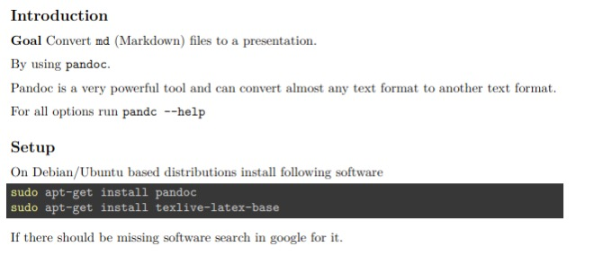

generated document

## Results Presentation

Preview of the generated presentation

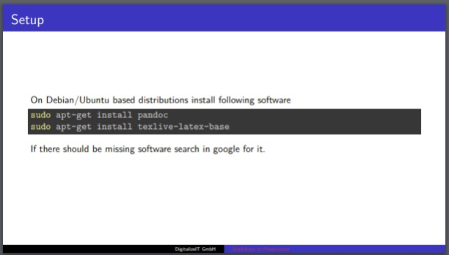

generated presentation