School of Computing and Information Systems

Web & Multimedia Development Assignment Report

Assignment Submission Cover Sheet
Field | Details
Student ID | ______________________________
Student names | ______________________________
Student email | ______________________________
Cohort | ______________________________
Assignment title | SCIS WMD_2026 A01
Date of submission | 20 May 2026
Programme of Study | ______________________________
Year of Study | Year 1
Website name | Motion Clothing
Repository URL | Add GitHub repository URL here
GitHub Pages URL | Add published website URL here

Intellectual Property Statement
By signing below, I certify that this assignment is my own work and is free from plagiarism. I understand that the assignment may be checked for plagiarism by electronic or other means and may be transferred and stored in a database for data-matching purposes to help detect plagiarism. The assignment has not previously been submitted for assessment in any other unit or institution. I have read and understood the Botswana Accountancy College plagiarism guidelines policy.
Agree: [ ]
Signature: ______________________________
Date: ______________________________

Motion Clothing Website Specification Report

Student/Project Details
Website name: Motion Clothing
Business type: Clothing and streetwear brand
Repository URL: Add GitHub repository URL here
GitHub Pages URL: Add published website URL here
Final presentation date: 20 May 2026

Research and Benchmarking
The website plan was informed by recognised web development sources and common small-business website practices:
- The W3C describes web standards as the foundation for consistent, interoperable web experiences across browsers and devices. This supports the decision to use standard HTML5, CSS3 and accessible page structure.
- Bootstrap 5.3 documentation explains that its grid system uses containers, rows and columns for responsive layouts. This supports the decision to use Bootstrap for the product grid, navigation and form layout.
- GitHub Pages documentation explains that a site can be published from a selected branch and folder. This supports the planned publishing method for the assignment website.
- The Motion Clothing product catalogue and brand images were used as primary business content because the website is designed for the brand itself.

1. Website Specifications

Website Objective
The objective of the Motion Clothing website is to promote a Botswana-inspired clothing brand online and make it easy for customers to learn about the brand, view available products, contact the business and send feedback.

Business Goals
- Increase brand awareness for Motion Clothing.
- Display products clearly with images, names and prices.
- Provide simple contact details for enquiries and orders.
- Build customer trust through a professional, consistent website.
- Collect customer feedback to improve service and products.
- Support future online selling by creating a product catalogue that can later be connected to a real checkout system.

Target Audience
The website targets young fashion-conscious customers, especially students, young adults and streetwear lovers in Botswana.
Audience factor | Description
Age range | Mainly 16 to 35 years
Location | Botswana, especially Gaborone and nearby areas
Interests | Streetwear, casual fashion, affordable clothing, local brands
Technical aptitude | Comfortable using smartphones, social media, online forms and basic websites
Devices used | Mostly mobile phones, but also laptops and desktop computers

Website Type
The website is a small business brand and product showcase website. It is not a full e-commerce website because payments are not processed online, but it allows users to view products and contact the business.

Content to be Designed for Users
The website content includes a brand introduction, mission and vision, product catalogue, contact information, enquiry form and customer feedback form. This content was selected because the target users need to quickly understand the brand, view products and communicate with the business.

2. Information Design and Taxonomy

Content Categories
- **Brand information:** Home and About pages.
- **Product information:** Products page with images, product names and prices.
- **Customer communication:** Contact page with contact form and business details.
- **Customer response:** Feedback page with rating and feedback form.

Site Map
flowchart TD
Home["Home / index.html"] --> About["About / about.html"]
Home --> Products["Products / products.html"]
Home --> Contact["Contact / contact.html"]
Home --> Feedback["Feedback / feedback.html"]
About --> Products
Products --> Contact
Contact --> Feedback

Navigation Paths
All pages use the same navigation menu:
- Home
- About
- Products
- Contact
- Feedback
This structure ensures that users can move to any important page from anywhere on the website.

Three-Click Rule
The website follows the three-click rule because every major page can be reached directly from the navigation bar in one click. Users can move from the Home page to product information, contact details or feedback without searching through hidden pages.

Storyboard Flow
- User opens the Home page and sees the Motion Clothing brand, slogan and featured products.
- User visits the About page to understand the brand story, mission, vision and values.
- User opens the Products page to view clothing items, prices and product images.
- User visits the Contact page to send an enquiry or find phone/email details.
- User visits the Feedback page to rate the website or service.

3. Page Template Design

Template Layout
Each page follows a consistent page template:
- Sticky navigation bar at the top.
- Large header/banner area with page title.
- Main content section.
- Footer with copyright and location.

Page Uniformity
The same navigation bar, logo, colour palette, button style, spacing system and footer are used across all five pages. This keeps the user experience consistent and directly supports the page-uniformity marking criterion.

Wireframe Description
Home page wireframe:
- Top: logo and navigation.
- Hero section: brand headline, slogan and shop button.
- Middle: short brand introduction.
- Product preview: three featured product images.
- Call-to-action section: link to all products.
- Bottom: footer.
Products page wireframe:
- Top: logo and navigation.
- Header: page title.
- Product grid: product cards in rows.
- Each product card includes image, name, price and Add to Cart button.
- Bottom: footer.
Contact and Feedback page wireframes:
- Top: logo and navigation.
- Header: page title.
- Form section with labels, inputs and submit button.
- Contact page also includes business email, phone, location and hours.
- Bottom: footer.

Wireframe Evidence
Desktop wireframe/page template
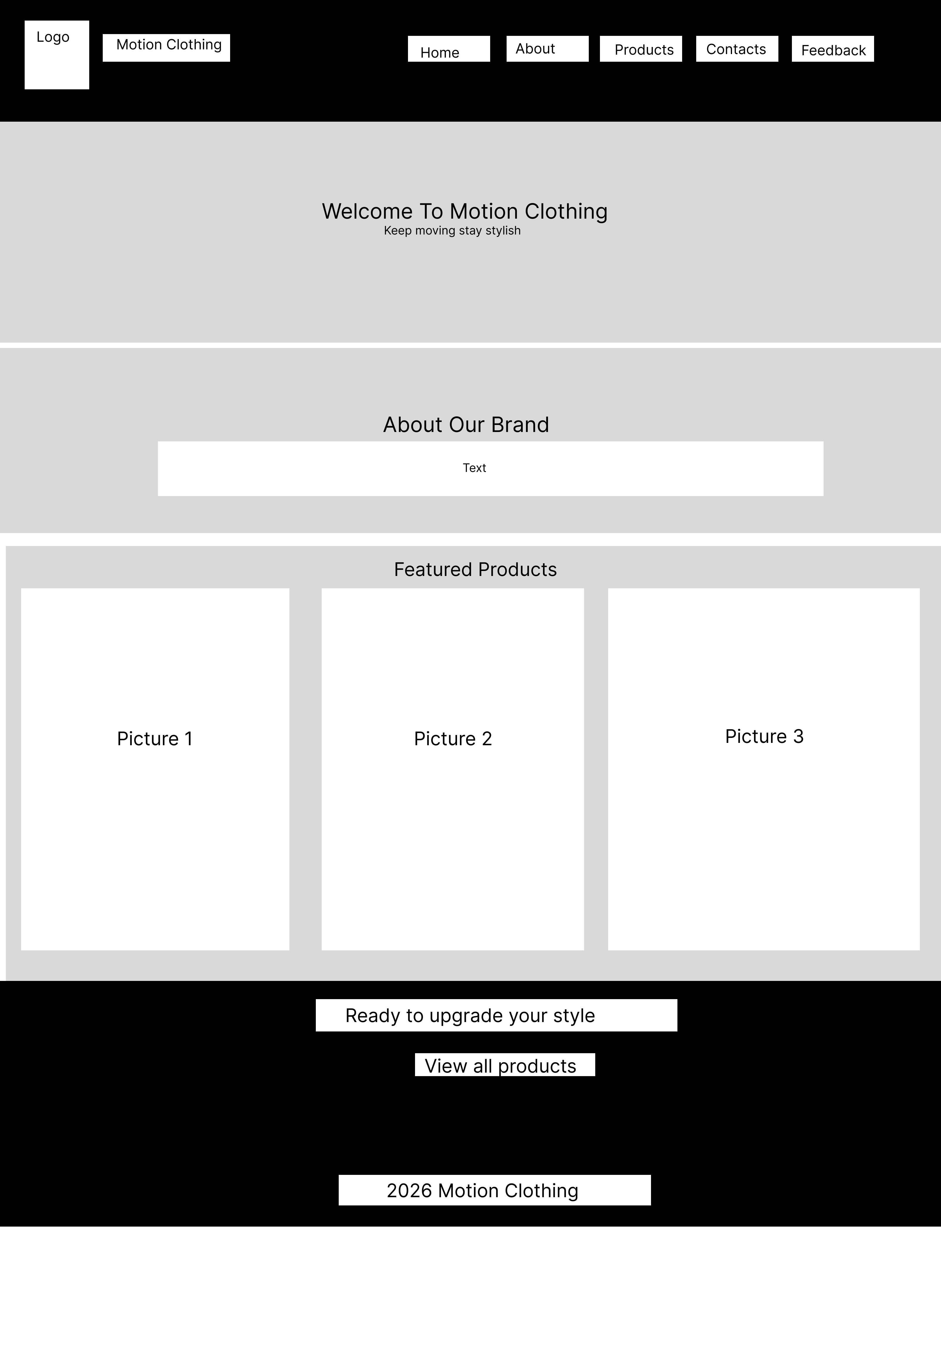
Android expanded wireframe/page template
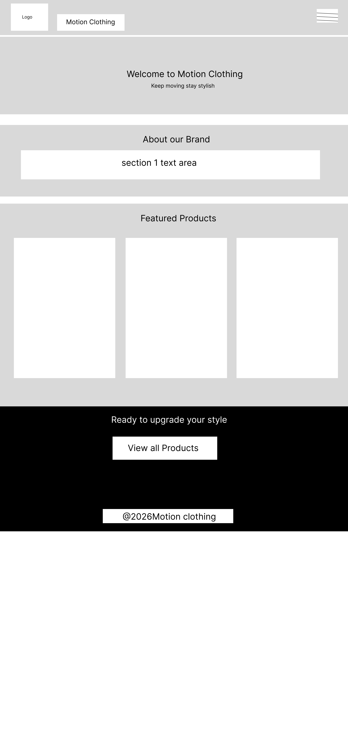
Android medium wireframe/page template
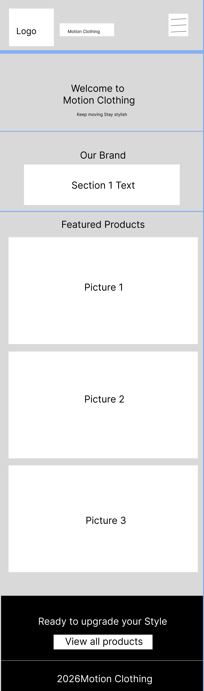
The following screenshots are included as visual wireframe/page-template evidence. They show how the planned layout is structured for desktop and mobile screen sizes:
- `screenshots/Desktop - 1 (6).png` shows the desktop page template with logo, navigation, hero section, brand introduction, featured products, call-to-action section and footer.
- `screenshots/Android Expanded - 1 (3).png` shows the wider Android/mobile layout and confirms that the page structure remains readable on smaller devices.
- `screenshots/Android Medium - 1 (10).png` shows the smaller Android layout and confirms that content still follows the intended page order.

Visual Design Decisions
- **Colour scheme:** Black, white and gold were selected to match the Motion Clothing logo and product catalogue.
- **Typography:** Arial/Helvetica was used because it is clean, readable and available across browsers.
- **Spacing:** Sections use clear padding and whitespace so the content is separated into readable blocks.
- **Images:** Product and brand images are placed in cards and banner sections to make the website visually appealing to the target audience.

4. Technical Brief

Development Technologies
- **HTML5:** Used for page structure and semantic content.
- **CSS3:** Used for custom styling, layout, responsive behaviour and visual presentation.
- **Bootstrap 5.3.3:** Used for responsive grid, navigation bar, buttons and form styling.
- **JavaScript:** Used for form submission messages and Add to Cart button interaction.

Structural, Presentation and Behavioural Layers
Layer | Implementation
Structural layer | HTML5 files define the page sections, headings, navigation, images, product cards and forms.
Presentation layer | External CSS3 file and Bootstrap classes control layout, colours, spacing, responsiveness and page uniformity.
Behavioural layer | JavaScript displays confirmation messages for contact/feedback forms and Add to Cart buttons. HTML5 `required`, `type="email"` and form controls provide validation.

Development Tools
- **VS Code:** Code editing.
- **Web browser developer tools:** Testing layout and responsiveness.
- **Git and GitHub:** Version control and repository hosting.
- **GitHub Pages:** Publishing the website online.
- **Image editing software such as GIMP/Canva:** Preparing logos, catalogue images and banners.

Website Files
- `index.html`
- `about.html`
- `products.html`
- `contact.html`
- `feedback.html`
- `style.css`
- `script.js`
- Product and brand images in `.jpg` format.

Image and Multimedia Use
The website uses a logo, banner image and product images. All content images include descriptive `alt` text and explicit `width` and `height` attributes to support accessibility, W3C-friendly markup and stable page layout.

5. Quality Assurance

Test Samples
Screenshots are stored in the `screenshots` folder:
- `Desktop - 1 (6).png`
- `Android Expanded - 1 (3).png`
- `Android Medium - 1 (10).png`

QA Test Table
Test | Expected result | Status
Home page opens | `index.html` loads with header, navigation, product preview and footer | Passed
Navigation links | Home, About, Products, Contact and Feedback links open the correct pages | Passed
Product images | Product images display correctly on Home and Products pages | Passed
Feedback form | Form shows required fields and displays confirmation message after submit | Passed
Contact form | Form shows required fields and displays confirmation message after submit | Passed
Mobile display | Website stacks neatly on narrow screens | Passed
Desktop display | Website uses multi-column layout on large screens | Passed
Browser compatibility | Website can run in Chrome, Firefox, Edge, Safari and Opera because it uses standard HTML5, CSS3, Bootstrap and JavaScript | Passed
Broken links | Internal page links point to existing files | Passed

Detailed Test Samples
Test sample | Device/browser | What was tested | Evidence
Desktop layout | Desktop browser at wide screen resolution | Header, navigation, featured products and footer layout | `screenshots/Desktop - 1 (6).png`
Android expanded layout | Mobile/tablet screen width | Mobile-friendly stacking and navigation behaviour | `screenshots/Android Expanded - 1 (3).png`
Android medium layout | Mobile screen width | Readability and content placement on smaller screens | `screenshots/Android Medium - 1 (10).png`
Broken link test | File inspection | All local `href` and `src` references point to existing files | Passed, no missing local references
Form validation test | Contact and Feedback pages | Required fields and email input validation | Passed

6. Publishing and Promotion

Hosting Method
The website should be hosted on GitHub Pages. The website files must be uploaded to a GitHub repository and GitHub Pages must be enabled from the repository settings.

GitHub Commands
git init
git add .
git commit -m "Add Motion Clothing website"
git branch -M main
git remote add origin https://github.com/USERNAME/REPOSITORY-NAME.git
git push -u origin main

Ongoing Git Commands Used During Development
git status
git add index.html about.html products.html contact.html feedback.html style.css script.js
git commit -m "Build responsive Motion Clothing website"
git log --oneline

GitHub Pages Setup
- Open the GitHub repository.
- Go to **Settings**.
- Select **Pages**.
- Choose the `main` branch.
- Select the root folder.
- Save and copy the published GitHub Pages URL.

Website URL for Assessor
Add the final website link here after publishing:
`https://YOUR_USERNAME.github.io/YOUR_REPOSITORY/`

Promotion Methods
- Share the website link on Instagram, Facebook and WhatsApp.
- Add the website link to Motion Clothing social media profiles.
- Include the website link on digital posters and product catalogues.
- Encourage customers to use the Feedback page after purchasing.

7. Future Developments and Recommendations
- Add a real shopping cart and secure online payment system.
- Add product size options and stock availability.
- Add customer reviews and ratings for each product.
- Add a gallery or lookbook page showing full outfits.
- Improve search engine optimisation with more product descriptions and keywords.
- Add order tracking and delivery information.

Conclusion
The Motion Clothing website meets the assignment requirements by using HTML5, CSS3, Bootstrap and JavaScript. It includes at least five interlinked pages, a feedback form, images, responsive design, consistent page layout and a clear structure for publishing on GitHub Pages.

Marking Criteria Checklist
Criterion | Covered? | Evidence
Website objective and goals | Yes | Section 1, Website Objective and Business Goals
Target audience demographics and technical aptitude | Yes | Section 1, Target Audience table
Website/content type | Yes | Section 1, Website Type
Information architecture and taxonomy | Yes | Section 2, Content Categories and Site Map
Navigation paths and storyboard | Yes | Section 2, Navigation Paths and Storyboard Flow
Page template/wireframe planning | Yes | Section 3, Template Layout and Wireframe Description
Technical brief | Yes | Section 4, Development Technologies and Tools
QA testing and screenshots | Yes | Section 5, QA Test Table and screenshots folder
Publishing and promotion | Yes | Section 6, GitHub commands and GitHub Pages setup
Future recommendations | Yes | Section 7
Five interlinked pages | Yes | `index.html`, `about.html`, `products.html`, `contact.html`, `feedback.html`
Feedback page with form | Yes | `feedback.html`
HTML5, CSS3, Bootstrap and JavaScript | Yes | HTML files, `style.css`, Bootstrap CDN, `script.js`
Images with alt, width and height | Yes | Product and logo images in HTML files
Page uniformity | Yes | Shared navigation, footer, CSS and colour palette
No broken internal links | Yes | Local reference check passed

References
- World Wide Web Consortium. (2026). Web Standards. https://www.w3.org/standards/
- Bootstrap Team. (2026). Bootstrap 5.3 Grid system. https://getbootstrap.com/docs/5.3/layout/grid/
- Bootstrap Team. (2026). Bootstrap 5.3 Navbar documentation. https://getbootstrap.com/docs/5.3/components/navbar/
- GitHub Docs. (2026). Configuring a publishing source for your GitHub Pages site. https://docs.github.com/en/pages/getting-started-with-github-pages/configuring-a-publishing-source-for-your-github-pages-site

Appendix: QA Screenshot Evidence
Desktop - 1 (6).png

Android Expanded - 1 (3).png

Android Medium - 1 (10).png


