WEB AND MULTIMEDIA DEVELOPMENT ASSIGNMENT REPORT

Assignment Submission Cover Sheet

Field | Details
Student ID | FCSE25-005
Student names | KABO SETLHAPELO
Student email | FCSE25-005@thuto.bac.ac.bw
Cohort | 2026
Assignment title | SCIS WMD_2026 A01
Date of submission | 20 May 2026
Programme of Study | COMPUTER SYSTEM ENGINEERING
Year of Study | Year 1
Website name | Motion Clothing
Repository URL | Add GitHub repository URL here
GitHub Pages URL | Add published website URL here

Intellectual Property Statement
By signing below, I certify that this assignment is my own work and is free from plagiarism. I understand that the assignment may be checked for plagiarism by electronic or other means and may be transferred and stored in a database for data-matching purposes to help detect plagiarism. The assignment has not previously been submitted for assessment in any other unit or institution. I have read and understood the Botswana Accountancy College plagiarism guidelines policy.
Agree: [ ]
Signature: ______________________________
Date: ______________________________

Research and Benchmarking

- The plan for the website was based on what people who make websites think's a good idea and what small businesses usually do:

- The W3C says that web standards are important for making sure websites look good on all browsers and devices. This is why we decided to use HTML5, CSS3 and make sure the pages are easy to use.

- The people who made Bootstrap say that their grid system is good for making websites look good on all devices. They use containers, rows and columns to make the layout work well. This is why we chose to use Bootstrap for the product grid, navigation and forms on the website.

- GitHub Pages has instructions that say we can publish the website from a folder and branch. This is how we plan to make the website available to everyone.

- We used the Motion Clothing product catalogue and brand images as the content for the website because the website is, for the Motion Clothing brand itself. We wanted to make sure the website looks like it belongs to Motion Clothing.

1. Website Specifications

Website Objective

The Motion Clothing website aims to promote a clothing brand inspired by Botswana online. It helps customers learn about the brand see products get in touch with the business and send feedback.

Business Goals

• Increase awareness of the Motion Clothing brand.

• Show products with images, names and prices.

• Make it easy for people to contact us for questions and orders.

• Build trust with customers through a website.

• Collect feedback from customers to improve our service and products.

• Create a product catalogue that can be used for sales in the future.

Target Audience

The website is for people, in Botswana who love fashion, especially students, young adults and streetwear fans.

Audience factor | Description
Age range | Mainly 16 to 35 years
Location | Botswana, especially Gaborone and nearby areas
Interests | Streetwear, casual fashion, affordable clothing, local brands
Technical aptitude | Comfortable using smartphones, social media, online forms and basic websites
Devices used | Mostly mobile phones, but also laptops and desktop computers
Website Type

The website is for a business to show their brand and products. It is not an online store, but users can view products and get in touch with the business.

Content to be Designed for Users

The website will have:

An introduction to the brand

The business’s vision

A catalogue of products

Contact information

A form for enquiries

A form for customer feedback

This content is important because users need to understand the brand, view products and communicate with the business.

Information Design and Taxonomy

Content Categories

Brand information: . About pages

Product information: Products page with images, product names and prices

Customer communication: Contact page with contact form and business details

Customer response: Feedback page with rating and feedback form

Site Map

flowchart TD

flowchart TD
Home ["Home / index.html"] --> About ["About / about.html"]
Home --> Products ["Products / products.html"]
Home --> Contact ["Contact / contact.html"]
Home --> Feedback ["Feedback / feedback.html"]
About --> Products
Products --> Contact
Contact --> Feedback

Navigation Paths

All pages will have the navigation menu:

- Home

- About

- Products

- Contact

- Feedback

This way users can easily move to any page from anywhere on the website.

Three-Click Rule

The website follows the three-click rule. This means every major page can be reached directly from the navigation bar in one click. Users can move from the Home page to product information contact details or feedback without searching through pages.

Storyboard Flow

1. A user opens the Home page. Sees the Motion Clothing brand, slogan and featured products.

2. The user visits the page to understand the brand story, mission, vision and values.

3. The user opens the Products page to view clothing items, prices and product images.

4. The user visits the Contact page to send an enquiry or find phone/email details.

5. The user visits the Feedback page to rate the website or service.

Page Template Design

Template Layout

Each page will have:

A sticky navigation bar at the top

A large header/banner area with page title

A main content section

A footer with copyright and location

Page Uniformity

The navigation bar, logo, colour palette, button style, spacing system and footer will be used across all five pages. This keeps the user experience consistent.

Wireframe Description

Home page wireframe

Top: logo and navigation

Hero section: brand headline, slogan and shop button

Middle: short brand introduction

Product preview: three featured product images

Call-to-action section: link to all products

Bottom: footer

Products page wireframe

- Logo and navigation

- Header: page title

- Product grid: product cards in rows

- Each product card includes image, name, price and Add to Cart button

- Bottom: footer

Contact and Feedback page wireframes

- Logo and navigation

- Header: page title

- Form section with labels, inputs and submit button

- Contact page also includes business email, phone, location and hours

- Bottom: Footer

Wireframe Evidence

Desktop wireframe/page template

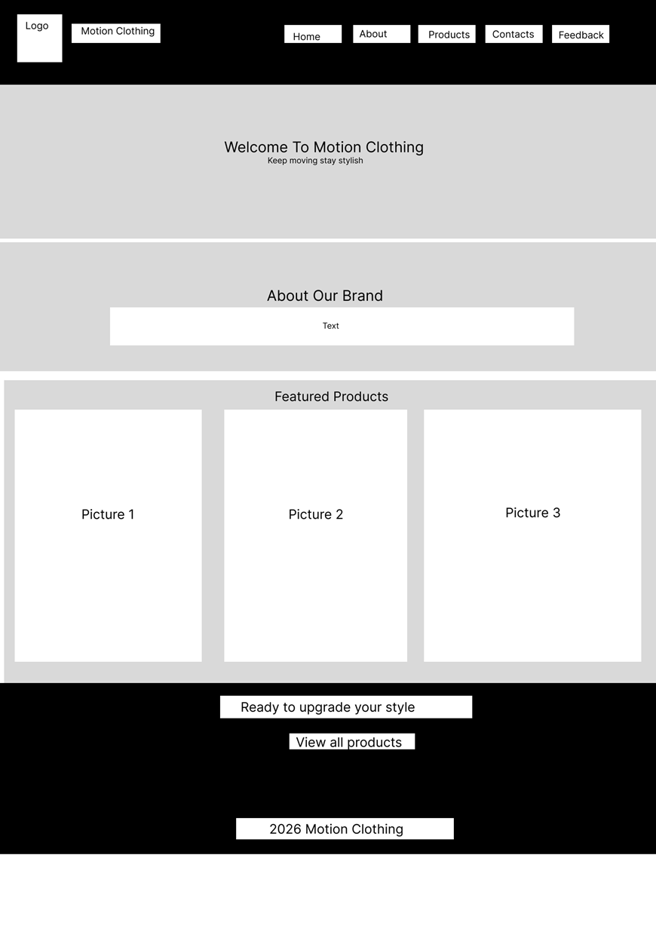

Android expanded wireframe/page template

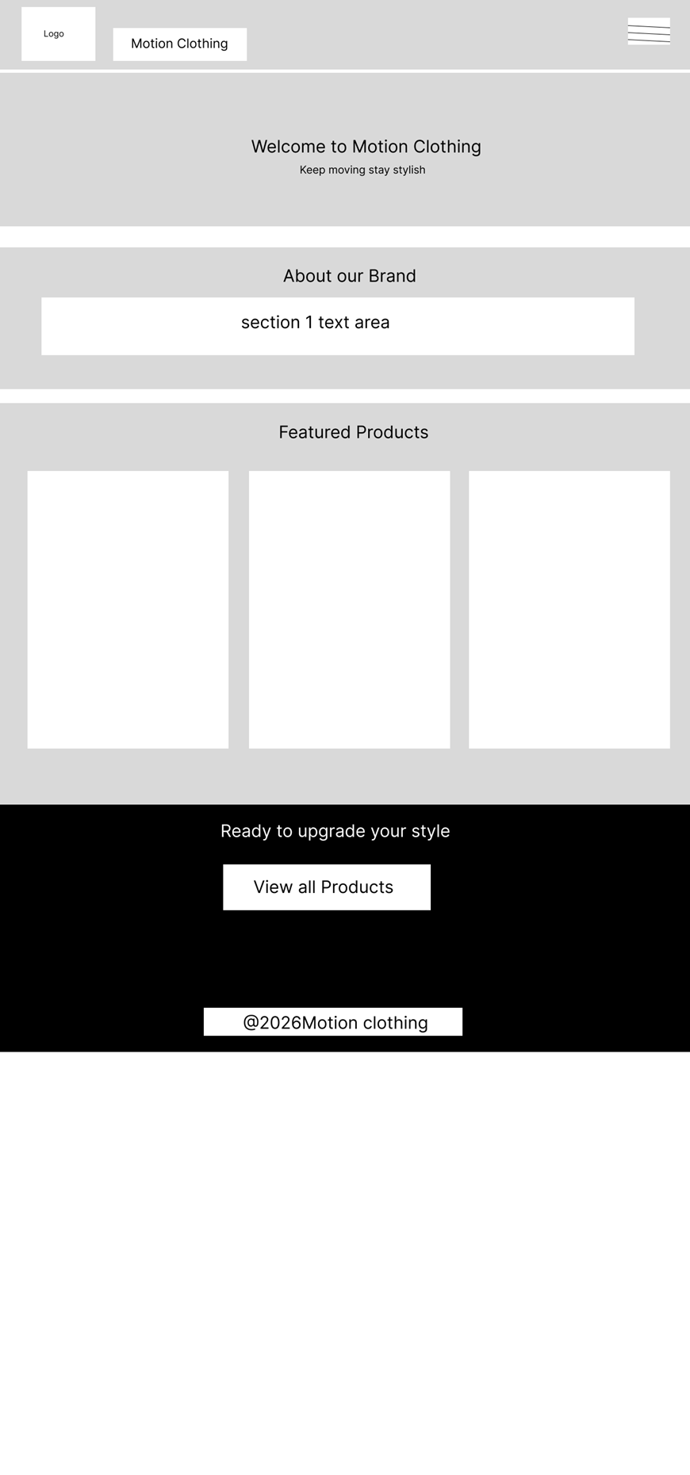

Android medium wireframe/page template

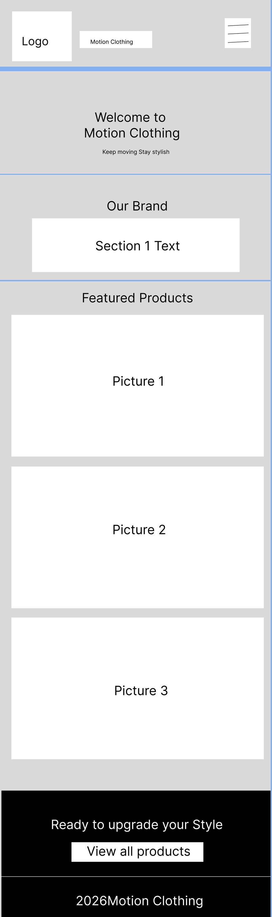

The following screenshots show the planned layout for desktop and mobile screen sizes:

- `screenshots/Desktop. 1 (6).png`

- `screenshots/Android Expanded. 1 (3).png`

- `screenshots/Android Medium. 1 (10).png`

Visual Design Decisions

- Colour scheme: Black, white and gold were chosen to match the Motion Clothing logo and product catalogue.

- Typography: Arial/Helvetica was used because it is clean, readable and available across browsers.

- Spacing: Sections use padding and whitespace to separate content into readable blocks.

- Images: Product and brand images are placed in cards and banner sections to make the website visually appealing.

Technical Brief

Development Technologies

HTML5: Used for page structure and semantic content

CSS3: Used for custom styling, layout, responsive behaviour and visual presentation

Bootstrap 5.3.3: Used for grid, navigation bar, buttons and form styling

JavaScript: Used for form submission messages. Add to Cart button interaction

Structural, Presentation and Behavioural Layers

Layer | Implementation
Structural layer | HTML5 files define the page sections, headings, navigation, images, product cards and forms.
Presentation layer | External CSS3 file and Bootstrap classes control layout, colors, spacing, responsiveness and page uniformity.
Behavioral layer | JavaScript displays confirmation messages for contact/feedback forms and Add to Cart buttons. HTML5 `required`, `type="email"` and form controls provide validation.

Development Tools

VS Code: Code editing

Web browser developer tools: Testing layout and responsiveness

Git and GitHub: Version. Repository hosting

GitHub Pages: Publishing the website online

Image editing software: Preparing logos, catalogue images and banners

Website Files

`index.html`

`products.html`

`contact.html`

`feedback.html`

`style.css`

`script.js`

Product and brand images in `.jpg` format

Image and Multimedia Use

The website uses a logo, banner image and product images. All content images include alt` text and explicit `width` and `height` attributes.

Quality Assurance

Test Samples

Screenshots are stored in the `screenshots` folder:

`Desktop. 1 (6).Png`

`Android Expanded. 1 (3).Png`

`Android Medium. 1 (10).Png`

QA Test Table

Test | Expected result | Status
Home page opens | `index.html` loads with header, navigation, product preview and footer | Passed
Navigation links | Home, About, Products, Contact and Feedback links open the correct pages | Passed
Product images | Product images display correctly on Home and Products pages | Passed
Feedback form | Form shows required fields and displays confirmation message after submitting | Passed
Contact form | Form shows required fields and displays confirmation message after submitting | Passed
Mobile display | Website stacks neatly on narrow screens | Passed
Desktop display | Website uses multi-column layout on large screens | Passed
Browser compatibility | Website can run in Chrome, Firefox, Edge, Safari and Opera because it uses standard HTML5, CSS3, Bootstrap and JavaScript | Passed
Broken links | Internal page links point to existing files | Passed

Detailed Test Samples
Test sample | Device/browser | What was tested | Evidence
Desktop layout | Desktop browser at wide screen resolution | Header, navigation, featured products and footer layout | `screenshots/Desktop - 1 (6).png`
Android expanded layout | Mobile/tablet screen width | Mobile-friendly stacking and navigation behavior | `screenshots/Android Expanded - 1 (3).png`
Android medium layout | Mobile screen width | Readability and content placement on smaller screens | `screenshots/Android Medium - 1 (10).png`
Broken link test | File inspection | All local `href` and `src` references point to existing files | Passed, no missing local references
Form validation test | Contact and Feedback pages | Required fields and email input validation | Passed

Publishing and Promotion

Hosting Method

The website will be hosted on GitHub Pages. The website files must be uploaded to a GitHub repository, and GitHub Pages must be enabled from the repository settings.

GitHub Commands

`git init`

`git add.`

`git commit -m "Add Motion Clothing website"`

`git branch -M main`

`git remote add origin https://github.com/USERNAME/REPOSITORY-NAME.git`

`git push -u origin

Ongoing Git Commands Used During Development

`git status`

`git add index.html about.html products.html contact.html feedback.html style.css script.js`

`git commit -m "Build responsive Motion Clothing website"`

`git log --oneline`

GitHub Pages Setup

1. Open the GitHub repository

2. Go to Settings

3. Select Pages

4. Choose the `branch

5. Select the root folder

6.. Copy the published GitHub Pages URL

Website URL for Assessor

Add the final website link here after publishing: `https://YOUR_USERNAME.github.io/YOUR_REPOSITORY/`

Promotion Methods

- Share the website link on Instagram, Facebook and WhatsApp

- Add the website link to Motion Clothing social media profiles

- Include the website link, on posters and product catalogues

- Encourage customers to use the Feedback page after purchasing

7. Future Developments and Recommendations

• We should add a shopping cart and a secure online payment system to make purchases easy.

• It would be great to add product size options and stock availability to help customers make decisions.

• Customer reviews and ratings for each product would be really helpful, in building trust with buyers.

• A gallery or lookbook page showing outfits would be a nice addition to showcase our products.

• We need to improve search engine optimisation by adding product descriptions and keywords to help people find us online.

• Adding order tracking and delivery information would keep customers updated on their purchases.

The Motion Clothing website meets all the requirements. It uses HTML5, CSS3, Bootstrap and JavaScript. The website has five pages, a feedback form, images, a design that works on all devices and a consistent layout. This makes it easy to publish on GitHub Pages.

