Meta-analysis of the Seedling Microbiome:
Identifying Core Bacterial Taxa and Compositional Differences Across Plant Species.

Elizabeth Stanley
MSci Biological Sciences 2026
Supervisor: Tomislav Cernava
Word count: 10293

Abstract
The plant microbiome plays essential roles in maintaining plant health and function. This can aid in the production of high-quality resilient crops, a key goal in agriculture, as climate change threatens food security. The seedling stage is especially important, as early microbial establishment can influence the composition of the plant’s lifelong microbial community. Despite this, the microbiome of seedlings remains relatively understudied compared to mature plants. This study characterised the bacterial microbiome of seedlings using a meta-analysis of 16S rRNA gene fragments from 11 plant species including the families Brassicaceae and Fabaceae.
Seedlings harboured a diverse bacterial community with richness spanning 4 to 400 ASVs across samples. Additionally a conserved core microbiome was identified, dominated by four phyla (Proteobacteria, Actinobacteria, Firmicutes, and Bacteroidetes) and six core genera (Pantoea, Pseudomonas, Massilia, Sphingomonas, Paenibacillus, and Bacillus). A flexible microbiome consisting of low-abundance, variable taxa was also observed.
Alpha and beta diversity analyses showed some species-associated differences, although most species exhibited comparable diversity and substantial overlap in composition indicates shared microbial communities. Triticum aestivum showed the most distinct patterns, however, environmental variation and unequal sample representation mean that host-specific effects could not be fully separated.
The identification of core and flexible seedling microbiota provides insight into early plant microbiome composition and could be targets for functional analysis to elucidate their roles in plant health. This characterisation informs microbiome-based strategies to enhance agricultural productivity. Future work should further resolve host-specific effects in seedling microbiomes using more balanced and controlled sampling designs.
Summary for the layman
Plants are surrounded by microorganisms such as bacteria and fungi, together these make up the plant microbiome. Microorganisms live on the surfaces of leaves and roots, and sometimes inside the plant itself. Many microorganisms are essential for plant growth and health. Some bacteria can defend against harmful disease causing microorganisms, helping plants stay healthy.
Healthy crops are essential for producing enough food to support a growing population. However, effects from climate change such as rising temperatures are making it increasingly difficult to grow crops. Understanding how and why certain bacteria associated with plants are beneficial, and how they contribute to plant health, could support the development of new ways to improve crop productivity. For example, beneficial bacteria could potentially be added to struggling crops to increase its resistance to disease or environmental stress.
The seedling stage is a particularly important part of a plant’s life cycle. This is when many microorganism first move onto the plant, these microbes can stay and influence the presence of other microorganisms throughout the plants life. Despite this, seedling microbiomes have been studied far less than those of mature plants, especially across different plant species.
This study investigated the bacterial microbiomes of seedlings from 11 different plant species used in agriculture, including crops such as wheat, carrot, and bean. Data from publicly available studies was combined to create a large dataset for analysis, consisting of plant microbiomes across multiple geographic locations.
The results showed that seedlings contain a wide variety of bacteria. Bacterial groups differed in abundance between plant species, however some were consistently found across all plants studied such as Pseudomonas, and Pantoea. These shared bacteria form a “core microbiome” and may play important roles in plant health, making them promising targets for future research. Other bacteria varied between species, forming a more variable microbiome potentially influenced by environmental conditions and plant type.
Some plants, particularly wheat, showed more distinct bacterial communities than others. However, it was difficult to determine whether these differences were caused by the plant species themselves or by environmental factors, such as climate, because samples came from different studies and conditions. Future research should aim to use more equal numbers of samples between different plants, including data from multiple different locations of each plant to better distinguish the effects of plant species from environmental influences on the microbiome.

Table of Contents
Abstract 2
Summary for the layman 2
List of Abbreviations 5
Introduction 6
The plant microbiome and its functional importance 6
Plant Microbiome composition and assembly 7
Seedling stage and microbiome development 9
Future applications of the seedling microbiome 11
Aims of the project 11
Materials & Methods 12
Bioinformatic analysis of 16S rRNA gene fragment sequences 12
Data Processing and filtering of seedling microbiome data 13
Visualization of Community and taxa-level analysis of the seedling microbiome 14
Results 16
Seedling dataset after meta analysis 16
Alpha diversity of the seedling microbiome 18
Beta diversity of the seedling microbiome 22
Taxonomic composition of the seedling microbiome 23
Discussion 27
Diversity and Composition of Bacterial Seedling Microbiomes Across Plant Species 27
Core and Variable Components of Bacterial Seedling Microbiomes 29
Methodological Limitations and Considerations 30
Future Directions in Seedling Microbiome Research 31
Conclusion 32
Acknowledgements 32
References 33
Appendices 39

List of figures

Figure 1 Sources of Microbes and Factors shaping Microbiome Assembly in Seedlings. 11
Figure 2 Methods Flow Diagram 16
Figure 3 Alpha diversity measurements of seedling associated bacterial communities across plant host species. 21
Figure 4 Beta diversity Bray-Curtis dissimilarity plot of bacterial seedling community separated by plant host species. 23
Figure 5 Relative abundance of Bacteria in seedlings across plant host species 25
Figure 6 : Core and flexible bacterial fractions across plant seedlings. 27

List of tables
Table 1 Plant species and studies included in the meta analysis 18

List of Abbreviations
ASV – Amplicon Sequence Variant
DADA2 – Divisive Amplicon Denoising Algorithm 2
ENA – European Nucleotide Archive
EU – European Union
FASTQ – Sequencing read file format
HPC – High-Performance Computing
IAA – Indole-3-acetic acid
IQR – Interquartile Range
NCBI – National Centre for Biotechnology Information
PCA – Principal Component Analysis
PCoA – Principal Coordinates Analysis
PERMADISP – Permutational Analysis of Multivariate Dispersions
PERMANOVA – Permutational Multivariate Analysis of Variance
QIIME2 – Quantitative Insights Into Microbial Ecology 2
SD – Standard Deviation
SRA – Sequence Read Archive

Introduction
Modern agriculture faces increasing pressure to produce high-yielding resilient crops as global food demand rises alongside population growth (1,2). Climate change further threatens food security, with extreme weather events creating hostile environments for plant growth, reducing yield and limiting the availability of arable land (2,3). Furthermore, regulations from the EU are restricting the use of chemical fertilisers and pesticides, reducing the ability to rely on them to support crop productivity (4). These challenges highlight the urgent need for more sustainable strategies to improve crop performance and resilience (2).
The ‘One health’ Framework emphasises the interconnectedness of the health of humans, plants and the environment (5). Improving plant health can reduce reliance on agrochemicals, potentially benefiting ecosystems and human health (6). Microorganisms play fundamental roles in ecosystem functioning, and the plant microbiome is increasingly recognised as a key determinant of plant productivity (7). Microbial communities can influence nutrient acquisition, growth regulation, stress tolerance and disease resistance in plants (8). Understanding and harnessing the plant microbiome is a promising, sustainable, approach to improve crop resilience and yield (8).

The plant microbiome and its functional importance
The plant microbiome refers to the community of microorganisms that co-exist with the plant, such as bacteria, fungi, archaea and all the metabolites they produce (9). Plants and their associated microbes form a dynamic and interconnected system, often described jointly as a holobiont, in which microbial communities contribute directly to plant fitness (9).
Microbial communities can enhance plant adaption by supporting tolerance to biotic and abiotic stresses (10). For example, Pseudomonas and Bacillus promote growth in stressed plants through the production of phytohormones such as IAA which can regulate root development and promote resilience to drought (11,12). Other microorganisms influence nutrient availability by fixing nitrogen or solubilising phosphorous, both of which are essential macronutrients for plant development (13).
The presence of a beneficial trait in a microorganism does not necessarily guarantee its expression. For example, Pseudomonas species can suppress plant pathogens, but this function is highly context-dependent, influenced by environmental conditions, host plant genetics, and the composition and diversity of the surrounding microbial community (14)(Figure 1). Therefore, while beneficial microbes have the potential to enhance plant health and growth, their functional impact ultimately can depend on how microbial communities are assembled, interact and are maintained over time.

Plant Microbiome composition and assembly
Plant tissue provides multiple niches for microbial colonisation, including belowground compartments such as the rhizosphere and the above ground regions such as the phyllosphere (8). The rhizosphere typically has the highest microbial diversity, this is because plant derived compounds, such as sugars, are released as root exudates, these provide a rich source of nutrients for microorganisms (15,16). The phyllosphere is more nutrient limited and exposed to fluctuating environmental conditions resulting in lower microbial diversity (16). Microorganisms can also colonise the plant both internally (endophytes) and externally (epiphytes) contributing to their complexity (17). Diversity in microbial communities is important to maintain plant fitness, reductions in diversity have shown reduced growth and lower biomass in the host plant (18).
The assembly of the plant microbiome is shaped by the host’s genetic and environmental factors, such as soil type and climate (14,19)(Figure 1). Studies have shown that different species of plants can sometimes attract distinct microbial communities (20–22). For example, Actinobacteria were found to be significantly higher in Poaceae families (22). Phylogenetic distance among plants has also been linked to differences in microbiome composition, with more closely related species expected to host more similar microbial communities ((23,24)
Plant genotype plays a key role by influencing traits such as root morphology and the composition of root exudates, which selectively recruit specific microbial taxa (24) (Figure 1). Root exudate composition can also vary with plant developmental stage, these shifts could contribute to changes in the microbiome composition throughout the plant life cycle (16).
Genetic factors, including microbial-associated (M) genes, have been shown to influence microbial community structure (25)(Figure 1). Specific metabolites produced by the plant can selectively recruit and promote the growth of beneficial microbial taxa, for example, p-coumaric acid promotes bacteria within Pseudomonades (26). These findings indicate that plants exert genetic control over microbiome assembly (25). Characterising microbiomes across species is essential for identifying plant-specific, genetically mediated interactions, these microbes are key targets to improve plant health (14).
Microbiome assembly originates in the parent plant, seeds can act as vectors for vertical transition of microbes across generations, providing an initial microbial community (27)(Figure 1). However only a subset of seed-associated microbes have been found to be retained during early development, indicating potential selective processes during microbiome assembly (28). The microbial community is further shaped by horizontal acquisition from the surrounding environment, soils have been identified as a key contributor affecting microbial assembly (14,29)(Figure 1).
Studies have identified the presence of a core microbiome across plant species (9,22,30). In this study, we define the core microbiome as the most widespread microbial taxa within a host population. It consists of taxa that are consistently associated with plants, alongside a more variable component influenced by host identity and environmental conditions (22,31). Core taxa are thought to persist throughout plant development and possess traits linked to stress tolerance and plant health (14).
Microbiome assembly is a dynamic and stage-dependent, initiated in the seed and further shaped by host selection and environmental inputs (32)(Figure 1). The seedling stage represents the first critical phase at which these processes intersect.
Seedling stage and microbiome development
Seedlings represent a transitional stage between the seed and developing plant (33). This stage is the most vulnerable of the plant life cycle, with the highest mortality rate primarily driven by drought and fungal infection (33). Given the role of microbial communities in stress tolerance and disease suppression, the microbiome is well positioned to support seedling health and growth (14).
Definitions of the seedling stage vary, but has been defined as the period from radicle emergence to the onset of photosynthetic growth, marked by the first true leaf (34). Its duration differs across species, typically lasting 1–2 weeks in fast-growing plants and up to 3–4 weeks in slower-developing species (35,36).
Seedlings are particularly susceptible to microbial colonisation, making early microbial interactions highly influential (37). The order and timing of microbial arrival can lead to priority effects, where early colonisers shape the establishment of subsequent community members (38). Early colonisers can modify the local environment by producing beneficial metabolites or antimicrobial compounds, influencing community composition and function (37). For example, Pseudomonas syringae can suppress plant immunity, weakening plant defences and facilitating subsequent colonisation (39). However, much of this evidence comes from simplified experimental systems, whose relevance to natural communities remains uncertain (40). Microbial exposure at the seedling stage can have lasting effects on the mature plant (41). It is thought that microbial communities may stabilise relatively early in development with initial colonisation playing a key role in determining long term community structure (41).
The seedling microbiome remains relatively understudied compared to mature plant systems. Much of the existing research on seedlings has focused primarily on the transition from seed to seedling and the influence of soil-derived microbes or other external factors, rather than on seedling microbiomes themselves or comparisons across species (28,29,32). Studies in crops, such as rice, have demonstrated that microbial communities differ significantly between seedling and later developmental stages, with shifts observed in both diversity and community structure (32) (Figure 1).
Much of the current understanding of seedling microbiomes is based on simplified or species-specific studies, limiting broader generalisation. There is currently no large-scale, cross-species analysis of seedling microbiomes, making it difficult to determine whether observed assembly patterns are consistent across plant species or if host specific effects are present. Addressing this gap is essential for developing a more comprehensive understanding of microbiome assembly during early plant development.
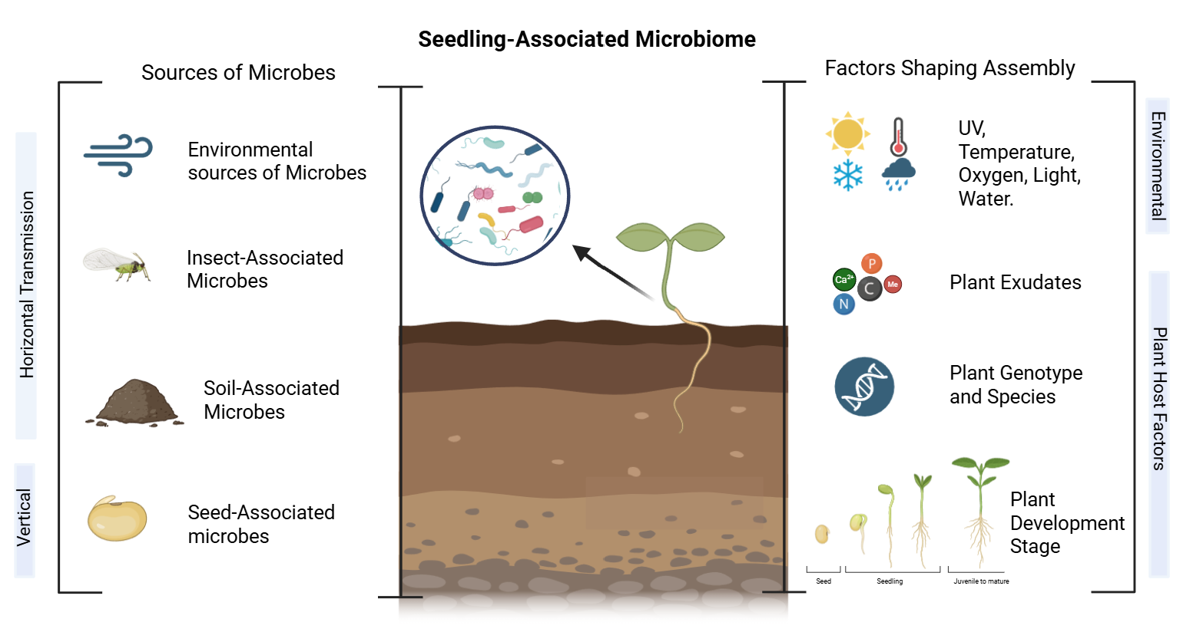
Recent advances in high-throughput DNA sequencing has greatly expanded research capacity and enabled large-scale meta-analyses, as demonstrated by studies characterising seed-associated microbiomes (22,30,42). Applying similar approaches to the seedling stage would allow the identification of key microbial taxa involved in early plant development and could provide insights into the processes shaping community assembly. This could ultimately support the design of targeted microbiome-based strategies to improve crop health in agriculture.
Figure 1 Sources of Microbes and Factors shaping Microbiome Assembly in Seedlings.
The image in the centre shows a seedling the leaves represent the phyllosphere and the roots the rhizosphere. The circle contains a zoomed in view of the microbial community present on seedlings. The left hand side box represents different sources of microorganisms that might get transferred to the plant, either horizontally as with soil microbes, microbes carried on insects, and other environmental sources, or vertically from parent plant into the seed and then to the germinating seedling. The right hand box shows the different factors that can shape plant microbiome assembly, these are the same for mature plants and seedlings. Environmental factors such as ultraviolet light and temperature can alter the microbes that assemble, those able to withstand high UV may reside in the phyllosphere for example. The plant releases Exudates, this can also be linked to host genetics and ‘Microbial Genes’ where the plants genetics control the production of specific metabolites. These metabolites specifically attract or enrich plant beneficial microorganisms. Plant species can thus also have an effect as plant species can be separated by their genetic differences. Plant developmental stage such as seed, seedling or mature plant stages can produce different exudates and attract different microorganisms. The seedling stage is particularly understudied especially across plant species.

Future applications of the seedling microbiome
One emerging strategy to improve plant health is the use of bioinoculants, where a consortia of beneficial microorganisms are applied to seeds or soil (43). This could reduce reliance on agrochemicals, contributing to improved soil quality and human health (10). In addition, advances in microbial and host engineering may enable the development of plants that more effectively recruit and maintain beneficial microbial communities (44). This could support the development of climate-resilient, high-yielding crops and contribute to addressing global food insecurity (10). However their success depends on a deeper understanding of microbiome assembly particularly during the early developmental stages.

Aims of the project
This study aims to characterise the bacterial microbiome of plant seedlings through a meta-analysis of publicly available 16S rRNA gene fragment sequence data from 11 plant species across seven studies, spanning four plant families: Brassicaceae, Fabaceae, Poaceae, and Apiaceae. We seek to assess microbial diversity across the seedling microbiome. Identify the dominant taxonomic groups present, and determine whether a conserved core microbiome exists alongside a variable fraction. The study also aims to evaluate how host plant species influences microbiome composition and diversity, and to identify patterns in community structure across different species. These insights will improve understanding of microbiome assembly during early plant development and support the development of microbiome based strategies to enhance crop productivity and resilience.

Materials & Methods
Studies included in the seedling microbiome dataset
Seedling microbiome data used in this meta analysis comprise a collection of raw sequencing datasets of seedling microbiomes across various plants, obtained by other studies. These studies are gathered from publicly available database repositories such as NCBI, SRA and ENA (45,46). Open access data was used to allow reproducibility and enables a broader assessment of bacterial taxa across different plant species. Eight different studies with raw sequence data of seedling microbiomes were included. The data spanned 16 different plant species from a range of locations, in early plant development (seedlings) across 176 samples.

These studies provide raw sequence data (FastQ files) comprising 16S rRNA amplicon sequencing gene fragments from Illumina sequencing. Metadata contains details on the plant species, developmental stage/conditions, accession number and author (Appendix A). This was used to categorize the plants by species and enable comparisons among them.

Bioinformatic analysis of 16S rRNA gene fragment sequences
The studies were processed bioinformatically by following official tutorials of QIIME2 (47) (Figure 2). Full code used is available in Appendix A. Raw FASTQ files obtained from the studies were downloaded using fastq-dl (v.3.0.1) into a high-performance computing environment (HPC) Iridis 6 provided by the university of Southampton. Sequence read filtering, quality control and adaptor trimming was performed using fastp (v. 1.0.1) to clean the raw FASTQ files (48). Qiime2 (v.2024.10.1) is a bioinformatics platform for microbiome and microbial community analysis and was used to process data and view files (47). MultiQC (v. 1.32) was used to aggregate the quality control data across multiple samples (49). Sequence quality plots were generated to show average sequence quality over each base of all reads and were used to determine trimming and filtering parameters for DADA2 (see Appendix B).

Demultiplexed sequence data were denoised with DADA2 (v.2024.10.0) to generate ASVs (50). Raw paired-end reads were merged, quality filtered and trimmed. Reads with a quality score ≤ 2 were excluded and chimeric sequences were removed as per the default parameters. Quality plots showed a drop in quality at 270bp in forward reads and 240 bp in reverse reads. Based on this, reads were initially truncated to 270 bp (forward) and 240 bp (reverse) In DADA2. After reviewing the results, truncation parameters were adjusted to 250 bp for forward and 250 bp for reverse reads to maximize read retention while maintaining high-quality scores. Taxonomic assignment of each ASV was performed using a naïve Bayes taxonomy classifier implemented in QIIME2, trained on the SILVA 138 database with a 99% similarity cut-off (51).

Unassigned ASVs or ASVs affiliated to mitochondria and chloroplasts were removed using taxonomy-based filtering to avoid host contamination. Eukaryotes or archaea were removed as the 16S rRNA gene primers used are primarily designed for bacterial profiling and may not efficiently capture eukaryotic and archaeal diversity (52).

Data Processing and filtering of seedling microbiome data
The code and files to reproduce the analyses and figures are in Appendix A. Further data processing, management, diversity and community analyses, and visualizations were performed in R (v.4.3.3) (Figure 2). Packages used include microbiome (v.1.22), phyloseq (v.1.44), vegan (v.2.6.10), dplyr (v.1.1.4) and tidyr (v.1.3.1).

Data was converted into a phyloseq object in R. Cyanobacterial reads were detected in the dataset at an extremely low relative abundance (7.0 × 10⁻⁵ % of total reads). This negligible amount was considered unlikely to represent substantial chloroplast contamination and may reflect true low abundance microbial taxa so were retained (53). Library sample size was extremely uneven ranging from 9 to 196965 reads (Appendix C). Samples with sequencing depths exceeding the upper 1.5 × IQR threshold were considered outliers and excluded from downstream analyses, this resulted in 3 samples being removed. Additionally samples with < 1000 reads were excluded from the meta-analysis. This is to reduce bias associated with low library size and insufficient sampling depth that can artificially affect diversity estimates and community composition comparisons. Singletons were retained and taxa with total abundance > 1 were kept. Plant species with sufficient number of samples were retained ( ≥3 samples ) to ensure sufficient replicates for analysis and improve robustness between plant comparisons, five plant species were removed (54).

It should be noted that several samples were lost at these filtering steps due to a high proportion of unassigned reads, low sequencing depth and low sample replication for some plant species. Two datasets were created, the data was transformed in one by relative abundance for use in taxa compositions. The second was a rarefied dataset performed at the lowest read number observed (min = 1033 reads/sample). This rarefaction depth provided a high sequence count per sample while minimizing sample loss to 7.76% of samples. All samples with less than 1033 sequences were removed leaving 107 samples. The rarefied data was used for both alpha and beta analysis due to the large differences in library size to minimize bias associated with unequal sequencing depth (1033–196965 reads per sample; approximately 191-fold difference) (55)
Visualization of Community and taxa-level analysis of the seedling microbiome
Analysis was performed in R using the packages listed previously. All figures were prepared using the ggplot2 (v.3.51) package. Diversity across seedling microbiota in the study was explored using multiple alpha diversity metrics: Observed ASV richness, Shannon diversity and Simpson diversity. These indices assess between them species abundance and distribution within microbial communities (56). Differences in microbial community composition between plant species were assessed using a beta diversity measure. Bray-Curtis dissimilarity was calculated at the genus level and plotted with principle coordinate analysis (PCoA) (57).

Core and flexible microbiota in seedlings were identified across all the plant species and those specific to each plant species were identified. Arbitrary criteria that an ASV should be detected in a minimum of two studies and be present in at least half of the samples (minimum prevalence 50%) was used to define core taxa. Statistical effects of plant species on seedling microbiota diversity and structure were investigated using Kruskall–Wallis nonparametric tests in R due to failing the Shapiro wilks normality test indicating non normal distribution. Post hoc pairwise comparison between all species was performed using Dunns test (5% significance) with p-values adjusted with the Benjamini-Hochberg method to determine which levels of the independent variable differ from each other. For Bray-Curtis dissimilarity, PERMANOVA tested differences among plant species, and PERMDISP tested differences in within-group dispersion (9,999 permutations in R).
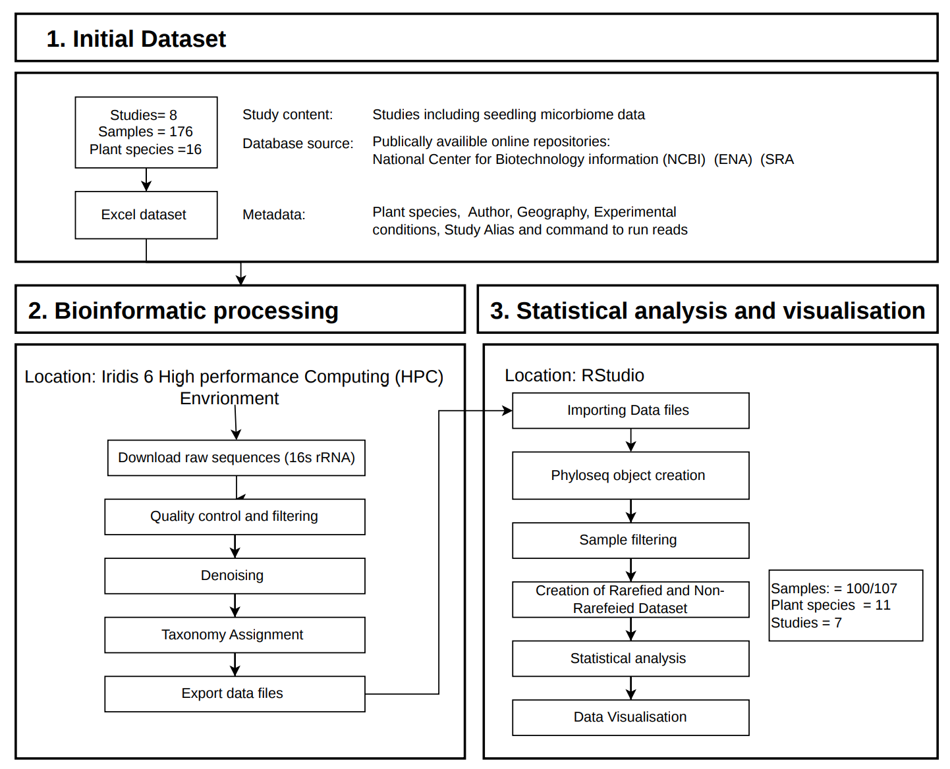
Figure 2 Methods Flow Diagram
Flow diagram showing the steps undertaken in the methods to process the seedling microbiome data. Top Box was the first step showing the initial dataset composition. Box 2 shows the bioinformatic processing steps conducted on the data in iridis6 HPC . Box three shows the statistical analysis and visualization conducted in R studio. The initial study, plant species and sample number is listed in box 1 and the final counts used in the results is listed in box three after processing and filtering of the data.

Results

Seedling dataset after meta analysis
To assess the diversity and composition of the seedling bacterial microbiome, 16S rRNA gene sequencing data from seven publicly available microbiome studies were analysed, covering 11 plant species across 7 geographic locations (Table 1). This provided an overview of the bacterial microbiome of seedlings across different plant species. Detailed information on the studies and references can be found in Appendix A (Table 1). Initially, eight studies were included in the seedling dataset but one study was removed during filtering due to an insufficient number of reads. Of the 16 species present in these studies, four species were removed from downstream analyses due to having fewer than three biological replicates and one was removed due to anomalous microbial profile. The final meta analysis was conducted on 100 samples from 7 studies representing 11 plant species.
Sequence data was processed using QIIME 2 and DADA2, both rarefied and non rarefied datasets were generated. Sequencing depth varied substantially among samples (1033–196965 reads per sample, approximately 191x fold difference) (Appendix D). To account for this variation and ensure comparability across plant species, alpha and beta diversity analyses were conducted using the rarefied dataset, minimising sequencing-depth bias (55).

Additionally, comparison of alpha diversity estimates between rarefied and unrarefied datasets showed broadly similar patterns for Observed ASV richness and Shannon diversity, whereas Simpson diversity estimates were more variable in the unrarefied dataset, particularly among samples with lower sequencing depth (Appendix D)(figure 3). Rarefaction reduced this spread and produced more consistent diversity estimates across samples supporting the choice to used the rarefied dataset for alpha analysis.
The seedling studies included in the meta analysis cover agriculturally important species from four plant families: Brassicaceae (four species), Fabaceae (five species), Apiaceae (one species) and Poaceae (one species). Sample representation across species was highly uneven, species contributed between 3 and 29 samples (Table 1). The dataset was dominated by Triticum aestivum (25% of all samples, n=29), Raphanus sativus (15% of samples), and Phaseolus vulgaris (11.2% of samples). The majority of species were represented by ≤ 6 samples (n =6). Uneven sample sizes and lower read counts should be considered when interpreting the diversity analyses.
Table 1 Plant species and studies included in the meta analysis
Table showing each plant species included in the meta-analysis (n = 11). The number of samples and studies are shown for each plant species including the references for the studies and the location the seedlings are from.
Plant family | Plant species | Number of samples | Number of studies | Geography | References in Metadata
Poaceae | Triticum aestivum | 29 | 1 | Denmark | Nunes et al. 2022
Brassicaceae | Brassica napus | 6 | 2 | France; South Korea | Barret et al. 2015;  Kim et al. 2022
Brassicaceae | Brassica oleracea | 7 | 1 | France; Chile; Japan | Barret et al. 2015
Brassicaceae | Brassica rapa | 4 | 1 | France | Barret et al. 2015
Brassicaceae | Raphanus sativus | 18 | 3 | France; South Korea | Barret et al. 2015;  Chesneau et al. 2022;  Kim et al. 2022
Fabaceae | Glycine Clandestina | 7 | 2 | Australia | Chandel et al. 2022 1;  Chandel et al. 2022 2
Fabaceae | Glycine max | 3 | 1 | Australia | Chandel et al. 2022 1
Fabaceae | Medicago truncatula | 3 | 1 | France | Barret et al. 2015
Fabaceae | Medicago sativa | 6 | 1 | South Korea | Kim et al. 2022
Fabaceae | Phaseolus vulgaris | 12 | 2 | France; Chile | Barret et al. 2015;  Chesneau et al. 2022
Apiaceae | Daucus carota | 5 | 2 | New Zealand; USA; Chile | Barret et al. 2015;  Acuna et al. 2023
Total: 4  Families | 11  Species | 100 Samples | 7  Studies | 7  Locations

Alpha diversity of the seedling microbiome
The alpha diversity patterns of seedling microbiota were explored using Observed ASV, Shannon’s diversity index (reflecting both richness and evenness) and Simpson’s diversity index (1-D) (a measure of dominance and evenness). Beta diversity was measured using Bray-Curtis Dissimilarity to assess community distribution differences between plant species.
A total of 5662 bacterial ASVs corresponding to 31 phyla and 581 genera across 100 seedling microbiome samples were identified. Observed ASV richness varied widely between samples from 4 to 417 ASVs. Mean number of ASVs by plant species ranged from the highest in Triticum aestivum (140 ASVs) to the lowest in Medicago sativa (17 ASVs) (Figure 3).
Across all plant species, the mean ASV richness was 47 ± 34 ASVs (mean ± SD) and the median richness was 32.5 ± 31.7 ASVs. To account for unequal sample sizes among plant species, richness was first calculated within each species and then averaged across species. The relatively large standard deviations associated with both the mean and median values indicate substantial variability in ASV richness among plant species. The higher mean compared with the median suggests a positively skewed distribution likely driven by the exceptionally high richness observed in Triticum aestivum (Figure 3A).
Kruskal–Wallis showed significant differences in richness among plant species (χ² = 62.05, df = 13, p < 0.001). Dunn’s post hoc tests (Benjamini–Hochberg corrected) indicated Triticum aestivum differed significantly from multiple species including Medicago sativa, Phaseolus vulgaris, and Raphanus sativus (p < 0.05).
Shannon diversity also differed significantly among species (χ² = 69.74, df = 13, p < 0.001), with the highest diversity observed in Triticum aestivum (>4.31) and the lowest in Medicago sativa (<1.39) (Figure 3B). Shannon’s diversity index extends from the observed richness measure by incorporating both richness (number of different taxa) and evenness (relative abundance distribution). The large range in Shannon values indicates high variation in seed microbiota composition (Figure 3B). Mean Shannon diversity across plant species was 2.77 ± 0.77. Dunns post hock test also identified significantly higher diversity in Triticum aestivum compared to Medicago sativa, Phaseolus vulgaris, and Raphanus sativus (adjusted p < 0.001). Additionally, significant difference was detected between Medicago truncatula and Glycine clandestina (p = 0.038). The other species pairings were not significant suggesting broadly similar Shannon diversity across most plant species (Figure 3B).
Similarly, Simpson diversity differed significantly among species (χ² = 68.61, df = 13, p < 0.001), confirming variation in both dominance and evenness of bacterial taxa (Figure 3C).Simpsons diversity (1-D)ranges from 0 (low diversity/high dominance) to 1 (high diversity/low dominance). Ranging from highest in Triticum aestivum (0.977 ± 0.015) to lowest Medicago sativa (0.627 ± 0.089) (Figure 3C). Moderately high diversity was observed across Brassica, Glycine, Raphanus, and Phaseolus species, with greater variability within some species (notably Raphanus sativus and Phaseolus vulgaris). Dunn’s tests also confirmed higher Simpson diversity in Triticum aestivum compared to multiple species (p < 0.05), and a significant difference between Medicago truncatula and Glycine clandestina (p = 0.0279).
Across all alpha diversity metrics, Triticum aestivum consistently showed the highest diversity and evenness, whereas Medicago species generally displayed lower diversity and greater dominance (Figure 3: A,B,C). Although Kruskal–Wallis tests indicated significant overall differences among plant species, Dunn’s post hoc tests identified only a limited number of significant pairwise comparisons, mainly involving Triticum aestivum. This suggests that diversity differences were driven primarily by specific species rather than being uniform across all taxa, with most species showing broadly similar diversity values (Figure 3: A,B,C).
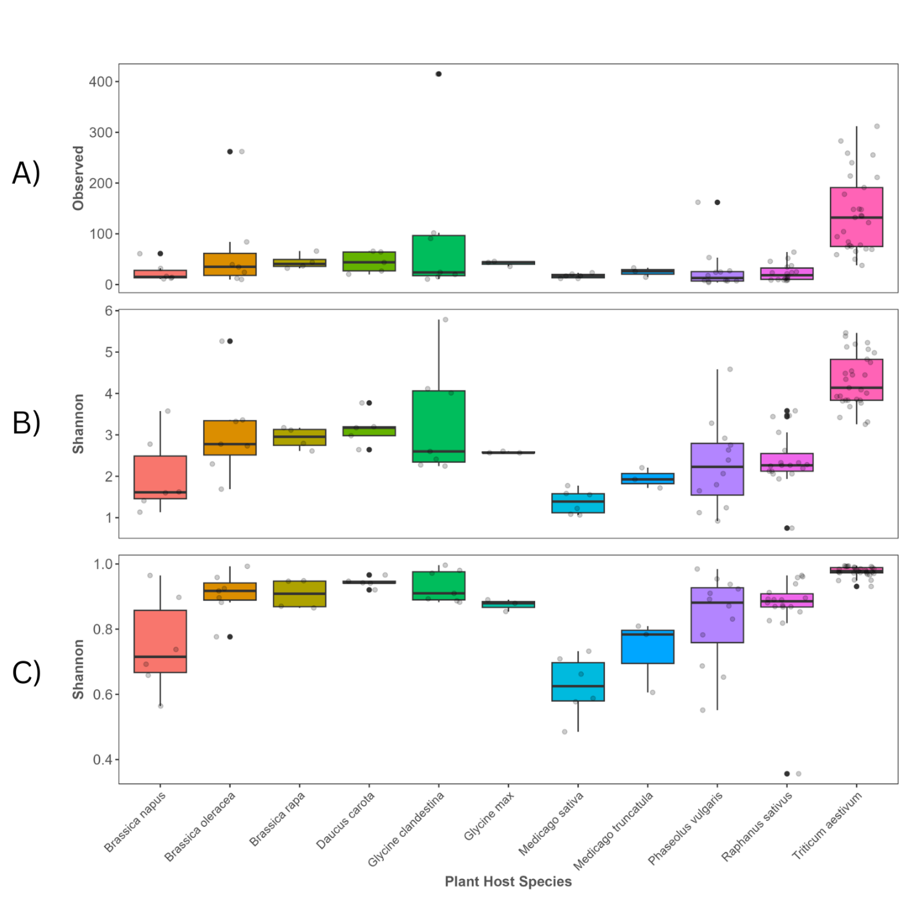
Figure 3 Alpha diversity measurements of seedling associated bacterial communities across plant host species.
Boxplots show alpha diversity of bacterial communities identified on seedlings across plant species. Alpha diversity was assessed using boxplots of (A) observed richness (ASV richness), (B) Shannon diversity, and (C) Simpson’s diversity. Boxes represent the interquartile range (IQR), the centre line indicates the median, and whiskers extend to 1.5 × IQR. Points represent individual samples, with points beyond the whiskers indicating outliers. Simpson’s diversity was calculated as $1-D$, with values ranging from 0 (low diversity/high dominance) to 1 (high diversity/low dominance). Sequence data were filtered to retain bacterial ASVs only and rarefied to 1,033 reads per sample to account for uneven library sizes. Sample sizes differed among host species (Table 1). Differences among host species were tested using a Kruskal–Wallis test followed by Dunn’s multiple comparison test.

Beta diversity of the seedling microbiome
Plant species influence on seedling bacterial compositions was assessed with beta diversity measure, Bray–Curtis dissimilarity with Principal coordinates analysis (PCoA) at the genus level (Figure 4). Axis 1 and Axis 2 explained 17.5% and 16.3% of the variation. PERMANOVA indicated significant differences in community composition among plant species (pseudo-F = 5.18, R² = 0.42, p < 0.001). PERMDISP also detected significant differences in dispersion within species (F = 8.16, p < 0.001). This suggests that the observed differences may be due to both differences between plant species and differences in how variable the samples are within each species.
In the plot, several species formed relatively tight clusters (Medicago truncatula), whereas others showed greater within-species variability (Brassica napus) (Figure 4). Some overlap occurred among species indicating that certain microbial taxa are shared among species, however, distinct grouping patterns were still observed (Triticum aestivum and Medicago sativa) indicating differences in overall community composition (Figure 4). Bray-Curtis plots coloured by geographic location, study and plant family can be seen in Appendix G, they showed loose clustering across components of all factors.

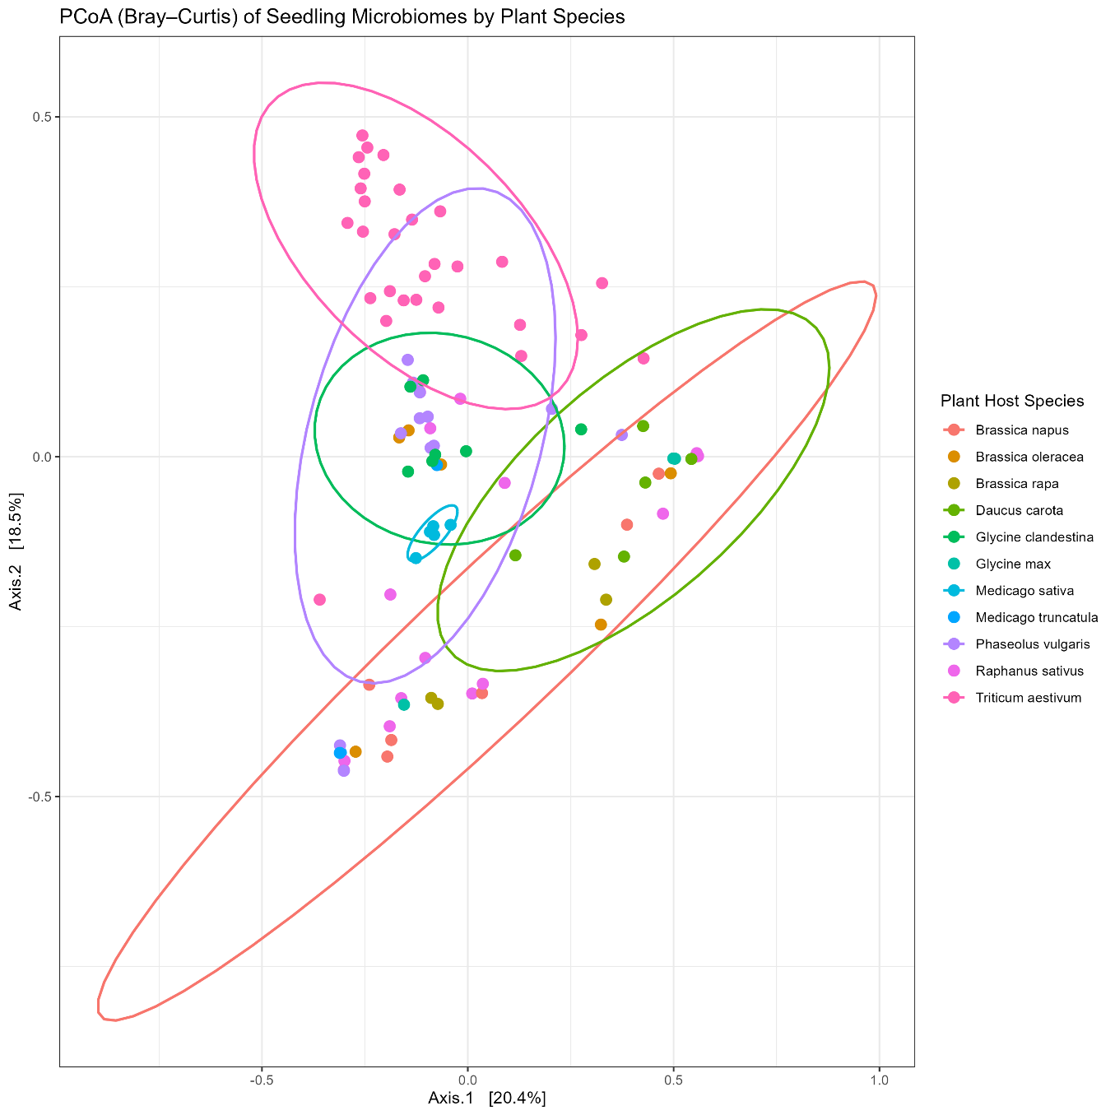
Taxonomic composition of the seedling microbiome
Figure 4 Beta diversity Bray-Curtis dissimilarity plot of bacterial seedling community separated by plant host species.
Principal coordinates analysis (PCoA) of Bray–Curtis dissimilarity at the genus level was performed using bacterial community data rarefied to 1,033 reads per sample. Each point represents an individual seedling sample and is coloured by plant host species. Ellipses represent 95% confidence intervals around group centroids and are shown around selected plant species to aid visualisation of clustering patterns, including the closest grouping (Medicago sativa), the most significantly distinct grouping (Triticum aestivum), and the most dispersed grouping (Brassica napus), with additional ellipses included to highlight overlap among groups. Axis 1 and Axis 2 explained 17.5% and 16.3% of the variation. Differences in community composition among host species were assessed using PERMANOVA, and homogeneity of multivariate dispersion was tested using PERMDISP.
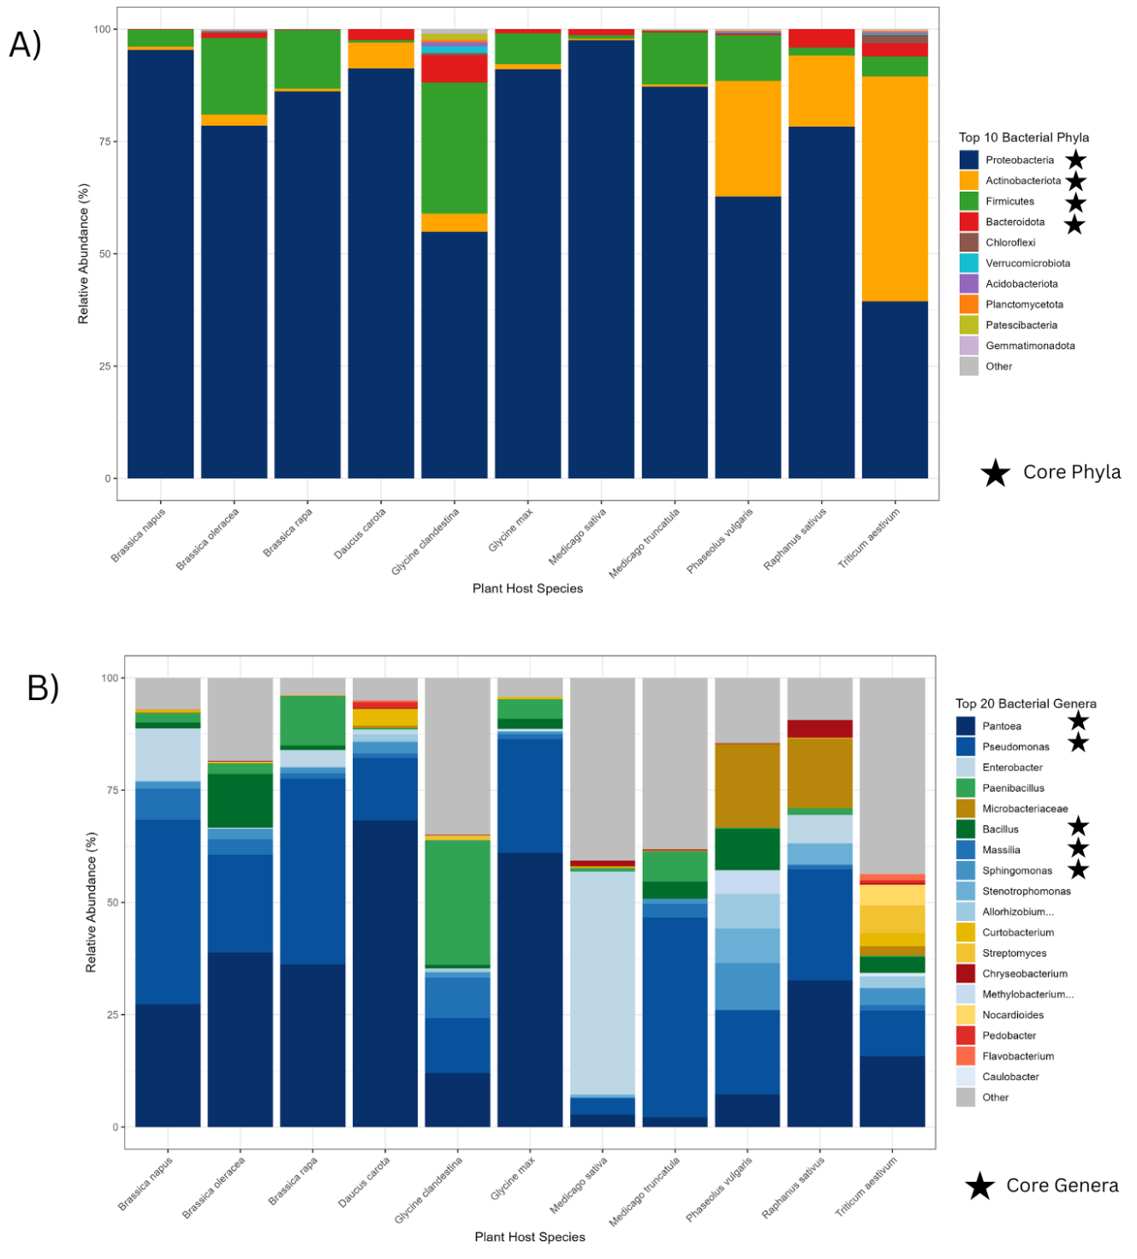
Taxonomic composition in seedlings varies across plant species in both relative abundance and variety of taxa present (Figure 5: A,B). Taxonomic affiliation was conducted at phylum and genus level due to 16S rRNA gene markers lacking resolution for species-level differentiation (Earl et al., 2018) (figure 1: A, B). Top 4 phyla were consistently dominant across plant species accounting for the majority of the abundance while all remaining phyla occurred at low abundance (Figure 5A). Genus level composition was more diverse: the top 20 genera together represented approximately two-thirds of total relative abundance, indicating a more even distribution of taxa at this level (Figure 5B).

Figure 5 Relative abundance of Bacteria in seedlings across plant host species
Stacked bar plots show the relative abundance (%) of (A) the top 10 bacterial Phyla and (B) the top 20 bacterial Genera detected in seedling samples from different plant host species. The top 10/20 taxa are calculated by their relative abundance. Each bar represents a host plant, the coloured segments indicate the proportion of each bacterial genus within the total bacterial community. Genera are colour coded according to the legend and the phylum they belong to e.g. Proteobacteria: shades of blue; Actinobacteria: shades of yellow; Firmicutes: shades of green and Bacteroidota: shades of red. All top 20 bacterial genera fit within these 4 phyla. Taxa not within the top 10/20 highest relative abundance are labelled as ‘other’ and is encapsulated by the grey segment. Phyla and Genera that are considered core (prevalence of ≥50% of samples and detection in more than two studies) have a star next to their name. . The x-axis shows plant host species and the y-axis indicates relative abundance as a percentage of total bacterial reads.
The communities of the seedling microbiome can be structured into a core and a flexible fraction. Four phyla were identified as core taxa across all plants species : Proteobacteria, Actinobacteria, Firmicutes, and Bacteroidetes (Figure 6A). They were present in ≥ 13 plant species and had a prevalence in of ≥50% of samples and detection in more than two studies (Figure 6A). Together, these accounted for 98.0% of all reads in
the dataset (993,976 reads) and 85.2% of total ASV richness (4,964 of 5,824 ASVs) Proteobacteria was by far the dominant phylum, accounting for 78.34% of total reads, with Pantoea representing the single most abundant genus at 24.1%.
At the genus level, six core genera were identified across all plant species. Four belonged to Proteobacteria: Pantoea, Pseudomonas, Massilia, and Sphingomonas. Two belonged to Firmicutes: Paenibacillus and Bacillus (Figure 6A). No genera within Bacteroidetes or Actinobacteria met the prevalence threshold, suggesting that these phyla were mainly represented by more variable, low-abundance ASVs (Figure 6A)
The most prevalent taxa largely coincided with the most abundant. However some taxa showing high relative abundance did not meet the prevalence threshold required for inclusion in the core microbiome. For example, Enterobacter, Microbacteriaceae, and Pseudarthrobacter were relatively highly abundant in certain plant species but had ≤50% prevalence (Figure 5B, Appendix H).
The percentage of taxa that fall into a core or flexible microbiome varies considerably depending on the taxonomic level observed, at the phylum level, 98% consists of core taxa whereas only 53% of genera is defined as core (Figure 6B). Additionally, across plant species the core phyla remained consistently high whereas the core genera varied greatly depending on the plant species, comprising 94% of Glycine max but only 12 % of Medicago sativa (Appendix E).
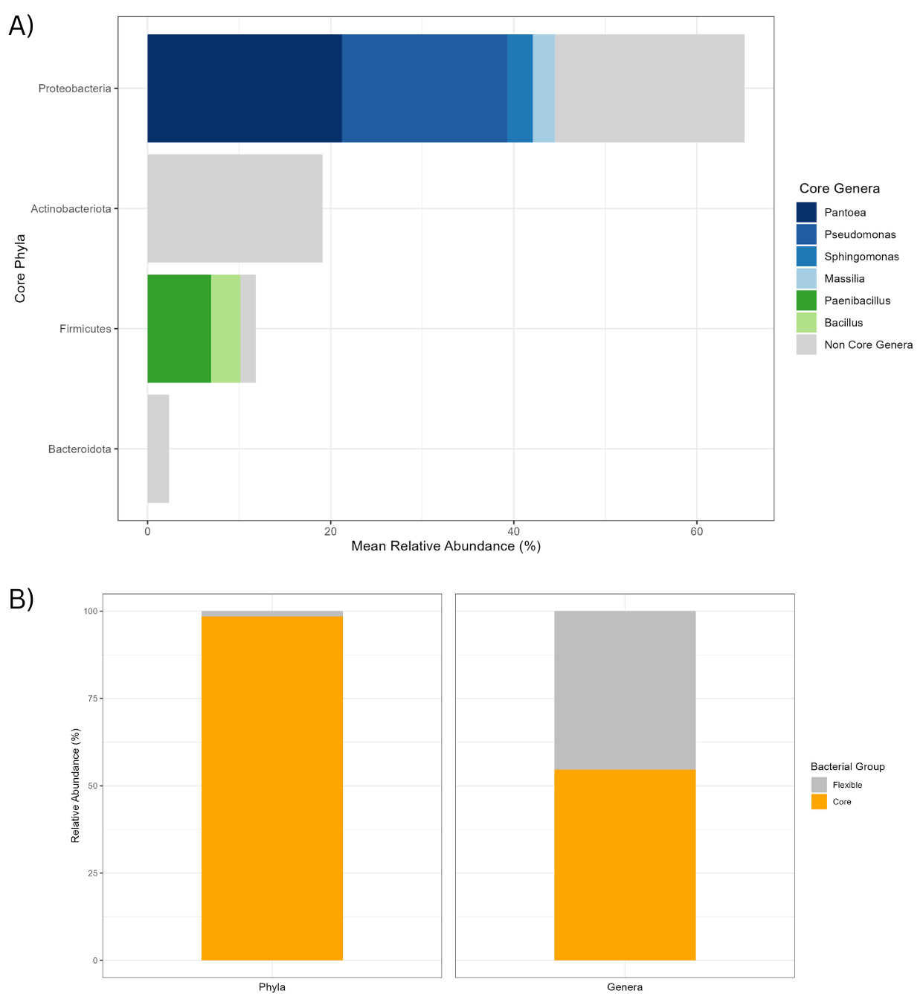

Discussion
Figure 6 : Core and flexible bacterial fractions across plant seedlings.
Relative abundances of bacterial taxa were combined across all seedling samples and visualized to distinguish core and flexible community members. Core taxa were defined as those present in ≥50% of samples and detected in more than two independent studies.
(A) Mean relative abundance (%) of core bacterial phyla and their associated core genera. Bars are separated to show contributions from individual core genera, with remaining fractions representing non-core genera within each phylum.
(B) Proportionate representation of core versus flexible bacterial fractions at the phylum and genus levels. Core taxa (orange) and flexible taxa (grey) are shown as relative percentages of the total community composition
This study aimed to characterize the bacterial seedling microbiome using a meta-analysis approach across 11 agriculturally important plant species from 4 different families (Brassicaceae, Fabaceae, Apiaceae, Poaceae). To our knowledge, this is the first large-scale synthesis of seedling datasets revealing insights into seedling microbiome composition. Seedling microbiomes were found to be diverse and varied in abundance and richness across plant species. Seedling taxa are dominated by four core phyla (Proteobacteria, Actinobacteria, Firmicutes, and Bacteroidetes) and a small number of prevalent core genera along with a flexible component.
Alpha and beta diversity analyses showed some species-associated differences in composition and diversity, however most species exhibited broadly comparable diversity and substantial overlap in composition, suggesting similar microbial communities between plant species. Interpretation of drivers for plant microbiome differences is limited by confounding factors such as, environmental variation and uneven sampling effort. We were unable to detect clear host-specific effects in microbial community assembly across species.
Diversity and Composition of Bacterial Seedling Microbiomes Across Plant Species
Bacterial diversity varied widely across plant species (17–140 ASVs). Similar variability in plant microbiota richness has been reported in previous studies, and values observed in individual samples are also consistent with past findings (22,37). For example, a seed study reported 23 ASVs in both radish and bean seeds, we observed 23 ASVs in radish and a slightly higher richness in bean seedlings (29 ASVs). This pattern is consistent with evidence that seedlings tend to harbour greater microbial diversity than seeds (37).
Plants with greater microbial diversity and evenness, such as Triticum aestivum (wheat), which showed the highest alpha diversity, may benefit from a broader range of microbial functions that support plant fitness (18)(18,31). Lower diversity observed in Medicago sativa (lucerne) was accompanied by the dominance of Enterobacter which may reduce community resilience and limit the plants capacity to respond to environmental stress (18) (Figure 5). Most other plant species were dominated by Pantoea, a genus widely associated with plants and linked to plant growth promotion(58). Plant species with higher sampling (>15) showed more even compositions of bacteria. However, Poaceae was seen to have more Actinobacteria than other plant families, as seen before in seeds (22),
Distinct clustering of Triticum aestivum in the beta diversity analysis, including its more even taxonomic distribution compared with other species may reflect host-specific influences on microbiome assembly. Triticum aestivum was the most phylogenetically distinct species in this study, host genetic differences may have contributed to its distinct microbial community composition (Appendix F). This aligns with previous studies showing that plant species can significantly influence microbiome diversity and structure (22).
However, sampling depth is this study was highly uneven, Tritium aestivum had the highest (n=29) and Medicago sativa one of the lowest (n= 6 ). Richness estimates are sensitive to sampling efforts as larger samples often detect a more comprehensive range of taxa while smaller samples may miss underlying ecological patterns (59). Observed patterns may therefore reflect sampling disparity rather than plant-specific differences in microbial communities (60). In addition, samples were unevenly collected across seven geographic locations, often with only one study representing each plant species. Bray–Curtis plots also suggested loose clustering by location and study (Appendix G). Differences in soil microbiomes, climate, sampling effort, and study-specific batch effects may therefore have influenced microbiome assembly, making it difficult to distinguish host-specific effects from environmental influences (14).
The maximum ASV richness observed in this study was relatively low (400 ASVs per sample) compared to a seed microbiome meta-analysis reporting up to 2000 ASVs per sample (22). This is notable as microbial diversity is generally expected to increase from seeds to seedlings (37). Several factors may explain this apparent underestimate. Rarefaction was used to control for uneven sequencing depth, which can reduce the detection of low-abundance taxa and underestimate true diversity (61). Additionally, the relatively small number of plant species sampled in this study (n = 14) compared to the seed study (n =50) may have limited the diversity captured (22). However, differences may be less pronounced than they appear, as the higher richness estimates come from pooled seed samples across multiple individuals, which can inflate diversity compared to the individual seedling samples analysed here. Future studies should aim to use larger more even sample sizes to increase reliability of results.
Core and Variable Components of Bacterial Seedling Microbiomes
Bacterial taxa across seedlings are found to predominantly belong to four phyla (Proteobacteria, Actinobacteria, Firmicutes, and Bacteroidetes), they accounted for 98% of all samples. Proteobacteria was the most dominant phyla representing 65% of all samples. These findings are consistent with patterns reported in previous plant microbiome studies, particularly in above-ground plant compartments such as the phyllosphere, where proteobacteria often is in high abundance (22,37,38). Plant compartments were not distinguished in this study, so the results likely reflect a composite signal across tissues. While differences in microbial communities among plant regions are well documented, especially within individual plants, comparative data across multiple species at the seedling stage remain limited (14,31). Future work should aim to resolve compartment-specific patterns across species.
The subset of phyla noted above and genera (Pseudomonas, Bacillus, Paenibacillus, Pantoea, and Sphingomonas) were found to be extremely abundant and prevalent in seedlings and are consistently detected across plant species. These taxa form a “core microbiome”, the presence of core taxa have been widely seen in plants (9,22,28). Core taxa identified here overlap closely with those reported previously, particularly at the seed level, supporting the idea that seeds act as a primary inoculum for seedlings by transmitting key microbial taxa during early plant development (37). These species likely form a stable community across diverse plant species and are suggested to be well adapted to plant-associated environments, potentially carrying functional traits that are essential for host fitness (14,62). The number of core genera identified in this study (n = 6) is relatively small compared to other studies reporting 13 and 18 taxa, respectively (22,37). This discrepancy may reflect sampling limitations that could have underestimated core diversity (60).
Conserved genera identified in this study have already been shown to have roles in promoting plant fitness (10,22,30,63). Pantoea agglomerans can act as a biocontrol agent by producing antifungal compounds, suppressing plant pathogens (25,64). Species of Sphingomonas have been associated with enhanced plant stress resilience and the production of beneficial phytohormones (65).
A proportion of taxa were found to be low in abundance and highly variable across samples, they were considered “flexible”. This component should not be ignored as studies have shown them to be an important reservoir of microbial diversity that may facilitate plant adaptation to differing environmental conditions (66).
The proportions of core and flexible taxa at the genus level varied across plant species ( appendix E). This could reflect environmental pressures selecting for a more variable microbial community or host-specific effects selecting for more unique bacteria. However, plant species with greater sampling effort showed a lower proportion of core taxa, suggesting that patterns observed are due to sampling depth, as more sampling can capture a wider range of taxa (60) .
Methodological Limitations and Considerations
Beyond the previously mentioned differences in sampling effort and environmental conditions, several additional factors could affect microbial community differences seen across plants. There was variation in seed preparation before germination (e.g. sterilisation or washing) which can alter the initial microbiome and affect community assembly (22). Seedling traits such as size and the duration of the seedling stage vary among plant species and may influence differences in microbial diversity (34). For example, increasing plant age has been shown to increase microbial diversity in Arabidopsis (67). Inconsistent reporting of these factors makes it unclear whether they influenced the results. Future studies should record seedling size (e.g. mass or height) and sampling time to allow proper comparison and analysis.
Future Directions in Seedling Microbiome Research
This study compared seedling microbiomes across only 11 plant species, this represents a fraction of plant species commonly grown in agriculture, the majority of plant species still remain uncharacterised at the seedling microbiome stage (69). This study included agriculturally important crops, such as wheat (tritium aestivum) and bean (Phaseolus vulgaris), however major global staples such as rice and maize were absent (70). Plant species included were often represented by only one study with limited sample sizes. Future work should expand coverage to include both additional crop species and non-agricultural plants, enabling comparisons between domesticated and wild microbiomes, wild species may demonstrate beneficial microbe associations hat have been lost. Incorporating multiple studies per species and achieving more balanced sample sizes (≥5 samples per species) would help reduce bias, account for geographic and batch effects, and improve confidence in detecting plant-specific microbiome patterns (22,60). Greater understanding and consideration of soil type, plant genotype, and geographic variation is also needed to better explain drivers of plant specific microbiome composition (22).
This study is only able to characterise bacterial communities due to the use of 16S rRNA primers (52). Whilst bacterial taxa are often the most dominant other microorganisms can also play critical roles in plant heath and their presence is worth capturing (14). Fungi are thought to be more sensitive to climate change, and characterising fungal communities in seedlings could help predict how climate change may influence microbial communities (71). Additionally, archaea have also been found to be consistently associated with plants and can exhibit substantial diversity, however they are often not well identified in plant microbiome studies and their functional contributions are poorly understood (14). Future studies should aim to expand microorganisms identified by using appropriate markers (e.g. ITS for fungi, 18S rRNA for eukaryotes, and archaeal-specific primers) (22).
Core seedling taxa are promising targets for future functional analysis (14,22). Improved understanding of the beneficial roles of microorganisms on plants, along with knowledge of their composition and assembly, can inform microbiome based strategies aimed at enhancing plant health and resilience (22). This is increasingly important with climate change threatening global food production (2). Outcomes can inform microbiome engineering strategies such as bioinoculants, crop breeding and plant genetic selection (10,25). These are aimed at improving plant and soil health and resilience while reducing dependence on pesticides (10). Real-world applications require more detailed knowledge of functional roles and interactions of core microbiome members across agriculturally important crops (10,72).
Conclusion
This meta-analysis provides new insights that help address a critical gap in our understanding of microbiome composition during the seedling stage. The identification of conserved core taxa across plant species highlights key targets for functional analysis to improve understanding of their roles in plant health at this early stage (14). However plant species-specific differences remain unresolved, likely influenced by multiple factors such as host genotype and environmental variation (14). A deeper understanding of the seedling microbiomes across plant species will require broader plant species coverage and more balanced sampling across diverse environments. These findings support progress toward targeted plant-microbiome strategies to improve growth of agricultural crops which may increase global food security (2,10).
Acknowledgements
The author acknowledges the use of the IRIDIS 6 High Performance Computing Facility, and associated support services at the University of Southampton, in the completion of this work.
Tomislav Cernava for supervising this project and the work of Olimi Epedito in collecting the data on the seedling microbiome and aiding in the bioinformatic workflow.

References
1. ELD initiative. Report for Policy and Decision Makers: Reaping Economic and Environmental Benefits From Sustainable Land Management. Bonn, Germany: Initiative and Deutsche Gesellschaft für Internationale Zusammenarbeit (GIZ) GmbH ); 2015.
2. Singh BK, Trivedi P, Egidi E, Macdonald CA, Delgado-Baquerizo M. Crop microbiome and sustainable agriculture. Nat Rev Microbiol. 2020 Nov;18(11):601–2. doi:10.1038/s41579-020-00446-y
3. Janni M, Maestri E, Gullì M, Marmiroli M, Marmiroli N. Plant responses to climate change, how global warming may impact on food security: a critical review. Front Plant Sci. 2024 Jan 5;14:1297569. doi:10.3389/fpls.2023.1297569 PubMed PMID: 38250438; PubMed Central PMCID: PMC10796516.
4. Cuadros-Casanova I, Cristiano A, Biancolini D, Cimatti M, Sessa AA, Mendez Angarita VY, et al. Opportunities and challenges for Common Agricultural Policy reform to support the European Green Deal. Conserv Biol. 2023;37(3):e14052. doi:10.1111/cobi.14052
5. Adisasmito WB, Almuhairi S, Behravesh CB, Bilivogui P, Bukachi SA, Casas N, et al. One Health: A new definition for a sustainable and healthy future. PLoS Pathog. 2022 Jun 23;18(6):e1010537. doi:10.1371/journal.ppat.1010537 PubMed PMID: 35737670; PubMed Central PMCID: PMC9223325.
6. Shekhar C, Khosya R, Thakur K, Mahajan D, Kumar R, Kumar S, et al. A systematic review of pesticide exposure, associated risks, and long-term human health impacts. Toxicol Rep. 2024 Nov 30;13:101840. doi:10.1016/j.toxrep.2024.101840 PubMed PMID: 39717852; PubMed Central PMCID: PMC11664077.
7. Turner TR, James EK, Poole PS. The plant microbiome. Genome Biol. 2013;14(6):209. doi:10.1186/gb-2013-14-6-209 PubMed PMID: 23805896; PubMed Central PMCID: PMC3706808.
8. Trivedi P, Leach JE, Tringe SG, Sa T, Singh BK. Plant–microbiome interactions: from community assembly to plant health. Nat Rev Microbiol. 2020 Nov;18(11):607–21. doi:10.1038/s41579-020-0412-1
9. Vandenkoornhuyse P, Quaiser A, Duhamel M, Le Van A, Dufresne A. The importance of the microbiome of the plant holobiont. New Phytol. 2015;206(4):1196–206. doi:10.1111/nph.13312
10. Tiwari A, Sharma AK, Pinnaka AK, Datta S. The plant microbiome: A key driver of plant health and productivity. Physiol Mol Plant Pathol. 2025 Sep 1;139:102818. doi:10.1016/j.pmpp.2025.102818
11. Koza NA, Adedayo AA, Babalola OO, Kappo AP. Microorganisms in Plant Growth and Development: Roles in Abiotic Stress Tolerance and Secondary Metabolites Secretion. Microorganisms. 2022 Jul 28;10(8):1528. doi:10.3390/microorganisms10081528 PubMed PMID: 36013946; PubMed Central PMCID: PMC9415082.
12. Etesami H, Glick BR. Bacterial indole-3-acetic acid: A key regulator for plant growth, plant-microbe interactions, and agricultural adaptive resilience. Microbiol Res. 2024 Apr;281:127602. doi:10.1016/j.micres.2024.127602 PubMed PMID: 38228017.
13. Tang X, Zhang Y, Meng P, Yuan Y, Li C, Zhi X, et al. The Impact of Nitrogen and Phosphorus Interaction on Growth, Nutrient Absorption, and Signal Regulation in Woody Plants. Biology. 2025 Apr 30;14(5):490. doi:10.3390/biology14050490 PubMed PMID: 40427679; PubMed Central PMCID: PMC12108901.
14. Trivedi P, Leach JE, Tringe SG, Sa T, Singh BK. Plant–microbiome interactions: from community assembly to plant health. Nat Rev Microbiol. 2020 Nov;18(11):607–21. doi:10.1038/s41579-020-0412-1
15. Dong CJ, Wang LL, Li Q, Shang QM. Bacterial communities in the rhizosphere, phyllosphere and endosphere of tomato plants. PLoS ONE. 2019 Nov 8;14(11):e0223847. doi:10.1371/journal.pone.0223847 PubMed PMID: 31703074; PubMed Central PMCID: PMC6839845.
16. Nadarajah K, Abdul Rahman NSN. Plant–Microbe Interaction: Aboveground to Belowground, from the Good to the Bad. Int J Mol Sci. 2021 Sep 27;22(19):10388. doi:10.3390/ijms221910388 PubMed PMID: 34638728; PubMed Central PMCID: PMC8508622.
17. Babalola OO, Fadiji AE, Enagbonma BJ, Alori ET, Ayilara MS, Ayangbenro AS. The Nexus Between Plant and Plant Microbiome: Revelation of the Networking Strategies. Front Microbiol. 2020 Sep 4;11:548037. doi:10.3389/fmicb.2020.548037 PubMed PMID: 33013781; PubMed Central PMCID: PMC7499240.
18. Rodríguez CE, Antonielli L, Mitter B, Trognitz F, Sessitsch A. Heritability and Functional Importance of the Setaria viridis Bacterial Seed Microbiome. Phytobiomes J. 2020 Jan;4(1):40–52. doi:10.1094/PBIOMES-04-19-0023-R
19. Zagal D, Graham JG, Bisson J, Green SJ, Pauli GF. Medicinal Plant Microbiomes: Factors Affecting Bacterial and Fungal Community Composition. Planta Med. 2024 Dec;90(15):1130–42. doi:10.1055/a-2420-0270 PubMed PMID: 39447601; PubMed Central PMCID: PMC11816503.
20. Malacrinò A, Abdelfattah A, Belgacem I, Schena L. Plant genotype influence the structure of cereal seed fungal microbiome. Front Microbiol. 2023 Jan 4;13. doi:10.3389/fmicb.2022.1075399
21. Matthews A, Pierce S, Hipperson H, Raymond B. Rhizobacterial Community Assembly Patterns Vary Between Crop Species. Front Microbiol. 2019 Apr 4;10. doi:10.3389/fmicb.2019.00581
22. Simonin M, Briand M, Chesneau G, Rochefort A, Marais C, Sarniguet A, et al. Seed microbiota revealed by a large-scale meta-analysis including 50 plant species. New Phytol. 2022;234(4):1448–63. doi:10.1111/nph.18037
23. Dastogeer KMG, Tumpa FH, Sultana A, Akter MA, Chakraborty A. Plant microbiome–an account of the factors that shape community composition and diversity. Curr Plant Biol. 2020 Sep 1;Plant Interactions with Microbes and Environment23:100161. doi:10.1016/j.cpb.2020.100161
24. Negre Rodríguez M, Pioppi A, Kovács ÁT. The role of plant host genetics in shaping the composition and functionality of rhizosphere microbiomes. mSystems. 10(8):e00041-24. doi:10.1128/msystems.00041-24 PubMed PMID: 40643236; PubMed Central PMCID: PMC12363198.
25. Cernava T. Coming of age for Microbiome gene breeding in plants. Nat Commun. 2024 Aug 5;15(1):6623. doi:10.1038/s41467-024-50700-7
26. Su pin, Kang, H., Peng, Q. Microbiome homeostasis on rice leaves is regulated by a precursor molecule of lignin biosynthesis | Nature Communications. Nat Commun [Internet]. 2024 [cited 2026 May 6];15(23). Available from: https://www.nature.com/articles/s41467-023-44335-3
27. Michl K, David C, Dumont B, Mårtensson LMD, Rasche F, Berg G, et al. Determining the footprint of breeding in the seed microbiome of a perennial cereal. Environ Microbiome. 2024 Jun 17;19(1):40. doi:10.1186/s40793-024-00584-3
28. Wang X, Li Y, Rensing C, Zhang X. Early inoculation and bacterial community assembly in plants: A review. Microbiol Res. 2025 Jul 1;296:128141. doi:10.1016/j.micres.2025.128141
29. Chandel A, Mann R, Kaur J, Norton S, Auer D, Edwards J, et al. The Role of Soil Microbial Diversity in the Conservation of Native Seed Bacterial Microbiomes. Microorganisms. 2022 Mar 30;10(4):750. doi:10.3390/microorganisms10040750 PubMed PMID: 35456799; PubMed Central PMCID: PMC9028870.
30. Yao Y, Zhao L, Zhang Y, Duan A, Yang Y, Wang A, et al. Comparative analysis of the seed microbiome in four major oilseed crops (rapeseed, sunflower, soybean, sesame) reveals host-specific assembly and potential application of seed core microbes. Front Plant Sci. 2026 Jan 26;17. doi:10.3389/fpls.2026.1721916
31. Berg G, Grube M, Schloter M, Smalla K. Unraveling the plant microbiome: looking back and future perspectives. Front Microbiol. 2014 Jun 4;5:148. doi:10.3389/fmicb.2014.00148 PubMed PMID: 24926286; PubMed Central PMCID: PMC4045152.
32. Peng Q, Sun S, Ma J, Chen S, Gao L, Du X, et al. The effect of developmental stages on microbiome assembly in the phyllosphere and rhizosphere of rice grown in urban area soil. Environ Microbiome. 2025 Jul 11;20(1):86. doi:10.1186/s40793-025-00748-9
33. Eriksson O, Ehrlén J. Seedling recruitment and population ecology. In: Leck MA, Simpson RL, Parker VT, editors. Seedling Ecology and Evolution [Internet]. Cambridge: Cambridge University Press; 2008 [cited 2026 Apr 17]. p. 239–54. Available from: https://www.cambridge.org/core/books/seedling-ecology-and-evolution/seedling-recruitment-and-population-ecology/BDFFF2F1C5A90AE9288D4DD313D42960 doi:10.1017/CBO9780511815133.013
34. Winkler DE, Garbowski M, Kožić K, Ladouceur E, Larson J, Martin S, et al. Facilitating comparable research in seedling functional ecology. Methods Ecol Evol. 2024;15(3):464–76. doi:10.1111/2041-210X.14288
35. Wei X, Zhao Y, Lu X, Zhang M, Du J, Guo X, et al. A high-throughput method for monitoring growth of lettuce seedlings in greenhouses based on enhanced Mask2Former. Comput Electron Agric. 2024 Dec 1;227:109681. doi:10.1016/j.compag.2024.109681
36. Liu Q, Zhou X, Li J, Xin C. Effects of seedling age and cultivation density on agronomic characteristics and grain yield of mechanically transplanted rice. Sci Rep. 2017 Oct 26;7(1):14072. doi:10.1038/s41598-017-14672-7
37. Wang M, Eyre AW, Thon MR, Oh Y, Dean RA. Dynamic Changes in the Microbiome of Rice During Shoot and Root Growth Derived From Seeds. Front Microbiol. 2020 Sep 8;11. doi:10.3389/fmicb.2020.559728
38. Carlström CI, Field CM, Bortfeld-Miller M, Müller B, Sunagawa S, Vorholt JA. Synthetic microbiota reveal priority effects and keystone strains in the Arabidopsis phyllosphere. Nat Ecol Evol. 2019 Oct;3(10):1445–54. doi:10.1038/s41559-019-0994-z PubMed PMID: 31558832; PubMed Central PMCID: PMC6774761.
39. Wu S, Lu D, Kabbage M, Wei HL, Swingle B, Records AR, et al. Bacterial effector HopF2 suppresses Arabidopsis innate immunity at the plasma membrane. Mol Plant-Microbe Interact MPMI. 2011 May;24(5):585–93. doi:10.1094/MPMI-07-10-0150 PubMed PMID: 21198360; PubMed Central PMCID: PMC3071429.
40. Debray R, Herbert RA, Jaffe AL, Crits-Christoph A, Power ME, Koskella B. Priority effects in microbiome assembly. Nat Rev Microbiol. 2022 Feb;20(2):109–21. doi:10.1038/s41579-021-00604-w
41. Aleklett K, Rosa D, Pickles BJ, Hart MM. Community Assembly and Stability in the Root Microbiota During Early Plant Development. Front Microbiol. 2022 Apr 21;13:826521. doi:10.3389/fmicb.2022.826521
42. Toju H, Kurokawa H, Kenta T. Factors Influencing Leaf- and Root-Associated Communities of Bacteria and Fungi Across 33 Plant Orders in a Grassland. Front Microbiol. 2019 Feb 19;10:241. doi:10.3389/fmicb.2019.00241 PubMed PMID: 30837969; PubMed Central PMCID: PMC6390183.
43. kundu M. Bioinoculants: a sustainable tool for enhancement of productivity and nutritional quality in horticultural crops. In: Bio-Inoculants in Horticultural Crops [Internet]. Woodhead Publishing; 2024 [cited 2026 Apr 21]. p. 373–408. Available from: https://www.sciencedirect.com/science/chapter/edited-volume/pii/B9780323960052000234 doi:10.1016/B978-0-323-96005-2.00023-4
44. Afridi MS, Ali S, Salam A, Terra WC, Hafeez A, Sumaira, et al. Plant Microbiome Engineering: Hopes or Hypes. Biology. 2022 Dec 7;11(12):1782. doi:10.3390/biology11121782 PubMed PMID: 36552290.
45. Leinonen R, Sugawara H, Shumway M. The Sequence Read Archive. Nucleic Acids Res. 2011 Jan;39(Database issue):D19–21. doi:10.1093/nar/gkq1019 PubMed PMID: 21062823; PubMed Central PMCID: PMC3013647.
46. O’Cathail C, Ahamed A, Burgin J, Cummins C, Devaraj R, Gueye K, et al. The European Nucleotide Archive in 2024. Nucleic Acids Res. 2025 Jan 6;53(D1):D49–55. doi:10.1093/nar/gkae975
47. Bolyen E, Rideout JR, Dillon MR, Bokulich NA, Abnet CC, Al-Ghalith GA, et al. Reproducible, interactive, scalable and extensible microbiome data science using QIIME 2. Nat Biotechnol. 2019;37(8):852–7. doi:10.1038/s41587-019-0209-9
48. Chen S, Zhou Y, Chen Y, Gu J. fastp: an ultra-fast all-in-one FASTQ preprocessor. Bioinformatics. 2018 Sep 1;34(17):i884–90. doi:10.1093/bioinformatics/bty560 PubMed PMID: 30423086; PubMed Central PMCID: PMC6129281.
49. Ewels P, Magnusson M, Lundin S, Käller M. MultiQC: summarize analysis results for multiple tools and samples in a single report [JavaScript]. Bioinformatics [Internet]. 2016 [cited 2026 Apr 7]. p. 3047. Available from: http://dx.doi.org/10.1093/bioinformatics/btw354 doi:10.1093/bioinformatics/btw354
50. Callahan BJ, McMurdie PJ, Rosen MJ, Han AW, Johnson AJA, Holmes SP. DADA2: high-resolution sample inference from Illumina amplicon data. Nat Methods. 2016;13(7):581. doi:10.1038/nmeth.3869
51. Quast C, Pruesse E, Yilmaz P, Gerken J, Schweer T, Yarza P, et al. The SILVA ribosomal RNA gene database project: improved data processing and web-based tools. Nucleic Acids Res. 2013 Jan 1;41(D1):D590–6. doi:10.1093/nar/gks1219
52. Hathaway JJM, Moser DP, Blank JG, Northup DE. A Comparison of Primers in 16S rRNA Gene Surveys of Bacteria and Archaea from Volcanic Caves. Geomicrobiol J. 2021 Sep 1;38(9):741–54. doi:10.1080/01490451.2021.1943727
53. Hanshew AS, Mason CJ, Raffa KF, Currie CR. Minimization of chloroplast contamination in 16S rRNA gene pyrosequencing of insect herbivore bacterial communities. J Microbiol Methods. 2013 Nov;95(2):149–55. doi:10.1016/j.mimet.2013.08.007 PubMed PMID: 23968645; PubMed Central PMCID: PMC4133986.
54. Maki KA, Diallo AF, Lockwood MB, Franks AT, Green SJ, Joseph PV. Considerations When Designing a Microbiome Study: Implications for Nursing Science. Biol Res Nurs. 2019 Mar;21(2):125–41. doi:10.1177/1099800418811639 PubMed PMID: 30409024; PubMed Central PMCID: PMC6700895.
55. Weiss S, Xu ZZ, Peddada S, Amir A, Bittinger K, Gonzalez A, et al. Normalization and microbial differential abundance strategies depend upon data characteristics. Microbiome. 2017 Mar 3;5(1):27. doi:10.1186/s40168-017-0237-y
56. Cassol I, Ibañez M, Bustamante JP. Key features and guidelines for the application of microbial alpha diversity metrics. Sci Rep. 2025 Jan 3;15(1):622. doi:10.1038/s41598-024-77864-y
57. Clarke KR, Somerfield PJ, Chapman MG. On resemblance measures for ecological studies, including taxonomic dissimilarities and a zero-adjusted Bray–Curtis coefficient for denuded assemblages. J Exp Mar Biol Ecol. 2006 Mar 7;A Tribute to Richard M. Warwick330(1):55–80. doi:10.1016/j.jembe.2005.12.017
58. Petrović M, Janakiev T, Grbić ML, Unković N, Stević T, Vukićević S, et al. Insights into Endophytic and Rhizospheric Bacteria of Five Sugar Beet Hybrids in Terms of Their Diversity, Plant-Growth Promoting, and Biocontrol Properties. Microb Ecol. 2024;87(1):19. doi:10.1007/s00248-023-02329-0 PubMed PMID: 38148389; PubMed Central PMCID: PMC10751262.
59. Grey EK, Bernatchez L, Cassey P, Deiner K, Deveney M, Howland KL, et al. Effects of sampling effort on biodiversity patterns estimated from environmental DNA metabarcoding surveys. Sci Rep. 2018 Jun 11;8(1):8843. doi:10.1038/s41598-018-27048-2
60. Bullington LS, Lekberg Y, Larkin BG. Insufficient sampling constrains our characterization of plant microbiomes. Sci Rep. 2021 Feb 11;11:3645. doi:10.1038/s41598-021-83153-9 PubMed PMID: 33574436; PubMed Central PMCID: PMC7878899.
61. Schloss PD. Rarefaction is currently the best approach to control for uneven sequencing effort in amplicon sequence analyses. mSphere. 9(2):e00354-23. doi:10.1128/msphere.00354-23 PubMed PMID: 38251877; PubMed Central PMCID: PMC10900887.
62. Lemanceau P, Blouin M, Muller D, Moënne-Loccoz Y. Let the Core Microbiota Be Functional. Trends Plant Sci. 2017 Jul;22(7):583–95. doi:10.1016/j.tplants.2017.04.008 PubMed PMID: 28549621.
63. Velloso C, Ribeiro V, Carvalho C, Oliveira C, Lana U, Marriel I, et al. Tropical Endophytic Bacillus Species Enhance Plant Growth and Nutrient Uptake in Cereals. In. 2021. p. 157–80. doi:10.1007/978-3-030-65447-4_7
64. Dutkiewicz J, Mackiewicz B, Lemieszek MK, Golec M, Milanowski J. Pantoea agglomerans : a mysterious bacterium of evil and good. Part IV. Beneficial effects. Ann Agric Environ Med. 2016 Jun 2;23(2):206–22. doi:10.5604/12321966.1203879
65. Asaf S, Numan M, Khan A, Al-Harrasi A. Sphingomonas : from diversity and genomics to functional role in environmental remediation and plant growth. Crit Rev Biotechnol. 2020 Jan 6;40:1–15. doi:10.1080/07388551.2019.1709793
66. Walsh CM, Becker-Uncapher I, Carlson M, Fierer N. Variable influences of soil and seed-associated bacterial communities on the assembly of seedling microbiomes [Internet]. [cited 2026 Apr 21]. Available from: https://dx.doi.org/10.1038/s41396-021-00967-1
67. Micallef SA, Channer S, Shiaris MP, Colón-Carmona A. Plant age and genotype impact the progression of bacterial community succession in the Arabidopsis rhizosphere. Plant Signal Behav. 2009 Aug;4(8):777–80. doi:10.4161/psb.4.8.9229 PubMed PMID: 19820328; PubMed Central PMCID: PMC2801398.
68. Yan K, Han W, Zhu Q, Li C, Dong Z, Wang Y. Leaf surface microtopography shaping the bacterial community in the phyllosphere: evidence from 11 tree species. Microbiol Res. 2022 Jan 1;254:126897. doi:10.1016/j.micres.2021.126897
69. Khoshbakht K, Hammer K. How many plant species are cultivated? Springer Nat Link. 2008;55:925–8.
70. Soto-Gómez D, Pérez-Rodríguez P. Sustainable agriculture through perennial grains: Wheat, rice, maize, and other species. A review. Agric Ecosyst Environ. 2022 Feb 28;325:107747. doi:10.1016/j.agee.2021.107747
71. Hoefle D, Sommer M, Wassermann B, Faticov M, Serra D, Berg G, et al. Oak seedling microbiome assembly under climate warming and drought. Environ Microbiome. 2024 Aug 28;19(1):62. doi:10.1186/s40793-024-00602-4
72. Arif I, Batool M, Schenk PM. Plant Microbiome Engineering: Expected Benefits for Improved Crop Growth and Resilience. Trends Biotechnol. 2020 Dec 1;38(12):1385–96. doi:10.1016/j.tibtech.2020.04.015

Appendices
A – See Southampton Git Lab Repository (My files are set viewable to internal users only).
https://git.soton.ac.uk/es9g23/meta-analysis-of-the-seedling-microbiome

Appendix B
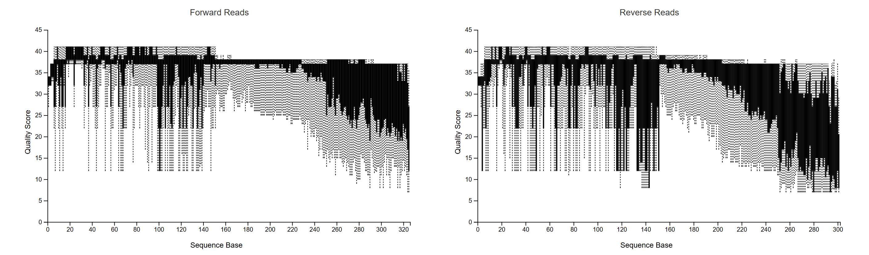
Appendix: Figure 1 Quality plots of seedling microbiome data
QIIME2 view showing Quality plots of both forward (left) and reverse (right) reads from the 16S rRNA gene fragment data of seedling microbiomes. The quality dropped earlier for the reverse reads and they were truncated at 240 using DADA2 to remove low quality reads, Truncation parameters were chosen corresponding to where most reads fell below a Phred quality score of 25.

Appendix C
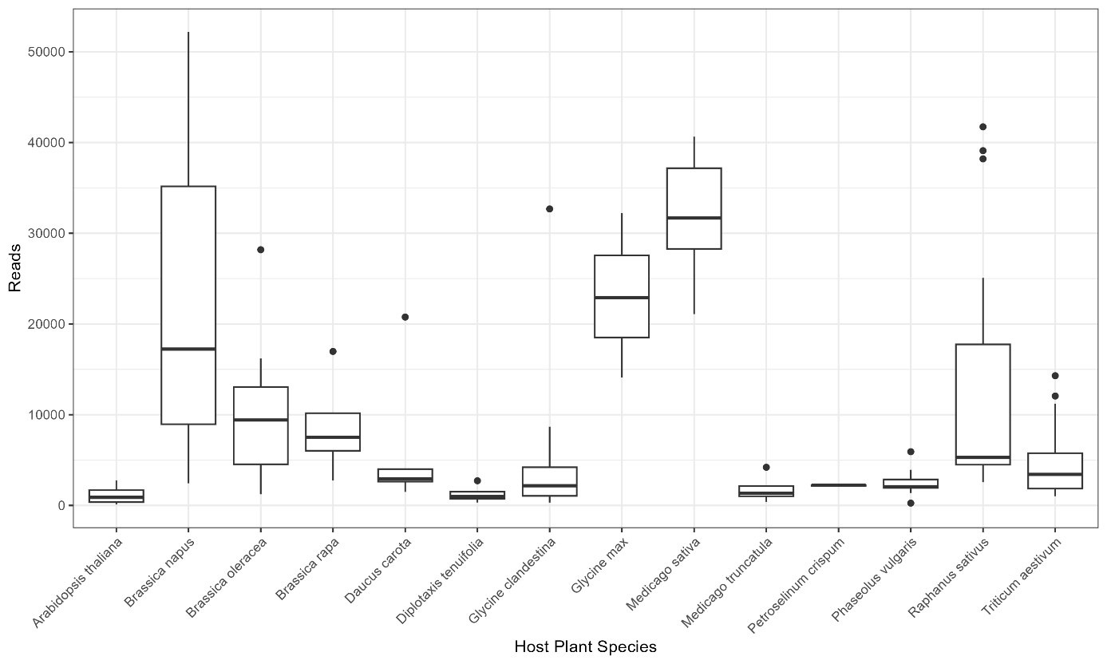
Appendix: Figure 2 Plot showing the number of reads seen across the reads in each plant species.
Three plant species shown here were removed from the final dataset: Arabidopsis thaliana, Diplotaxis tenyifolata, Petroselinum crispum, the first two were removed due to a low read depth and sample size of <2.

Appendix D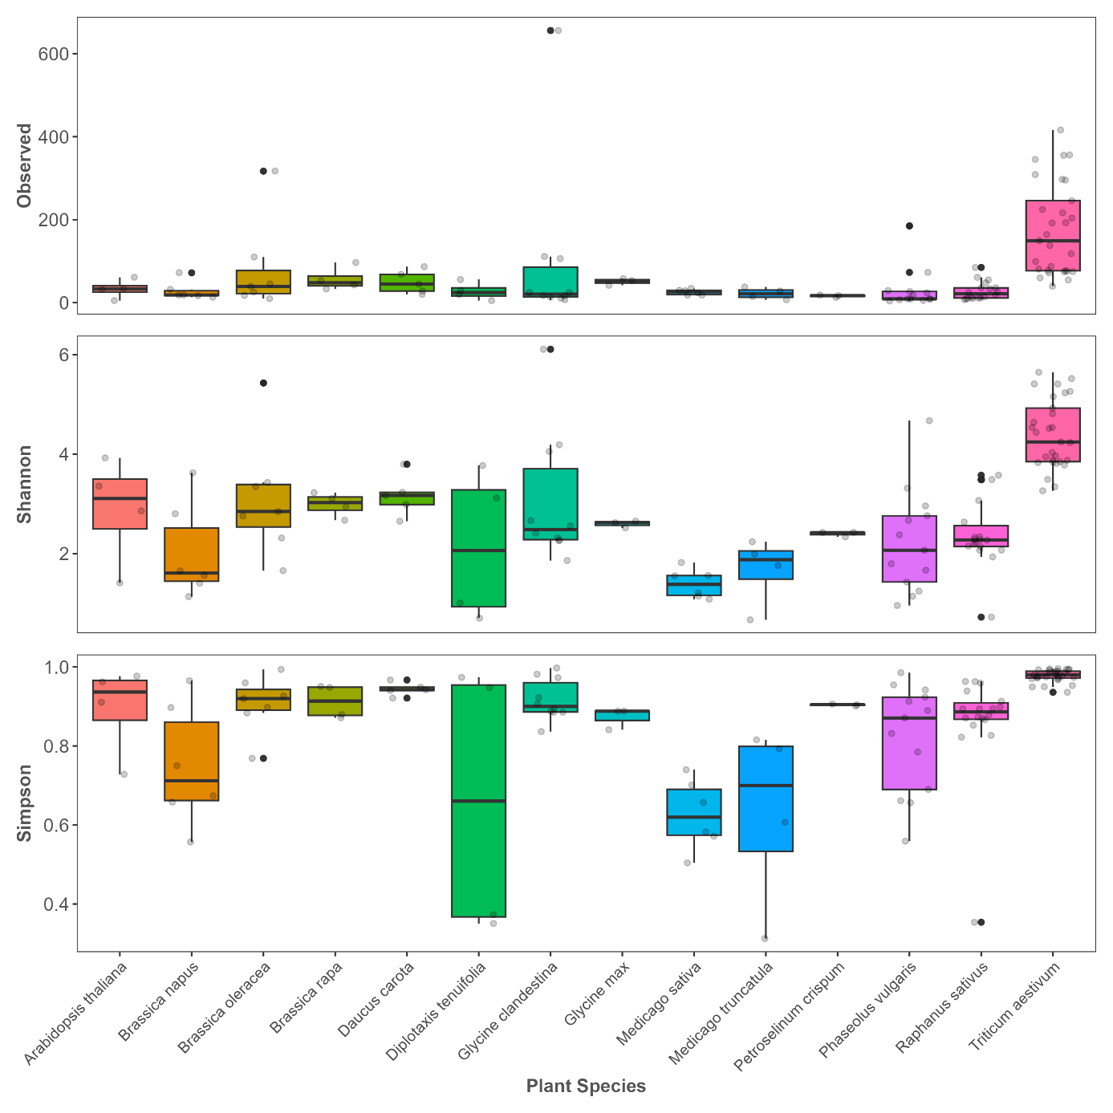
Appendix: Figure 3 Alpha diversity plot of microbiome of seedlings using Non Rarefied data
When compared to the Alpha plot using Rarefied data, this Non rarefied plot shows a lower Simpson value for samples with the lowest sampling effort: Diplotaxis, Medicago, Phaseolus. Some of the species present in this plot were removed from the data used during filtering.
Appendix E
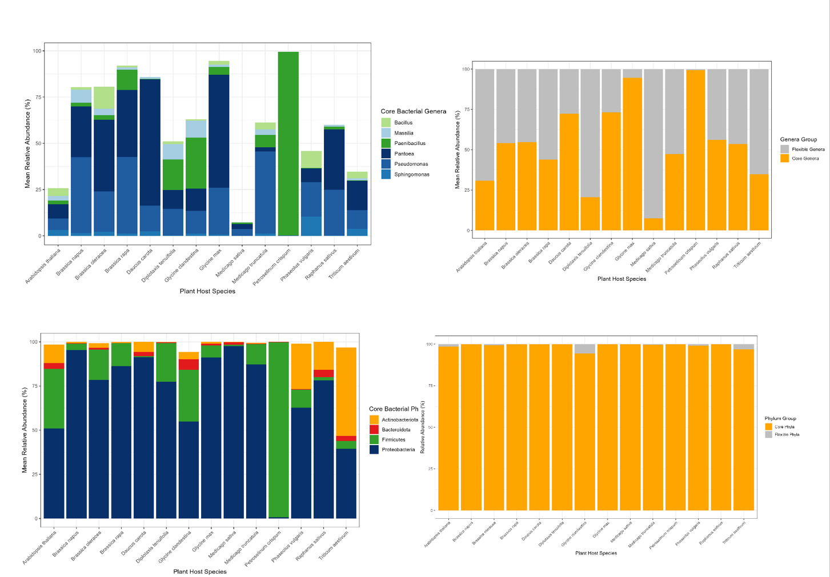
Appendix: Figure 4 Taxonomic plots showing the core phyla and genera across all plant species. top shows the genus level and bottom shows the phylum level, on the left shows the core taxa the right shows the fraction of taxa belonging to core (orange) and flexible (grey).
Appendix F
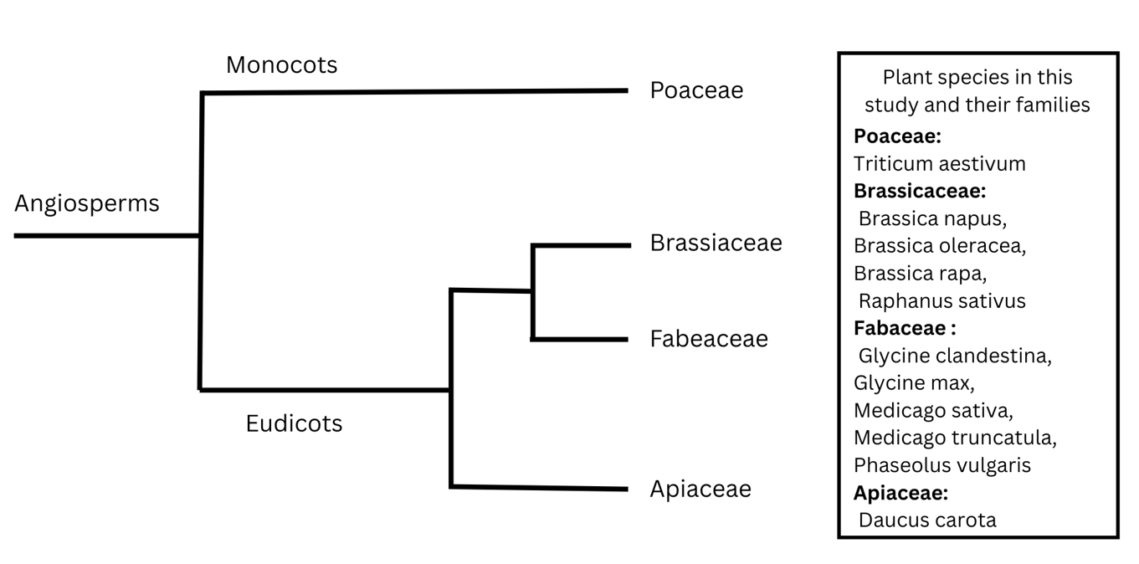
Appendix: Figure 5 Hierarchal classification of the relationship between the plant families present in this study. Not to scale. Created using Phylogenetic trees seen in (Li et al 2021). Plant species are listed under their family name on the right in no particular order.
Appendix G
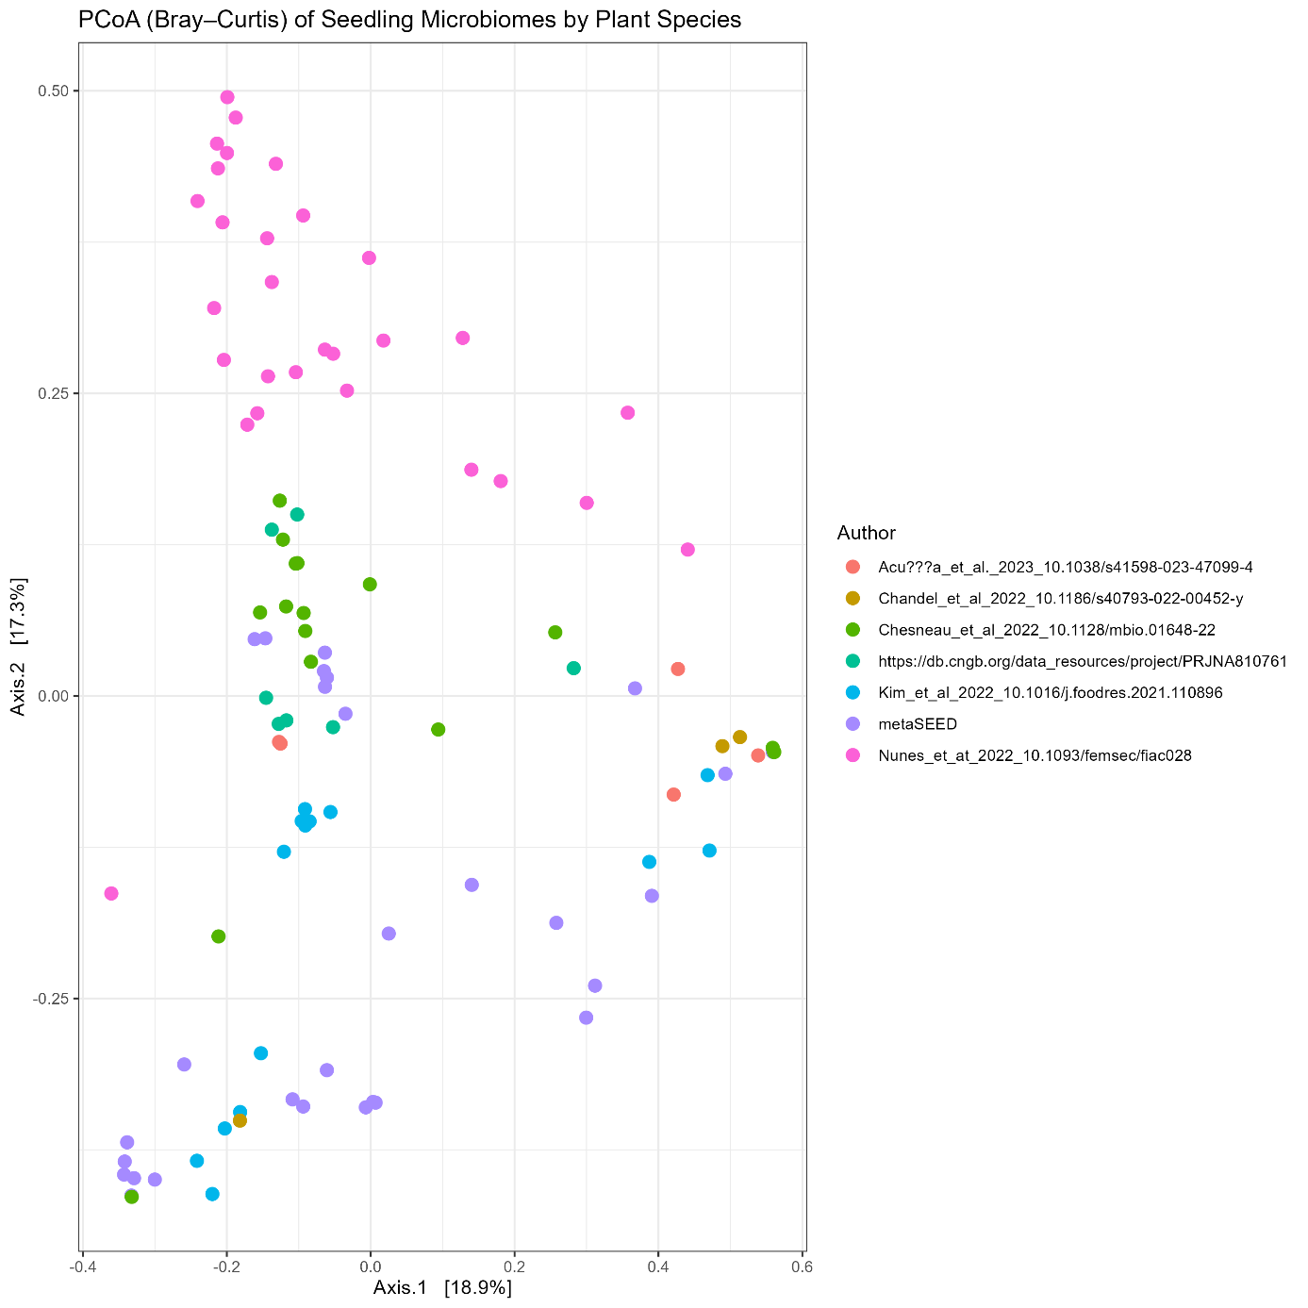
Appendix: Figure 6 Bray curtis plot coloured by Author
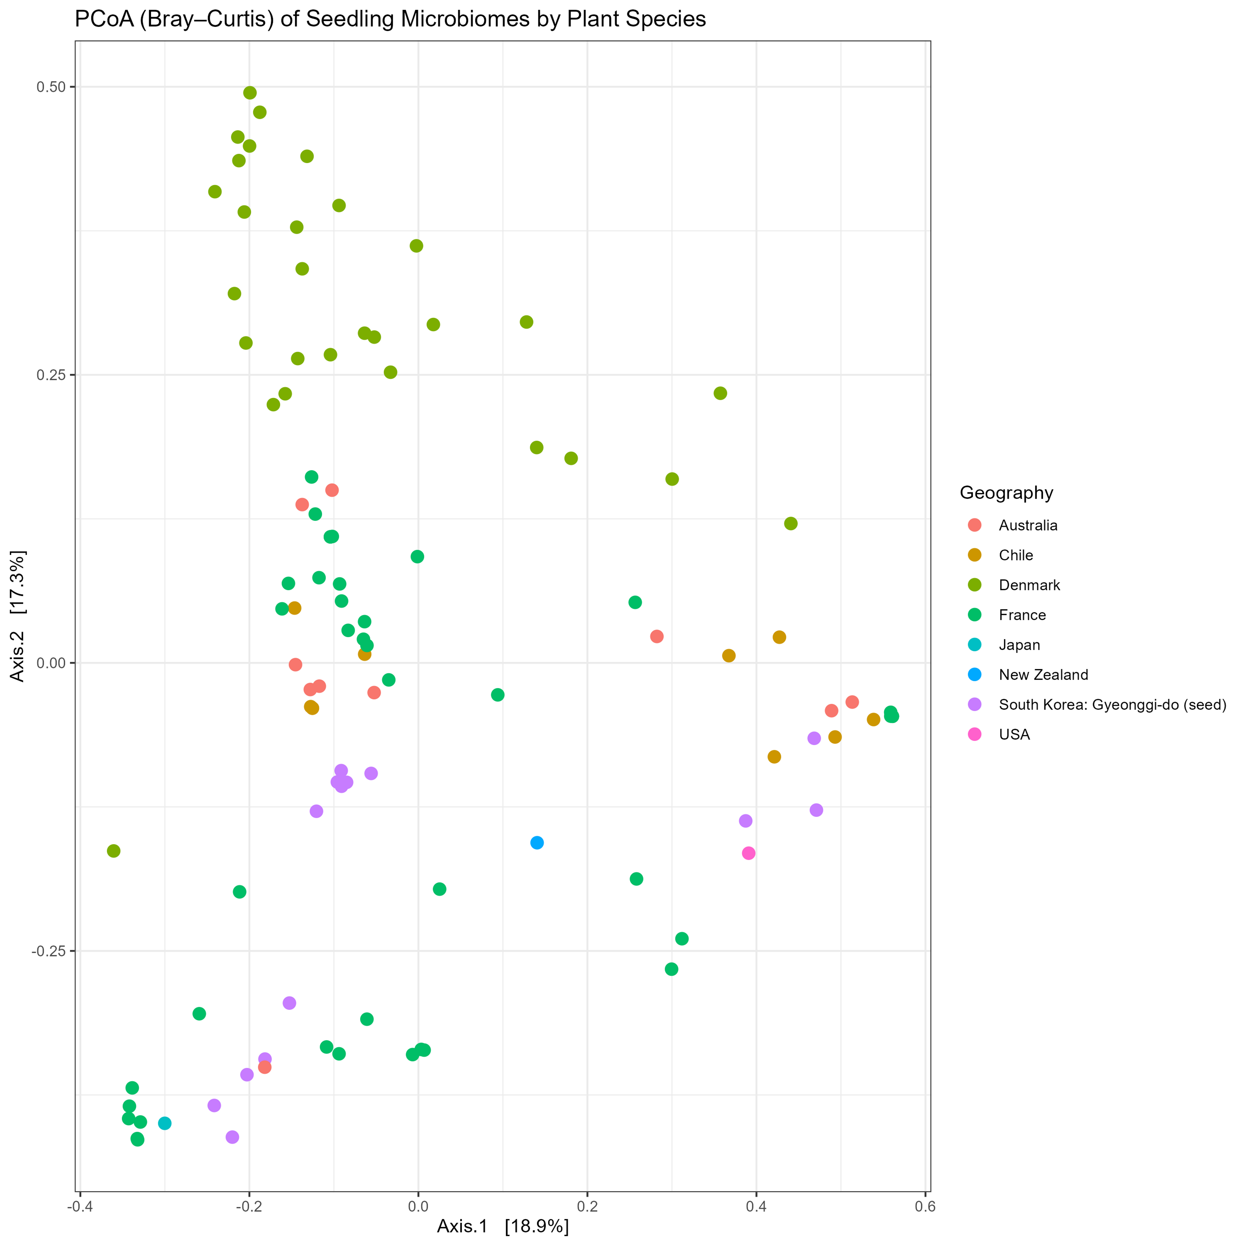
Appendix: Figure 7 Bray curtis coloured by Geographic location
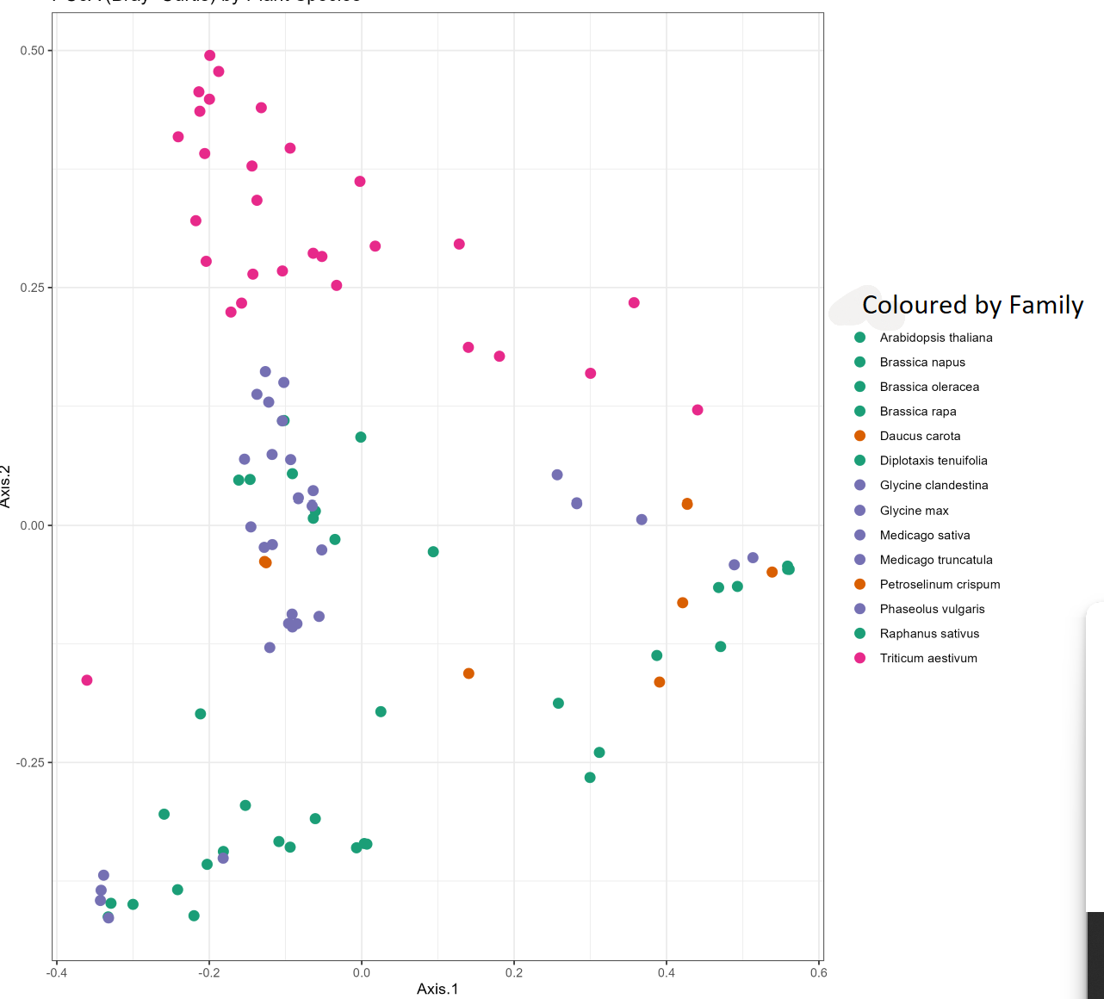
Appendix: Figure 8 Bray-curtis plot coloured by Plant family. Pink is Poaceae, Orange is Apiaceae, Green is Brassiaceae, Purple is Fabeaceae.

