What taxa associate with seed-to-seedling plant transition?

Expedito Olimi^{1,2*}, Elizabeth Stanly², Gabriele Berg¹, Tomislav Cernava²
¹Graz University of Technology, Institute of Environmental Biotechnology, Austria
² School of Biological Sciences, University of Southampton, Southampton, United Kingdom.
* Correspondence: expedito.olimi@tugraz.at

Abstract
The plant microbiome plays important roles in plant health, aiding in the production of resilient crops. Early microbial establishment shapes the plant’s lifelong microbiome, yet there remains a knowledge gap regarding the microbiome encompassing the seed-to-seedling plant transition. In a meta-analysis, we re-processed public 16S rRNA gene amplicon datasets of seeds and seedlings from eight studies (five of which sampled both stages) through a unified pipeline. We then tested how developmental stage and host attributes shape the diversity, composition, taxon–stage associations, host specialisation, and functional potential.
Phylum Proteobacteria was predominant at both stages (mean relative abundance 70.7% in seeds and 74.0% in seedlings), followed by Firmicutes (11.4% and 15.8%) and Actinobacteriota (14.9% and 8.2%). The dominant classes were Gammaproteobacteria (61.3% and 67.2%), Alphaproteobacteria (9.4% and 6.9%), Bacilli (11.4% and 15.5%), and Actinobacteria (14.9% and 8.2%). The predominant genera were Pantoea (22.1% and 18.2%), Pseudomonas (15.7% and 21.3%), Erwinia (11.9% and 3.5%), Paenibacillus (1.5% and 9.5%), Bacillus (3.1% and 4.8%), Sphingomonas (4.8% and 3.8%), and Massilia (3.2% and 2.8%). The developmental stage effect (seed vs seedling) on alpha diversity was minimal (Shannon index, Kruskal–Wallis H = 19.7, p = 9.1 × 10⁻⁶, ε² = 0.010). It also varied between studies and plant families (lower in Fabaceae seedlings, higher in Poaceae seedlings; pooled Hedges' g = 0.14, 95% CI −0.81 to 1.09). Host genus had a much larger effect (ε² = 0.108), whereas plant family, by contrast, explained little of the variation in alpha diversity (ε² = 0.017).
Generally, plant stage explained 1.6% of the variation in the bacterial community composition (PERMANOVA at ASV level, p = 0.001). By comparison, host genus explained 10.1% and plant family 6.0%. Within each stage (genus level), host genus explained more of the variation among seedlings (16.2%) than among seeds (8.3%). DESeq2 and indicator species analysis jointly identified 171 stage-specific ASVs (86 in seeds and 85 in seedlings), that mainly belonged to 23 genera. Bacillus was the most consistently seedling-enriched genus, higher in seedlings in four of five plant families and five of six host genera (pooled Hedges' g = 0.58 and 0.64). Exiguobacterium was the most seed-enriched genus within plant families (g = −0.91, 95% CI −1.61 to −0.21), although neither genus kept a significant effect after correction for multiple testing. Alpha diversity showed no host phylogenetic signal (Blomberg's K ≤ 0.15, all p ≥ 0.35). Host–microbe phylosymbiosis was evident only for seed communities at the ASV level (Mantel r = 0.60, p = 0.004). A null-model screen of host breadth identified 241 host-generalist ASVs (on six or more host species) and 1,120 host specialists (on one). Generalists belonged exclusively to the phyla Proteobacteria, Firmicutes, and Actinobacteriota, and none was predicted to be anaerobic. The seed-to-seedling transition is therefore host-contingent. Seedling-inoculant strategies built on stage-level generalisations could miss the host context in which they are deployed. Balanced multi-host sampling and functional data are needed to test these patterns robustly.
Keywords: seed microbiome, seedling microbiome, 16S rRNA, and developmental stage

Background
There is increasing need for resilient crops in light of increasing global food demand, amidst climate change reshaping the environments in which those crops are grown. This has, in part, inspired research and development of microbiome-based products for enhancing plant health and productivity (Singh et al., 2020; Trivedi et al., 2020; Compant et al., 2025). Regulatory restrictions on chemical fertilisers and pesticides further reduce the productivity gains that can be derived from using synthetic inputs (Cuadros-Casanova et al., 2023). The One Health framework treats human, plant, and environmental health as a single interconnected system (Bordenstein & Theis, 2015; Adisasmito et al., 2022; Ginnan et al., 2025). Within this framework, the plant microbiome has become a central candidate for sustainable productivity strategies. Plants’ early-life microbial associations are crucial in shaping these outcomes, although this hypothesis has not been fully examined at the seedling stage.
The plant microbiome (i.e., bacteria, archaea, fungi, protists and their metabolic output) together with the host constitute the holobiont, in which microbial communities contribute directly to plant fitness (Vandenkoornhuyse et al., 2015). Microorganisms shape beneficial traits: nutrient acquisition, growth regulation, biotic and abiotic stress tolerance, and disease resistance (Trivedi et al., 2020; Compant et al., 2025). These traits can exist in single isolates, but their expression is context-dependent and shaped by environmental conditions, host genetics, and the surrounding community (Trivedi et al., 2020). Thus, the functional impact of any one taxon ultimately depends on its community-level assembly and maintenance over time. Studies of the seed microbiome have identified core taxa that are potentially vertically transmitted (Simonin et al., 2022, 2023; Abdelfattah et al., 2023; Sulesky-Grieb et al., 2024; Sanz-Puente et al., 2025; Chen et al., 2025; Qi et al., 2026). However, they offer limited insight into whether these taxa can be maintained early during plant establishment and beyond.
Plant tissue provides multiple unique niches for microbial colonisation, including the belowground rhizosphere and the aboveground phyllosphere, as well as internal (endophyte) and external (epiphyte) compartments (Trivedi et al., 2020; Compant et al., 2025). Plant microbiome assembly is largely shaped by host genotype, through plant chemistry which is modulated by microbiome-regulating (Microbiome or M) genes (Su et al., 2024, 2025; Cernava, 2024; Negre Rodríguez et al., 2025). It is also dynamic across the plant life cycle: the seed itself is not a sterile starting point. Vertically transmitted endophytes, seed-coat microbes (epiphytes), and the resident communities of the immediate substrates all contribute to the early seedling microbiome (Rochefort et al., 2021; Abdelfattah et al., 2023; Wang et al., 2025; Qi et al., 2026). The seedling community is further restructured by horizontal microbial acquisition from the soil and surrounding environment (Johnston-Monje et al., 2014; Igwe & Vannette, 2018; Chang et al., 2019; Liu et al., 2019; Rochefort et al., 2021; Wang et al., 2025).
Most of what we currently know about seed or seedling microbiomes comes from few hosts and single-site experiments, and from either the seed or the seedling stage. Only a few studies have captured the microbiome across seed and seedling stages; however, little is known about the compositional changes that accompany the seed-to-seedling transition, or how these changes might generalize across hosts. Examining these specific transition phases is important, in part, because they constitute the developmental window often targeted for the isolation and application of microbial inoculants and seed-coat biological inoculants. To study the microbial (bacterial) community composition that might be key in shaping the early plant-life microbiome or accompanying the seed-to-seedling transition, we conducted a meta-analysis of 16S rRNA gene amplicon datasets of seeds and seedlings. The datasets were drawn from eight publicly available studies covering 12 host genera from six plant families across 10 countries (Figure 1). We processed each dataset using a common pipeline so that comparisons across studies rest on ASVs inferred with identical settings rather than on thresholds defined within the respective studies.
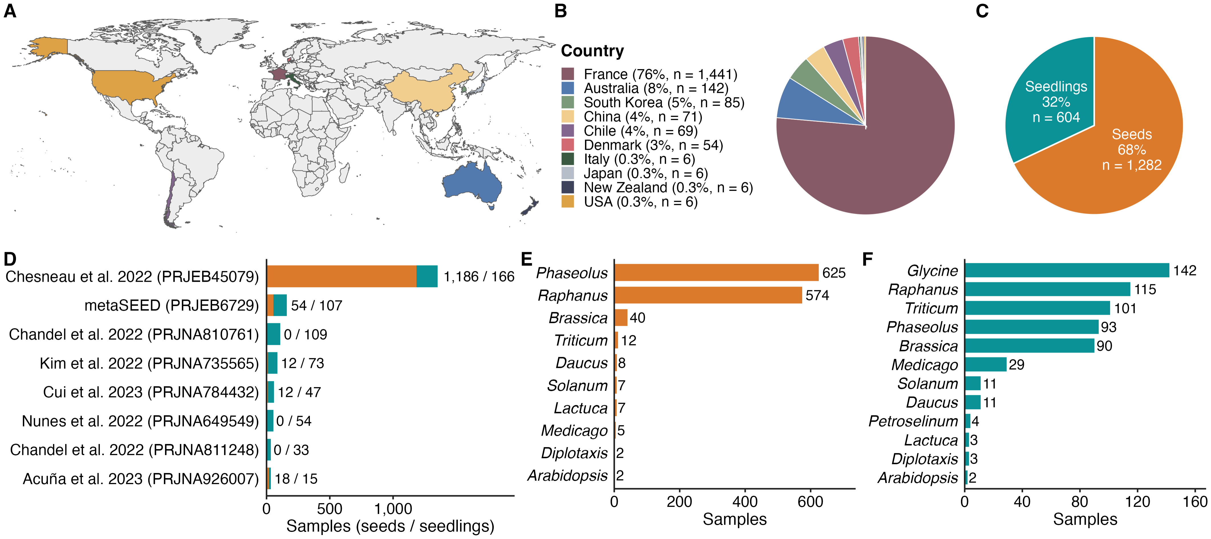
Figure 1. Overview of the compiled seed and seedling 16S rRNA gene amplicon dataset. The dataset comprises 1,886 samples from eight studies. (A) World map of the countries from which samples originate or where the experiments were performed, coloured as in B (countries that did not contribute samples are shown in grey). (B) Pie chart showing the proportion of samples by country. (C) Share of samples from seeds (n = 1,282) and from seedlings (n = 604). (D) Number of samples per study, as horizontal bars stacked by developmental stage (seeds, then seedlings); studies are labelled by reference and BioProject accession and ordered by sample number, each bar ending in its two counts (seeds / seedlings). A single study (Chesneau et al., 2022) contributes 1,352 of the 1,886 samples. (E, F) Number of samples per host plant genus among seeds (E; 10 genera) and among seedlings (F; 12 genera). Seeds are shown in orange and seedlings in teal throughout.

Dataset assembly and scope
We searched the literature databases including Web of Science, Pubmed, Scopus, Europe PMC’s open access full texts, using the Boolean search string: \(\("seed bacteria" OR "seed bacterial community" OR "seed bacteriome" OR "seed endophytes" OR "seed endophytic" OR "seed microbes" OR "seed microbial community" OR "seed microbiome" OR "seed microbiota" OR "seed mycobiome" OR "seed-associated bacteria" OR "seed-associated microbes" OR "seed-associated microbiota" OR "seed-borne bacteria" OR "seed-borne endophytes" OR "seed-transmitted" OR spermosphere OR "vertical transmission"\) AND \("seed-to-seedling" OR "seedling bacterial community" OR "seedling colonisation" OR "seedling colonization" OR "seedling endophytes" OR "seedling microbes" OR "seedling microbial community" OR "seedling microbiome" OR "seedling microbiota"\) AND \(16S OR "16S rDNA" OR "16S rRNA" OR amplicon OR "amplicon sequencing" OR "high-throughput sequencing" OR Illumina OR "marker gene" OR metabarcoding OR MiSeq OR "next-generation sequencing" OR NovaSeq OR PacBio OR pyrosequencing OR "rRNA gene sequencing"\)\). Studies which were peer-reviewed, used 16S rRNA amplicon sequencing, had both seed and seedling datasets available in public repository databases (ENA or SRA) were prioritised. The eight retained studies are listed in Figure 1D.
Sequence processing
Raw FASTQ files were downloaded into a high-performance computing environment following fastq-dl pipeline (https://github.com/rpetit3/fastq-dl). The reads were imported into QIIME2 environment (v2023.9.1;https://qiime2.org) (Bolyen et al., 2019). Paired-end reads were pre-processed and quality checked (fastp v1.0.0: https://github.com/OpenGene/fastp) (Chen et al., 2018) and Cutadapt (Martin, 1994). They were then processed with the DADA2 v1.26.0 pipeline, in which reads were filtered, trimmed, denoised, merged, and chimera removed (Callahan et al., 2016). This resulted in amplicon sequence variants (ASVs), a table of feature counts, and representative sequences for downstream analysis. The representative sequences were subsequently assigned taxonomy by alignment against the SILVA v138.2 reference sequence database (Quast et al., 2013; Yilmaz et al., 2014). Classification used VSEARCH (v2.30.0) within the q2-feature-classifier plugin (Rognes et al., 2016; Bokulich et al., 2018). The processed datasets were imported into R v4.3.2 in RStudio v1.1.423, using the packages phyloseq, vegan (Oksanen et al., 2020), metagenomeSeq, DESeq2, indicspecies, igraph, phytools, ape, phangorn, metafor, ggplot2, ggtree, and ggtreeExtra, and in Python (v3.14). All settings were read from a single configuration file (analysis_config.json). The code is available as described under Availability of data and materials (https://github.com/kaboyo/Seedling_metaanalysis). Significance was set at α = 0.05. Multiple comparisons were corrected by the Benjamini–Hochberg method (Benjamini & Hochberg, 1995). Headline statistics were checked by an independent reimplementation of the analyses. Non-bacterial, chloroplast, mitochondrial, and cyanobacterial ASVs, soil samples, samples with fewer than 500 reads, and ASVs present in fewer than three samples or with fewer than 10 reads were removed. Contaminants could not be removed systematically, as no negative controls were deposited.
Alpha diversity was calculated on data rarefied to an even depth of 500 reads per sample. The filtered count table was randomly subsampled without replacement (vegan::rrarefy, seed 123), and samples below this depth were excluded. Three indices were computed: observed richness, Shannon diversity, and Pielou's evenness, the ratio of Shannon diversity to the natural logarithm of richness. That is, J′ = H′/ln S, where H′ = −Σ pᵢ ln pᵢ is the Shannon index, pᵢ the proportion of the sample's reads belonging to ASV i, and S the observed richness. Differences between groups were tested with Kruskal–Wallis tests. Effect size was expressed as epsilon squared, ε² = (H − k + 1)/(n − k), where H is the test statistic, k the number of groups, and n the number of samples. Values of ε² are near 0 when the groups do not differ and approaches 1 when the grouping accounts for all of the variation in ranks. Tests were performed across samples for each grouping variable (developmental stage, plant family, and host genus). Stages were also compared within each study, plant family and host genus that sampled both stages (n ≥ 3 samples per stage for plant families and host genera). The stage effect within plant families and host genera was also expressed as Hedges' g and combined by random-effects meta-analysis, with Cochran's Q for heterogeneity among strata. Rarefaction to 1,000 reads served as a sensitivity check.
Beta diversity was calculated as Bray–Curtis dissimilarities of counts normalised by cumulative sum scaling (CSS; metagenomeSeq) (Paulson et al., 2013). Community structure was visualised by principal coordinates analysis (PCoA; at genus and ASV levels). Community structuring was further assessed by PERMANOVA (vegan::adonis2, 999 permutations, seed 123). Variables were tested individually and then in a marginal model combining a host attribute (host genus or plant family) and developmental stage. Variance was also partitioned between developmental stage and host attributes (Peres-Neto et al., 2006). Seed and seedling samples were also ordinated separately, and host genus, plant family, and study were tested within each stage using PERMANOVA.
Taxonomic composition was summarized at the phylum, class, and genus level as the mean of per-sample relative abundances, so that each sample carries equal weight regardless of sequencing depth. Composition was shown per early developmental stage, host genus, and plant family. Stage-specific contrasts in composition used only the studies that sampled both stages, with relative abundance averaged within and then across studies. The mean genus-level profiles of each host genus at each stage (n ≥ 3 samples) were clustered by average linkage of their Bray–Curtis dissimilarities, separately for seeds and seedlings. Microbial co-occurrence was examined separately for seeds and for seedlings, among the 50 most abundant ASVs of each stage. Spearman rank correlations were computed between every pair of these ASVs (1,225 pairs per stage). The p-values were adjusted for multiple testing by the Benjamini–Hochberg method. A pair was kept as an edge only when both thresholds were satisfied: an absolute correlation of at least 0.6 (|ρ| ≥ 0.6) and an adjusted p-value below 0.05. The networks were built with igraph (Antonov et al., 2023), with ASVs as nodes and node size proportional to degree (the number of edges of an ASV). Their connected components, groups of ASVs linked to one another but not to the rest of the network, were taken as modules.
Associations between taxa and developmental stage were examined in two steps. First, ASVs were screened using DESeq2 (poscounts size factors; adjusted p < 0.05, absolute log2 fold change > 1) and by indicator analysis (IndVal.g, 999 permutations, uncorrected p < 0.05). The genera holding an ASV significant in both analyses were retained. Second, genus counts were transformed to centred log-ratios (pseudocount 0.5). The difference between seedlings and seeds was expressed as Hedges' g within each plant family and each host genus (n ≥ 3 samples per stage; six plant families and eight host genera), where the genus occurred in at least 10% of the samples. The effects of genera estimated in at least two strata (18 genera in each) were then pooled by random-effects meta-analysis (restricted maximum likelihood), with the Knapp–Hartung adjustment for plant families and a random effect of study for host genera. Briefly, the Hedges' g is a standardised effect size: the difference between two group means divided by their pooled standard deviation, with a correction for small samples (Hedges, 1981). Here, it expresses by how many standard deviations a genus's abundance differs between seedlings and seeds. Positive values mean higher in seedlings and negative values higher in seeds. By convention, about 0.2 is small, 0.5 moderate and 0.8 large.

Host phylogenetic signal in alpha diversity was tested on a time-calibrated phylogeny of the host species (TimeTree 5) (Kumar et al., 2022). We used the mean of each index per host species and stage (n ≥ 3 samples). Signal was measured with Blomberg's K (999 permutations) (Blomberg et al., 2003) and Pagel's λ, and a bootstrap 95% confidence interval for λ (B = 500) (Pagel, 1999). Phylosymbiosis (Brooks et al., 2016) was tested within each developmental stage by relating the mean Bray–Curtis dissimilarity between host species to their divergence time. We used Mantel tests (Mantel, 1967) and multiple regression on distance matrices (999 permutations), with and without the proportion of between-study sample pairs as a covariate.

Genera were classified as seed specialists, seedling specialists, or stage generalists with the multinomial species classification method (CLAM; (Chazdon et al., 2011); specialisation threshold 2/3, α = 0.005), using the five studies(Chazdon et al., 2011) that sampled both developmental stages. Host generalists and specialists were then identified among ASVs and genera from the host species presence/absence matrix, in two steps. First, a breadth threshold was derived from a null model in which each host species received a random draw of taxa equal to its observed richness (1,000 iterations). The threshold was the smallest number of host species, above the expected breadth, at which more taxa were observed than the null mean (six host species for ASVs and seven for genera). Secondly, taxa meeting the threshold were tested for phylogenetic clustering of their hosts, by comparing the mean pairwise phylogenetic distance (Webb et al., 2002) among their hosts with that of every possible set of the same number of host species. Taxa meeting the threshold without significant clustering were classed as generalists, those occurring on a single host species as specialists, and the remainder as intermediate. Host breadth of genera was also measured from abundance, as Levins' niche breadth across host species (B = 1/Σp²). Here, p is the proportion of a genus's abundance found on each host species. B ranges from 1 (all abundance on a single host) to N (abundance spread evenly over all N host species). Each host was first reduced to one average sample of 1,000 reads, so that sample number does not determine breadth. Observed values were compared with 999 null tables that preserve row sums, column sums, and the number of zeros (vegan::nullmodel, quasiswap). Genera above the 97.5th or below the 2.5th percentile of the null distribution were classed as host generalists or host specialists.
Maximum-likelihood trees were built for the generalist ASVs (MUSCLE v5.3, Edgar, 2022; trimAl v1.5, Capella-Gutiérrez et al., 2009; and IQ-TREE v3.0.1 (Wong et al., 2026), with ModelFinder (Kalyaanamoorthy et al., 2017), and 1,000 ultrafast bootstraps, Hoang et al., 2018). Trees for the specialist ASVs and for both classes together were built with other tools (MAFFT v7.526, Katoh & Standley, 2013; trimAl; and FastTree v2.2.0 (Price et al., 2010), under GTR with gamma-distributed rates). Alignments were trimmed with the “automated1” setting of trimAl. Trees were midpoint-rooted with phangorn (Schliep, 2011) and drawn with ggtree (Yu, 2022), with rings for taxonomy, predicted oxygen use, host plant family, and host breadth added with ggtreeExtra (Xu et al., 2021). The two classes were compared by Fisher's exact tests at each taxonomic rank. Host breadth was related to non-zero relative abundance, within the five phyla richest in ASVs, by linear regression and one-sided Spearman correlation.
Traits were predicted per ASV with BugBase (v0.1.0;Ward et al., 2017), FAPROTAX (v1.2.12; Louca et al., 2016), and metaTraits (GTDB genus-level summary; Podlesny et al., 2026). For BugBase, ASVs were matched to Greengenes (McDonald et al., 2012) with vsearch at ≥ 97% identity (Rognes et al., 2016). Binary traits with at least 100 annotated ASVs were tested against log2(n_hosts + 1) with binomial generalised linear models. Here, n_hosts is the number of host species on which an ASV was detected. Numeric traits were tested by Spearman correlation with n_hosts. KEGG orthologue composition were predicted using PICRUSt2 (v2.6.2; (Douglas et al., 2020); with maximum NSTI 0.15, which retained 2,755 of the 2,823 ASVs). The 7,883 of 13,793 predicted orthologues that varied among ASVs(Douglas et al., 2020) were tested as follows: they were classed as generalist- or specialist-enriched at FDR < 0.05 and an absolute log2 odds ratio of at least 0.5, and annotated to KEGG level-2 categories and PGPg_finder functions (Pellegrinetti et al., 2024). Three groups (predicted anaerobic, nitrogen-fixing, and small-genome bacteria, the last being the smallest 1% of genome sizes) were described by ASV number, relative abundance, taxonomic and generalist–specialist composition, and host loading. Their member taxa detected on at least three host genera were tested among host plant phylogenies with Kruskal–Wallis tests. Traits, orthologue categories, and special groups were also compared between developmental stages, using three quantities: the share of each sample's annotated relative abundance held by ASVs carrying a trait, the share of its predicted orthologue copies in a category (ASV counts divided by predicted 16S copy number), and the relative abundance of each group. Each was expressed as Hedges' g (seedlings versus seeds) within each plant family, performed on samples (n≥3) per stage. The estimates were pooled by random-effects meta-analysis using the Knapp–Hartung adjustment.

Results
Across the eight studies, 1,886 samples (1,282 seeds and 604 seedlings) and 2,823 ASVs passed taxonomy, prevalence, and depth filtering (Figure 1C, D). Rarefaction to a depth of 500 reads per sample retained 1,851 samples for the alpha-diversity analyses. The retained dataset covered 12 host genera from six plant families, and 10 countries (Figure 1A, B, E, F). Three of the eight studies sampled seedlings only, so the within-study seed-to-seedling contrast based on five studies.

Bacterial community composition was dominated by a small set of taxa
Seed and seedling bacterial communities were dominated by a few taxa: Proteobacteria at phylum level and Pantoea, Pseudomonas and Erwinia at genus level. Proteobacteria dominated at both stages (mean relative abundance 71.8%; 70.7% in seeds and 74.0% in seedlings), followed by Firmicutes (12.8%; 11.4% and 15.8%), Actinobacteriota (12.7%; 14.9% and 8.2%), and Bacteroidota (2.2%). Gammaproteobacteria was the most abundant and widespread class (61.3% and 67.2% in seeds and seedlings, respectively), followed by Alphaproteobacteria (9.4% and 6.9%), Bacilli (11.4% and 15.5%), Actinobacteria (14.9% and 8.2%), and Bacteroidia (2.5% and 1.5%). Pantoea, Pseudomonas, and Erwinia were the most abundant genera, together accounting for 56.4% of genus-assigned reads. They were followed by Exiguobacterium, Enterobacter, Paenibacillus, Sphingomonas, Bacillus, Massilia, and Kosakonia. Differences between stages were most apparent at the genus level. Some genera were more abundant in seeds than in seedlings, including Erwinia (11.9% and 3.5%) and Exiguobacterium (6.1% and 0.1%). In contrast, Pseudomonas (15.7% and 21.3%), Paenibacillus (1.5% and 9.5%), Enterobacter (0.5% and 4.6%), and Kosakonia (0.8% and 2.4%) were more abundant in seedlings. Pantoea was abundant at both stages in similar proportions (22.1% and 18.2%). Composition at phylum and genus level also varied between host genera and plant families (Figure 2A).
Co-occurrence networks of both stages consisted of positive links, mostly between ASVs of the same genus (Supplementary Figure S1). The seed network was composed of 206 significant positive correlations (ρ = 0.81–1.00), with 148 of them between ASVs of the same genus. They formed six modules: Pantoea with Erwinia (13 ASVs), Microbacteriaceae with Frondihabitans (11), Pseudomonas (8), Exiguobacterium (6), Sphingomonas (6), and Erwinia (6). The seedling network contained 171 positive correlations (ρ = 0.66–1.00) among 47 ASVs; and formed seven modules, including: Pantoea with Erwinia (13), Paenibacillus (9), a mixed module of Pseudomonas, Enterobacter, Pantoea, and Kosakonia (7), Pseudomonas (7), Frondihabitans with Microbacteriaceae (7), and two pairs, Enterobacter with Trabulsiella and two Phaseolibacter ASVs. The Exiguobacterium and Sphingomonas modules were therefore specific to seeds, and the Paenibacillus module to seedlings. Because the correlations pool the studies of each stage, the modules may have reflected shared study of origin as much as ecological association. All but one module of each network drew more than 90% of their reads from a single study.

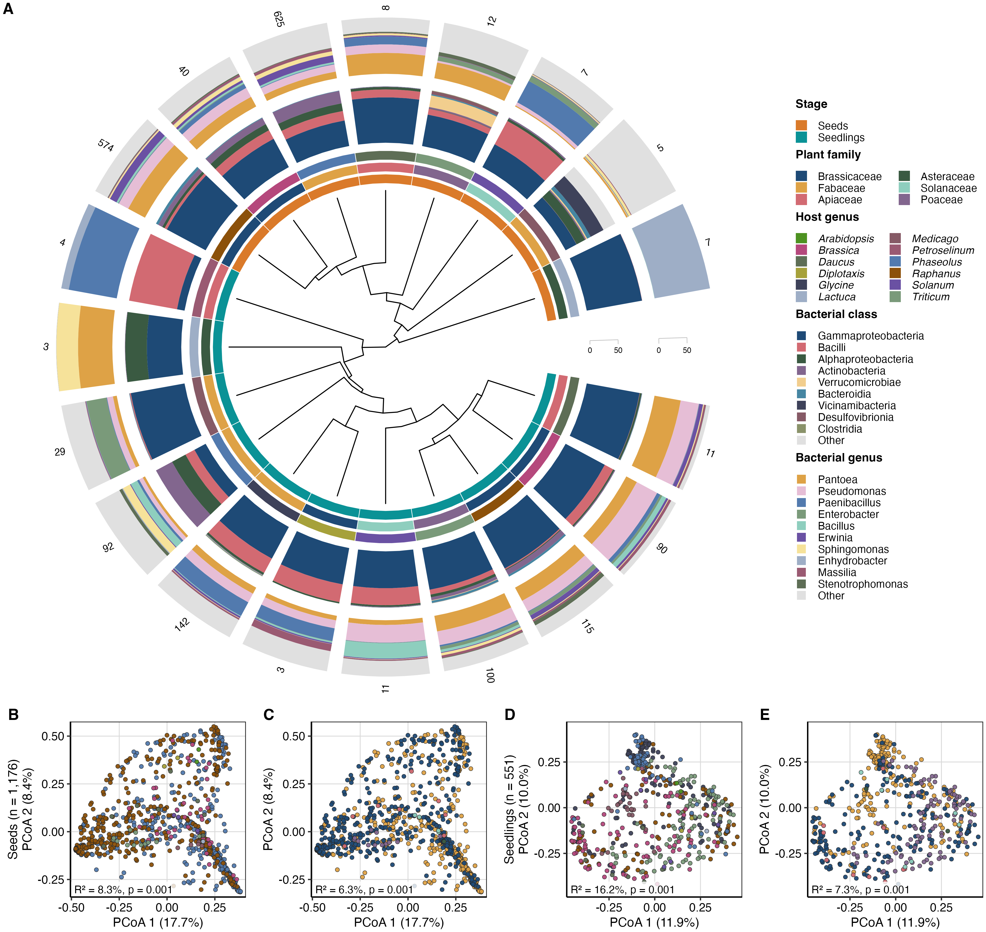
Figure 2. Composition and beta diversity of the seed and seedling bacterial community. A, Circular dendrogram of the host genera at each developmental stage (n ≥ 3 samples), clustered on mean genus-level composition (Bray–Curtis, average linkage) separately for seeds and seedlings. Rings, from the centre outwards: developmental stage (seed or seedling), plant family and host genus. Bars show the mean relative abundance (%) of bacterial classes (inner bars) and genera (outer bars). Numbers beside each tip show the number of samples. B–E, Principal coordinates analysis of Bray–Curtis dissimilarities (cumulative sum scaling, genus level), for seeds (B, C) and seedlings (D, E) and coloured by host genus (B, D) and plant family (C, E). The percentage variation in community composition (R²) and p-values of each variable within each stage are shown on the panels.

The bacterial community was structured more by host than by developmental stage
Host genus and plant family structured bacterial community composition far more strongly than developmental stage did (Table 1; Supplementary Figure S2A). In univariate PERMANOVA at ASV level, developmental stage explained 1.6% of the variation, whereas plant family explained 6.0% (F = 23.85), and host genus 10.1% (F = 18.99; all p = 0.001). The genus level showed the same pattern: stage 1.5%, plant family 5.4%, and host genus 9.7% (all p = 0.001). In marginal models (Table 2; Supplementary Figure S2B), each host variable explained more of the variation in community composition than developmental stage did. Because the stage effect was small relative to host, seed and seedling datasets were then ordinated and tested separately (Figure 2B–E). Within each stage, host variables structured the bacterial community (genus level: PERMANOVA, all p = 0.001). Host microbial structure was stronger among seedlings than seeds: host genus explained 16.2% versus 8.3% of the variation, and plant family 7.3% versus 6.3%. However, study also explained much more of the variation among seedlings (19.2%) than among seeds (2.6%; Supplementary Figure S2C, D), and among seedlings it explained more than host genus did. The stronger host structure among seedlings therefore could not be separated from the studies that sampled them. The ASV level showed the same pattern (Supplementary Figure S2E–J): among seeds (n = 1,277) and seedlings (n = 602), host genus explained 8.0% and 16.4% of the variation, plant family 6.6% and 8.2%, and study 2.5% and 22.1% (PERMANOVA, all p = 0.001).

Alpha diversity differed more among plant hosts than between developmental stages
Alpha diversity differed only slightly between seeds and seedlings and much more among host genera (Supplementary Table S1a, b). Both the Shannon index (Kruskal–Wallis H = 19.7, p = 9.1 × 10⁻⁶, n = 1,851; effect size: ε² = 0.010) and observed richness (H = 7.2, p = 0.007, ε² = 0.003) differed significantly between developmental stages. Pielou's evenness did not differ significantly between developmental stages (H = 1.3, p = 0.25, ε² < 0.001). The differences in community alpha diversity also depended on rarefaction depth. At 1,000 reads (n = 1,760), richness did not differ between the developmental stages (seeds vs seedlings) (H < 0.001, p = 0.98, ε² < 0.001).
At either stage, the mean alpha diversity of host species showed no phylogenetic signal (Figure 3A; Supplementary Table S2a). Across 10 host species for seeds (n = 1,266 samples) and 14 for seedlings (n = 577), Blomberg's K ranged from 0.03 to 0.15 (p ≥ 0.35); as well as Pagel's λ estimated at zero for all three indices. Within host families, the stage effect was inconsistent (Figure 3B; Supplementary Table S1c, d). For instance, seedlings were less diverse than seeds in family Fabaceae (Shannon index: Hedges' g = −0.90, 95% CI −1.05 to −0.75; ε² = 0.145; q < 0.001) but more diverse in Poaceae (g = 1.09, 95% CI 0.47–1.72; ε² = 0.106; q = 0.002). In Brassicaceae, the Shannon diversity was unchanged (g = −0.01) but richness increased in seedlings when compared with seeds (g = 0.24), while evenness decreased (g = −0.71). No significant differences were observed for families Apiaceae and Solanaceae. Pooled across the five plant families, the stage effect was close to zero for the estimated alpha diversity indexes (Shannon g = 0.14, 95% CI −0.81 to 1.09, p = 0.71; richness g = 0.13, p = 0.67; evenness g = −0.09, p = 0.71). Additionally, there was strong heterogeneity in Shannon diversity among the different families (Shannon Cochran's Q = 94.1, df = 4, p < 10⁻¹⁸; I² = 96%).
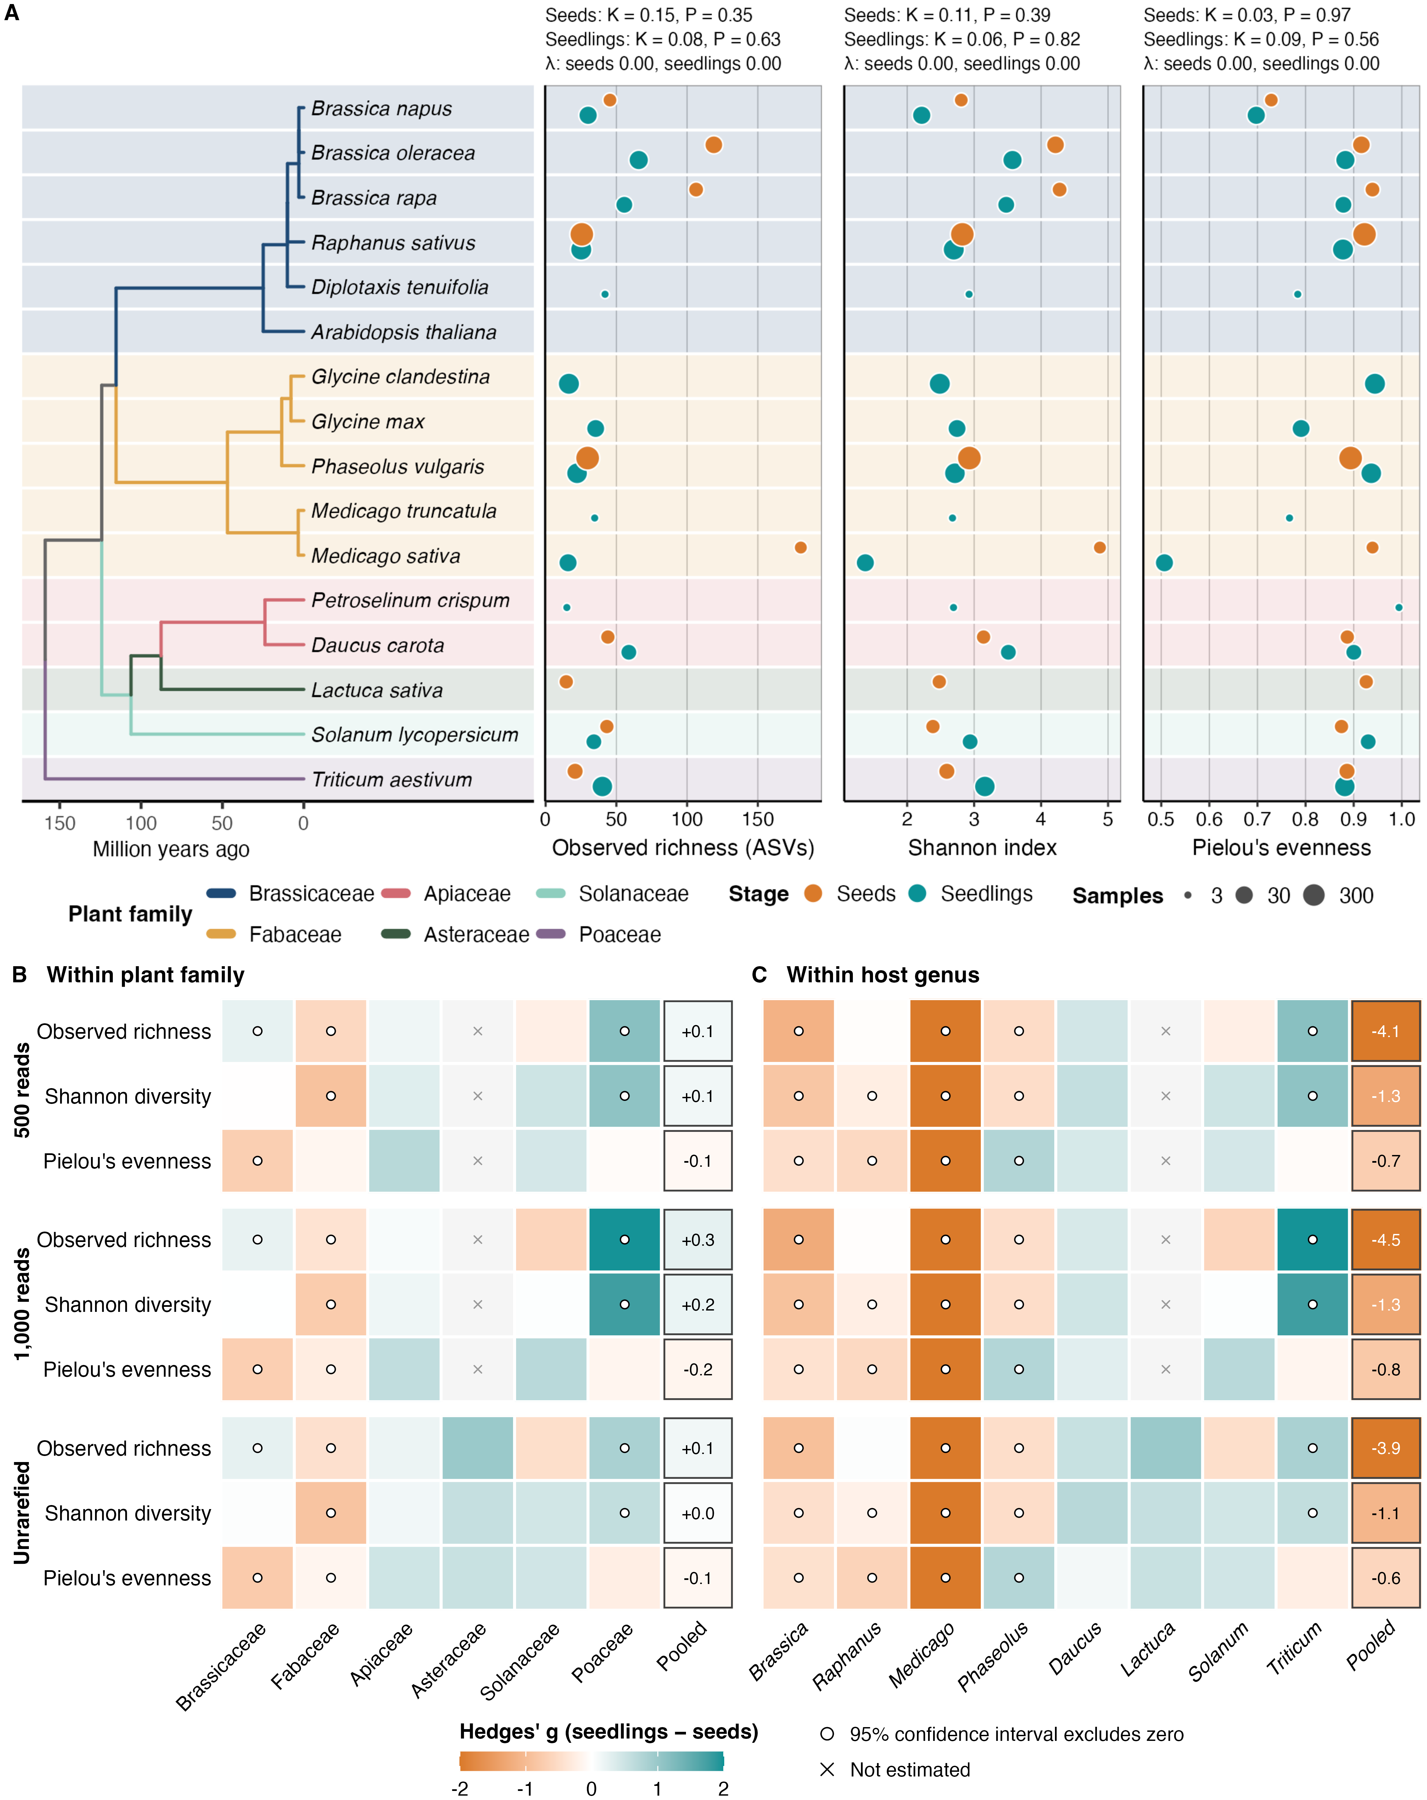
Figure 3. Alpha diversity in relation to host phylogeny across developmental stages. A, Time-calibrated phylogeny of the 16 host plant species (TimeTree 5), coloured by plant family, with the mean observed richness, Shannon index and Pielou's evenness of each host at each developmental stage after rarefaction to 500 reads. Point size gives the number of samples; hosts with fewer than three samples at a stage carry no point. Blomberg's K (999 permutations) and Pagel's λ are given above each panel. B, C, Effect of developmental stage on alpha diversity within plant families (B) and within host genera (C). Cells are Hedges' g estimations, seedlings minus seeds (orange, higher in seeds; teal, higher in seedlings); the framed column is the random-effects pooled estimate, a dot marks a 95% confidence interval that excludes zero, and a cross a cell that could not be estimated. Observed richness, Shannon diversity and Pielou's evenness at 500 reads, at 1,000 reads and in the unrarefied dataset.
Among the eight plant genera, Shannon diversity differed between stages in only five (q < 0.05); for instance, it was lower in seedlings in Brassica, Medicago, Phaseolus and Raphanus and higher in Triticum. Meanwhile, the pooled effect was close to zero (g = −1.31, 95% CI −5.18 to 2.56; I² = 99.6%; Figure 3C). Host genus produced a much larger Kruskal–Wallis statistic (Shannon H = 208.8, p = 1.1 × 10⁻³⁸, ε² = 0.108). Plant family, by contrast, explained little of the variation in alpha diversity (Shannon H = 37.0, p = 6.1 × 10⁻⁷, ε² = 0.017; richness ε² = 0.019; evenness ε² = 0.036). Host effects on alpha diversity were therefore most apparent at the host genus level.

Host phylogeny had little imprint on community composition
Phylosymbiosis was weak and confounded by the study effect (Figure 4A; Supplementary Table S2b). At genus level, the dissimilarity between bacterial communities of two host species was unrelated to their divergence time for either stage (seeds: Mantel r = 0.31, p = 0.096; seedlings: r = −0.07, p = 0.59). At ASV level, the seed communities of distantly related hosts were more dissimilar (Mantel r = 0.60, p = 0.004; multiple regression on distance matrices, R² = 0.37, p = 0.010). Host divergence remained significantly associated with community dissimilarity after the proportion of between-study sample pairs was included as a covariate (p = 0.033); however, study contributed independently to dissimilarity (p = 0.046). Among seedlings, microbiome association with host divergence was significant only by rank-based Mantel test (ρ = 0.37, p = 0.025; Pearson r = 0.19, p = 0.087). However, this was lost when study was included (p = 0.70; study p = 0.001); therefore, only seed association at ASV level remained significant after controlling for study.
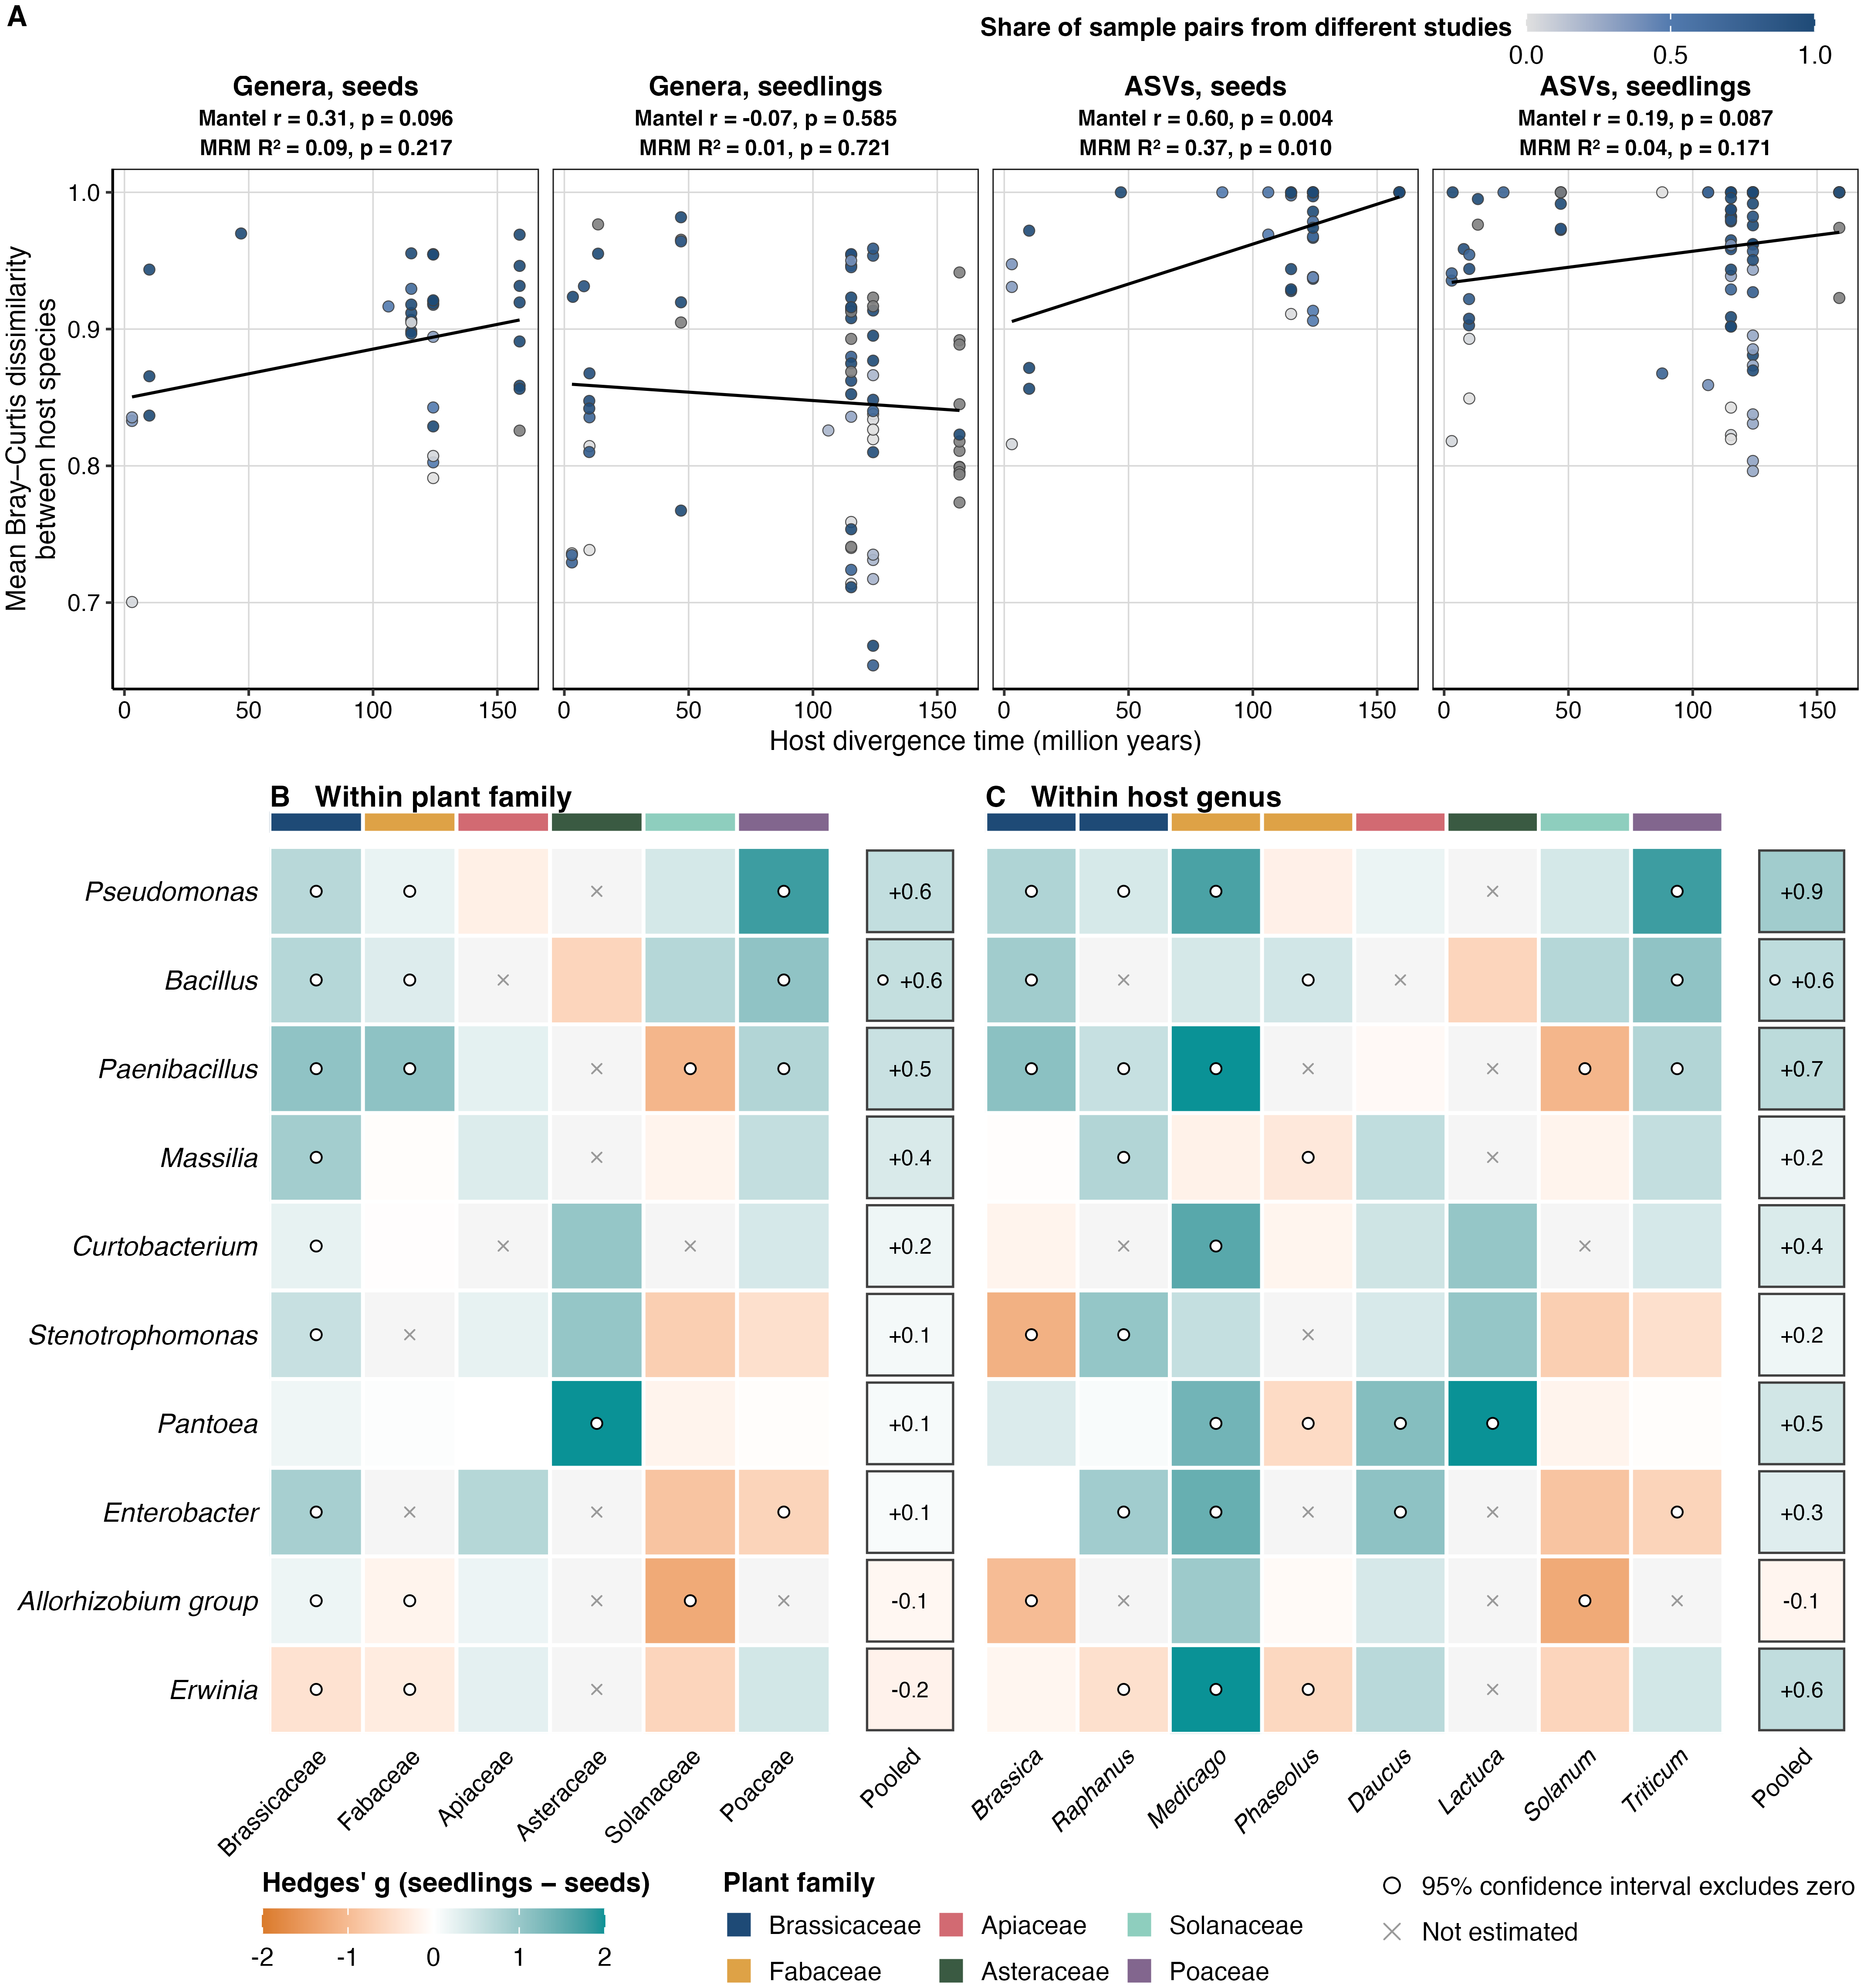Figure 4. Phylosymbiosis and the effect of developmental stage on bacterial genera. A, Divergence time between pairs of host species against the mean Bray–Curtis dissimilarity between their samples, at genus and ASV level within each developmental stage. Shade gives the share of sample pairs from different studies; the line is the least-squares fit. Mantel r and the R² of the multiple regression on distance matrices are given with permutation p-values (999 permutations). B, C, Effect of developmental stage on genera within plant families and host genera, respectively. Cells are Hedges' g for centred log-ratio abundance, seedlings minus seeds (orange, higher in seeds; teal, higher in seedlings). The framed column is the random-effects pooled estimate. A circle marks a 95% confidence interval that excludes zero, and a cross a cell that could not be estimated. Rows are the 10 genera, of the 23 with an ASV significant in both DESeq2 and indicator analysis, that could be estimated in at least three plant families and three host genera; the strip above the columns indicate the plant family.
Few taxa were associated with developmental stage across hosts
Only 171 ASVs were associated with developmental stage, and were split almost evenly between seeds and seedlings stages. For seedlings, these ASVs were assigned to Pantoea (28), Paenibacillus (20), Pseudomonas (13), Bacillus (8), and Enterobacter (4); while the seed ASVs belonged to Pseudomonas (13), Chryseobacterium (13), Erwinia (12), Exiguobacterium (12), Curtobacterium (8), and Arthrobacter, Paracoccus, and Serratia (7 each). The strongest indicators were seed-associated bacteria, in which eleven of the twelve ASVs with the highest indicator values belonged to Exiguobacterium.

Stage effects were inconsistent within plant families and host genera
Within plant families and genera, no bacterial genus retained a significant stage-specific effect, although Bacillus tended to be higher in seedlings and Exiguobacterium in seeds. Because the initial screen pooled all samples, developmental stage effect could not be separated from study and host. Therefore the stage effect of each of the genera within each plant family and genus was estimated (for n≥3 samples per stage, for the genus present in at least 10% of samples) as Hedges' g of centred log-ratio abundance, and pooled by random-effects meta-analysis for the genera estimated in at least two plant families and genera (Figure 4B, C; Table 3; Supplementary Table S3). Following Benjamini–Hochberg correction, no pooled effect was significant (all q > 0.13). Bacillus was consistently higher in seedlings in four of five plant families (g = 0.58, 95% CI 0.05–1.11, uncorrected p = 0.037) and five of six host genera (g = 0.64, 95% CI 0.18–1.09, uncorrected p = 0.015). Pseudomonas (g = 0.60 across plant families and 0.92 across host genera) and Paenibacillus (g = 0.54 and 0.66) were also higher in seedlings. Pantoea, the most abundant genus, showed almost no stage-specific difference within plant families (g = 0.09, 95% CI −0.08 to 0.26; I² = 3%) and across host genera (g = 0.45, 95% CI −0.35 to 1.26; I² = 92%). Exiguobacterium was lower in seedlings in both plant families (g = −0.91, 95% CI −1.61 to −0.21, uncorrected p = 0.039, q = 0.35) as well as in three plant genera in which it could be estimated (g = −0.77, 95% CI −1.18 to −0.36, uncorrected p = 0.015, q = 0.14).

Few genera were stage specialists, and host generalists were from few bacterial lineages
The multinomial classification (CLAM), applied to the pooled samples of the five studies that sampled both stages, classed 152 genera as seed specialists, 40 as seedling specialists, and 58 as stage generalists (Supplementary Table S4). The seedling specialists were Paenibacillus, Kosakonia and Saccharibacillus, and Duganella and Sphingobacterium, whereas the 36 seed specialists included Exiguobacterium, Brevundimonas, Paracoccus, and Arthrobacter and Erwinia. With respect to host range, 53 genera were classed as host generalists and 141 as host specialists on the basis of their presence across host species (Supplementary Figure S3A). Levins' niche breadth, which weighed abundance rather than presence, classed only six genera as host generalists (Stenotrophomonas, Pedobacter, Allorhizobium-Neorhizobium-Pararhizobium-Rhizobium, Rathayibacter, Variovorax, and Novosphingobium), and 25 as host specialists; while 151 were categorised within the null range and 100 as too rare to classify (Supplementary Table S4). Fourteen of these 25 specialists, including Pseudomonas, Paenibacillus, Acinetobacter, and Enterobacter, were presence-based generalists found on 7 to 15 host species.
Host generalists were most confined to three phyla: Proteobacteria (176 ASVs), Firmicutes (52), and Actinobacteriota (13). They were enriched relative to specialists in Proteobacteria (odds ratio 2.4, q = 1.6 × 10⁻⁷) and Firmicutes (odds ratio 1.8, q = 0.005). By contrast, Bacteroidota (98 specialist ASVs), Acidobacteriota (65), Verrucomicrobiota (28), Planctomycetota (26), and Chloroflexi (25) were represented only among specialists (Fisher's exact tests, all q < 0.04; Figure 5A, B; Supplementary Figure S3B; Supplementary Table S5). On the phylogeny of both classes, generalists were interleaved with specialists of the same lineages rather than forming separate clades. Each generalist was detected on two to four of the six host plant families. No generalist, except 111 specialists was predicted to be anaerobic. The genera found on the most host species (13 to 15) were Pantoea, Sphingomonas, Paenibacillus, Pseudomonas, Massilia, Stenotrophomonas, Erwinia, and Bacillus (Figure 5C). Within Proteobacteria and Actinobacteriota, ASVs detected on more host species were also the most abundant where they were observed (regression of log10 relative taxa abundance on the number of host species, R² = 0.034 and 0.050, q = 5.1 × 10⁻¹³ and 2.5 × 10⁻⁵; one-sided Spearman ρ = 0.14 and 0.25; Supplementary Figure S3C; Supplementary Table S5b). In Firmicutes and Acidobacteriota, the relationship was weaker and significant only by Spearman correlation (ρ = 0.10 and 0.25, both q = 0.026; regression q = 0.15 and 0.081), whereas for Bacteriota no relationship was observed (q ≥ 0.12). Across the five phyla, host breadth explained at most 6% of the variation in abundance.

Predicted traits separated host generalists from specialists, but not seeds from seedlings
Host generalists were predicted to be aerobic and metabolically versatile, whereas anaerobic and fermentation traits were associated with host specialists. Of the 333 binary predicted traits tested, 130 were associated with host breadth (q < 0.05), 82 were more frequent and 48 less frequent as the number of species increased (Figure 5D; Supplementary Table S6). The most significant association was a decline in predicted anaerobic metabolism (BugBase; odds ratio 0.22 per doubling of host number, q = 6.7 × 10⁻¹³), together with obligate anaerobiosis (metaTraits; odds ratio 0.11) and nine significant fermentation traits. Conversely, ASVs found on more host species were more often predicted to grow on malonate (odds ratio 2.03), glycerol (1.95), and acetate (1.75). They were also more often predicted to degrade aromatic compounds (1.77 in metaTraits and 1.91 in FAPROTAX) and to use nitrate as an electron acceptor (1.53). Predicted methylotrophs (2.33) and plant pathogens (1.65; FAPROTAX) were also frequent. Of the 29 numeric traits, 11 were correlated with host breadth, albeit weak (|ρ| ≤ 0.11), including the metaTraits generalism score (ρ = 0.08) and habitat count (ρ = 0.10). Of the 7,883 predicted KEGG orthologues that varied among ASVs, 1,036 were enriched in host generalists and 1,451 in host specialists (Figure 5E; Supplementary Figure S4A; Supplementary Table S7). Specialist-enriched orthologues outnumbered generalist-enriched ones in carbohydrate metabolism (144 vs 82), energy metabolism (115 vs 74), glycan biosynthesis and metabolism (93 vs 52), and xenobiotic degradation (98 vs 42), and, among plant-growth promotion functions, in plant colonisation (259 vs 129) and bioremediation (112 vs 67). Conversely, generalist-enriched orthologues predominated in the metabolism of cofactors and vitamins (89 vs 60), phytohormone and plant-signal production (75 vs 55), and stress control and biocontrol (96 vs 82).
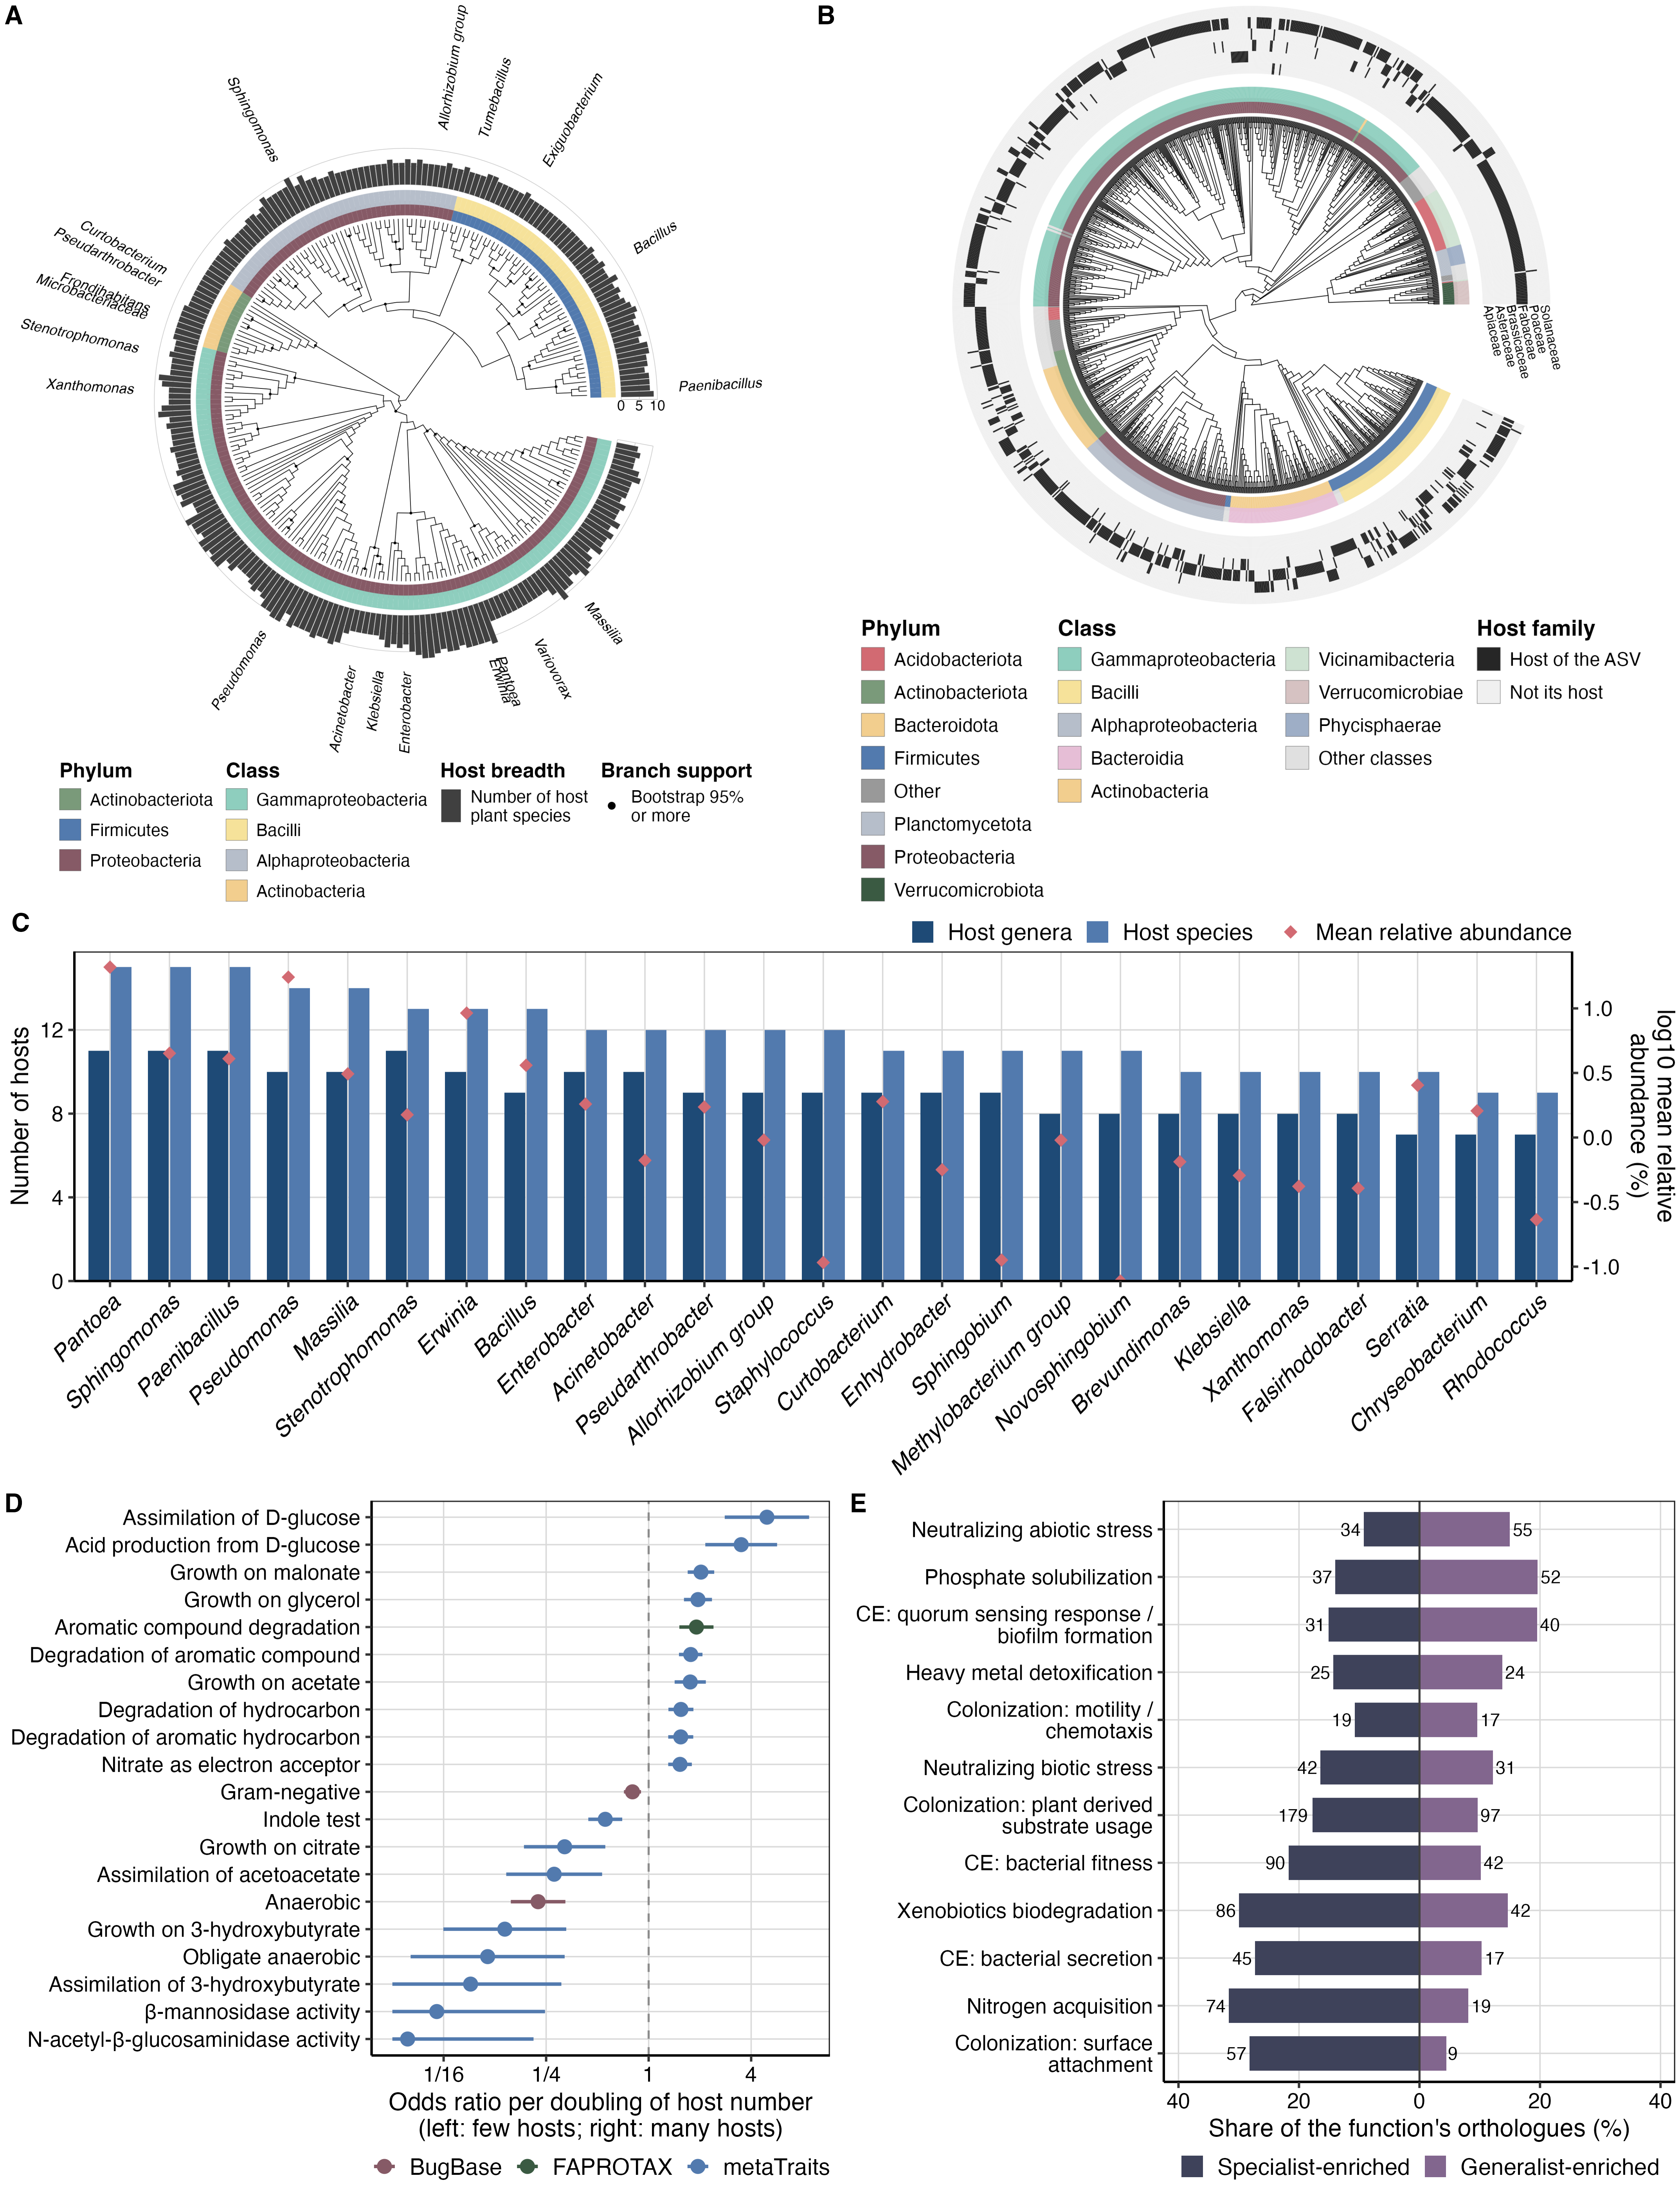
Figure 5. Host generalists and specialists: phylogeny, host breadth and predicted functions. A, Maximum-likelihood phylogeny of the 241 host-generalist ASVs (ASVs found on at least six host species). The two inner rings show phylum and class; the outer bars present the number of host plant species on which each ASV was found. Dots mark the tree internal branches with ultrafast bootstrap support of at least 95%, and the 20 most abundant genera are named. B, Maximum-likelihood phylogeny of 1,113 host-specialist ASVs (ASVs found on a single host species). The inner rings show phyla and classes, followed by one ring for each plant family (Apiaceae, Asteraceae, Brassicaceae, Fabaceae, Poaceae and Solanaceae), shaded dark where the family is the ASV’s host. Because the sequences come from different regions of the 16S rRNA gene, the deeper branches are poorly resolved. C, the 25 genera found on the most host species: bars give the number of host species and host genera (left axis), and diamonds show the mean relative abundance across all samples (right axis, log10 scale). D, the ten predicted traits most significantly associated with host breadth (lowest q; binomial generalised linear models, q ≤ 0.05). Points give the odds ratio per doubling of the number of host species, and lines its 95% confidence interval, on a log2 axis; values above 1 indicate traits more frequent among ASVs found on more host species. Colours show the source database and analysis tool/s (BugBase, FAPROTAX or metaTraits). E, for each plant-growth-promotion function (PGPg_finder), the share of its KEGG orthologues enriched in host specialists (left) or host generalists (right) (FDR < 0.05 and absolute log2 odds ratio of at least 0.5); numbers beside the bars give the orthologues. All traits and orthologues were predicted from the 16S rRNA gene. Acronym CE, stand for competitive exclusion.

Three groups with distinctive predicted traits were rare: predicted anaerobes (154 ASVs, 5.5% of all ASVs; detected in 181 samples, mean relative abundance 0.37%), nitrogen fixation (23 ASVs; 69 samples; 0.09%), and small-genome bacteria (22 ASVs; 61 samples; 0.06%). Moreover, none of these ASVs belonged to a host generalist. Among their members detected on at least three host genera (Supplementary Figure S4B, C), three anaerobic taxa, Corynebacterium, Dolosigranulum, and Peptostreptococcaceae, that differed in relative abundance among host plant orders (Kruskal–Wallis q < 10⁻⁶). None of the four nitrogen-fixing taxa showed significant differences (q ≥ 0.50). Corynebacterium and Dolosigranulum were taxa typical of human skin and airways, these could be a result of contamination in particular studies.
Between developmental stages, the predicted functions showed less changes within plant families (Supplementary Figure S5; Supplementary Table S8). No predicted trait based on KEGG level-2 or PGPg_finder category, or other special group showed significant pooled seedling–to–seed difference after correction (q ≥ 0.058). Before correction, seedlings carried a smaller share of predicted facultative anaerobes than seeds (g = −0.30, 95% CI −0.49 to −0.10, six plant families) and a larger share of predicted nitrate reducers (g = 0.26, 95% CI 0.10–0.43). Their predicted orthologue content was slightly lower in potassium solubilisation (g = −0.19) and in functions neutralising biotic stress (g = −0.27). The three special groups did not differ between stages (all p ≥ 0.23).

Discussion
The seed-to-seedling transition is a unique plant development phase whose microbiome structure and diversity, in part, bears a host-dependent context. Across 1,886 seed and seedling samples drawn from eight studies and 12 host genera, the bacterial communities of seeds and seedlings were dominated by a small set of Proteobacteria, mainly Gammaproteobacteria (Pantoea, Pseudomonas, Erwinia). Firmicutes (class Bacilli) and Actinobacteriota (class Actinobacteria) constituted most of the remainder. Developmental stage (seed vs seedling) explained least to the variation in bacterial diversity even than host phylogeny at family and genus levels; where host genera had far-much effects on bacterial diversity. Moreover, lower diversity in Fabaceae seedlings and higher diversity in Poaceae seedlings were evidenced. Regarding community structure, host genus consistently shapes community composition than stage.
Our results partly align with previous studies based on a single-host that showed the predominance of Pseudomonas and Pantoea (Simonin et al., 2022; Michl et al., 2024; Chen et al., 2025). Pseudomonas was higher in seedlings of four plant families and six host genera. Pantoea, the most abundant genus, was a developmental stage generalist. The most consistent seedling indicator included the spore-forming Firmicutes, Bacillus. It was higher in seedlings in four plant families and in five host genera. Additionally, Paenibacillus was categorised as a seedling specialist. Both genera include bacterial species which are common soil inhabitants, as well as prolific metabolite producers (Moran et al., 2025). Their increase in seedlings might be consistent with the theory of horizontal acquisition from the germination substrate (Johnston-Monje et al., 2014; Rochefort et al., 2021). However, the source of these microorganisms could not be resolved with the current dataset, owing to metadata limitations. On the other hand, Exiguobacterium and Erwinia together with a broad set of Actinobacteriota (Arthrobacter, Pseudarthrobacter, Curtobacterium) and Bacteroidota (Chryseobacterium) were more abundant as well as classified as seed specialists. Moreover, seed specialists outnumbered the seedling specialists almost fourfold. This underscores the notion that seed microbial inhabitants are so specialised for the unique niche presented by the seed environment (Abdelfattah et al., 2023). Chesneau and colleagues (2022) reported a strong host-level microbial structuring in Phaseolus and Raphanus; our cross-study analysis suggests that this is a broader pattern than a host-specific artifact.
Host identity also structured more strongly the seedling than seed communities. Within each stage, host genus explained about twice as much of the compositional variation among seedlings as among seeds (Figure 2B–E). This could be attributed to the further host filtering effect strengthened after seed germination. We posit that, while the seed stage constitute the bottleneck stage of plant development cycle, as earlier discussed (Abdelfattah et al., 2023), the seedling phase enables host-dependent filtering and assembly of the plant microbiome. Host effects at this early stage are plausibly mediated through the plant chemistry governed by the so-called Microbiome (M) genes which modulate the plant microbiome assembly process (Su et al., 2024, 2025; Cernava, 2024), than as a phylogenetically conserved assembly.
The host generalists were drawn from only three phyla, non-anaerobic, and were enriched in traits of metabolic versatility: growth on diverse carbon sources, degradation of aromatic compounds, and nitrate respiration. The host specialists, by contrast, included the Bacteroidota, Acidobacteriota, Verrucomicrobiota, and anaerobes typical of the soil habitat. The broad host range of generalists potentially reflect the ability of a few aerobic and copiotrophic lineages to grow or be associated with numerous hosts plants rather than co-diversifying with them. However, many single-host ASVs may also have been classified as specialists because of single-host sampling.
Host generalists were predicted to use a wider range of simple carbon sources (malonate, glycerol and acetate), to degrade aromatic compounds and to respire nitrate, and their predicted genes were enriched in cofactor and vitamin metabolism, phytohormone production, and stress control and biocontrol. Host specialists carried more enriched genes for carbohydrate, energy and xenobiotic metabolism and for plant colonisation, consistent with a narrower, host-specific use of resources. Predicted functions, however, barely differed between seeds and seedlings, suggesting that the transition replaced taxa more than functions. As these functions were predicted from the 16S rRNA gene rather than measured, they remain hypotheses to be further studied using function-specific approached like metagenomic profiling, in planta inoculation assays, metabolomics, and metatranscriptomics. Beyond the abovementioned caveats above, there are three further limitations to the current study. First, the tests of phylogenetic signal and phylosymbiosis rest on few host species (i.e., nine tofifteen hosts). Secondly, no negative controls were deposited, so suspected contaminants (for example Akkermansia, Corynebacterium, and Dolosigranulum) were evidenced in the datasets; thirdly, the original studies differed in DNA extraction, primer choice, amplicon region, and sequencing depth, which our unified pipeline does not eliminate.

Conclusion
In this study, we highlight the importance of host in structuring the bacterial communities of seeds and seedlings, constituting the bottleneck and early plant establishment phases. We also confirm that developmental stage carries host-dependent taxon-level signal of seed-to-seedling transition, mainly composed of Pantoea, Paenibacillus, Pseudomonas, and Bacillus. Bacillus was the most consistent seedling-associated genus, while Exiguobacterium was the most consistent seed-associated. Developmental stage explained only a small fraction of community variation. Consistent with previous work on the importance of early developmental microbiome assembly, our results add a cross-study perspective of how this process is shared across hosts and how much is host-specific.

Declarations

Ethics approval and consent to participate
Not applicable. All datasets analysed in this study were obtained from publicly available sources.

Availability of data and materials
All raw sequencing datasets analysed here are publicly available from NCBI SRA under the accessions listed in Figure 1D. The harmonized feature table, taxonomy, sample metadata, and the full QIIME2 and R analysis pipeline used to generate the results are deposited on GitHub (https://github.com/kaboyo/Seedling_metaanalysis) and are available without restriction.

Competing interests
The authors declare that they have no competing interests.

Funding
This research was funded in part by the Austrian Science Fund (FWF) (grant number: https://doi.org/10.55776/J4753) awarded to E.O.

Authors' contributions
E.O. conceptualized the study, retrieved and harmonized the public datasets, performed data processing and analysis and wrote the original manuscript, with input from E.S. The manuscript was revised by G.B. and T.C. All authors read and approved the final manuscript.

Acknowledgements
We thank the original authors of the datasets re-analysed in this work for depositing their raw sequencing data publicly; this manuscript would not exist without their commitment to open data. The authors acknowledge the use of the High-Performance Computing Facility and the associated support services at the University of Southampton in the completion of this work.

References
Abdelfattah A, Tack AJM, Lobato C, Wassermann B, Berg G. 2023. From seed to seed: the role of microbial inheritance in the assembly of the plant microbiome. Trends in Microbiology 31: 346–355.
Adisasmito WB, Almuhairi S, Behravesh CB, Bilivogui P, Bukachi SA, Casas N, Cediel Becerra N, Charron DF, Chaudhary A, Ciacci Zanella JR, et al. 2022. One Health: A new definition for a sustainable and healthy future. PLoS Pathogens 18: e1010537.
Antonov M, Csárdi G, Horvát S, Müller K, Nepusz T, Noom D, Salmon M, Traag V, Welles BF, Zanini F. 2023. igraph enables fast and robust network analysis across programming languages.
Benjamini Y, Hochberg Y. 1995. Controlling the False Discovery Rate - a Practical and Powerful Approach to Multiple Testing. Journal of the Royal Statistical Society. Series B: Statistical Methodology 57: 289–300.
Blomberg SP, Garland JR. T, Ives AR. 2003. Testing for Phylogenetic Signal in Comparative Data: Behavioral Traits Are More Labile. Evolution 57: 717–745.
Bokulich NA, Kaehler BD, Rideout JR, Dillon M, Bolyen E, Knight R, Huttley GA, Gregory Caporaso J. 2018. Optimizing taxonomic classification of marker-gene amplicon sequences with QIIME 2’s q2-feature-classifier plugin. Microbiome 6: 90.
Bolyen E, Rideout JR, Dillon MR, Bokulich NA, Abnet CC, Al-Ghalith GA, Alexander H, Alm EJ, Arumugam M, Asnicar F, et al. 2019. Reproducible, interactive, scalable and extensible microbiome data science using QIIME 2. Nature Biotechnology 37: 852–857.
Bordenstein SR, Theis KR. 2015. Host Biology in Light of the Microbiome: Ten Principles of Holobionts and Hologenomes. PLOS Biology 13: e1002226.
Brooks AW, Kohl KD, Brucker RM, Opstal EJ van, Bordenstein SR. 2016. Phylosymbiosis: Relationships and Functional Effects of Microbial Communities across Host Evolutionary History. PLOS Biology 14: e2000225.
Callahan BJ, McMurdie PJ, Rosen MJ, Han AW, Johnson AJA, Holmes SP. 2016. DADA2: High-resolution sample inference from Illumina amplicon data. Nature Methods 13: 581–583.
Capella-Gutiérrez S, Silla-Martínez JM, Gabaldón T. 2009. trimAl: a tool for automated alignment trimming in large-scale phylogenetic analyses. Bioinformatics (Oxford, England) 25: 1972–1973.
Cernava T. 2024. Coming of age for Microbiome gene breeding in plants. Nature Communications 15: 6623.
Chang C, Chen W, Luo S, Ma L, Li X, Tian C. 2019. Rhizosphere microbiota assemblage associated with wild and cultivated soybeans grown in three types of soil suspensions. Archives of Agronomy and Soil Science 65: 74–87.
Chazdon RL, Chao A, Colwell RK, Lin S-Y, Norden N, Letcher SG, Clark DB, Finegan B, Arroyo JP. 2011. A novel statistical method for classifying habitat generalists and specialists. Ecology 92: 1332–1343.
Chen X, Olimi E, Lobato C, Berg G, Cernava T. 2025. The tomato seed microbiome is mainly shaped by host genotype and production site. mSystems 11: e01441-25.
Chen S, Zhou Y, Chen Y, Gu J. 2018. fastp: an ultra-fast all-in-one FASTQ preprocessor. Bioinformatics 34: i884–i890.
Chesneau G, Laroche B, Préveaux A, Marais C, Briand M, Marolleau B, Simonin M, Barret M. 2022. Single Seed Microbiota: Assembly and Transmission from Parent Plant to Seedling. mBio 13: e01648-22.
Compant S, Cassan F, Kostić T, Johnson L, Brader G, Trognitz F, Sessitsch A. 2025. Harnessing the plant microbiome for sustainable crop production. Nature Reviews Microbiology 23: 9–23.
Cuadros-Casanova I, Cristiano A, Biancolini D, Cimatti M, Sessa AA, Mendez Angarita VY, Dragonetti C, Pacifici M, Rondinini C, Di Marco M. 2023. Opportunities and challenges for Common Agricultural Policy reform to support the European Green Deal. Conservation Biology 37: e14052.
Douglas GM, Maffei VJ, Zaneveld JR, Yurgel SN, Brown JR, Taylor CM, Huttenhower C, Langille MGI. 2020. PICRUSt2 for prediction of metagenome functions. Nature Biotechnology 38: 685–688.
Edgar RC. 2022. Muscle5: High-accuracy alignment ensembles enable unbiased assessments of sequence homology and phylogeny. Nature Communications 13: 6968.
Ginnan N, Crandall SG, Imchen M, Dini-Andreote F, Miyashiro TI, Singh V, Ganda E, Bordenstein SR. 2025. Ecologically expanding the One Health framework to unify the microbiome sciences. mBio 16: e03147-24.
Hedges LV. 1981. Distribution Theory for Glass’s Estimator of Effect Size and Related Estimators. Journal of Educational Statistics 6: 107–128.
Hoang DT, Chernomor O, von Haeseler A, Minh BQ, Vinh LS. 2018. UFBoot2: Improving the Ultrafast Bootstrap Approximation. Molecular Biology and Evolution 35: 518–522.
Igwe AN, Vannette RL. 2018. Plant species and soil type influence rhizosphere bacterial composition and seedling establishment on serpentine soils. : 489344.
Johnston-Monje D, Mousa WK, Lazarovits G, Raizada MN. 2014. Impact of swapping soils on the endophytic bacterial communities of pre-domesticated, ancient and modern maize. BMC Plant Biology 14: 233.
Kalyaanamoorthy S, Minh BQ, Wong TKF, Von Haeseler A, Jermiin LS. 2017. ModelFinder: Fast model selection for accurate phylogenetic estimates. Nature Methods 14: 587–589.
Katoh K, Standley DM. 2013. MAFFT multiple sequence alignment software version 7: improvements in performance and usability. Molecular biology and evolution 30: 772–780.
Kumar S, Suleski M, Craig JM, Kasprowicz AE, Sanderford M, Li M, Stecher G, Hedges SB. 2022. TimeTree 5: An Expanded Resource for Species Divergence Times. Molecular Biology and Evolution 39: msac174.
Liu F, Hewezi T, Lebeis SL, Pantalone V, Grewal PS, Staton ME. 2019. Soil indigenous microbiome and plant genotypes cooperatively modify soybean rhizosphere microbiome assembly. BMC Microbiology 19: 201.
Louca S, Parfrey LW, Doebeli M. 2016. Decoupling function and taxonomy in the global ocean microbiome. Science 353: 1272–1277.
Mantel N. 1967. The detection of disease clustering and a generalized regression approach. Cancer research 27: 209–220.
Martin M. 1994. Cutadapt removes adapter sequences from high-throughput sequencing reads. EMBnet.journal 17: 10–12.
McDonald D, Price MN, Goodrich J, Nawrocki EP, DeSantis TZ, Probst A, Andersen GL, Knight R, Hugenholtz P. 2012. An improved Greengenes taxonomy with explicit ranks for ecological and evolutionary analyses of bacteria and archaea. The ISME Journal 6: 610–618.
Michl K, David C, Dumont B, Mårtensson L-MD, Rasche F, Berg G, Cernava T. 2024. Determining the footprint of breeding in the seed microbiome of a perennial cereal. Environmental Microbiome 19: 40.
Moran M, Turner H, Yanchar J, Preece J, Ahlborn G, Robison R. 2025. Various Bacillus and Paenibacillus Spp. Isolated From Soil Produce Compounds With Potent Antimicrobial Activity Against Clinically Relevant Pathogens. MicrobiologyOpen 14: e70179.
Negre Rodríguez M, Pioppi A, Kovács ÁT. 2025. The role of plant host genetics in shaping the composition and functionality of rhizosphere microbiomes. mSystems 10.
Oksanen AJ, Blanchet FG, Friendly M, Kindt R, Legendre P, Mcglinn D, Minchin PR, Hara RBO, Simpson GL, Solymos P, et al. 2020. Package ‘ vegan ’.
Pagel M. 1999. Inferring the historical patterns of biological evolution. Nature 401: 877–884.
Paulson JN, Stine OC, Bravo HC, Pop M. 2013. Differential abundance analysis for microbial marker-gene surveys. Nature Methods 2013 10:12 10: 1200–1202.
Pellegrinetti TA, Monteiro GGTN, Lemos LN, Santos RAC dos, Barros AG, Mendes LW. 2024. PGPg_finder: A comprehensive and user-friendly pipeline for identifying plant growth-promoting genes in genomic and metagenomic data. Rhizosphere 30: 100905.
Peres-Neto PR, Legendre P, Dray S, Borcard D. 2006. Variation partitioning of species data matrices: estimation and comparison of fractions. Ecology 87: 2614–2625.
Podlesny D, Kim CY, Robbani SM, Schudoma C, Fullam A, Reimer LC, Koblitz J, Schober I, Iyappan A, Van Rossum T, et al. 2026. metaTraits: a large-scale integration of microbial phenotypic trait information. Nucleic Acids Research 54: D835–D841.
Price MN, Dehal PS, Arkin AP. 2010. FastTree 2 – Approximately Maximum-Likelihood Trees for Large Alignments (AFY Poon, Ed.). PLoS ONE 5: e9490.
Qi X, Jin D, Olimi E, Chen X, Cernava T. 2026. What do we know about the seed microbiome? Microbiome 14: 106.
Quast C, Pruesse E, Yilmaz P, Gerken J, Schweer T, Yarza P, Peplies J, Glöckner FO. 2013. The SILVA ribosomal RNA gene database project: Improved data processing and web-based tools. Nucleic Acids Research 41: 590–596.
Rochefort A, Simonin M, Marais C, Guillerm-Erckelboudt A-Y, Barret M, Sarniguet A. 2021. Transmission of Seed and Soil Microbiota to Seedling. mSystems 6: 10.1128/msystems.00446-21.
Rognes T, Flouri T, Nichols B, Quince C, Mahé F. 2016. VSEARCH: A versatile open source tool for metagenomics. PeerJ 2016: e2584.
Sanz-Puente I, Redondo-Salvo S, Torres-Cortés G, de Toro M, Fernandes S, Börner A, Lorenzo Ó, de la Cruz F, Robledo M. 2025. Seed-mediated vertical transmission of Pantoea core endophytes. The ISME Journal 19: wraf192.
Schliep KP. 2011. phangorn: phylogenetic analysis in R. Bioinformatics 27: 592–593.
Simonin M, Briand M, Chesneau G, Rochefort A, Marais C, Sarniguet A, Barret M. 2022. Seed microbiota revealed by a large-scale meta-analysis including 50 plant species. New Phytologist 234: 1448–1463.
Simonin M, Préveaux A, Marais C, Garin T, Arnault G, Sarniguet A, Barret M. 2023. Transmission of synthetic seed bacterial communities to radish seedlings: impact on microbiota assembly and plant phenotype. Peer Community Journal 3.
Singh BK, Trivedi P, Egidi E, Macdonald CA, Delgado-Baquerizo M. 2020. Crop microbiome and sustainable agriculture. Nature Reviews Microbiology 18: 601–602.
Su P, Kang H, Peng Q, Peng W, Sun S, Du X, Zhang C, Lei Z, Bai L, Tang Q, et al. 2025. Host metabolites explain microbiome variation between different rice genotypes. Microbiome 13: 185.
Su P, Kang H, Peng Q, Wicaksono WA, Berg G, Liu Z, Ma J, Zhang D, Cernava T, Liu Y. 2024. Microbiome homeostasis on rice leaves is regulated by a precursor molecule of lignin biosynthesis. Nature Communications 15: 23.
Sulesky-Grieb A, Simonin M, Bintarti AF, Marolleau B, Barret M, Shade A. 2024. Stable, multigenerational transmission of the bean seed microbiome despite abiotic stress. mSystems 9: e00951-24.
Trivedi P, Leach JE, Tringe SG, Sa T, Singh BK. 2020. Plant–microbiome interactions: from community assembly to plant health. Nature Reviews Microbiology 18: 607–621.
Vandenkoornhuyse P, Quaiser A, Duhamel M, Van AL, Dufresne A. 2015. The importance of the microbiome of the plant holobiont. New Phytologist 206: 1196–1206.
Wang X, Li Y, Rensing C, Zhang X. 2025. Early inoculation and bacterial community assembly in plants: A review. Microbiological Research 296: 128141.
Ward T, Larson J, Meulemans J, Hillmann B, Lynch J, Sidiropoulos D, Spear JR, Caporaso G, Blekhman R, Knight R, et al. 2017. BugBase predicts organism-level microbiome phenotypes. : 133462.
Webb CO, Ackerly DD, McPeek MA, Donoghue MJ. 2002. Phylogenies and Community Ecology. Annual Review of Ecology, Evolution, and Systematics 33: 475–505.
Wong T, Ly-Trong N, Ren H, Baños H, Roger A, Susko E, Bielow C, De_Maio N, Goldman N, Hahn M, et al. 2026. IQ-TREE 3: Phylogenomic Inference Software using Complex Evolutionary Models.
Xu S, Dai Z, Guo P, Fu X, Liu S, Zhou L, Tang W, Feng T, Chen M, Zhan L, et al. 2021. ggtreeExtra: Compact Visualization of Richly Annotated Phylogenetic Data. Molecular Biology and Evolution 38: 4039–4042.
Yilmaz P, Parfrey LW, Yarza P, Gerken J, Pruesse E, Quast C, Schweer T, Peplies J, Ludwig W, Glöckner FO. 2014. The SILVA and “All-species Living Tree Project (LTP)” taxonomic frameworks. Nucleic Acids Research 42: D643–D648.
Yu G. 2022. Data Integration, Manipulation and Visualization of Phylogenetic Trees. Boca Ratonsscs: Chapman and Hall/CRC.

Table 1. Univariate PERMANOVA of Bray–Curtis dissimilarities of CSS-normalised counts, with each variable tested independently, at the ASV level (n = 1,879) and genus level (n = 1,727) (999 permutations; p = 0.001).
Variable | ASV (R²) | ASV pseudo-F | Genus (R²) | Genus pseudo-F | n (ASV)
Dev. stage | 0.016 | 30.91 | 0.015 | 26.07 | 1,879
Plant family | 0.060 | 23.85 | 0.054 | 19.57 | 1,879
Host genus | 0.101 | 18.99 | 0.097 | 16.79 | 1,879

Table 2. Marginal PERMANOVA and variance partitioning of Bray–Curtis dissimilarities of CSS-normalised counts between host (genus or plant family) and developmental stage, at the ASV level (n = 1,879) and the genus level (n = 1,727). Marginal R² is the variation explained by each term beyond the other (999 permutations; p = 0.001 for every term; F in parentheses); the partition (adjusted R²) gives the variation explained by host and stage, individually or a combination of both variables.
 | ASV, host genus | Genus, host genus | ASV, plant family | Genus, plant family
Marginal R²: host | 0.090 (16.98) | 0.086 (14.96) | 0.055 (22.22) | 0.051 (18.95)
Marginal R²: developmental stage | 0.0051 (10.67) | 0.0040 (7.59) | 0.011 (23.11) | 0.013 (23.05)
Partition: host alone | 0.084 | 0.081 | 0.053 | 0.049
Partition: stage alone | 0.0047 | 0.0035 | 0.011 | 0.012
Partition: shared by host and stage | 0.011 | 0.011 | 0.0047 | 0.0023
Partition: unexplained | 0.900 | 0.905 | 0.932 | 0.937

Table 3. Stage effect of the ten stage-associated genera that could be estimated in at least three plant families and three host genera: Hedges' g of centred log-ratio abundance (seedlings minus seeds; positive values, higher in seedlings), pooled by random-effects meta-analysis across plant families (Knapp–Hartung) and across host genera (with a random effect of study). k, number of strata; q, Benjamini–Hochberg-adjusted p (Supplementary Table S3).
Genus | Plant families (k) | Hedges' g (95% CI) | q | Host genera (k) | Hedges' g (95% CI) | q
Pseudomonas | 5 | 0.60 (−0.31 to 1.51) | 0.51 | 7 | 0.92 (−0.10 to 1.95) | 0.42
Bacillus | 5 | 0.58 (0.05 to 1.11) | 0.35 | 6 | 0.64 (0.18 to 1.09) | 0.14
Paenibacillus | 5 | 0.54 (−0.53 to 1.60) | 0.59 | 6 | 0.66 (−0.49 to 1.80) | 0.52
Massilia | 5 | 0.38 (−0.19 to 0.94) | 0.51 | 7 | 0.19 (−0.29 to 0.67) | 0.61
Curtobacterium | 4 | 0.17 (−0.22 to 0.55) | 0.59 | 6 | 0.37 (−0.32 to 1.05) | 0.52
Stenotrophomonas | 5 | 0.10 (−0.71 to 0.91) | 0.89 | 7 | 0.17 (−0.79 to 1.12) | 0.77
Pantoea | 6 | 0.09 (−0.08 to 0.26) | 0.59 | 8 | 0.45 (−0.35 to 1.26) | 0.52
Enterobacter | 4 | 0.07 (−1.37 to 1.50) | 0.96 | 6 | 0.32 (−0.65 to 1.28) | 0.61
Allorhizobium–Rhizobium group | 4 | −0.11 (−0.93 to 0.71) | 0.88 | 5 | −0.14 (−1.35 to 1.06) | 0.80
Erwinia | 5 | −0.19 (−0.66 to 0.29) | 0.69 | 7 | 0.61 (−1.17 to 2.39) | 0.61

Supplementary figures
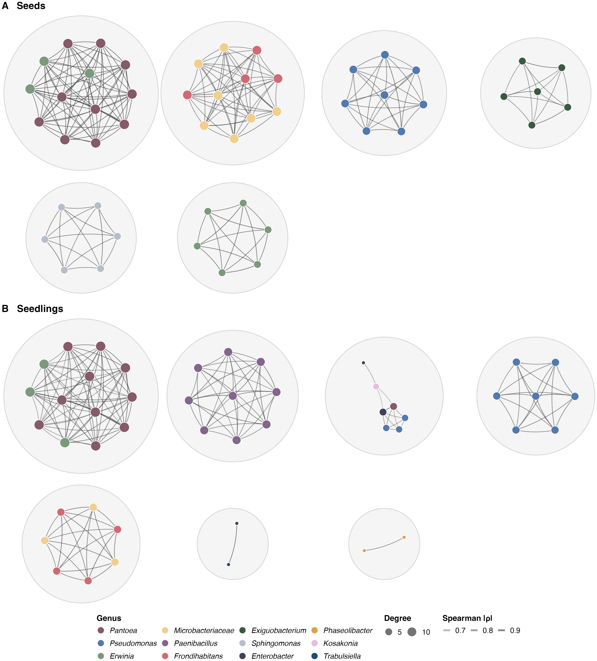 Figure S1. Co-occurrence networks of seeds and seedlings. Networks of the 50 most abundant ASVs of each developmental stage, built separately for seeds (A; 1,282 samples) and seedlings (B; 602 samples) and drawn by connected module. Nodes are ASVs, coloured by genus and sized by degree; edges are Spearman correlations with |ρ| ≥ 0.6 and adjusted p < 0.05 within the stage. Each grey disc holds one module, and the modules are arranged by their number of ASVs, from the largest to the smallest; the genera that make up each module are named in the results.

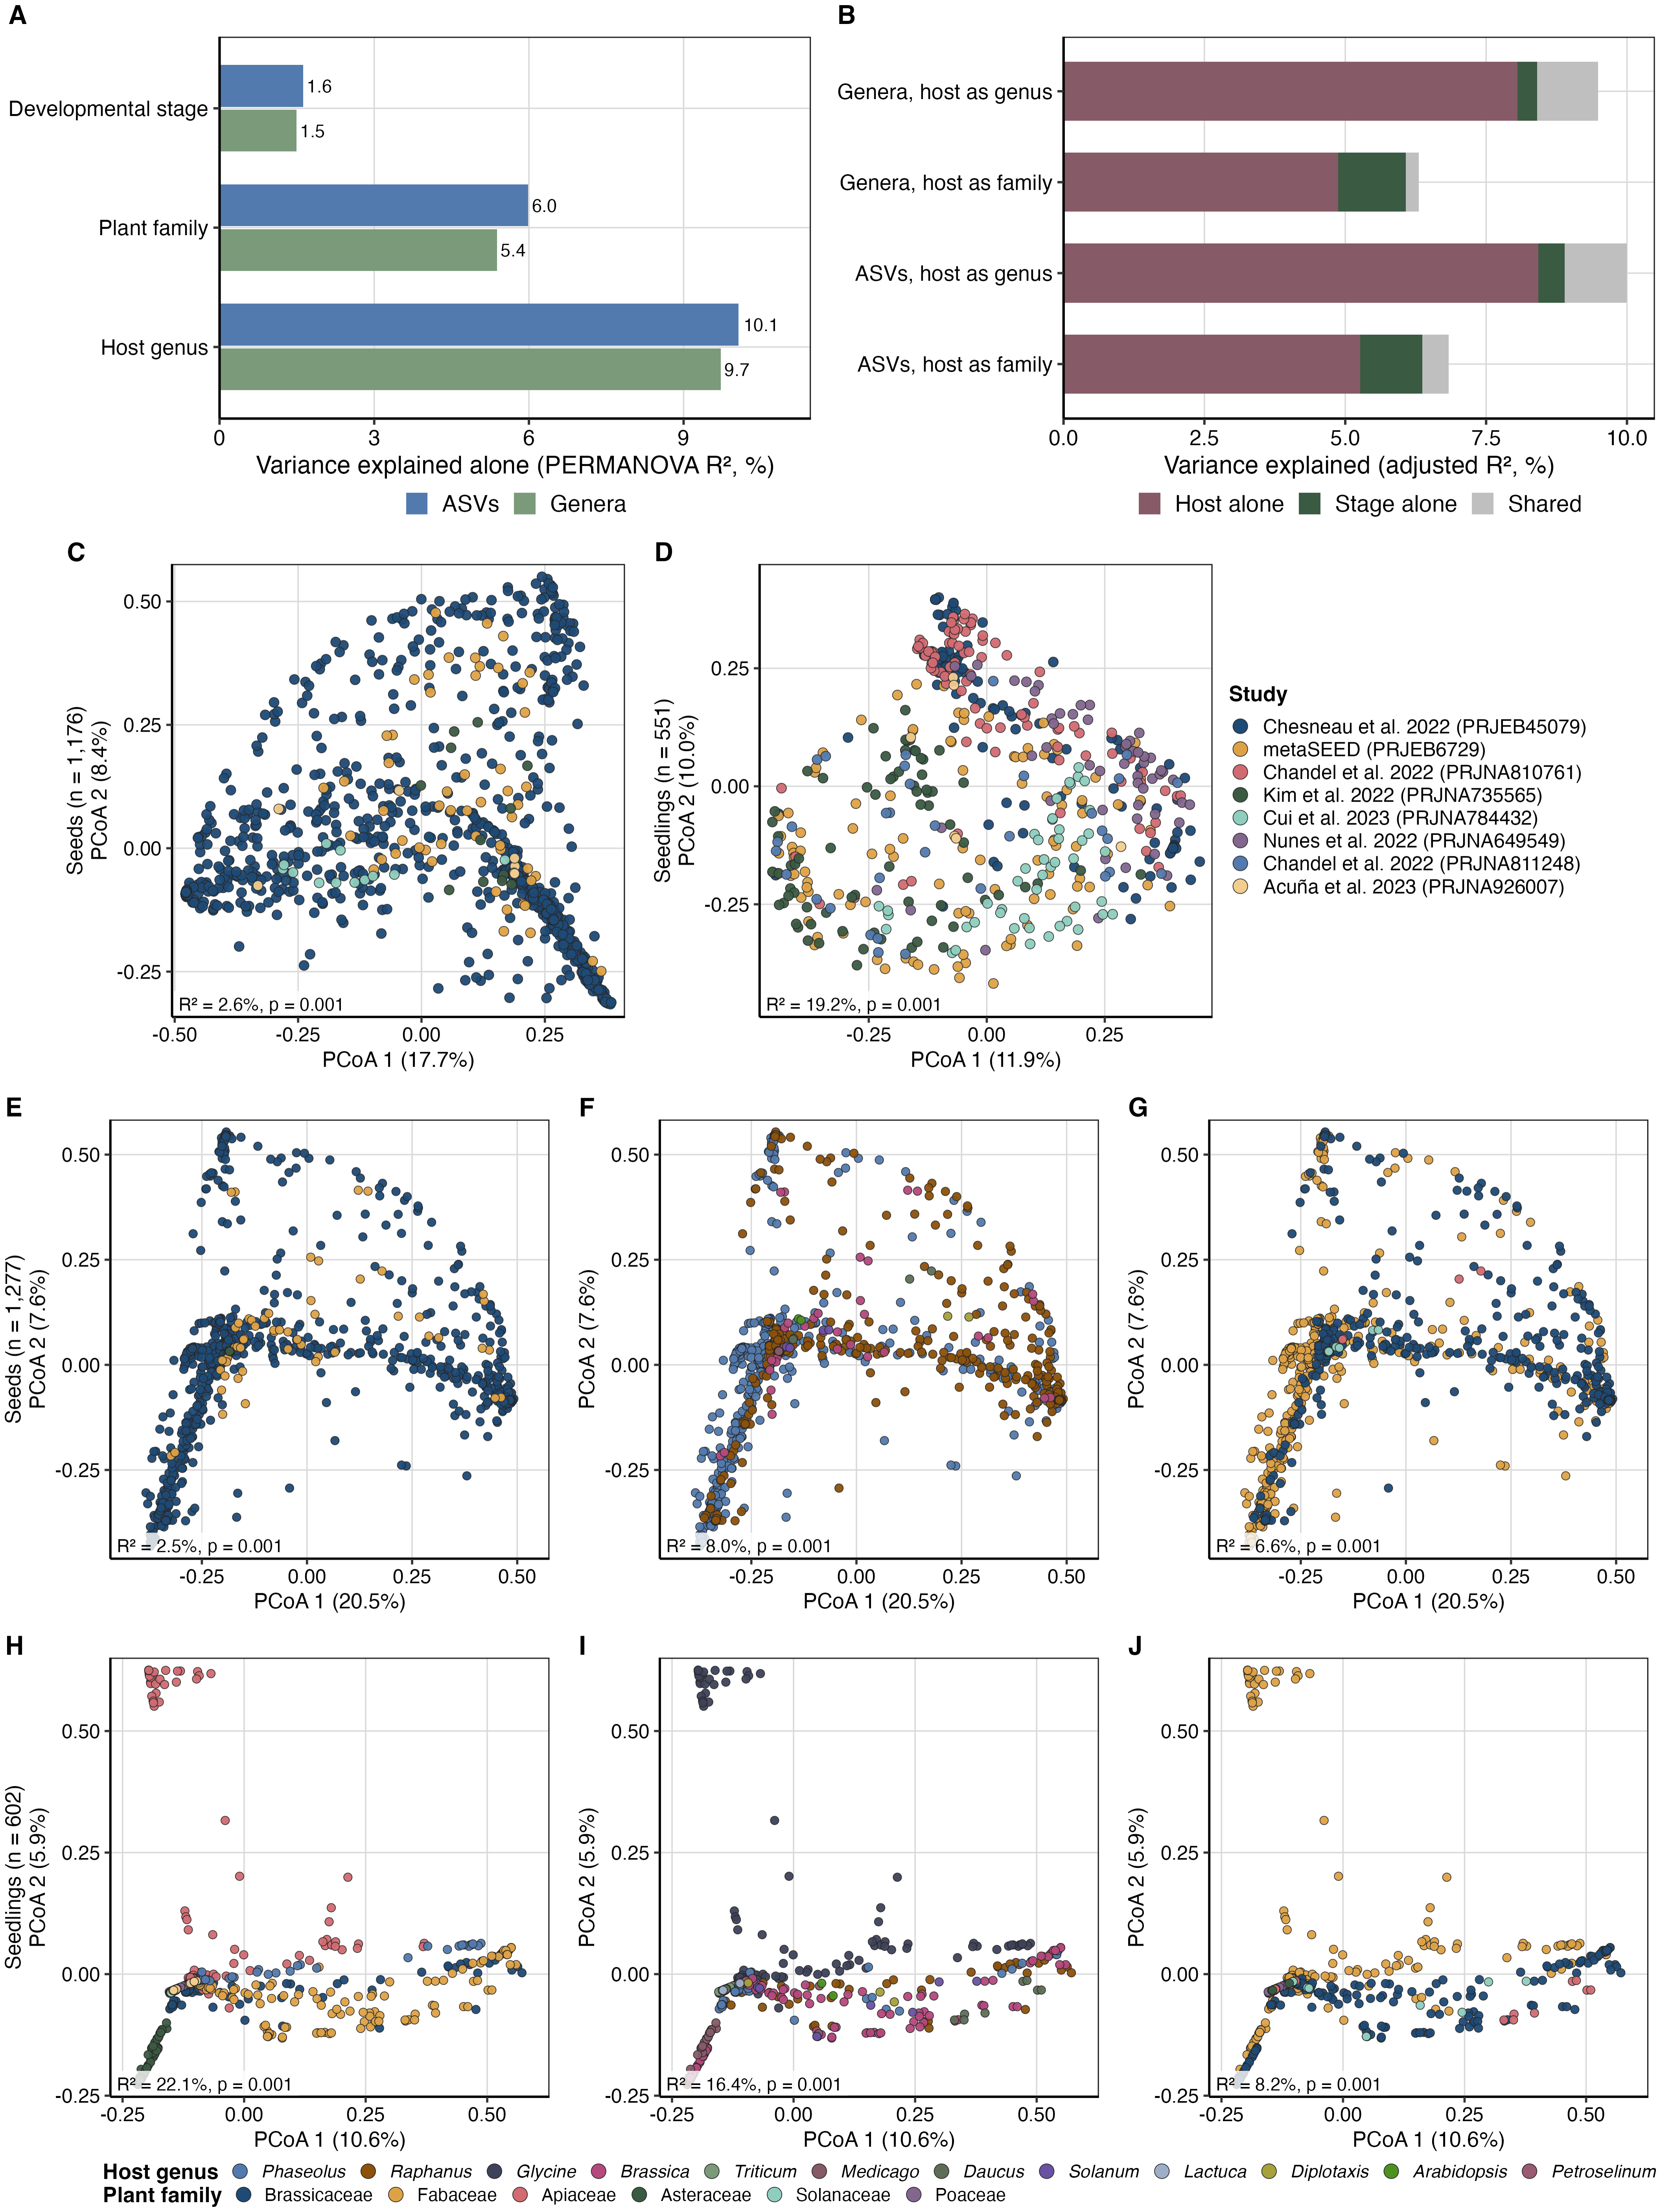
Figure S2. What structures the communities: explained variance, and study and host within each stage. A, PERMANOVA R² of each variable alone (developmental stage, plant family, and host genus), at genus and at ASV level (999 permutations). B, Variance partitioning between host (as host genus or plant family) and developmental stage (adjusted R²), at genus and at ASV level. C, D, Principal coordinates analysis of Bray–Curtis dissimilarities (cumulative sum scaling, genus level), computed separately for seeds (C) and seedlings (D), as in Figure 2B–E, and coloured by study. E–J, The same at ASV level, for seeds (E–G) and seedlings (H–J), coloured by study (E, H), host genus (F, I) and plant family (G, J). R² and p of the PERMANOVA of the variable within the stage are given on each panel (999 permutations). Each stage has its own axes.
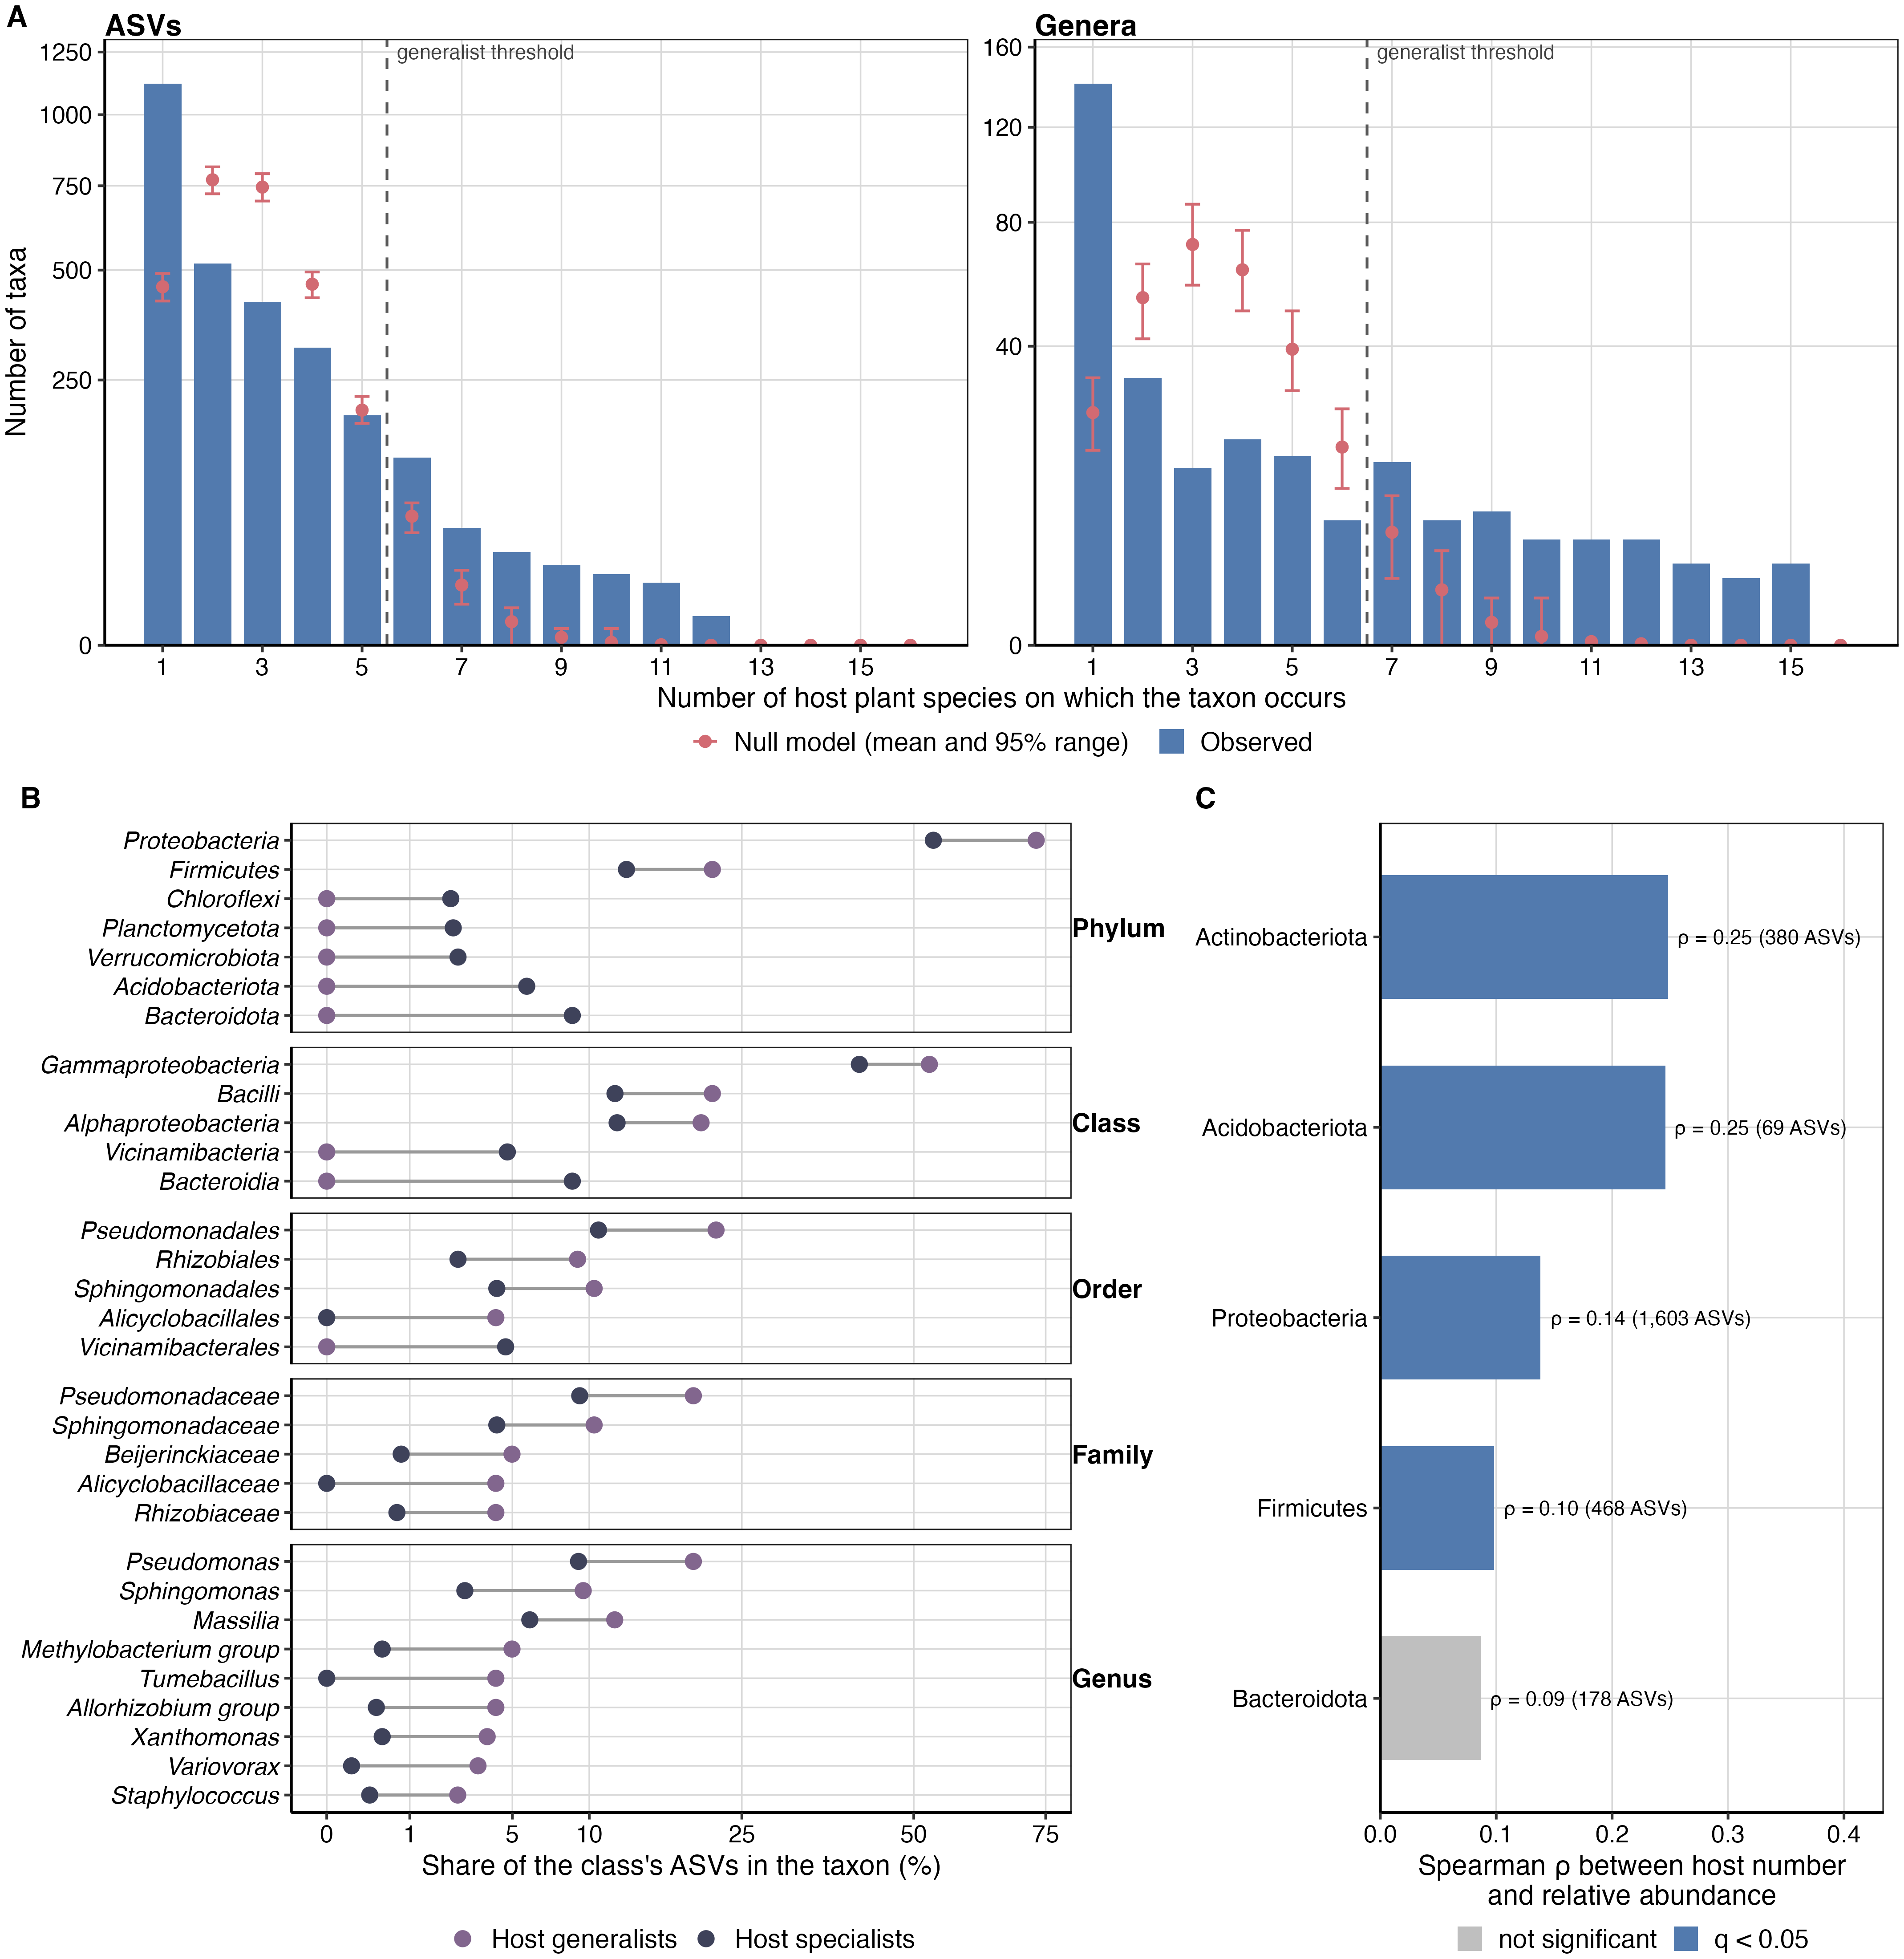
Figure S3. Host breadth: the null model and the taxa of host generalists and specialists. A, ASVs and genera found on each number of host plant species (bars) against the null expectation (points, mean; error bars, 95% range of 1,000 iterations). The dashed line marks the generalist threshold. B, Taxa whose share of ASVs differs between the two classes (Fisher's exact test, q < 0.05). C, Spearman correlation (ρ) between the number of host species and relative abundance, within the five phyla richest in ASVs, with the number of ASVs tested.
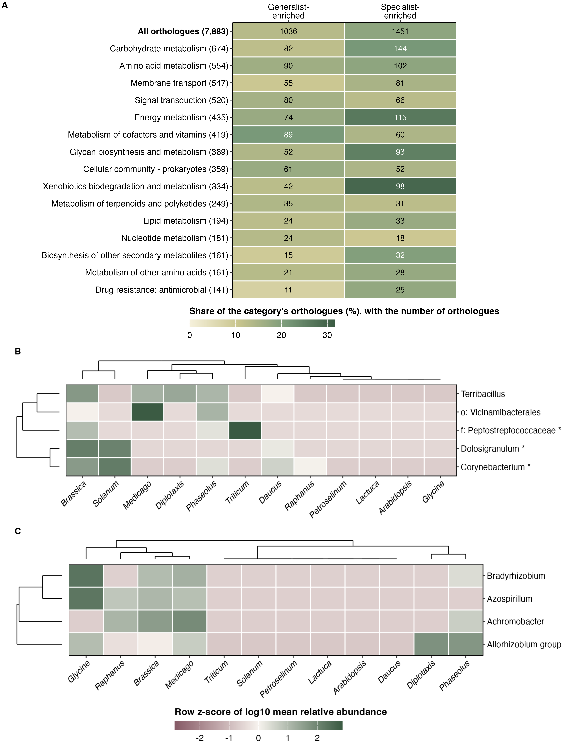
Figure S4. Predicted functions and host: orthologue categories and bacteria with distinctive traits. A, Share of the KEGG orthologues of each KEGG level-2 category that is enriched in host generalists or in host specialists (FDR < 0.05, absolute log2 odds ratio of at least 0.5), with the number of orthologues in each cell; the 15 categories with the most orthologues and, in the first row, all 7,883 orthologues. B, Predicted anaerobic bacteria (BugBase). C, Predicted nitrogen-fixing bacteria (FAPROTAX). Colour is the mean relative abundance of each taxon on each host plant genus, log10-transformed and scaled by row; rows and columns are clustered by Ward's method. A star marks taxa that differ among host plant orders (Kruskal–Wallis, q < 0.05); f, family; o, order. Orthologues, traits and special groups are predicted from the 16S rRNA gene.
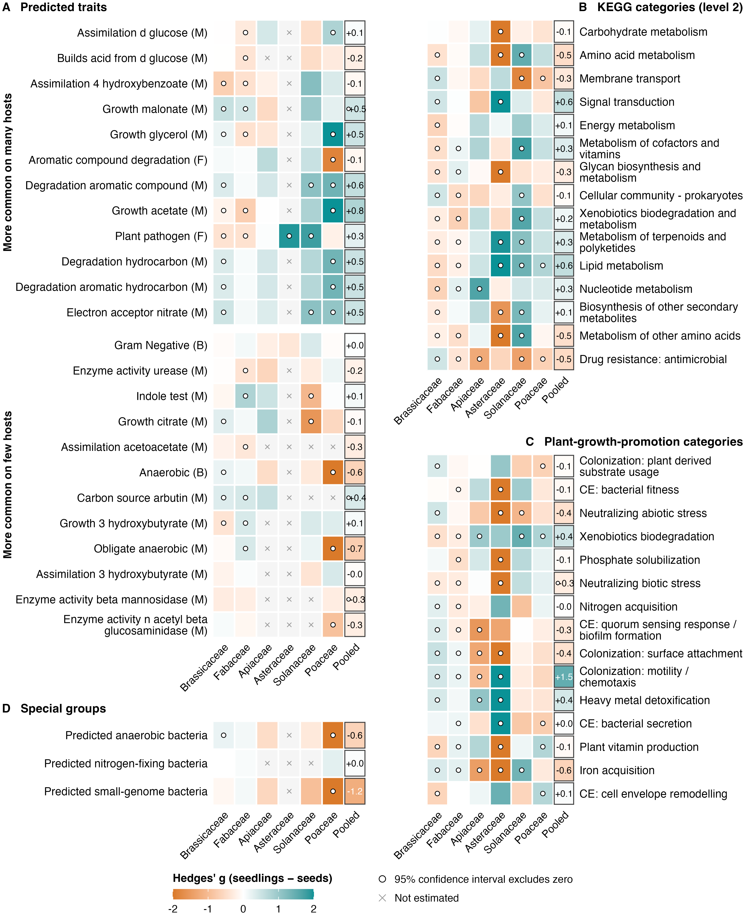
Figure S5. Predicted functions between developmental stages. Cells are, within each plant family, Hedges' g, seedlings minus seeds (orange, higher in seeds; teal, higher in seedlings); the framed column is the random-effects pooled estimate, a dot marks a 95% confidence interval that excludes zero, and a cross a cell that could not be estimated. A, Predicted traits. B, C, KEGG level-2 and PGPg_finder categories. D, The three special groups. Orthologues, traits and special groups are predicted from the 16S rRNA gene.

