Kevin Abrahams

Project 2 Assignment

CMIS 242

3/20/20

|  |  |  |  |
| --- | --- | --- | --- |
| **Input** | **Expected Output** | **Actual Output** | **Pass?** |
| Make and Model: Chevrolet Bolt  Sales Price: 36620  Automobile Type: Electric  Weight in Pounds: 3563 | **\*\* Output \*\***  A sales tax of 1681.0 is displayed after clicking the compute sales tax button.  The following is displayed in the console after clicking display report:  Make and Model: Chevrolet Bolt  Sales Price: 36620.0  Sales Tax: 1681.0  Electric Vehicle  Weight: 3563 | **\*\* Output \*\***  A sales tax of 1681.0 is displayed after clicking the compute sales tax button.  The following is displayed in the console after clicking display report:  Make and Model: Chevrolet Bolt  Sales Price: 36620.0  Sales Tax: 1681.0  Electric Vehicle  Weight: 3563 | Yes |
| Make and Model: Toyota Yaris  Sales Price: 15650  Automobile Type: Other | **\*\* Output \*\***  A sales tax of 782.5 is displayed after clicking the compute sales tax button.  The following is displayed in the console after clicking display report:  Make and Model: Toyota Yaris  Sales Price: 15650.0  Sales Tax: 782.5 | **\*\* Output \*\***  A sales tax of 782.5 is displayed after clicking the compute sales tax button.  The following is displayed in the console after clicking display report:  Make and Model: Toyota Yaris  Sales Price: 15650.0  Sales Tax: 782.5 | Yes |
| Make and Model: Pontiac Vibe  Sales Price: 17000  Automobile Type: Hybrid  Miles per Gallon: 32 | **\*\* Output \*\***  A sales tax of 750.0 is displayed after clicking the compute sales tax button.  The following is displayed in the console after clicking display report:  Make and Model: Chevrolet Bolt  Sales Price: 36620.0  Sales Tax: 1681.0  Electric Vehicle  Weight: 3563 | **\*\* Output \*\***  A sales tax of 750.0 is displayed after clicking the compute sales tax button.  The following is displayed in the console after clicking display report:  Make and Model: Chevrolet Bolt  Sales Price: 36620.0  Sales Tax: 1681.0  Electric Vehicle  Weight: 3563 | Yes |

**Test Case 1 Screenshot:**

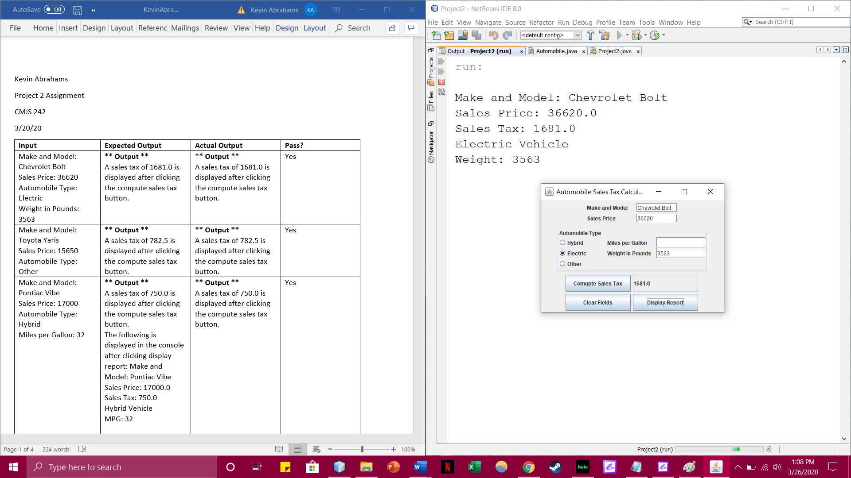

**Test Case 2 Screenshot:**

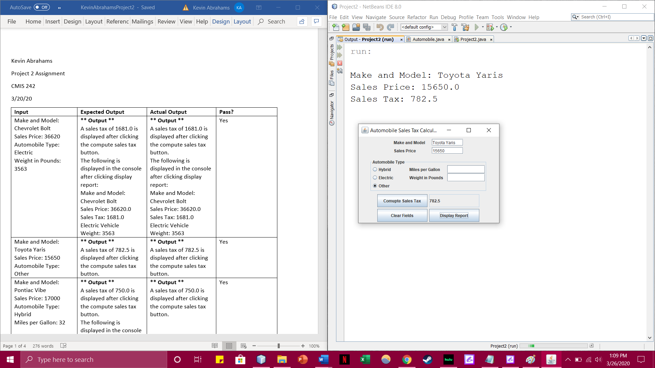

**Test Case 3 Screenshot:**

