Kevin Abrahams

Project 4 Assignment

CMIS 242

4/1/20

|  |  |  |  |
| --- | --- | --- | --- |
| **Input** | **Expected Output** | **Actual Output** | **Pass?** |
| Transaction No: 12345  Address: 1st Orange Avenue  Bedrooms: 3  Square Footage: 500  Price: 100000 | Inserting and finding the same property  **\*\* Output \*\***  Successfully added new property to database  Successfully found the property with the provided transaction number. Below is the property’s info:  Property Address: 1st Orange Avenue  Number of Bedrooms: 3  Square Footage: 500  Price: 100000  Current Status: FOR_SALE | Inserting and finding the same property  **\*\* Output \*\***  Successfully added new property to database  Successfully found the property with the provided transaction number. Below is the property’s info:  Property Address: 1st Orange Avenue  Number of Bedrooms: 3  Square Footage: 500  Price: 100000  Current Status: FOR_SALE | Yes |
| Transaction No: 78159  Address: 145 Rose Street  Bedrooms: 2  Square Footage: 300  Price: 80000 | Trying to delete a property from database without first inserting it  **\*\* Output \*\***  ERROR: No property with the specified transaction number exists within database. | Trying to delete a property from database without first inserting it  **\*\* Output \*\***  ERROR: No property with the specified transaction number exists within database. | Yes |
| Transaction No: 34518  Address: 888 Mary Road  Bedrooms: 4  Square Footage: 550  Price: 135000 | Inserting new property, changing its status to UNDER_CONTRACT, finding the property, and then lastly deleting it  **\*\* Output \*\***  Successfully added new property to database  Successfully changed the status of the database property with the provided transaction number.  Successfully found the property with the provided transaction number. Below is the property’s info:  Property Address: 888 Mary Road  Number of Bedrooms: 4  Square Footage: 550  Price: 135000  Current Status: UNDER_CONTRACT  Successfully deleted property from database. | Inserting new property, changing its status to UNDER_CONTRACT, finding the property, and then lastly deleting it  **\*\* Output \*\***  Successfully added new property to database  Successfully changed the status of the database property with the provided transaction number.  Successfully found the property with the provided transaction number. Below is the property’s info:  Property Address: 888 Mary Road  Number of Bedrooms: 4  Square Footage: 550  Price: 135000  Current Status: UNDER_CONTRACT  Successfully deleted property from database. | Yes |
| Transaction No: 78399  Address: North Avenue  Bedrooms: 2  Square Footage: 200  Price: 75000 | Inserting property, deleting it, and then trying to find it  **\*\* Output \*\***  Successfully added new property to database  Successfully deleted property from database.  ERROR: The property with the provided information could not be found. | Inserting property, deleting it, and then trying to find it  **\*\* Output \*\***  Successfully added new property to database  Successfully deleted property from database.  ERROR: The property with the provided information could not be found. | Yes |

**Test Case 1 Screenshots:**

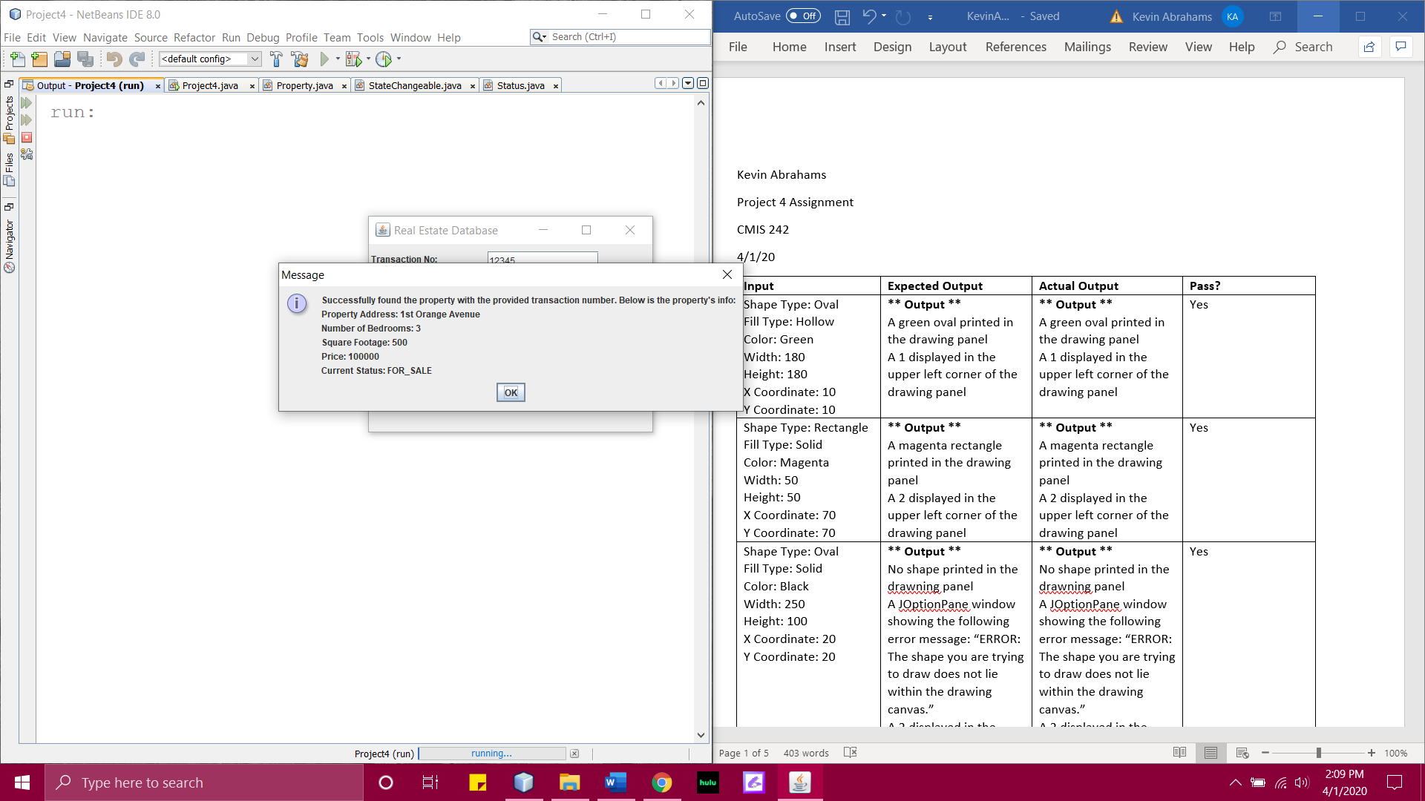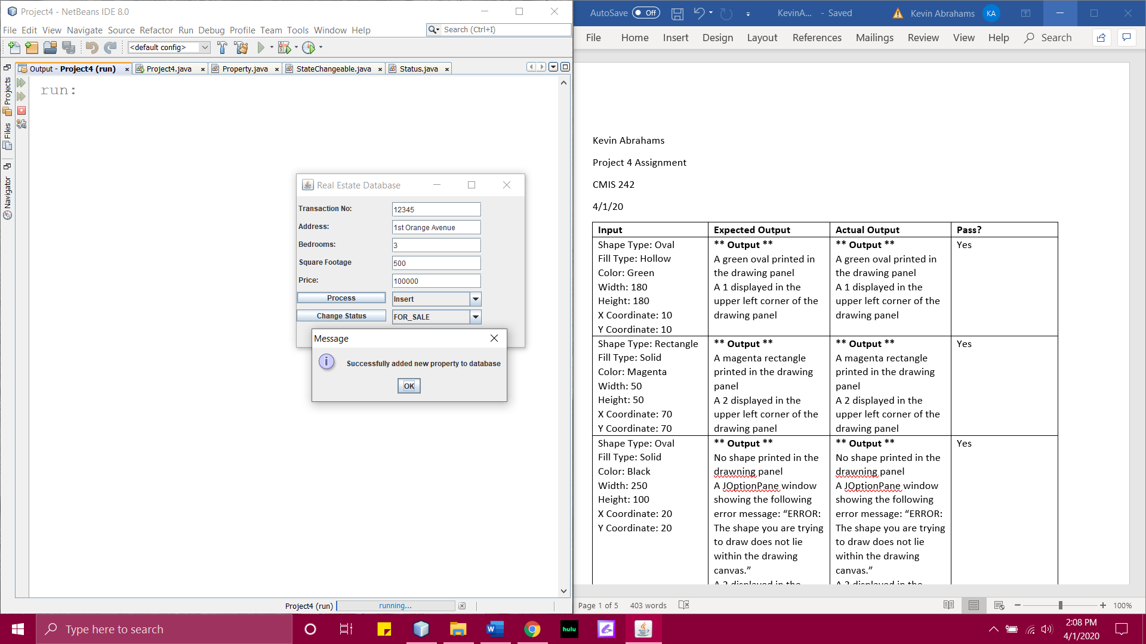

**Test Case 2 Screenshot:**

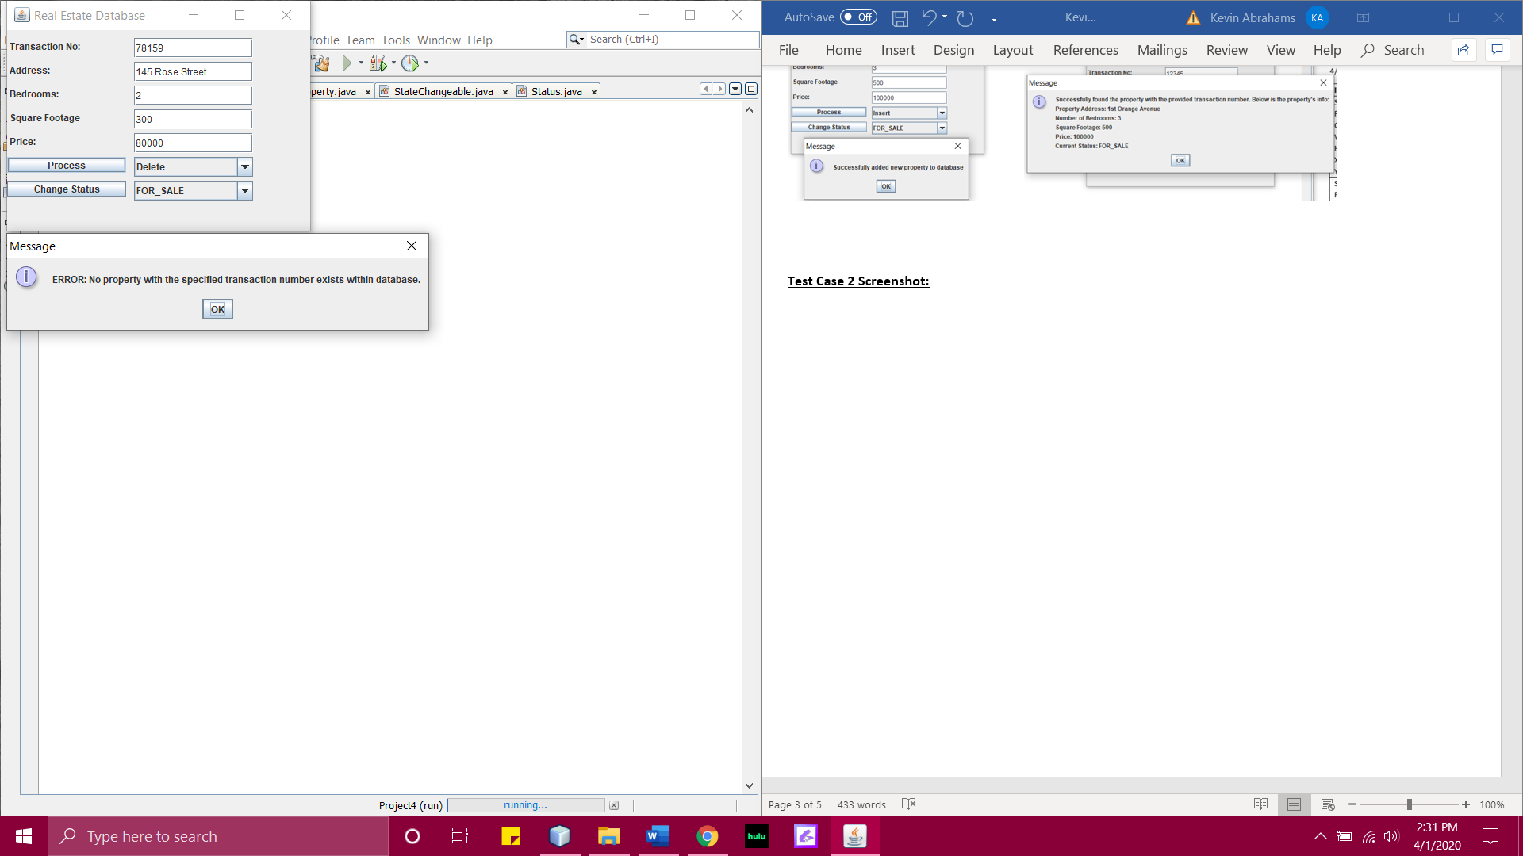

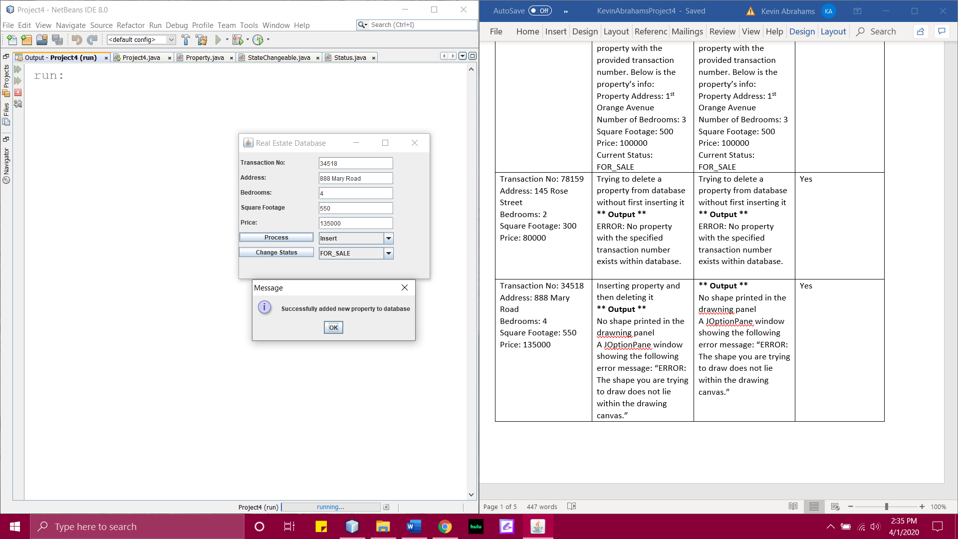**Test Case 3 Screenshots:**

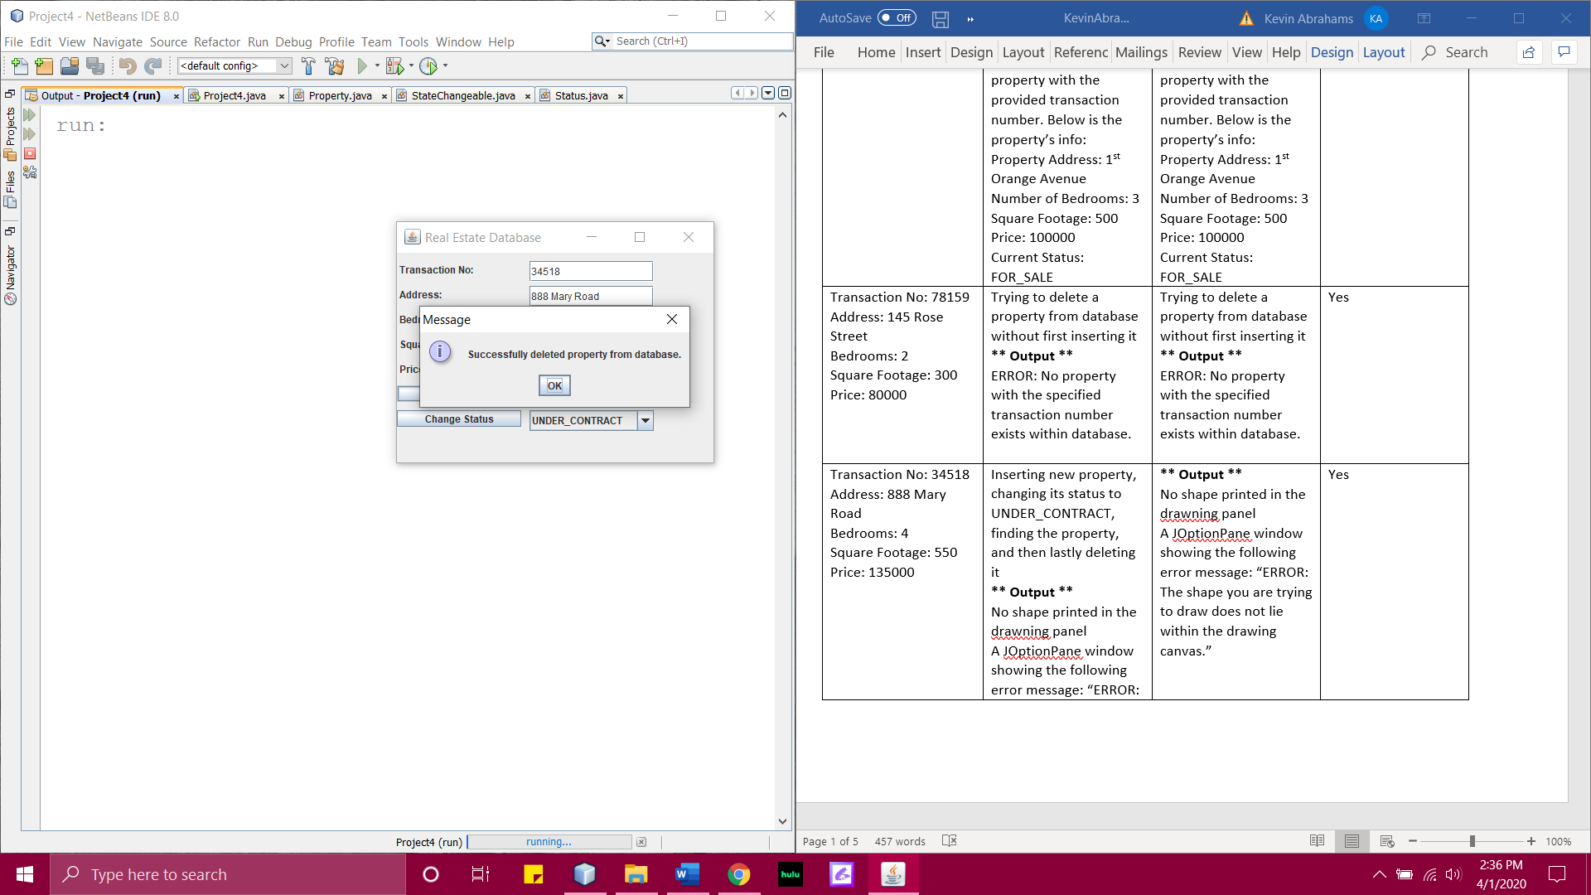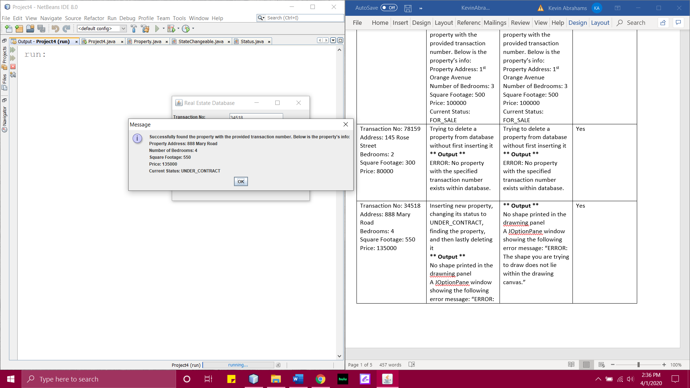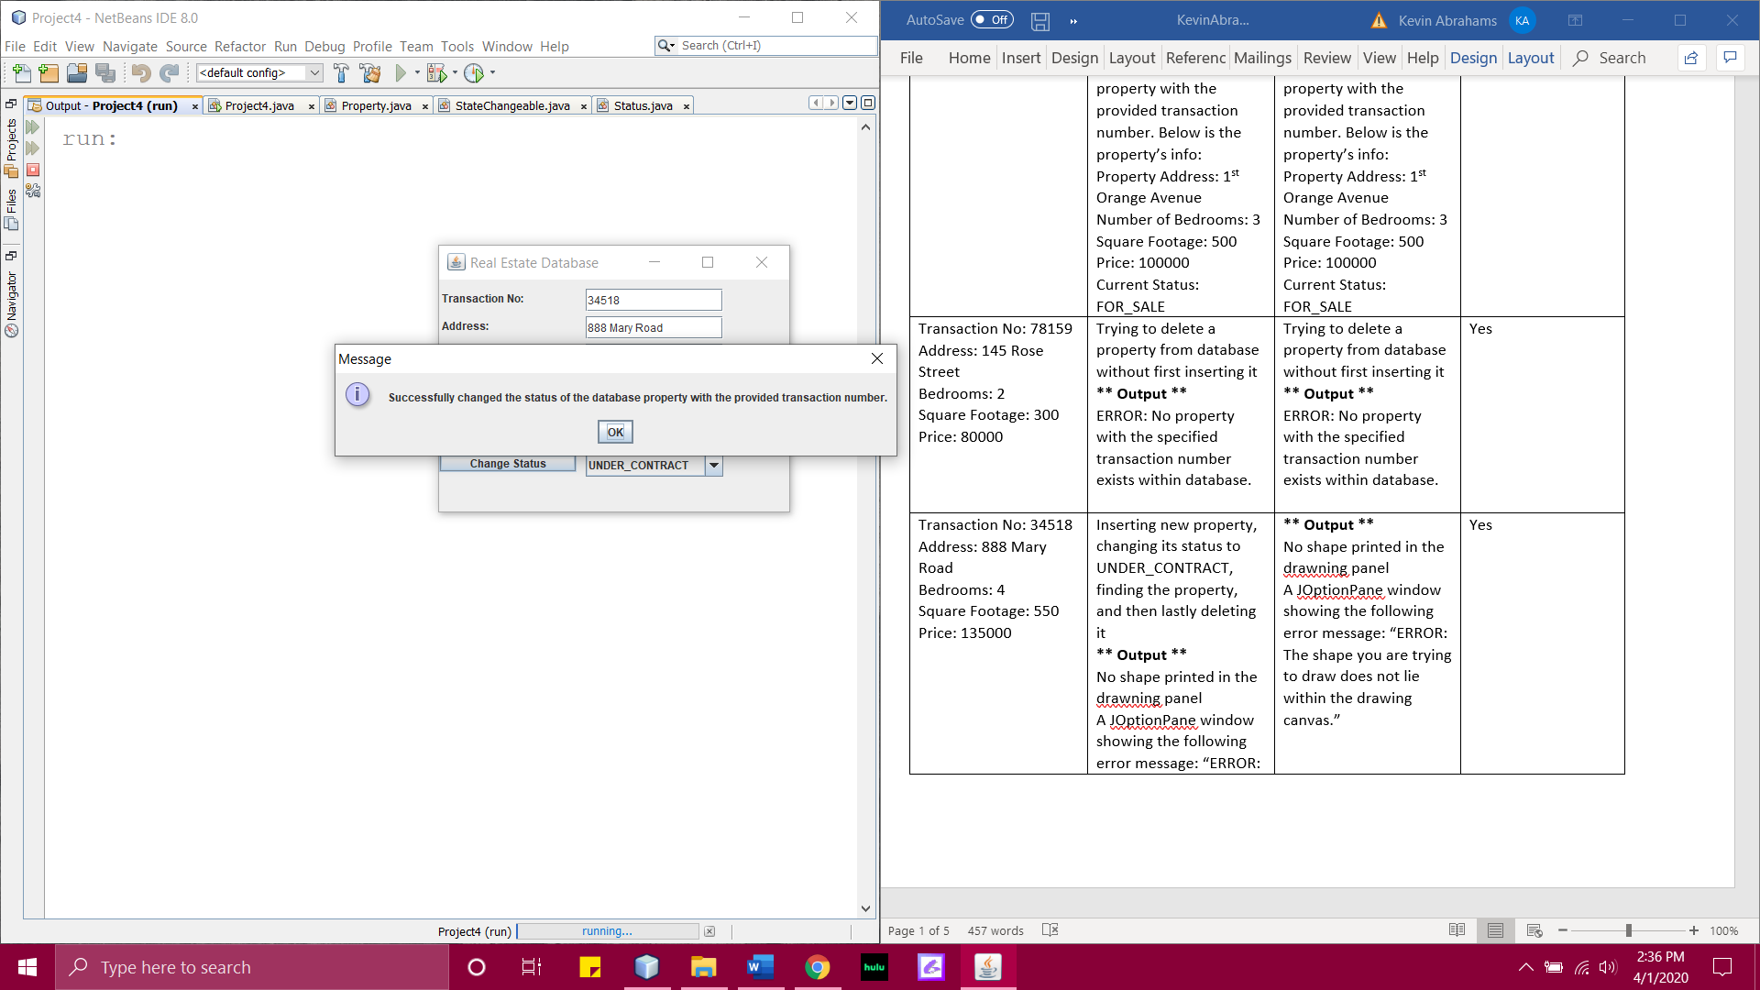

**Test Case 4 Screenshots:**

