Kevin Abrahams

Project 3 Assignment

CMIS 242

3/25/20

|  |  |  |  |
| --- | --- | --- | --- |
| **Input** | **Expected Output** | **Actual Output** | **Pass?** |
| Shape Type: Oval  Fill Type: Hollow  Color: Green  Width: 180  Height: 180  X Coordinate: 10  Y Coordinate: 10 | **\*\* Output \*\***  A green oval printed in the drawing panel  A 1 displayed in the upper left corner of the drawing panel | **\*\* Output \*\***  A green oval printed in the drawing panel  A 1 displayed in the upper left corner of the drawing panel | Yes |
| Shape Type: Rectangle  Fill Type: Solid  Color: Magenta  Width: 50  Height: 50  X Coordinate: 70  Y Coordinate: 70 | **\*\* Output \*\***  A magenta rectangle printed in the drawing panel  A 2 displayed in the upper left corner of the drawing panel | **\*\* Output \*\***  A magenta rectangle printed in the drawing panel  A 2 displayed in the upper left corner of the drawing panel | Yes |
| Shape Type: Oval  Fill Type: Solid  Color: Black  Width: 250  Height: 100  X Coordinate: 20  Y Coordinate: 20 | **\*\* Output \*\***  No shape printed in the drawning panel  A JOptionPane window showing the following error message: “ERROR: The shape you are trying to draw does not lie within the drawing canvas.”  A 2 displayed in the upper left corner of the drawing panel | **\*\* Output \*\***  No shape printed in the drawning panel  A JOptionPane window showing the following error message: “ERROR: The shape you are trying to draw does not lie within the drawing canvas.”  A 2 displayed in the upper left corner of the drawing panel | Yes |
| Shape Type: Oval  Fill Type: Solid  Color: Red  Width: 130  Height: 95  X Coordinate: 25  Y Coordinate: 40 | **\*\* Output \*\***  A red oval printed in the drawing panel  A 3 displayed in the upper left corner of the drawing panel | **\*\* Output \*\***  A red oval printed in the drawing panel  A 3 displayed in the upper left corner of the drawing panel | Yes |
| Shape Type: Rectangle  Fill Type: Hollow  Color: Blue  Width: 100  Height: 140  X Coordinate: 25  Y Coordinate: 50 | **\*\* Output \*\***  A blue rectangle printed in the drawing panel  A 4 displayed in the upper left corner of the drawing panel | **\*\* Output \*\***  A blue rectangle printed in the drawing panel  A 4 displayed in the upper left corner of the drawing panel | Yes |

**Test Case 1 Screenshot:**

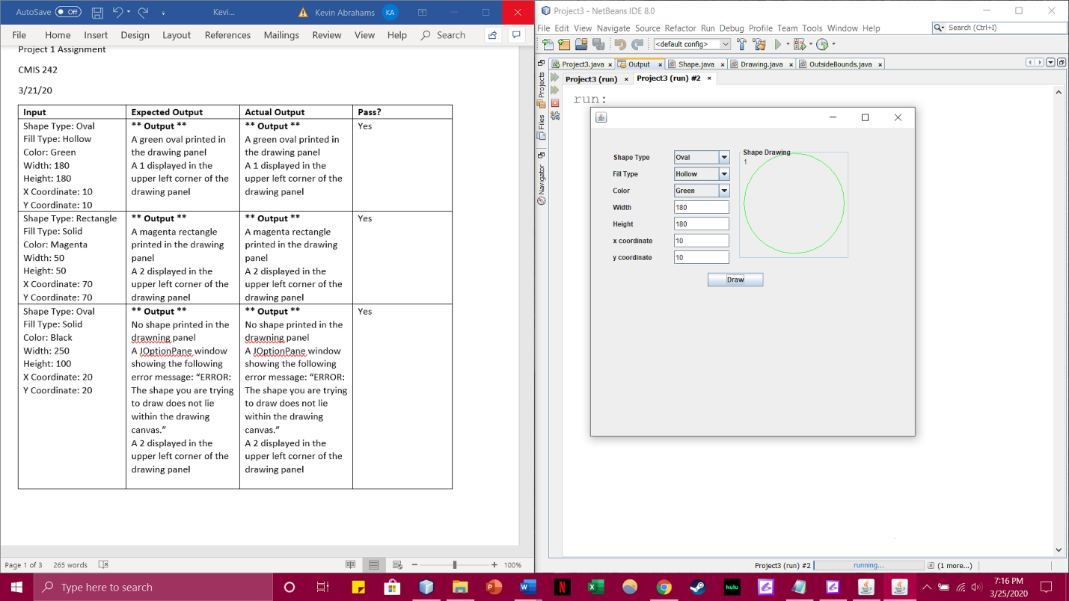

**Test Case 2 Screenshot:**

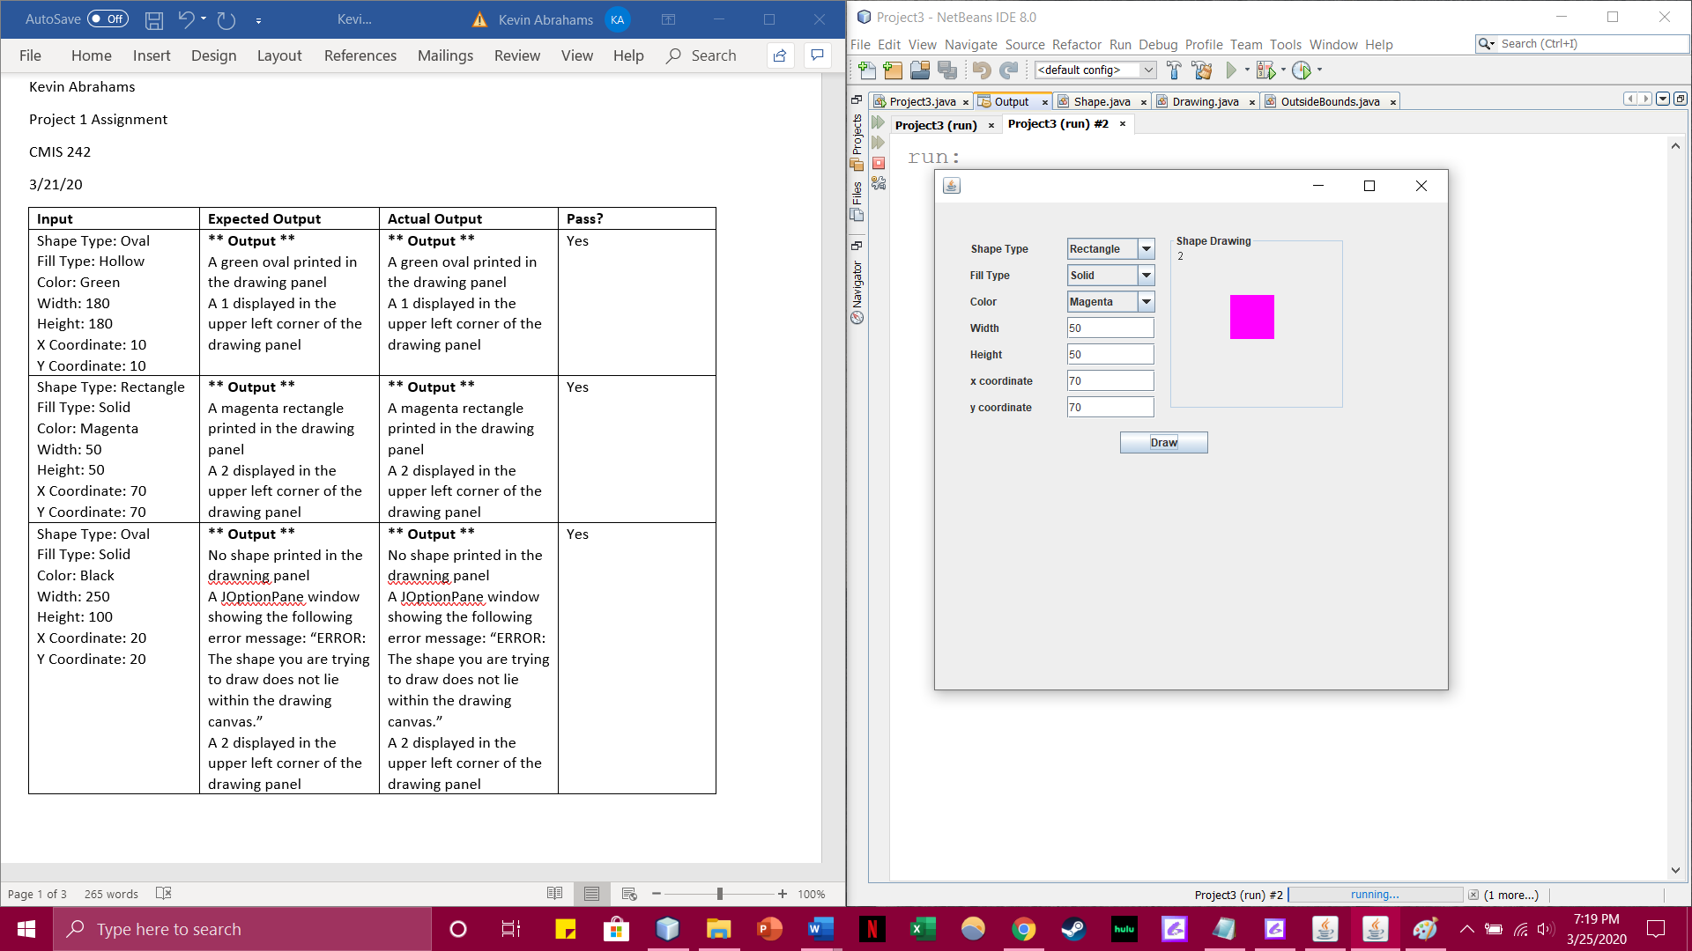

**Test Case 3 Screenshot:**

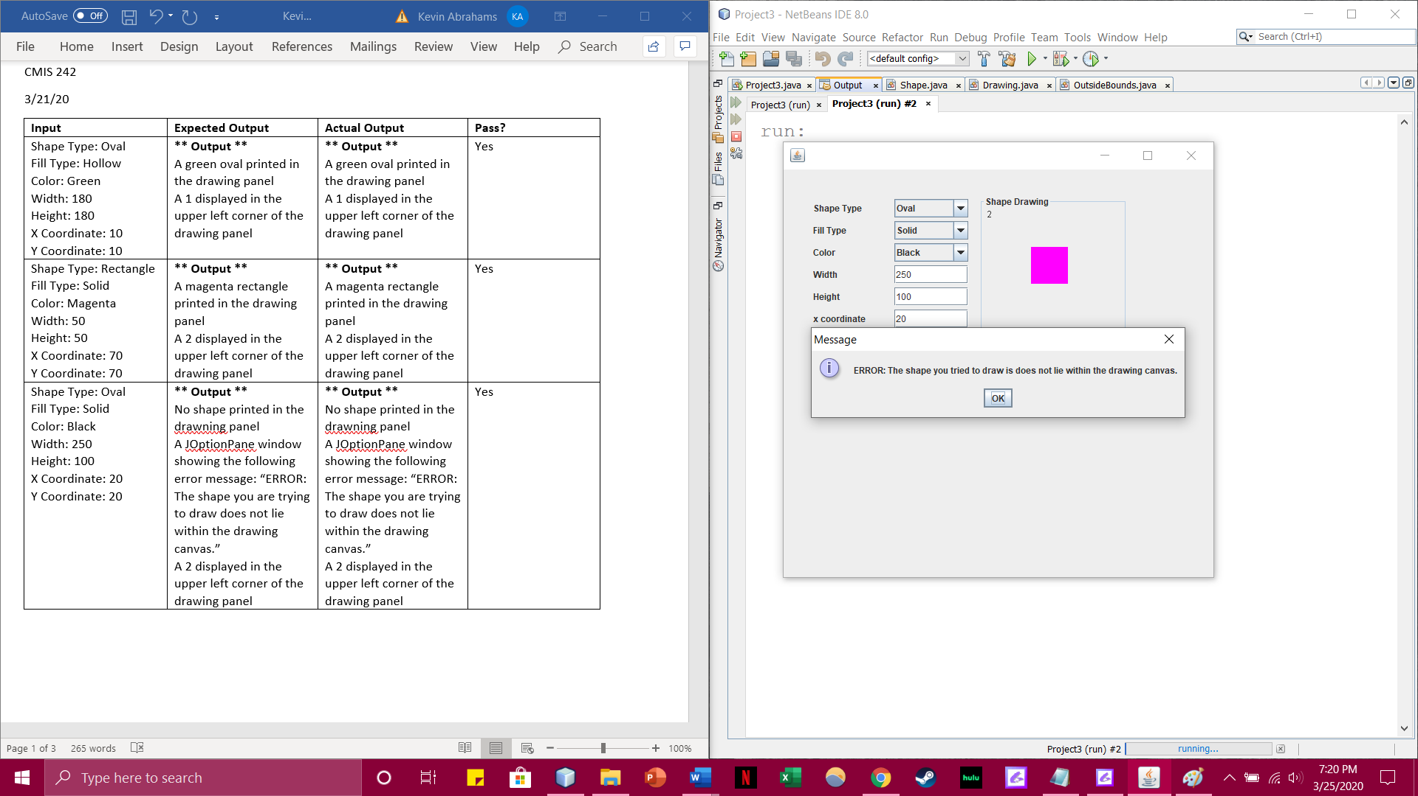

**Test Case 4 Screenshot:**

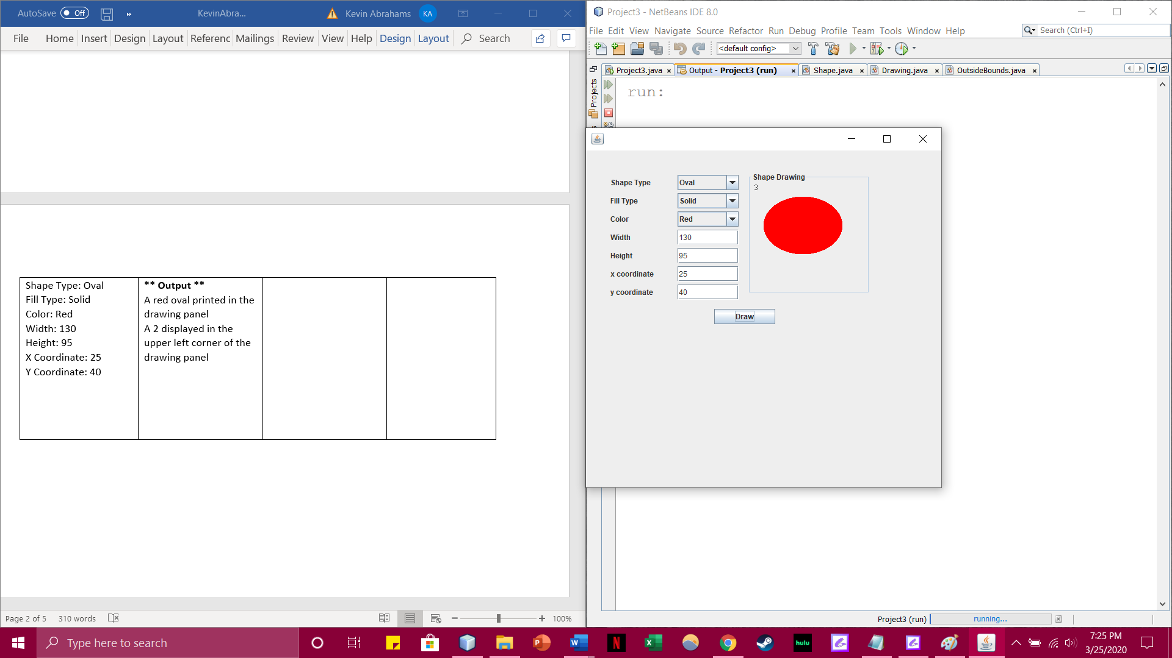

**Test Case 5 Screenshot:**

