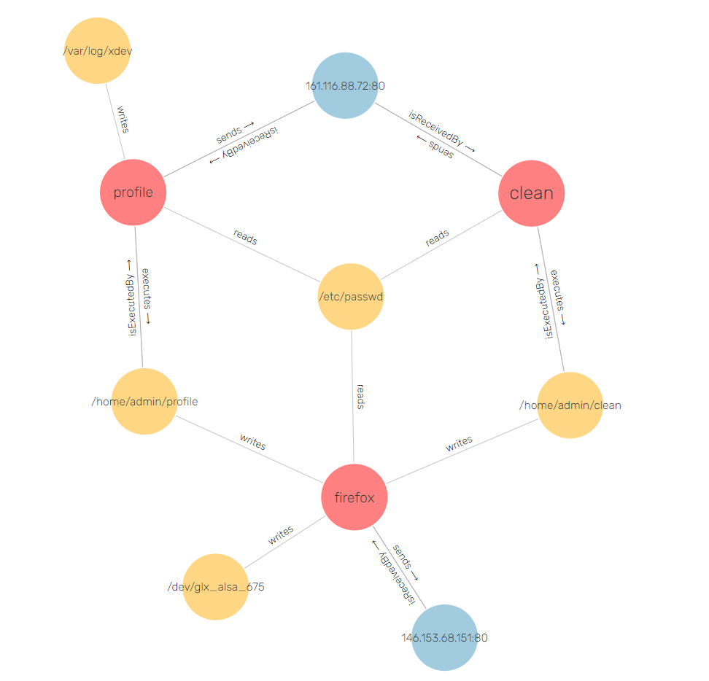

Original Dataset: 3,7 GB

**Before Decay (attenuation only):**

Alarm **count:** 5464 **, Time for parsing: 3.3 minutes**

**After Decay :**

Alarm count : 39, time for parsing : 3.1 minutes