CHAPTER 3: METHODOLOGY

3.1 Introduction
This chapter presents the methodology adopted in the design and development of
CropGuard AI, a mobile application that enables Ghanaian farmers to detect
crop diseases from a photograph of a plant leaf and to receive an appropriate
treatment plan. The chapter describes how the proposed system is structured and
how each of its components works, rather than presenting the low-level code
itself (the detailed algorithms and their implementation are reserved for
Chapter 4).
The chapter begins with the overall architecture of the proposed system and a
description of each architectural component. It then evaluates the type of
software application being developed and states the system's main functionalities
(functional requirements). The stakeholders of the system are identified, the
requirement-gathering process is described, and the requirements are formally
specified through Functional User Requirements, Functional System Requirements
and a complete set of UML diagrams (use case, activity and sequence diagrams)
with accompanying use-case descriptions. Non-functional requirements are then
outlined and justified. The candidate classes of the system are identified and
modelled in a UML class diagram, the principal algorithms are presented together
with their flowcharts, and the chosen project method and software process model
are justified. Finally, the logical design considerations (UI wireframes and the
database design) and the development tools used in the methodology are described.
Diagram conventions in this chapter. All diagrams are provided as text (Mermaid / ASCII) so they render in Markdown and can be pasted directly into Lucidchart, draw.io or Mermaid Live (https://mermaid.live) to produce the final exported figures for the report. Where a screenshot or hand-drawn wireframe is expected, a placeholder [Insert Figure …] is given.

3.2 Architecture of the Proposed System
CropGuard AI is built on a layered Clean Architecture with a strict,
unidirectional dependency rule: outer layers depend on inner layers, never the
reverse. The system is organised into three layers — Presentation,
Domain and Data — supported by a cross-cutting Core layer. This
separation makes the system testable, allows the user interface and the data
sources (database, machine-learning model, cloud services) to evolve
independently, and keeps the business rules isolated from framework details.
A defining characteristic of the architecture is that it is offline-first:
the core capability — capturing an image and classifying the disease using an
on-device Convolutional Neural Network (CNN) — works entirely without an internet
connection. Cloud services (authentication, synchronisation, community feed) are
treated as optional enhancements layered on top of the offline core.

3.2.1 High-Level Architecture Diagram
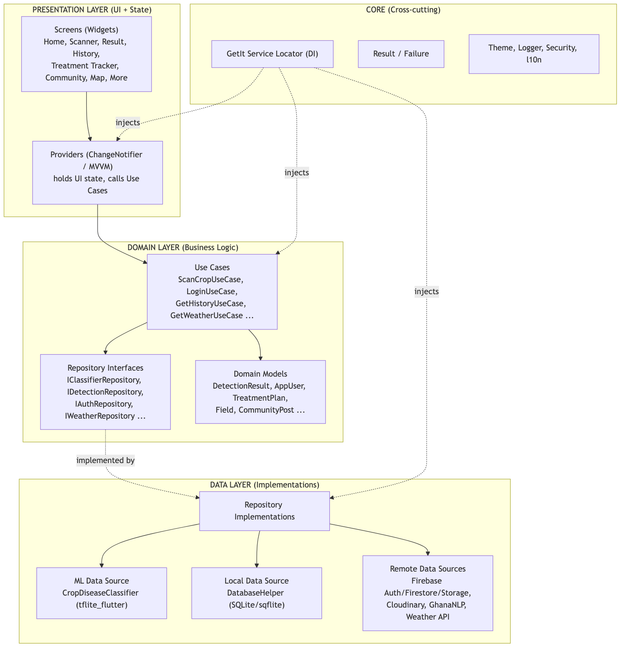
Dependency flow: UI → Use Cases → Repository Interfaces → Data Sources.
The user interface never imports SQLite, Firebase or the TensorFlow Lite engine
directly; every operation passes through a use case, and every fallible operation
returns a Result<T> object that carries either the data or a typed Failure.
Dependency Injection is provided by GetIt (a service locator), which
constructs and wires every data source, repository, use case and provider at
application start-up.

3.3 Component Designs and Component Descriptions
This section describes how each component in the architectural design functions.
(The detailed algorithms are presented in Chapter 4; here we describe the working
of each component, supported by diagrams where required.)

3.3.1 Presentation Components (Screens and Providers)
The presentation layer follows the MVVM pattern. Each feature has a Screen
(a pure Flutter widget that only renders state) and a Provider (a
ChangeNotifier that holds the UI state and calls use cases). When a use case
returns a Result, the provider folds it into one of four UI states —
loading, success, error or empty/offline — and notifies its listeners, which
triggers a rebuild of the screen. This keeps widgets free of business logic and
guarantees that a Failure never reaches the UI as an unhandled exception.
Navigation between screens is handled by go_router, with a ShellRoute that
hosts the bottom navigation bar (Home, History, More) and full-screen push
routes for the Scanner and Result screens.

3.3.2 Use Case Components (Domain Logic)
Each use case encapsulates a single unit of business logic and orchestrates one
or more repositories. The principal use cases are:
Use Case | Responsibility
ScanCropUseCase | Runs classification, derives severity, persists the result, updates the scan streak
LoginUseCase / RegisterUseCase / SignInWithGoogleUseCase / SignInAnonymouslyUseCase / LogoutUseCase / SendPasswordResetUseCase | Authentication operations
GetHistoryUseCase / DeleteDetectionUseCase / RestoreDetectionUseCase | Scan-history management
GetHomeDataUseCase | Aggregates farm statistics, recent scans and weather for the dashboard
GetWeatherUseCase | Retrieves localised weather and disease-risk forecast

For example, ScanCropUseCase works as follows: it calls the classifier
repository to obtain a Classification; it maps the model's confidence and
health flag onto a severity band (healthy, early, moderate, severe);
it builds a DetectionResult enriched with the disease's display name, cause and
recommended treatments; it persists the result through the detection repository;
and it records the scan against the user's daily streak. Each step short-circuits
to a typed Failure if it fails.

3.3.3 Machine-Learning Component (`CropDiseaseClassifier`)
This is the core component of the system. It wraps tflite_flutter and runs a
CNN (MobileNetV2-based, trained by transfer learning) entirely on the device. Its
working can be summarised as:
- Model loading. Two quantised TFLite models and their label files are loaded
from the application assets (cropguard_plant_disease.tflite with 54 classes
and cropguard_plant_disease_v2.tflite with 16 classes).
- Pre-processing. The captured image is decoded, resized to 224 × 224
pixels, and each pixel's R, G, B channels are normalised to the range [0, 1]
to form a [1, 224, 224, 3] float input tensor.
- Inference. Both models are executed on the tensor. Because the two models
have different numbers of output classes, each model's top confidence is
adjusted by subtracting its uniform-chance probability (1 / numClasses) so
that the smaller model's naturally softer soft-max does not dominate. The model
with the higher adjusted score wins.
- Result assembly. The winning label is looked up in an on-device disease
database to attach the display name, crop type, cause and treatments, producing
a ClassificationResult.
- Confidence gating. A confidence threshold of 0.60 is applied; results
below this trigger a "low-confidence / retake photo" warning.
Crucially, inference is executed inside a background isolate (via Flutter's
compute()), so the heavy pixel-tensor construction and interpreter execution do
not block the UI thread or cause jank on low-end devices.
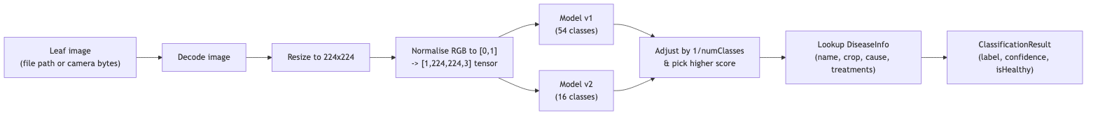
Figure 3.1 — Working of the CropDiseaseClassifier component.

3.3.4 Local Persistence Component (`DatabaseHelper`)
This component wraps SQLite (sqflite) and is the offline store for scan
history, fields, treatment plans and notifications. It manages schema creation
and versioned migrations (current schema version 11), inserting detections,
querying history (all/recent/by-id), deleting and restoring records (and the
associated image files on disk), and computing farm statistics and the 7-day
disease trend used on the dashboard. All multi-step writes use SQLite
transactions to preserve data integrity.

3.3.5 Remote Data Components
These optional components synchronise and enrich data when connectivity is
available:
- Firebase Auth — email/password, Google Sign-In and anonymous (guest) login.
- Cloud Firestore — cloud mirror of scans and the community feed.
- Firebase Storage / Cloudinary — hosting of community and scan images.
- GhanaNLP service — text-to-speech / speech-to-text for the voice assistant
in local languages.
- Weather API — weather and disease-risk forecasting for the dashboard.

3.3.6 Core / Cross-Cutting Components
- Service Locator (GetIt) — registers and injects all dependencies.
- `Result<T>` / `Failure` — uniform error-handling envelope.
- Security helpers — root/jailbreak detection, screenshot blocking on
sensitive screens, and certificate pinning.
- Localization (l10n) — English, Twi, Ewe and Dagbani via ARB files.

3.4 Evaluation and Analysis of the Type of Software System to be Developed
CropGuard AI is a native cross-platform mobile application (Android and iOS),
developed with the Flutter framework and the Dart language. The evaluation of
candidate application types is summarised below.
Application type | Suitability for CropGuard AI
Web application | Rejected — requires constant connectivity; cannot easily run on-device CNN inference; poor camera/offline support in rural areas with weak networks.
Native (per-platform) app | Capable but doubles development effort (separate Kotlin and Swift codebases) for a student project.
Hybrid / cross-platform (Flutter) | Selected — single codebase for Android and iOS, near-native performance, first-class camera and on-device ML support, and an offline-first runtime.

The application is therefore best classified as an **intelligent, data-driven,
offline-first mobile application** that combines:
- an embedded machine-learning system (on-device CNN inference);
- a local transactional database system (SQLite); and
- a client of cloud back-end services (Firebase/Cloudinary) for optional
synchronisation and community features.
This hybrid classification (on-device intelligence + optional cloud back-end) is
the central reason the system remains fully usable in rural farming areas with
intermittent connectivity, while still benefiting from the cloud when a network
is present.

3.5 Main Functionalities of the Proposed System (Functional Requirements)
The system shall provide the following primary functionalities:
- FR1 — Disease detection. Capture or select a leaf image and classify the
crop disease on-device using the CNN.
- FR2 — Result and treatment plan. Display the disease name, confidence,
severity, cause and recommended treatments; warn when confidence is low.
- FR3 — Scan history. Persist every scan locally and allow the farmer to
view, delete and restore past scans.
- FR4 — Treatment tracker. Generate treatment steps with due dates and let
the farmer mark steps complete.
- FR5 — Authentication. Allow email/password, Google and guest (anonymous)
sign-in, registration and password reset.
- FR6 — Dashboard / farm health. Show farm statistics, a 7-day disease trend,
recent scans and weather/disease-risk forecast.
- FR7 — Community feed. Post questions/observations with optional images and
view expert responses.
- FR8 — Outbreak map. Visualise geolocated disease detections on a map.
- FR9 — Voice assistant. Provide text-to-speech and speech-to-text in local
languages.
- FR10 — Notifications and reminders. Issue treatment and scan reminders.
- FR11 — Report export. Export a scan report as a PDF for sharing.
- FR12 — Localization. Operate fully in English, Twi, Ewe and Dagbani.

3.6 Identification of Stakeholders
Stakeholder | Role / Interest in the system
Smallholder farmer (primary user) | Captures leaf images, receives diagnoses and treatment plans, tracks crop health. The system's main beneficiary.
Agricultural extension officer | Uses scan history and the outbreak map to advise farmers and monitor regional disease spread.
Agronomist / plant-health expert | Provides expert responses on the community feed; validates treatment recommendations.
Application administrator / developer | Maintains the app, retrains/updates the ML model and disease database, manages Firebase rules.
Ministry of Food and Agriculture (MoFA) / NGOs | Interested in aggregate outbreak data for policy and food-security planning.
Cloud service providers (Firebase, Cloudinary, GhanaNLP) | External systems the application integrates with.
Researchers / data scientists | Interested in anonymised detection data for model improvement.

3.7 Requirement-Gathering Process
The requirements were elicited using a combination of techniques appropriate to
an agricultural-technology project in the Ghanaian context:
- Interviews with smallholder farmers and extension officers to understand
how crop diseases are currently identified and the pain points of manual
diagnosis (cost, delay, expert scarcity).
- Observation of the photograph-and-diagnose workflow to determine the need
for offline operation, simple UI and local-language support.
- Document and literature review of existing plant-disease datasets
(e.g. PlantVillage), prior mobile diagnosis tools, and agricultural extension
guidelines, which informed the disease classes and treatment content.
- Questionnaires distributed to a sample of farmers to rank desired features
(e.g. voice assistance, community advice, weather alerts).
- Prototyping and feedback — low-fidelity wireframes were shown to
representative users and refined iteratively, consistent with the agile
approach adopted (Section 3.13).
- Technical/feasibility analysis to confirm that on-device CNN inference at
224 × 224 resolution is viable on typical mid-range Android phones.

3.8 Requirement Specification

3.8.1 Functional User Requirements
These describe what the user expects from the system, in user-facing terms:
- FUR1: As a farmer, I want to take a photo of a leaf and immediately see what
disease it has, even without internet.
- FUR2: As a farmer, I want clear treatment advice for the detected disease.
- FUR3: As a farmer, I want to review my previous scans.
- FUR4: As a farmer, I want reminders for the treatment steps I must perform.
- FUR5: As a farmer, I want to use the app in my own language (Twi, Ewe,
Dagbani or English).
- FUR6: As a farmer, I want to hear the diagnosis read aloud and ask by voice.
- FUR7: As a farmer, I want to ask the community and get expert answers.
- FUR8: As an extension officer, I want to see where outbreaks are occurring.
- FUR9: As a user, I want to create an account, log in, or continue as a guest.
- FUR10: As a farmer, I want to export and share a scan report.

3.8.2 Functional System Requirements
These describe what the system must do to satisfy the user requirements:
- FSR1: The system shall acquire an image from the device camera or gallery.
- FSR2: The system shall pre-process the image (decode, resize to 224 × 224,
normalise RGB to [0, 1]).
- FSR3: The system shall run on-device CNN inference and return the top label
with a confidence score.
- FSR4: The system shall reject/flag classifications below the 0.60 confidence
threshold.
- FSR5: The system shall map confidence and health status to a severity band
(healthy, early, moderate, severe).
- FSR6: The system shall persist each detection to the local SQLite database.
- FSR7: The system shall synchronise data to Firestore when connectivity and
authentication are available.
- FSR8: The system shall authenticate users via Firebase (email, Google,
anonymous).
- FSR9: The system shall generate treatment-plan steps with due dates and
persist completion state.
- FSR10: The system shall compute farm statistics and a 7-day disease trend.
- FSR11: The system shall render all user-facing text from localized resources.
- FSR12: The system shall run inference on a background isolate to keep the UI
responsive.

3.8.3 UML Diagrams

(a) Use Case Diagram — Front-End (Farmer-facing) Model
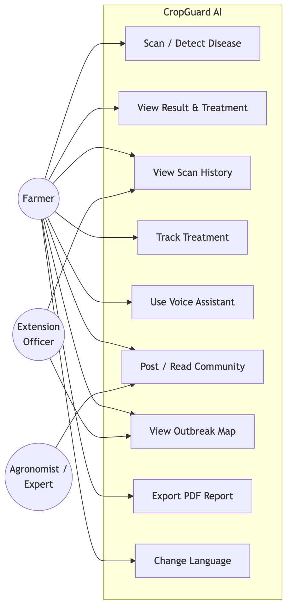
Figure 3.2 — Front-end use case diagram.

(b) Use Case Diagram — Back-End (System/Admin) Model
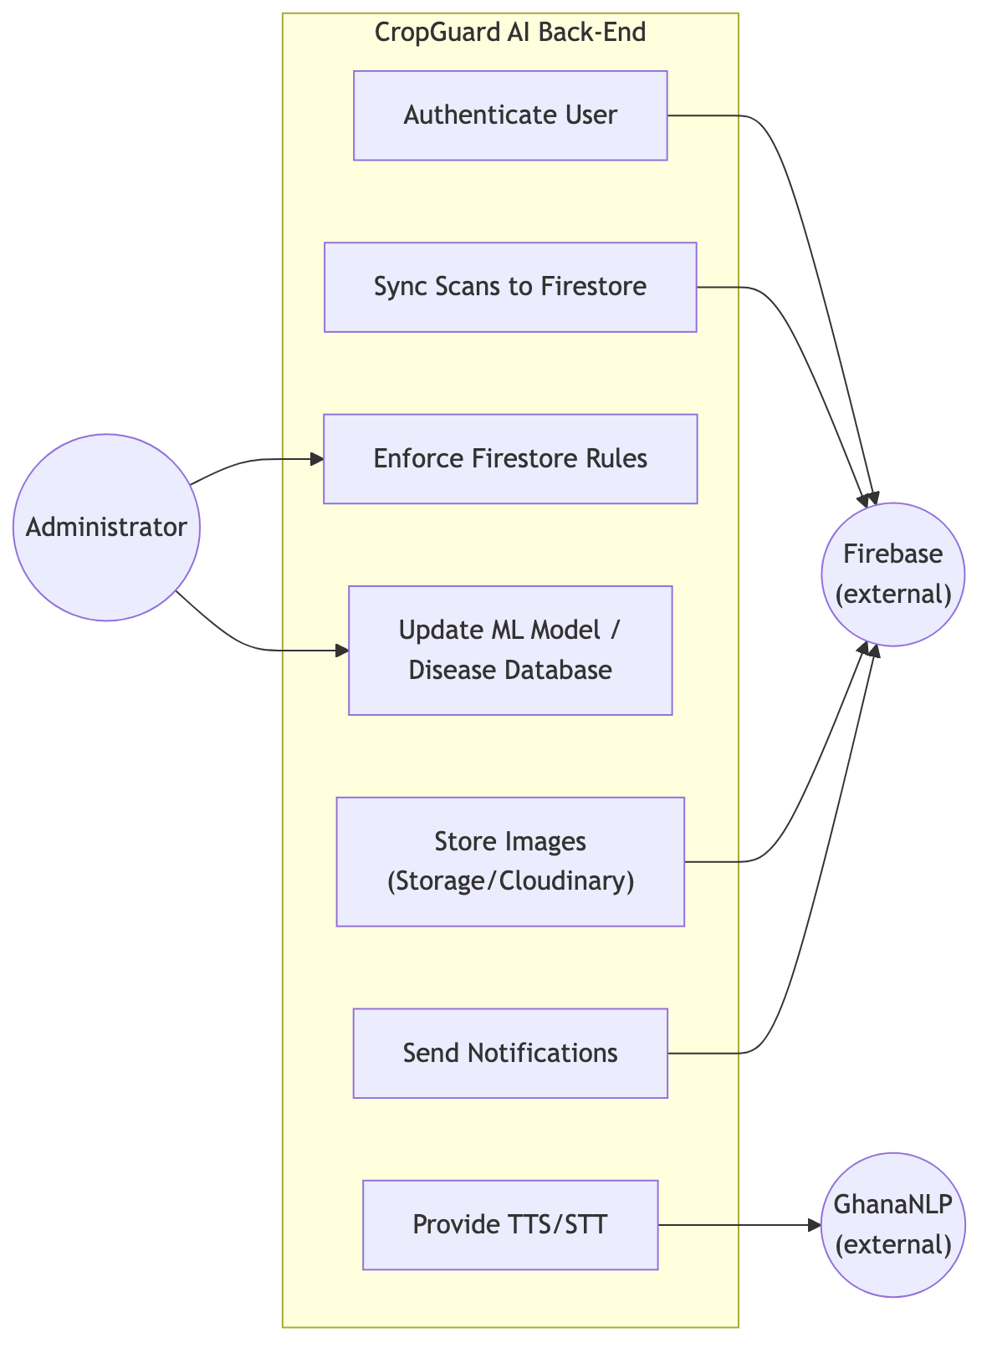
Figure 3.3 — Back-end use case diagram.

(c) Use Case Descriptions
Actors
Actor | Role
Farmer | Primary user; captures images, views diagnoses and treatments, manages history, uses voice and community features.
Agronomist / Expert | Responds to community questions; validates advice.
Extension Officer | Monitors outbreaks and history to support farmers in the field.
Administrator | Maintains the app, ML model, disease database and security rules.
Firebase (external) | Provides authentication, database, and storage services.
GhanaNLP (external) | Provides local-language TTS/STT.

Selected use case descriptions
Use Case | Description
Scan / Detect Disease | The farmer captures or selects a leaf image; the system pre-processes it, runs on-device CNN inference, applies the confidence threshold, derives severity, and returns a result. Pre-condition: model loaded. Post-condition: a detection is produced and saved.
View Result & Treatment | Displays disease name, confidence, severity, cause and treatments; offers low-confidence guidance and PDF export.
View Scan History | Lists past detections from the local database; supports delete and restore.
Track Treatment | Generates dated treatment steps and lets the farmer mark them complete; schedules reminders.
Use Voice Assistant | Reads the diagnosis aloud and accepts spoken queries in a local language via GhanaNLP/local TTS.
Post / Read Community | Lets farmers post observations (with optional image) and read expert responses.
View Outbreak Map | Plots geolocated detections so officers/farmers can see disease spread.
Authenticate User | Registers/logs in users via email, Google or anonymous sign-in.
Sync Scans to Firestore | Mirrors local detections to the cloud when online and authenticated.
Update ML Model / Disease DB | Administrator ships an updated .tflite model, labels and disease information.

(d) Activity Diagram — Disease Detection Flow
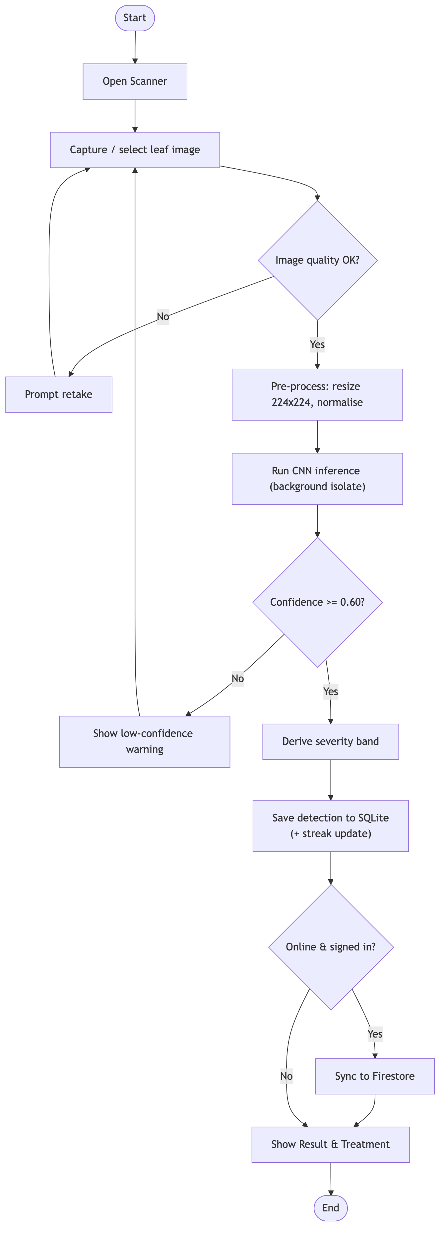
Figure 3.4 — Activity diagram for the disease-detection flow.

(e) Sequence Diagram — Scan a Crop
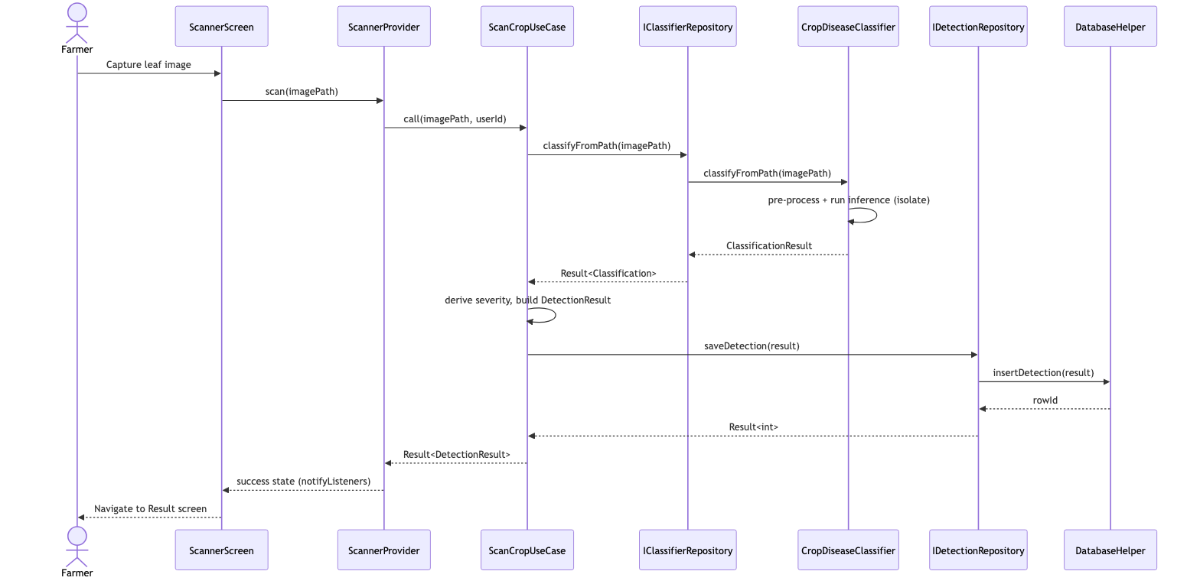
Figure 3.5 — Sequence diagram for the "Scan a Crop" use case.

(f) Sequence Diagram — User Login
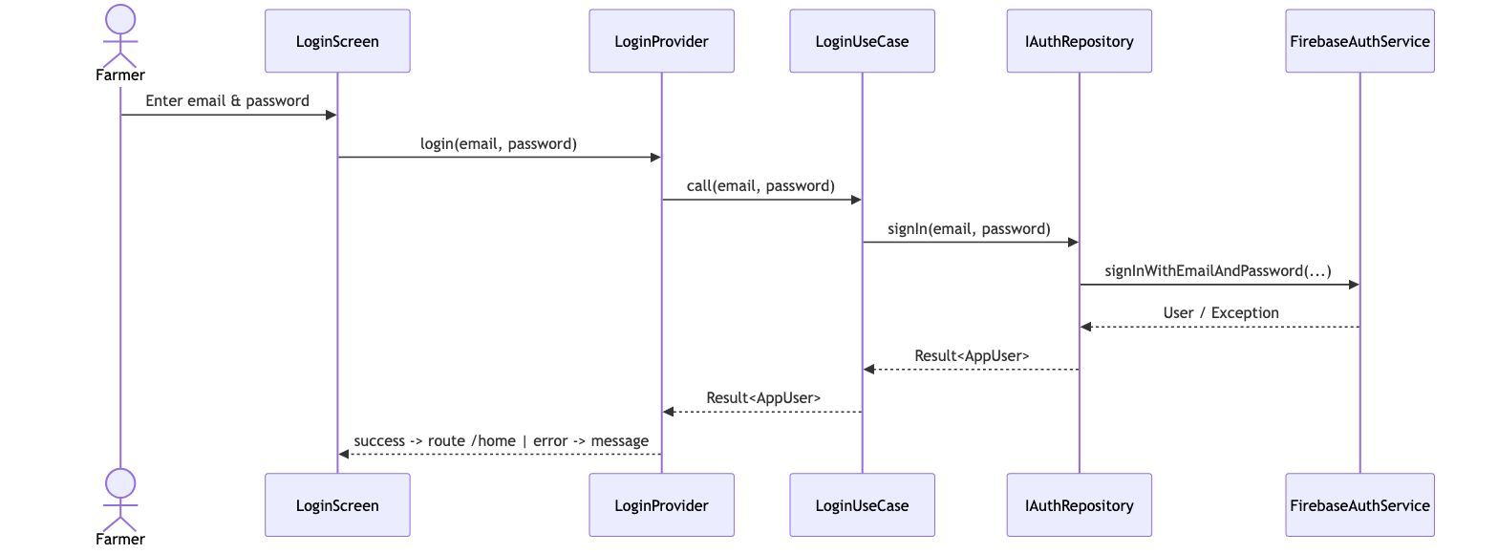
Figure 3.6 — Sequence diagram for the "User Login" use case.

3.9 Non-Functional Requirements
# | Non-Functional Requirement | Justification
NFR1 — Offline capability | Detection, history and treatment tracking must work without internet. | Target users farm in rural areas with weak/no connectivity; on-device inference removes the network dependency.
NFR2 — Performance | A scan should return a result within a few seconds and never freeze the UI. | Inference runs in a background isolate; the model is quantised and uses 224 × 224 input for speed on mid-range phones.
NFR3 — Usability | Simple, icon-led UI usable by low-literacy farmers. | Reduces the barrier to adoption; supported by voice assistance and large touch targets.
NFR4 — Localization | Full support for English, Twi, Ewe and Dagbani. | Reaches farmers who do not read English; all strings come from ARB resources.
NFR5 — Reliability / data integrity | No data loss; consistent writes. | SQLite transactions and the Result<T> pattern guarantee consistent, recoverable operations; delete supports restore.
NFR6 — Security & privacy | Images analysed on-device; sensitive screens protected. | On-device inference keeps farm images private; root/jailbreak detection, screenshot blocking and certificate pinning harden the app.
NFR7 — Portability | Runs on Android and iOS from one codebase. | Flutter enables cross-platform delivery, minimising cost and maintenance.
NFR8 — Maintainability | Layered, testable architecture. | Clean Architecture + DI + unit tests (mocktail) make components replaceable and verifiable.
NFR9 — Scalability | Cloud back-end must handle growth. | Firebase/Firestore scale managed services; the outbreak feature aggregates data without app changes.
NFR10 — Accessibility | Voice input/output and high-contrast theming. | Supports users with limited literacy or visual constraints.

3.10 Candidate Classes and UML Class Diagram
The candidate classes were identified by noun analysis of the requirements and
the domain model. The principal classes are the domain models
(DetectionResult, AppUser, TreatmentPlan, Field, CommunityPost), the
use cases (e.g. ScanCropUseCase, LoginUseCase), the repository interfaces and
their implementations, and the data sources (CropDiseaseClassifier,
DatabaseHelper).
Visibility symbols: + public, - private, # protected. Multiplicity: 1, 0..1, 1..*, * as indicated on associations.
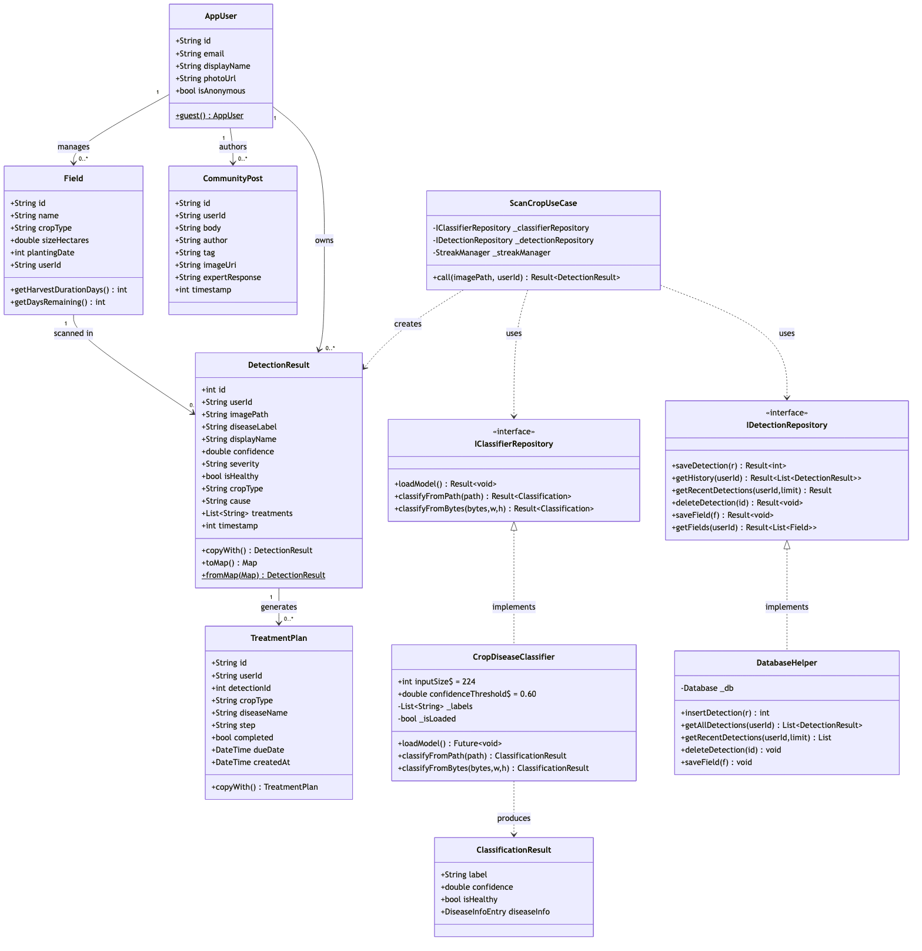
Figure 3.7 — UML class diagram (visibility symbols and multiplicities shown).

3.11 Algorithms
The principal algorithms of the system are presented below in pseudocode. (Their
full implementation appears in Chapter 4.)

Algorithm 3.1 — On-Device Disease Classification
ALGORITHM ClassifyDisease(imageSource)
INPUT : imageSource (file path OR raw RGBA camera bytes)
OUTPUT: ClassificationResult(label, confidence, isHealthy, diseaseInfo)
1. IF model not loaded THEN loadModels(v1, v2) and labels
2. raw ← decode(imageSource)
3. IF raw = NULL THEN RETURN NULL
4. resized ← resize(raw, 224, 224)
5. FOR each pixel (x, y) in resized:
6. tensor[0][y][x] ← [ R/255, G/255, B/255 ]
7. (label1, conf1) ← runModel(v1, tensor)
8. (label2, conf2) ← runModel(v2, tensor)
9. adj1 ← conf1 − 1 / count(labels_v1) // normalise by class count
10. adj2 ← conf2 − 1 / count(labels_v2)
11. IF adj1 ≥ adj2 THEN (label, conf) ← (label1, conf1)
12. ELSE (label, conf) ← (label2, conf2)
13. info ← DiseaseDatabase.lookup(label)
14. RETURN ClassificationResult(label, conf, info.isHealthy, info)

Algorithm 3.2 — Scan Crop Use Case (severity + persistence)
ALGORITHM ScanCrop(imagePath, userId)
1. result ← ClassifierRepository.classifyFromPath(imagePath)
2. IF result.isError THEN RETURN Error(result.failure)
3. c ← result.data ; IF c = NULL THEN RETURN Error(MLFailure)
4. IF c.isHealthy THEN severity ← HEALTHY
5. ELSE IF c.confidence ≥ 0.85 THEN severity ← SEVERE
6. ELSE IF c.confidence ≥ 0.70 THEN severity ← MODERATE
7. ELSE severity ← EARLY
8. detection ← buildDetection(userId, imagePath, c, severity, now())
9. saved ← DetectionRepository.saveDetection(detection)
10. IF saved.isError THEN RETURN Error(saved.failure)
11. StreakManager.recordScan() // fire-and-forget
12. RETURN Success(detection.withId(saved.data))

Algorithm 3.3 — User Authentication (Login)
ALGORITHM Login(email, password)
1. IF email invalid OR password empty THEN RETURN Error(ValidationFailure)
2. result ← AuthRepository.signIn(email, password)
3. IF result.isError THEN RETURN Error(AuthFailure)
4. cacheSession(result.data)
5. RETURN Success(result.data) // navigate to Home

Algorithm 3.4 — Treatment-Plan Generation & Reminder
ALGORITHM GenerateTreatmentPlan(detection)
1. steps ← DiseaseDatabase.treatmentsFor(detection.diseaseLabel)
2. due ← now()
3. FOR each step in steps:
4. plan ← TreatmentPlan(detection.id, step, due, completed=false)
5. Database.insert(plan)
6. scheduleNotification(plan, due)
7. due ← due + interval(step)
8. RETURN steps

3.12 Flowcharts for the Algorithms
Drawn in Mermaid below; export the final figures from Lucidchart/draw.io.

Flowchart 3.1 — Disease Classification (Algorithm 3.1)
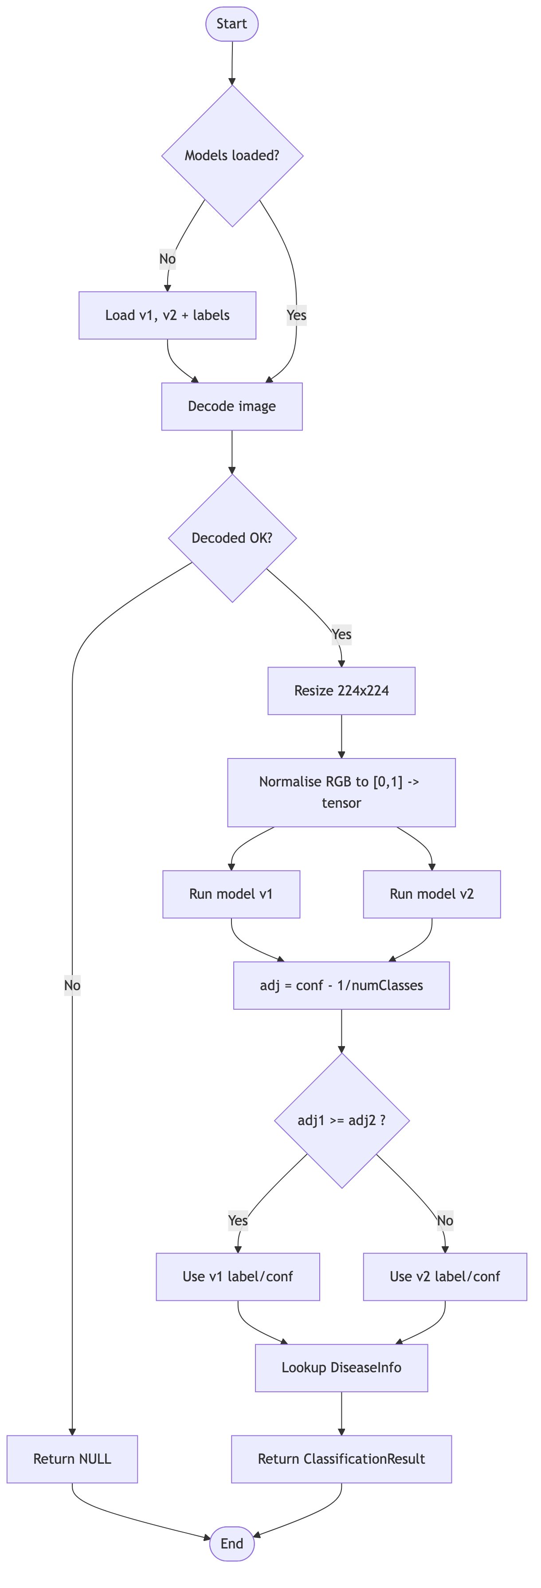

Flowchart 3.2 — Scan Crop Use Case (Algorithm 3.2)
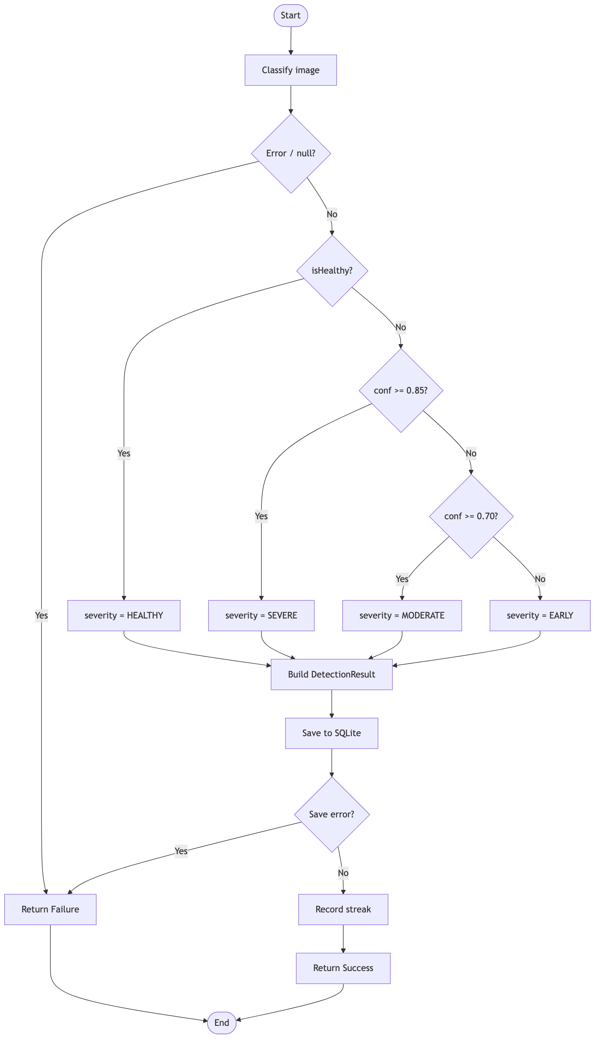

3.13 Project Methods to be Employed
The project employs an Agile software-development method rather than a
plan-driven (waterfall) one. Development proceeds in short, iterative increments:
each iteration delivers a working slice of functionality (for example, the scan →
result flow, then history, then the treatment tracker), which is tested and
refined based on feedback before the next feature is built. This iterative,
feedback-driven approach suits a student project whose requirements (disease
classes, UI for low-literacy users, language coverage) were expected to evolve as
prototypes were shown to farmers.

3.14 Software Process Model and Justification
The chosen software process model is the **Agile — Iterative and Incremental
model** (with practices drawn from Scrum/Kanban such as short sprints and a
prioritised backlog).
Justification for the choice:
- Evolving requirements. Requirements were refined through farmer feedback
and prototyping; an incremental model accommodates change far better than a
rigid waterfall plan.
- Early, continuous delivery of value. The offline scan → result core was
delivered first as a working increment, then progressively enhanced (history,
tracker, community, map), allowing early validation of the most critical
feature.
- Risk reduction. The highest-risk component (on-device CNN inference and its
performance on mid-range phones) was prototyped early in an iteration,
de-risking the rest of the project.
- Feedback integration. Regular feedback from supervisor and representative
users could be folded into the next iteration, improving usability.
- Fit with a layered, testable architecture. Clean Architecture with
dependency injection and unit tests makes each increment independently
buildable and verifiable, which is exactly what iterative development needs.
A purely plan-driven (waterfall) model was rejected because it assumes stable,
fully-known requirements and defers testing and user feedback to the end —
unsuitable for an exploratory, ML-driven product targeting a population whose
needs are best understood through iteration.

3.15 Project Design Considerations (Logical Designs)

3.15.1 UI Design (Wireframes)
The interface is designed around a simple, icon-led flow with a three-tab bottom
navigation (Home, History, More) and a prominent scan action. Key screens:
+---------------------------+ +---------------------------+
| CropGuard AI (≡) | | ← Scanner |
|---------------------------| |---------------------------|
| Farm Health Ring 82% | | [ camera preview ] |
| [ ▢ Weather / Risk ] | | [ live frame ] |
| | | |
| Recent Scans | | align leaf in frame |
| • Maize – Blight (Sev) | | |
| • Tomato – Healthy | | ( ◉ Capture ) |
| | | [ gallery ] [ flip ] |
| [ 📷 SCAN A CROP ] | | |
|---------------------------| +---------------------------+
| Home History More |
+---------------------------+
+---------------------------+ +---------------------------+
| ← Result | | ← Treatment Tracker |
|---------------------------| |---------------------------|
| [ leaf thumbnail ] | | Maize – Leaf Blight |
| Maize Leaf Blight | | ☑ Remove infected leaves |
| Confidence: 0.87 ████▏ | | ☐ Apply fungicide (3d) |
| Severity: SEVERE ⬤ | | ☐ Re-scan in 7 days |
| Cause: fungal ... | | |
| Treatments: | | [ + Add reminder ] |
| 1. ... 2. ... | | |
| [ 🔊 Listen ] [ ⤓ PDF ] | +---------------------------+
+---------------------------+

*Figure 3.8 — Low-fidelity wireframes (Home, Scanner, Result, Treatment Tracker).
[Insert high-fidelity Figma/Lucidchart wireframes here.]*
Design considerations applied: large touch targets and minimal text for
low-literacy users; a colour-coded severity badge and confidence bar for
at-a-glance interpretation; a voice (listen) control on the result screen; an
offline banner when connectivity is lost; and full localization so every
label adapts to the selected language.

3.15.2 Database Design
The system uses SQLite locally (mirrored optionally to Firestore). The local
schema (version 11) consists of four tables: detections, fields,
treatment_plans and notifications.

(a) Entity–Relationship Diagram
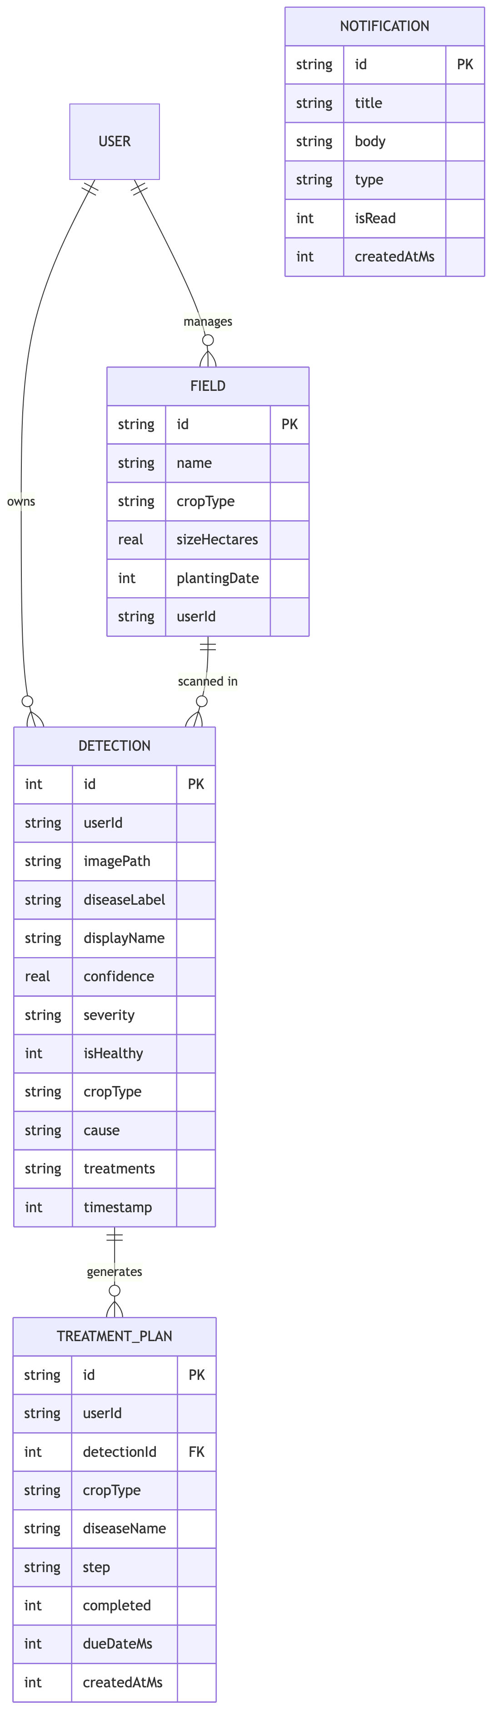
Figure 3.9 — Entity–Relationship diagram.

(b) Database Schema (SQLite DDL)
CREATE TABLE detections (
id INTEGER PRIMARY KEY AUTOINCREMENT,
userId TEXT NOT NULL DEFAULT '',
imagePath TEXT NOT NULL,
diseaseLabel TEXT NOT NULL,
displayName TEXT NOT NULL,
confidence REAL NOT NULL,
severity TEXT NOT NULL DEFAULT 'unclear',
isHealthy INTEGER NOT NULL,
cropType TEXT NOT NULL,
cause TEXT NOT NULL DEFAULT '',
treatments TEXT NOT NULL DEFAULT '', -- '||'-joined list
timestamp INTEGER NOT NULL
);
CREATE TABLE fields (
id TEXT PRIMARY KEY,
name TEXT NOT NULL,
cropType TEXT NOT NULL,
sizeHectares REAL NOT NULL DEFAULT 0,
plantingDate INTEGER,
userId TEXT NOT NULL DEFAULT ''
);
CREATE TABLE treatment_plans (
id TEXT PRIMARY KEY,
userId TEXT NOT NULL DEFAULT '',
detectionId INTEGER NOT NULL DEFAULT 0,
cropType TEXT NOT NULL,
diseaseName TEXT NOT NULL,
step TEXT NOT NULL,
completed INTEGER NOT NULL DEFAULT 0,
dueDateMs INTEGER NOT NULL,
createdAtMs INTEGER NOT NULL
);
CREATE TABLE notifications (
id TEXT PRIMARY KEY,
title TEXT NOT NULL,
body TEXT NOT NULL,
type TEXT NOT NULL DEFAULT 'reminder',
isRead INTEGER NOT NULL DEFAULT 0,
createdAtMs INTEGER NOT NULL
);

Table 3.1 — Local SQLite schema (version 11).

3.16 Development Tools
The following tools are used in the methodology; each entry explains how it is
used in this project.
Tool / Technology | How it is used in the methodology
Flutter (Dart) | The primary framework. Used to build the entire cross-platform UI and application logic from a single codebase that compiles to native Android and iOS. All screens, providers, use cases and models are written in Dart.
TensorFlow Lite (`tflite_flutter`) | The on-device inference engine. Used to load the quantised CNN model and run classification locally on the leaf image, enabling offline detection.
TensorFlow / Keras (training, off-device) | Used to train and fine-tune the MobileNetV2-based CNN via transfer learning, then export the .tflite model bundled in the app assets.
SQLite (`sqflite`) | The local relational database. Used to persist scan history, fields, treatment plans and notifications, with versioned migrations and transactions.
Firebase (Auth, Firestore, Storage, Remote Config, Crashlytics) | The cloud back-end. Used for user authentication, optional cloud synchronisation of scans and the community feed, image hosting, remote configuration of the GhanaNLP key, and crash reporting.
Cloudinary | Used as an image hosting/CDN service for community and scan images.
GhanaNLP API | Used to provide local-language text-to-speech and speech-to-text for the voice assistant.
GetIt | The dependency-injection container. Used to register and resolve all data sources, repositories, use cases and providers at start-up.
Provider | The state-management library. Used to implement the MVVM pattern (ChangeNotifier providers driving the widgets).
go_router | Used to define all navigation routes, including the bottom-navigation shell.
flutter_map / OpenStreetMap | Used to render the outbreak map without paid API keys.
Visual Studio Code / Android Studio | The IDEs used to write, run, debug and profile the application.
Git & GitHub | Version control. Used to track changes, manage iterative increments and back up the codebase.
flutter_test & mocktail | The testing tools. Used to write unit tests for use cases (mocking repository interfaces) and widget tests, supporting the agile "test each increment" practice.
Lucidchart / draw.io / Mermaid | Used to design and export the UML diagrams, ER diagram, flowcharts and wireframes presented in this chapter.
Figma | Used to design the high-fidelity UI mockups/wireframes before implementation.

End of Chapter 3.

