PLACES IN THE BIBLE
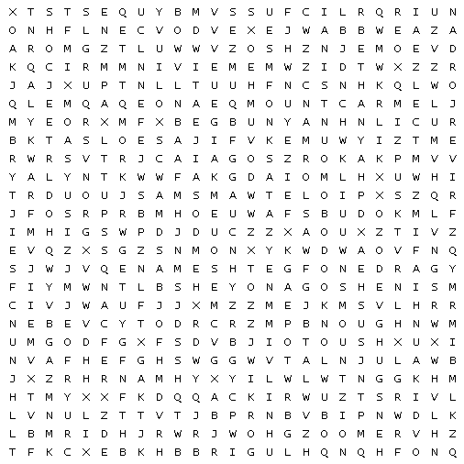

Bethany |  | DeadSea |  | Eden
GardenofGethsemane |  | Goshen |  | MountArarat
MountCarmel |  | MountNebo |  | MountofOlives
MountSinai |  | MountZion |  | RiverJordan
SeaofGalilee

New Testament Books
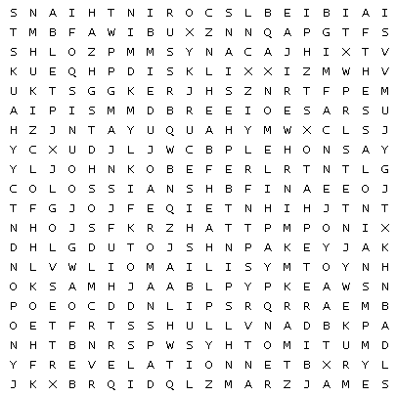

Acts |  | Colossians |  | Corinthians
Corinthians |  | Ephesians |  | Galatians
Hebrews |  | James |  | John
John |  | John |  | John
Jude |  | Luke |  | Mark
Matthew |  | Peter |  | Peter
Philemon |  | Philippians |  | Revelation
Romans |  | Thessalonians |  | Thessalonians
Timothy |  | Timothy |  | Titus

