# **Installing PyCharm Edu**

You will need software to write Python programs. At Wake Tech, we have chosen a tool called PyCharm. If you take this course online or want to write Python programs at home, you can install PyCharm on your home computer.

If you use a Mac, you need to install the latest version of Python interpreter in the computer yourself before you install PyCharm. First go to the following website to download Python 3.6.6:

<https://www.python.org/downloads/release/python-366/>

Then watch the following video to see how to install it in your Mac:

[https://www.youtube.com/watch?v=uA8SA81nivg](https://www.youtube.com/watch?v=uA8SA81nivg" \t "_blank)

You only need to watch the first half of the video. The second half talks about IDLE, which we do not use in CSC120.  You can ignore that part.

# Step 1

We are using PyCharm Educational Edition. Please go to the website of [Jet Brains](https://www.jetbrains.com/pycharm-edu/) [<https://www.jetbrains.com/pycharm-edu/>] to download PyCharm Edu. The latest version is 2021.1.3. Click the “Download Free” button to go to the download page. PyCharm Edu is available for Windows, Mac OSX, and Linux. Click the dropdown next to the “Download” button to choose Windows (.exe) or MacOS (.dmg, Intel) operating system of your choice. Then click the “Download” button to download the installer.

# Step 2

Start the installer when the download is complete. The PyCharm Edu Setup Wizard will start. Click *Next* to begin. We only show installation of PyCharm Edu in Windows in the rest of this document. The installation process is similar in other operating systems.

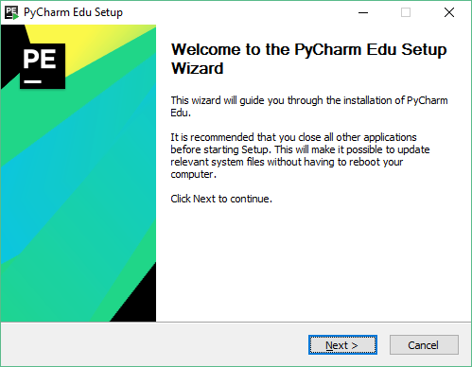

# Step 3

You will be asked to choose the folder in which to install PyCharm Edu. Just use the default. Then click *Next*.

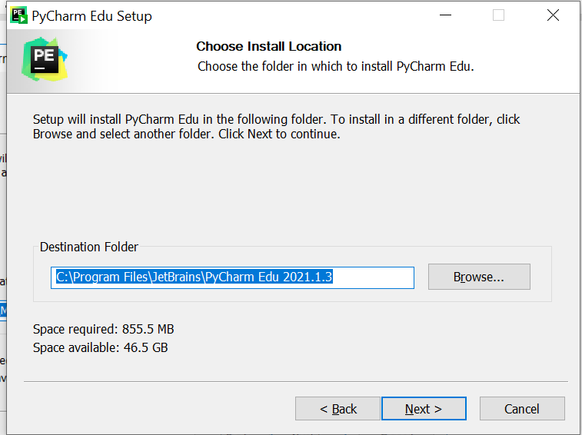

# Step 4

**Choose “Python 3.8” and check the box for “.py’**. You can also create a desktop shortcut by choosing “32-bit launcher” or “64-bit launcher”, depending on what system your computer is running. Then click *Next*.

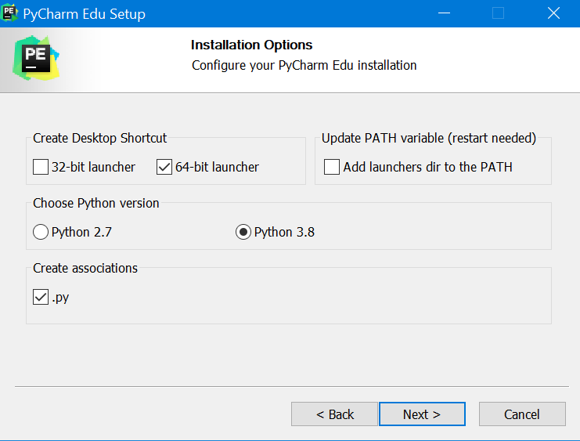

# Step 5

You will be asked to choose Start Menu Folder. Just use the default “JeBrains”. Then click *Install*.

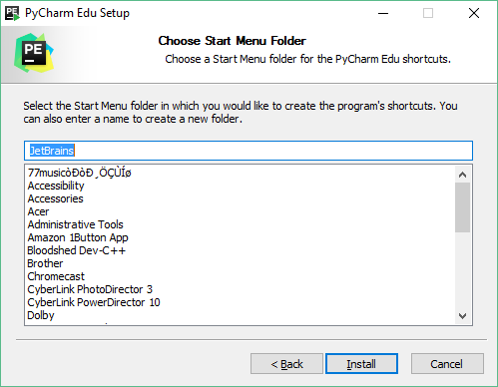

# Step 6

The Setup Wizard will then install PyCharm Edu in your computer. Wait until it is done. Click *Finish* to end installation.

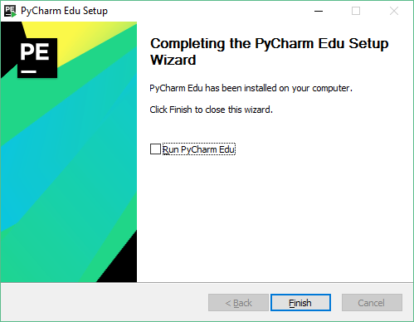

# Step 7

You should see the shortcut *JetBrians PyCharm Edu* on your desktop. Double click it whenever you want to start the software.

