1. **Student Motivation Statement (**20 points)

I find Computer Science very interesting and hope it will help me in my current job someday.

1. **Student’s Computer Science Background** (20 points)

* Do you have any experience with programming? If yes, which language?
  + I’ve taken a class on Python programming
* Have you ever used Python? If so, in what capacity?
  + My only experience with Python is the one class.
* Do you have any experience with concepts of digital or binary logic?
  + I learned a little about Binary about 15 years ago, I remember it being 0’s and 1’s.
* Do you have any experience with algorithm design?
  + We learned about IPO diagrams in my Python class

1. **Student’s Resource Availability (**20 points)

* Do you have access to a laptop and internet?
  + Yes to both.
* Are you able to find the lectures and assignments on Blackboard? If so, please provide a screenshot of the Lesson 1 folder contents from Blackboard.
  + Yes.
  + 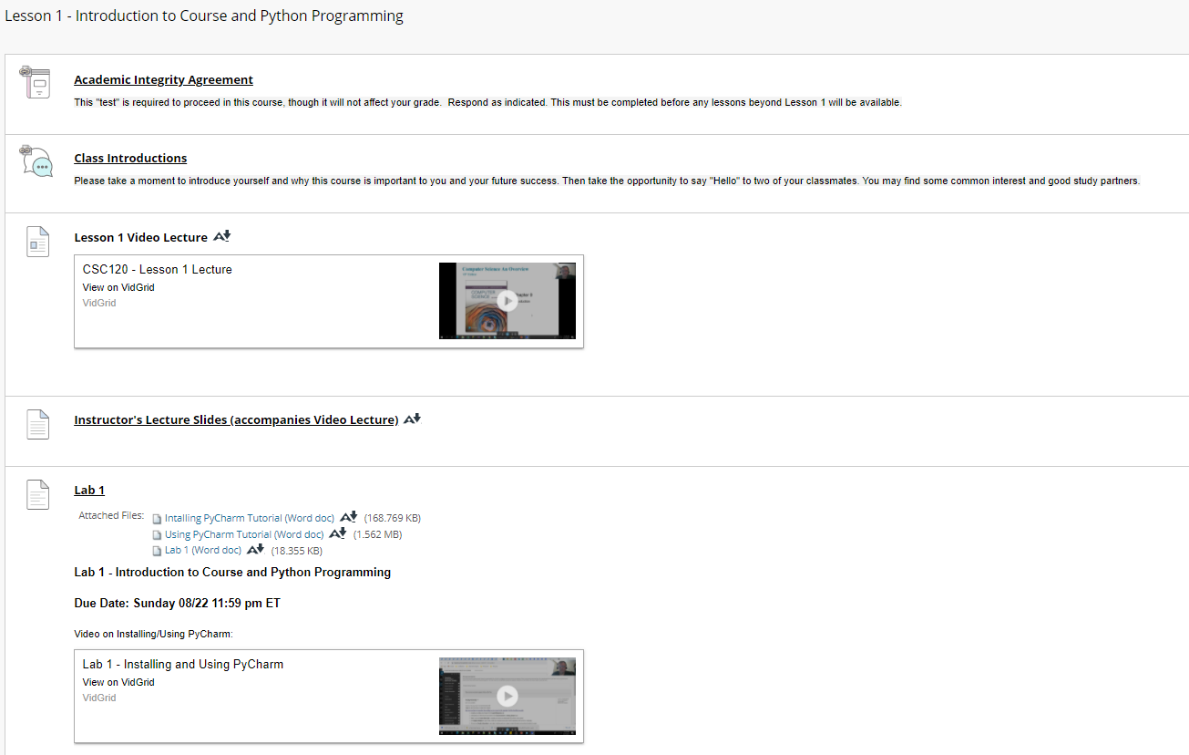
* Do you know where to read the announcements on Blackboard? If so, please provide a screenshot of the Announcements page from Blackboard.
  + Yes
  + 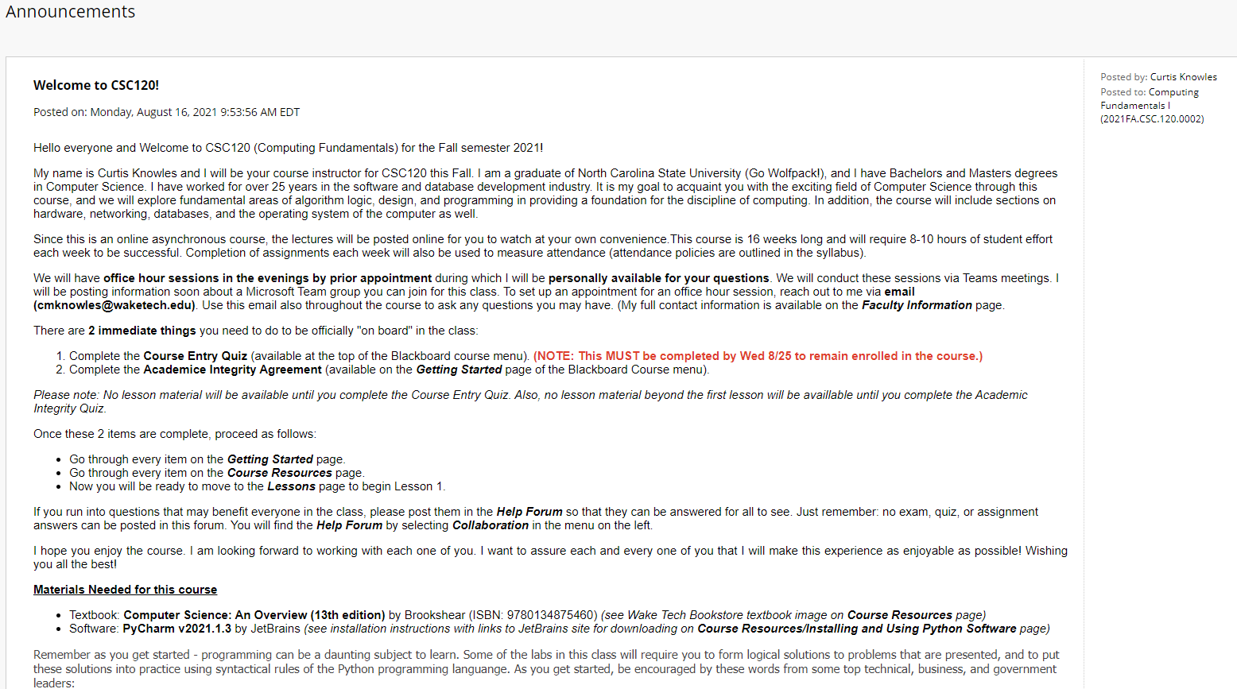
* Do you know where to find the Course Syllabus? If so, please provide a screenshot of a page from Blackboard showing the Course Syllabus link on it.
  + Yes
  + 