# **Using PyCharm To Write Python Programs**

PyCharm is a tool to write and run Python programs. This document shows you how to use PyCharm.

# **Creating a Folder to Store Python Projects**

Before you start, create a folder in your computer to store your Python projects. For example, create a folder “Python Projects” in your C drive.

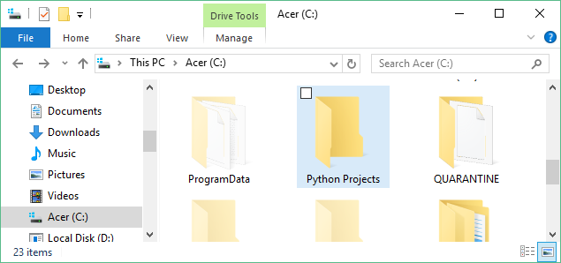

# **Starting PyCharm**

If you already have PyCharm installed and have a desktop shortcut created, please double click it to start PyCharm.

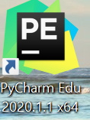

# **Creating a Python Project**

You will see the following window after PyCharm has started.

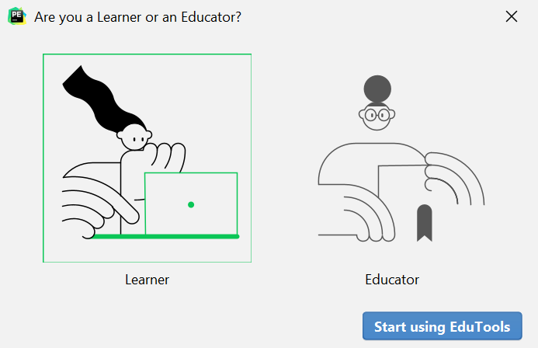

Choose “Learner” and click the “Start using EudTools” button. It will bring you to the following page:

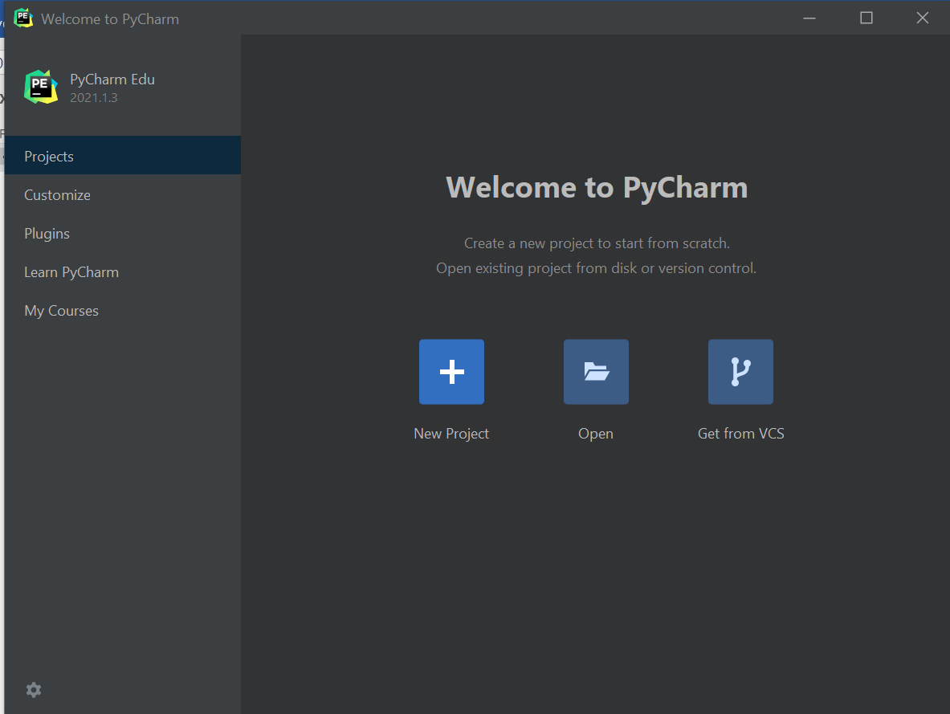

Click “New Project” to create a new Python project. A Python project is a collection of Python programs. To do a lab assignment, you need to create a Python project first and then add Python programs to the project. In the next page, type “C:\Python Projects\Project 1” in the Location box. That will add a new project named “Project 1” to the folder “C:\Python Projects”, which was created earlier (see the section “Creating a Folder to Store Python Projects”). Also be sure the following settings are used:

* New environment using: Virtualenv
* Base Interpreter: C:\Program Files\Python38\python.exe
* Create main.py welcome script: Checked

Then click “Create”.

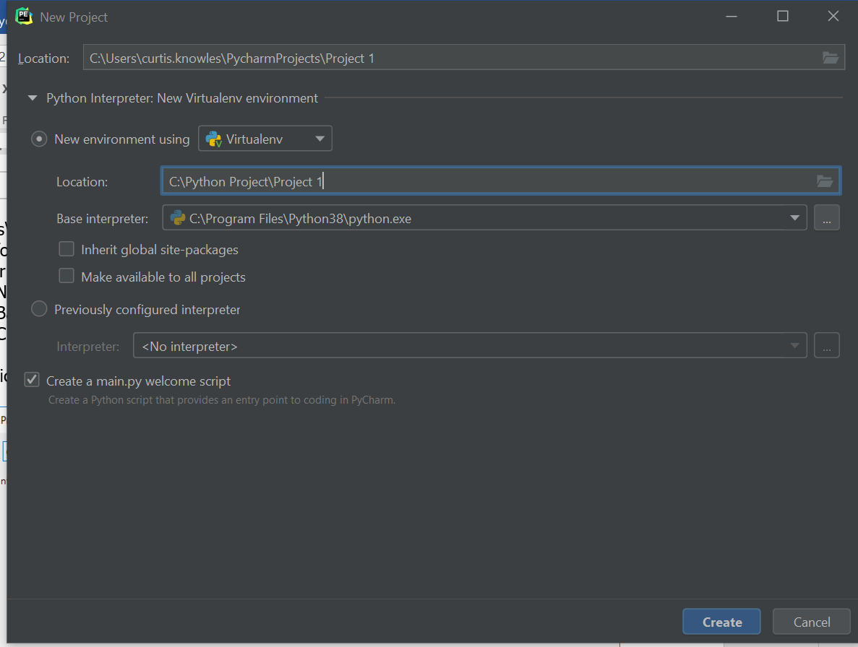

Your new project will be created. You will see its name on the left panel of the PyCharm window.

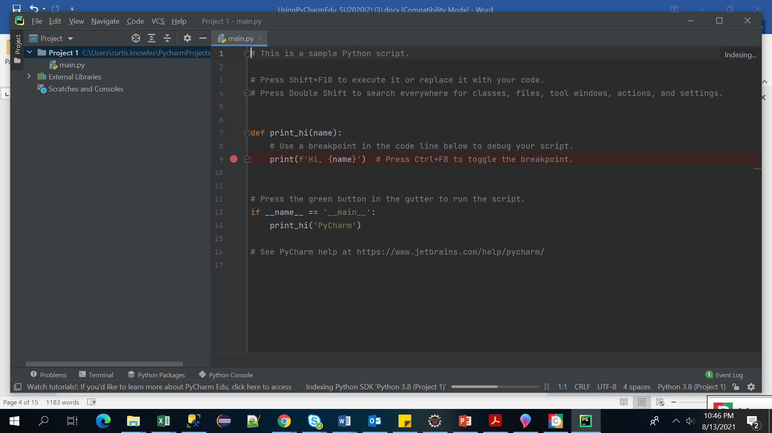

# **Creating a New Python Program File**

Next, we need to create a new Python file and add it to the project. Right click the “Project 1” icon. Then choose “New” in the drop-down menu. Then choose “Python File”.

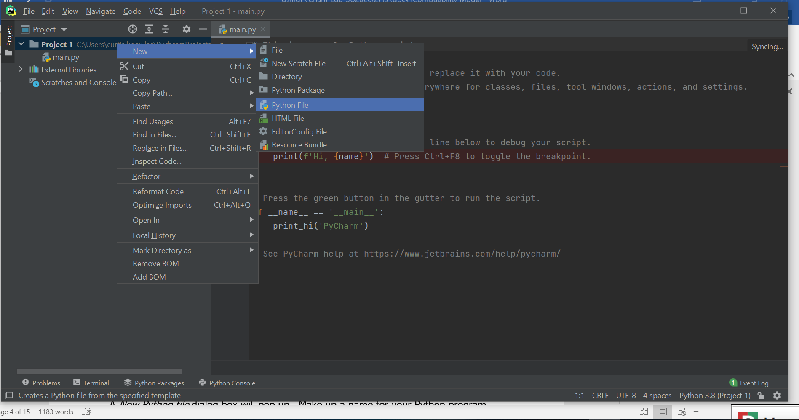

A *New Python file* dialog box will pop up. Make up a name for your Python program. Let’s use the name *myFirstProgram*. Press Enter to continue.

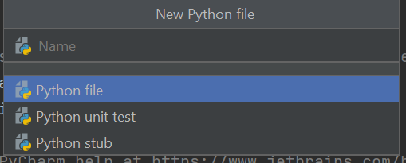

A New Python file named *myFirstProgram.py* will be created and added to *Project 1*.

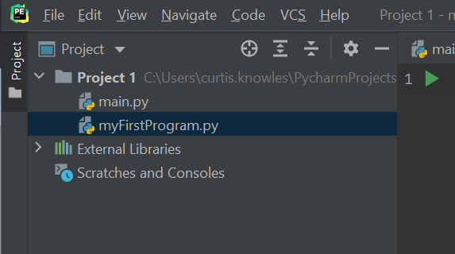

This is a blank Python program. Let’s add one Python statement to this program:

print('This is my first Python program')

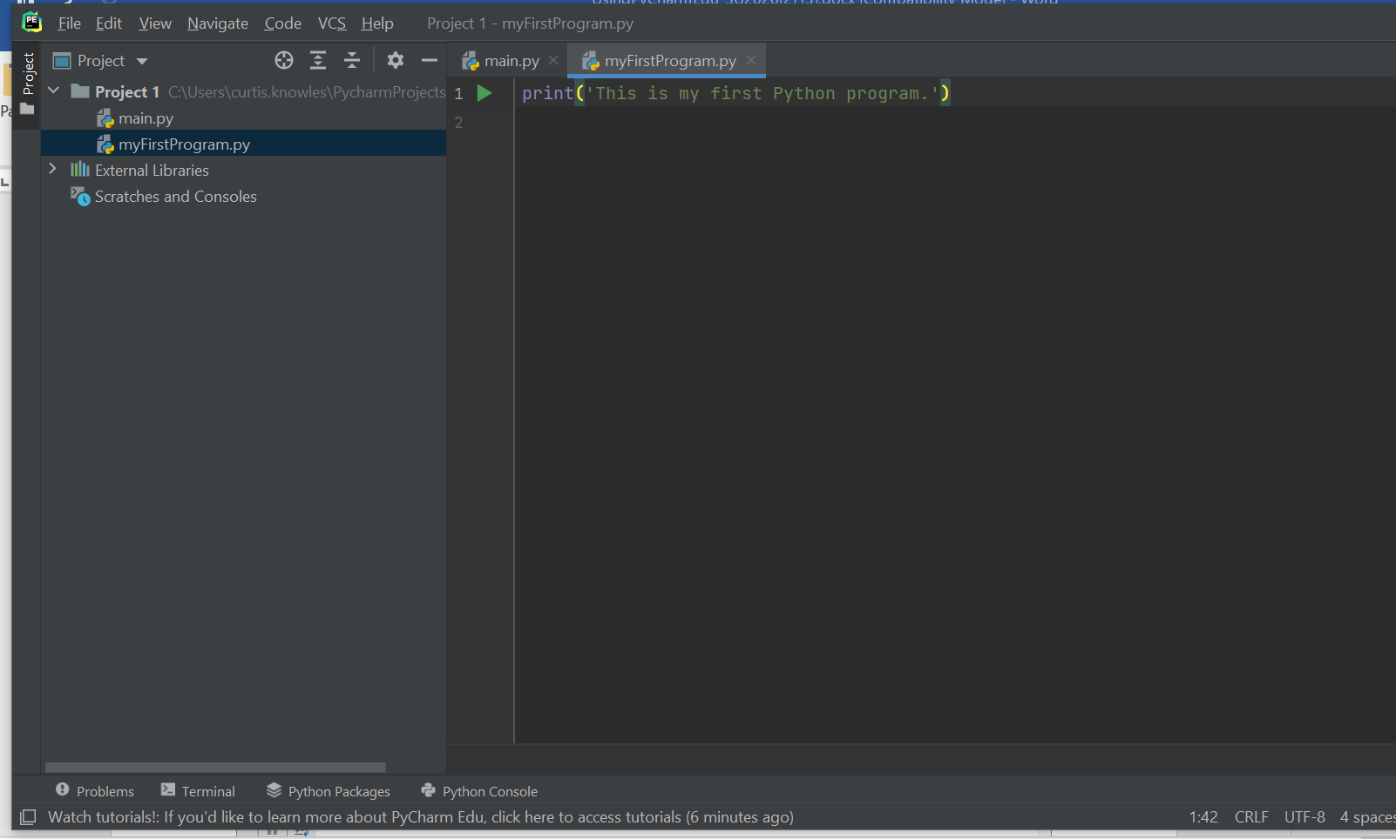

We will add more Python statements later.

# **Running Python Program**

Now let’s learn how to run a Python program. Right click on “myFirstProgram.py” in the left panel. Then choose *Run ‘myFirstProgram’* in the drop-down menu.

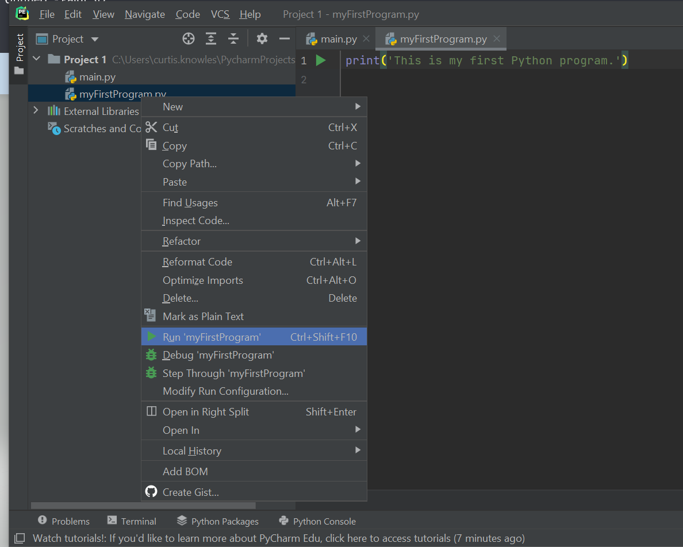

A *Run* panel will show up in the lower part of the PyCharm window, which displays output and other run-time messages of the program.

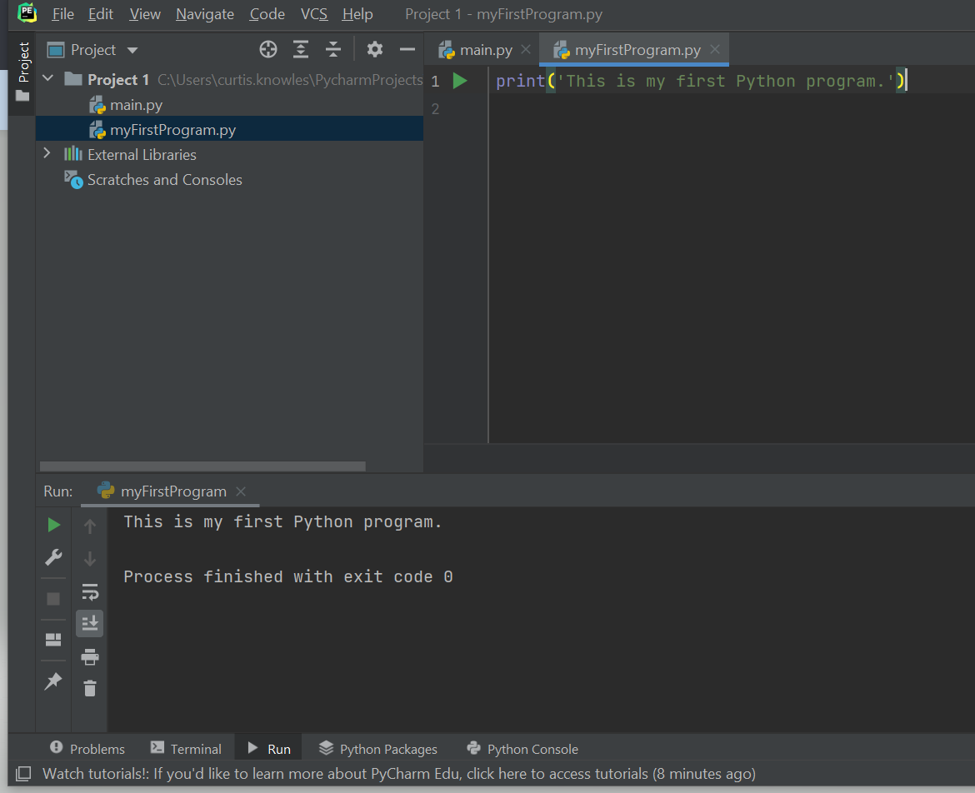

The statement in the Python program

print('This is my first Python program')

instructs the computer to display the following output:

This is my first Python program

That is exactly what we see in the run panel. The message “Process finished with exit code 0” means the program has finished running with no error.

# **Displaying Text**

Now you have created and run your first Python program. Let’s learn more about writing statements to displaying text.

In programming, texts are called strings. A string is a sequence of characters. When a string appears in the actual code of the program, it is called string literal. In Python, string literals must be enclosed in quote marks. Displaying a string is quite easy. We can use something called print function. The following is an example,

print('This is my first program')

It tells the computer to display the following text:

This is my first program

We can add more statements to display more text. Let’s add these two statements to the program:

print('I am so proud of myself.')

print('I cannot wait to learn more.')

Run your program. Now three lines of text are displayed in the *Run* panel.

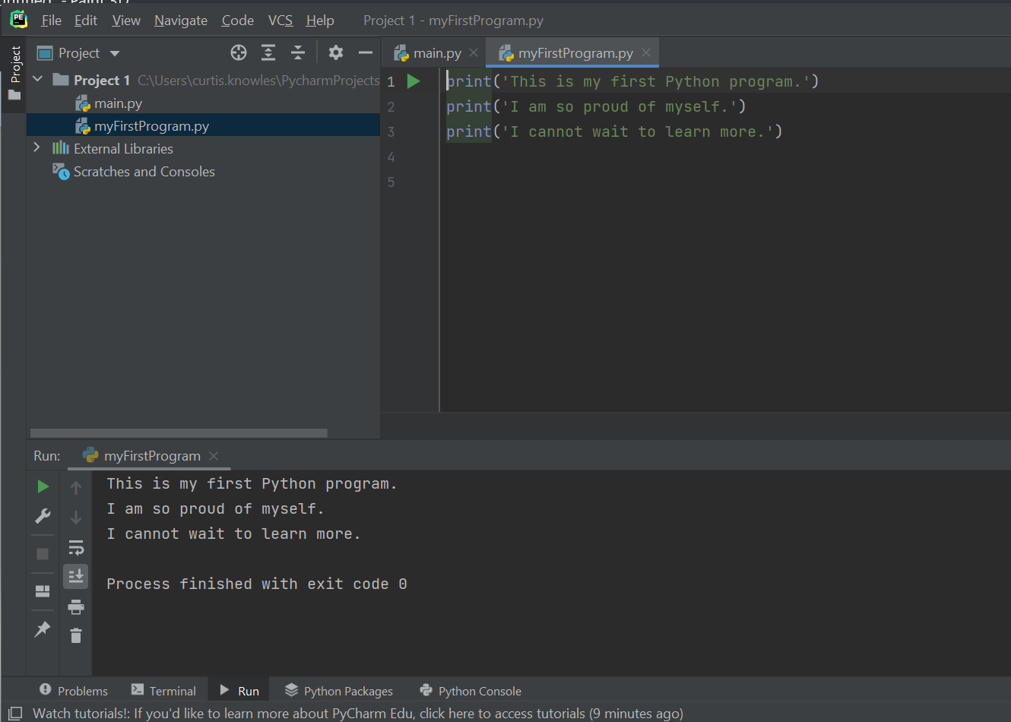

# **Saving Python Program**

PyCharm auto-saves your file when you run the program or when you close your file. There is no need to save the file yourself.

# **Adding More Python Files to the Project**

Let’s add another Python program to the project. Right click on the “Project 1” icon. Then choose “New” in the drop-down menu. Then choose “Python File”.

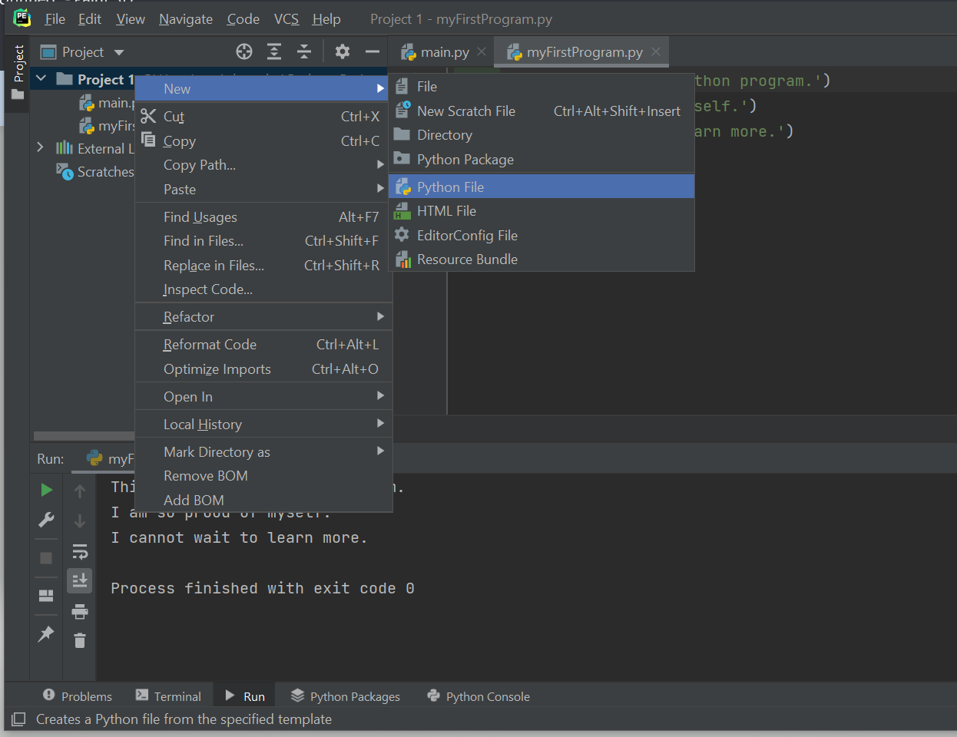

A *New Python file* dialog box will pop up. Make up a name for your Python program. Let’s use the name *courseInfo*. Press Enter to continue.

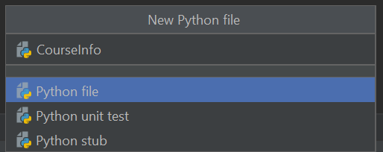

You will see a new Python file *CourseInfo.py* added to *Project 1*.

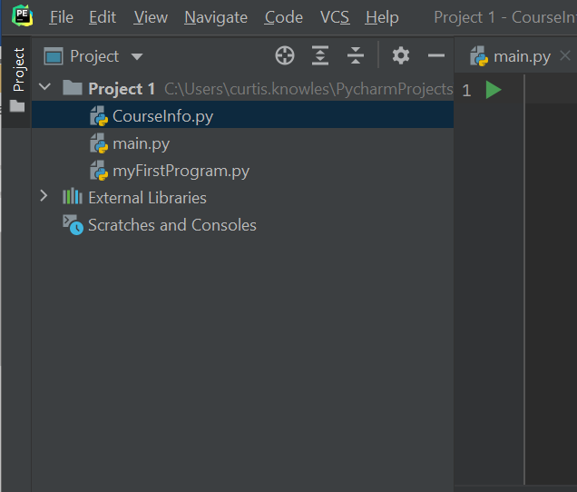

The goal of this program is displaying information about a course. Let’s add a few print statements to the program:

print('CSC120.0002')

print('Title: Computing Fundamentals I')

print('Instructor: C Knowles')

print('Lecture/Lab: Online')

Run your program. You will see four lines of text displayed in the *Run* panel.

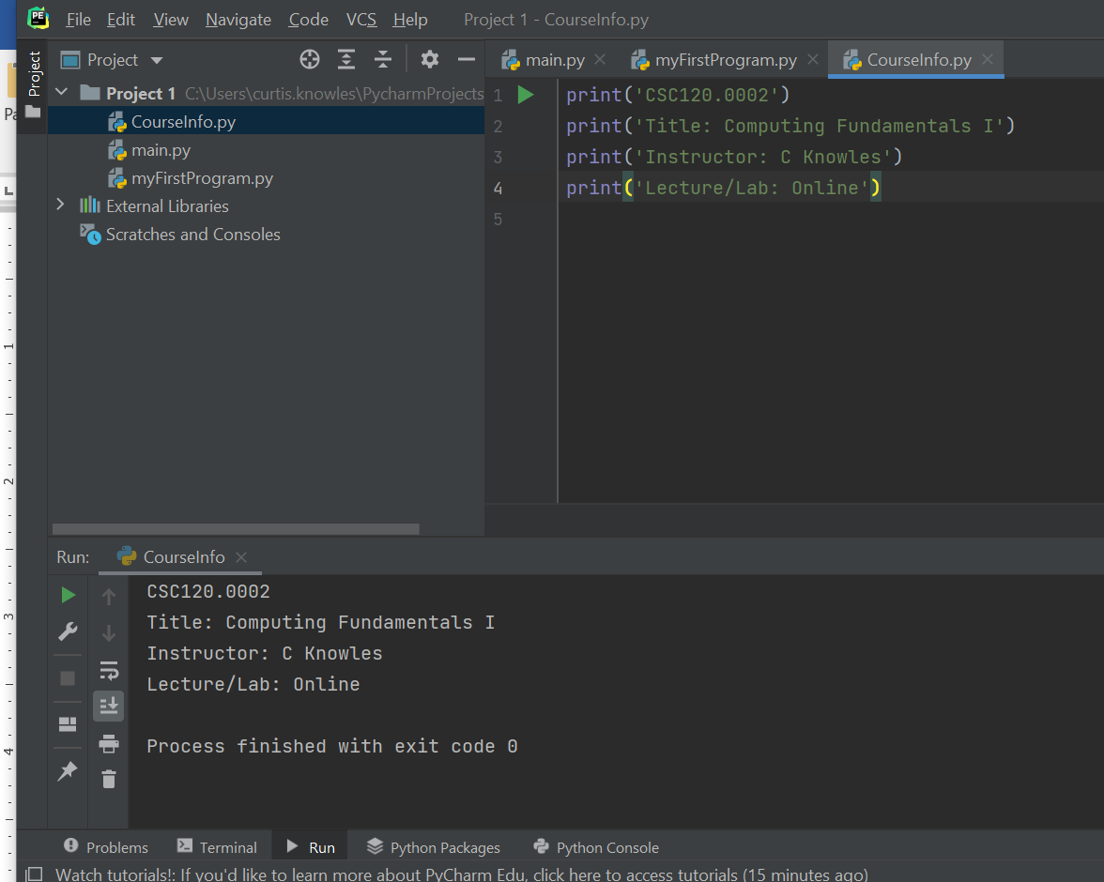

# **Common Syntax Errors**

Sometimes we will type something wrong in the program code, such as misspelling a keyword, or forgetting a quote mark, etc. A violation of Python language rules is called a syntax error. Your program will not run properly if syntax errors exist in your program. In fact, PyCharm actually scans your program code frequently and highlights your syntax errors while you are still typing your code. In this section, we will show you a few common mistakes in the print statement. This will prepare you to detect and fix syntax errors in your own programs.

## Error 1: Mistyping print

print tells the computer to display output. It is actually the name of a built-in function. We will explain more about functions later in this course. Suppose you mistype print like the following example:

prin('CSC120.0002')

You will see that prin is underlined in red in the code to indicate a syntax error. If you ignore this error and try to run your program, an error message will be shown in the *Run* panel:

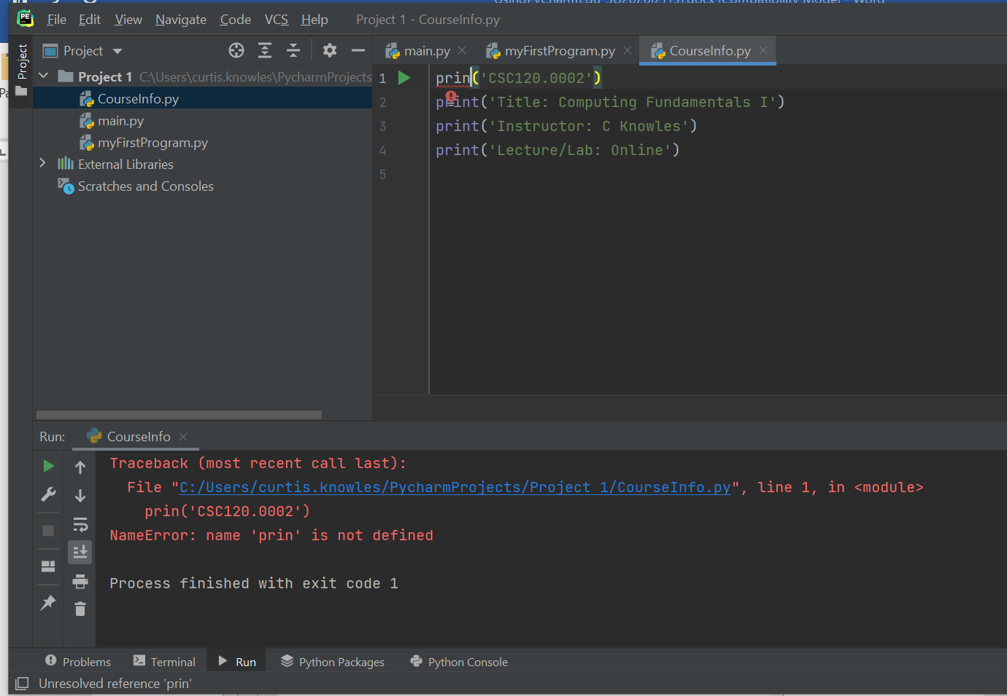

The error message states that “name 'prin' is not defined”. To fix the problem, change prin to print and re-run your program.

## Error 2: Case-Sensitivity

Notice that all five letters in print must be in lowercase. If you capitalize any letters in print, you will get a syntax error. Example:

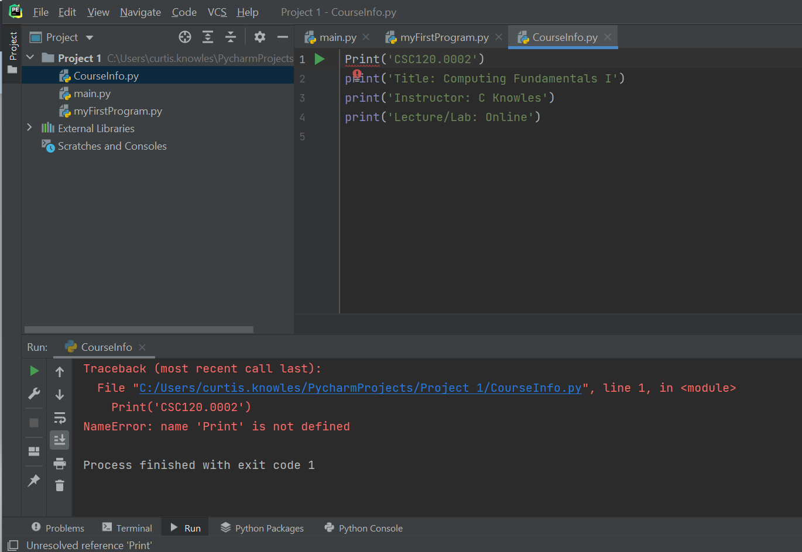

## Error 3: Forgetting parenthesis

The syntax of the print function requires a parenthesis after the word print, with the item being displayed inserted inside the parenthesis. If you forget to type the parenthesis, you will get a syntax error. Example:

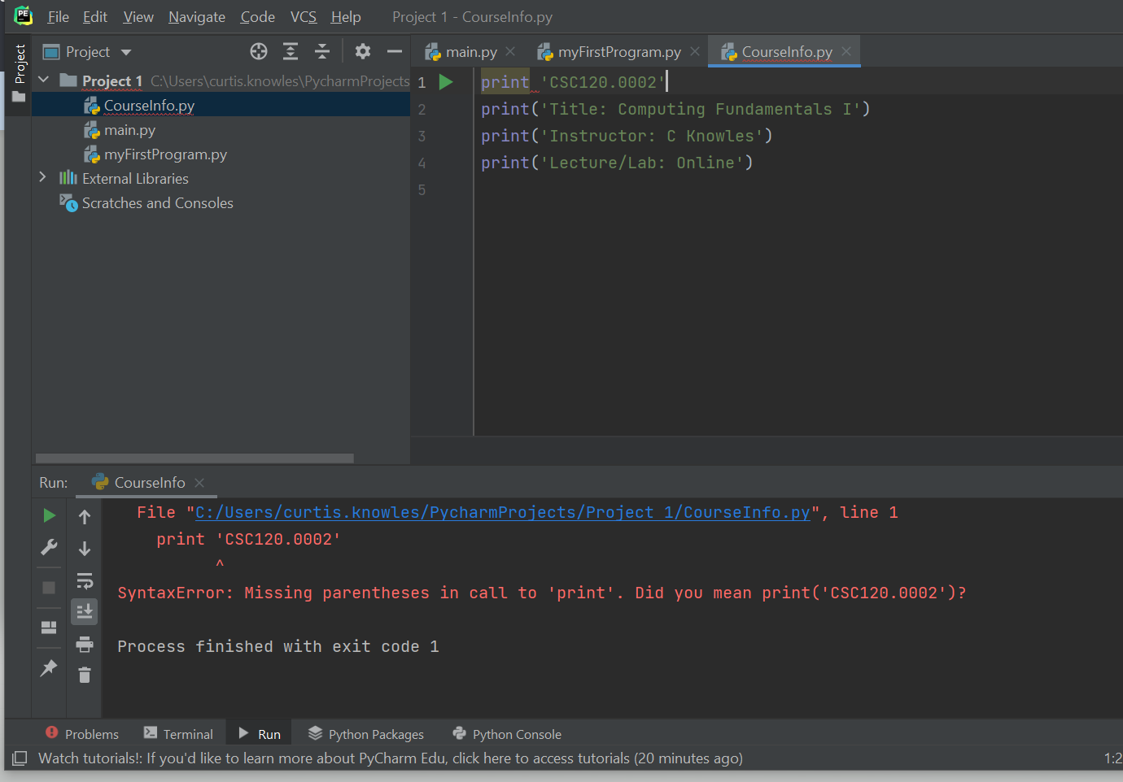

## Error 4: Forgetting quote marks

In Python, a string literal must be enclosed in quote marks. You will get a syntax error if the quote marks are not there. Example:

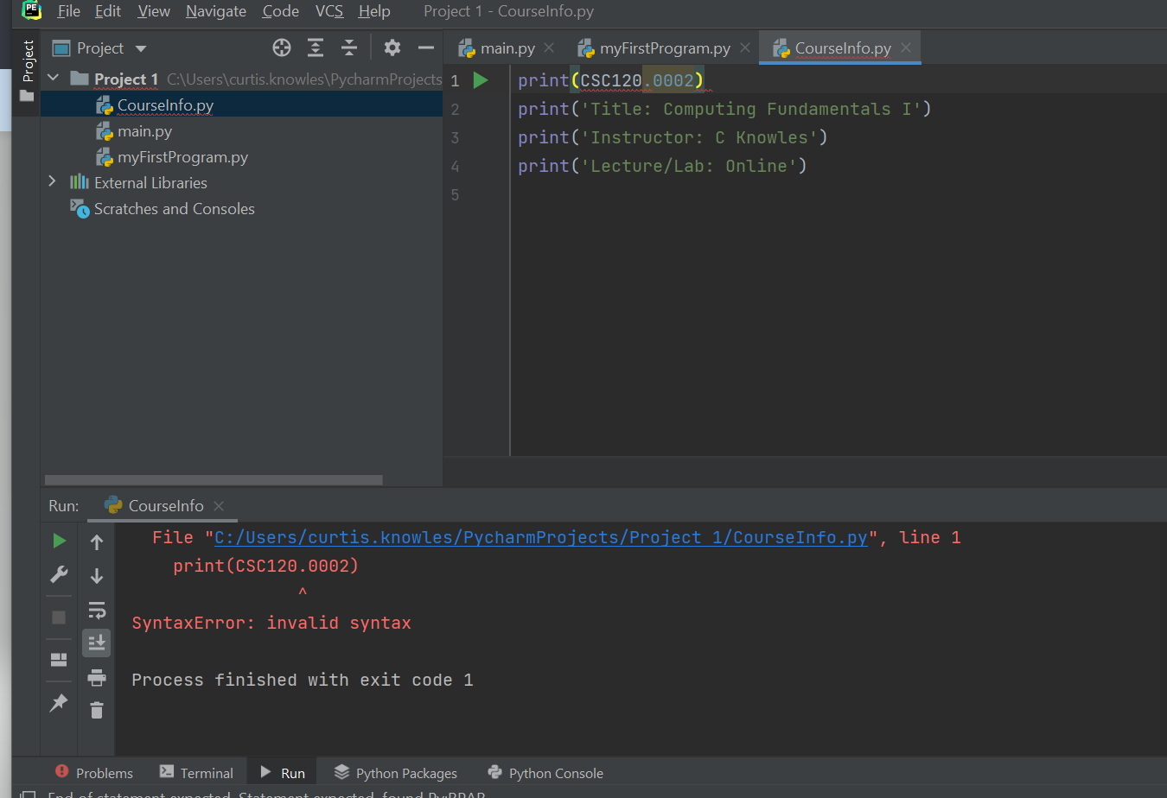

# **Locating Your Python Projects and Python Files**

After you have finished a lab assignment, you need to locate your Python files and submit them to Blackboard. When you created your Python project, you chose a folder in which your project was saved. Now you need to need to go to that folder in your computer to location your files. Suppose the location “C:\Python Projects” was selected to store your project. Go to that location in Windows File Explorer to find your project. Open the project folder to locate your files.

The “.py” file extension is used for your Python code files. When Python code files are required for submission in a Blackboard assignment, these are the files you will attach to the Blackboard submission for grading your Python code.

