CSC 120 Lab 06

Question 1 Install VirtualBox on your system.

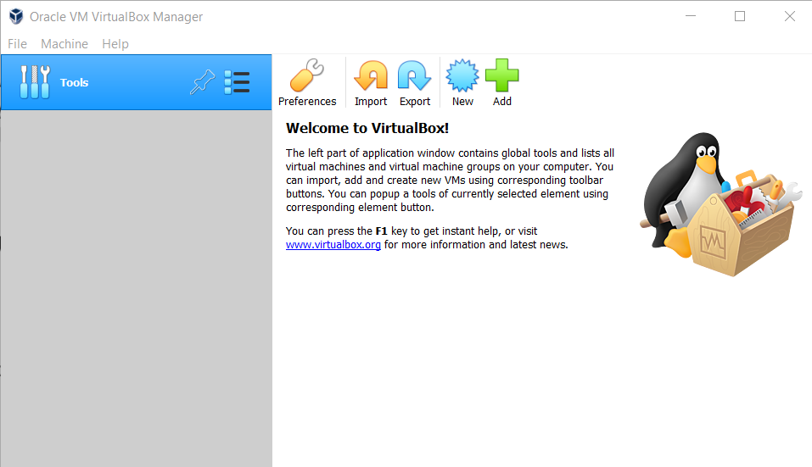

Question 2 Install Ubuntu 20.04 as a virtual machine using VirtualBox.

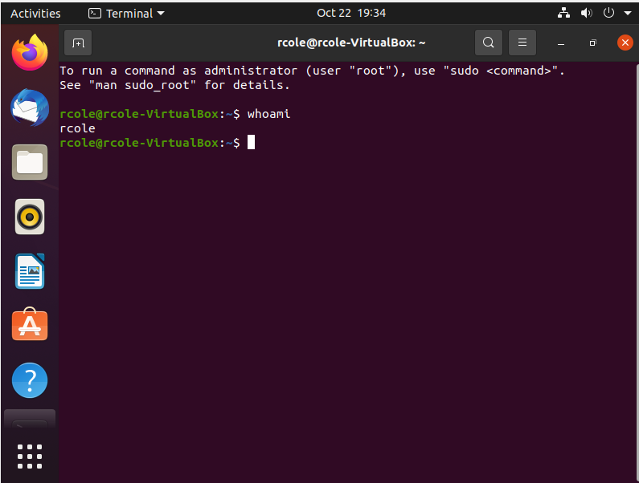

Question 3 Running basic commands on the terminal. Paste the screenshots of

the output for each sub-question

A)



B)

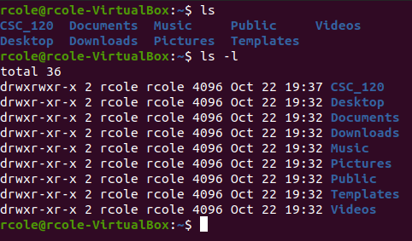

The “ls” command list files and folders in the current directory. It can also be used to list files in other directories when followed by the name of the other directory.

C)



The “cd” command is used to change directories. It can be followed by a directory to switch to or go back a directory if used alone.

D)

The “sudo” command is used to give administrative privileges when running the command that follows it.

E)



I installed vlc player with the command “sudo apt install vlc”.

F)



The output of the “pwd” command was /home/rcole/Desktop. It shows your current directory path.

Question 4 Exploration

There are many differences between a Virtual Machine and the host operating system. The host operating system runs directly on the computer’s hardware and interacts with it. Only one host operating system can be loaded at a time. Virtual machines emulate an additional operating system. It behaves like an actual physical computer but it is a digital version. It can run multiple operating systems on a single computer. It runs in a separate window and is isolated from the host OS. When it comes to cloud computing, virtual machines are a basic building block. Virtual machines allow each user to have their own OS instance running. Technology companies can host many users off of one server giving them the same experience as if they had dedicated hardware.

Question 5 Conceptual Question

A process is a program that is running or being executed. You can have many processes for same program.

System software manages processes, files, and I/O such as Windows or Linux. Application software performs user tasks such as notepad or chrome.

Question 6 Programming Question

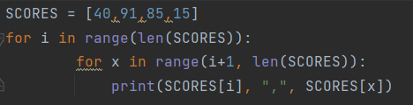

Extra Credit Challenge Question

