Wake Technical Community College
CSC120 Computing Fundamentals I – Fall 2021
Instructor: Curtis Knowles

LAB 5 – Lessons 6 and 7: Python Programming, Parts 3 and 4

DUE DATE:

This lab is due by Sunday 10/3 (11:59pm ET). Wake Tech does NOT allow any late submissions for this assignment.

OBJECTIVES:

In this lab assignment, students will learn:
- How to create a list
- How to write code to access list elements
- How to write code alter a list
- How to write iterate over a list
- How to do list concatenation
- How to create and use dictionaries

GRADING:

This lab is worth 100 points. Submit all required files as attached files to the Lab 5 submission in Blackboard in one of the following formats:
- a Word document named Lab5_<Last>_<First>.docx
- a Text document named Lab5_<Last>_<First>.txt
- Python .py files for each problem named:
  - Lab5_Prob1_<Last>_<First>.py
  - Lab5_Prob1_<Last>_<First>.py
  - Lab5_Prob3_<Last>_<First>.py

If you copy/paste the code you write in PyCharm into the Word or Text document and submit it that way for grading, DO NOT copy/paste screenshots of your code into the Word document (points will be deducted if you do this). Instead, copy/paste the actual code text into the Word document. I must be able to copy/paste the code from Word back into PyCharm to make sure it runs without error in PyCharm.

Instruction and Problems

Write a Python program for each of the problems in this lab.

Problem 1

A teacher wants a program to give extra points to students who fail a test. Write a Python program to do the following:

- Ask the user to enter 5 test scores. Store the scores in a list. Display the list.
- Copy all 5 test scores to another list. Use a loop to examine each test score in the new list. If the score is below 60, add 10 extra points to the score. Display the list.
- Compare the old score and new score of each student. If the old score and new score are different, display the two scores.

The following is an example.

Enter a test score: 45
Enter a test score: 77
Enter a test score: 88
Enter a test score: 52
Enter a test score: 90
All scores: [45.0, 77.0, 88.0, 52.0, 90.0]
Students who scored below 60 get 10 extra points.
All scores: [55.0, 77.0, 88.0, 62.0, 90.0]
Students whose scores have changed:
Old score: 45.0 New score: 55.0
Old score: 52.0 New score: 62.0

Copy your Python program into the text file as indicated above. Submit the file to Blackboard for credit.

Problem 2

Write a Python program to do the following:
- Ask the user to enter as many integers from 1 to 10 as he/she wants. Store the integers in a list. Every time after the user has entered an integer, use a yes/no type question to ask whether the user wants to enter another one. Display the list.
- Display the largest element, the smallest element, the sum of all elements and the length of the list.
- Calculate and display the average of the elements.
- Reverse the order of the elements. Display the reversed list.
- Move the last element to the front of the list, i.e., the last element becomes the first element while other elements remain the same. [Hint: Insert the last element to the front first, then delete the last element]

The following is an example:

Enter an integer from 1 to 10: 5
Enter another integer?[y/n] y
Enter an integer from 1 to 10: 9
Enter another integer?[y/n] y
Enter an integer from 1 to 10: 8
Enter another integer?[y/n] y
Enter an integer from 1 to 10: 5
Enter another integer?[y/n] y
Enter an integer from 1 to 10: 7
Enter another integer?[y/n] n
Number list: [5, 9, 8, 5, 7]
Largest element: 9
Smallest element: 5
Sum of all elements: 34
Length of list: 5
Average: 6.8
List reversed: [7, 5, 8, 9, 5]
Last element moved to front: [5, 7, 5, 8, 9]

Copy your Python program into the text file as indicated above. Submit the file to Blackboard for credit.

Problem 3

This program is about dictionaries. We want to use a dictionary to store frequency count of each letter in a string. Write a Python program to do the following:

(a) Ask the user to enter a string. Convert all letters to uppercase. Count the frequency of each letter in the string. Store the frequency counts in a dictionary. You should count letters only. Do not count any other characters such as digits and space. Display the dictionary.
(b) Ask the user to enter a letter. Convert it to uppercase. Check whether the letter is in the dictionary. If it is not, display the message “Letter not in dictionary”. Otherwise, display the frequency count of that letter, remove the letter from the dictionary and display the dictionary after that letter has been removed.
(c) Create a list to store the letters that are in the dictionary. Sort and display the list.

The following is an example.

Enter a string: Magee, Mississippi

Dictionary: {'M': 2, 'A': 1, 'G': 1, 'E': 2, 'I': 4, 'S': 4, 'P': 2}
Choose a letter: s
Frequency count of that letter: 4
Dictionary after that letter removed: {'M': 2, 'A': 1, 'G': 1, 'E': 2, 'I': 4, 'P': 2}
Letters sorted: ['A', 'E', 'G', 'I', 'M', 'P']

EXTRA CREDIT PROBLEM (worth 25 points)

Create a program that converts feet to meters and meters to feet. The formulas for conversion are:

feet = meters / 0.3048 meters = feet * 0.3048

Create and call functions as follows:

display_title() – displays the program title on screen
display_menu() – displays the menu options on screen
to_meters(feet) – converts feet to meters and returns the
meters result to the main calling program
to_feet(meters) – converts meters to feet and returns the
feet result to the main calling proram

Continue to ask if the user wants to perform another conversion until they enter “N”.
If the user enters an invalid menu option, print an “Invalid Entry” message and ask if they want to perform another conversion.

Your output should look similar to the following: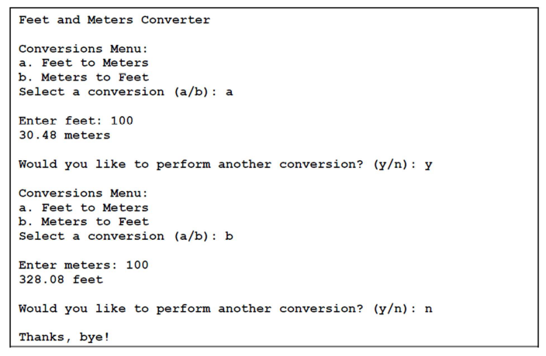

General Requirements (20 pts total)

Correct filenames submitted [10 points]
If using Word or Text document, Python code is copy/pasted instead of using screenshots [10 points]

Grading rubric for Problem 1 (25 pts total)

Creating score list [8 points]
Modifying score list [8 points]
List scores that have changed [9 points]

Grading rubric for Problem 2 (25 pts total)

Create and display list [7 points]
Display largest, smallest, sum, length, and average [10 points]
Reverse the list [4 points]
Move last element to front [4 points]

Grading rubric for Problem 3 (30 pts total)

Create dictionary [6 points]
Check whether letter chosen by user is in dictionary [6 points]
Display frequency count of letter chosen by user [6 points]
Remove letter from dictionary [6 points]
Sort the list of letters in dictionary [6 points]

