

# **MODULE: 1**

# **SE – Overview of IT Industry**

***1. What is software? What is software engineering?***

***Ans.***

* **What is software?**

Software is a set of instructions. Software is a collection of programs and data that tell a computer how to perform specific tasks. Software is that part of a computer.

* **What is software engineering?**

Software engineering is the development of software using well defined scientific principles and methods.

Software engineers create web applications, mobile apps, robots, operating systems, and network systems. They develop software solutions that meet their companies' needs and expectations. Note that the terms "software engineer" and "software developer" are used interchangeably in the industry, but these positions' responsibilities vary slightly.

***2. Explain types of software?***

***Ans.***

**1) System S/W: -** system software control and manage the operations of computer hardware (E.X: windows, Linux etc.)

**2) Application S/W: -** The software that helps you to do a specific type of work is called application software (E.X: MS word, Excel etc.)

**3) Driver S/W: -** Device drivers control the devices connected to a computer, enabling them to perform their specific tasks. (E.X: printer, mouse, modem, etc.)

**4) Programming S/W: -** Programming software and programming tools enable developers to develop, write, test and debug other software programs (E.X: compilers, debuggers etc.)

**5) Middleware S/W: -** Middleware mediates between application and system software or between two different kinds of application software. For example, middleware enables Microsoft windows to talk to Excel and Word.

***3. What is SDLC? Explain each phase of SDLC***

***Ans.***

**SDLC (Software Development Life Cycle): -** It describes the sequence of phases or steps to develop any software

* **phase of SDLC**

# 

**1. Planning/Requirement Gathering (What):** Develop a detailed project plan including timelines, quality, budget, and risk management strategies.

**2. Analysis (How):** The requirements for the target software are specified. These requirements get approval from customers and market analysts.

**3. Design and Prototype:** The design phase defines how a software application will work. During this phase, teams decide on the programming language, screen layouts, and relevant documentation they will use.

**4. Implementation (Coding):** Write the code according to the design documents and coding standards.

**5. Testing:** Often, testing happens in parallel with development, as developers write and test the code they’ve produced before moving on to the next coding task.

**6. Deployment:** The deployment process starts once the testing phase is over and there are no bugs or errors in the development backlog.

**7. Maintenance:** Implement new features and updates based on user feedback and changing requirements.

***4. What is DFD? Create a DFD diagram on Score Board***

***Ans.***

A visual model that represents the flow of data through a process or system.

* **Data Flow Diagrams are used to:**
* Show where data comes from and goes
* Show which activities transform data
* Show which outputs are stored in the system
* Show which outputs are utilized by other activities or entities

**Data Flow Diagram (DFD)**

## Level: 0

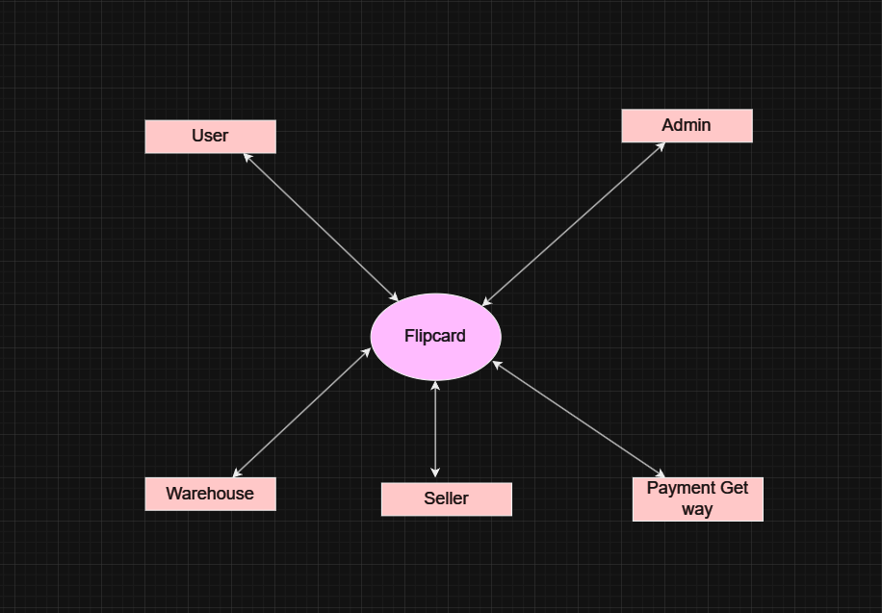

## Level: 1

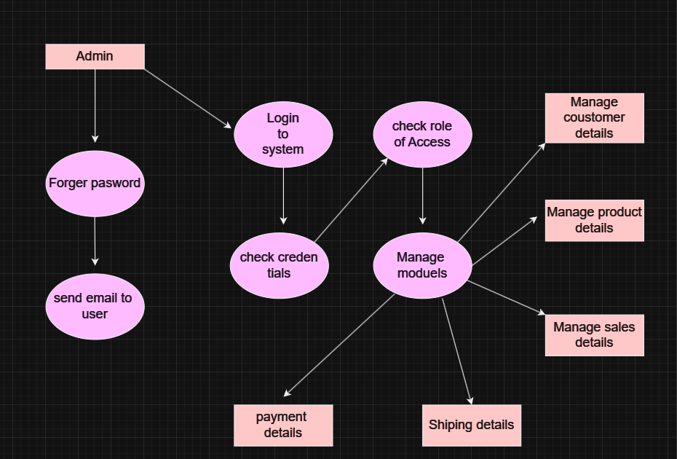

***5. What is Flow chart? Create a flowchart to make addition of two numbers.***

***Ans.***

A flowchart is a type of diagram that represents a workflow or process. A flowchart can also be defined as a diagrammatic representation of an algorithm, a step-by-step approach to solving a task.

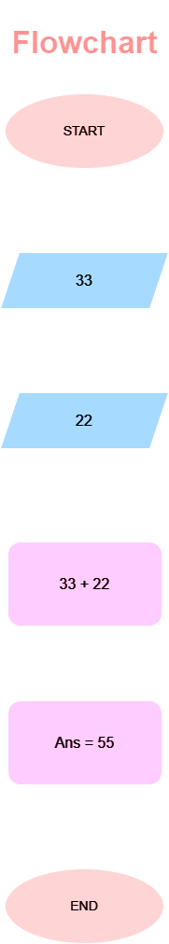

***6. What is a Use case Diagram? Create a use-case on bill payment on Payment.***

***Ans.***

A Use Case Diagram is a vital tool in system design, it provides a visual representation of how users interact with a system.

# Use Case

