Project Report On

Link in Bio Tool

Developed By

Aayush Pathak & Hardik Thakkar

Submitted To



Geetanjali College of Computer Science and Commerce (BBA)
Saurashtra University Rajkot
2023-2024

Project Guide
Prof. Pranav Trivedi

NO | NAME | Page No.
1 | Project Profile | 1
2 | Acknowledgement | 3
3 | Preface | 4
4 | Project Profile | 5
4 | Project Requirement | 6
5 | Software Development Life Cycle | 7
6 | ER Diagram | 9
7 | DFD’s Diagram | 14
8 | Data Dictionary | 16
9 | Test Cases | 24
10 | Screen Shots | 26
11 | Future Enhancement Of Project | 40
12 | Limitation Of Project | 41
13 | Bibliography | 42

Index

Acknowledgment

I am happy to submit my idea for the "Linkmonks (Link in bio tool)" Application to Saurashtra University, Rajkot for a BCA degree in the computer branch.

I am grateful to Prof. Brijesh Shah Head of the Department and all the faculty members of the Department of Computer Science for their kind support throughout this journey.

I take the privilege to acknowledge the elite authors of numerous books and papers and blogs we have referred to during this progress.

I also say a big thank you to my parents for such support and without them, I can do nothing, not in just projects but also in life. Thankful to my family for their support.

The feeling of gratefulness for anyone’s help directly arises from the bottom of my heart. A small but important and timely help can prove to be a milestone in one's life.

Preface

In 21st Century of Technology, Computer and related service is the most useful, automatic and highly speed of work. B.C.A is course in which practical aspect is important as theoretical aspect. In the present world importance of education is increasing.

The project training in a student’s life is like a live experience in the industry. If we have experience then & then we get top of the level. Most Important Factor of B.C.A Course is Project Work.

The Project Work is Must for Every Student in Different Government or Private Organization during the Study Period. We are developing project in 5th Semester of B.C.A we are the student of Geetanjali Group of Colleges Is Affiliated with Saurashtra University, Rajkot.

I created this project dynamic and in this project we provide select, insert, update and delete operation on client user can easily show site and give feedback. In client side there is so many features like view all links, delete & edit link if the user id and link user id is same, user profile, user posts count, specific user post, etc.

As this is fully and educative project site so it has made many limitations as per the fully furnished site view.

I have gone through and study necessary information, which is collected and presented in this report. I am trying my best in this project. I had taken almost care that the information provided in the project is true and project is in a smooth running condition and error free.

Project Profile

Project Title : Linkmonks

Development Software : VS Code

Front End : Reactjs, Tailwindcss, Shadcn-ui

Backend : Appwrite

Year : 2023-24

Project Guide : Prof. Pranav Trivedi

Submitted By : Aayush Pathak & Hardik Thakkar

Documentation Tool : Microsoft Word

Operating System : Windows 10

Project Requirements

Processor | Core2Duo or above
Ram | Minimum 2GB Ram
Operating System | Any
Graphics Card | You Don’t Need Graphic Card
Database | Appwrite Database
Language | React js

Software Development Life Cycle (SDLC)

Software Development Life Cycle Steps:
Here, this website was developed based on SDLC (Software Development Life Cycle).
SDLC has a different step of development of websites or any type of application.
Following the SDLC steps are used in the website development: -
- System Requirement Analysis.
- Feasibility study
- System Design
- Code Generation
- Testing
- Implementation
- Maintenance

System Requirement Analysis:
In this phase, the development team visits the need for possible software requirements in micro-depth to develop the system.
The basic clearance of the website they informed by the system requirement analysis investigation team. Understanding fully what a project will deliver is critical to its success.

Feasibility study:
Feasibility means the analysis team's report first study and that after the decision to create this website.
This team internally shows the company’s possibility of developing this type of website. Tools and Technology, Economically, Government Rules & regulations are considered.
Based on the feasibility study the project ‘Logistic Application’ is feasible.

System Design:
This phase works on the creation of the first pre-model of the whole system.
In terms of the end user/server technology, the number of tiers needed for the package architecture, the database design, the data structure design, etc., are all defined in this phase.

Implementation:
Implementation was the phase where the actual coding and development took place. Programmers and developers wrote the software code based on the design specifications. This phase included rigorous testing to identify and fix any coding errors or bugs.

Testing:
The testing phase involved systematically evaluating the software to ensure it met quality standards. Different testing levels, such as unit testing, integration testing, and user acceptance testing, were conducted to validate the software’s functionality, performance,and reliability. Defects were identified and addressed during this phase.

Maintenance:
The maintenance phase represented the ongoing support and enhancement of the software post-deployment. It included activities such as bug fixes, updates, security patches, and the addition of new features. This phase aimed to keep the software in optimal condition and aligned with changing user requirements and technological advancements. Effective maintenance was crucial for long-term software sustainability.

ER-Diagram
An entity Relationship Diagram (ERD) is a data modeling technique that graphically illustrates an information system’s entities and the relationship between those entities . An ERD is a conceptual and representation model of data used to represent the entity from work infrastructure .

1) user
name

imageUrl

Email

active_plan_id

is_pro

user

$Id

accountId

2) links

seo_description
seo_keywords
seo_keywords
slug

imageId
imageUrl

is_show_social_icons

is_show_watermark

links

$Id

userId

is_show_verified_icon

3) link_blocks

block_type

other_values

block_order

Link

total_clicks

link_blocks

$Id

link_id

4) stats

city

zip

ip_address

countryCode

country

stats

$id
link_id

region

5) social_media_links

telegram

facebook

instagram

linked_in

github

social_media_links

$id
link_id

twitter

System Design Tools [DFD’s]

DFD (Data Flow Diagram) :

DFD 0 Level Diagram

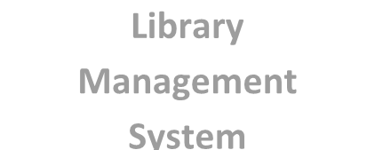

Linkmonks

User

Admin

DFD 1 Level Diagram

User
Login

Links

Display
Blocks

Add
Blocks

Delete Blocks
Books

Data Dictionary

- Database Collections :-
  - users
  - links
  - link_blocks
  - stats
  - social_media_links
  - plans

- user

Sr No. | Fields | Data Type | Size | Constraints
1 | $id | string | - | Primary key
2 | accountId | string | 100 | -
3 | email | string | 100 | -
4 | imageUrl | string | 100 | -
5 | name | string | 100 | -
6 | active_plan_id | string | 25 | -
7 | is_pro | boolean | - | -

2) links :-
Sr No. | Fields | Data Type | Size | Constraints
1 | $id | string | - | Primary key
2 | userId | string | 25 | -
3 | slug | string | 20 | -
4 | imageUrl | string | 100 | -
5 | imageId | string | 25 | -
6 | is_show_verified_icon | boolean | - | -
7 | is_show_social_icons | boolean | - | -
8 | is_show_watermark | boolean | - | -
9 | seo_keywords | string | 150 | -
10 | seo_description | string | 150 | -
11 | seo_title | string | 75 | -
12 | ga_tag | string | 25 | -
13 | description | string | 150 | -
14 | is_private | Boolean | - | -

3) link_blocks:-

Sr No. | Fields | Data Type | Size | Constraints
1 | $id | String | - | Primary key
2 | link_id | String | 25 | -
3 | block_type | String | 25 | -
4 | other_values | String | 500 | -
5 | Link | url | - | -
6 | total_clicks | Integer | - | -
7 | block_order | Integer | - | -
8 | is_private | Boolean | - | -
9 | restriction_type | String | 10 | -
10 | scheduled_block_id | String | 25 | -
11 | is_featured | Boolean | -

stats:-

Sr No. | Fields | Data Type | Size | Constraints
1 | $id | String | - | Primary key
2 | link_id | varchar | 50 | -
3 | ip_address | Ip | - | -
4 | city | String | 10 | -
5 | zip | integer | - | -
6 | country | String | 60 | -
7 | region | String | 60 | -
8 | countryCode | String | 16 | -
9 | Referrer | Url | - | -
10 | Total_views_by_ip | Integer | - | -

social_media_links:-

Sr No. | Fields | Data Type | Size | Constraints
1 | $id | String | - | Primary key
2 | link_id | varchar | 50 | -
3 | telegram | string | 30 | -
4 | instagram | String | 30 | -
5 | facebook | String | 50 | -
6 | github | String | 20 | -
7 | twitter | String | 20 | -
8 | linked_in | String | 100 | -
9 | snapchat | String | 100 | -
10 | pinterest | String | 100 | -

plans:-

Sr No. | Fields | Data Type | Size | Constraints
1 | $id | String | - | Primary key
2 | price | String | 100 | -
3 | Plan_name | string | 30 | -
4 | max_links_allowed | integer | - | -
5 | max_blocks_per_link | integer | - | -
6 | Visitor_limits | Integer | - | -
7 | Social_media_links | Boolean | - | -
8 | Google_analytics | Boolean | - | -
9 | Seo_optimization | Boolean | - | -
10 | Verified_badge | Boolean | - | -
11 | Support_24/7 | Boolean | - | -
12 | Animations | Boolean | - | -
13 | Custom_domain | Boolean | - | -
14 | Sub_links | Boolean | - | -
15 | Scheduled_blocks | Boolean | - | -
16 | Email_subscription | Boolean | - | -
17 | Advanced_statistics | Boolean | - | -
18 | Multiple_tabs | Boolean | - | -
19 | Plan_desc | String | 150 | -
20 | Plan_type | String | 25 | -
21 | Monthly_price | String | 100 | -
22 | Yearly_price | String | 100 | -
23 | Lifetime_price | String | 100 | -
24 | payment_link | Link | - | -

Test Cases

Case Name | Case Description | Actual Output | Test Result
Register | Register with new account | Register with the new account while already taken email cannot be registered again | Pass
Login | A window with a two textbox email and password. | Write correct email and password and login successfully. | Pass
Home | Screen Displays all menus and create link form . | Screen Displays all menu or name of the Linkmonks and create link form. | Pass
Single link | Display single link page with all the tabs of settings of link | Display single link page with all the tabs of settings of link toggle multiple links | Pass
Add Blocks | Add multiple blocks,reorder& edit it | Created new blocks, reordered & edited also it woks perfectly, | Pass
Remove Blocks | Remove blocks | Removed some blocks and updated the blocks and its working perfectly | Pass
Stats tab | Display stats with proper data | Displayed all the stats with proper data of visitors in the selected link | Pass
Add Restriction | Add restriction for the free plan users that it is not accessible by the free plan users | Added restriction with the only pro users can access stats tab | Pass
Update account | Updated name and password | Updated name and password by entering old and new password works perfectly | Pass
Update Social Media Link | Update social media links in the selected link | Updated social media links workins perfectly | Pass

Screenshots

- Landing Page:-

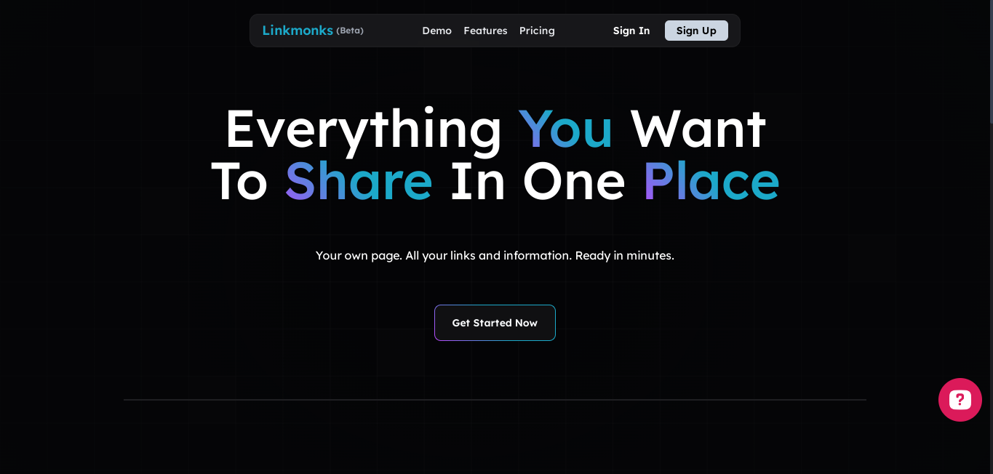

- This page is a basic landing page which is accessible by authorized and unauthorized users so this is our first page where we can see which features we provide and also which feature is available in pro and free plan using pricing cards

- Register Page:-

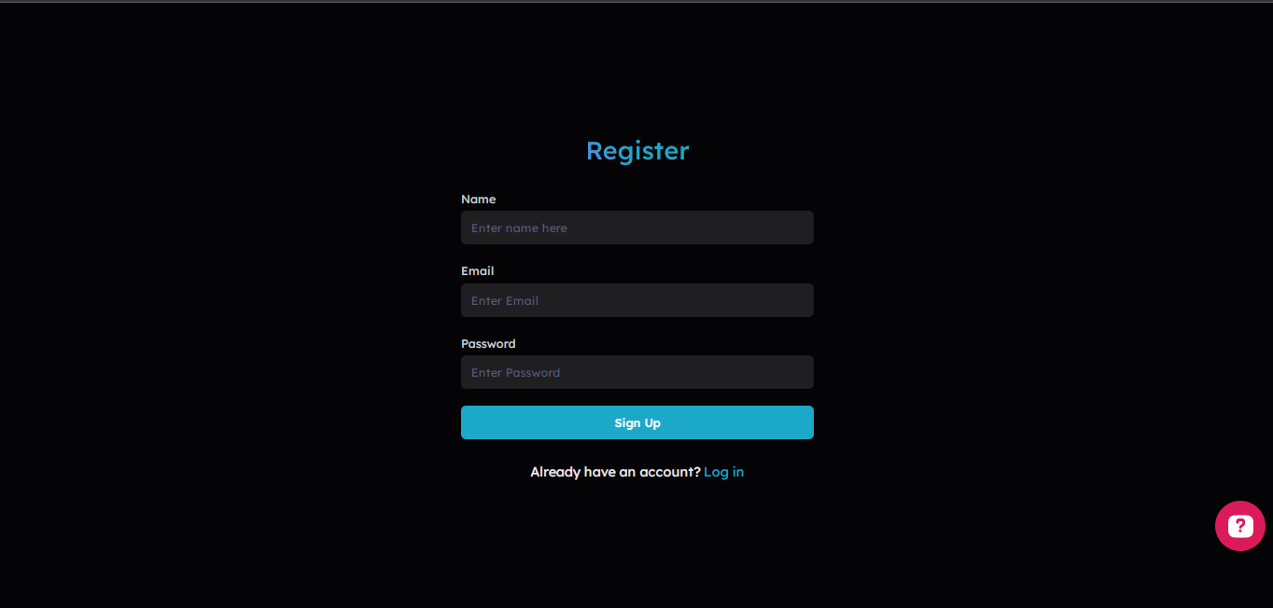

- This is a register page where users can register by entering their email and password and name. If the email is already taken then we display an error message that the email is already taken please try to login or enter new email. This page also contains the login page link If an user is already have an account then they can go to the login page by clicking on it.

- Login Page:-

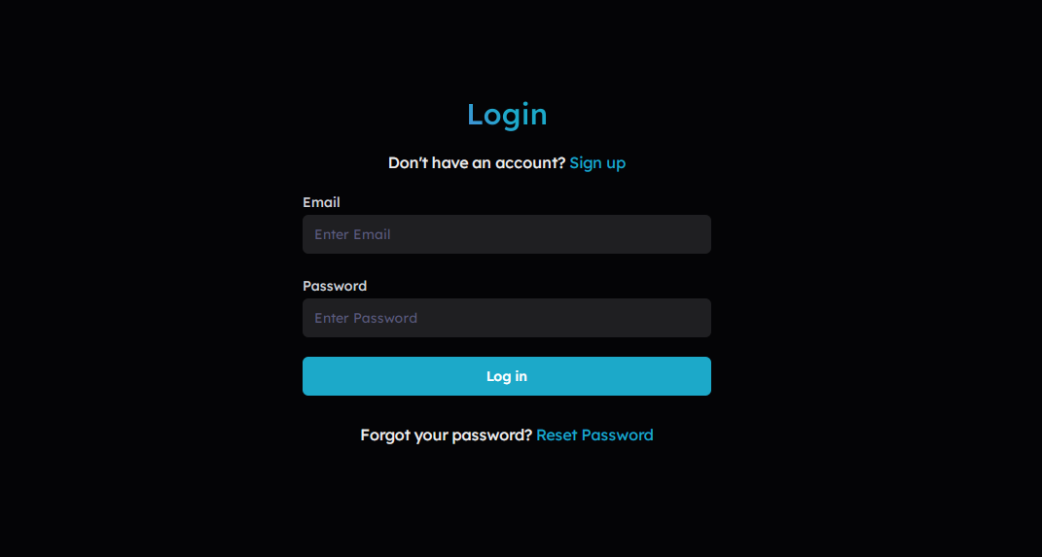

- This is a login page which is used to authenticate user to access their account in linkmonks. If an user is not having an account then the error. And if the password and email is entered correctly then user logs in to their account

- HomePage:-

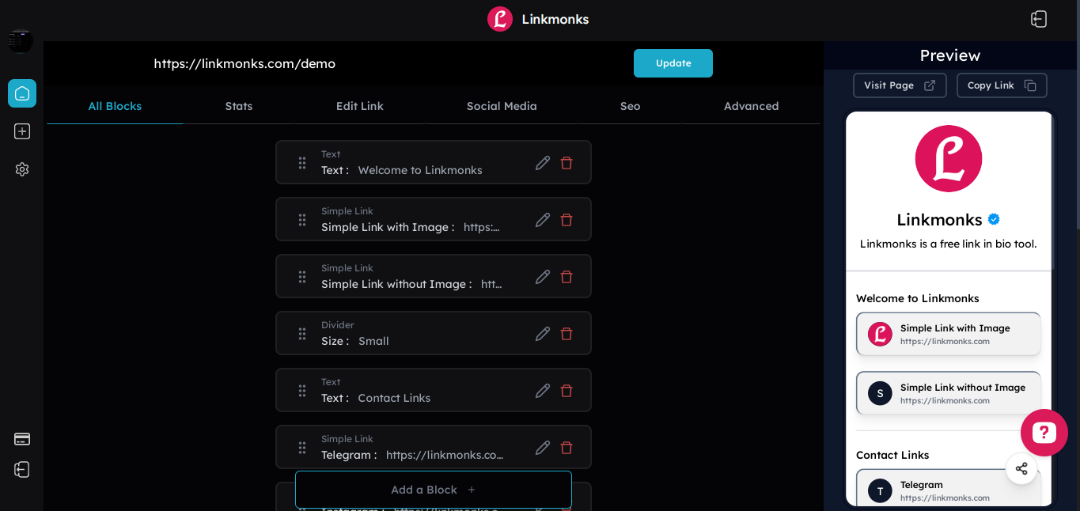

- This is home page where user can select links and add blocks in it. This page contains multiple tabs that user can manage their link in a single page by navigating through the multiple tabs

- Stats Page:-

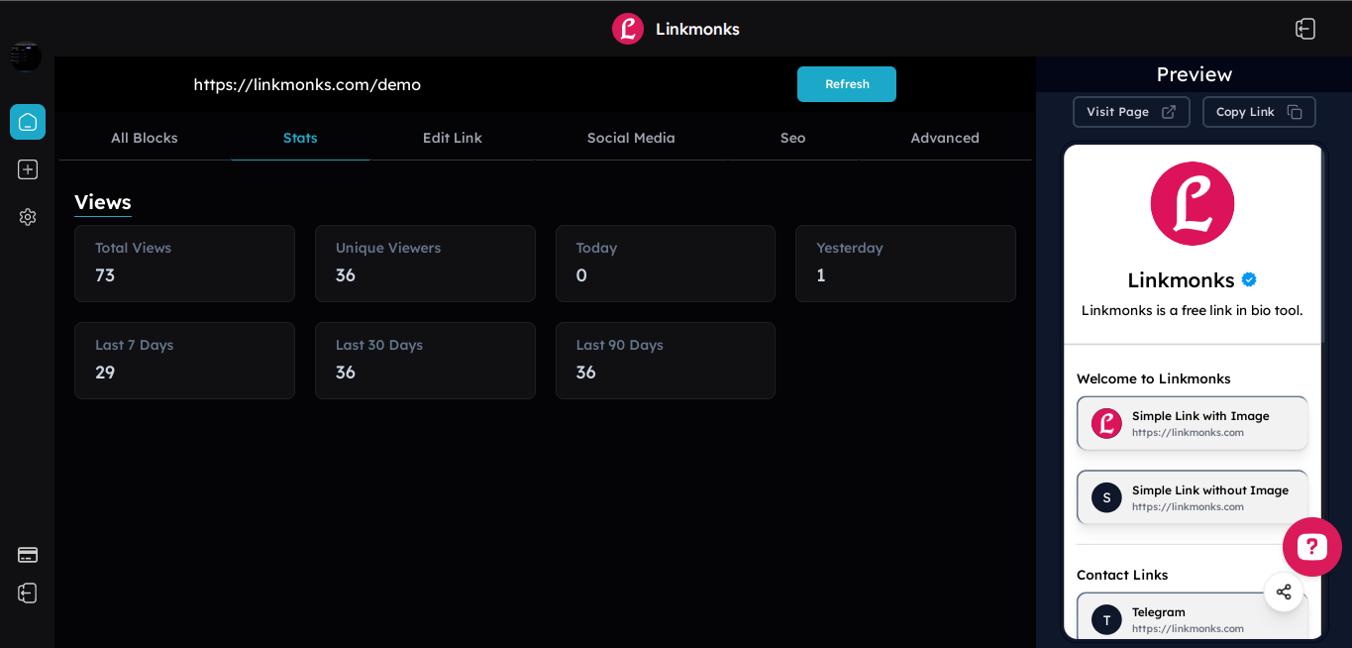

- This is the stats page where all the stats data will be displayed of the selected link.

- Edit Link:-

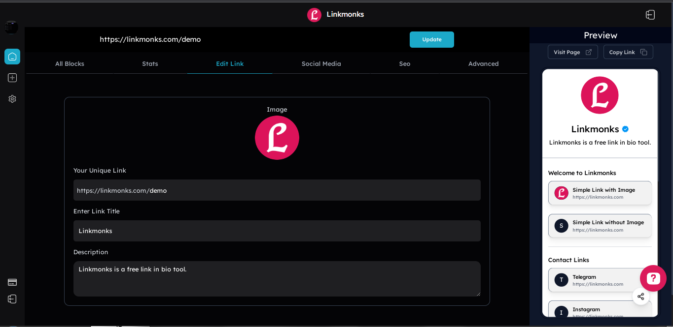

- This is an edit link page where user can change their slug and title and description

- update social media:-

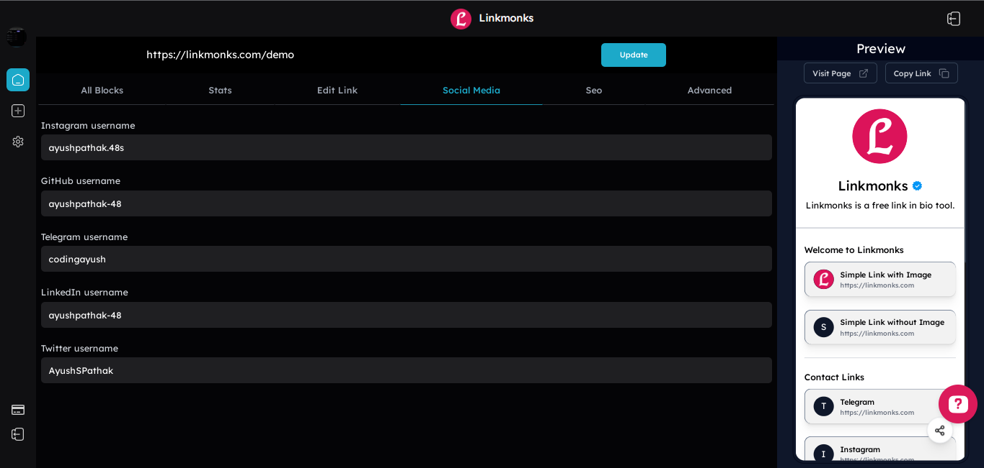

- In this page user can edit their social media links that is displayed below the description in as shown in preview

- Advanced Link Settings:-

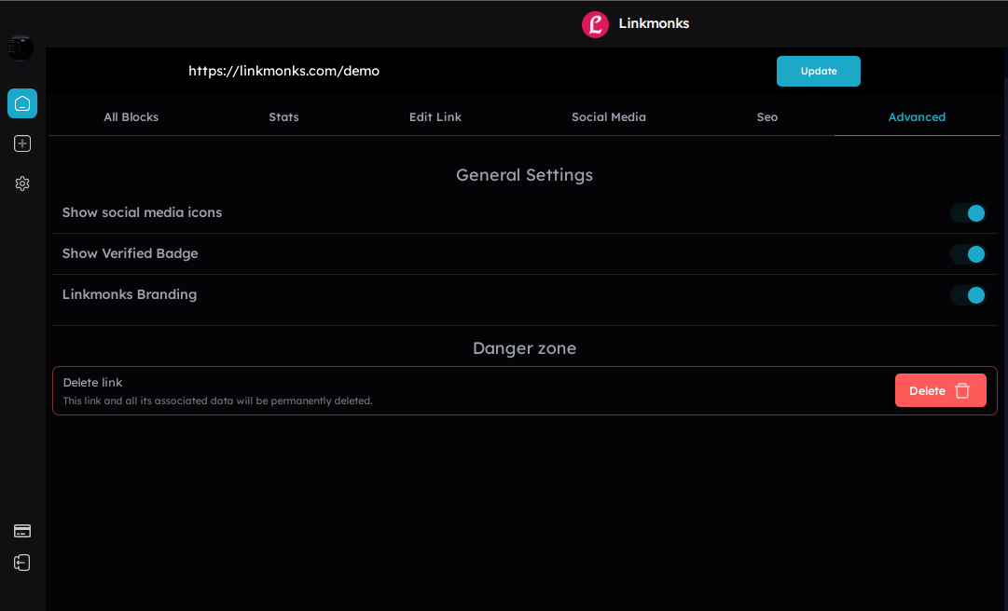

- This is an advanced link settings page where user can delete their link or toggle social media links whether to show this or not
- User can also enable verified badge if the user is a pro user where free user doesn’t have access to the toggle button.

- Seo Settings:-

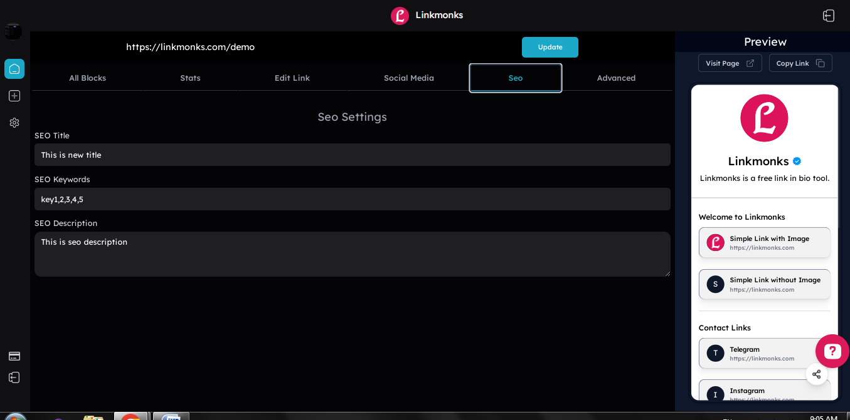

- In this page user can manage their seo settings if the user is a pro user

- Create link:-

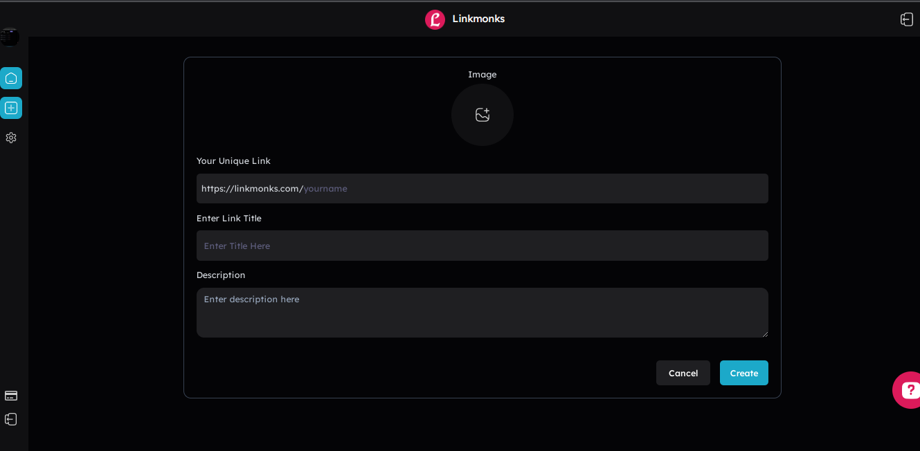

- This is a create link page where user can create links limited depends on their current plan.

- Account Settings :-

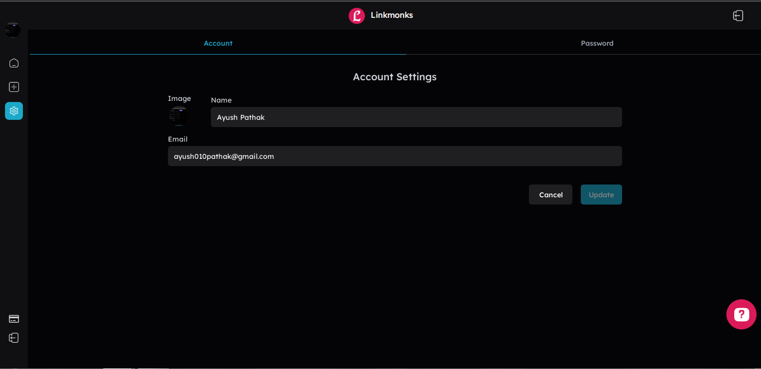

- In this page user can edit their account settings.’

- Update password:-

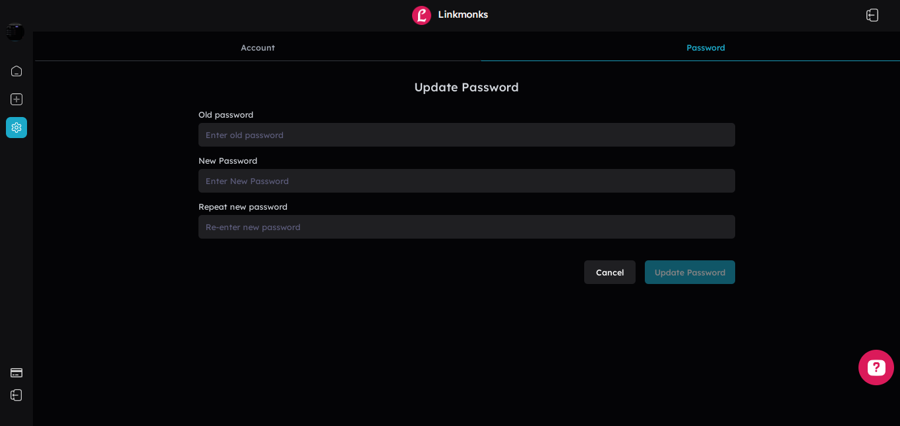

- This page allows user to update their password by entering old and new password.

- Subscription Page:-

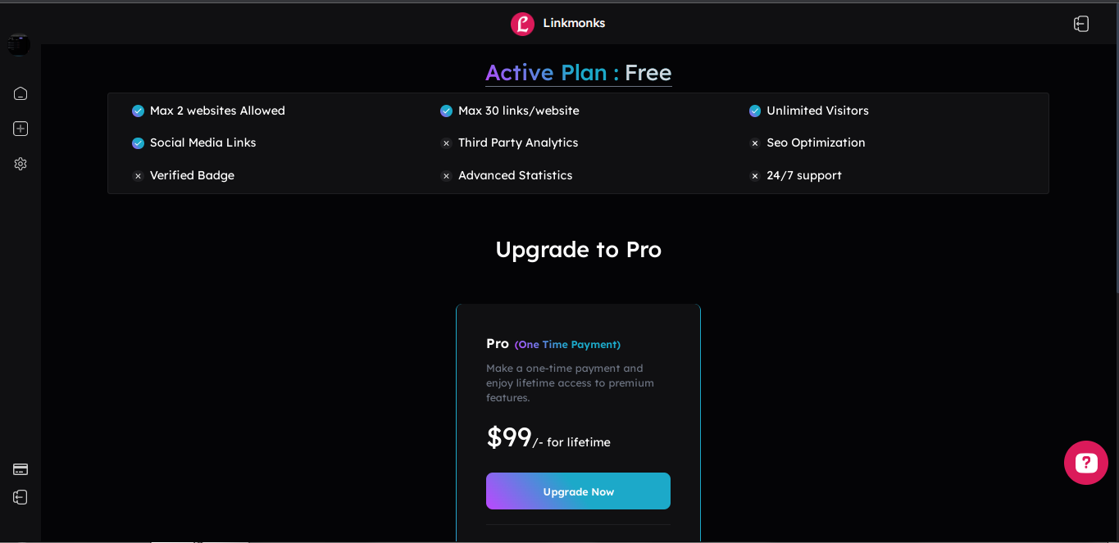

- This page shows the user current plan.

- Single Link Display Page:-

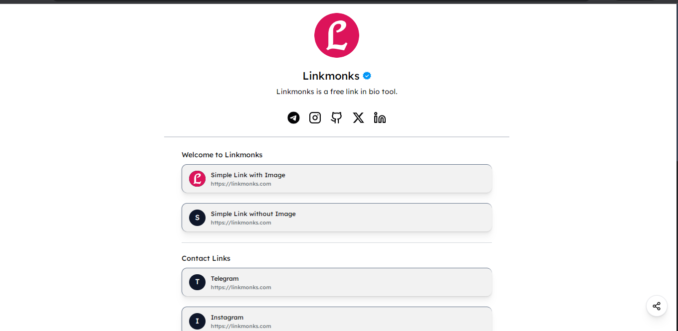

- This is the main page where user can share with others with their unique url.
- This page also have share feature and more coming soon…

Future Enhancement Of Projects

Enhancing a Link in Bio Tool involves adding new features like password protected blocks, providing email newsletter forms, contact forms, improving existing functionality of stats page.

1.Password Protected Link:
Implement a fast and efficient search system with filters for easy resource discovery.

2. Providing Single Block Stats:
Develop a user-friendly mobile app for on-the-go access to library services.

3.Email Newsletters:
Set up automated reminders for due dates and reservation pickups.

4.Contact Forms:
Integrate barcode scanning for swift check-in and check-out processes.

5.QR Code with company logo:
Include a simple feedback system for user suggestions and opinions.

6.Share single link:
Ensure the system's responsiveness across various devices for a seamless experience.

7.Email Campaigns:
Enable automatic email notifications for overdue items and other important updates.

8.Export Statistics Data:
Streamline data management with the ability to import/export data in bulk.

Limitation Of Project:

The limitations of a Link in Bio project can vary based on the specific implementation and context. Here are some common limitations associated with Linkmonks:

Limited Budget:
Insufficient funding may restrict the implementation of advanced features and necessary infrastructure.

Limited Scalability:
Some LMS may face challenges when scaling up to handle a growing number of users, transactions, or resources.

Dependency on Internet Connectivity:
If the system heavily relies on internet connectivity, downtime or slow network speed can disrupt service.

Bibliography

- https://stackoverflow.com/

- https://www.javatpoint.com/

- https://www.w3schools.com/

