A Model for Temporal Contiguity Improvements in Cross-situational Word Learning

George Kachergis, Chen Yu, and Richard M. Shiffrin

{gkacherg, chenyu, shiffrin}@indiana.edu

Department of Psychological & Brain Science / Cognitive Science Program

Bloomington, IN 47405 USA

Abstract
Recent research has demonstrated that participants often learn a surprising number of word-object pairings solely from their co-occurrence statistics across individually ambiguous trials. To limit simple working-memory strategies, past designs prevented the same pairing from appearing in consecutive trials. Yet such temporal contiguity often appears in real world settings, and seems likely to improve learning. The present research examines and models the effects of such repetitions. Indeed, our results show that allowing word-referent pairs to appear in adjacent trials increases overall learning. However, not only are more repeated pairs learned, but more unrepeated pairs are learned, as well. We propose that repetition allows learners to segregate repeated pairs from unrepeated pairs, thereby allowing differential attention between the subsets. The findings are explored with an associative learning model to provide a formal account of the underlying learning mechanisms.
Keywords: statistical learning; language acquisition; cross-situational word learning; ambiguity

A Model for Temporal Contiguity Improvements in Cross-situational Word Learning
To learn a new language, a learner—be they an infant or a traveler in a foreign land—may depend on others to occasionally name the objects in their shared environment. However, it may not be clear to the learner exactly which object a speaker is naming at any given moment. The learner may disambiguate which words refer to which objects if names co-occur most frequently with their intended referents, and the learner remembers frequent word-object pairings. Such cross-situational learning (Gleitman, 1990) does not even rely on every correct pairing appearing more frequently than others, since learners employ a mutual exclusivity bias—one word for each object, demonstrated in toddlers (Markman & Wachtel, 1988)—to effectively infer word-object mappings that are completely correlated with other pairs (Kachergis, Yu, & Shiffrin, in press).
In the cross-situational word learning paradigm (Smith & Yu, 2007), a learner acquires word meanings by tracking the co-occurrences words and objects across situations containing several words and objects. For example, adults are presented with a series of study trials, each displaying four uncommon objects (e.g., an abstract sculpture) while four pseudowords are spoken (e.g., “manu”, “bosa”). Although each pseudoword refers to an onscreen object, the intended referent is not indicated, leaving the correct pairings on each trial quite ambiguous. With this trial configuration, when given a total of 18 word-object pairs across 27 trials—yielding 6 repetitions per pair—the average adult learner adult learner chooses the correct object for each word from 3 other objects (i.e., 4AFC testing) for 9.5 of the 18 pairs.
Given perfect knowledge of which words and objects appeared on each trial, and perfect discrimination among the words and objects, myriad simple algorithms can perform this task. For example, maintaining a word x object co-occurrence count matrix and choosing the most frequent object for each word guarantees flawless performance. However, such a strategy requires accurately storing and retrieving an 18x18 matrix of counts—an unlikely feat for human memory. Instead, human learners likely select and store a subset of the word-object co-occurrences on each trial, perhaps on the basis of what is noisily remembered from preceding trials. For example, if words {w₁, w₂, w₃, w₄} and objects {o₁, o₂, o₃, o₄} appeared on the first trial, and {w₁, w₅, w₆, w₇} and {o₁, o₅, o₆, o₇} were presented on the next trial, learners may realize that pair 1 (i.e., w₁-o₁) was repeated, and devote more attention to storing this association than to the still-ambiguous word-object pairings (i.e., pairs 5-7). Assuming that influences from such trial-to-trial contiguity are present, Yu & Smith (2007) and other previous studies from our lab did not allow such contiguities: pairs were forbidden from appearing in consecutive trials.
However, such repetitions are common in real learning environments, in part because the physical environment is often temporally contiguous: objects do not spontaneously disappear, to be replaced by new objects. Rather, both situations and topics of conversation may gradually evolve over time, with objects and topics being replaced bit by bit as one passes from one room to the next. Such temporal contiguity can aid learning in several ways. As illustrated above, repeating one pair in two consecutive trials can allow inference of the repeated pair, assuming memory for first trial. Similarly, consider two successive trials on which three of the four word-referent pairs are repeated: {w₁, w₂, w₃, w₄; o₁, o₂, o₃, o₄} followed by {w₁, w₂, w₃, w₅; o₁, o₂, o₃, o₅}. In this case, pair 5 may be inferred if w₅ and o₅ can be identified as the unrepeated stimuli. Thus, a single unrepeated pair might be as useful for learning as a single repeated pair.
However, in both of these examples, temporal contiguity may not only confer an advantage for the single pair that can be inferred: if a learner can indeed separate repeated from unrepeated stimuli, this will also reduce—though not eliminate—the ambiguity of the larger subset of stimuli, since repeated words should refer to repeated objects, and unrepeated words to unrepeated objects. Thus, in the case of one repeated pair, the three unrepeated pairs (5-7) form only 9 possible pairings, whereas a trial with no repeated (or all repeated) stimuli contains 16 possible pairings. With three repeated pairs, the situation is the same. Hence, temporal contiguity might help not only by allowing direct inference of single pairs, but also by reducing the complexity of the learning problem—but only if learners can indeed separately associate repeated and unrepeated stimuli.
In the following studies we assess the effects of different degrees of temporal contiguity and model the results. In Experiment 1, we simply shuffle trials to achieve different degrees of successive repetitions. In Experiment 2, we test specific types of trial-to-trial repetitions to better discern the effects. Finally, we introduce an intuitive extension to a cross-situational word learning model (Kachergis et al., in press) that captures the main findings.

Experiment 1
We employ the cross-situational paradigm described above (Yu & Smith, 2007). Participants are told they will be learning words for strange objects in an alien language by viewing a series of scenes with four objects and four spoken words, but that the word order was random with respect to the objects’ placement. The manipulation of interest in this study is the repetition of some word-object pairs on successive trials. As discussed above, the degree of overlap between two trials may reasonably facilitate learning in different ways: repeating a single pair—or all but one of the pairs—allows inference of the unique pair, but may also improve learning of the remaining pairs by reducing the number of conceivable pairings. In general, it is expected that trial orderings with more trial-to-trial repetitions will yield higher overall learning.
Each training block consisted of sequences of 27 trials, during which 18 pseudoword-object pairs were presented six times (correct pairs co-occurring six times; spurious word-object co-occurrences ranged from 0 to 4, M = 1.5). The control condition was a fixed temporal sequence containing no pairs that repeated on successive trials. In all of the other conditions, the individual training trials were the same set used in this control condition. However, the order of the trials was shuffled many times to create orderings with degrees of trial-to-trial repetitions. Because the orderings were all constructed from the same set of trials, all co-occurrence statistics remained identical across conditions.
The successive repetition (SR) score of a trial ordering is the mean number of word-referent pairings that overlap across all consecutive pairs of trials. The minimum SR score is 0, as no pairs ever overlap. (A single trial repeated 27 times would give an SR score of 4, but of course this is not a reasonable learning situation.) The maximum SR score we were able to obtain by reshuffling the control sequence was 2.04. That is, in this condition, on average, a little over two word-referent pairs repeated in every pair of successive trials. The sequences we constructed and used had SR scores of 0.00, 0.33, 0.67, 1.00, 1.41, and 2.04.
Assuming memory of the preceding trial, repeating some of the pseudoword-referent pairs from trial n-1 on trial n allows segregation of possible pairings into two subgroups – repeated pairs and unrepeated pairs – perhaps as a result of attention being drawn to the repeated stimuli. Such segregation of a large set with many possible pairings (i.e., 4×4 = 16) into two smaller subsets with a fewer total number of pairings (i.e., 2×2 + 2×2 = 8) reduces ambiguity, so it was expected that conditions with higher SR scores would result in increased learning.

Participants
Participants were undergraduates at Indiana University who received course credit for participating. There were 185 participants in condition SR = 0—a control condition we use in many experiments; 36 in conditions SR = .33, .66, 1.0, and 1.41; and 31 in condition SR = 2.04. None had participated in other cross-situational experiments.

Stimuli
Stimuli are 48 images of unusual objects (e.g., sculptures) and 48 spoken pseudowords. The pseudowords are computer-generated, phonotactically-probable in English (e.g., “bosa”), and pronounced by a monotone, synthetic female voice.
On each training trial, pictures of four uncommon objects (e.g., a metal sculpture) were simultaneously shown while four spoken pseudowords were serially played. The 72 computer-generated pseudowords are phonotactically-probable in English (e.g., “bosa”), and were spoken by a synthetic, monotone female voice. The 72 words and 72 objects were randomly assigned to four sets of 18 word-object pairings.
On each training trial, the four pictures appeared immediately. After two seconds of initial silence, each pseudoword was played for one second with two seconds of silence between pseudowords, for a total trial duration of 12 seconds. The pseudowords were presented in random order. Each training sequence consisted of 27 such trials, with each ‘correct’ pseudoword-object mapping occurring 6 times, and other mappings occurring from 0 to 4 times (M =1.5).
Upon completion of each training phase, participants were tested for their knowledge of the ‘correct’ (i.e. high frequency of occurrence) pairings. On each test trial, a single pseudoword was played and all 18 objects were displayed. Participants were asked to click on the correct object for that pseudoword. Each pseudoword was tested once, and the test order was randomized for each participant and condition. Participants completed four training/test conditions. Condition order was counterbalanced.

Design
Participants were informed that they would see a series of trials with four pictures and four alien words played in random order. They were also notified that their knowledge of which words go with which pictures would be tested at the end.
On each 8 s training trial, two objects are displayed throughout, while two pseudowords are heard successively; after 2s of silence, the two words are each heard for 1s, followed by 2s of silence… Condition order is counterbalanced, and each learner participates in all four early repetition conditions for a single level of late stage repetitions.
In each between-subjects condition, the late training stage had the same structure: each pair appears three (3 Late), six (6 Late), or nine (9 Late) times, for a total of 18, 36, or 54 trials, each with two pairs (one pair trained late only, and one pair trained both early and late: e.g., {w₁,w₇,o₁,o₇}).

Procedure
Learners are instructed that they will see a series of trials with two objects and two alien words, and that they should try to figure out what each word means for a final test. Participants are not told there were different stages of training, and there is no perceptible break. After training, their knowledge was assessed using 11-alternative forced choice (11AFC) testing: on each test trial a single word was played, and the participant was instructed to choose the appropriate object from a display of 11 of the 12 trained referents. In order to assess knowledge about both associations, each word was tested twice: once without its corresponding early object, and once without its late object. For example, to test w₁-o₁, the 11 objects in the testing trial excluded o₇. Similarly, the testing trial for w₁-o₇ contained all of the other 11 objects except o₁. For conditions with both early and late training stages, the data are sorted into four cases. Consider the late study trial {w₁,o₁,w₇,o₇}, in which w₁ and o₁ were studied both early and late, and w₇ and o₇ were studied only late. We thus test four associations: w₁-o₁, w₁-o₇, w₇-o₇, and w₇-o₁. The within-stage associations w₁-o₁ and w₇-o₇ respect ME, whereas w₁-o₇ and w₇-o₁ are across-stage pairings that should not be learned under strict ME. For conditions with no early training, there is only one distinguishable case.

Results and Discussion
Figure 1 shows the overall performance achieved in each condition of Experiment 1. Increasing the degree of successive repetitions does produce increased performance, as predicted, showing a strong correlation (R² = .99). However, the increases are surprisingly modest relative to what might have been expected a priori. For detailed analysis of each condition, to-be-learned pairs were grouped according to the number of times they had successive repetitions in the sequence (see Table 1). Surprisingly, the relation between performance and SR was often non-monotonic. For example, consider the trial ordering with mean SR = 1.0. In this condition, the non-repeated pairs were learned with 45% accuracy, the pairs that overlapped once were learned with only 30% accuracy, and the pairs that overlapped three times were learned with 66% accuracy. In some other conditions, performance was more or less equal for all degrees of repetition. Only in the two conditions of low SR (SR=.33 and SR=.67) did greater successive repetition confer a modest learning advantage.
A mixed ANOVA (3, 6, or 9 late repetitions [between-subjects] × 3, 6, or 9 early repetitions × early or late pair stage × across- or within-stage pairing type) showed a main effect of pairing type (F(1,101)=161.76, p<.001) and an interaction between pairing type and the number of late repetitions (F(2,101)=10.89, p=.001). As in the 3 late condition, filtering with the use of ME produced excellent learning of the late pairs. However, the increased late training does not much improve the relative amount of learning of the ME-compliant within-stage pairs (M_{3-Late}=.71, M_{6-Late}=.74, M_{9-Late}=.84). Nonetheless, learning of the across-stage pairs (pairings that are inconsistent with strong ME) increases with additional late training (M_{3-Late}=.15, M_{6-Late}=.28, M_{9-Late}=.34).
These results show that learning is increased by increasing the average degree of successive repetitions, even while leaving all within-trial co-occurrence statistics constant. However, based on the detailed analysis in Table 1, it is clear that this learning increase was not simply due to increased learning for successively repeated pairs. For instance, in the SR=1.0 condition, non-repeated pairs were learned better than 1- and 2-repetition pairs. The difficulty of learning a given pair is not solely due to the number of successive repetitions for that pair in a sequence. Perhaps the presence of other repeated pairs interfered with the learning of a given pair. Another relevant factor may be the interaction of spacing and sequential effects: for each case where a pair occurs in successive trials, that pair will appear one fewer time later in training (since each pair only appeared 6 times during training).
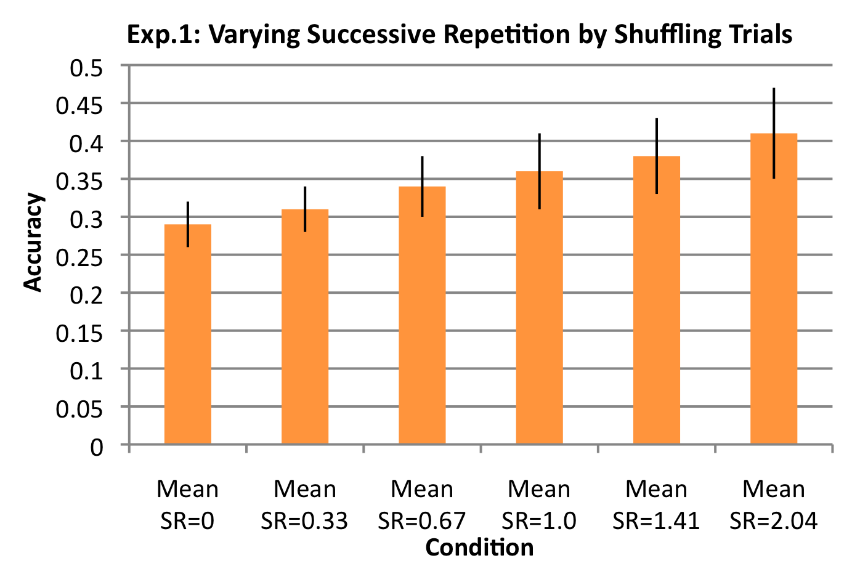
Figure 1: Accuracy (18AFC; chance=.056) for conditions with varying degrees of average successive repetitions (SR). Greater mean SR in a condition tended to improve learning performance, although not as drastically as expected. Error bars are +/-SE.

Experiment 2
Experiment 1 showed that increasing the mean successive repetitions in a trial ordering facilitates learning for the entire set of pairings, but that greater numbers of successive repetitions does not always confer an advantage for the repeated pairs. Instead, learning of unrepeated pairs seems to improve with the presence of greater overall successive repetitions in the condition. To better understand the role that successive repetitions can play in statistical learning of both repeated and unrepeated pairs, we implemented three different types of temporal contiguity in three sequences of 27 training trials, exemplified in Table 2. In the 1 pair/2 trials condition, 9 of the 18 pairs appeared in two consecutive trials at some point during the training. In the 1 pair/3 trials condition, 9 of the 18 pairs appeared in three consecutive trials. Importantly, in both of these conditions, no other stimuli in the overlapping trials simultaneously overlapped. In the 2 pairs/2 trials condition, however, each of the 18 pairs at some point appeared with another pair in two consecutive trials.
Importantly, these conditions offer different ways to perform inferences and consequently reduce the degree of ambiguity. For example, consider just two successive trials with one pair only repeated, as in the 1 pair/2 trials condition. The repeated pair may be immediately inferred to be correct, but the remaining six pairs on the two trials remains ambiguous—there are still 9 possible pairings for each of the three remaining words and objects in each trial. For another example, when two pairs are repeated in two successive trials, as in the 2 pairs/2 trials condition, no pairing can be unambiguously inferred. However, overall ambiguity is considerably reduced: If (A B X Y; b a y x) occurred on trial n, and (A B E F; a b e f) occurred on trial n+1, then memory for the preceding trial allows the following inferences: (A, B) and (b, a) must go together, in some pairing; (E, F) and (f, e) must go together, in some pairing; (X, Y) and (y, x) must go together, in some pairing. Thus no pairing can be unambiguously determined, yet the six items on the two trials have only eight possible pairings—a significant reduction of ambiguity. Note that in all of these conditions, the conceivable inferences are reliant upon memory and attention.

Participants
Participants were undergraduates at Indiana University who received course credit for participating. Twenty-three participants completed only the three SR conditions, and an additional 44 participants completed all conditions. None had participated in other cross-situational experiments.

Stimuli & Procedure
The sets of pseudowords and referents for Experiment 2, the number of trials, the number of stimuli per trial, and other details of the procedure were identical to those used in Experiment 1, except that individual trials and their orderings were constructed to be consistent with the three different types of successive repetitions described above.
Results
Figure 2 displays the overall learning performance for each training condition in Experiment 2. Participants learned significantly more successively repeated pairs (M = .47) than non-repeated pairs (M = .27) in the 1 pair/2 trials condition (paired t(66) = 6.93, p < .001), demonstrating that a single successive repetition boosts learning of that pair.
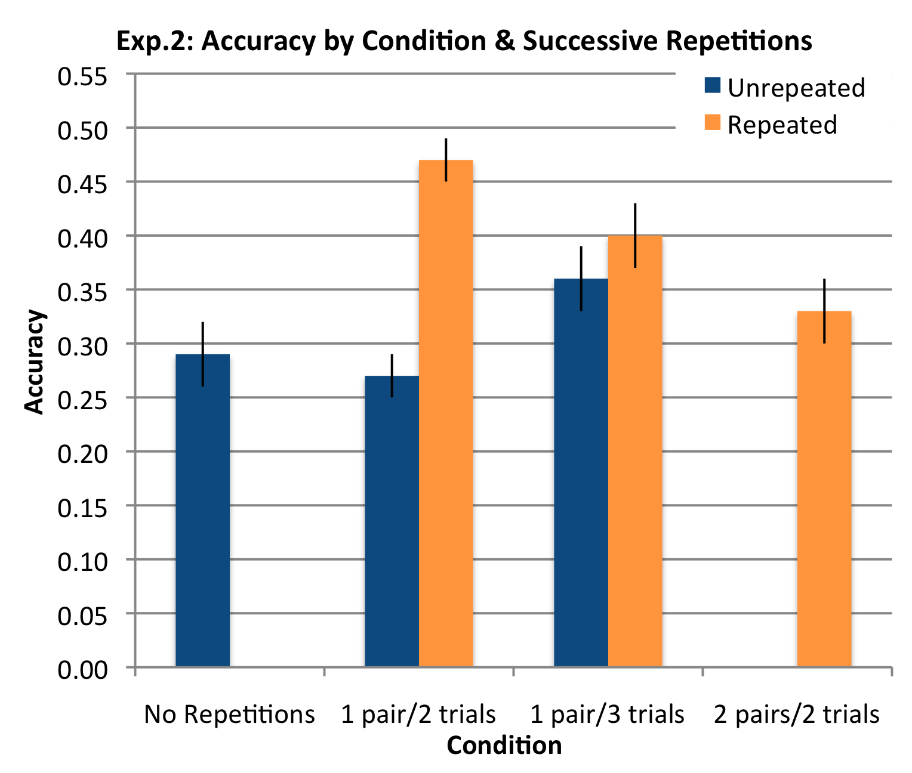
Figure 2: Accuracy (18AFC; chance=.056) for the three conditions in Exp. 2, and the TC=0 condition (no overlaps) from Exp. 1 for comparison. Error bars are +/-SE.

However, performance for repeated pairs (M = .40) in the 1 pair/3 trials condition was not significantly greater than for the non-repeated pairs (M = .36, paired t(62) = 1.31, p > .05). Instead, a higher proportion of non-repeated pairs were learned in the 1 pair/3 trials condition than in the 1 pair/2 trials condition (paired t(62) = 3.24, p < .01). Thus, although there was no SR advantage within the 1 pair/3 trials condition, more non-repeated pairs were learned instead, and overall pair learning in this condition (M = .37) was not significantly different than overall learning in the 1 pair/2 trials condition (M = .33, paired t(62) = 0.98, p > .05). Although each of the conditions with some variety of successive repetition trended toward greater overall performance than the condition with no repetitions, none were significantly greater.
It is rather striking that performance dropped for successively repeated pairs from condition 1 pair/2 trials to 1 pair/3 trials to 2 pairs/2 trials, even though the opportunities for unambiguous inference rose from 1 pair/2 trials to 1 pair/3 trials, and then dropped very low for 2 pairs/2 trials. It is equally intriguing that the non-repeated pairs benefited more when one pair repeated over three rather than two successive trials. Our ongoing hypothesis is that this has to do with how statistical learners allocate their real-time attention during statistical associative learning, how the repetitions of certain pairs create a local attentional salience—either for the repeated pairs or for the unrepeated pairs, and how learners dynamically adjust their attentional weights on possible pairings trial by trial (see Kruschke 2003, e.g.). A formal account of this hypothesis requires a computational model to allow us to further investigate these processes that may comprise statistical word learning.

General Discussion
Learning from the successive presentation of instances requires that learning in one moment be connected to learning in previous moments. That is, in order for a learner to use a past trial containing the information that A is linked to a to rule out a link between A and b, the learning must connect the noticed association on this trial to previously learning. Given all that we know about human memory, the temporal separation of the two learning trials should matter. That is, unlike batch statistical processors, for human learners, the order of learning trials and the temporal contiguity of certain trials should matter. Two experiments in the present study confirmed our hypothesis. Adult learners performed significantly better in the learning conditions with repeated pairings. A closer look of the results in Experiment 1 showed that both repeated and non-repeated words were learned better. This observation suggests two plausible ways that the additional information in temporal continuity may be utilized to facilitate learning. In general, a key mechanism in a statistical associative learner is to decide in real time which word-referent pairs to attend to among all possible ones available in an unambiguous environment. From this perspective, repeated pairs may be temporally highlighted and therefore attract the learner’s attention. On the other hand, repeated pairs may also be treated as background and therefore make non-repeated pairs novel and more attentionally salient. These two mechanisms may operate in parallel and dynamically interweave. Indeed, the results in Experiment 2 provide direct evidence to support this proposal – human learners in that study seem to be able to fully take advantage of different types of temporal continuity by developing different computational inferences, suggesting that the learning system seems to be highly adaptive by discovering and adjusting to the most effective way to process the learning input.
Cross-situational statistical learning mechanisms may be criticized on the basis that these processes may not be efficient because they require the accumulation of statistical evidence trial by trial until it is strong enough to disambiguate learning situations. Nonetheless, statistical regularities and physical constraints in the real world may provide more information than the stimuli in our training. In the real world of real physics, there is likely to be considerable overlap between the objects present in a scene from one moment to the next and in the topics of discourse from one moment to next. Natural discourse seems likely - like our overlapping conditions - to shift incrementally from one trial to the next. If language learners in the real world are sensitive to overlapping regularities as we suspect, cross-situational learning mechanisms may be well fit for the task of word learning.

Acknowledgments
This article is an extended and updated version of a paper that appeared in the Proceedings of the 31st Annual Meeting of the Cognitive Science Society. This research was supported by National Institute of Health Grant R01HD056029 and National Science Foundation Grant BCS 0544995. This research was supported by National Institute of Health Grant R01HD056029 and National Science Foundation Grant BCS 0544995. Special thanks to Jeanette Booher for data collection.

References
Bloom, P. (2000). How children learn the meaning of words. Cambridge, MA: MIT Press.
Conway, C. & Christiansen, M. H. (2005). Modality constrained statistical learning of tactile, visual, and auditory sequences. Journal of Experimental Psychology: Learning, Memory & Cognition, 31, 24-39.
Frank, M. C., Goodman, N. D., & Tenenbaum, J. B. (2009). Using speakers’ referential intentions to model early cross-situational word learning. Psychological Science.
Gleitman, L. (1990). The structural sources of verb meanings. Language Acquisition, 1(1), 1–55.
Golinkoff, R. M., Hirsh-Pasek, K., Bailey, L. M., and Wegner, N. R. (1992). Young children and adults use lexical principles to learn new nouns. Developmental Psychology, 28(1), 99–108.
Goodman, J. C., Dale, P. S., Li, P. (2008). Does frequency count? Parental input and the acquisition of vocabulary. Journal of Child Language, 35(03), 515-531.
Hunter, M. & Ames, E. (1988). A multifactor model of infant preferences for novel and familiar stimuli. In Rovee-Collier, C. & Libsitt, L. (Eds.) Advances in Infancy Research, vol. 5 (pp. 69-95). Stamford, CT: Ablex.
Kachergis, G., Yu, C., & Shiffrin, R.M. (2009). Temporal contiguity in cross-situational word learning. In N. Taatgen, H. van Rijn, J. Nerbonne, & L. Schomaker (Eds.) Proceedings of 31st Annual Meeting of the Cognitive Science Society. Austin, TX: Cognitive Science Society.
Kachergis, G., Yu, C., & Shiffrin, R. M. (2010). Adaptive constraints and inference in cross-situational word learning. In S. Ohlsson & R. Catrambone (Eds.), Proceedings of the 32nd Annual Conference of the Cognitive Science Society. Austin, TX: Cognitive Science Society.
Kruschke, J. K. (2003). Attention in learning. Current Directions in Psychological Science, 12, 171-175.
Markman, E.M. & Wachtel, G.F. (1988). Children’s use of mutual exclusivity to constrain the meanings of words. Cognitive Psychology, 20, 121–157.
Smith, L.B. (2000). How to learn words: An Associative Crane. In R. Golinkoff & K. Hirsh-Pasek (Eds.), Breaking the Word Learning Barrier (pp. 51-80): Oxford: Oxford University Press.
Smith, L. & Yu, C. (2008). Infants rapidly learn word-referent mappings via cross-situational statistics. Cognition, 106, 1558–1568.
Yu, C. (2008). A statistical associative account of vocabulary growth in early word learning. Language Learning and Development, 4(1), 32–62.
Yu, C. & Smith, L.B. (2007). Rapid word learning under uncertainty via cross-situational statistics. Psychological Science, 18, 414–420.
Yurovsky, D. & Yu, C. (2008). Mutual exclusivity in cross-situational statistical learning. Proceedings of the 30th Annual Conference of the Cognitive Science Society (pp. 715-720). Austin, TX: Cognitive Science Society.

Data for four participants in the 1 pair/3 trials condition was lost due to computer failure.

