CHIZUBE OZIOMA UFODIKE
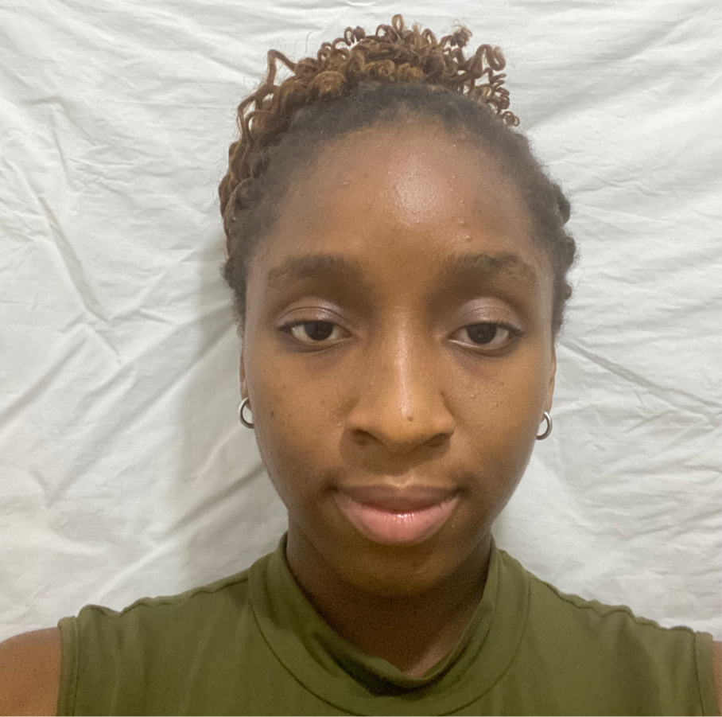

PERSONAL STATEMENT

I am excited to pursue a degree in Physiology, driven by my fascination with the intricate mechanisms governing human life. My curiosity about the complex interactions between body systems and the remarkable adaptability of living organisms fuels my passion for this field.

Through volunteer work at [hospital/health organization], I gained insight into the impact of physiological disorders on individuals and families. This experience solidified my commitment to understanding the underlying processes that maintain health and drive disease.

In school, I excelled in biology, chemistry, and mathematics, demonstrating my strong foundation in the sciences. My A-level courses in relevant subjects further deepened my knowledge and analytical skills.

The University of Memphis renowned Physiology program, with its esteemed faculty and cutting-edge research facilities, is ideal for nurturing my academic and professional growth. I am eager to engage with distinguished researchers, explore innovative techniques, and contribute meaningfully to the scientific community.

Upon graduation, I plan to pursue a career in physiology , applying my knowledge to improve human health and quality of life.

I bring enthusiasm, dedication, and a strong work ethic to my academic pursuits. I am confident that studying Physiology at University of Memphis will empower me to make a meaningful impact in the scientific community and beyond.

