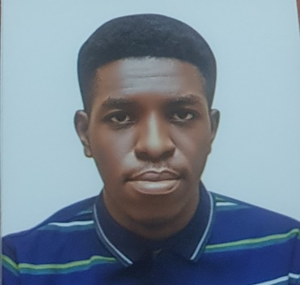

Personal Statement

From an early age, I have always been captivated by the complexities of how things operate. Whether it was taking apart everyday electronics or making basic devices out of leftover components, my interest in mechanical systems has influenced my academic path and professional goals. In addition to being a continuation of this commitment, earning a Master of Science in Engineering will help me become an expert in handling the most difficult engineering problems that exist today.

I hold a Bachelor of Engineering (B.Eng.) in Mechatronics from Afe Babalola University, where I graduated with Second Class Honours, Upper Division. Throughout my undergraduate studies, I excelled in courses such as Robotics, Control Systems, and Mechanical Design, all of which provided a solid foundation in both theoretical and practical aspects of engineering. My final year project involved the design and implementation of a Robotic Gripper capable of performing precision tasks, which further fuelled my desire to explore the boundaries of engineering innovation.
Beyond my core courses, I actively participated in workshops and seminars on emerging technologies, particularly in automation and artificial intelligence. These experiences have deepened my interest in leveraging technology to improve industrial processes and everyday life.

During my internships at Pixels Solution and Ingrace Multiple Concepts, I strengthened my technical and problem-solving skills in real-world settings. At Pixels Solution, I contributed to the design and maintenance of web systems, while at Ingrace Multiple Concepts, I worked on automotive services, gaining hands-on experience in mechanical repairs, engine diagnostics, and customer service. These internships equipped me with a unique blend of digital and mechanical expertise, demonstrating the versatility needed in today's interdisciplinary engineering environment.
These experiences not only improved my technical abilities but also taught me the importance of collaboration and adaptability. Whether working with a team of developers or mechanics, I learned how to translate complex problems into workable solutions while managing time and resources efficiently.

The rapidly evolving field of engineering demands a deeper understanding of advanced concepts and cutting-edge technologies. I believe that pursuing a Masters in Engineering will provide me with the specialized knowledge and research capabilities to tackle more complex problems. I'm especially interested in learning more about disciplines that fit with my professional background and personal objectives, such automation, sustainable engineering solutions, and renewable energy systems.
Moreover, the opportunity to study abroad will expose me to diverse perspectives and innovative approaches in the field of engineering. I look forward to working with world-class faculty and collaborating with peers who share a common passion for pushing the boundaries of technology. I am confident that the academic strength and research opportunities at your institution will equip me with the skills needed to contribute meaningfully to the global engineering community.

Upon completing my master's degree, I aim to work in an engineering firm that focuses on sustainable and technologically advanced solutions. My long-term goal is to develop innovative systems that optimize efficiency and reduce environmental impact, particularly in developing countries. I envision myself playing a role in shaping the future of engineering by leading projects that merge technology with sustainable development.

In conclusion, my academic background, hands-on experience, and passion for engineering have prepared me for the challenges and opportunities that lie ahead in a Master’s program. I am eager to contribute to and benefit from the vibrant academic community at your institution, and I am confident that this program will serve as the perfect platform for me to realize my full potential as an engineer. Thank you for considering my application.

